Rethinking Wireless
Technology, Architecture, and Public Policy

By Kevin Werbach
For the New America Foundation

I. Introduction 2
A. Believe in Magic 2
II. Wireless Fundamentals 3
A. Basic Concepts 4
B. The role of government 7
III. Paradigm Shift: From Passive to Active 8
A. The traditional approach 8
B. When the devices get smart 9
C. Survey of active wireless techniques 10
D. Interference mitigation 13
E. Implications of intelligent approaches 14
F. WiFi as a case study 15
IV. The Unlicensed World 17
A. Types of wireless systems 17
B. The Spectrum of Spectrum-Use Regimes 19
C. Current unlicensed products 20
D. Success stories 23
V. Future scenarios 25
A. Expanding the space of possibilities 25
B. The Last Wireless Mile 26
C. Interoperable public safety communications. 27
D. Adaptive mobile phones 27
E. Personal broadcast networks 28
VI. Conclusion 29
Bibliography 30

Introduction

Wireless. The very word belies its significance. Wireless communication is defined by what it is not, like the horseless carriage or the fat-free muffin. Yet the real value of a satellite television broadcast, a WiFi connection to a laptop, or a mobile phone call isn’t the absence of dangling wires. Mobility, portability, ubiquity, and affordability are all enhanced when signals pass through the air rather than through a strand of copper or optical fiber. Talking on a mobile phone is different, and in many ways better, than using a landline connection. If it weren’t, a billion people wouldn’t have signed up for mobile phone service, despite the alternative of a century-old wired phone industry.

The governments of the United States and other countries face important decisions concerning wireless communication. Is there a “spectrum shortage,” and if so, how can it be alleviated? Should more spectrum be set aside for “unlicensed” uses? Should spectrum licensees be given property rights to resell or otherwise control their spectrum more thoroughly? Do we need different rules to deal with interference? Should new technologies be allowed to “underlay” or “interweave” with existing licensed services? Can government, military, and public safety spectrum be managed more effectively?

These are vitally important questions. Wireless communication represents a $TK billion market in the US alone. It is crucial to how we communicate, work, learn, entertain ourselves, access health care, and protect our nation. In the last few years, entirely new industries have emerged through innovative wireless technologies that share spectrum without licensing. Regulatory and business decisions in the years to come could magnify the innovation occurring today, or reverse it at great cost to the nation.

Yet wireless remains deeply misunderstood and under-appreciated. Basic concepts like spectrum and interference suffer from widespread misconceptions. The technological developments of recent decades have not penetrated the public consciousness, even as the fruits of these developments become part of daily life for hundreds of millions of people. Just as economists know that information technology must have a role in productivity growth but can’t find it in their statistics, the wireless industry is experiencing a transformation that even many of its own experts do not fully appreciate.

Believe in Magic

In the words of legendary science fiction author Arthur C. Clarke, “any sufficiently advanced technology is indistinguishable from magic.” Wireless communication is a form of magic. Words and pictures fly over invisible pathways with near instantaneous speed. We control devices at a distance, with no apparent means of connection. Dozens of signals, carrying many different types of messages, traverse the air simultaneously. A time traveler from the Middle Ages would surely see divine intervention – or witchcraft – all around him.

For us, wireless communication is a familiar form of magic. It drives the radios we’ve had in our homes since our grandparents’ day, the mobile phones that one billion of us use to communicate, the televisions we watch an average of seven hours each day, the remote controls that start those TVs, and even the throwaway boxes that open our garage doors. This familiarity breeds contentment. We think we understand how wireless communication works. We don’t.

Our intuitions about wireless, by and large, are mistaken. They are based on outdated technologies and inaccurate analogies. If we hope to move forward in exploitation of the airwaves, we must take a step back. We must understand wireless communication for what it really is. And then we must re-evaluate our assumptions about what it could be. That is what this paper attempts to do.

Paradigm shifts are both difficult and essential for progress. Copernicus and Galileo showed that the Earth revolves around the sun, contrary to the received wisdom of the day. Eventually their view prevailed, launching an age of extraordinary discovery. In the last century, quantum mechanics overthrew the long-established Newtonian worldview. A hundred years of subsequent physics experiments confirm that our universe contains no such thing as solid matter or definite cause and effect. These ideas are so deeply weird that most of us simply refuse to accept them. We live in the familiar classical environment of our common-sense awareness. At the same time, we blithely accept technologies such as the integrated circuit and the laser which could not exist without the scientific fruits of the alien quantum world.

Wireless communication is more magical than we assume. More than one service can occupy the “same” spectrum, in the same place, at the same time. The frequencies that now carry one signal could someday carry thousands... or billions. There could be as many video broadcasters as today there are mobile phone subscribers. Government could cease the frustrating and inefficient task of parceling out spectrum, and instead allow users to share the airwaves without licensing. Innovation could proceed by leaps and bounds rather than a hesitant, drawn-out shuffle.

Appreciating the potential of wireless technology has always been difficult. When Guglielmo Marconi invented the radio, he envisioned it being used for person-to-person communication, not one-to-many broadcasting. Alexander Graham Bell invented the telephone while developing tools to help deaf people, and thought it would be used to broadcast wireless music concerts. If these scientific giants could be so wrong about their own creations, might we not be wrong in our assumptions about wireless?

This is not mere idle speculation. Decisions made in the 1920s have defined the contours of wireless communication ever since. A huge market sits atop the existing regulatory framework, which in turn sits atop conceptual and technical assumptions. Change those assumptions, and we can change the framework. Change the framework, and the market could become something far greater than it is today. Maintain the status quo or worse, and the opposite might result.

The manifestations of the dramatic change are so-called “unlicensed” wireless communications systems. The word unlicensed, like the word wireless, emphasizes what is missing. What is so extraordinary about unlicensed devices is what they can do, and the incentives they create for innovation and growth.

Wireless Fundamentals

The phrase “spectrum policy” primarily evokes mobile phone service. For instrumental reasons, broadcast television is considered “mass media,” satellite transmissions are “international,” high-speed data to the home is “broadband,” military radars are “national security,” and so forth. Yet all of these are manifestations of wireless communication. Baby monitors and Bluetooth headsets are just radios, as much as the music-spouting device in your car.

Considered this way, the wireless landscape is vast. There are dozens of services, generating billions of dollars and supporting a wide array of functions:

Service | Mkt Size | Payload | Range | Architecture | Use Case
Radio (AM/FM) |  | Voice, music | City | Broadcast | Stationary, mobile
Broadcast TV |  | Video | City | Broadcast | Stationary
Mobile telephony |  | Voice, data | National | Cellular | Mobile
Private radio |  | Voice, data | City | Cellular, Point-to-point | Mobile
Fixed wireless (to end-users) |  | Voice, data | Neighborhood | Broadcast | Stationary
Point-to-point microwave |  | Voice, data | Several miles TK | Point-to-Point | Stationary
Satellite broadcast |  | Video | National | Broadcast | Stationary
Satellite radio |  | Voice, music | National | Broadcast | Mobile
Paging |  | Voice, data | National | Broadcast | Mobile
Wide-area wireless data |  | Data | City/National | Cellular, point-to-point | Stationary, mobile
Public safety |  | Voice, data | City | Broadcast | Mobile
Military |  | Voice, data | Various | Various | Various
Radio astronomy |  | Data | Galactic | N/A | Stationary
Amateur radio |  | Voice, data, video | Various | Various | Various
Maritime and aviation communications |  | Voice, data | Various | Various | Mobile
Radar, GPS, and other sensors |  | Data | National | TK | Mobile
Wireless LAN |  | Data | Hundreds of feet | Cellular | Nomadic
Other unlicensed devices |  | Data, voice | Tens to hundreds of feet | Point-to-point (primarily) | Various

Basic Concepts

Fundamentally, a wireless communications system involves one or more radio frequency transmitters and one or more receivers. Transmitters radiate, and receivers receive, within a certain range of frequencies, but those are properties of the equipment, not some distinct medium the signals pass through. By the same token, what governments regulate are the capabilities of transmitters, and to a lesser extent receivers, rather than the spectrum itself.

Radio waves are a form of electromagnetic radiation, like everything from lasers or lightning bolts. “Radio frequency” signals are generally considered those with frequencies between TKkhz and 100 GHz. Their propagation characteristics are well-understood by physicists. Radio waves can propagate indefinitely, with declining power over distance, unless dissipated TK by obstacles such as walls or the Earth’s atmosphere. Their susceptibility to such obstacles depends on the frequency and power involved.

The point of this physics lesson is that most of the topics spectrum policy concentrates on, such as “interference” and “spectrum,” are value judgments based our uses of wireless communication. Radio waves do not bounce off one another. When two or more of them share the same space at the same time, it can be difficult for receivers to distinguish them. In practical terms, the TV picture gets fuzzy or the mobile phone drops a call. But your mobile phone dropping a call is fundamentally different from your landline call not getting through because “all circuits are busy.” In one case, the connection literally stops at an overloaded switch. In the other, what is lost is only the useful information.

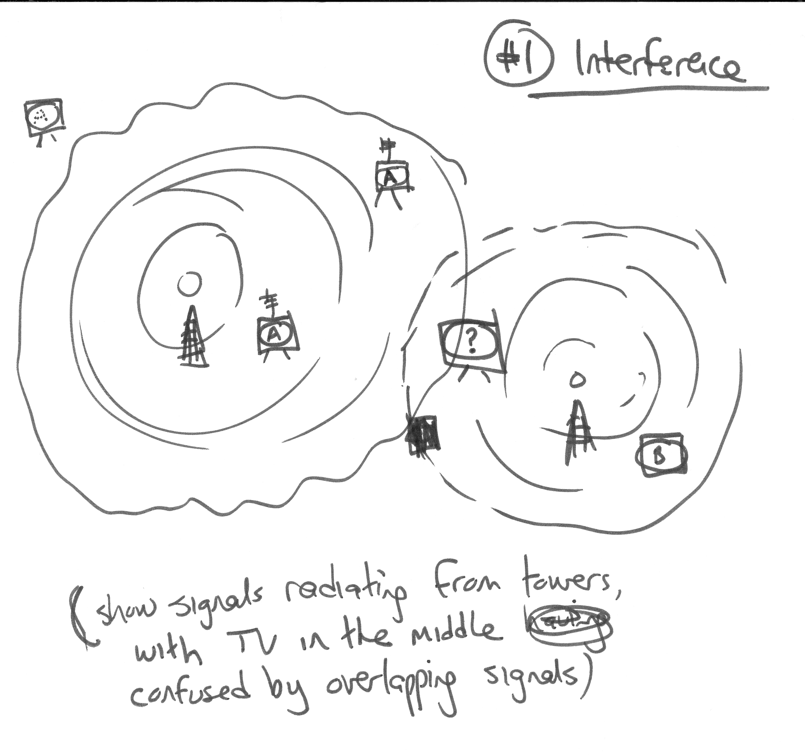
Illustration 1 – “Interference”

This seemingly arcane distinction is critical. For the overloaded phone switch, nothing the caller or the called party can do makes any difference. The electrical or optical signal terminates in the middle. In the wireless case, better technology at the endpoints can reconstruct useless noise back into useful information. In other words, change the communications devices or the regulatory environment, and you may change the capacity of the system.

There are several fundamental concepts that explain aspects of wireless communications systems.

Capacity

Capacity is the essential metric for wireless communications. Marconi originally thought that only one radio could transmit in a given area, because other radios would interfere with the signal. However, he recognized that tuning forks can be made to vibrate on the same frequency. If the radio signal were associated with a carrier wave of a particular frequency TK, a second radio on a different frequency could operate in the same area. TK explanation.

In effect, Marconi figured out how to use frequency to multiplex radio signals. Other improved these techniques. Because frequency division was the only viable means of operating multiple simultaneous radio transmitters when radio developed as a commercial service, it became the basis for government radio policy. Regulating radio meant regulating frequencies, by parceling out the usable spectrum to licensees and service categories. And so it remains today.

Frequency division, however, is not the only means of multiplexing radio signals. Another one is time. The government could have allowed each broadcaster to transmit during a certain hour of the day only, for example. Frequency division was obviously a better solution, both on capacity and practical grounds. In some cases, though, time division makes sense. Some mobile phone systems, for example, chop up their licensed frequencies into split-second time slots, and interweave digital communications signals among them. In addition to time and frequency, spatial multiplexing can be done based on both three-dimensional relative location of the transmitter and the angle at which a signal hits an antenna. But again, spectrum regulation talks only about frequencies.

These multiplexing techniques, along with improvements in tuners and signal processors, are the reason the radio spectrum can now accommodate services such as television, mobile telephony, satellite radio, and wireless Internet connectivity where once there was only radio. Expanding capacity is a primary goal of wireless policy. More capacity increases the value of the radio spectrum, both in economic and social terms.

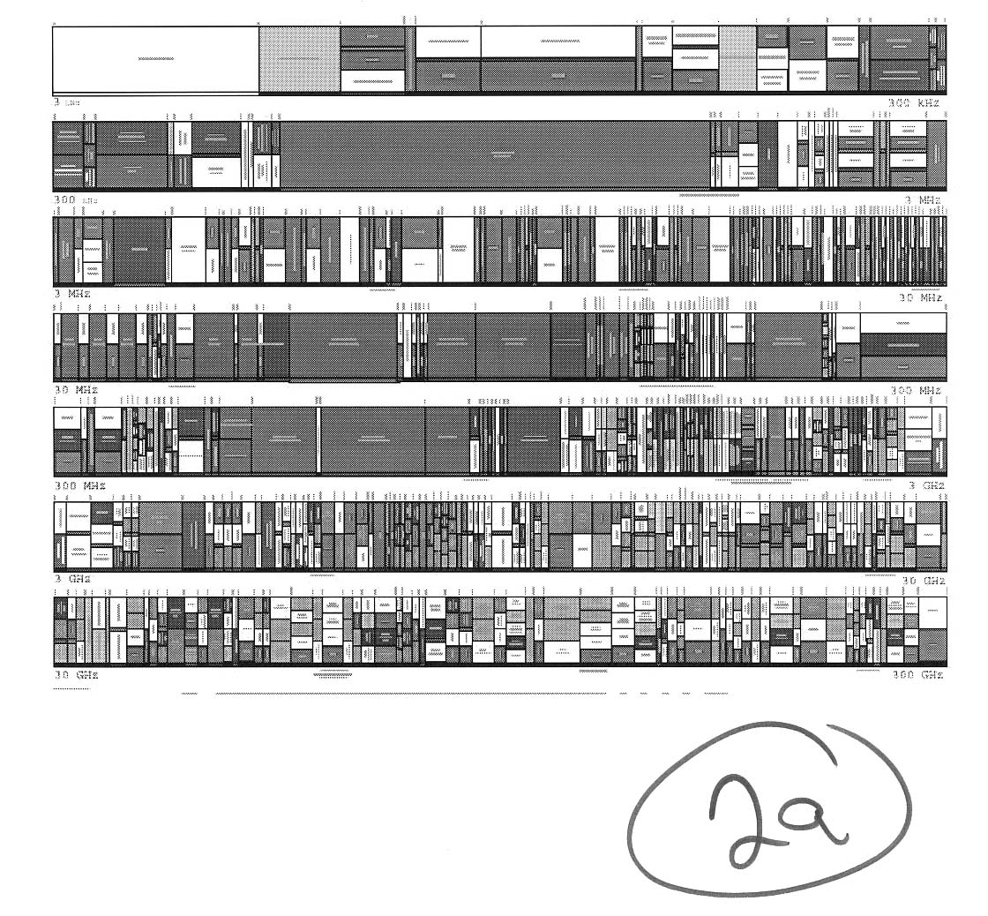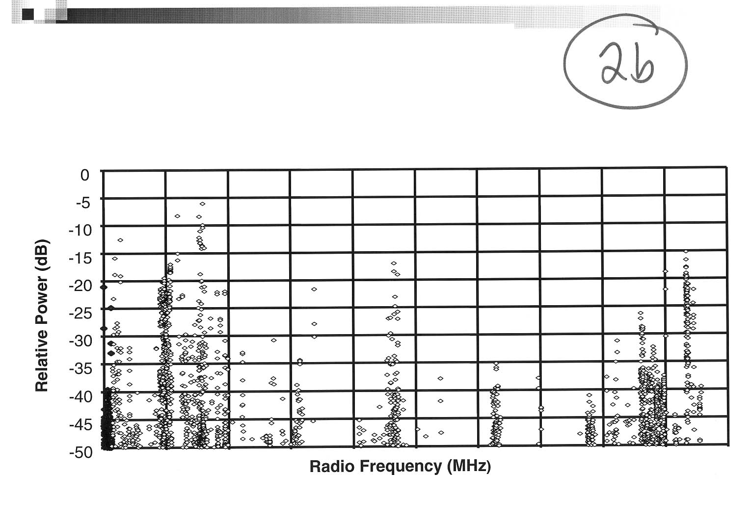

Illustration 2 – Two views of capacity

Architecture

Fortunately, even the gaggle of capacity-enhancing techniques listed above is incomplete. Capacity depends not just on the way a device distinguishes one signal from another, but on the architecture of the overall communications system it is part of.

What does architecture mean in this context? A simple example would be to compare a radio broadcast with a mobile telephone call. Radio is a broadcast service, meaning that a tower sends out a signal at the maximum allowed power in all directions. It blankets an area, so that every receiver within range (typically a metropolitan area) can tune in the signal.

Mobile phone networks, by contrast, use a cellular architecture. Each tower sends relatively low-power signals to any handset within a few square miles TK. For handsets out of that range, there are other towers. Because of the low power, users talking to one tower don’t notice the signals that other users are exchanging at the same time with a different tower. The same spectrum is being “re-used.”

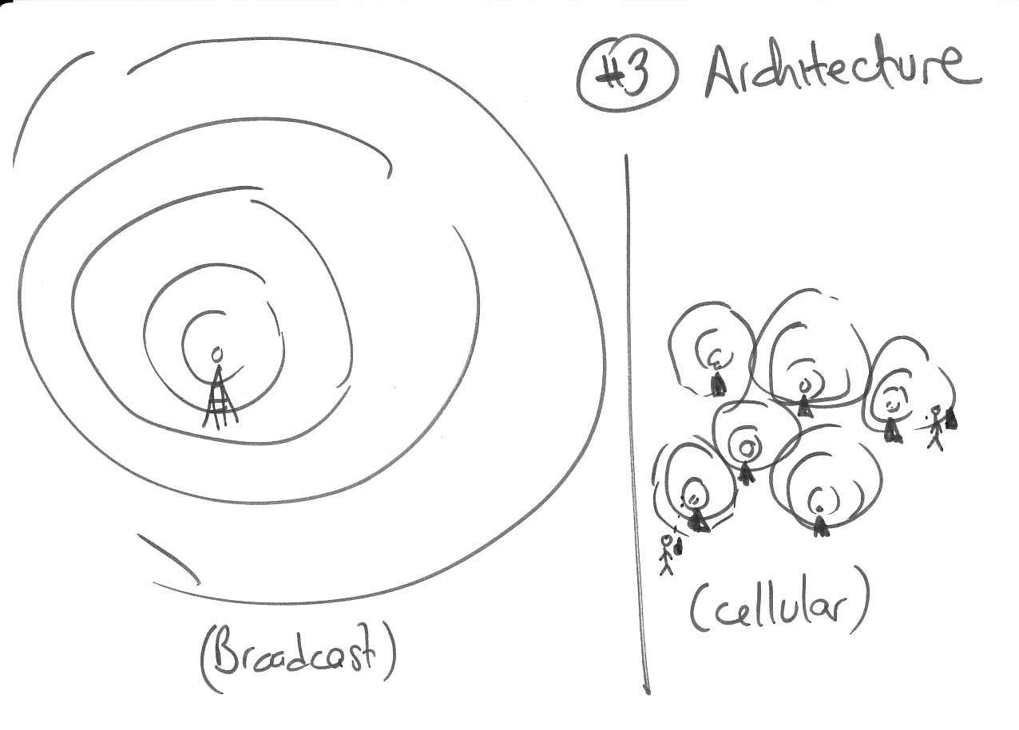

Illustration 3 -- ARCHITECTURE COMPARISON DIAGRAM

Notice the distinctions. The broadcast model lets the transmitters and receivers be simple (and therefore cheap), because there is only one transmitter sending data in one direction. The cellular model requires many more towers and more expensive devices, but in return it lets many more conversations occur simultaneously, in both directions. There are other significant differences, and other network architectures with their own characteristics. The range of possible architectures is constrained primarily by the way the legal regime divides up and regulates spectrum.

Shannon’s Law

As with most things in wireless, the basic science underlying this discussion has both a conventional wisdom aspect and a deeper story. Bell Labs researcher Claude Shannon, in his seminal work in the late 1940s, created the mathematical concept of information theory. Shannon developed equations to measure the ability of a communications channel to carry useful information. As usually explained, “Shannon’s Law” defines a maximum capacity, which is proportional to the frequency or band width of the channel. As a result, bandwidth has become almost synonymous with capacity. Because there is only so much bandwidth, and any service can only have a small portion of it, this model implies strict limits on possible capacity.

This paraphrase of Shannon’s capacity theorem leaves out critical facts. The version in question describes the simplest possible case – one transmitter and one receiver. Add more of either, and the solution is no longer so easy. More devices may cause “interference,” or may create opportunities to interweave signals or otherwise add intelligence to the network. Similarly, a wider band adds capacity, but it’s not the only way to so.

The scientific field of multi-user information theory takes Shannon’s work and extends it for these more complex (and more realistic) situations. It is a fruitful area of research and experiment. In the half-century since Shannon’s initial work, we have learned many things about what is possible with wireless communications. But there are many things we still do not know. For example, we don’t even know the maximum potential capacity of a system with an arbitrary number of devices. This core uncertainty should make us hesitate before uttering any statements about what is or is not possible in the wireless realm.

Layers

Data networks tend to operate using a layered model. Rather than defining the entire system as an integrated whole, engineers split it up into a communications “stack.” This allows for separation of functions that can be optimized individually. For example, technology developed for telephone networks can be applied to different “physical” layers, including cable TV networks and wireless environments. The standard conceptual reference for the layered model of data networking is the seven-layer framework of the Open Standards InstituteTK (OSI). The higher the layer, the more specific the technology is to the service being delivered.

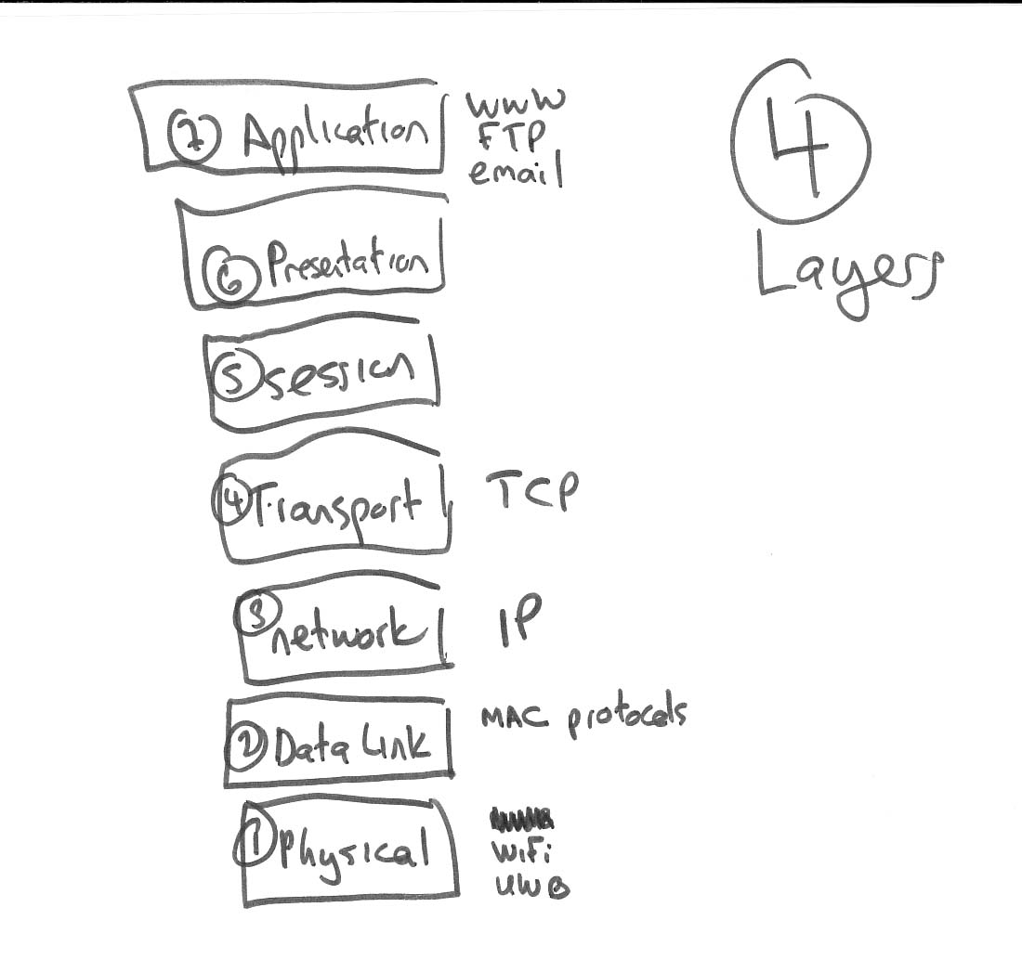

Illustration 4—Layers (Just blocks – may not need the illustrator)

For the wireless systems under consideration here, the most important layers are the two bottom TK ones, physical (PHY) and media access control (MAC). The physical layer in the interface to the physical world: how the data are transmitted across the carrier medium. The media access control layer specifies how that information is organized. The two layers are often tightly coupled, but not always so. For example, many companies are taking the 802.11b (WiFi) physical layer, throw out the WiFi MAC layer and add their own proprietary MACs that offer additional features such as mesh networking or quality of service controls.

The role of government

What is “possible” in communications always has two meanings: technical and legal. Technical possibility is a function of scientific discovery and commercialization. Legal possibility is defined by the regulatory system. Many things are possible in the technical realm but not in the legal. (Occasionally, the reverse is true!) No discussion of the business and social fundamentals of wireless technology would be complete without taking government rules into account.

From its earliest days, the communications industry has been subject to pervasive government regulation, in the US and elsewhere. In wireless, that regulation takes the form of spectrum policy. The Federal Communications Commission (FCC) tells some entities that they can use particular frequencies, usually for specific purposes and with detailed technical and economic requirements. It tells everyone else that they cannot use those frequencies. And it enforces those rules, punishing violators.

Extensive government regulation of spectrum is taken for granted. But let us ask for a moment, why should that be so? Communication over the airwaves is speech, just like communication through the wired phone network or through a microphone at a political rally. Government regulation of speech is strictly limited under the Constitution. Yet we tolerate a government agency, the FCC, bestowing the ability to speak upon individual companies, telling them exactly how they can speak, and punishing others who attempt to speak.

There are several rationales for government regulation of spectrum. The airwaves are considered a public asset, not to be left to the vagaries of the private market. Regulation promotes a diversity of access by different voices, and maximizes efficiency in use of the airwaves. Government involvement prevents the chaos of ruinous interference that might occur in a vacuum. And there are important public safety and national security uses of wireless communication that government promotes and managed.

Behind all these rationales stands a single assumption: scarcity. If spectrum were not scarce, and simultaneous uses of the same spectrum were not mutually exclusive, there would be no reason to treat it differently from other forms of speech. Whether spectrum is in fact as scarce as we assume will be a major theme of this paper.

Spectrum regulation developed early in the 20th century in response to two developments: a burgeoning commercial radio broadcast industry, and fears of chaos if government did not step in. Though the actual story is more complicated, the failure of nearby ships to heed the distress signal of the Titanic was seen as evidence for more extensive government intervention. Back at home, nascent radio broadcasters were squabbling about interference, arguing who had the right to transmit on particular channels TK. Secretary of Commerce Herbert Hoover pushed for federal oversight of spectrum allocation. Eventually, the Federal Radio Act TK and then the Communications Act of 1934 were passed, establishing the Federal Communications Commission as the prime arbiter of the airwaves TK.

For sixty years, spectrum policy meant deciding which uses – and which users – were entitled to frequencies. The biggest change in recent years has been the shift to auctions and flexible licenses as the preferred assignment mechanism. Responding to the critique articulated by Nobel Prize-winning economist Ronald Coase in the 1950s TK, the FCC and many other governments now use auctions as the primary assignment tool, rather than comparative hearings or lotteries. TK

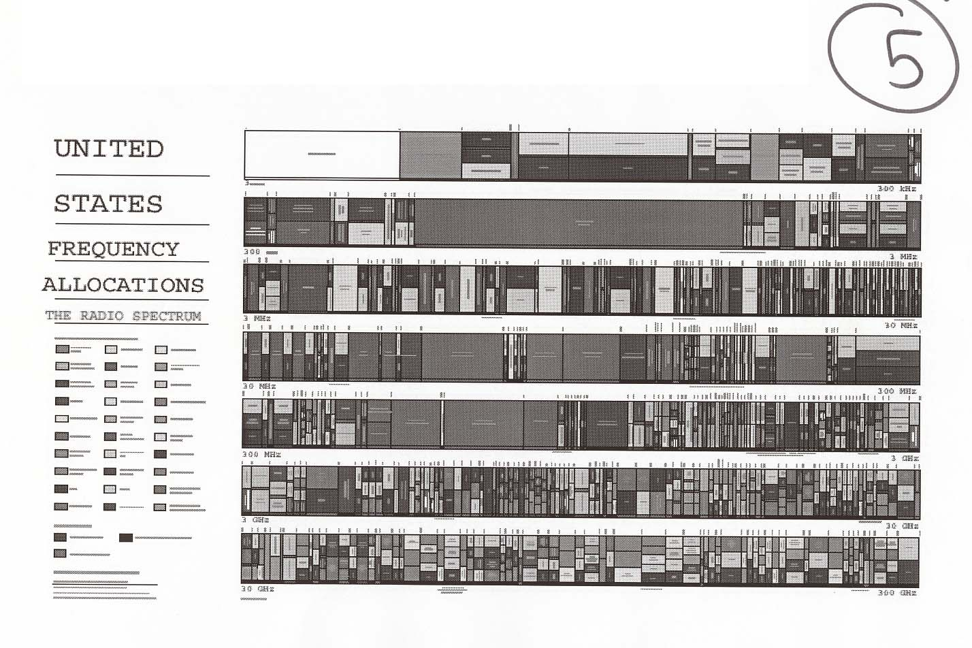
Illustration 5 – NTIA spectrum map

In addition to the assignment mechanism, an important element of the FCC’s licensing regime is what the licensees were given. In virtually all cases except the most recent auctioned spectrum, licensees did not receive the right to control the spectrum absolutely. They got a right to use the frequency to provide a particular service, and only that service.

A small amount of spectrum is assigned not to any specific users, but for “unlicensed” operation. The government sets technical requirements, such as power limits, for users of the band, and provides certification mechanisms for devices that operate within it. Users of unlicensed devices have no formal protection against interference from other user in the band, but they need no special permission to operate there. The FCC also allows very low power devices (less than one watt) to operate in TK virtually any band under its Part 15 rules, on the grounds that they are too quiet to interfere with any other service.

Paradigm Shift: From Passive to Active

The traditional approach

Traditional wireless systems are passive. They assume dumb receivers and dumb transmitters, whose function is to blast out a signal at the maximum allowable power level. The model is quite straightforward: Imagine a baseball pitcher throwing a fastball and a catcher receiving it. The pitcher needs to know where to aim, and the catcher must reach the right direction for the pitch, but that’s about it.

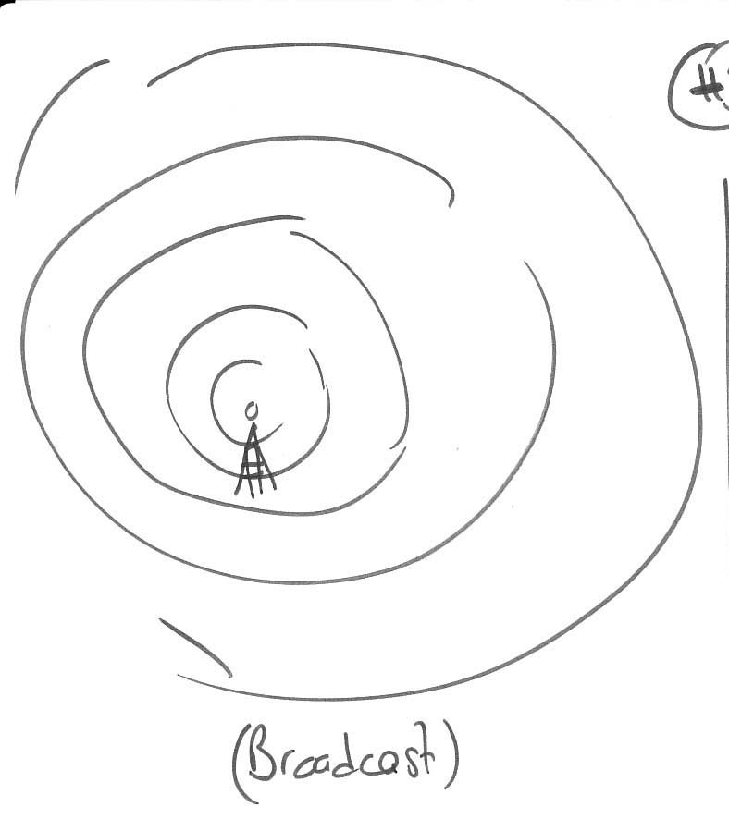

Illustration 6 – BRoadcast model (Or maybe something with a pitcher and catcher as in the text)

The good aspect of this model is that it doesn’t require much sophistication in the endpoints. Transmitters and receivers that don’t think much for themselves are relatively cheap to build. When the costs of radio hardware and computing power are high, such savings make a difference in what’s economically possible.

The downside of the passive approach is that the devices aren’t smart enough to get out of each other’s way if there are multiple signals in the same space and frequency band. That means systems must have exclusivity within bands. In the early days, such as when radio and TV broadcasting were established, the systems weren’t even smart enough to tell what was in their band. The FCC established wide “guard bands” around licensed frequencies where no one could transmit. That’s why the three US broadcast TV networks are typically on channels 2, 4 and 7 or 3, 6, and 10, rather than 1, 2, and 3. The “white space” in between is dark to ensure receivers in each channel don’t become confused.

The limiting factor for passive wireless systems is the cost and computational capability of hardware, more so even than scarcity of spectrum. TK more.

As everyone knows, computers have become more capable over time. In a famous formulation, Intel co-founder Gordon Moore noticed that transistor density on microprocessors doubled every 18 months thanks to advances in technology. His observation became a prediction, then a law, which has held true for 35 years. The implication of Moore’s Law is that whatever a computer can do today, it can do twice as well in 18 months, or twice as cheaply.

A radio itself is not a computer. It is a device for transmitting signals. However, computers can be used to control radios, or to process those signals. Just as devices from automobiles to air conditioning systems benefit from having computer “brains,” computers can improve wireless communications devices. With today’s computing power, in fact, they can totally transform them.

When the devices get smart

Intelligent transmitters and/or receivers can engage in a different form of wireless communication than the traditional passive systems. Rather than merely waiting with a catcher’s mitt up for an incoming signal, the receivers can contribute to the communications process. Rather than hurling a ball toward a static target, the transmitters can craft what they send for maximum efficiency. Call this active wireless communication. The baseball metaphor breaks down in this context. After all, a baseball is a solid physical object. It is either here, there, or somewhere in the middle.

Think, then, of a group at a cocktail party. Many people can hold conversations with one another simultaneously. They can do so not because they each shout over the others, or because they agree on a set of rules to define who can talk when and how. It’s obvious to us that the reason so many people can talk at once is that the speakers modulate their volume and the listeners use their brains to distinguish their partner from the ambient noise. If you’ve ever tried listening to a piece of music and concentrating on different instruments to pull them out of the mix, you’ll understand this process immediately. Now transfer the setting from smart human listeners to smart digital radios.

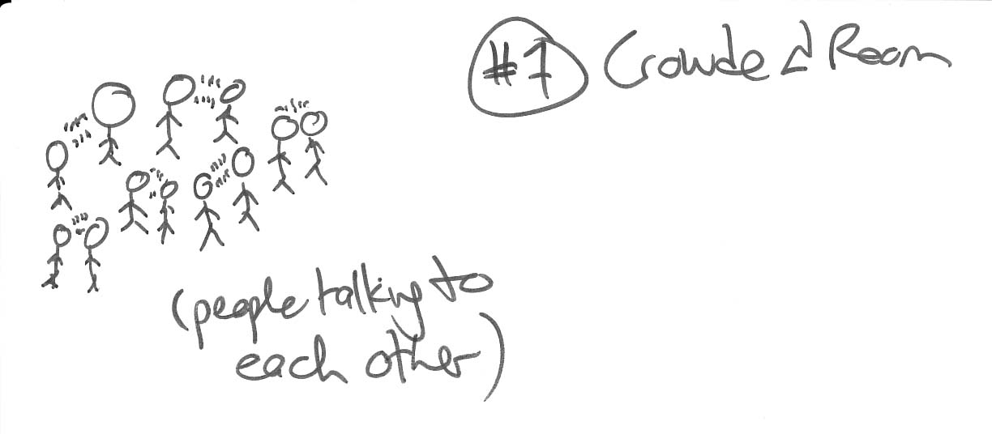

Illustration 7 – Crowded room analogy

Another analogy is the Internet. The Internet doesn’t have master directories or switches controlling the flow of information. Every router can decide independently where to send traffic. This works effectively thanks to cheap capacity and cheap computers that power the routers and other devices such as caches and Web servers at the edges of the network.

TK – Ocean, real-estate, and football analogies?

As these analogies show, the switch from passive to active approaches has several consequences. First, the capacity of the system to transmit useful information increases. The same spectrum can hold more communications. The intelligence of devices is substituting for brute-force capacity between them. Second, the architecture of the wireless system changes. Instead of cheap, dumb terminals at the endpoints, there are agile, intelligent devices. The system as a whole becomes more decentralized and more flexible. Two-way communication replaces one-way blanket broadcasting as the dominant mode of connectivity. Third, what was once a single-purpose, hardwired system dominated by the proprietary radio components increasingly becomes a general-purpose, adaptive platform dominated by commodity computing components. These subtle changes have dramatic consequences, which will be explored later in this paper.

Survey of active wireless techniques

Active wireless communication is a deliberately broad classification that includes many technical mechanisms, with new ones being developed all the time. Once the transmitters and receivers are seen as computers that can contribute to the efficacy of the communications system, all sorts of possibilities emerge. These possibilities do not require any particular spectrum, or any particular spectrum policy regime. However, as will be discussed later, spectrum policy influences very significantly the kinds of techniques that are used, by establishing the economic conditions and incentives for spectrum users.

Advanced Multiplexing

As discussed above, wireless systems designers have long understood how to “multiplex” multiple signals by sending them along different frequencies, or by splitting up spectrum into tiny slices of time. These multiplexing techniques are entirely consistent with the industry structure that developed under the dominance of the passive wireless approach. Frequency-division multiplexing requires the most limited possible intelligence in devices, with spectrum bands exclusively allocated to specific users. Time-division multiplexing is more complex, but traditionally requires all the devices in a system to synchronize their “clocks” in order to know which signal is in which time slice. Such synchronization effectively requires exclusive control of a frequency.

There are newer multiplexing techniques with different results. The first developed was “spread spectrum.” Hollywood actress Hedy Lamarr and musician George Antheill TK filed for a patent on a spread-spectrum communications system in 19TK, though real-world deployment occurred later. A spread-spectrum system inverts the passive model of transmitting with high power on a narrow channel. Using low power and spreading the signal across a wider range of frequencies, it’s possible to cram more transmissions into the same spectrum. The basic notion is that if the transmission is broken up into pieces, each of which is tagged with a code, a receiver that knows the code can reconstruct the message. The wider the spreading, the more space there is in between the coded packets to send other signals at the same time.

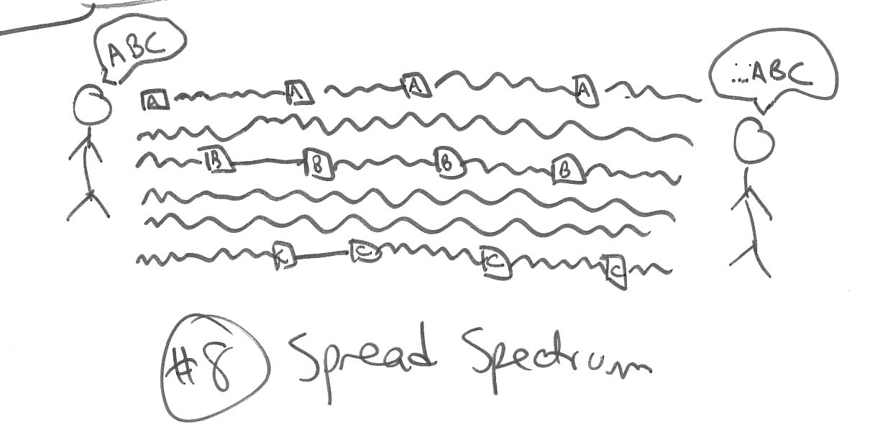
Illustration 8 – Spread spectrum

Taking spread-spectrum to its logical conclusion, if the signal is spread wide enough, the power used can be so low that the signal is invisible to other systems in the same band. Radio frequencies are never totally empty of noise. Radiation-emitting devices such as hair dryers and microwave ovens, as well as cosmic background radiation tK, create a “noise floor” that all systems must contend with. Passive systems do so by using high-enough power that it’s easy to distinguish the high-power signal from the low-level noise. With enough smarts, though, an active spread-spectrum system can transmit signals without ever raising above the noise-floor threshold. This approach is known as ultra-wideband (UWB). Because of fears about interference, commercial use of ultra-wideband for communication was illegal until early 2002, when the FCC authorized it for the first time.

Space-time coding

Many other multiplexing schemes are possible beyond spread-spectrum and UWB. For example, companies such as Northpoint Communications TK have developed systems that multiplex satellite and terrestrial transmissions in the same frequency band. Satellite signals arrive from above, while terrestrial signals are sent horizontally. A smart enough system can distinguish these two signals based on their angle of arrival, and can even do so without requiring modifications to the existing satellite system.

Northpoint’s technology is an example of a broader class of techniques that take into account the physical location of transmitters and receivers. Passive broadcasting uses a saturation approach. The receivers can be anywhere within the propagation footprint of the signal. The transmitter has no idea where they are beyond that, and the receivers know nothing other than that the transmitter is in the same footprint. As the Northpoint system shows, however, the location of transmitters and receivers is a useful piece of information. A signal arriving from thousands of miles overhead is different from a signal arriving laterally from a few years away, even if both are within the same frequency band.

Space time coding techniques use the physical topology of the network, or the surrounding environment, to add efficiency to wireless communications systems. For example, the BLAST system developed at AT&T Bell Labs TK employs “antenna diversity” to increase capacity. Instead of a single antenna at the receiver, BLAST employs multiple antennas with TK distance between them. Comparing the signal received at the different antennas makes it easier to distinguish transmissions from noise, increasing effective capacity. TK more BLAST details.

Even factors that seemingly reduce capacity can be employed to increase it. The bane of many wireless systems is “multipath.” When radio waves encounter obstacles such as walls, some fraction of them bounce off the obstacle and the remainder pass through. The ones that bounce may still reach the receiver. But they do so through a more circuitous, and therefore slightly slower, path. The receiver sees the same signal twice (or more), a split second apart. This multipath effect can confuse the receiver, degrading the signal quality.

With a properly-defined system, however, multipath becomes just another information-adding physical element in the wireless system. Knowing how a signal is bouncing around tells the receiver something about the location and nature of the transmitter. If the two temporally-spaced signals are identified as the same transmission, they can be combined in a buffer to enhance the output signal. Similar techniques can be used for other factors that traditionally cause “interference,” such as mobility.

Meshed networking

Meshed networking is somewhat different than the previous techniques. It is a family of cooperative network architectures. The basic definition of a mesh is that receivers talk to each other as well as to the transmitter. A good example of a meshed netwok is the Internet. Every router has a table that allows it to send packets to many other routers, rather than through a central clearinghouse. Thanks to this architecture, the Internet avoids congestion choke points and single points of failure. When one link is down or overloaded, traffic automatically shifts to other links.

Wireless systems have traditionally used either a pure broadcast architecture (one central transmitter), or a hub-and-spoke approach as with cellular telephone networks (users connected through local towers). The benefit of a mesh approach is that there are likely to be other end-users of the network closer to you than a tower or central broadcast facility. Shorter distances mean better signal, lower power requirements, and ability to avoid obstacles such as trees.

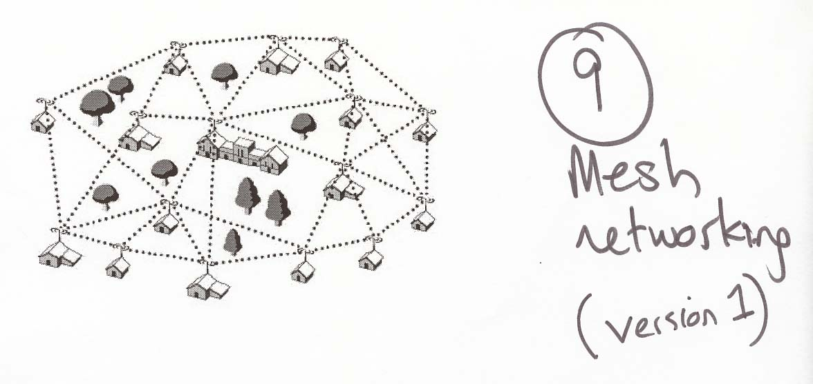

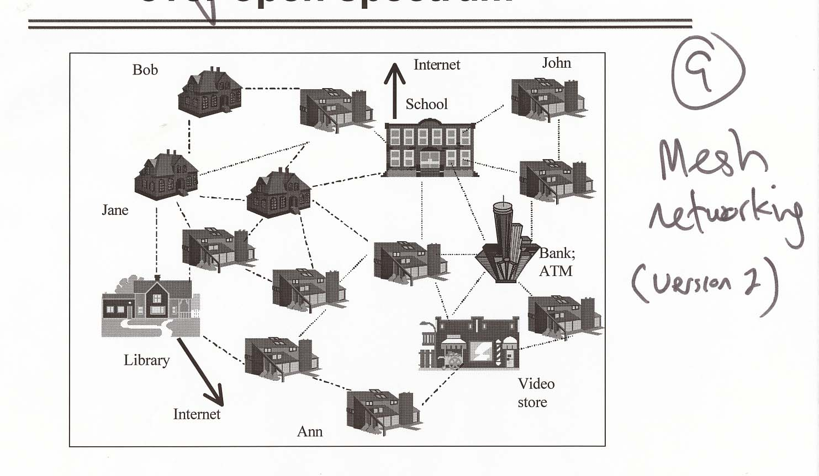

Illustration 9 –mesh networking (two versions as models only)

Consider the task of providing “last mile” high-speed Internet connectivity to a neighborhood. [TK DIAGRAMS FROM SKYPILOT OR ELSEWHERE]. The benefit of the mesh is that every new house brought online adds something to the network, improving performance and reliability. The difficulty is that a mesh doesn’t work with one or two nodes. The system requires a critical mass of devices to operate effectively. That number depends on the service and deployment environment. TK Several companies have tried to deploy last-mile meshed wireless networks, including Rooftop Communications, which was acquired by Nokia, and SkyPilot and TK. Rooftop was recently folded TK.

Several existing unlicensed technologies offer some form of meshed networking, including Bluetooth and 802.11. Meshed networking is defined through software that rides on top of the physical-layer connection, so it can be applied to virtually any radio technology. TK

Software-defined radio

At the heart of any wireless communications system is the radio. A radio transmits or receives wireless signals encoded into waves that oscillate at frequencies somewhere within the radio spectrum. Traditionally, those radios have been fixed in hardware. A radio talks to a fixed swath of spectrum, and understands a fixed modulation scheme for coding signals. It’s like a dedicated telephone line between two businesses. You simply can’t use it to call your grandmother, or another business across the street.

Software-defined radio (SDR) uses software to control how to the radio works TK. It’s like replacing the dedicated phone line with a connection that goes through an electronic switch. Suddenly many of the characteristics that were immutable become flexible. Capabilities not envisioned when the device was built can be added later.

SDR has several benefits. One device can support multiple services transmitting on different frequencies with different encoding schemes. A mobile phone handset, for example, could receive signals from more than one service provider, or from service providers in different countries, regardless of what technical standard they employ. This is particularly important for markets, such as public safety, where incompatibilities between systems, such as those used by police and fire departments responding to the same emergency, are critical problems. The US military has funded significant research and development related to SDR for similar reasons. The Joint Tactical Radio Service TK (JTRS) is now under development through prime contractor TK and subcontractors including Vanu, a startup in Cambridge, MA that is a leading SDR technology developer.

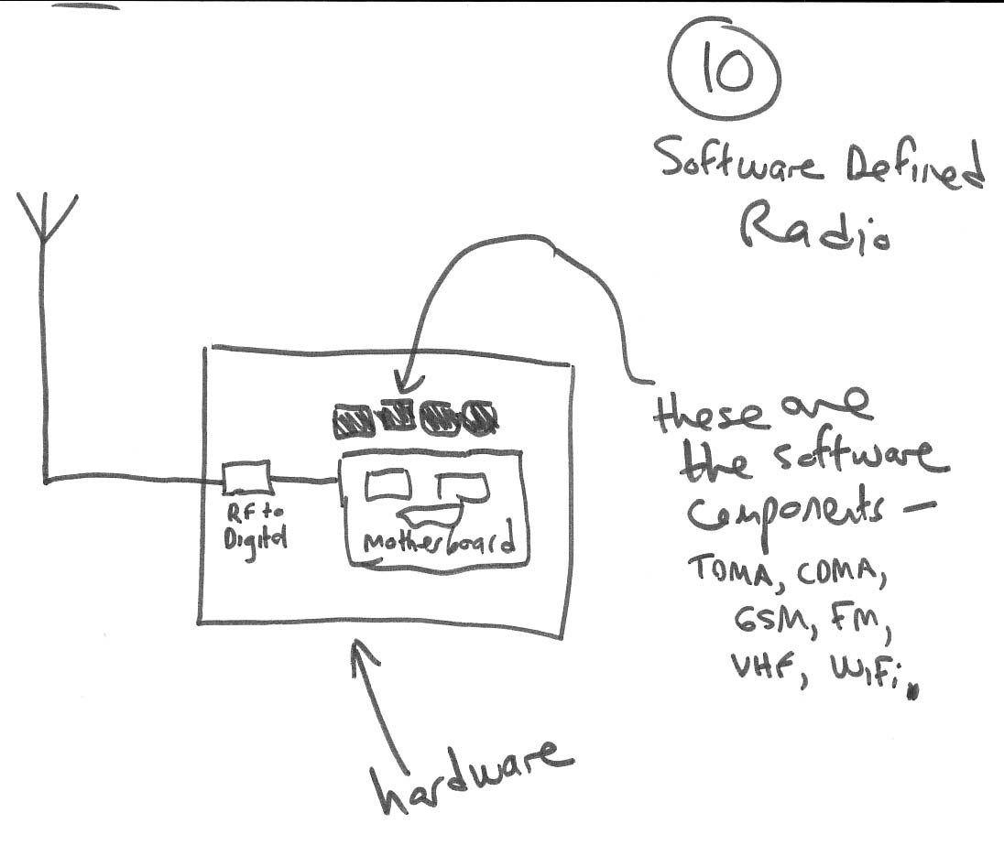
Illustration 10 – Software defined radio

The flexibility of SDR reduces costs by eliminating duplicate equipment, both for users and for service providers. Imagine a cellular network, for example, where each service provider only had to put up towers where others had not, rather than each of them having to build a redundant national footprint.

The potential of SDR goes significantly beyond cost reduction. Because a software radio is software, it can run on general-purpose computers such as Windows and Linux devices, using mass-produced digital signal processors (DSPs) and other hardware. Such devices benefit from Moore’s Law and the competitive dynamics that steadily push costs down and capabilities up. As DSP chips become more powerful for the same price, an SDR system can decode a larger swath of spectrum or perform other new functions. SDR systems can also take the decoded radio signals and feed them into other applications, such as TK.

Agile or cognitive radios are a sub-category of SDR that is currently in the development stage. Agile radios can “jump” from one frequency to another in a matter of milliseconds. Combined with processing capabilities that allow such devices to sample the spectrum around them, agile radios can in effect manufacture new spectrum. Even a channel supposedly occupied by a licensed system is empty much of the time in much of the defined physical area. An agile radio could hop among local, short-duration empty spaces in the spectrum, moving whenever it sensed another transmission in the same band. Such devices could effectively become their own virtual networks, creating connections with other nodes wherever they were.

Interference mitigation

Wireless systems never exist in a vacuum. Techniques for enhancing capacity also affect the way devices interact with each other, and with their surroundings. In other words, they change the interference environment. As discussed above, interference is a consequence of wireless system design, rather than an inherent property of the radio spectrum. Interference is also inherently a legal construct. No radio signal on planet Earth is perfectly pure. There is always some noise floor that impinges on transmissions. Someone whether a government regulator, a technical standards body, a court, or two parties to a contract, must define the threshold at which indeterminate background noise becomes detrimental interference.

The passive mechanism to overcome ambient “interference” is to raise power output. The louder the signal the easier it is to find among other noise. Of course, raising power increases the likelihood of impinging on other signals, especially those adjacent either geographically or frequency-wise. Regulators must therefore define power output and license geography limits carefully. Historically, large amounts of spectrum were kept as guard bands where no one could transmit, to allow a wide “buffer” between licensed signals.

Passive wireless systems have traditionally dealt with interference from other transmissions through legal means. No one else may transmit in licensed bands. The FCC’s rules provide penalties TK for TK “harmful interference”, which is defined in terms of the effects of the second signal on the licensed service TK. When the FCC proposed to authorize a large number of lower-power FM radio stations for use by community groups, licensed radio and TV broadcasters expressed alarm that their transmissions would be threatened. TK low power FM fight.

Active wireless systems look at interference differently. As noted, with some techniques the very factors that supposedly create interference – physical obstacles, multipath signal duplication, and mobility – can actually be used to improve capacity. In other cases, active systems can simply use their more powerful processing capabilities in receivers to distinguish signal from noise. It’s the equivalent of listening closely rather than asking the person you’re conversing with to talk more loudly. Because of their flexibility, active systems often have the ability to “maneuver” around potential interference, whether by splitting up signals into packets spread across a wide range of frequencies, hopping from place to place in the spectrum, our sending communications through a physically distinct route across a mesh network.

This new array of interference responses is in fact a significant reason for the growth of active wireless approaches. Passive systems can stretch capacity out of the spectrum and coexist with one another, but only to a point. Demand for wireless services continues to increase. Techniques such as spread-spectrum and software-defined radio have been the subject of significant funding and research because they address real problems that emerge within the traditional spectrum licensing regime.

Implications of intelligent approaches

The switch from passive to active wireless communication has huge consequences. Technical approaches created to solve technical problems turn out to have major policy, business, and even social consequences. These consequences, such as the possibility of replacing spectrum licensing with “commons,” have generated a great deal of attention. They would not be possible without the technical advances we have described so far. In many cases, the technical advances have grown up within the dominant wireless paradigm, as for example with Qualcomm’s CDMA spread-spectrum technology for licensed cellular networks. As wireless technology moves forward, however, the possibilities for radical change will become more difficult to ignore.

TK – here or below: more on practical benefits of unlicensed systems (social, economic)

Commons

The first and biggest consequence of these new technologies is that licensing is no longer absolutely required. Recall that the original basis for spectrum licensing by the government was the belief that the alternative was ruinous and pervasive interference. If devices can operate with sufficiently low power and high intelligence to avoid one another, that is no longer necessarily true. There need not be an assumption that everyone will be a “good neighbor” or that enforcement mechanisms will succeed in resolving competing claims of priority. With a properly defined environment, users effectively can’t prevent each other from communicating. That opens the door for a new regime that allows anyone to transmit within fairly general technical guidelines.

This notion of allowing anyone to transmit has become known as a “spectrum commons.” The analogy here is to common lands in the Middle Ages in England, where anyone could graze their sheep. In recent years, extensive scholarship has developed to apply the commons notion to a remarkable variety of settings. TK commons idea. As will be discussed below, there are several varieties of spectrum commons, including unlicensed bands and underlays.

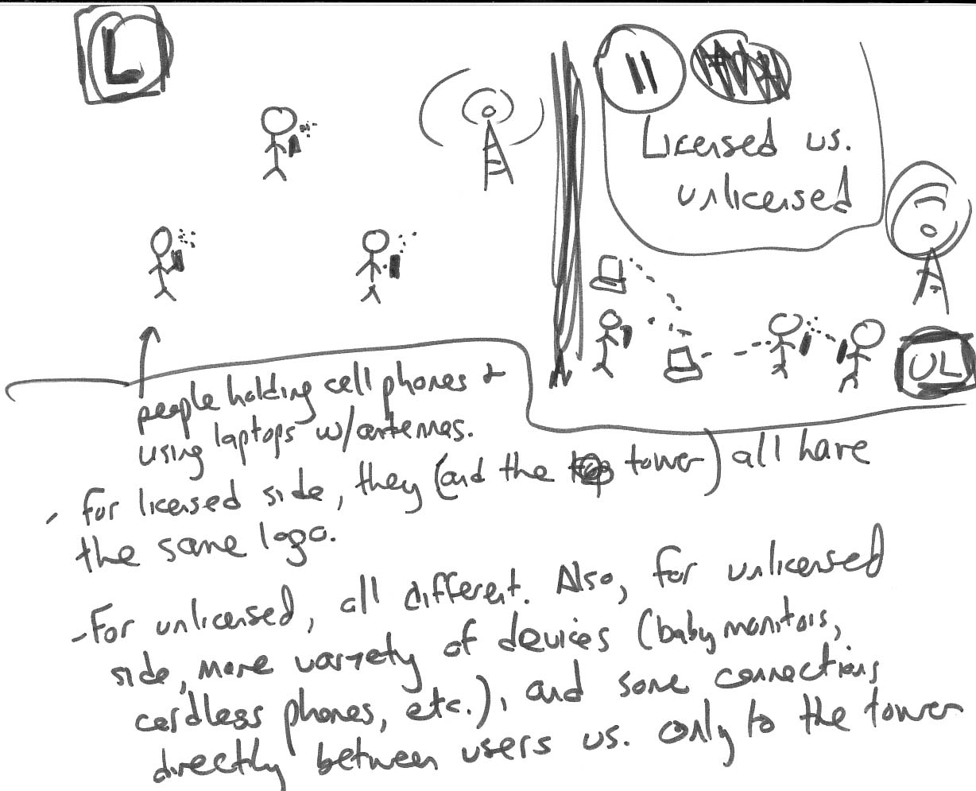
Illustration 11 – Unlicensed vs. licensed business models

Market structure

The second implication of active wireless systems is that the business structure of markets changes. Passive systems necessitate exclusivity. The downside of exclusivity is that no one else can contribute to a network. The licensee must bear the total cost of building network infrastructure. It typically recovers that cost by charging fees to users for both devices and communications services. Any vendor of user or network equipment must sell to or through the licensed operators. They are the only customers who can take technologies and legally put them into the market.

There is nothing inherently wrong with this “infrastructure” market model. It is traditionally the market structure used for services that have high capital costs and benefit from economies of scale. Having every person responsible for building the roads passing their home wouldn’t make much sense, nor would having every person responsible for bringing their own connection to a central telephone exchange. There are, however, serious downsides. Deployment is slow because it is costly and requires proven models for recouping that cost. Innovation is constrained because only a few licensees control access to the market. Uniformity and interoperability are enforced by the licensee, but services and equipment are costly because they are provided in limited volumes and based on proprietary standards.

As wireless devices become more intelligent and commons arrangements become viable, new market structures become possible. If the spectrum is no longer part of the service equation, the primary element of the “service” offered to end-users becomes the devices those users purchase. Because those devices run on standards defined by industry bodies rather than mandated by spectrum licensees, there can be open, competitive markets to build better and more cost-effective equipment. Users pay a significant fraction of the total network build-out costs directly, by purchasing hardware, greatly reducing the expenses service providers must undertake. For many services, there are still core network costs, for access points, backhaul to wired Internet backbones, authentication, roaming, and security, but these are limited compared to the all-encompassing network buildout that licensed operators must undertake.

Furthermore, intelligent wireless device s allow for markets with greater diversity at several points. Many equipment vendors, several providers, and application or content providers can compete, because there is no mandatory control point and each provider can leverage the infrastructure built by others. TK

Incentives for robustness

Intelligent or active spectrum management techniques may be used in any regulatory environment. In fact, spread spectrum mechanisms are now widely employed in licensed cellular telephony systems. Qualcomm’s code-division multiple access (CDMA) technology, a form of spread spectrum, is widely used in second-generation systems and is part of every TK major third-generation (3G) standard.

However, the nature of spectrum regulation heavily influences incentives for deployment of intelligent devices. The traditional, and still dominant, environment is exclusive licenses for frequency bands. Spectrum licensees have incentives to squeeze as much capacity as possible out of their spectrum. On the other hand, they have incentives to make the devices users must purchase as inexpensive as possible. In a passive system, the money is all in the service; the devices are dumb. There is no need to make them robust against interference, because interference from other systems is prohibited and policed by the FCC. Similarly, there is no great incentive to make the devices flexible, because the service provider is focused only on supporting its own service.

All that changes in a commons environment. Because wireless devices in a commons have no legally guaranteed protection against interference, they must guard against it using technical means. Fortunately, that is what active wireless devices are good at.

Passive systems create incentives to make the receivers as dumb as possible. Dumber means cheaper, after all. Because the central transmitter does the heavy lifting, there are no significant benefits from intelligence at the edge devices. When end-user devices become active, however, they contribute to the integrity and performance of the overall system. Making them smarter and more robust improves performance. And without license restrictions keeping other devices from transmitting on the same frequencies, robustness based on intelligence is the only path open. TK

WiFi as a case study

WiFi is the most prominent unlicensed wireless technology available today. It is a family of spread-spectrum wireless local area networking standards designed to allow users to send and receive data at 11-45 Mbps within a few hundred feet of another WiFi device or access point. WiFi is a great case study for the impact of intelligent wireless technologies.

Wireless data networking services have been available since the 1980sTK, beginning with the wide-area services offered by Ardis, a joint venture of IBM and Motorola and RAM Mobile Data. Ardis was purchased by American Mobile Satellite and renamed Motient; after reorganizing through bankruptcy in early 2002 it is still trying to right itself financially. RAM Mobile data was renamed Mobitex and is now part of Cingular Wireless. It is the primary network TK used by wireless email devices such as the RIM Blackberry and the Palm VII. Motient and Mobitex targeted enterprise and messaging markets. Another wide-area wireless network, the Metricom Ricochet system, offered services directly to end-users, providing wireless Internet access in several US cities for laptop users. Metricom filed for bankruptcy in TK; its assets were purchased by Aerie Networks, which is attempting to re-launch the service.

These previous wireless data networks generally use licensed spectrum, though Ricochet employed TK 900 mhz unlicensed frequencies in some areas. They offer low-speed connections (19.2 kbps or less) with wide-area coverage in cities or nationwide. Today, third-generation cellular networks are beginning to packet data networking services as well, typically at higher speeds. None of these offerings has yet become a mass-market success story. Ricochet signed up TK customers and TK.

WiFi has been exactly the opposite story. The Institute for Electrical and Electronic Engineers (IEEE) ratified the 802.11b standard for wireless local area networking (WLAN) in 1999. Vendors such as RadioLAN and Proxim had been offering proprietary WLAN systems, for both office environments and home networking. 802.11b, related to the 802.TK Ethernet standard, was envisioned primarily as a wireless replacement for wired Ethernet connections in corporate environments. In TK 1999, though, Apple Computer introduced a consumer 802.11b device, the Airport, using chipsets from Lucent. The market exploded.

The WiFi market topped $1 billion annually (primarily in hardware sales) by 2002. Most of that period, since the NASDAQ peaked in March 2000, has been a time of contraction in the overall technology and telecom sector. More than half of US companies now support WiFi networks, and another 22 percent plan to do so within a year. Despite continued slow growth in the economy, WiFi sales are projected to keep growing. Instat TK sees the market reaching $4.6 billion by 2005, and other research firms have issued similar projections. By 2008, says Allied Business Intelligence, 64 million WiFi nodes will be shipped annually.

What made WiFi such a success, especially compared to previous wireless data systems? After all, WiFi provides only short-range connections; on its own it can’t provide ubiquitous coverage in a neighborhood or city. WiFi has thrived because it has benefited from an ecosystem that could only exist with the type of technology it uses. Because WiFi is a low-power, spread spectrum technology, WiFi devices can coexist without the requirement of spectrum licensing to prevent interference. That means there need be no service providers, controlled hardware markets, or expensive spectrum licenses. Anyone can buy a WiFi device and establish a network.

Because WiFi is an open standard and an equipment-centered rather than service-centered market (again, both of which flow from the nature of the technology), costs are subject to computer industry downward pressure. A WiFi access point that cost hundreds of dollars when introduced is available for less than $100 today. Chipsets are down in the $10 range, allowed laptop, personal digital assistant (PDA) and mobile phone vendors to incorporate them with little or no price increase for the overall system. The WiFi market wouldn’t have taken off without standards – both the technical ones defined by the IEEE and the interoperability testing and certification done by the Wi-Fi Alliance (formerly WECA), an industry trade group. There is a need for such industry standards because there is an entire industry of vendors, rather than one service provider and its chosen suppliers, operating in the WiFi universe. Now that the standards are in place, the market can take advantage of contributions from many different vendors.

WiFi is now experiencing the next phase of development that can occur with intelligent wireless systems. It is evolving and diversifying. The IEEE has already extended the original 802.11b with several variants which will be discussed below. Meanwhile, startups are offering new kinds of devices that add functionality to the original short-range WiFi access points. Vivato, for example, has developed a smart phased-area antenna technology that can extend the range and capacity of WiFi signals, while remaining completely backward compatible with existing equipment. Locustworld in the UK is shipping 802.11 mesh networking boxes that automatically create ad hoc meshed networks with each other. Others TK?

In a traditional passive wireless system, changing the network technology means upgrading the whole network. Not just end-user devices but all the core transmission elements must be upgraded. The costs and time frames involve parallel those of deploying the system the first time. The transition from analog to digital television (DTV) is a perfect example. DTV technology has been commercially available for more than a decade. In the US, the formal transition to DTV began in 1996, and still only a tiny handful of customers can receive DTV broadcasts. In Japan, high-definition TV (HDTV) service has been commercially available since TK, but Japan chose an analog standard. Improving digital technology is now considered the best way to deliver HDTB, and Japan had to effectively start the entire process over again. Compare that to the transition from orphaned WLAN standards. Two standards that competed with 802.11, Europe’s Hyperlan for high-speed WLANs and the HomeRF standard for home networking, have lost out in the marketplace. Though some equipment has been orphaned, most vendors have quickly switched to offering 802.11 products. TK

The Unlicensed World

Types of wireless systems

The space of possibilities

It is impossible to speak of wireless technologies in the abstract. The deployment scenario is a significant factor in any wireless communications system. A system that works effectively for streaming video between a conference room and a nearby office may not make sense for collecting small snippets of data from a thousand sensors spread around a square mile area. And vice versa. This is true of both licensed and unlicensed systems. However, because unlicensed bands are inherently flexible, systems designers tend to have more options to choose among. TK

Four primary factors influence the capabilities of a wireless communications system:

Spectrum characteristics – Spectrum isn’t fungible. Shorter wavelengths generally mean better propagation through physical obstacles such as trees and walls. Also, the existence of other uses in frequency bands has a significant effect on what is possible TK.

Deployment environment – Wireless communications systems may be used indoors or outdoors, across short or long distances. Transmission in rural areas is different than in urban canyons. Mobile connectivity differs from service to fixed locations.

Service structure – Even within the same physical environment, wireless communications systems have different operational requirements. Is the service broadcast (one-to-many transmission) or one-to-one communication like voice telephony? Is it one way or interactive? Voice, video, data, or all three?

Capacity requirements – Some capacity requirements are determined by service structure. Realtime video stream require more capacity than “toll quality” voice, for example. But there are more variables than that. What is the acceptable bandwidth, latency, and reliability for the service? Over what periods of time? TK

Putting these factors together produces three basic types of unlicensed wireless networks: wire extension, mobile, and indoor. The same technology may be used in more than one, and each has subcategories that can be served in different ways. The value of thinking about unlicensed systems in this general way is that it gets away from the specific services and protocols in the market today.

Wire extension means providing connectivity to a fixed point, such as a home, that is not reached by high-speed wired connections. The actual connection may be to a neighboring home, in a meshed configuration, to a central access point in a neighborhood, or to a distant tower through a point-to-point beam. The home example is the vaunted last-mile, where cable modem and DSL services are available, but not everywhere and at relatively high prices in the US. At the other end of the bandwidth scale, wire replacement can mean connecting a headset to a mobile phone in your pocket, or a printer to your laptop across a room, situations where personal-area networking protocols such as Bluetooth work best.

Mobile networks allow the user to move around and stay connected. The most familiar example are cellular phone systems, which use a network of towers that hand off connections to provide the experience of pervasive connectivity. Mobile systems generally require specialized protocols to preserve sessions across high-speed transitions between cells, and they require networks of cells. There is no technical reason such systems couldn’t be built using unlicensed devices, but the practical difficulties are significant. The cell towers themselves have little value until they are part of a network, in contrast to fixed “hotspots” as are prominent with WiFi today.

In an indoor environment, some connectivity can be assumed. The value of wireless services is that they can allow mobility or extension of those wired connections within the indoor location. That may be an office, a home, or a public space such as an airport or café. Indoor is a separate category because indoor environments are necessarily bounded in space, and bounded by walls that both create challenges for reception and reduce the likelihood of interference with other systems outside. Today’s WiFi market is primarily concentrated on indoor applications.

[TK – CHART SHOWING DISTANCE (PAN/LAN/MAN) vs. CAPACITY?]

Today’s WiFi market

For WiFi specifically, there are four major markets today: home networking, corporate/campus networking, commercial hotspots, and public access.

Home networking means sharing an Internet connection, or a peripheral such as a printer, among more than one PC. Vendors such as Proxim, Netgear, Linksys (recently acquired by Cisco), D-Link, SMC TK, and 2Wire have sold millions of access points and cards to end-users for this purpose. Broadband service providers are now getting into the game, recognizing there is significant demand for home networking as an add-on to high-speed Internet access. TK stats.

Corporate or campus (in both the business and university sense) environments are slightly different than homes. Except for very small offices, multiple access points are required to cover the facility. These customers generally want security, authentication, and management capabilities to operate the WiFi network in conjunction with their existing wired networking infrastructure. All the major networking vendors, such as Cisco, Lucent TK, 3Com TK, and Nortel, now have substantial corporate Wifi customer bases.

Hotspots are access points available to anyone within a location, such as an airport, a café, or a hotel lobby. Sometimes the hotspots require a fee for access. Vendors such as Wayport and Mobilestar (now T-Mobile) deploy hotspots in locations that receive significant foot traffic, as both a money-maker and an incentive for more traffic. The best-known hotspot deployment is at Starbucks coffeehouses, now operated by T-Mobile. Aggregators such as Boingo and iPass allow users to pay one fee and access multiple networks of hotspots. Cometa, a joint venture funded by AT&T Wireless, IBM, Intel Capital, and venture capital firm 3i TK, plans to build 20,000 hotspots using a wholesale model, with its first customer being McDonalds. There are now TK hotspots in the US and TK worldwide.

Public access means providing free connectivity to users within a particular area. Sometimes this is done by private groups sharing their own networks or promoting the concept of ubiquitous wireless connectivity. In other cases the access is funded by public organizations, non-profits, or corporations as a type of civic amenity. We discuss several public access projects below in section TK.

The Spectrum of Spectrum-Use Regimes

With the growth of WiFi in the 2.4 GHz band, interest in unlicensed spectrum has spiked dramatically. “Unlicensed” is actually something of a misnomer. It implies that the government has not made the spectrum available to licensees, when in fact the spectrum has been allocated and assigned like any other spectrum block. Instead of a service provider gaining the rights to control use of the spectrum, subject to limits set in the terms of the license, manufacturers gain the rights to sell devices that conform to FCC-designated standards. The devices themselves must be licensed, generally on a generic and often self-licensing basis known as “type acceptance” TK. For these reasons, some parties prefer the term “licensed by rule.”

An important point here is that unlicensed does not mean unregulated. In the 2.4 GHz band, for example, the FCC mandates power limits and TK OTHER 2.4GHz requirements. New kinds of equipment that use different techniques than those already licensed must receive direct FCC approval. For example, Vivato, a startup that sells a novel “WiFi switch” based on phased-array antennas, recently TK received FCC approval for its technology.

The regulatory involvement in unlicensed bands is substantially different than in licensed bands. The rules are crafted to make possible shared uses. Power limits therefore tend to be significantly more restrictive than for licensed bands.

TK

“Licensed” and “unlicensed” are generally presented as the two models for spectrum usage. There are actually several variations, not entirely mutually exclusive. Furthermore, the fact that WiFi uses spectrum bands dedicated to unlicensed usage doesn’t mean that is the only mechanism for regulators to create more space for unlicensed devices and systems.

Looking at the possibility of spectrum commons purely as a matter of what regime to mandate for specific swaths of spectrum misses the point. Active wireless techniques, and the unlicensed systems they make possible, ultimately erode the very rationale for thinking of “the spectrum” as a physical asset that can and should be divided into frequency bands.

The four basic spectrum use models are exclusive licensed, exclusive unlicensed, easements, and white space.

Exclusive licensed

Most spectrum is exclusively licensed today. With the exception of two easements discussed below, the vast majority of frequencies are controlled by one or more entities. We will not discuss this model at length. It is the default mode of spectrum regulation.

Exclusive unlicensed

The opposite regime is to have no exclusive licensees in the band. Such as 5GHz TK. Note that the exclusive unlicensed approach doesn’t actually prohibit any uses in the way the licensing model does. It simply prohibits activities that violate the technical specifications for the band, such as power limits. TK more

Easements (Part 15 UWB, secondary/shared use)

Easements are a more common element of spectrum regulation than one would suppose. Today, many licensed bands such as TK actually have more than one user sharing the spectrum . Typically, one of these users is defines as “primary,” which means tk.
There is actually an easement regime already in effect for most TK of the spectrum. It’s known as Part 15, for the relevant section of the FCC’s rules. Part 15, among other things, grants a blanket TK authorization for unlicensed devices that emit less than one watt of power. One watt isn’t much, but it’s not nothing. Part 15 devices include a wide range of useful equipment such as baby monitors, garage door openers, and cordless phones.

Easements become significantly more interesting in the unlicensed context. TKs

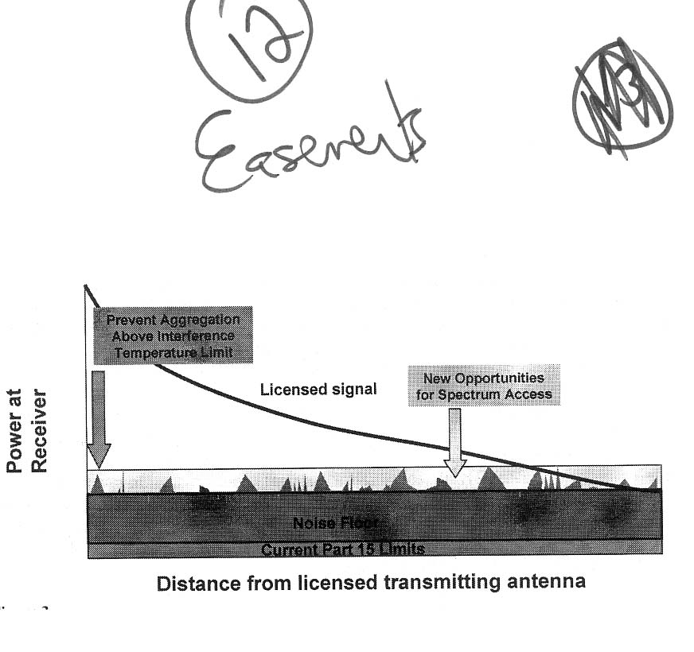
Illustration 12 – Easements (Chart is from the FCC Spectrum task Force Report)

White space

Some spectrum is not used, but not exactly un-used. This is typically spectrum set aside for “guard bands” between licensed frequencies for older services such as broadcast television. The guard bands are a kind of demilitarized zone. Letting the licensees on either side transmit there would create problems for the licensees on the other side, because neither is particularly good at distinguishing signals from noise.

Just because the original licensed service can’t transmit in those bands without interference, however, doesn’t mean no one can. Low-power unlicensed devices could operate in the white space of the guard bands without impinging on the high-power broadcast transmissions nearby.

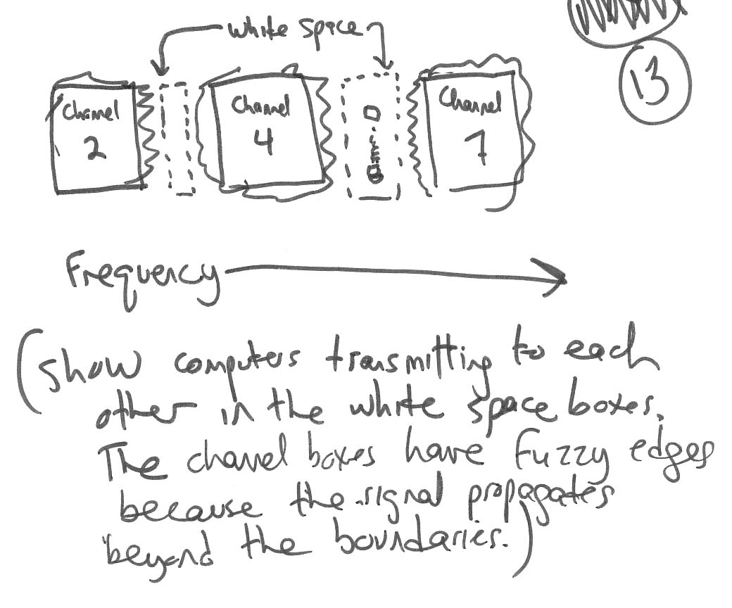
Illustration 13 – White space

Virtual white space

White space is deliberately kept free of transmissions, making it attractive for opportunistic unlicensed devices. However, there is a great deal more white space in the spectrum than guard bands. No spectrum is constantly used, at maximum capacity. There is plenty of white space in bands that are licensed and supposedly filled with transmissions. It may only be available for milliseconds, but it exists nonetheless.

Unlocking this “virtual whitespace” will require adaptive radios capable of sensing the local spectral environment and very quickly moving if they detect another signal in the same frequency range. Such devices are not commercially available today, but there is no reason to think they won’t be in time.

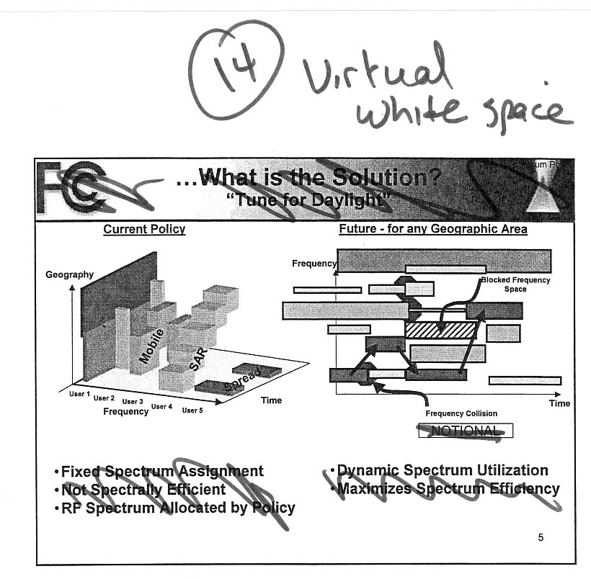
Illustration 14 – Virtual white space (diagram on right shows hopping around frequency blocks)

Current unlicensed products

Technology | Status | Range | Capacity | Representative Companies
802.11b
802.11a
802.11g
802.16
802.15

Local Area Networks (802.11)

802.11 refers to the IEEE working group for wireless Ethernet. The IEEE defines technical standards, but does not certify compliance with those standards. In parallel, industry associations such as the Wi-Fi Alliance create brand names which vendors are permitted to use if they meet compatibility requirements. The term WiFi, a play on HiFi stereo systems, is such a brand name. Originally referring only to 802.11b, it now encompasses 802.11 a, b, and g TK.

There are three widely deployed 802.11 technologies:

802.11b – The original WiFi, providing 11 Mbps connections using direct-sequenced spread spectrum modulation in the 2.4 Ghz frequency band.

802.11a – A higher-speed standard delivering 54 Mbps connections, but using different spectrum (5 GHz) and modulation (orthogonal frequency division multiplexing, OFDM) than 802.11b. As a result, 802.11a systems are not backward compatible with 802.11b, and require separate radios.

802.11g – A backward-compatible high-speed standard, delivering 54 Mbps through OFDM like 802.11a, but using the 2.4 GHz spectrum. Though the 802.11g standard has not bee formally ratified, several companies have released 802.11g gear, often under the “extreme” label. Apple’s Airport Extreme is one example. These devices can talk both to original 802.11b devices and to higher-speed 802.11g cards.

The remaining alphabet soup of IEEE 802.11 standards are mostly variants of these protocols. For example, 802.11e, based largely on technology developed by Sharewave (now part of chip vendor Cirrus Logic TK), adds quality of service mechanisms to better support video and voice traffic. 802.11j TK is a version of 802.11bTK that complies with regulatory requirements in Japan. TK others from IEEE list.

Though the WiFi name is getting a tremendous amount of attention and, as a result, has been expanded to include standards other than the original 802.11b, it’s important to keep in mind that WiFi is not a synonym for unlicensed wireless. WiFi is a local-area networking protocol. It delivers data, such as Internet connectivity and email, across links of no more than a few hundred feet.

Metropolitan-Area Networks and Last Mile (802.16)

Metropolitan-area networks (MANs) operate over longer distances than LANs, typically a mile or more. They are designed to provide relatively high bandwidth to a moderate number of fixed sites such as homes and businesses, compared to LANs which connect individual devices. One MAN application is the so-called “broadband last mile,” in competition with wired solutions such as digital subscriber line and cable modems. However, MAN systems are also used to provide “backhaul” connections from such last-mile networks to central aggregation points, point-to-point connections between facilities, or coverage throughout a campus or other geographically defined facility.

The IEEE has established a standards group, 802.16, for wireless MANs. The original 802.16 specification was designed for very high frequencies, over 10 GHz. A more recent subgroup, 802.16a, is crafting MAN standards for 2-10 GHz frequencies that, unlike the original standards, don’t require line-of-site visibility. 802.16 envisions systems delivering 70 Mbps of data over a 30 mile range. TK status of the group.

Though designed as LAN technologies, 802.11a and b are being used by some companies such as TK Etherlinx as the foundation for MAN systems. Generally these systems use the commodity 802.11 physical layer and devices, adding their own media access control (MAC) layer to boost range. Another option, which several service providers are reportedly considering, is to use standard 802.11 devices with enhanced access points from companies such as Vivato that boost the effective range.

Several companies including Motorola (with its Canopy system), Magis Networks, Proxim, IP Wireless, Navini, BeamReach, TK Aperto, and Alvarion offer proprietary products that are similar to 802.11b and 802.11a. Typically these systems offer better performance, reliability, or features such as security that aren’t well implemented in the 802.11 standards. Today, most of them operate in the 5 GHz band and focus on markets such as last-mile residential and small-business connectivity, especially in rural or otherwise under-served areas. Many of these companies are part of the 802.16 effort. It can be expected that, as with WiFi, many proprietary systems will eventually become standards-compliant. A new industry association, WiMax, hopes to do for unlicensed wireless MANs what WiFi did for LANs.

Other companies are taking a different route to deliver wireless MAN c0nnectivity. Instead of long-range MANs sending data directly to customers, they envision wireless mesh networks using short-range links to cover neighborhoods. One startup, Skypilot, plans to use standard 802.11b radios TK in the home connected to TK rooftop units based on TK 802.11a with added mesh networking software. Omnilux plans to use free-space optics technology, combined with mesh networking. Free-space optics operates in the visible or laser range of the spectrum, above the radio frequencies. It is therefore technically outside the entire range of FCC licensing, which applies only to communication “by wire orTK radio.”

Personal-Area Networks (802.15)

Moving the opposite direction from MANs, personal-area networks (PANs) are designed for very short-range connections, no more than a few dozen feet. WiFi can cover these distances, but because WiFi devices are designed to serve larger areas and provide relatively high-bandwidth connections, they require more power and have higher equipment costs than would be necessary for close-in, low-speed tasks such as communicating between a mobile phone and a headset. PAN applications are essentially “cable replacement.” They are tasks that people perform today by stringing wires between devices, but that could be done with more freedom if the wires weren’t necessary. These include scenarios such as printing from a laptop computer to a nearby printer, sending voice signals between a cordless phone and a base station, and TK. There are also high-capacity cable replacement tasks involving rich media, such as sending music between an Internet-connected home server and a home theater or stereo system.

The standards body for PANs is IEEE 802.15. TK status of group.

Bluetooth was the first prominent PAN standard. Based on technology originally developed by Ericsson, it is supported by a private industry standards body that now has TK members. Bluetooth provides TK Mbps connections over TK by automatically creating network clusters of nearby devices. Bluetooth received a great deal of media attention when the consortium was first announced, because of its heavyweight backers and excitement about the potential of all things wireless at the time. However, interoperability issues and questions about where Bluetooth really fits in the market have limited adoption. There have also been problems with Bluetooth and WiFi devices disrupting one another, though both communities are working to eliminate those conflicts. Bluetooth mobile phones, PDAs, and laptops are now available, and costs are coming down as volumes increase. TK

Even shorter range and lower-speed than Bluetooth is Zigbee. The protocol, developed by TK, is optimized for applications such as distributed sensor networks, which must only send a few kilobits of data at a time. -- TK

Ultra-wideband (UWB) is more than a PAN technology. However, its initial applications in the communications market are for short-range, PAN-type uses. UWB is a form of spread-spectrum transmission that uses such a wide band, and such low power, that it can “underlay” with licensed users in the same band. The UWB signal appears as background noise to other transmitters. The nature of the technology gives it several other advantages, including very low power consumption, security, and penetration of walls. Until the FCC’s decision in early 2002 to legalize UWB for communications, its primary application was for ground-penetrating radar and military uses.

Today, companies such as XTremeSpectrum and Time Domain are building UWB chipsets targeting short-range, high-bandwidth data applications. UWB systems can deliver TK 100 MBps over TK feet, which makes them ideal for uses such as streaming audio or video between media devices within the home. Several UWB companies have created the TK WiMedia alliance to promote this application. Though UWB was late to the PAN party because of its recent approval, it has recently been gaining adherents within the 802.15 group.

Success stories

WiFi, the first commercial unlicensed wireless communications technology, has only been around since 1999. In this short period of time, its growth has been nothing short of remarkable.

There are already 4.2 million frequent WLAN users, according to Gartner Group, and that number will grow to more than 31 million in 2007. " TK thousand hotspots today will rise to over 100,000 in five years, according to analysts. Boingo, the leading commercial hotspot aggregator, has over 1,200 nodes on its network. T-Mobile operates 2,300 hotspots, including Starbucks coffeehouses, Borders bookstores, American Airlines Admirals Clubs, and terminals at fifteen airports in North America. It just announced plans to put hotspots in the more than 1,000 Kinkos copy shops throughout the US. And this is only a fraction of the total. One Website lists over 5,000 hotspots worldwide, including both commercial and community nodes.

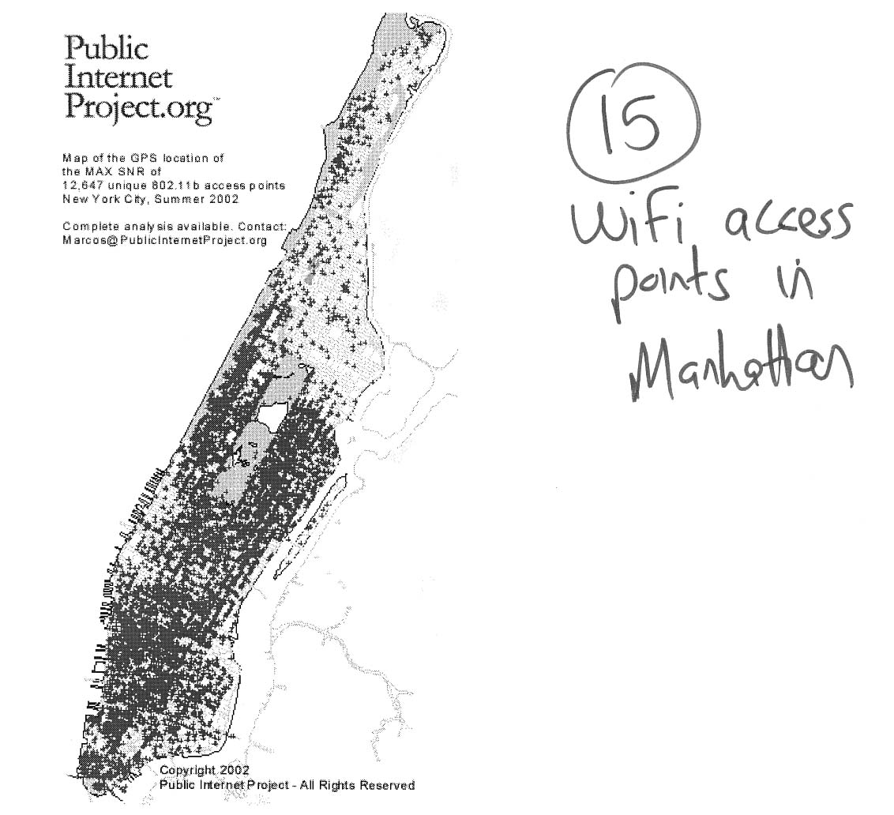
Illustration 15 – WiFi hotspots: Public Internet Project map of Manhattan

Commercial hotspots are going into virtually any location that receives a substantial amount of foot traffic. According to Pyramid Research, 1,000 hotels offer WiFi access today, mostly in lobbies and meeting rooms, and 25,000 will have it by 2007. Cometa expects to have 300 McDonalds “unwired” by the end of 2003. TK more

Alongside the commercial hotspots are a number of non-profit or public access deployments. These are happening without any coordinated government effort or funding through universal service subsidies, showing the power of WiFi to promote “bottom-up” connectivity.

Independent community access points

There are dozens of community WiFi organizations in cities throughout the United States, and around the world. Typically, these groups are made up of technologies and other early users of WiFi. They come together in physical meetings and through online discussions to share experiences, ask questions, and experiment with new technologies. In many cases, they install their own WiFi infrastructure, with access open to all. They deploy these hotspots where they can or want to, rather than follow some master plan.

The most active community WiFi groups include SFWireless in San Francisco; NYCWireless in New York; SeattleWireless; and Personal Telco Project in Portland, OR. The infrastructure is typically contributed by members, though increasingly these community groups have formed partnerships with local businesses and community development organizations.

Hotspots as civic amenities

In several cities, hotspot deployments are being funded by civic organizations or corporate sponsors as civic amenities, like parks or playgrounds. In Manhattan, Intel and the Bryant Park Restoration Corporation supported a project by NYCWireless to establish a WiFi network in Bryant Park, a popular outdoor gathering place in midtown. The University of Georgia has funded a network of WiFi hotspotscovering all of downtown Athens, GA. In Long Beach, CA, the Long Beach Economic Development Bureau partnered with several local businesses to establish a WiFi network covering several downtown blocks, with plans to expand it throughout the city’s business district.

For the civic groups involved, the costs of these WiFi networks are relatively minor, especially when businesses become involved and provide free Internet bandwidth and other services. Wireless connectivity is becoming a benefit that draws people into downtown areas.

Internet connectivity for rural communities

High-speed Internet connections are available to most of the US population today through digital subscriber line (DSL) or cable modem service. However, there are still tens of millions of Americans who live in rural or otherwise under-served areas, where such broadband offerings are not yet available. In some cases, the are unlikely to be available any time soon. Technically-minded citizens in some of these communities have seized upon unlicensed wireless as an alternative route to provide connectivity.

In Laramie, WY, a group of technologies led by Brett Glass established LARIAT, a non-profit community wireless network. It has been in operation since 19TK, originally using pre-WiFi unlicensed equipment in the 900 mhz band. TK details. A similar effort is MagnoliaRoad.net, a cooperative in a rural part of Colorado that is offering WiFi connectivity to local residents who have no other good broadband option. Meanwhile, Dewayne Hendricks of the Dandin Group is spearheading efforts to provide wireless Internet connectivity, using WiFi and other technologies, on several Indian reservations in the US and Canada.

Internet connectivity for low-income areas

High-speed connectivity has important benefits for low-income and under-served communities. Broadband Internet access opens the door to educational, informational, job-related, benefits, health and other materials. However, the costs of wiring low-income facilities such as public housing complexes has traditionally been prohibitive, given that most residents cannot afford to pay typical monthly broadband prices. WiFi is one answers.

In Boston, an MIT graduate student named Richard O’Bryant led an effort to put free Wifi hotspots in Camfield Estates , a 102-unit public housing development in the Roxbury area, with funding from HP and Microsoft. In Philadelphia, the United Way is building two WiFi hotspots in the poor section of West Philadelphia, which will offer broadband Internet access for $5 to $10 per month. It plans to give away computers and wireless cards to people in the community who cannot afford them. In Portland, OR, a non-profit called One Economy is putting WiFi connections into three public housing developments, serving over 500 residents.

Future scenarios

Expanding the space of possibilities

We have only scratched the surface of what active wireless systems can do. The growth of WiFi has been so striking, its possibilities so exciting, that WiFi has become virtually synonymous with unlicensed wireless and open spectrum. This is a mistake. WiFi is not the culmination of the wireless story; it is merely the end of the beginning.

WiFi has two great limitations: its protocol, and its spectrum environment. The engineers who created the 802.11 family of protocols had no idea that WiFi would take off the way it has, and would be used for in so many different deployment scenarios. They were creating a wireless Ethernet standard, parallel to the wired Ethernet standard that is the basis for more office computer networks today. Thus, WiFi has limited range, and a MAC layer that isn’t particularly good at meshed networking, quality of service, interference management, security, or many other functions that are important for many of its potential markets.

At the same time, the government regulators who established the 2.4 GHz and 5 GHz unlicensed spectrum bands where WiFi operates had even less idea of what was coming. Especially for 2.4 GHz, they were looking at “industrial, scientific, and medical” equipment, and devices such as cordless phones. The rules they created for managing those bands have been highly successful, but they were hardly designed to maximize the potential. Based on our current experience and understanding, we can think about how to design rules expressly to promote efficiency and innovation through unlicensed wireless technologies. First and foremost, this means making available more spectrum for unlicensed uses, whether it be through dedicated unlicensed bands, easements, or opening up of “white space.” Second, it means putting in place minimal rules for that spectrum, which may be as little as power limits, to foster an environment of efficient cooperative development.

The wireless future, under any scenario, is likely to be marked by increasingly pervasive but non-uniform connectivity. No wireless technology, let alone one service provider, can address all the markets and deployment scenarios, from short-range low-bandwidth to long-distance broadband. Even if unlicensed systems succeed beyond anyone’s wildest dreams, there will be a need for licensed services for many years. Even if there is soon WiFi in every coffee house, getting it in every dry cleaner will take longer, as will getting it in every train and airplane.

The downside of such a heterogeneous environment is that everyone is not connected all the time, and any one system or technology will provide only a small percentage of what connectivity does exist. The natural impulse in communications is to try to build all-encompassing networks, but sometimes that isn’t the best approach. WiFi hotspots are spreading because they are cheap, funded by users or facility owners, and go where there is demand today. They don’t yet go where there isn’t demand, but the good news is that users need not pay for the extra cost of putting access points there. As software-defined radios mature, they will make it possible stitch together some systems at the end-user device. In general, though, the real question is not how to provide ubiquitous wireless connectivity in the abstract, but how to address concrete needs and market opportunities.

The scenarios below represent examples of opportunities that unlicensed wireless technologies could address. They are relatively straightforward extensions of existing technology. Most, however, will require either spectrum reforms to expand the space available for unlicensed devices, or at the very least no regulatory actions that would hamstring unlicensed devices in the existing areas.

The Last Wireless Mile

Broadband connectivity to homes is a topic of great consternation in the communications industry today. Telephone companies are deploying DSL and cable TV operators are deploying cable modem systems. Today, TK percent of Americans subscribe to one of these options, and they are available to roughly TK% of homes. However, many millions of Americans still have neither available to them, and a greater number have only one option. Prices of these broadband services, approximately $50/month, are high compared to the rest of the world. These services are generally asymmetric, providing far more bandwidth down to the user than up from the user to the Internet. Combined with terms of service restrictions, this architecture limits users from running home servers and other actions. For business users, who typically need higher bandwidth than homes, the only viable option is often a traditional T-1 line at $1,000 per month or more. There is thus great interest in alternatives.

Basic WiFi or its variants, 802.11a and 802.11g, cannot simply be put into service for last-mile deployments. WiFi is a short-range technology designed primarily for connections to a nearby hotspot. Even if every home in a neighborhood had a WiFi access point, few of those nodes would see one another and there would be no mechanism to link them together. Even if signals could reach a neighborhood access point, backhaul costs would be significant, because every access point would need a wired connection to a T-1 or larger circuit.

We can, however, envision scenarios for unlicensed wireless last-mile connectivity based on technology that is in the market or likely to be soon. For homes, a meshed network configuration could be used to shorten link lengths, increase robustness through alternate traffic paths, and address impediments such as trees. A range-extending technology such as Vivato’s phased-array antennas could also be employed to receive signals from a cluster of nodes in a local area. For businesses or high-end residences, an 802.16 wireless MAN technology could be used to deliver tens of megabits per second over many miles. This same technology, or a variant, could be used to reduce the costs of backhaul, replacing costly wired connections.

An end user would buy a device, whether a dedicated piece of wireless hardware, a broadband “residential gateway,” or a piece of general-purpose hardware such as a laptop. The device could be designed to operate with a particular unlicensed wireless network, it might be deployed by a service provider, or it might have “discovery” capability to automatically locate and connect with nearby access points or wireless end-users. TK – more on the scenario.

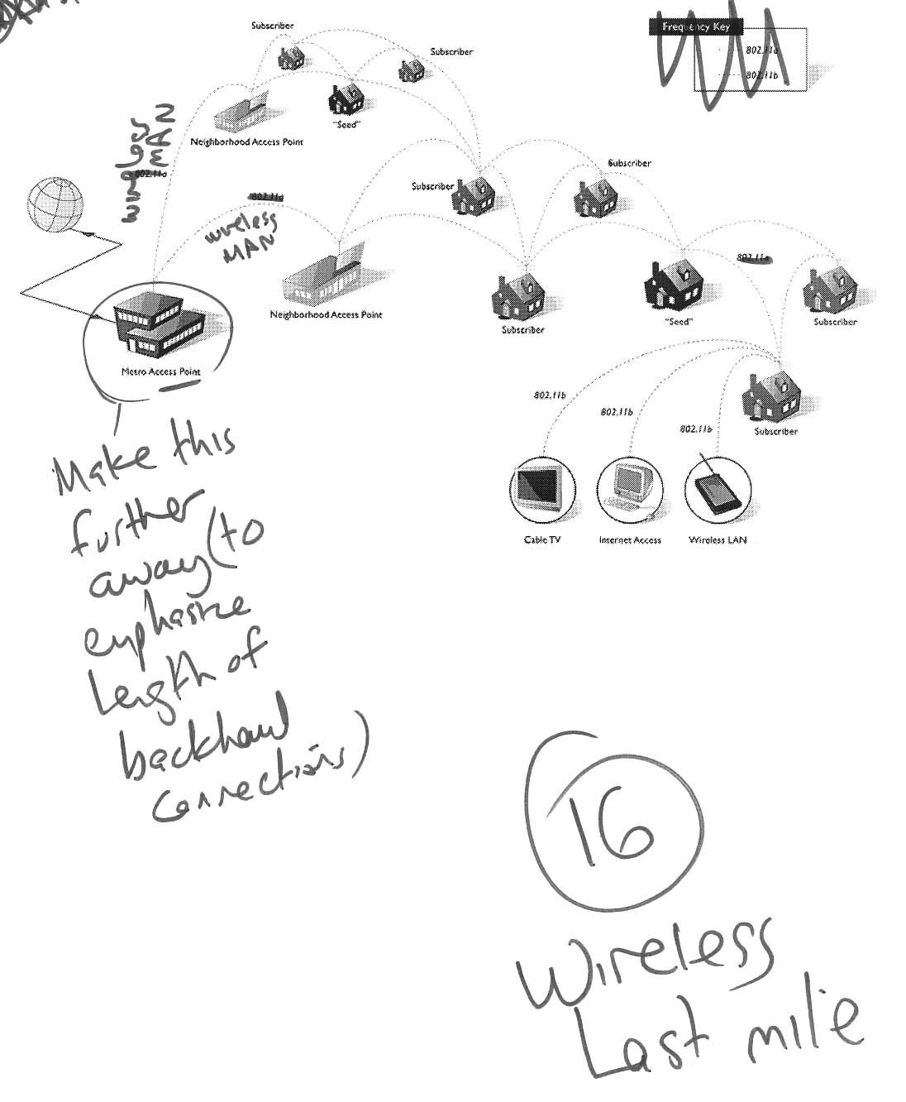
Illustration 16 – Wireless last mile

It is typically assumed today that last-mile broadband networks are designed to provide access to the Internet. Certainly, any broadband customer will want to access Internet-based services available through the World Wide Web, as well as global email, instant messaging, and other applications. However, these are not the only things that an unlicensed last-mile wireless could deliver. There is often value in online communications within a community, especially when that community has not previously had a high-speed, always-on network. These range from intra-community email to school bulletin boards to decisions of the city planning board. They could be called community intranet applications. Because the traffic is local, there is no need to connect to a backbone provider. In fact, there may not be a need for any provider at all. If users provide their own wireless nodes, and no node is overwhelmed with traffic, the community-wide network would function peer-to-peer, much as local area networks in businesses do today.

When the network needs to connect to the Internet, an economic problem emerges. Internet backbones charge for use based on bandwidth consumed. Even if Internet-based services and content are a minority of traffic on a wireless community last-mile network, there still must be backhaul connections to the Internet, and these must be paid for. There is a “free-rider” problem if the node connected to the backbone must bear all the costs, independent of whether there is any congestion across the unlicensed wireless links between the community nodes. Some pricing mechanism out to end-users may be necessary in such a situation. However, pricing could be implemented in several ways. It does not require central providers or per-packet settlement charges. For example, a cooperative could collect dues from all community members and apply those to the backhaul charge, with some limits on each user’s bandwidth to prevent free riding.

Interoperable public safety communications.

Today, public safety agencies use many different wireless communications systems. Many of them use outdated technology. Few if any can talk to one another. In an emergency, if the fire department can’t communicate with the police, the consequences could be disastrous. On September 11, 2001, firefighters were trapped in the World Trade Center because they were unable to learn from other public safety officers outside that the buildings were about to collapse. Stories abound, from 9/11 and other times, of firemen using commercial mobile phones because they had better performance and a wider audience than their expensive private radios. And when these networks go down, everything goes down with them Unfortunately, public safety organizations are saddled with many legacy communications systems that are costly and difficult to upgrade.

As software-defined radios (SDR) mature, they could replace the cacophony of devices with a single set of devices. One phone handset, PDA, or laptop could tap into any of the existing systems. A firefighter arriving on the scene could instantly check police communications as well as data transmissions providing essential information directly from dispatchers, such as building maps. Such a system would require robust security and authentication mechanisms, but these could also be built into the devices.

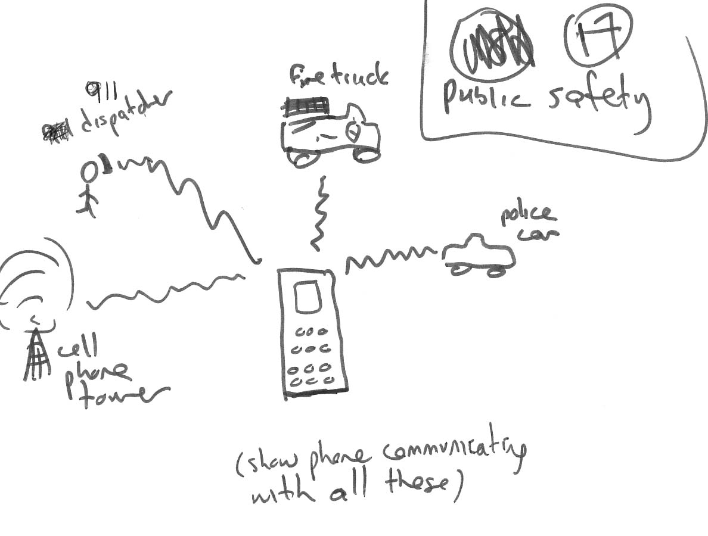
Illustration 17 – Interoperable public safety

Adaptive mobile phones

Mobile phone networks today are self-contained entities. In the US, for example, there are six competing national networks. Each has its own network of transmission towers. If you are within range of five of those towers but not the one for your service provider, you won’t get service. Things are a little better in Europe, where universal adoption of the GSM standard allows for more roaming agreements between carriers, but each carrier still must maintain its own complete network.

As mobile phones evolve into SDR devices, the structure of the business may change. Carriers will be able to share infrastructure much more widely, because their subscribers will be able to transparently access transmissions from whatever tower is closest to them, regardless of what frequency band or encoding mechanism it uses.

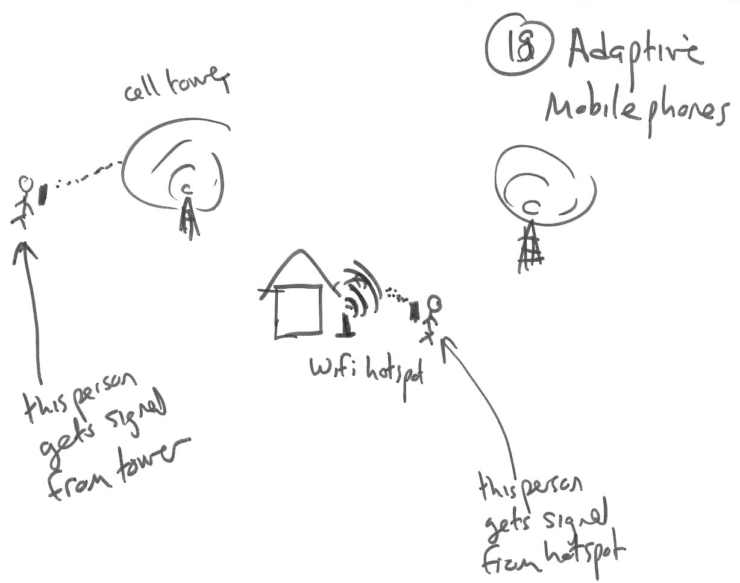
Illustration 18 – Adaptive Mobile phones

Further, there are an increasing number of local connectivity points, such as WiFi hotspots, that are separate from the wide-area wireless networks. When a user was within range of a hotspot, adaptive mobile phones could transparently shift communications from voice transmissions over the mobile networks to voice-over-IP or packet data connections through the WiFi infrastructure. Tapping these local nodes would reduce costs, avoiding the need to send data long distances over wireless networks, and would give users the maximum possible capacity, since WiFi hotspots tend to offer substantially greater bandwidth than wide-area data networks.

Personal broadcast networks

Today, broadcasting is the domain of the few. Only companies with licenses have access to the airwaves to deliver programming. Using a combination of the techniques described in this paper, it is possible to imagine a world in which anyone can be a broadcaster.

As each users sends out video streams, those would be relayed by other users wherever infrastructure was unavailable. Cognitive radios would seek out free space in the spectrum to carry the signals. Content creators could contract with operators of virtual broadcast networks who aggregated together reliable high-speed connectivity to reach an audience, creating a bottom-up division between different classes of traffic.

Who would want to have their own broadcast network? Some people would want to deliver the kinds of creative programming available on television today. These personal wireless networks would become a much more powerful version of the alternative outlets available today, such as public access channels on cable TV systems, public broadcasting stations, and the Web. If consolidation in the media distribution business threatened the diversity of voices available to viewers and listeners, personal broadcast networks would provide a powerful antidote.

But the existing market for heavily produced, mass market content would only be a small part of the total. Working parents would use personal broadcast networks to tap into video images of their children at home, steamed from webcams to their mobile phones. Distance learning courses could be delivered on demand, or specific instructional modules could be delivered dynamically when and where they were needed. Need to change a flat tire and don’t know what to do? Need on-the-spot medical advice? Use a personal broadcast network to watch an instructional video or establish a videoconference with an expert.

Predicting the future is dangerous. Any scenarios we envision today will likely miss the specific kinds of applications and content that will be popular tomorrow. But that doesn’t matter. The infrastructure of emerging wireless technologies can be adapted to whatever turn out to be the killer apps. Wireless networks built using intelligent, active techniques from the computer and networking industries will feature radical flexibility. Network owners need not predict uses in order to shape their infrastructure build-out, because there will be no owners, infrastructure, or build-out in the current senses of the words.

Conclusion

A powerful lesson from the history of communications and computing is that a few simple trends have extraordinary effects over time. The shift from analog to digital networks, for example, is revolutionizing all forms of communication and media. That transition has been going on for many years, and hasn’t yet finished. Similarly, growing intelligence of computing devices at the edges of networks exerts a powerful force that is magnified over time.

The paradoxical fact is that wireless communications are both more mundane and more remarkable than we believe today. The mundane aspect is that spectrum isn’t somehow special and removed from the forces affecting other industries touched by the relentless improvements in computing and data networking. Spectrum isn’t a domain where normal market and technological forces go out the window, replaced by iron scarcities. In fact, it’s not a place or a thing at all. It’s a mental construct we use to aid understanding. We are rapidly reaching the point where that mental construct does more harm than good.

The real question now is not whether but when. There is absolutely no question that wireless devices will continue to become more powerful, and that enterprising technologists will find new ways to multiplex and interweave radio signals. Whatever obstacles regulators or incumbents throw up will ultimately be routed around. The only immutable barriers are physical, and though they undoubtedly exist, we are nowhere near reaching them.

Through errors of both omission and commission, however, governments can delay and weaken the revolutionary changes that could bring into being the scenarios described in the previous section. If no more unlicensed spectrum is made available through dedicated bands, easements, or opportunities to use fixed or virtual white space, it will take that much longer to overcome the scarcities that define the market today. Such delay would have economic and social costs.

The last time a new networking and communications paradigm took hold, it was called the Internet. There too, it was possible to discern signs and possibilities years before the full commercial realization of the network. The US government, through both affirmative steps and conscious rejection of unnecessary regulation, laid the groundwork for the Internet to emerge as a powerful business and social force whose impacts are still being felt throughout the economy.

The next Internet is before us. It is an Internet of the air, in some ways even more powerful than the Internet of wires. If we put aside our preconceptions and outmoded notions, we can make it real.

Bibliography

Community WiFi directories

http://www.seattlewireless.net/index.cgi/SimilarProjectLinks
http://www.personaltelco.net/index.cgi/WirelessCommunities
http://www.afcn.org/
http://freenetworks.org/moin/index.cgi/WirelessNetworkingProjects
http://www.communitywireless.org/

Open spectrum

Yochai Benkler, Overcoming Agoraphobia and Some Economics of Wireless
Lessig materials in The Future of Ideas and CIO Insight
David Reed, FCC comments
David Weinberger, End of the Broadcast Nation and Salon interview with Reed
Nobuo Ikeda paper
Eli Noam articles

Illustrations

Spectrum analogies

Oceans (from People’s spectrum chart), real-estate, highways, and people talking in a crowded room/football field (People’s chart?).

Meshed vs. broadcast architectures -- diagram of signals hopping between nodes, compared to one signal saturating an area.

Interference. Stick figure illustration comparing the popular conception of interference (two signals bouncing off one another) with the reality (intermingled messages the receiver can't disambiguate).

Spread spectrum/wideband techniques. A prettier version of the diagrams in Benkler's presentation that he did for you last year.

Spectrum analyzer chart showing substantial whitespace in existing frequency utilization. Could be based on ones I've seen from Paul Kolodzy's XG presentation from DARPA, or Gerry Faulhaber's presentation at the Stanford conference.

Software-defined radio. Showing decoding multiple frequencies, and/or agile radio "creating" spectrum by hopping among "holes" in existing usage.

Commons vs. licensed business models. I'm imagining a diagram of a person holding a phone/PDA next to a tower and another user, with arrows pointing out who owns the components and how value is transferred.

Research Questions for intern (Matt Barranca)

- Details of “success stories” and other ones
- WiFi research reports – check with Cahners/Instat, Allied Business Intelligence, IDC, Jupitermedia
- Fill in chart of overall wireless market
- Pull together references for bibliography
- Chart of unlicensed technologies (p. 21)

TK Arthur C. Clarke.
TK – book about quantum physics.
TK – need source for Marconi and Bell’s incorrect predictions.
Technically, the waves are in quantum superposition. TK Reed and others.
Capacity may not always be expressed in raw throughput such as bits per second. Some services have particular requirements. For example, live voice communication needs low latency (delay), while high-quality video broadcasting requires limited packet loss. An environment that allows these uses may be more valuable than one that does not, even if total carrying capacity is lower.
This approach is known as Time Division Multiple Access (TDMA), and is used by AT&T Wireless TK.
Robert Matheson of the National Telecommunications and Information Administration (NTIA) of the US Department of Commerce has created an “electrospace model” that incorporates all these dimensions. TK Electrospace paper.
Capacity includes more providers of existing services, addition of new services, and room for current providers to enhance their offerings, all without stepping on others.
TK Shannon papers
TK multi-user information theory.
The layered model also has important implications for regulation. See TK my layered model paper.
The seven layers are TK. The OSI model is broadly used as a conceptual tool, but not always as a formal part of network design. In the 1980s TK, efforts to formally require adherence to the OSI standard failed TK.
Scarcity is not, strictly speaking, the only rationale for spectrum regulation. Some rules, such as restrictions on obscenity, are based on the intrusiveness of certain wireless communications services such as radio. TK Red Lion.
Separate from the technological critique developed here, there is a long an distinguished history of economic arguments against the current structure of spectrum regulation, going back to Ronald Coase’s 1950TK paper, The Federal Communications Commission. Even if spectrum is scarce, Coase’s argument goes, it would still be better allocated through market mechanisms than top-down government regulation. TK
TK – cite to Yochai’s article and references he cites.
The process of deciding which frequencies shall be available for which uses is known as allocation. Determining who is entitled to use those frequencies is called assignment. In many cases, spectrum bands are assigned to more than one user, or to one “primary” user and a group of “secondary” users TK.
The FCC’s licenses for personal communications services (PCS) bands gave licensees almost complete TK flexibility in the nature of the services they deployed in the spectrum they acquired.
This became an issue in the FCC proceeding authorizing ultra-wideband devices to underlay under existing licensed services. Sprint PCS argued that, because it had spend billions of dollars purchasing spectrum licenses and building out its mobile phone network, it had an expectation of exclusive control over the frequencies. The FCC rejected this claim, holding that even for flexible PCS spectrum, the license was not absolute.
“Passive” systems, as used in this paper, have a particular meaning. There are passive radar systems TK.
TK—cites to the crowded room analogy in writings by me and others.
See page tK.
TK- hedy lamarr
TK Frequency hopping and direct sequenced spread spectrum.
TK UWB
UWB was used for non-communications applications such as ground-penetrating radar, especially by the military.
Tk Northpoint. Note FCC process.
Technically, there is added information both in the conversational meaning of the term and in the mathematical sense defined by Shannon. TK Shannon information means possible states of a system TK. An intelligible conversation has little Shannon information, because it only carries one message. A noisy channel actually harbors much Shannon information, because many different could be decoded from it. TK – relate to space time coding.
TK -- This is a reminder that radio waves are simply photons, or beams of light. They follow the strange laws of quantum mechanics rather than behaving like the classical physical world we experience.
In a pure mesh, every receiver is also a transmitter and a repeater. However, this is not a requirement. The Internet, for example, has many different kinds of routers and networks, some of which are connected hierarchically with “edge” and “core” devices.
TK – Internet mesh architecture. Digital Tornado reference?
Bluetooth architecture TK. The 802.11 standard offers both “ad hoc” and “TK” modes. The vast majority of current deployments are through access points TK.
Any digital wireless system involves some measure of software. SDR involves using software to control most of the functions that traditionally were handled through RF hardware TK.
TK DARPA XG project; other commercial developments of agile radio. Policy-makers are beginning to consider the possibilities of cognitive radios even before they exist. The FCC’s Spectrum Task Force Report, for example, discusses the possibility of using time as a variable in spectrum allocation and TK.
See page TK above.
Whether it was ever true is an intriguing question, but one beyond the scope of this paper.
TK – stuff from Stuart Buck article.
See page TK re: licensed/unlicensed.
See TK, http://www.80211-planet.com/news/article.php/2174501
TK – Instat and other WiFi stats
MS/Cisco comments for spectrum task force re: licensed by rule.
In addition, the guard bands may already be overkill for the broadcast services themselves. Today’s solid state television sets are much more effective at receiving signals and limiting their own radiation than the devices prevalent when the FCC established the broadcast guard bands in the 1950sTK.
WiFi stands for “wireless fidelity” only in this marketing sense. HiFi systems actually have higher sound fidelity; there is nothing special about the fidelity of WiFi systems. In this paper, we write WiFi without a hyphen, though the Wi-Fi alliance and many others.
There is also an IEEE group, 802.20, that split off from 802.16 to focus on mobile broadband wide-area systems. However, it to date only envisions the use of licensed spectrum.
The original 802.16 group specified the use of licensed spectrum. However, a subgroup, 802.16TK HUMAN (high-speed unlicensed MAN) is working on related standards for TK unlicensed bands.
Describe each of these companies TK. In addition, many of these vendors offer licensed systems that use the same technologies, often operating in the 2.5 TK GHz MMDS/ITFS bands that are adjacent to the unlicensed ISM spectrum.
<http://wimaxforum.org/>. Members include Airspan Networks, Proxim, Alvarion, Aperto Networks, Wi-LAN, Intel, Nokia, OFDM Forum, Ensemble Communications, and Fujitsu Microelectronics America. See Intel, Proxim, Others Back the WirelessMAN, 802.11 Planet, April 8, 2003, <http://www.80211-planet.com/news/article.php/2178281>.
Information Week, <http://tm0.com/ctia/sbct.cgi?s=91143099&i=762547&m=2&d=4221926>.
TK – Kinkos/T-Mobile press release.
http://www.nodedb.org
http://www.businessweek.com/technology/content/mar2003/tc20030318_6843_PG2_tc106.htm
“United Way to bring wireless Internet to poor neighborhoods,” USA Today, March 18, 2003, <http://www.usatoday.com/tech/news/2003-03-18-wifi-poor_x.htm>.
See page TK, above.
Clay Shirky Permanet/Nearlynet article. Also cite SNS, other sources?

