Ustaw bloki w podobny sposób jak na rysunku poniżej. Dobierz odpowiednie parametry bloków.

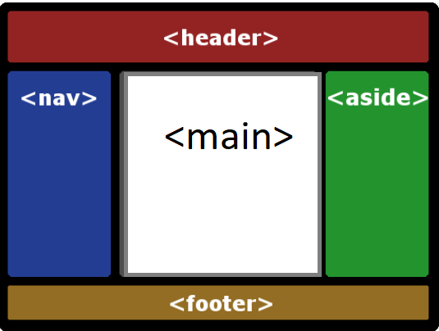

**HTML**

<div class="wrapper">

<aside class="item">aside</aside>

<footer class="item">footer</footer>

<main class="item">main</main>

<nav class="item">nav</nav>

<header class="item">header</header>

</div>

**CSS**

*,

*::after,

*::before {

box-sizing: border-box;

margin: 0;

padding: 0;

}

body {

height: 100vh;

font-family: 'Open Sans', sans-serif;

background-color: #333;

font-size: 3.6rem;

}

.wrapper {

display: grid;

grid-template-columns: 2fr 1fr;

grid-template-rows: 100px 100px 500px 100px;

}

.item {

display: flex;

align-items: center;

justify-content: center;

padding: 10px 20px;

text-transform: uppercase;

}

nav {

background-color: tomato;

}

header {

background-color: gold;

}

main {

background-color: cornflowerblue;

}

aside {

background-color: slateblue;

}

footer {

background-color: greenyellow;

}