**Tutorial for Set up of Bitcraze Crazyflie 2.0**

Open the box containing the drone.

**Assembling the drone:**

1. For details go to <https://www.bitcraze.io/getting-started-with-the-crazyflie-2-0/>
2. Connect the drone body to a USB power source. There should be *blue and red* lights flashing. If the connection is correct, the power *green* light will blink for five times really fast.
3. Start by twisting the wires of the four motors. This will reduce electronic noise and make the wires fit better in the motor mount “hooks”.
4. Push the four motors into the motor mounts. You will need some force to insert them. If it is difficult doing it as in the video try putting the motor can towards a table edge and press on the mount, however don’t press on the motor axis while inserting them as it might damage the motor. The motor should be inserted all the way to the stop in the mount.
5. Attach the twisted wire into the two small “hooks” that are underneath the motor mount.
6. Insert the motor mounts on the Crazyflie 2.X wings. They are press fit and might need a small amount of force. Make sure they go all the way to the stop. It’s not important which motor you put where. After it’s been inserted, connect the motor connectors to the Crazyflie 2.X
7. Now it’s time to attach the propellers. Note: There are two kinds of propellers, the clock wise (CW) and counter clock wise (CCW) propellers, each kind has their own bag in the box. Here we are attaching the CW propellers.

**Note**: *The propellers marked A rotate counter-clockwise and those marked B rotate c clock-wise. Assemble them according to the figure shown on the website with one exception. All the propellers should have the “Letter label” facing upwards.*

1. The rubber pad should be attached to the Crazyflie 2.X between the expansion headers. This will create friction, keep the battery from slipping out and also protect the electronics.
2. There are two types of headers in the box, long and short ones.

**Note**: Instead of the two short headers, use the two long ones. Push them in the slots from the bottom of drones. This helps in fixing the position of flow deck while flying the drones.

1. Place the battery between the headers inserted into the expansion connector and insert the battery holder board onto the headers. Watch out for the pins that can be a bit sharp when inserting it. The friction should hold the battery in place so tighten it until it does.
2. Now connect the battery and you are finished with the assembly. The battery wires can preferably be bent and placed underneath the PCB to be out of the way.
3. The assembly is finished, now it’s time to power it on! Note that the power button is a push button, not a sliding button. During the power-on self-test all the propellers will spin in sequence. Make sure they all spin, if they don’t then check the motor connections.

Once the setup is finished, please go through the rest of the website to have an idea about the various lights and other indicators of the drones.

**Installing drone Library and Client packages:**

Make sure you have sudo access on the computer.

Drone library link: <https://github.com/bitcraze/crazyflie-lib-python>

Drone client link: <https://github.com/bitcraze/crazyflie-clients-python>

1. Open terminal. Type in the following commands to download the Crazyflie library and client packages. Usually they are saved on the Desktop.

git clone https://github.com/bitcraze/crazyflie-lib-python

git clone https://github.com/bitcraze/crazyflie-clients-python

1. If you are in Desktop on the terminal, use the following commands to install the Crazyfie library:

sudo pip3 install –e ./crazyflie-lib-python

sudo apt-get install python3 python3-pip python3-pyqt5 python3-pyqt5.qtsvg

1. Open the Clients folder in Desktop and open the terminal from this folder. Or change the directory to the clients folder in Desktop. Type in the following commands install the Crazyflie client:

sudo pip3 install –e .

**Note**: There may be a problem with the installation of Crazyflie client depending on the version of the file downloaded from the internet. In some cases, this may require Python 3.5 or higher (the default on Sheldon in Python 3.4.3). In that case, you will have to install the required version of Python to run the client, at

<https://www.python.org/downloads/> (Be sure to add Python to PATH)

NOTES:

* If a log (or other) error is thrown after execution, turn the problem drone(s) off/on
* The drones behave erratically if the batteries are not well-charged (~3.7-3.8+ V)
* When running your own scripts, make sure that they are saved in the same directory as the crazyflie standard library
* Use sudo pip3 install PyUSB, and check <https://github.com/bitcraze/crazyflie-clients-python/blob/master/README.md> to ensure you have the proper dependencies. The instructions above should install all, but sometimes additional ones are needed

**Configuring the drones:**

Relevant link: [https://www.bitcraze.io/getting-started-with-the-crazyflie-2-0/ - config-client](https://www.bitcraze.io/getting-started-with-the-crazyflie-2-0/#config-client)

1. Connect the Crazydio Dongle.

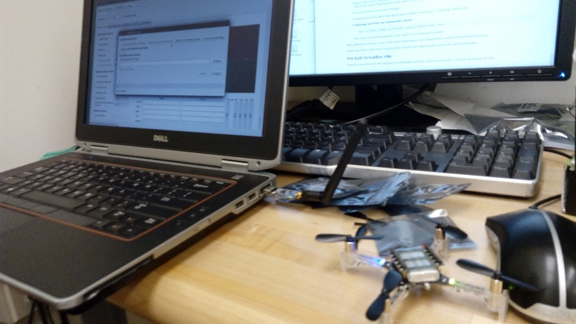

1. Power on the drone.
2. Open the Crazyflie Client from the terminal in the Clients directory:

sudo python3 bin/cfclient

Or navigate to the bin directory and type “cfclient”

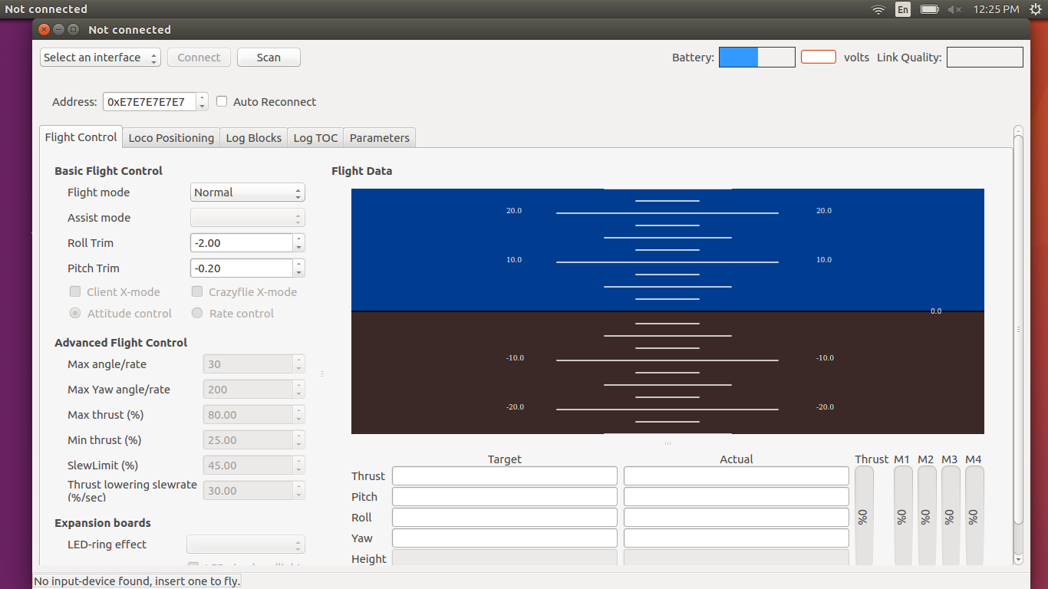

1. Open the web browser and go to <https://github.com/bitcraze/crazyflie-release/releases>. Download the source file titled “crazyflie-release-2019.02.1.zip” (This is the latest file. The date may be changed depending when the latest release was issued. You have to download source zip from the list.)
2. Turn the Crazyflie off.
3. Start the Crazyflie in bootloader mode by pressing the power button for 3 seconds. Both the blue LEDs will blink.
4. Go back to the Crazyflie client and click the Connect -> Bootloader menu.
5. Initially it will say “Not Connected”. Click on the button titled “Initiate bootloader cold boot”. This should boot up the firmware and the status will show “Connected to bootloader” like the example below. 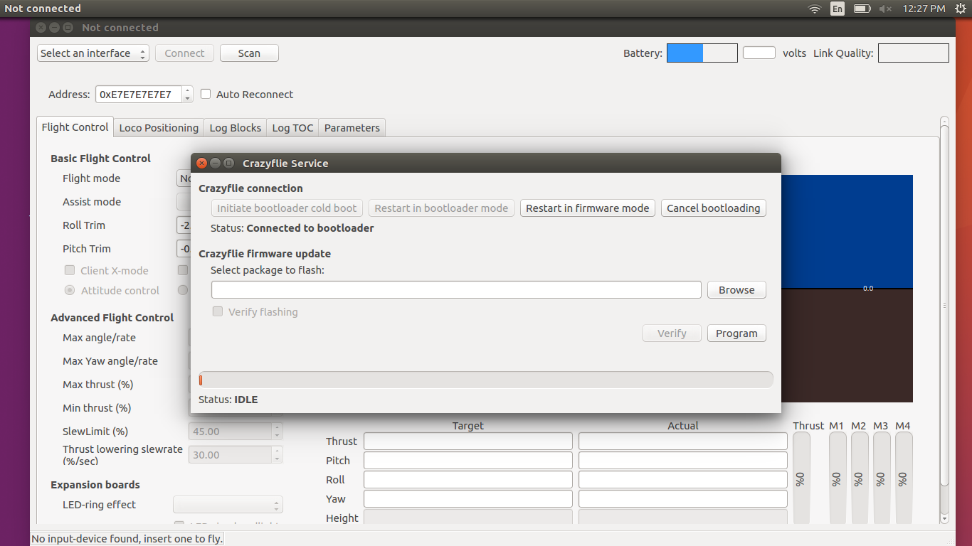
6. In case there is any issue, just turn off the drone and hold power button for 5 seconds. There should be two blinking blue lights which means everything is OK.
7. Click the “Browse” button and go to home/bitcraze/Downloads and select the file you downloaded earlier.

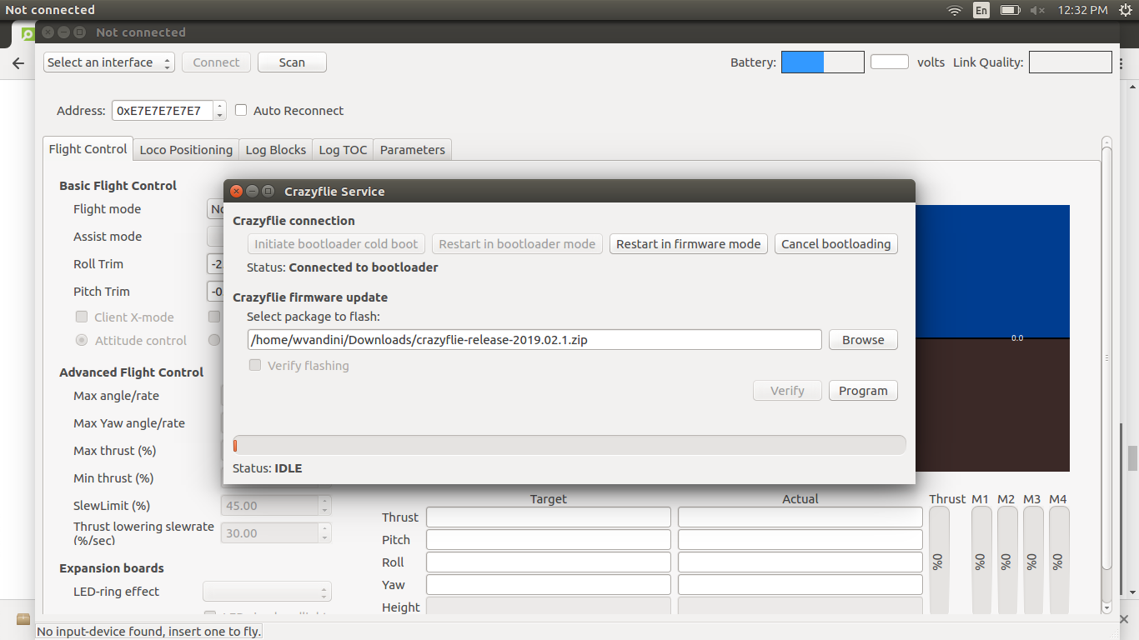

1. Click the “Program” button. The progress bar will go from 0% to 100% twice, as the firmware for the two processors is uploaded to the Crazyflie.
2. Click the “Restart in firmware mode” button. The Crazyflie reboots and is now updated.
3. Close the bootloader window.

NOTES:

* All drones with red labels on them are **already configured**, so the above steps are not needed. The channels are set (and referred to in the code) unless you manually change the channel(s) through the client.
* The client itself is not necessary to fly the drones. It is useful for checking battery life, channel names, controller parameters etc, but is only needed if configuring new drones
* The client does not appear to launch properly on Sheldon (Qt implementation error), but the scripts may still be able to be executed if the dongle is plugged in

**Connecting and flying the drone:**

1. In the Crazyflie client click the “Scan” button in top left corner. The radio settings for you Crazyflie is displayed in the drop-down list.
2. Choose your Crazyflie from the drop-down list.
3. Click the “Connect” button. This will connect the drone to the computer and make it ready for use.

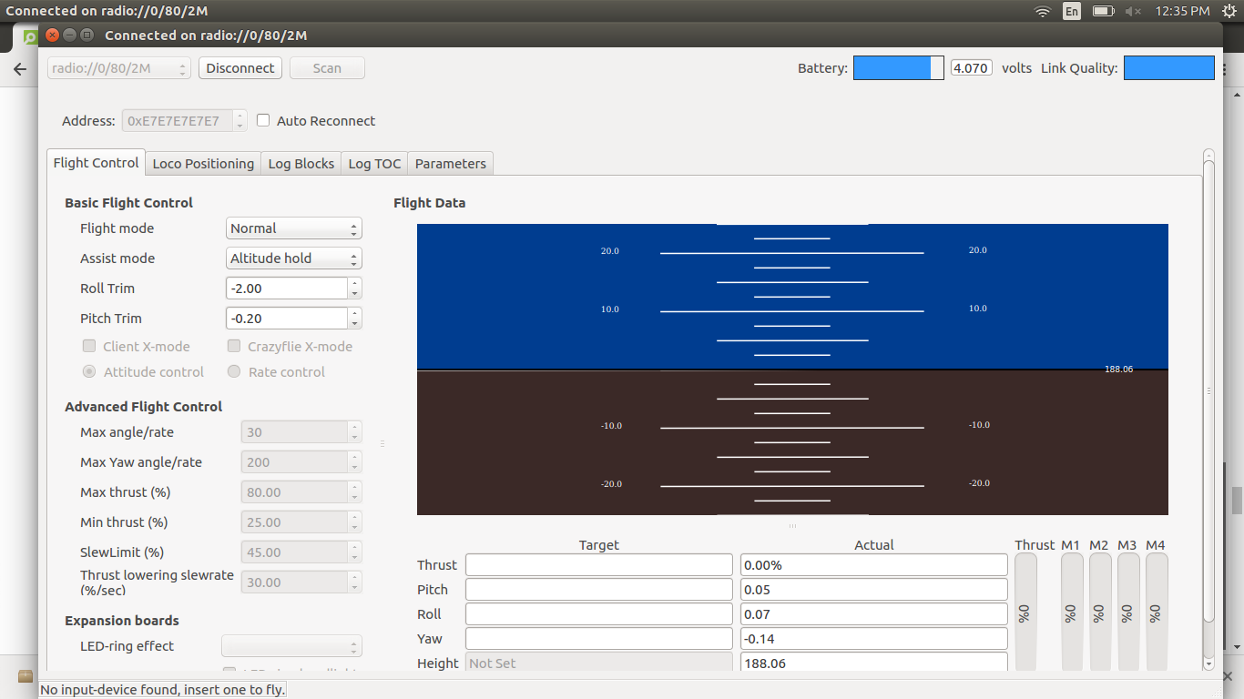

1. Go to the “Connect” **tab (not button)** and Select Configure 2.0 in case you want to change the default radio address provided to the drone. This will be required if the radio address is already in use by some other drone.
2. Select a different radio address and then click “write” followed by “exit”.

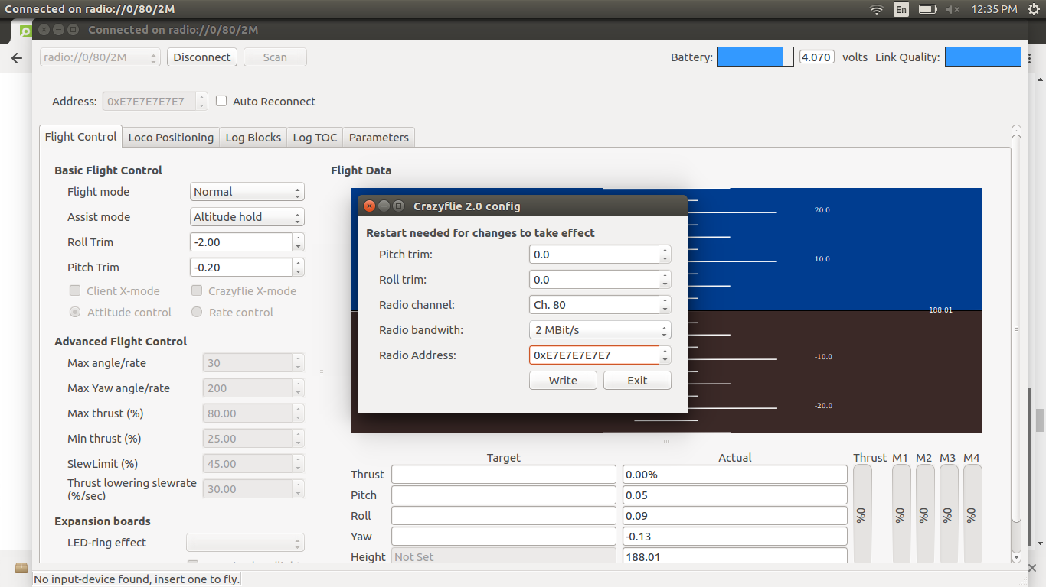

1. Restart the drone to confirm the address change.
2. Go to <https://www.bitcraze.io/getting-started-with-stem-drone-bundle/> and copy the python script in that page. This serves as a nice “first flight code”.Remember to change URI address to URI = 'radio://0/80/250K' to the address you configured your drone to have; for e.g., uri = 'radio://0/80/2M/E7E7E7E7E9' in the code.
3. Mount the flow deck on the bottom (rear side) of the drones.
4. Run the first flight script and see them fly!!!!

Have fun flying them!!!