Our ref: CM&OClPKOI002L117
October 03, 2017
The Medical Director
Gilead Medical & Dental Centre
House of Balm
No. C896/3 Kanda Highway
North Ridge
Accra
Dear Sir,
Medical Examination:
Ms PRISCILLA KUMI DICKSON
We write in respect of Ms Priscilla Kumi Dickson, who is being
considered for employment with Gilead Medical & Dental Centre.
We would be grateful if you would kindly conduct a thorough
medical examination on the above mentioned, to ascertain his
medical fitness for employment.
We would also be grateful if you would kindly send the
following to us:
- a signed copy of this letter
- medical examination report on the above
- the bill for this service.
Thank you for your co-operation.
Yours faithfully,


CDH FINANCIAL HOLDINGS LTD.
CDH House, 36 Independence Avenue
North - Ridge, Accra
P.O.Box 14911, Accra
T 0:1: + 233 (0) 30267 1050
+233 (0) 28 9971050
Fax: +233 (0) 30 266 2167
Email: info@cdhgroup.co
www.cdhgroup.co

b~~
S. SEYEN:A.-SUSU
Group Head, HR

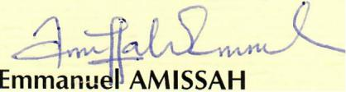
Group Head, Legal

