Our ref: CDH S&LlDPM/002L17 7
October 73, 2077
The Medical Director
Gilead Medical & Dental Centre
House of Balm
No. C896/3 Kanda Highway
North Ridge
Accra
Dear Sir,
Medical Examination:
Mr. DAVID PAAKOW MATE


CDH Savings & Loans Co. Ltd.

We write in respect of Mr. David Paakow Mate, who is being
considered for employment with CDH Savings &Loans Limited.
We would be grateful if you would kindly conduct a thorough
medical examination on the above mentioned, to ascertain his
medical fitness for employment.
We would also be grateful if you would kindly send the
following to us:
- a signed copy of this letter
- medical examination report on the above
- the bi II for this service.
Thank you for your co-operation.
Yours faithfully,

CDH House, 36 Independence Avenue
North- Ridge, Accra
P.O.Box 14911, Accra
T el: + 233 (0) 302 671 050
+ 233 (0) 28 997 1050
Fax: + 233 (0) 302 662 167
Email: info@cdhgroup.co
www.cdhgroup.co
Directors:
D.K.D. LETSA
Chairman
Nicholas VINGIRAI
Emmanuel ADU·SARKODEE
Samuel APPIAH·AMPOfO

l;~
S. SEYENA-SUSU
Group Head, HR

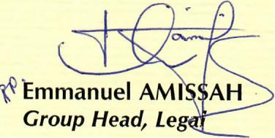

Abdallah ALI·NAKYEA
Joyce A TI A·KRAH
Desmond NARTEY
Martin ASAMOAH
Executive Director
A CDH Company

