

PHOENIX HEALIH INSTANCE GCHEME MEMBERSHIP IDENTIFICATION CARD

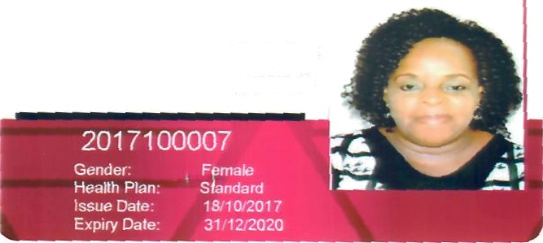

Gifty Aba

ARYITEY