Kyle Fawkes

November 18, 2015

Computation in the Physical Sciences

On the Edge of Discovery:

Zooplankton Abundance in the Discovery Passage

Introduction:

At the basis of marine food webs are the small photosynthesizing organisms called Phytoplankton (Beamish & McFarlane, 2014). These microscopic organisms float with the ocean currents, and provide food for zooplankton and other upper trophic level organisms to support marine ecosystems (Beamish & McFarlane, 2014). In the Strait of Georgia, phytoplankton typically have a large bloom at the beginning to middle of spring when the water begins to stratify and the amount of sunlight exposure increases (Beamish & McFarlane, 2014). Similarly just after this bloom of phytoplankton, the Strait undergoes a zooplankton bloom (Beamish & McFarlane, 2014). The timing of this spring bloom is paramount to many marine organisms in higher trophic levels, including juvenile Pacific Salmon (Beamish & McFarlane, 2014). Recently there have been changes in the timing of spring phytoplankton and zooplankton blooms in the Strait, which scientists attribute to climate change. Ultimately this has complicated the migration of Salmon out of the Strait, as well as their early development (Johannessen & McCarter, 2010; Allen & Wolfe, 2013). In addition, researchers have recently proposed that the lack of primary productivity in narrow and turbulent migration passages out of the Strait puts further stress on these young migrating Salmon, as they encounter a lack of food. This combination of the annual bloom variance in the narrow migration passages is a particularly new and mysterious area of research, which is still underexplored. For my Keystone I want to explore the feasibility of predicting the timing and strength of plankton blooms in the Discovery passage using a common oceanic productivity model known as NPZ (Nutrient, Phytoplankton, and Zooplankton) model (Franks, 2002). Creating an NPZ model and analyzing the output is outside the scope for this 3-week project. However, a complex and accurate NPZ model includes variables and parameters that account for the biotic factors as well as abiotic factors (Franks, 2002). Many of the biotic factors and relationships are addressable through the literature, however the abiotic factors in this region are somewhat understudied. Thus the primary motivation for this project originates from a necessity to understand the abiotic affects on plankton in the Discovery Passage. Since plankton growth is heavily affected by both vertical water turnover and temperature, we examine the multivariate relationship between sea surface temperature, wind driven vertical turnover and Zooplankton abundance in the narrow Discovery Passage. Unfortunately, vertical turnover is extremely difficult to measure, even wind driven vertical turnover, therefore we use significant wave height as a proxy for wind driven vertical turnover.

Methods:

In order to examine these multivariate relationship between sea surface temperature, wind driven vertical turnover and Zooplankton abundance, we employ two main methods; time-series analysis of all three variables for the spring bloom seasons 2009-2012, and multivariate linear regression on these same spring bloom seasons. Data for analysis came from two sources; Environment Canada and Department of Fisheries and Oceans/BC Centre for Aquatic Health Sciences. Sea surface temperature, and significant wave height data were collected every hour at Sentry Shoals buoy in the Northern Strait of Georgia, and recorded by Environment Canada (Figure 1.). Zooplankton Abundance was collected approximately twice per week in the Discovery Passage near the Campbell River Warf (Figure 1.). The Department of Fisheries and Oceans executed the collections and the data was recorded and analyzed by the BC Centre for Aquatic Health Science. Zooplankton collections only occurred during the spring bloom seasons in 2009, 2010, 2011, and 2012. The spring bloom season for each year is outlined in table 1.

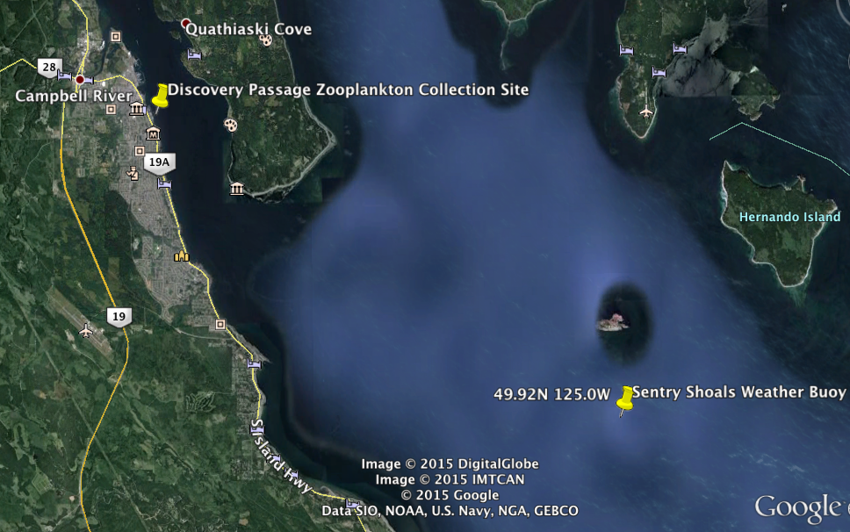

Figure 1. Displays a Google Earth map showing the data collection sites (Sentry Shoals Weather Buoy and Discovery Passage Shoreline) in relation to each other.

|  |  |  |
| --- | --- | --- |
| **Year of Collection** | **Start Date** | **End Date** |
| 2012 | 2012-03-30 | 2012-07-01 |
| 2011 | 2011-03-07 | 2011-07-03 |
| 2010 | 2010-03-03 | 2010-6-28 |
| 2009 | 2009-02-24 | 2009-07-05 |

Table 1. Shows the start and end date of the spring bloom season zooplankton collections.

All sea surface temperatures were measured in ° C, significant wave heights were measured in meters and Zooplankton Abundance was measured in zooplankton per meter cubed.

Before we explored the multivariate relationships between sea surface temperature, significant wave height and Zooplankton Abundance, we conducted a short statistical analysis of the relationship between sea surface temperature and significant wave height. The relationship was explored to confirm, as well as gain a better understanding of the trends of the environment in which the zooplankton live. And since sea surface temperature varies closely with air temperature, we were able to make it the control variable to examine the pattern of significant wave height throughout the year. Time-series analysis for sea surface temperature, significant wave height and Zooplankton Abundance was performed using weekly averages of the data during the spring bloom season. We then performed interactive multivariate linear regression on the three variables for each spring bloom season between 2009 and 2012. The goal of this regression was to examine the affects of sea surface temperature and significant wave height on zooplankton abundance. The code to perform data munging, plotting and statistical analysis was developed using ipython notebook. The notebook and script is viewable through the following link: <https://github.com/kwfawkes/Kyles_project>.

Results:

**Sea Surface Temperature & Significant Wave Height**

Sea surface temperature and significant wave height in the Northern Strait of Georgia display a negative relationship for a monthly timescale between 2009 and 2012. The linear model revealed a linear regression slope of -0.028. This means that for every degree of increase in average monthly sea surface temperature, the average monthly wave height will decrease by 0.28m on average. The model also revealed an value of 0.496 (Table 2.), which means that about 50% of the variability in the significant wave height is explainable by the variation in sea surface temperature.



Figure 2. Shows the linear regression model and relationship between sea surface temperature and significant wave height between 2009 and 2012. Data observations were averaged monthly during the timeline.

|  |  |  |  |  |
| --- | --- | --- | --- | --- |
| **Stat** | **Test** | **Timeframe** | **Variable** | **Value** |
| P-value | Linear regression | 2009-2012 | Constant | 6.77E-17 |
| P-value | Linear regression | 2009-2012 | Sea surface temperature | 4.73E-08 |
| R-squared | Linear regression | 2009-2012 | R-squared | 0.495972815 |

Table 2. Shows the R-squared and p-values for linear model of the relationship between sea surface temperature and significant wave height. Relationship is analyzed for monthly averages from 2009 to 2012.



Figure 3. Shows a time-series plot of Zooplankton abundance in relation to sea surface temperature and significant wave height for the spring bloom season in each year between 2009 and 2012. Data observations were averaged weekly for each variable.

|  |  |  |
| --- | --- | --- |
| **Year** | **R-squared** | **Stats Test** |
| 2012 | 0.403314272 | Linear regression |
| 2011 | 0.366363515 | Linear regression |
| 2010 | 0.148005072 | Linear regression |
| 2009 | 0.610644298 | Linear regression |

Table 3a. Shows the R-squared values for the interactive multivariate linear models between significant wave height, sea surface temperature and Zooplankton Abundance for the spring plankton bloom each year. Variable observations were averaged weekly for each spring.

|  |  |  |  |
| --- | --- | --- | --- |
| **Year** | **Test** | **Value** | **Variable** |
| 2012 | Linear regression | 0.015227649 | Constant |
| 2012 | Linear regression | 0.095893847 | Sea surface temperature |
| 2012 | Linear regression | 0.180115104 | Sea surface temperature & sig wave height |
| 2012 | Linear regression | 0.083780778 | Sig wave height |
| 2011 | Linear regression | 0.077476419 | Constant |
| 2011 | Linear regression | 0.493148839 | Sea surface temperature |
| 2011 | Linear regression | 0.943792921 | Sea surface temperature & sig wave height |
| 2011 | Linear regression | 0.618090728 | Sig wave height |
| 2010 | Linear regression | 0.628747512 | Constant |
| 2010 | Linear regression | 0.873337109 | Sea surface temperature |
| 2010 | Linear regression | 0.916157625 | Sea surface temperature & sig wave height |
| 2010 | Linear regression | 0.800040013 | Sig wave height |
| 2009 | Linear regression | 0.318299746 | Constant |
| 2009 | Linear regression | 0.030455324 | Sea surface temperature |
| 2009 | Linear regression | 0.376950345 | Sea surface temperature & sig wave height |
| 2009 | Linear regression | 0.541228359 | Sig wave height |

Table 3b. Shows the p-values for the interactive multivariate linear models between significant wave height, sea surface temperature and Zooplankton Abundance for the spring plankton bloom each year. There is a p-value for each relationship between zooplankton abundance and the other model terms. Variable observations were averaged weekly for each spring.

References:

Allen, S.E., & Wolfe, M.A. (2013) Hindcast of the timing of the spring phytoplankton bloom in the Strait of Georgia, 1968–2010. Progress in Oceanography, Volume 115.

Beamish, R., & McFarlane (2014). The Sea Among Us: The Amazing Strait of Georgia. Madeira Park, BC, Canada: Harbour Publishing Co.

Franks, P.J., (2002) NPZ Models of Plankton Dynamics: Their Construction, Coupling to Physics, and Application. Journal of Oceanography, Volume 58.

Johannessen, S. C., & McCarter, B. (2010). Ecosystem Status and Trends Report for the Strait of Georgia Ecozone. Retrieved from <http://www.dfo-mpo.gc.ca/CSAS/Csas/publications/resdocs-docrech/2010/2010_010_e.pdf>