PROJECT REPORT · C LANGUAGE CONSOLE APPLICATION
Smart Hospital &
Resource Allocation System
Patient triage · Ward & bed management · Billing · Analytics
———
CSC 1031 Software Development Fundamentals
University of Sri Jayewardenepura

Student Details
NAME |  | STUDENT ID
K.T.D.K.Himesh Wijethunga |  | AS20250647
SUBMITTED DATE
2026/Sep/20
GITHUB REPOSITORY
https://github.com/kwh440/Smart-Hospital-Resource-Allocation-System

Content
1 Introduction 3
2 Objectives 3
3 Project Overview 3
3.1 Assumptions Made During Development 4
4 Methodology 4
5 How I Planned My Project 5
6 Methods Followed for the Planning 6
7 How GitHub Was Used and Best Practices Followed 6
7.1 GitHub Repository 6
7.2 Best Practices Followed 7
8 Implementation 7
8.1 High-Level Architecture 8
8.2 Program Lifecycle & Menu Map 8
8.3 Core Business Rules 9
8.4 Implemented Functions (58) 9
8.5 Data Structure Designs 11
8.6 Persistence File Formats 13
9 Conclusion 13
10 Appendix 14
10.1 GitHub Repository 14
10.2 Source Code 14
10.3 Output Screenshots 14
10.4 Project Details 17
11 Challenges Faced 17
12 System Requirements 18

1 Introduction
A hospital has to decide, quickly and repeatedly, who needs care first, where each patient should stay and what the stay will cost. The Smart Hospital & Resource Allocation System is a menu-driven console application written in C that supports those decisions: it registers patients, ranks them by urgency, recommends and allocates ward beds, produces itemised bills and summarises hospital performance.
The project applies structured, modular C programming (structs, arrays, functions and file I/O) to a realistic problem and is version-controlled on GitHub. It runs in a terminal and keeps its data in plain text files, so no database or external library is needed.
8  source modules |  | 58  functions |  | 4 / 45  wards / beds |  | 2.8k  lines of C

2 Objectives
The objectives of this project are:
1 | Patient registration and triage — capture patient details, block duplicates and rank patients by three urgency levels.
2 | Ward and bed allocation — recommend a ward from age and urgency, assign the first free bed and release it on discharge.
3 | Automated billing — compute base fees, emergency surcharges, ward costs and age subsidies, and export itemised receipts.
4 | Performance analytics — report the triage mix, revenue, bed occupancy and the highest-paying patient.
5 | Data persistence — save and reload patient and bed records between runs using plain text files.
6 | Modular C programming — split responsibilities into header / source pairs with validated input and clear function contracts.
7 | Version control and documentation — use GitHub to track the work and document the design, outputs and results in this report.

3 Project Overview
The application presents a 13-option menu grouped into three areas. It loads saved data at start-up, loops until the user chooses option 13, and then writes all records back to disk. All state is held in fixed-size in-memory arrays.
PATIENT MANAGEMENT & TRIAGE | WARD & BED MANAGEMENT | FINANCIALS & ANALYTICS
- Register new patients with duplicate check  - Directory in arrival order  - Priority triage queue (Level 3 → 1)  - Search by ID or partial name  - Update patient records | - Doctor specialties directory  - Ward list with live availability  - Bed matrix and ward status tables  - Bed allocation with ward recommendation  - Discharge and bed release | - Performance and analytics report  - Itemised bill with surcharge and subsidy  - Receipt export to text file  - Save data and exit

3.1 Assumptions Made During Development

Environment & scope
- A single user operates the program at a time from one console; there is no login, role or concurrency handling.
- The program runs from a folder where a data/ sub-folder can be created, in a terminal with ANSI colour and Unicode box-drawing support. The Windows console is the primary target (ANSI mode and UTF-8 are enabled explicitly); the same code also builds on Linux through conditional compilation.

Capacity & identifiers
- Capacity is fixed at 100 patients, 45 beds, 4 wards and 7 specialties; registration is refused once 100 patients exist.
- Patient IDs are sequential (PAT-1001, PAT-1002 …). Patients are never deleted, so IDs stay unique.
- Two records with the same name and contact number are treated as the same person and the second registration is blocked.
- Each patient occupies at most one bed at a time; a patient with a bed cannot be allocated a second one.

Clinical & billing rules
- Urgency is entered by staff on a three-level scale (Normal, Urgent, Critical); Level 3 patients receive immediate attention (0-minute wait).
- Ward recommendation is advisory only; the user can always choose another ward. Beds are assigned first-fit (lowest free ID).
- All money values are in LKR. One base consultation fee is charged per bill; stay length is entered in whole days (0–365) and can be corrected at billing time.
- The 15 % age subsidy applies to the gross total for patients younger than 5 or older than 65. Outpatients (no ward) pay no ward cost.

Persistence & known limits
- Data is saved only when the user chooses option 13; closing the window without it discards changes made in that session.
- Text fields must not contain a semicolon (the file delimiter), and a saved patient line is assumed to fit in 255 characters.
- Discharging a patient frees the bed and resets their ward and bed to 0, so a bill or report generated after discharge treats the stay as outpatient. Bills are therefore assumed to be calculated before discharge.
- Contact numbers are stored as free text and are not format-checked.

4 Methodology
The system was developed in C and organised around the following design decisions:
- Modular decomposition — eight source units, each exposing its public interface through a header file; main.c only orchestrates.
- Data-first design — domain records are C structs stored in fixed-size global arrays; relationships use ID values rather than pointers.
- Rule-based logic — triage ordering, ward recommendation and billing use explicit formulas that are easy to test.
- Defensive input handling — bounded-integer and non-empty-string readers re-prompt until the input is valid.
- Plain-text persistence — semicolon-delimited files are loaded at start-up and saved on exit.
- Separated presentation — colours, animations and charts live in ui_effects.c, apart from business logic.

Development workflow and tools
Environment | Code::Blocks IDE with the GCC (MinGW) compiler on Windows
Way of working | Built in small steps: write one module, compile it, test it from the menu, then move on to the next
Compiler checks | Compiled with warnings enabled (-Wall) and fixed each warning before continuing
Version control | Git and GitHub: a feature branch for each module or task, merged into main once working
Documentation | Every function has a header comment giving its purpose, inputs and return value
Code comments | Comments were added with the help of Gemini 3.6 Flash in Antigravity, on a dedicated comment_branch

Testing approach
The program was tested manually through the menu with sample patients, and the results were checked against hand calculations.
Test | Expected result
Invalid input (letters, out-of-range numbers, empty text) | The prompt is repeated until valid input is entered
Register the same name and contact number twice | The second registration is blocked as a duplicate
Allocate a bed to a Critical patient | ICU is recommended, a free bed is assigned and the bed matrix updates
Bill a Critical Cardiology patient with 4 ICU days | LKR 4,500 + 2,250 surcharge + 100,000 ward cost = LKR 106,750
Save with option 13, then restart the program | Patients, beds and ward counters are restored

5 How I Planned My Project
I planned the project in five stages before writing most of the code:
Stage | What I did
1. Understanding the problem | Read the assignment requirements and listed what a small hospital system must do: register patients, prioritise emergencies, manage beds, calculate bills and report.
2. Identifying entities and features | Found four main entities (patient, ward, bed and doctor specialty) and grouped the features into 13 menu options in three areas.
3. Designing the data | Chose structs and fixed-size arrays to hold the entities, and decided how they refer to each other using ID numbers.
4. Splitting into modules | Divided the program into eight source files, each with one clear responsibility and its own header file.
5. Choosing tools and milestones | Selected Code::Blocks, GCC and GitHub, and scheduled the work in small milestones: data structures, patients, wards and beds, billing, reports, file handling, then polish and documentation.

6 Methods Followed for the Planning
I followed a simple top-down, step-by-step approach:
Method | How it was applied
Top-down design | Started from the main menu and broke each option into smaller functions. For example, option 12 is built from small formula functions such as calculateEmergencySurcharge and calculateAgeSubsidy.
Pseudocode and flow planning | Wrote the key rules (triage order, ward recommendation and billing) as pseudocode and simple flowcharts before coding them.
Incremental development | Implemented one module at a time, compiling and testing after each step so that errors were found early.
Modular programming | Used separate header and source files with clear function prototypes, and shared the main data arrays between modules.
Reusable helpers | Wrote the input-validation functions once and reused them wherever the program reads user input.
Review and refinement | Fixed bugs after testing and improved the console interface (colours, tables and animations) last, so it could not affect the logic.

7 How GitHub Was Used and Best Practices Followed

7.1 GitHub Repository
Repository URL | https://github.com/kwh440/Smart-Hospital-Resource-Allocation-System
Repository name | Smart-Hospital-Resource-Allocation-System
Branch | main (default), plus feature branches for modules and tasks (see 7.1)
Project | Smart Hospital & Resource Allocation System (C)

Branch structure
Development followed a simple feature-branch workflow. The stable, working version lives on the main branch, while each module or task was developed on its own branch and merged into main once it compiled and ran correctly.
Branch | Purpose
main | Stable, working version of the project (default branch)
patient_branch | Patient module: registration, triage queue, search and update
reports_branch | Performance and analytics report
console_graphics_effects | Console colours, animations and charts
comment_branch | Function and file comments
testing_and_debugging | Testing and bug fixing

Active branches in the GitHub repository
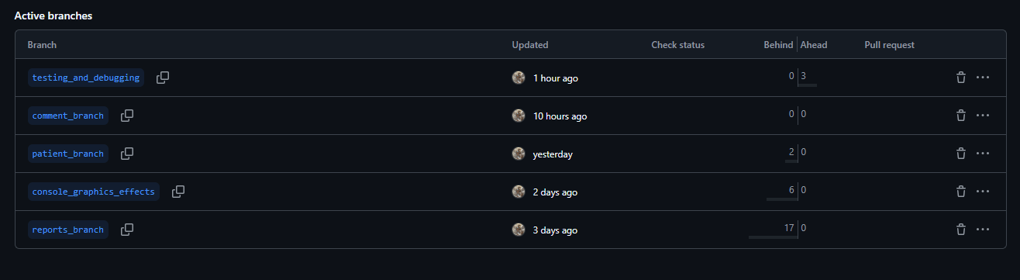

7.2 Best Practices Followed
- Repository hygiene — a .gitignore excludes compiled binaries (*.exe, *.o), Code::Blocks *.depend / *.layout files, bin/, obj/ and temporary or log files, so only source and data are tracked. The .depend and .layout files had been pushed by mistake earlier in development, and were removed from the repository in the final stage of the project.
- Feature branches — new work was done on separate branches and merged into main only when it was working, which kept main stable.
- Small, frequent commits — changes were committed one feature at a time, so each commit has a single clear purpose.
- Clear commit messages — messages describe what changed, for example “Add bed allocation with ward recommendation”, not just “update”.
- Push only working code — code was merged into main after it compiled and ran correctly, so main always holds a working version.
- History and backup — GitHub keeps every version, so earlier work can be restored and the project is safely backed up online.
- Documentation in the repository — the README and this report are kept alongside the source code.

8 Implementation
This section describes how the system is built: its architecture, the functions behind each menu option, and the data structures they operate on.

8.1 High-Level Architecture
The code is split by responsibility into three layers. main.c only orchestrates; domain modules own the business rules and never touch files directly; file_manager.c is the single gateway to disk, and ui_effects.c isolates every terminal-styling concern.
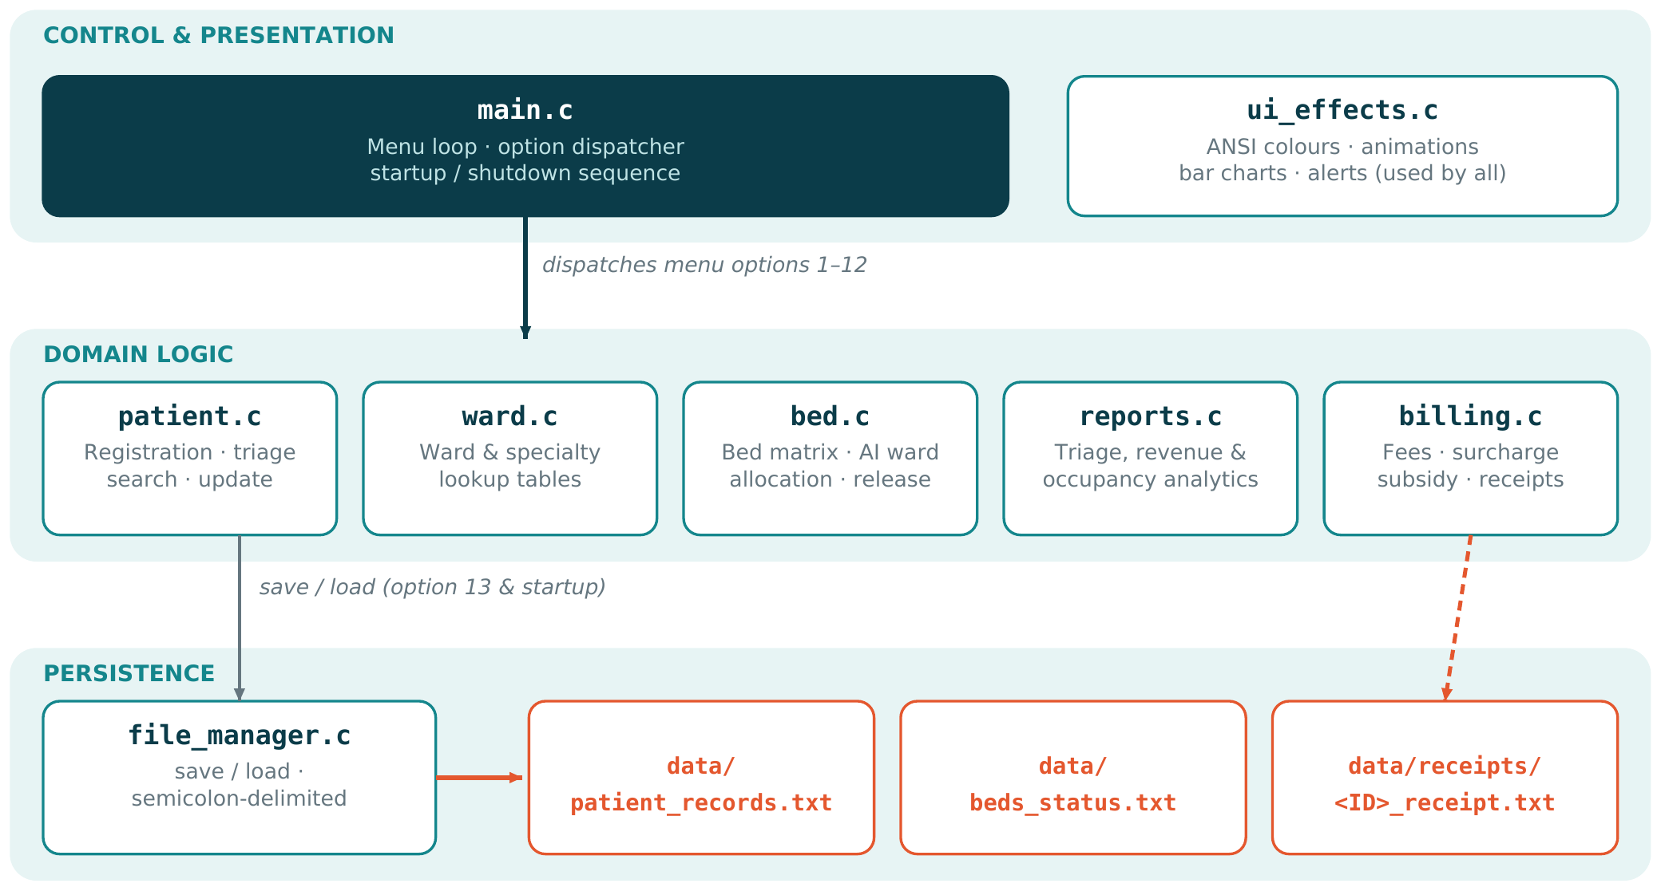

8.2 Program Lifecycle & Menu Map
# | Menu option | Handler | # | Menu option | Handler
1 | Register new patient | registerPatient | 8 | Ward bed status tables | displayBedOccupancyMetrics
2 | Patients directory | displayPatients | 9 | Allocate bed (AI recommendation) | allocateBed
3 | Priority triage queue | displayPriorityTriageQueue | 10 | Discharge & release bed | releaseBed
4 | Search patient | searchPatient | 11 | Performance reports | generatePerformanceReport
5 | Update patient | updatePatientRecord | 12 | Bill & export receipt | processBillCalculation
6 | Doctor specialties | displaySpecialties | 13 | Save data & exit | savePatientRecords + saveBedStatus
7 | Hospital wards | displayWards

8.3 Core Business Rules
Rule | Logic implemented
Triage ordering | Level 3 (Critical) → 2 (Urgent) → 1 (Normal). Stable bubble sort on a temporary copy, so arrival order is kept for ties and the directory is untouched.
Ward recommendation | Critical → ICU (4); age < 12 → Paediatric (2); Urgent → Surgical (3); otherwise General (1). Advisory only: the user may pick another ward.
Bed allocation | First-fit: the lowest free bed ID in the chosen ward is assigned. Ward counters and bed record are updated together.
Billing | Gross = base fee + surcharge + (ward daily rate × days). Surcharge = 0 % / 20 % / 50 % of base fee for Level 1 / 2 / 3. 15 % subsidy on gross if age < 5 or > 65. Final = Gross − Subsidy.
Wait-time estimate | Critical = 0 min. Otherwise (non-critical patients of the same specialty) × average consultation minutes; falls back to all non-critical patients if that queue is empty.

8.4 Implemented Functions (58)
Grouped by source file. † = defined and available, but not called by the current menu flow.
main.c | 2 functions
main() | Startup sequence, menu loop, dispatch, save on option 13
displayMenu() | Draws the boxed 13-option main menu

patient.c | 13 functions
clearInputBuffer() | Discards leftover characters in stdin
readIntBounded() | Reads an integer within min–max, re-prompts on error
readStringNonEmpty() | Reads a line and rejects empty input
readGender() | Menu-based gender selection (Male / Female)
isDuplicatePatient() | Detects an existing name + contact pair
registerPatient() | Full intake, triage level, optional ward and bed auto-allocation
displayPatients() | Directory table in registration order
findPatientByID() | Returns pointer to a patient record, or NULL
getPatientCount() † | Returns the number of registered patients
sortPatientsByPriority() | Stable bubble sort by emergency level (3 → 1)
displayPriorityTriageQueue() | Colour-coded priority queue with sorting animation
searchPatient() | Search by ID or case-insensitive partial name
updatePatientRecord() | Edit name, age, gender, contact, condition, urgency

ward.c | 4 functions
initWardsAndSpecialties() | Seeds 4 wards and 7 specialties with rates, beds, fees
displayWards() | Ward table with live available-bed count
displaySpecialties() | Specialty directory with fee, time and daily cap
getWardByID() | Returns pointer to a Ward, or NULL

bed.c | 10 functions
initBeds() | Builds 45 beds: 101–120, 201–210, 301–310, 401–405
displayBeds() | Combined bed view: matrix, cards and ward tables
displayBedMatrix() | 2-D grid, green = free, red = occupied
displayGraphicalBedCards() | 5-wide colour-coded bed cards per ward
displayBoxedWardBedStatus() † | Boxed per-ward status panels
findAvailableBed() | First free bed in a ward, or -1 if full
recommendWard() | Rule-based ward suggestion from urgency and age
displayBedOccupancyMetrics() | Occupancy summary per ward (menu option 8)
allocateBed() | Recommend, choose ward, assign first free bed
releaseBed() | Discharge patient, free bed, restore counters

billing.c | 9 functions
calculateWardCost() | Daily rate × days (0 when days ≤ 0)
calculateEmergencySurcharge() | 0 % / 20 % / 50 % of base fee by urgency
calculateGrossTotal() † | Simple ward cost + base charge (earlier version)
calculateGrossTotalV4() | Base fee + surcharge + ward cost
calculateAgeSubsidy() | 15 % discount for age < 5 or > 65
calculateFinalAmount() † | Returns gross unchanged (earlier version)
calculateFinalAmountV4() | Gross total − subsidy discount
calculateEstimatedWaitTime() | Queue length × specialty consultation time
processBillCalculation() | Interactive bill, on-screen statement, receipt file export

reports.c | 1 function
generatePerformanceReport() | Triage split, revenue and discounts, ward occupancy, top bill

file_manager.c | 5 functions
initDirectoriesAndFiles() | Ensures the data/ folder exists (cross-platform mkdir)
savePatientRecords() | Writes count + one semicolon-delimited line per patient
loadPatientRecords() | Parses records with strtok back into patients[]
saveBedStatus() | Writes all 45 bed records
loadBedStatus() | Restores beds and decrements ward available counters

ui_effects.c | 14 functions
milliSleep() (static) | Cross-platform millisecond delay
enableVTMode() | Turns on ANSI colours and UTF-8 on Windows
displayStartupScreen() | Animated splash with progress bar
drawBoxHeader() † | Double-line boxed section header
pauseConsole() | Waits for Enter before returning to menu
showProgressBar() | Progress bar for file operations
showLoadingSpinner() | Timed spinner for billing, sorting, reports
showBedScanningAnimation() | Ward bed-scan animation
showBedAllocationVisual() | Bed-assigned confirmation banner
showTriageAlert() | Urgency alert box (red / yellow / green)
showTriageQueueSortingAnimation() | Queue sorting animation
showHospitalStatusDisplay() | Live patients / beds occupancy box
drawBarChart() | Colour-coded horizontal block bar chart
displayColorLegend() | Colour key legend

8.5 Data Structure Designs
Four typedef struct records model the domain. They are stored in statically allocated global arrays (no malloc), which keeps memory use predictable and avoids leaks. Cross-references use ID values instead of pointers so every relationship can be written to and restored from text files.

8.5.1 Global storage
Variable | Type | Capacity | Notes
patients[] | Patient | 100 (MAX_PATIENTS) | Filled sequentially; patientCount is the live length (≈ 17.6 KB)
beds[] | Bed | 45 (TOTAL_BEDS_IN_HOSPITAL) | One entry per physical bed, fixed at start-up (≈ 1.2 KB)
wards[] | Ward | 4 (MAX_WARDS) | Lookup table; availableBeds is a live counter
specialties[] | Specialty | 7 (MAX_SPECIALTIES) | Read-only lookup for fees and consultation times

8.5.2 Entity relationships
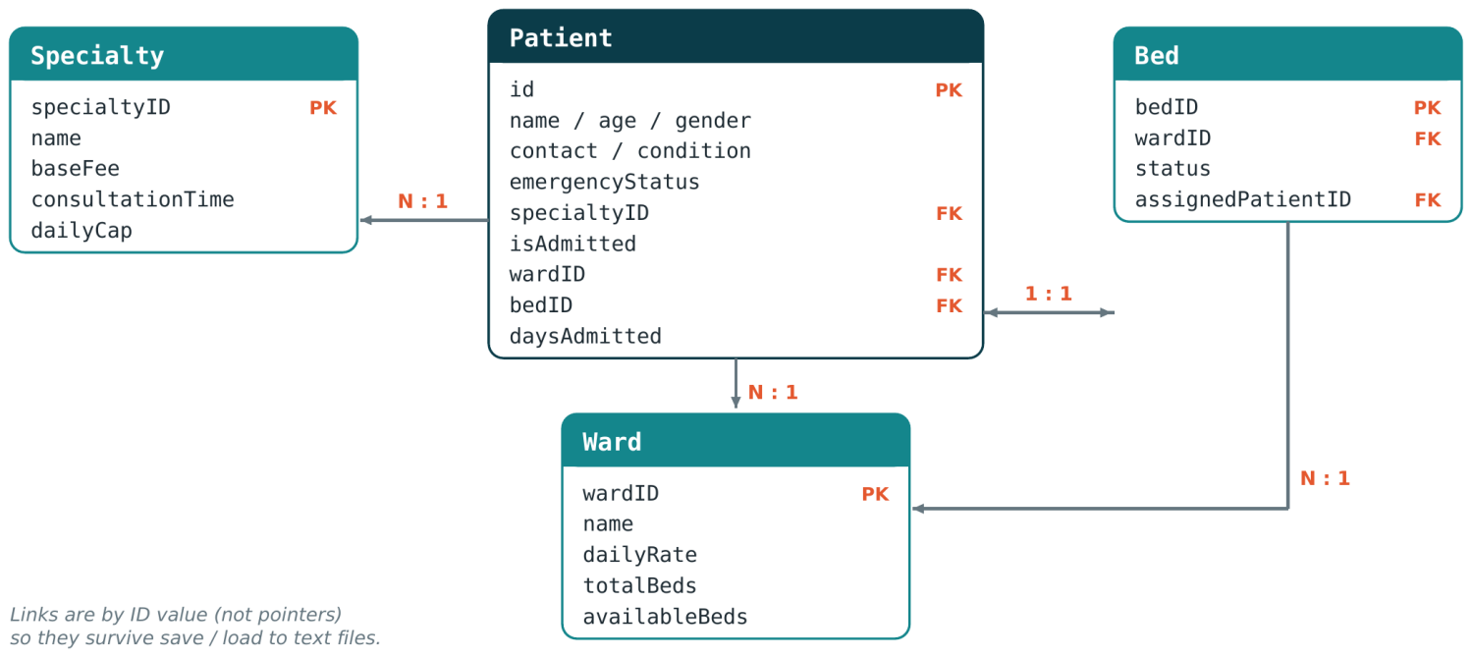

8.5.3 Patient (patient.h)
Field | Type | Description
id | char[20] | Unique key generated as PAT-%04d, starting at PAT-1001
name | char[50] | Full name
age | int | Years, validated 1–120; drives ward recommendation and subsidy
gender | char[10] | “Male” or “Female”
contact | char[20] | Telephone number (with name, forms the duplicate key)
condition | char[50] | Medical condition / visit reason
emergencyStatus | int | Triage level: 1 = Normal OPD, 2 = Urgent, 3 = Critical
specialtyID | int | Foreign key to specialties[], 1–7
isAdmitted | int | 1 = ward admission, 0 = outpatient
wardID | int | Foreign key to wards[], 1–4; 0 for OPD
bedID | int | Foreign key to beds[] (e.g. 401); 0 when no bed
daysAdmitted | int | Length of stay in days (0–365); feeds the ward cost

8.5.4 Bed, Ward and Specialty
Struct | Field | Type | Description
Bed | bedID | int | Unique ID by ward block: 101–120, 201–210, 301–310, 401–405
Bed | wardID | int | Owning ward, 1–4
Bed | status | int | 0 = Available, 1 = Occupied
Bed | assignedPatientID | char[15] | Patient ID, or the string “None” when free
Ward | wardID | int | Primary key, 1–4
Ward | name | char[30] | General, Paediatric, Surgical, ICU
Ward | dailyRate | float | Accommodation cost in LKR per day (3,000 General → 25,000 ICU)
Ward | totalBeds / availableBeds | int | Fixed capacity (20 / 10 / 10 / 5) and live free-bed counter
Specialty | specialtyID | int | Primary key, 1–7
Specialty | name | char[40] | e.g. Cardiology, Neurology, ENT
Specialty | baseFee | float | Consultation fee in LKR (1,500 – 5,000)
Specialty | consultationTime / dailyCap | int | Average minutes (15–30) and daily patient limit (10–30)

8.6 Persistence File Formats
data/patient_records.txt
<count>
id;name;age;gender;contact;condition;emergencyStatus;specialtyID;isAdmitted;wardID;bedID;daysAdmitted
data/beds_status.txt (45 lines)
bedID;wardID;status;assignedPatientID
data/receipts/<patientID>_receipt.txt
Human-readable itemised bill, one file per patient, overwritten on each calculation

Design rationale. Linear search is used for lookups because the data set is small (≤ 100 patients, 45 beds). Semicolons separate fields so names and conditions containing spaces load correctly with strtok.

9 Conclusion
The Smart Hospital & Resource Allocation System shows how core C concepts (structs, arrays, functions, file handling and input validation) combine into a working, menu-driven application. Its eight modules cover the whole patient journey: registration and triage, ward recommendation and bed allocation, billing with emergency surcharges and age subsidies, and analytics on triage, revenue and occupancy.
Data survives between runs through semicolon-delimited text files, and separating logic, storage and presentation keeps each module small enough to test and maintain. The design has known limits, listed in section 3.1: fixed capacity, single-user operation and saving only on exit. These are natural starting points for future work such as dynamic memory or a database back end.

10 Appendix

10.1 GitHub Repository
Repository URL | https://github.com/kwh440/Smart-Hospital-Resource-Allocation-System
Repository name | Smart-Hospital-Resource-Allocation-System
Branch | main (default), plus feature branches for modules and tasks (see 7.1)
Project | Smart Hospital & Resource Allocation System (C)

10.2 Source Code
Files | Role
main.c | Entry point, menu loop and dispatcher
patient.c / .h | Patient intake, validation helpers, triage queue, search and update
ward.c / .h | Ward and specialty lookup tables
bed.c / .h | Bed matrix, ward recommendation, allocation and release
billing.c / .h | Billing formulas, wait-time estimate and receipt export
reports.c / .h | Performance and analytics report
file_manager.c / .h | Save and load of patient and bed data
ui_effects.c / .h | Console colours, animations and charts

10.3 Output Screenshots
Screenshots taken from a sample run of the program.
Figure 1 · Start-up animation and main menu
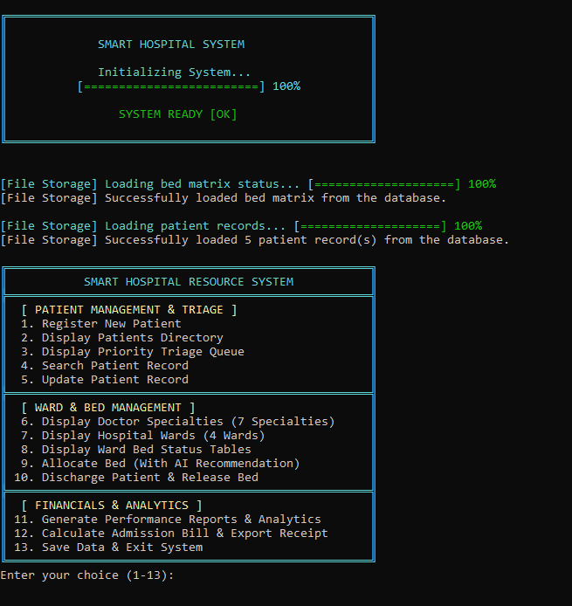 | WHAT IT SHOWS  - Animated splash screen with a progress bar.  - Saved bed matrix and patient records are loaded from disk (5 patient records restored).  - The 13-option main menu, grouped into Patient Management & Triage, Ward & Bed Management and Financials & Analytics.

Figure 2 · Patient registration (option 1)
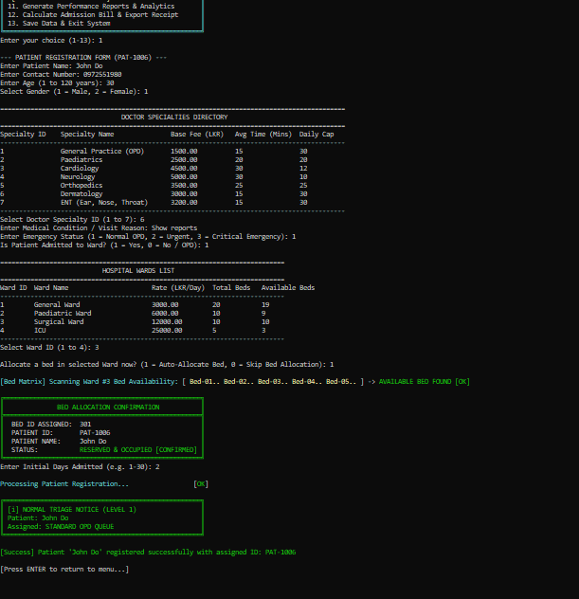 | WHAT IT SHOWS  - Intake form: name, contact number, age and gender.  - Specialty and ward directories are shown so the user can choose.  - Auto-allocation finds a free bed (301) and shows a confirmation box.  - Triage notice and a success message with the new ID, PAT-1006.

Figure 3 · Patients directory (option 2)
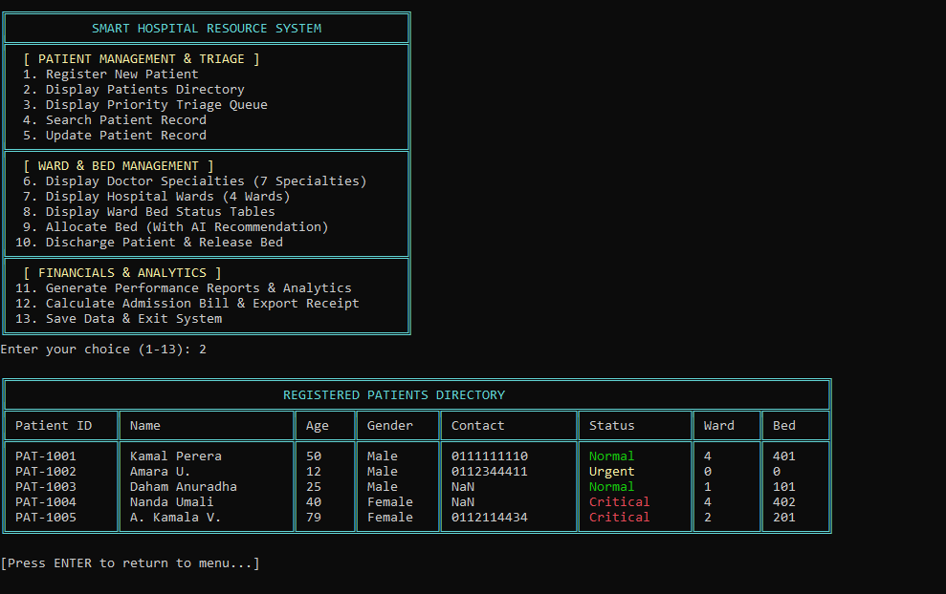 | WHAT IT SHOWS  - All registered patients in registration order.  - Columns: patient ID, name, age, gender, contact, status, ward and bed.  - The status is colour-coded (Normal, Urgent, Critical).  - Outpatients show ward 0 and bed 0.

Figure 4 · Priority triage queue (option 3)
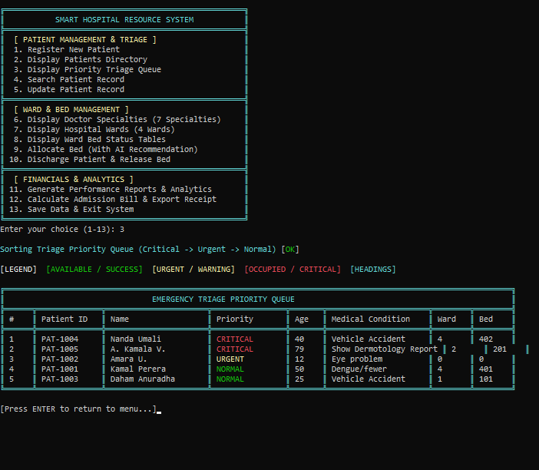 | WHAT IT SHOWS  - A sorting animation orders the queue Critical, Urgent, Normal.  - A colour legend explains the status colours.  - The table lists rank, patient, priority, age, medical condition, ward and bed.  - Critical patients come first; patients of equal priority keep their registration order.

Figure 5 · Performance reports and analytics (option 11)
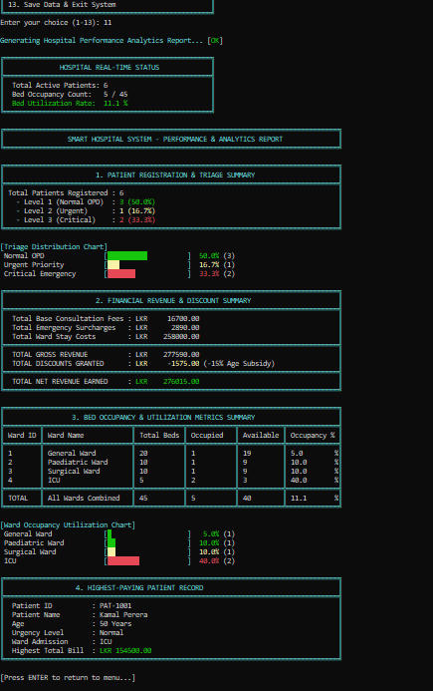 | WHAT IT SHOWS  - Real-time status: 6 active patients, 5 of 45 beds occupied (11.1 %).  - Triage summary with a colour-coded distribution chart.  - Revenue summary: gross revenue, age-subsidy discounts and net revenue in LKR.  - Bed occupancy table and utilisation chart for each ward.  - Highest-paying patient record.

Figure 6 · Bill calculation and receipt export (option 12)
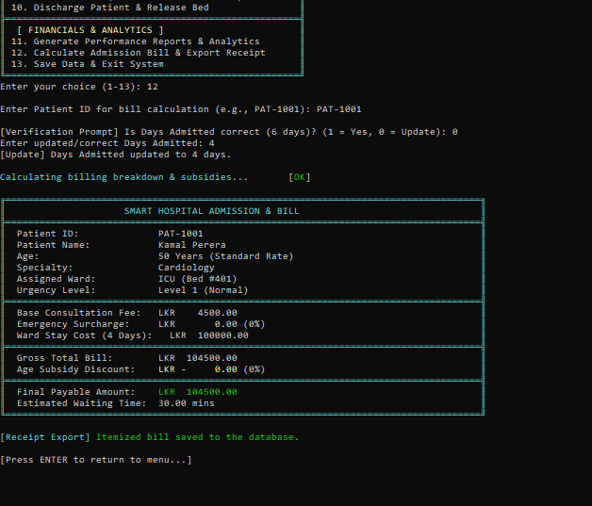 | WHAT IT SHOWS  - Days Admitted is verified and can be corrected (6 updated to 4 days).  - Itemised bill: base consultation fee, emergency surcharge and ward stay cost.  - Age subsidy discount and the final payable amount.  - The receipt is exported to a text file.

10.4 Project Details
Project title | Smart Hospital & Resource Allocation System
Language | C (C99 / C11)
IDE | Code::Blocks (v20.03 or later recommended)
Version control | GitHub
Operating system | Windows 10 / 11 (also Linux and macOS)
Repository branch | main (default), with feature branches

11 Challenges Faced
As a first-year student building a multi-file C program, I met the following challenges:
Challenge | How I overcame it
Handling keyboard input safely | Leftover characters in the input buffer skipped prompts and bad input caused loops. I wrote clearInputBuffer, readIntBounded and readStringNonEmpty and used them everywhere.
Keeping patient and bed data consistent | A patient stores a ward and bed ID while the bed stores the patient ID. I updated both sides in one function when allocating or releasing a bed, and also updated the ward's free-bed counter.
Saving and loading text files | Names and conditions contain spaces, so I used semicolons as separators and strtok to read them back, and loaded the beds before the patients so ward counters stay correct.
Sorting the triage queue | Sorting the main array would have destroyed the registration order, so I sorted a temporary copy with a stable bubble sort.
Showing colours on the Windows console | ANSI colours did not appear by default, so I enabled virtual-terminal mode in enableVTMode and used conditional compilation for platform differences.
Learning Git and managing time | This was my first project with GitHub. Working module by module with regular commits made progress easy to track and deadlines easier to manage.

What I learned. The project strengthened my understanding of structs, arrays, pointers, functions, file handling and modular design in C, and showed me the value of planning, testing in small steps and using version control.

12 System Requirements
The application is a pure command-line program that needs only a C compiler and a terminal.
Language and standard | C, C99 / C11 compliant (ANSI C standard)
Compiler | GCC 4.8+, MinGW-w64, Clang 3.8+ or MSVC 2017+
IDE / tools | Code::Blocks v20.03 or later, recommended with GCC / MinGW; or a command-line terminal (PowerShell, Bash, CMD)
Operating system | Windows 10 / 11, Linux or macOS
Target binary | Pure CLI console application
Terminal | ANSI VT100 Virtual Terminal colour support (UTF-8 for box-drawing characters)
Storage | Read / write access to the local ./data/ directory (patient_records.txt, beds_status.txt); billing receipts are written to data/receipts/
Hardware | No special hardware; about 20 KB of static data at run time

Standard C library dependencies (built in, no external libraries)
Header | Used for | Functions used
stdio.h | Console and file I/O | printf, scanf, fgets, file I/O
stdlib.h | Process control and conversion | system, atoi
string.h | String manipulation | strcmp, strcpy, strlen, strtok, strcspn
ctype.h | Character classification | tolower

Build and run For Windows (PowerShell / Command Prompt):

# 1. Build (Compile all C files from src/ into bin/hospital_app.exe) gcc -Wall -std=c99 -I src src/*.c -o bin/hospital_app.exe
# 2. Run .\bin\hospital_app.exe

For Linux / macOS (Terminal):
# 1. Build gcc -Wall -std=c99 -I src src/*.c -o hospital
# 2. Run ./hospital

