## Assignment 5 - Sprint 3

IS424

Group 7

Peer Evaluation System

Breydn Duckett, Olivia Lang, Diana Pena-Moreno, Kyle Wiesinger

### User Stories

1. As a student, I need the ability to see what courses I’m currently part of and what evaluations I’ve completed.
2. As a professor, I want the ability to edit my existing courses.
3. As a user, I want to be able to see who created the website and how to contact them.
4. As a student, I want the process of completing evaluations to be very simple and straightforward.
5. As a professor, I need to be able to view the individual student evaluations they submitted.
6. As a user, I need an easily navigable website.

### Tasks

1. Plan out the website pages
   1. Ensure the website pages (Student Profile, Professor Edit Survey, Team, Contact, and Professor View Individual Evaluations) are well thought out and include all the necessary features to complete the user stories. Each of these pages should be well designed, have functional features, and is easy to navigate for the users.
2. Create the Trello Board
   1. Next, the Trello Board should be created and updated daily to determine what needs to be done, what is currently being worked on, and what work has been completed. This will ensure that the team stays on track and allows us to visually see our progress and achievements.
3. Create the Burndown Chart
   1. The Burndown Chart should be completed next to have a graphical representation of how quickly the team is completing the user stories. This will also ensure that the effort expended matches up with the work being accomplished (essentially that the team is not wasting time and effort).
4. Code the website using Javascript, Python, or HTML
   1. The next step is to code the website. Using Javascript, Python, HTML, or a blend of the three, the coders will create the buttons, headers, text, and layout of the page. The team cannot move forward until the functional coding is done because the website has to be navigational for anyone who accesses the website. In addition, we expect the team to create prototypes, a login page, and profile pages for the website.
5. Upload code to Github
   1. Frequently uploading our code to Github will allow us to collaborate with other team members. We can ensure that we’re using the most up-to-date code from team members and avoid issues that might arise from storing files on our desktop and sharing via email or some other communication method.
6. Ensure the website is functional
   1. Third, the team will make sure that the website is functional. This means checking that the buttons work, the links lead to different pages, and that the correct audience can view and use the page that they need. If the website is not functional, there is no point in moving forward with design.
7. Add aesthetic design to the website using CSS
   1. Fourth, the aesthetics of the website will be created. This is important because it helps the user navigate the website and provides an interactive experience. Color, icons, and more can be added in this step so that the website is modern and pleasing to the eye.
8. Ensure the website still works with added design
   1. Finally, all of the coding needs to be checked to make sure that the website works with the added design elements. Sometimes, adding design accidentally disables a button and these changes need to be addressed quickly for the user experience.

Trello Board Link

<https://trello.com/invite/b/u70JSMdZ/b9a9c23895d67ec0c2db076862f15ee1/peer-evaluation-system-sprint-3>

Burndown Chart

Scrum Master: Kyle

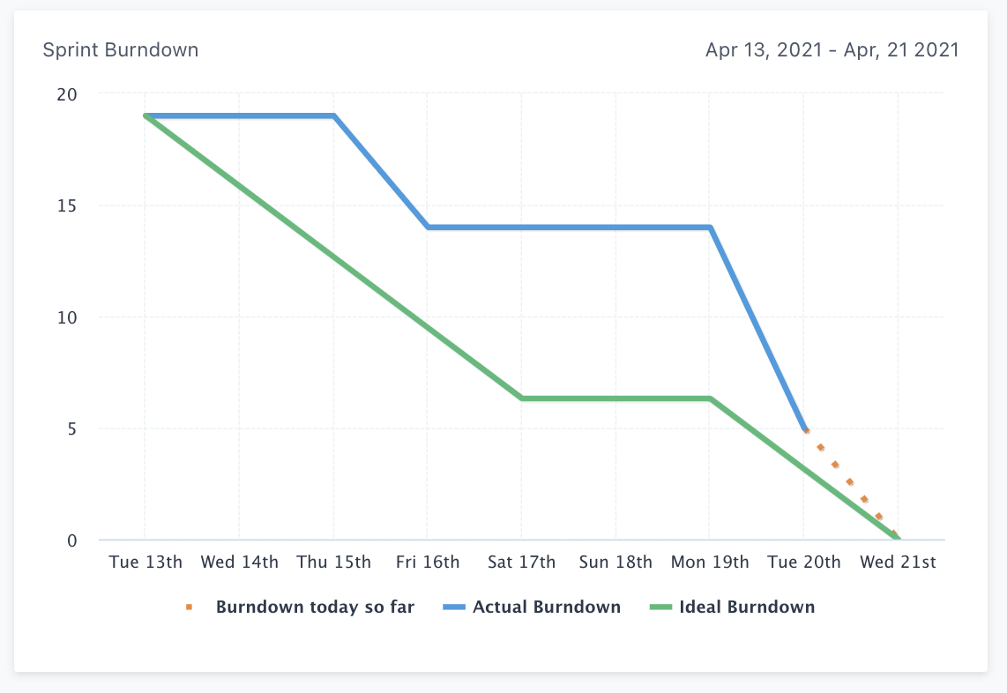

GitHub Repo Link

<https://github.com/kwiess/PeerEvaluationSystem>

Meeting Evidence #1

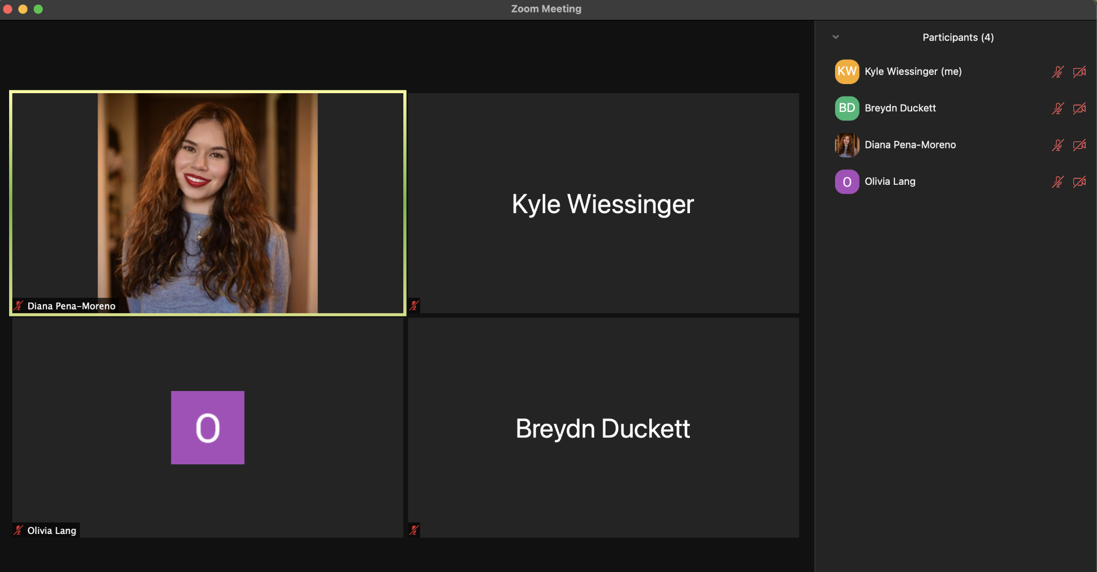

What did you do yesterday?

* Breydn: completed some work on a couple pages for the website
* Diana: Worked on some pages for the website
* Kyle: I updated the Trello Board and Burndown Charts
* Olivia: began coding for additional websites pages

What are you planning to do today?

* Breydn: continue and finish coding the website pages
* Diana: Continue coding pages for the website
* Kyle: code some pages for the website
* Olivia: continue working on coding

Any problems you are facing?

* Breydn: none so far
* Diana: no issues
* Kyle: no problems
* Olivia: none

Meeting Evidence #2

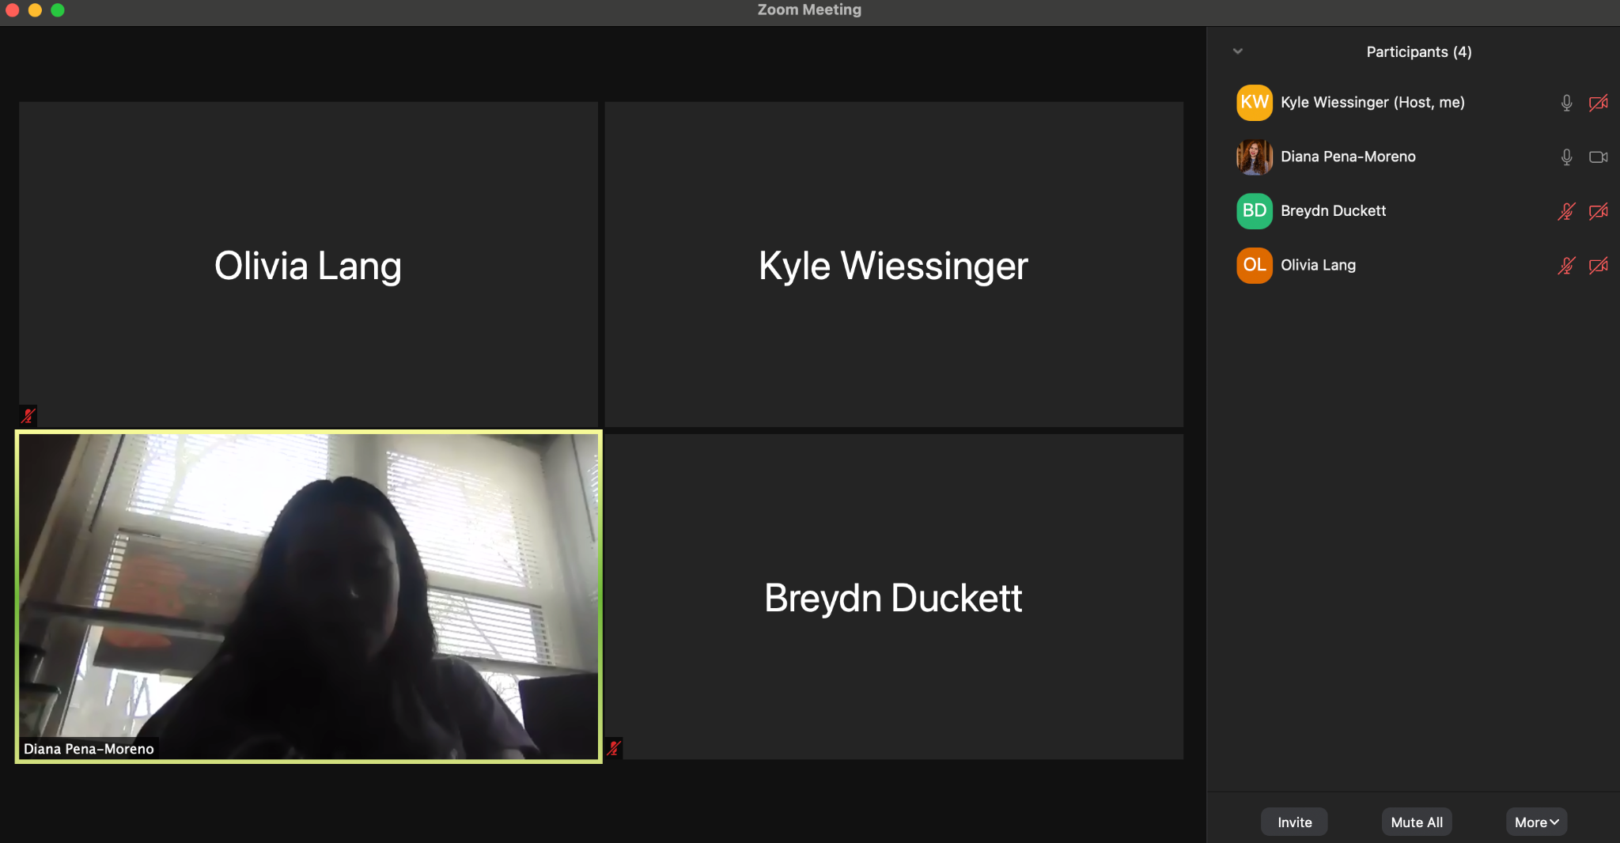

What did you do yesterday?

* Breydn: finished preparing database for php
* Diana: worked on coding pages
* Kyle: began coding PHP
* Olivia: Finished coding all my additional html pages

What are you planning to do today?

* Breydn: try to begin coding with PHP
* Diana: working on pages
* Kyle: continue coding with PHP
* Olivia: Look into coding with PHP

Any problems you are facing?

* Breydn: Not much experience with PHP
* Diana: unfamiliar with a lot of coding so it takes a long time to do tasks
* Kyle: I’ve never used PHP before so I don’t really know what I’m doing
* Olivia: minimal experience with PHP

### Sprint Review:

a. What did you learn from doing our third sprint?

* We learned how to better organize our team and schedule/progress. Our team also learned about coding (html, php, css) because this is something fairly new to us.

b. What did go well? Why?

* We were able to complete all the tasks on time. Our team members collaborated more than in previous sprints and our final deliverable is starting to come together.

c. What didn’t go well? Why not?

* The coding was more difficult and time consuming than we originally expected. Some of the prototypes weren’t fully thought out and didn’t match what we’re doing with the coding.

d. How can you make things better next time?

* Balance out the team’s skill by recruiting someone who can code to help other team members
* Start earlier on the coding so we have more time to teach ourselves what we’re doing.

e. Are you satisfied with what you already completed?

* Yes, we think the HTML portion of the website really came together considering we don’t have much experience with coding.

f. Which group was invited? Everybody was present?

* Group 8. Everyone was present.

