FlightGear with APM:SITL
Downloading, installing and running.

Prerequisites:
- SITL installed and working on an Ubuntu machine.
Instructions to do that can be found here: http://www.rcgroups.com/forums/showpost.php?p=28711757&postcount=2
- A high speed internet connection

So, you've gotten APM.SITL installed and running and maybe got a flight or two done.
You may also have noticed that unless you are a developer, there's actually not much fun you can do with it.

Luckily, there is a way to connect a flight simulator to see what happens in SITL.
The simulator used is Flightgear, an open-source flightsimulator. (www.flightgear.org)
At the time of writing this, (July 2014) the FlightGear version is 3.0.0

How-to:

- Download and install FlightGear

Start your Ubuntu machine.
Open a terminal

Type: sudo apt-get install flightgear [enter]
enter your password and answer “Y” if asked
Flight is now downloaded and installed. It will take a long time. (~20 minutes, depending on your link speed and computer.)
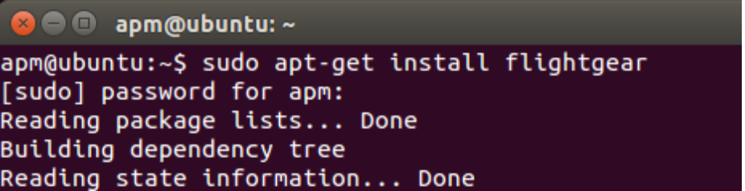

(You can do the following while you wait for the FlightGear installation.)

Open a file manager:
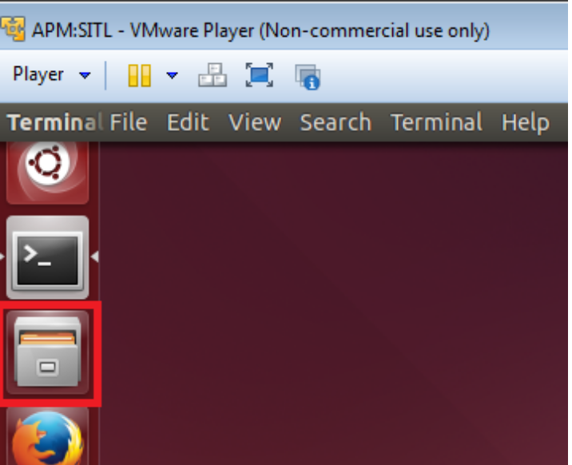
Browse to Home/ardupilot/Tools/autotest
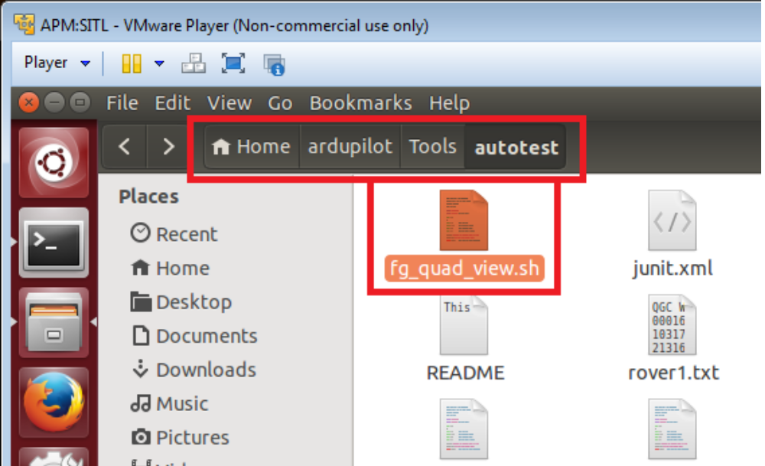
Right-click on the file: fg_quad_view.sh
Select “Open with gedit”

Find and delete the two lines:
--disable-intro-music \
and
--disable-skyblend \
fg_quad_view.sh should now look like this:
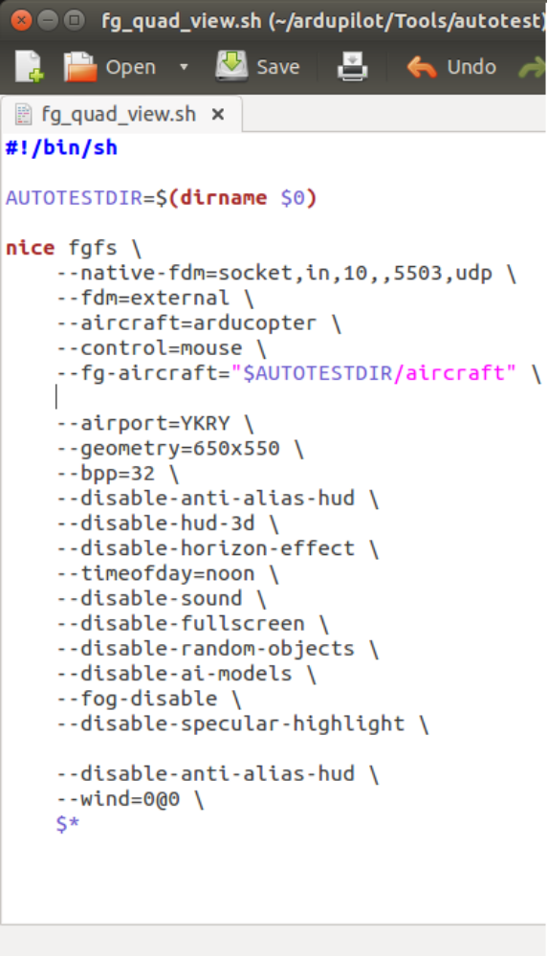
Save and exit.

When the FlightGear installation has finished you are ready to test.

There are two ways to start FlightGear with SITL, either manually, or automatically.
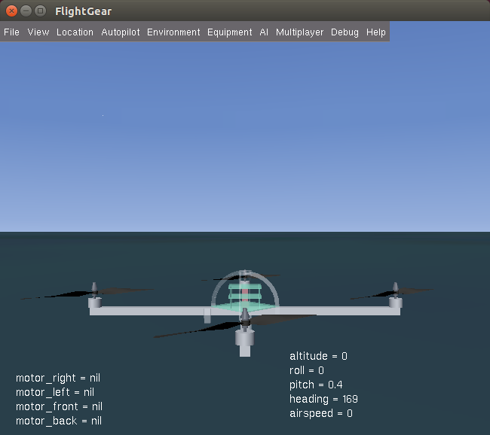
The manual way requires that you open two terminals
The automatic way requires that you edit one file per vehicle. (Copter and Plane)

The manual way:
- For Copter
Open a terminal:
Type: cd ardupilot/Tools/autotest [enter]
./fg_quad_view [enter]

FlightGear will now start.
Wait for it to start. You will see the Copter from the cockpit view when it's ready.

Open a second terminal
Type: ./sitl_install [enter]
2 [enter]

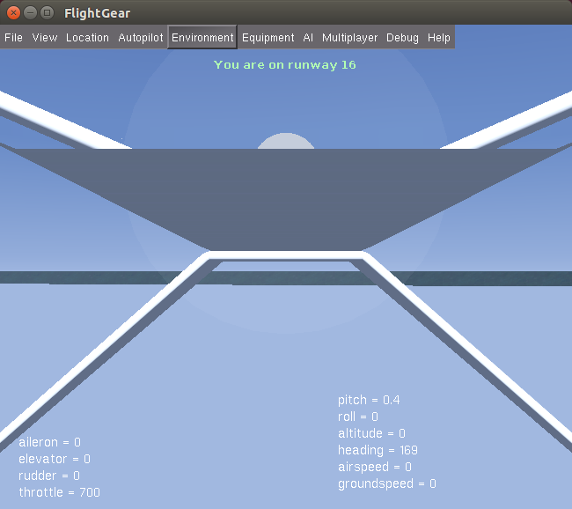
SITL-Copter will now start.

- For Plane
Open a terminal:
Type: cd ardupilot/Tools/autotest [enter]
./fg_plane_view [enter]

FlightGear will now start.
Wait for it to start. You will see the Plane from the cockpit view when it's ready.

Open a second terminal
Type: ./sitl_install [enter]
3 [enter]

SITL-Plane will now start.

The automatic way:
(This only works for some people. If FlightGear hangs with the text “Loading Scenery”, you'll need to use the Manual way, as described above.)
The two files you need to edit are in your “Home”-directory.
The easiest way to do this is by opening a file browser, navigate to “Home”, right-click the file, select “open with gedit”
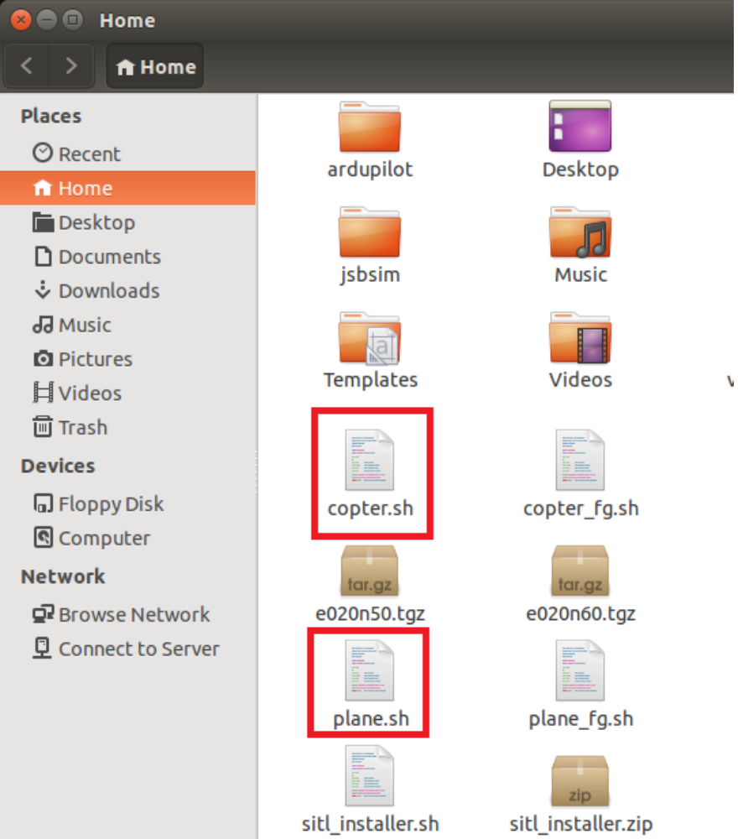
- For copter

Edit the file copter.sh by adding the following lines, below the text “#! /bin/bash”

cd
cd ardupilot/Tools/autotest
./fg_quad_view.sh &

Making your file look like this:

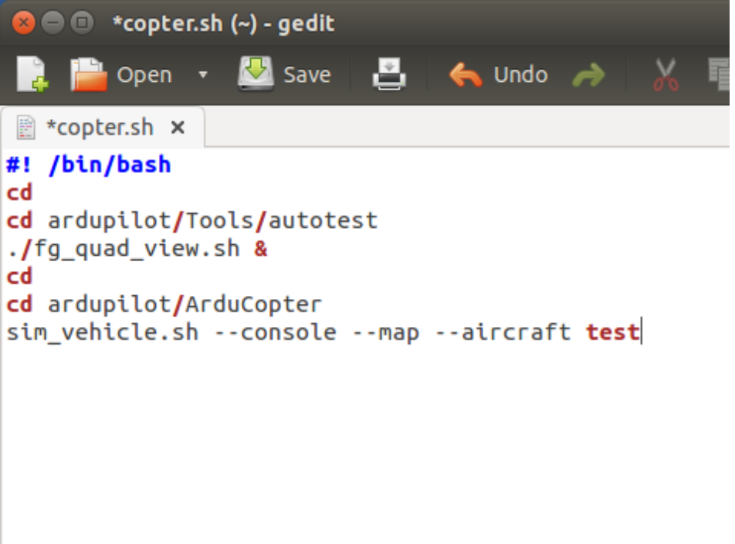

Save and exit.
Start SITL the usual way, and watch the magic as FlightGear shows you what SITL is doing.

- For Plane

Edit the file plane.sh by adding the following lines, below the text “#! /bin/bash”

cd
cd ardupilot/Tools/autotest
./fg_plane_view.sh &

Making your file look like this:

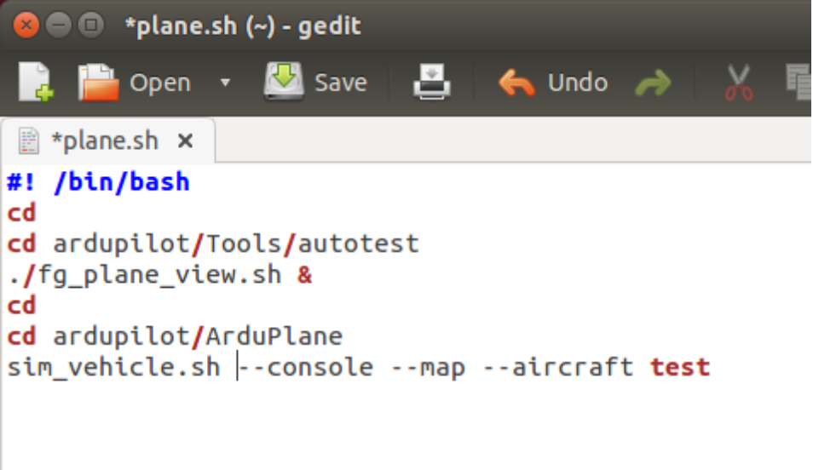

Start SITL the usual way.

