Using the SITL Launcher/Installer
By JNJO with massive help from TheQuestor and bionicbone.
Special Thanks to all Ardupilot developers that made this possible.

The SITL Launcher/Installer was written by RCG User “TheQuestor” as an easy to use method of getting the APM:SITL installed and launched.
The installer used in this guide is “sitl_installer_2.0”
The installer might be updated with a new version number, but this guide will not be updated with new screenshots, unless it's necessary.

Prerequisites:

A high speed Internet connection

Ubuntu 14.04 installed, either as your main operating system, or as a virtual machine in MS Windows.

See the guide “SITL_Ubuntu_Installation_v1.0”, for details on how to set up a virtual Ubuntu machine using Vmware.

That guide can be downloaded from:
http://www.rcgroups.com/forums/showpost.php?p=28711757&postcount=2

Start Ubuntu and log on.
Open Firefox (In ubuntu)
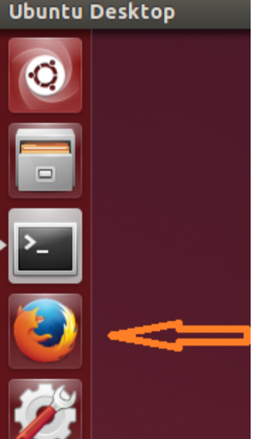
Paste the following link in the Firefox adress field. http://www.rcgroups.com/forums/showpost.php?p=28711757&postcount=2 [enter]
Download the file “sitl_launcher_2.0.zip” from that page.

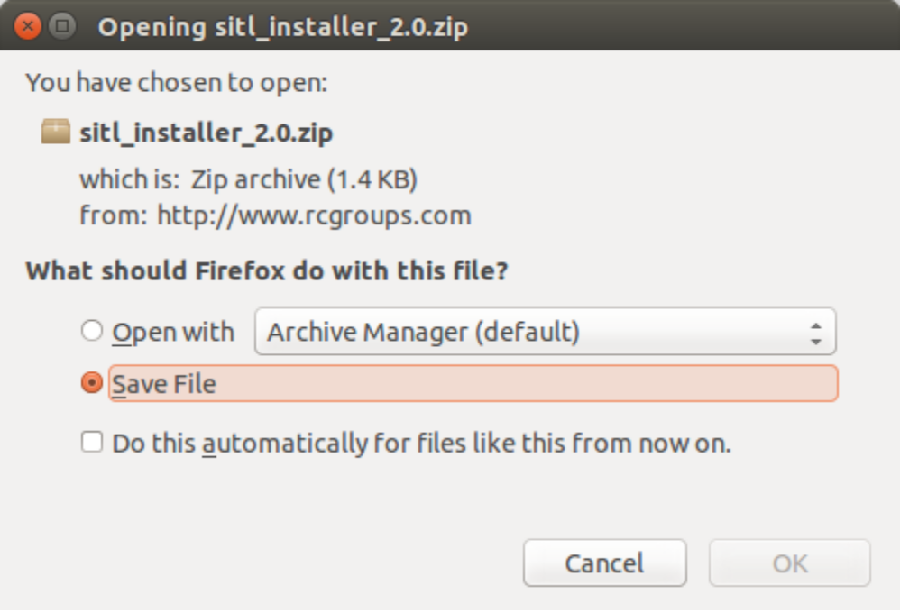

Press the down-arrow in the top right corner in Firefox, the the little folder icon in the drop-down list.
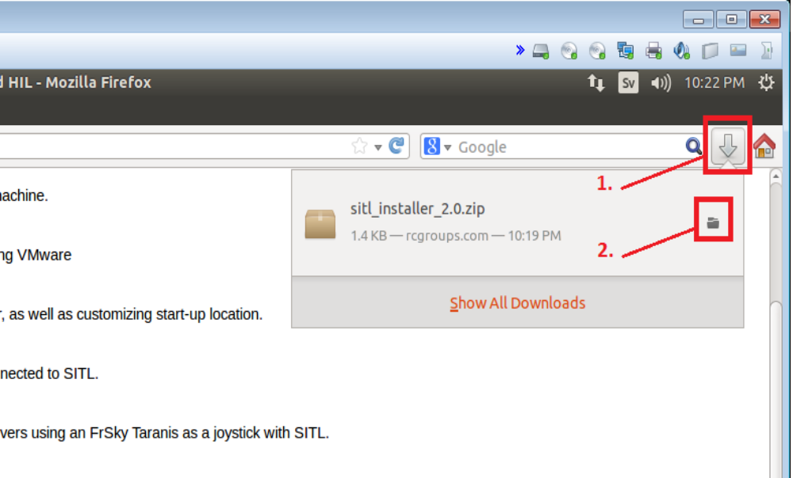

Double-click on the file sitl_launcher_installer.zip
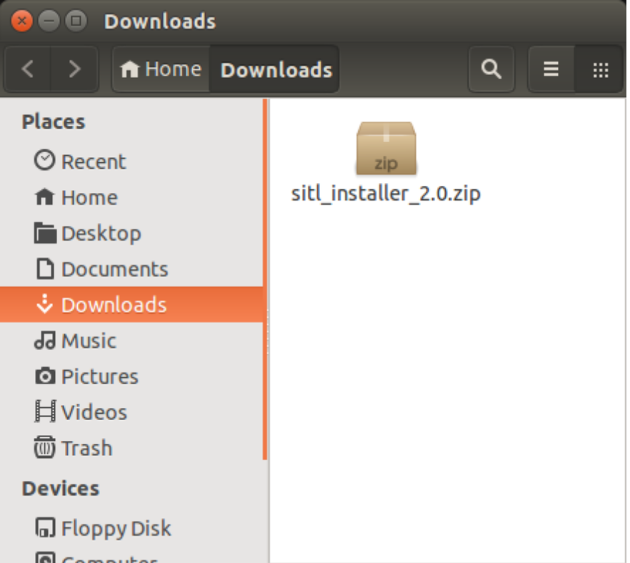

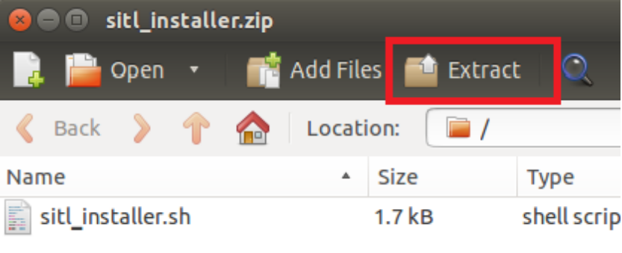
Extract the file “sitl_installer_2.0.sh” to your home directory

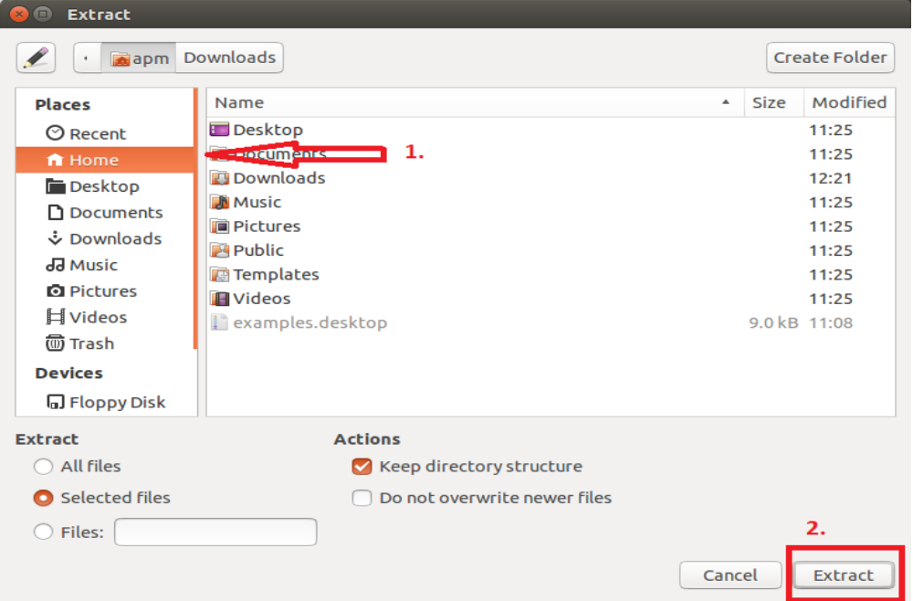

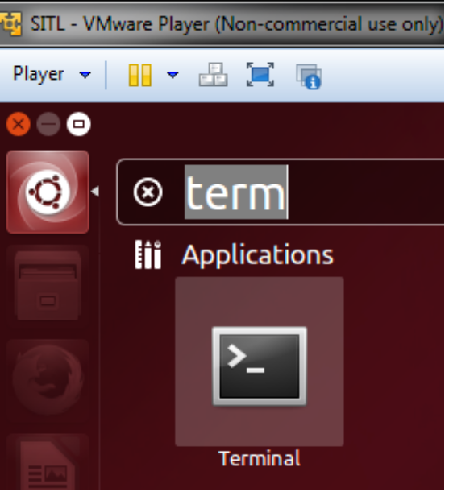
Open a terminal.

(Useful hint: You can drag the Terminal Icon to the where the other icons are, to give you quicker access to it.)

Type (or copy/paste this text) sudo apt-get install dos2unix [enter]
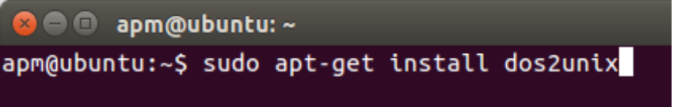
Enter your password.
Wait for the installer to finish.
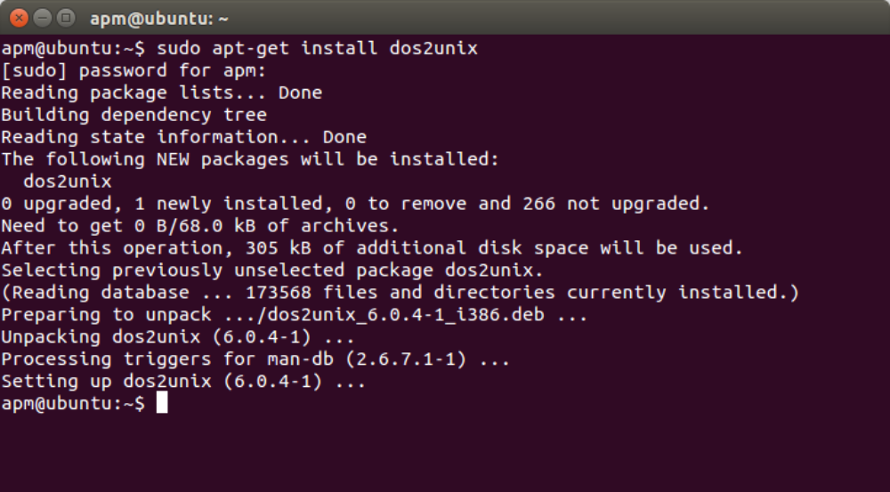
Type: dos2unix sitl_installer_2.0.sh [enter]
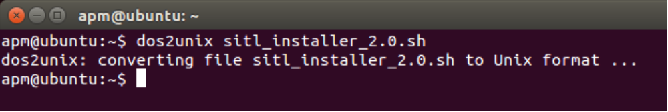

Type: chmod +x sitl_installer_2.0.sh [enter]'
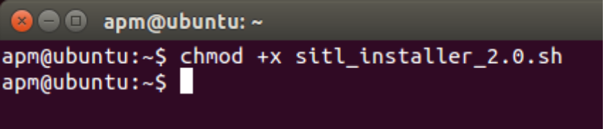

Type: ./sitl_installer_2.0.sh [enter]
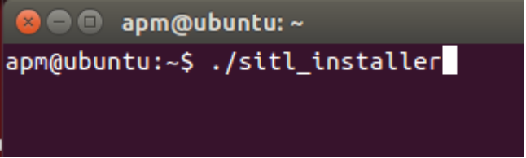
You will see this window:
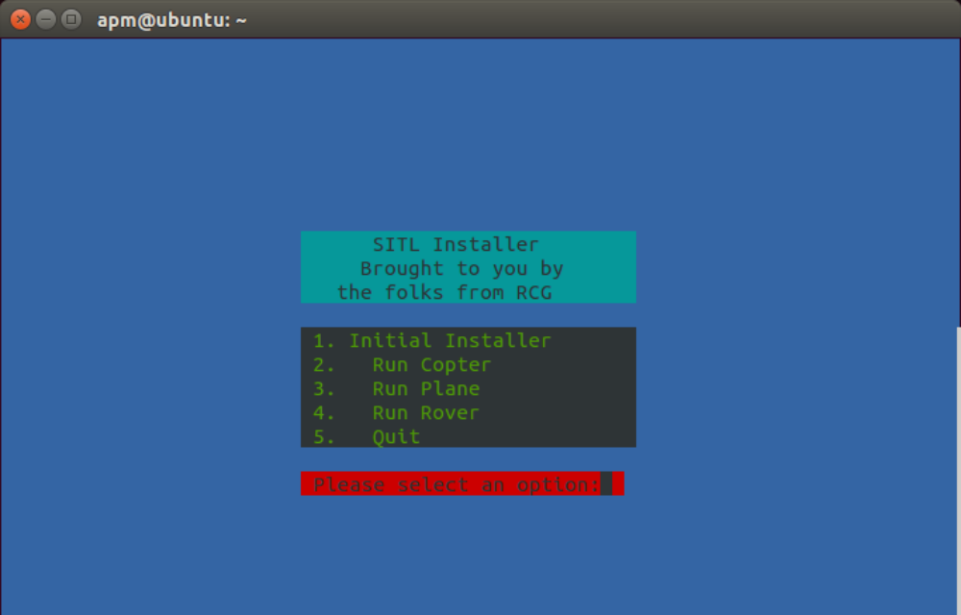

Option 1: Will install everything you need to run the basic SITL-simulation
Option 2: Will start SITL-Copter once the installation is finished
Option 3: Will start SITL-Plane once the installation is finished
Option 4: Will start SITL-Rover once the installation is finished
Option 5: Does exactly what is says it does....

To install SITL, press 1 [enter]
Enter your password [enter]

Your terminal will look like this, while it's downloading and installing several programs for a good while: (> 20 minutes)
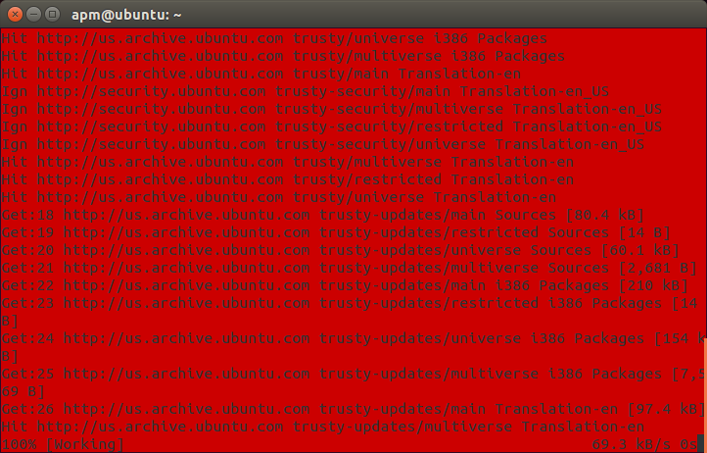
A few times through the installation, you will be promted a few times to answer “y” if you wish to continue. Just type y [enter] every time.

When it's finished, you will be prompted to restart your Ubuntu machine.
Please do so, to make everything work.

When the installation is finished, the terminal will look like this:
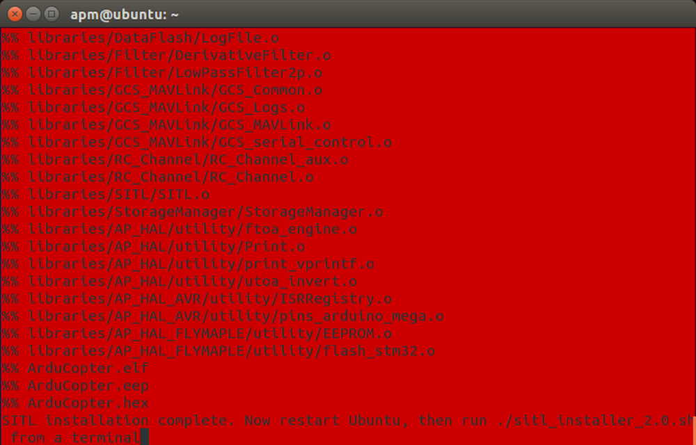
Once Ubuntu has restarted, open a terminal and type: ./sitl_installer_2.0.sh [enter]

Type ./installer_sitl [enter] (arrow-up for latest command works too.)
This will open the launcher window.

Type: 2 [enter] to start SITL:Copter
Answer “y” on the question about resetting parameters to default the first time you run a vehicle. There is normally no need to load defaults after the first time.
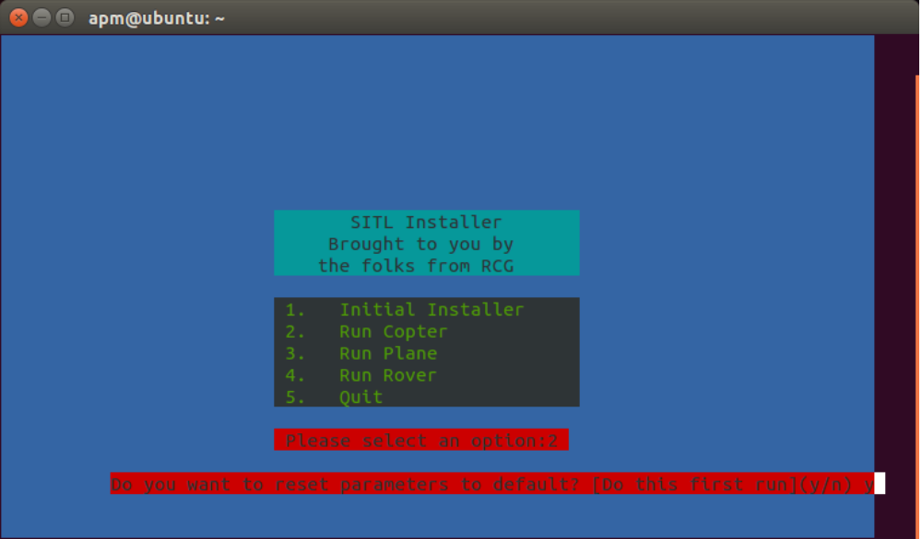

Eventually, SITL will start, showing you a console, a map and the terminal where you enter commands.
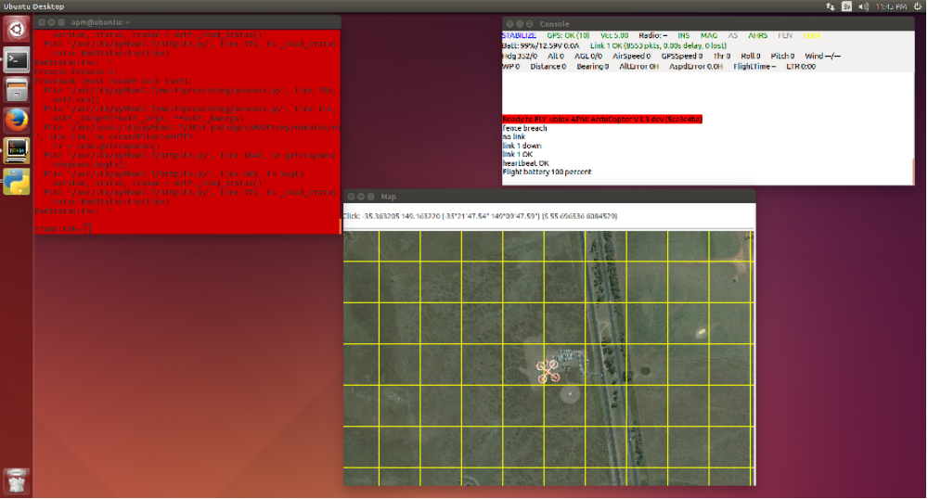

To get airborne; In terminal type:
arm throttle [enter] (Arms the copter)
rc 3 1700 [enter] (Sets throttle pwm in to 1700)
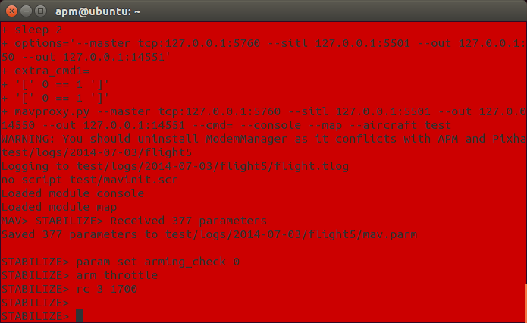

Watch the “Thr” and “Alt” values in the console.
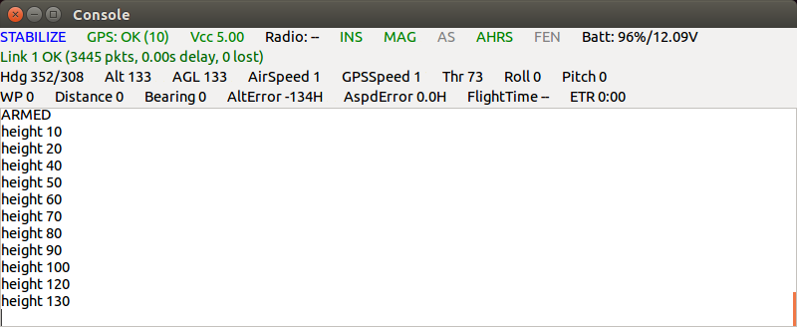
In the terminal, type: help [enter} to list a list of all commands.
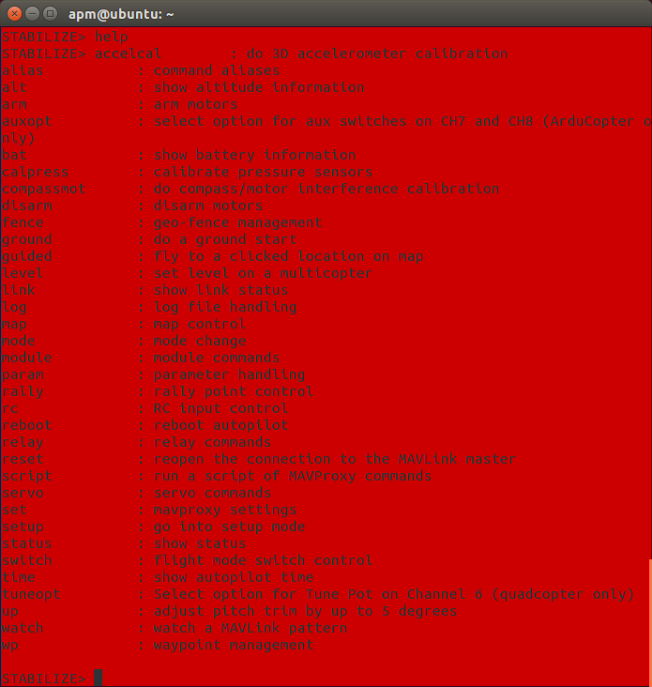

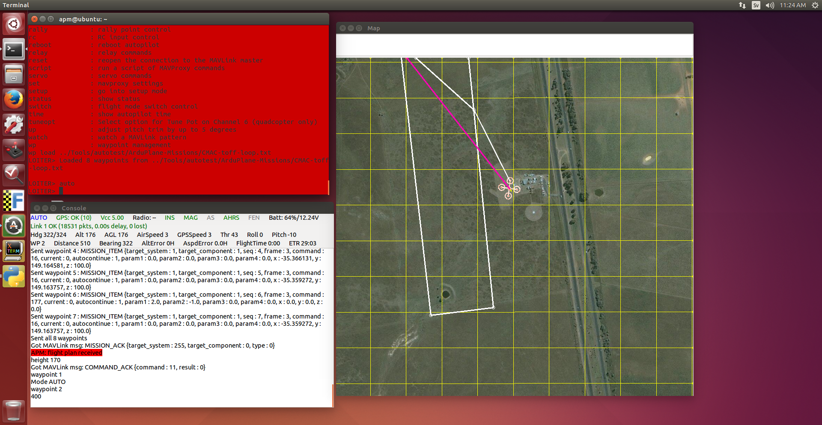
Load a missionfile by typing: wp load ../Tools/autotest/ArduPlane-Missions/CMAC-toff-loop.txt [enter]
Set the 'copter to Auto-mode and watch it fly the mission.
mode auto [enter]
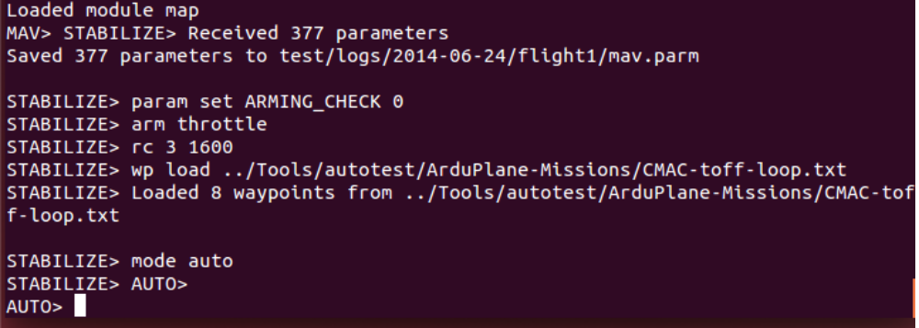
Good, huh? The simulation flies itself. :D

To get the most out of SITL, you really need to get to know MAVProxy.
MAVProxy documentation is here → http://tridge.github.io/MAVProxy/

Plenty fun can be had by connecting APMPlanner or MissionPlanner as well as a flight simulator, like FlightGear.
Also, a joystick, or even better, an FrSky Taranis, can be connected as a way of controlling SITL.
Guides for doing that can be found at:
http://www.rcgroups.com/forums/showthread.php?t=2190616

Have fun, and thanks to Tridge and the other Ardupilot developers for all their hard work on this code.

