A0

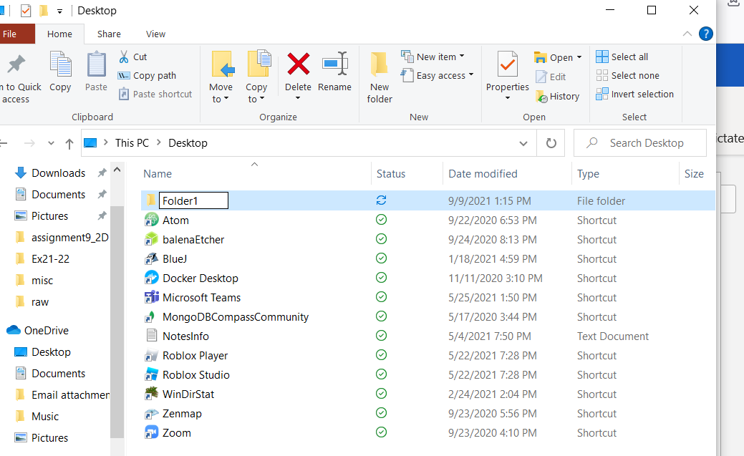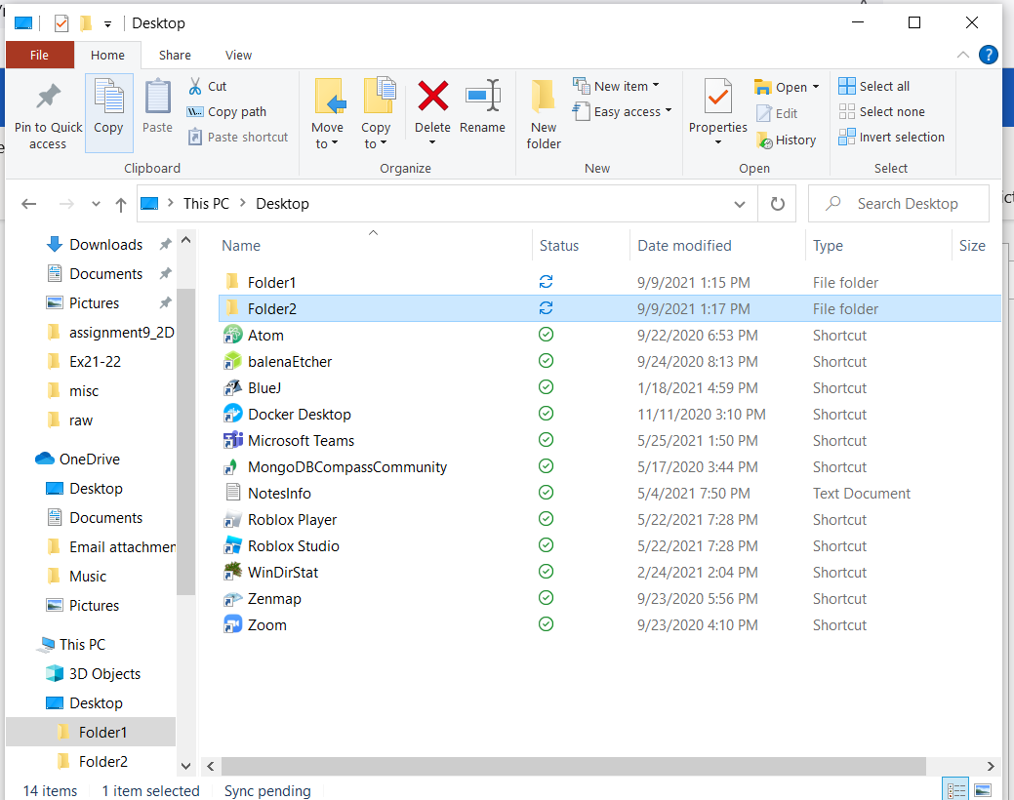

5. (a.)

Folder2 has disappeared from the view of desktop and has been moved inside of folder1.

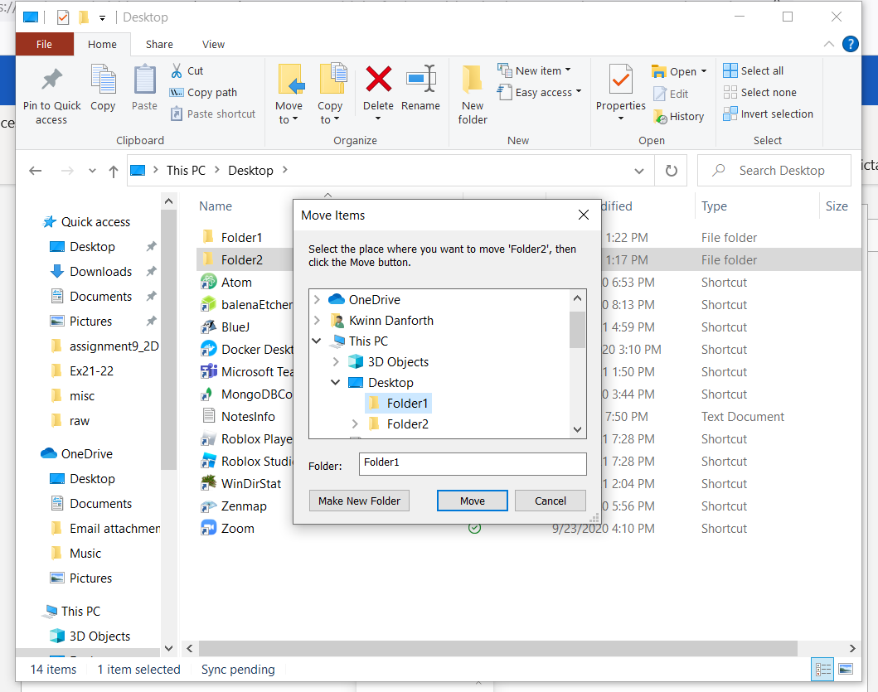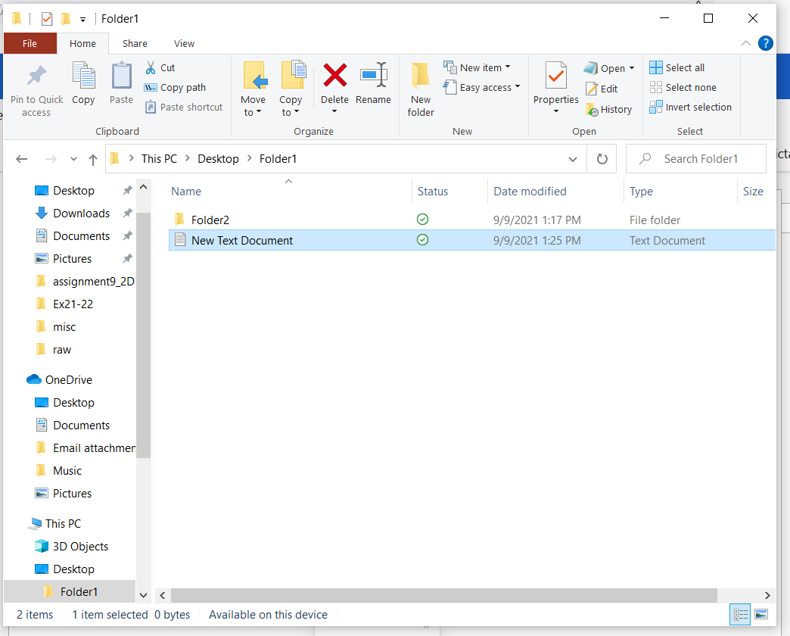

7. (a.)

.txt is the file extension for the text document.

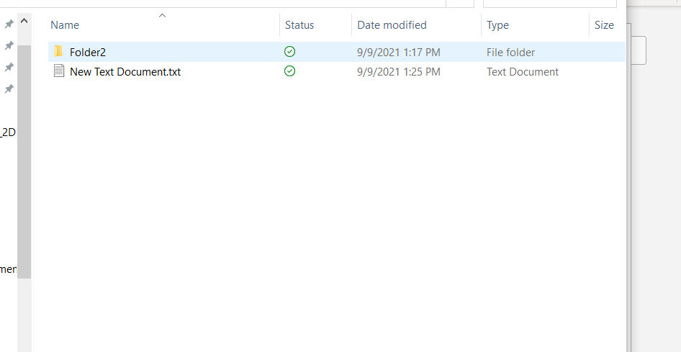

8. (a.)

I copied the text file into Folder2 by right clicking the document and selecting copy. Then I went into Folder2 right clicked and selected paste.

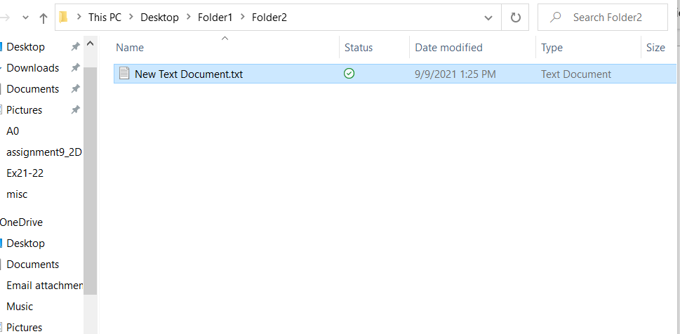

9. (a.)

The attribute AL is associated with this text file.

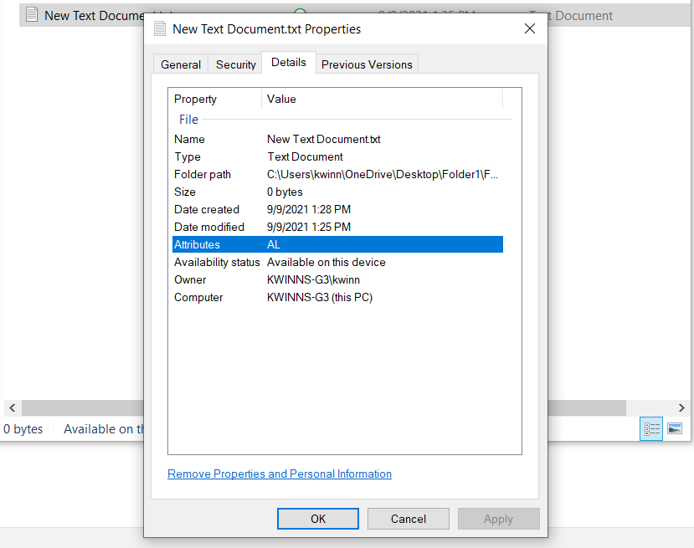

10. (a.)

‘C:\Users\kwinn\OneDrive\Desktop\Folder1\Folder2’, -> \Folder3 is the complete path to Folder3.

(b.)

? directories are listed under folders in windows 10. \*\*\*

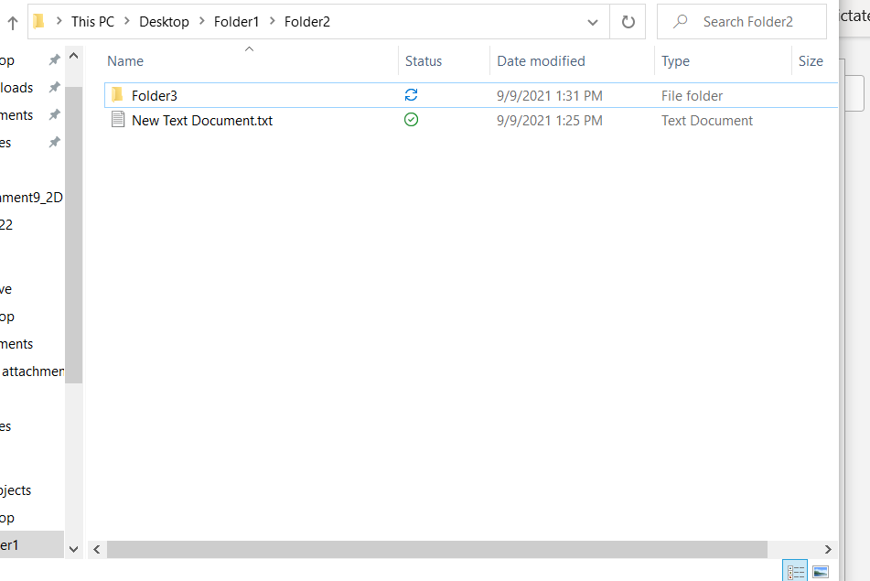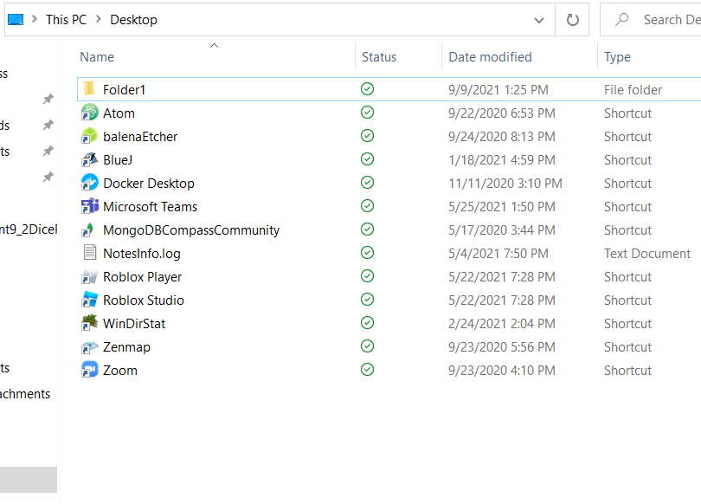

12. (a.)

Dragging and dropping Folder1 onto Quick Access pins Folder1 to Quick Access. Someone may want to do this with a folder that they want to be easier to find. It does not actually move or copy the folder. It just creates a link to where the folder is actually located.

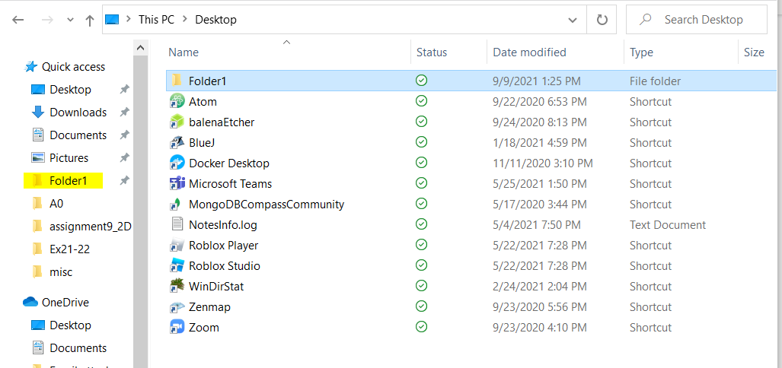

13. (a.)

$WINDOWS$, $Windows.~WS, $WinREAgent, Apps, Dell, Downloads, Drivers, ESD, GitHub, Intel, Microsoft, misc, OneDriveTemp, perfLogs, Program Files, Program Files (X86), ProgramData, Python 3.8, Recovery, Users, Windows, ZoomRecord are the folders listed in the Local Disk (C: ).

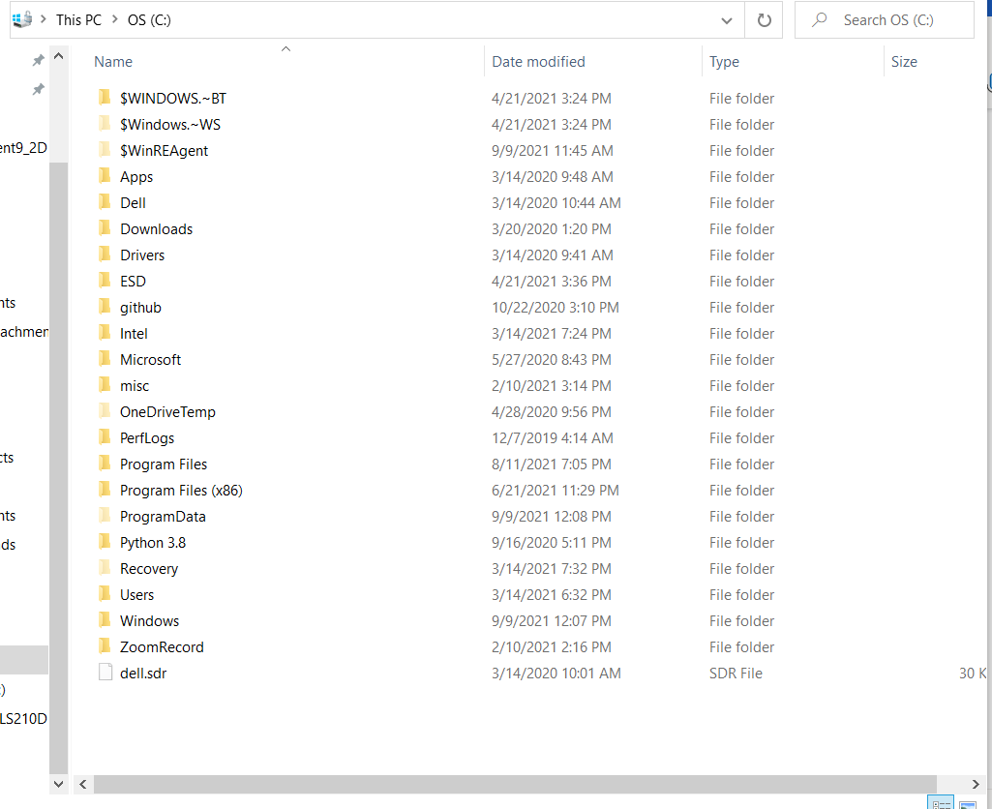

14.

Default, Kwinn, Public

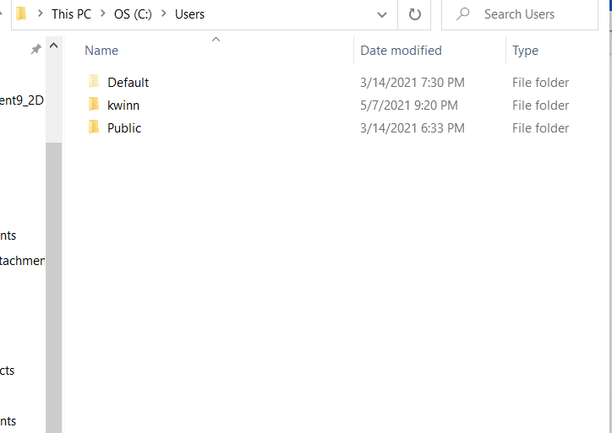

15.(a.)

Yes, I was able to open the folder associated with my username. I was able to open it because I have Full Control permissions for this folder including Read & execute.

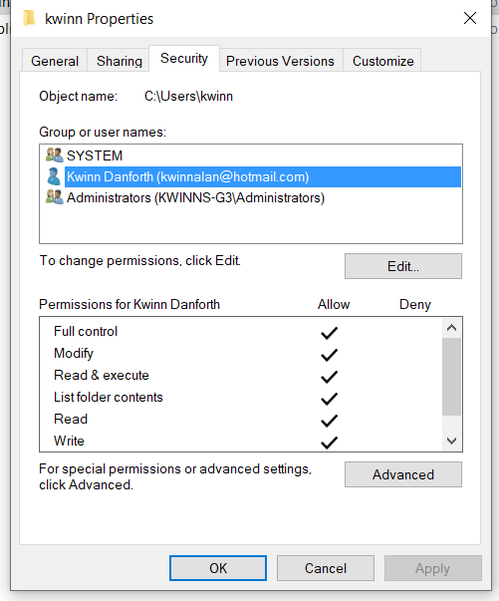

16.(a.)

Yes, I was able to open the folder in the User directory named Default (the only one that wasn’t mine or public). I was able to open it because Everyone has the Read & execute permissions on this folder. I figure if I did have another user with their own folder in the User directory, I may not be able to access it if I do not have the proper permissions to said User folder.

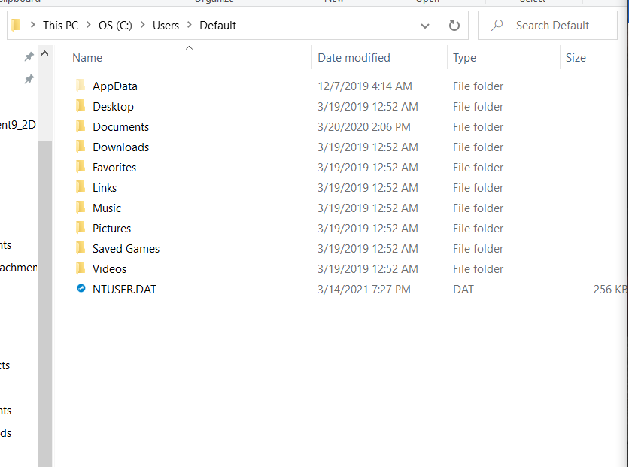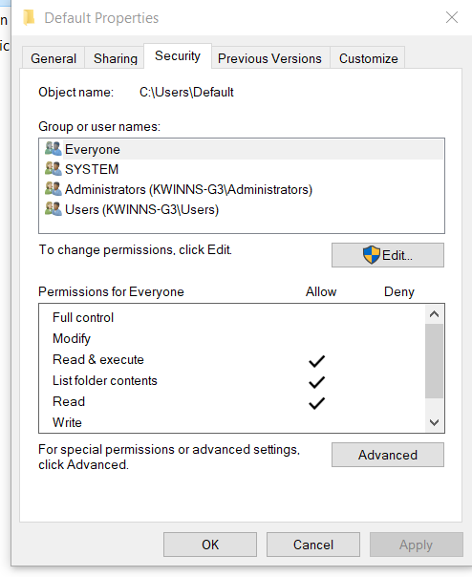

17.(a.)

Libraries, Public Account Pictures, Public Desktop, Public Downloads, Public Music, Public Pictures, Public Videos are all the folders in the User/Public directory.

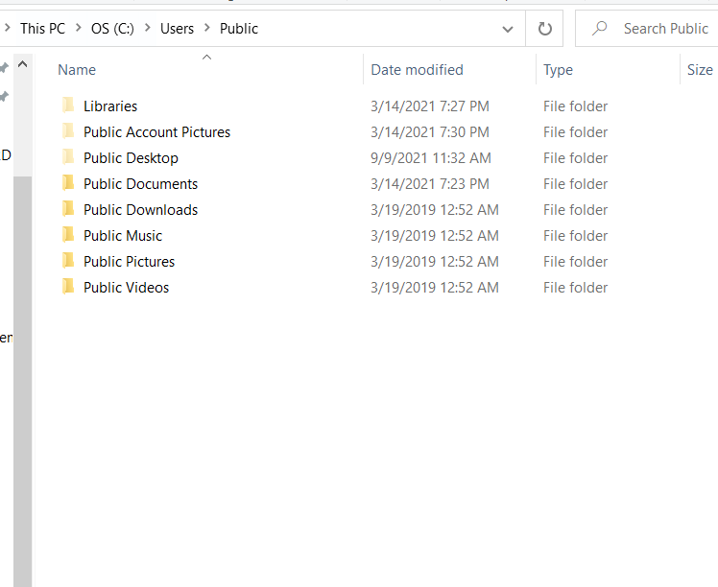

20.(a.)

Documents, Music, Pictures, Videos are the folders listed under the libraries heading.

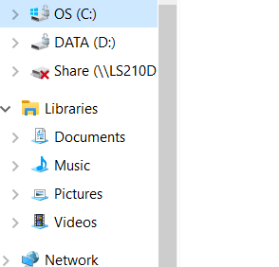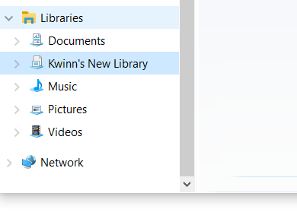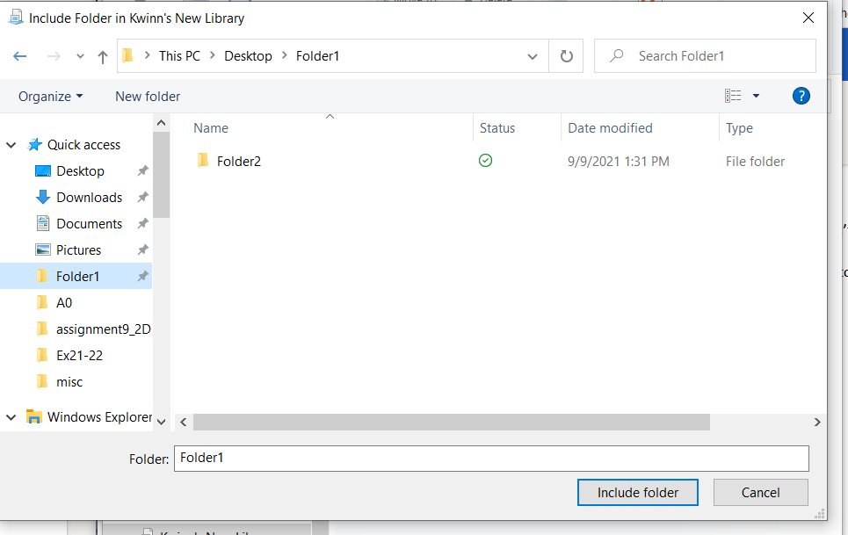

23.(a.)

You would remove Folder1 from the Library by going into library tools and selecting Manage library. Then click the folder you want to remove (Folder1) and click remove.

