Assignment 8 Part A

Using rsync to transfer files to and from a Remote Machine

CIS 140

NCMC

Kwinn Danforth

First, we will need to install rsync on our local machine. After downloading the compressed rsync package it must be unpacked. Below we must use two commands to unpack the two levels of compression. Zstd first and then tar after as seen below.

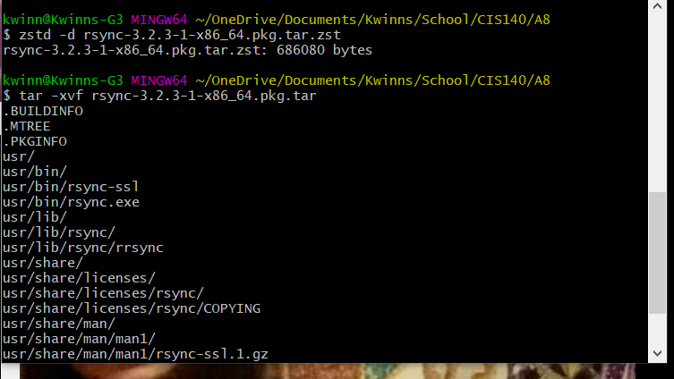

Now that we have our rsync.exe file we need to move it to Git/usr/bin/ seen below.

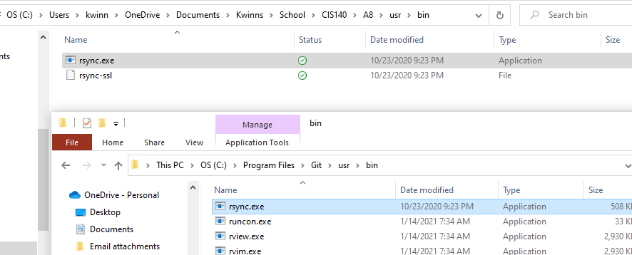

Next, we need to download and unpack the dependencies rsync needs to work in the same two step manner as before. See below.

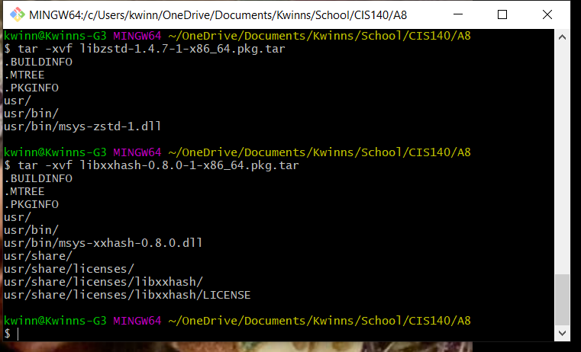

Below you can see we need to also copy these dependencies to the Git/usr/bin/ directory on our local machine as well.

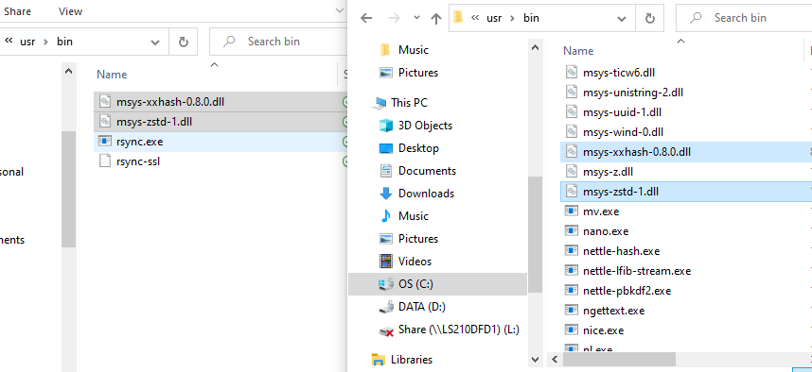

I checked and rsync was also already installed on the remote machine I am using. If it were not, it is a Rocky Linux machine so the yum command could easily download and install from the yum package manager repository.

Now that rsync is installed on both the remote and local machines we can use it from our git bash terminal on our local machine.

Below you can see how I used the rsync command to copy a file named Chapter17_Exercises.txt from the local machine to the remote one.

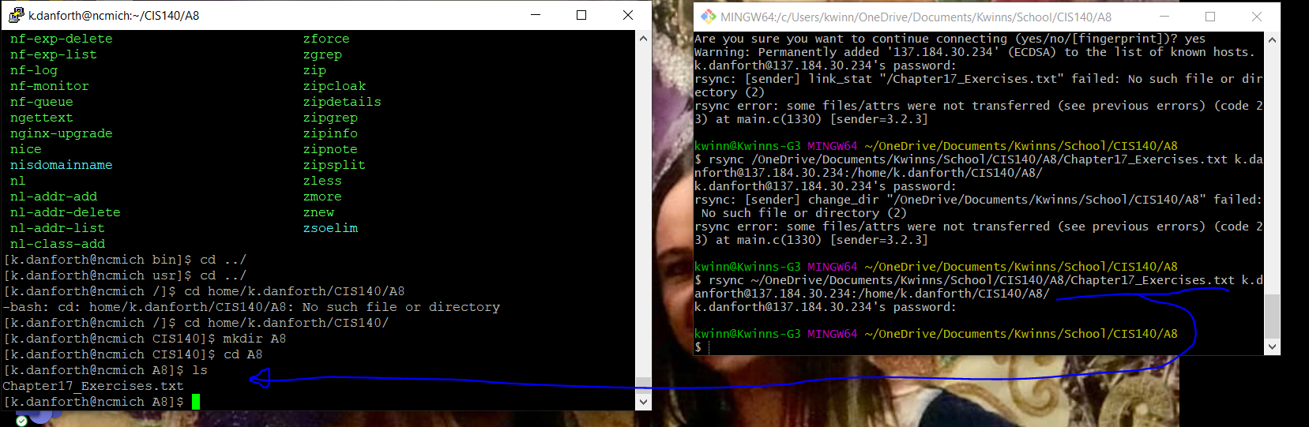

And at last, below you can see that using the rsync command from the GitBash terminal on my local machine we can copy the file named sendBackTest.txt from the remote machine onto the local machine.

