8.1

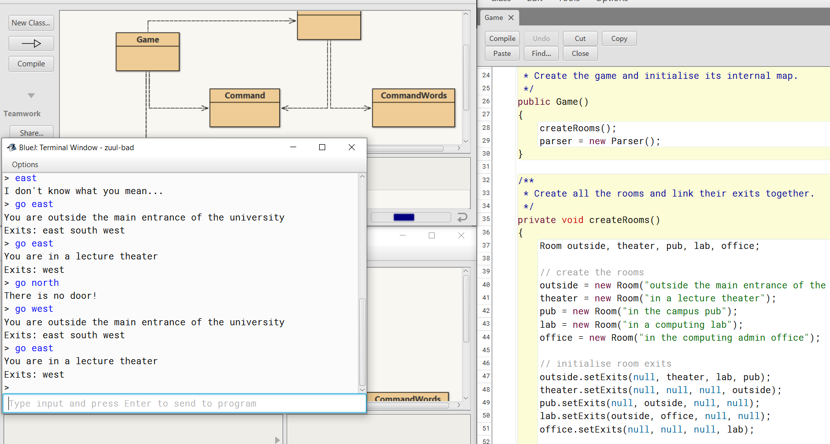

So, this zuul-bad application is an app that is supposed to be a very boring adventure game. Really what it does is describe a place where you are and allows you to choose which way to go next then it describes where you’re again. There are only a limited number of places to go and nothing else to do other than have them described to you.

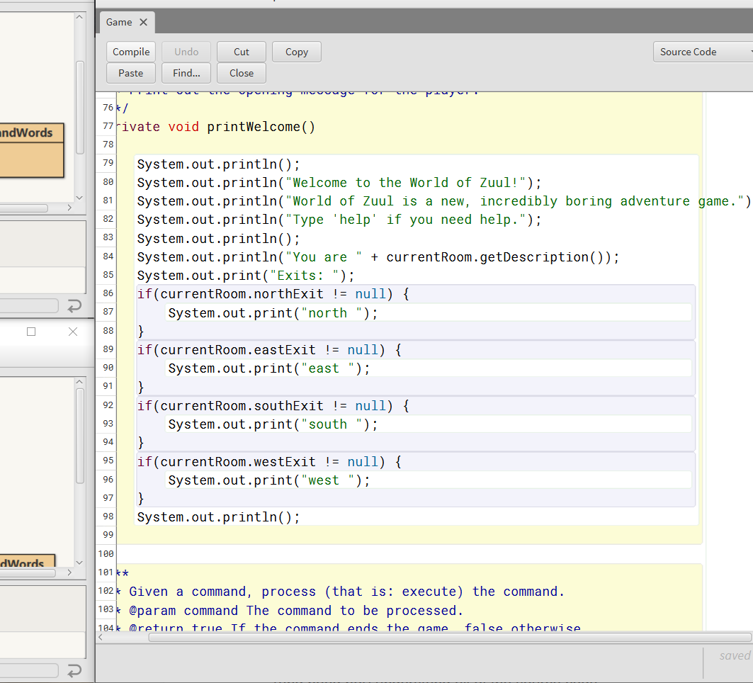

8.2

The first class we have in the zuul package is the Game class. This class creates an instance of the Game and has a method called play. The zuul package also has three other classes Command, CommandWords, Room and the Parser. The Command class holds two cords command word and second word. Command words them holds an array of three strings “go”, “help”, and “quit”. These are the valid command words this class also has a method to check a string to see if it is a command word. Room is the class that holds the location a definition of each area of the map. Parser class has a method that takes in user input and tries to interpret it as a zuul command word.

8.3

The game that I have thought of is a choose your own adventure story game. Where a user has some options and gets a different story depending on their choices. Another option I thought about is maybe a maze of some sort.

8.5

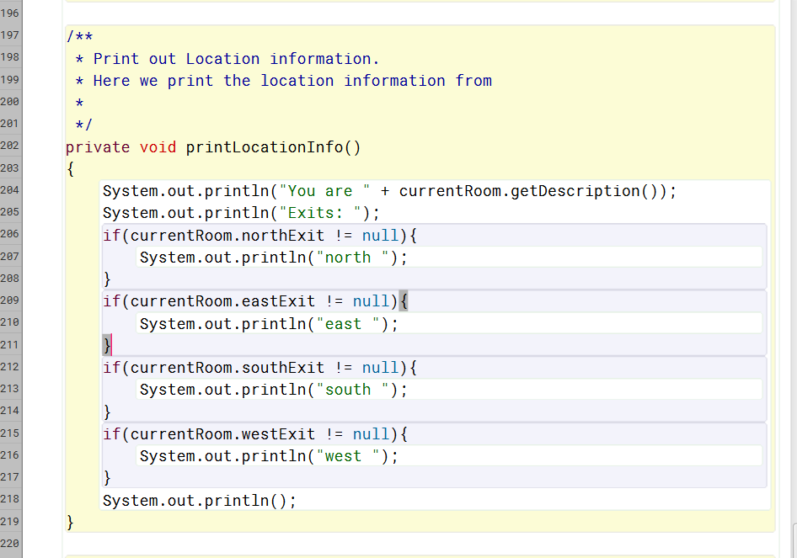

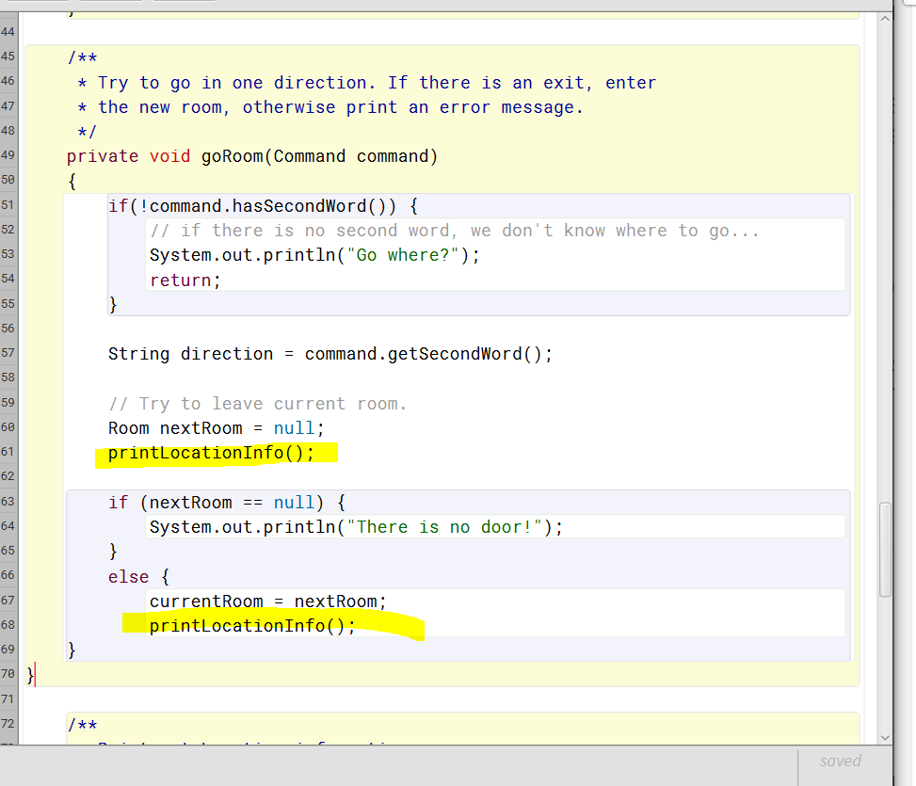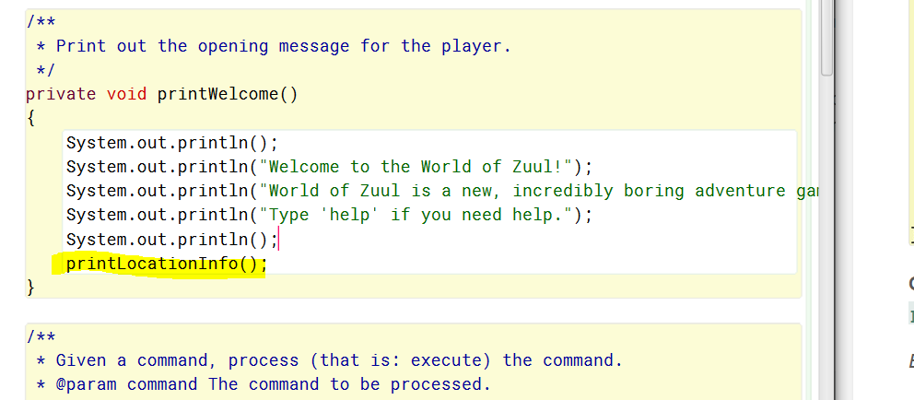

8.9

KeySet is a method of the HashMap class of the java.util library. KeySet is used to return a Set view of the keys included in the hash set. Changes to the hash map set are reflected and vice versa.

8.10

In the Room class of the zuul project we have a method called getExitString(). This method returns a description of the rooms exits. It does this by checking to see if an exit is not null and if it is not then it prints the exit string and adds the exit to it.

8.11

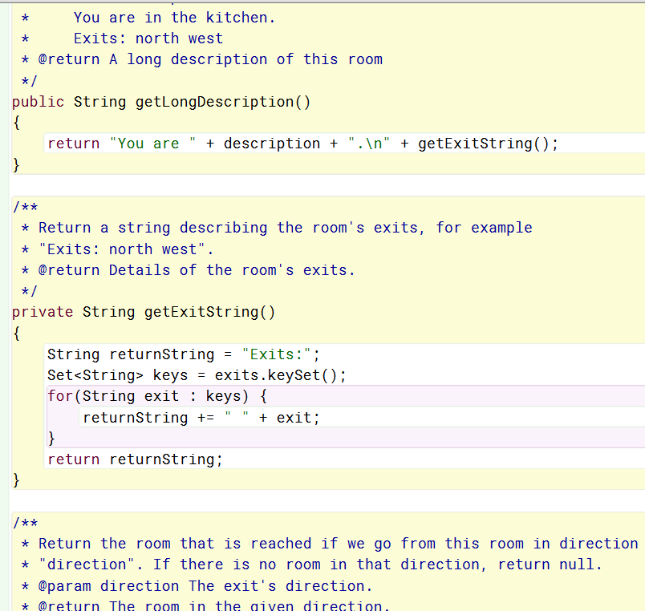

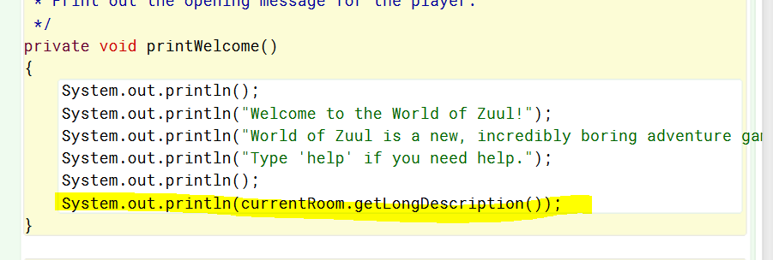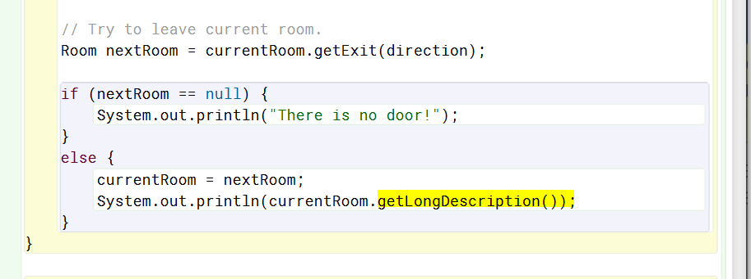

8.16

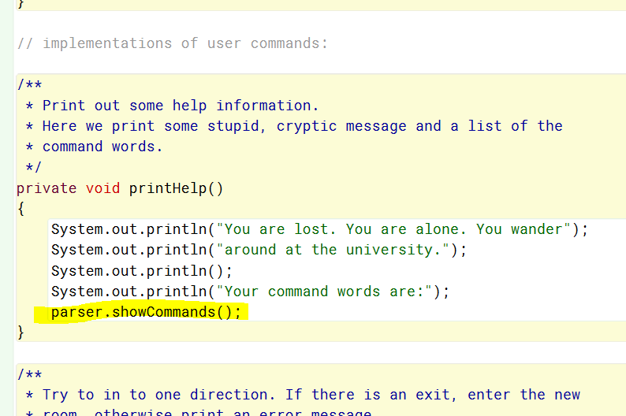

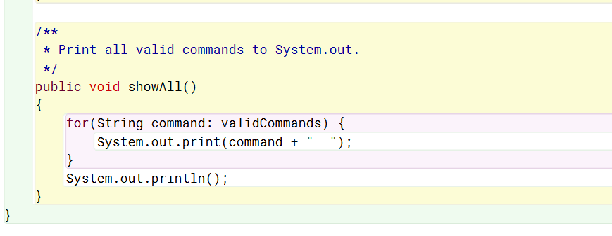

8.17

No, because the game method askes the Room method to use its showAll method to show all the commands that have been added to the commandWords class.

8.18

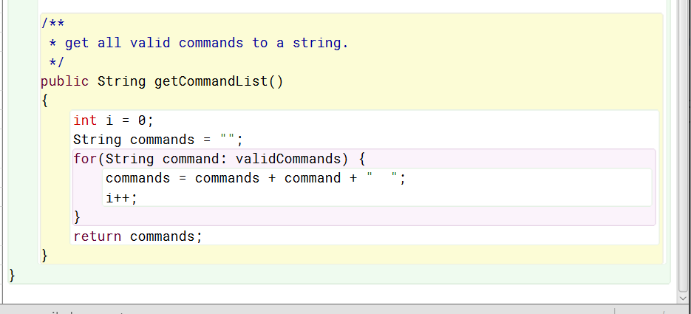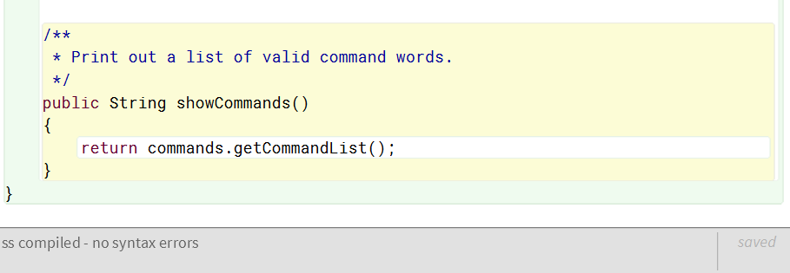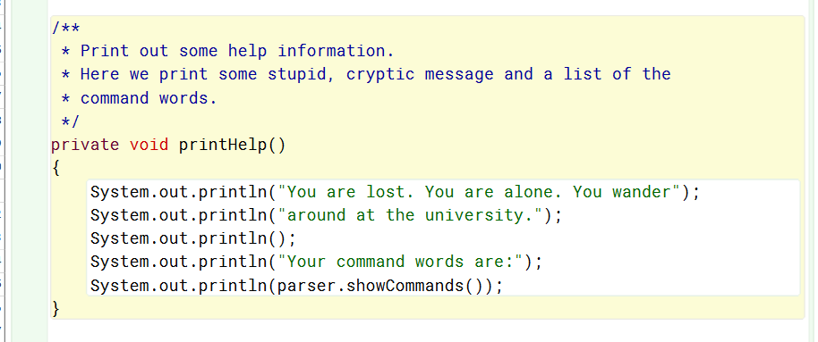

8.19

MVC or the model view controller software design structure is a structure used as a framework to develop GUI graphical user interfaces. This structure has three main components the Model is the brain of the application responsible for getting and manipulating the data. The model interacts with the controller and the controller creates the view. The view is the actual user interface that the user sees. The controller then can communicate with the controller or the view and takes in user input. The controller kind of acts as a middleman between the model and the view.

8.20

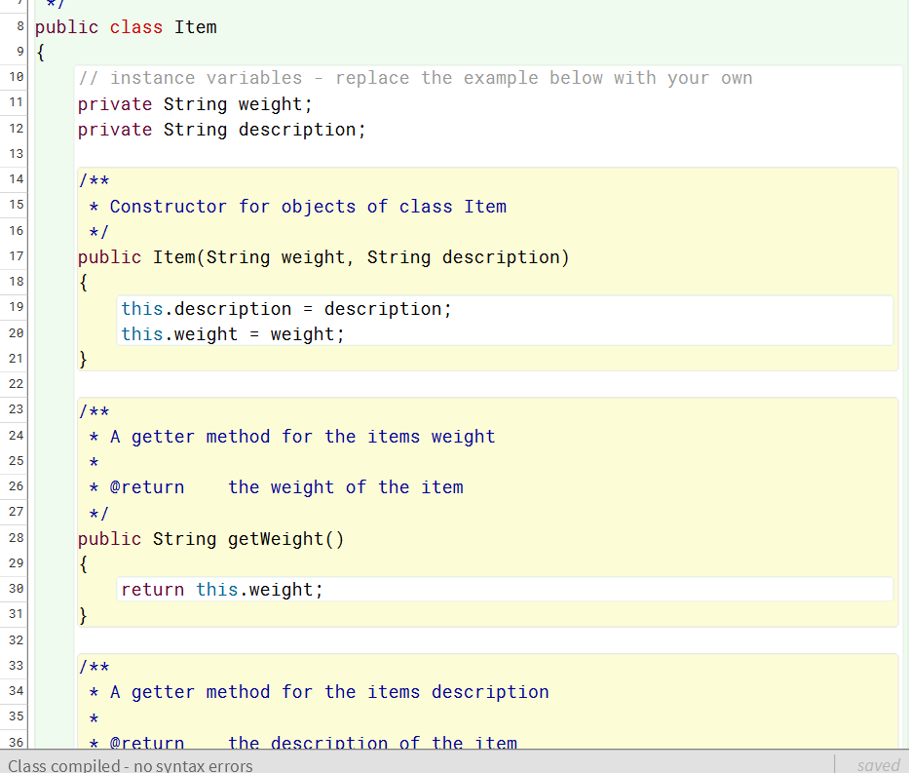

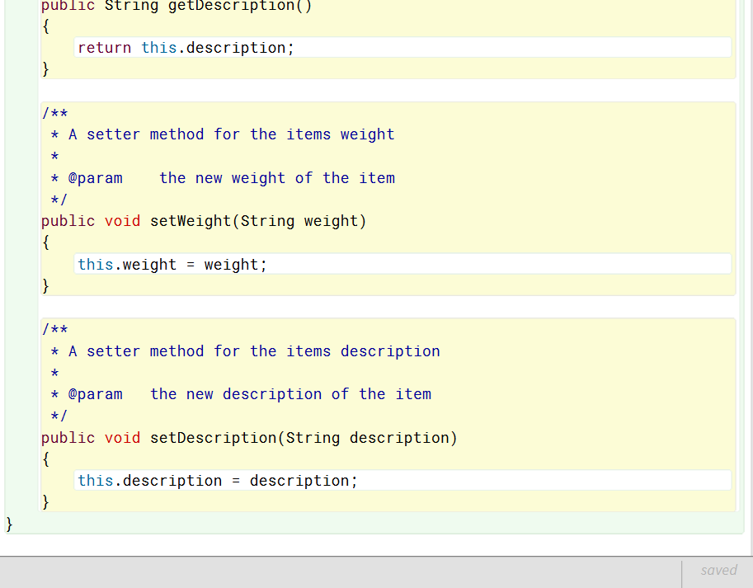

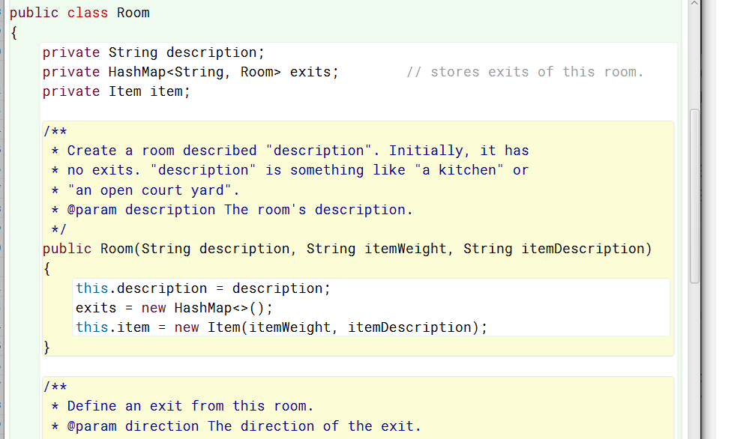

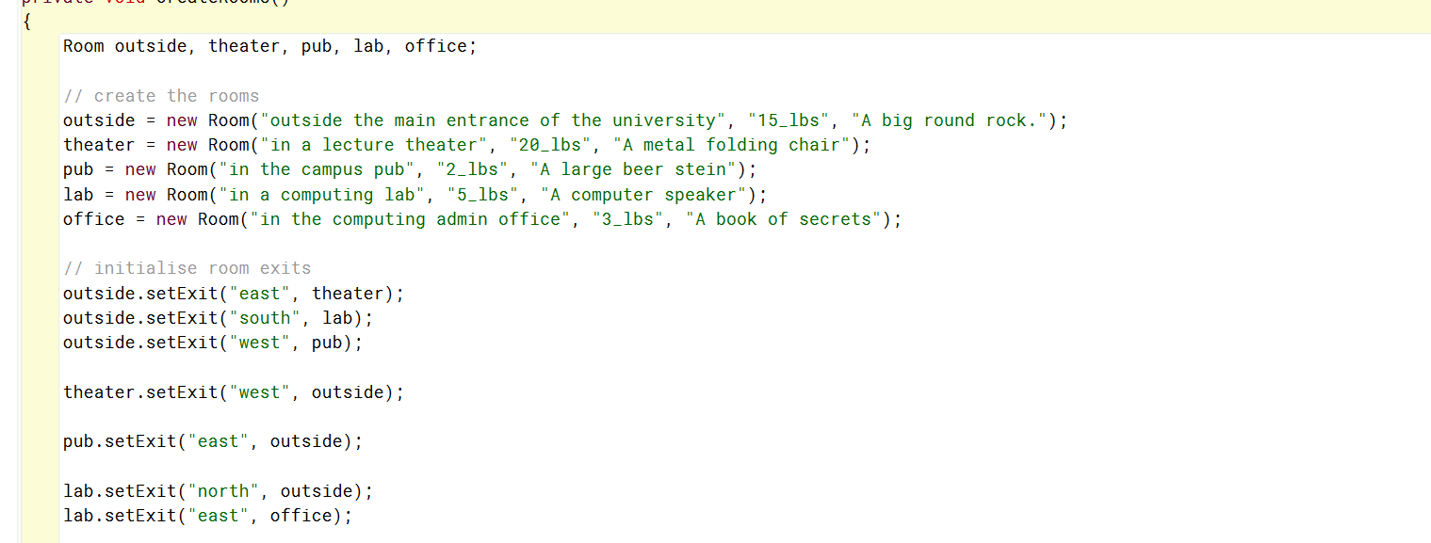

8.21

The way that I have set this up is that when each room is created in the Game class the information for eah item in each room is also supplied. The Item class will create the string to be supplied and the