**MGIS 3320 E-Commerce Implementation**

## TuTh 3:30-4:45 pm, SHB 340

**Instructor: Kamphol Wipawayangkool, Ph.D. E-mail:** [kamphol@shsu.edu](mailto:kamphol@shsu.edu)

**Office:** SHB 236K

**Office Hours:** TuTh 5-6 pm and by appointment (also via Zoom)

**Office Phone**: 936-294-4049

# Software:

1. Download VS Code at: <https://code.visualstudio.com/Download>
2. Use VS Code online at: <https://vscode.dev/>
3. Create a GitHub account at: <https://github.com/> (See instruction under the Syllabus section on Bb.)

**Textbook:** Murach's HTML and CSS, by Zak Ruvalcaba and Anne Boehm, ISBN: 978-1-943872-86-2 (**recommended**)

**Course Description:** Students are introduced to the implementation of common business applications for e-commerce using Internet related technologies. Hypertext Markup Language (HTML), Cascading Style Sheets (CSS), scripting language(s), and other current technologies are covered in the context of e-commerce. Credit 3. Prerequisites: MGIS 3310 and 50 credit hours.

**Learning Outcomes:** The students are expected to be able to:

## Understand and apply essential HTML, CSS, and JavaScript skills to create and manage a web site.

**Course Requirements:**

|  |  |
| --- | --- |
| Quizzes (10 x 5%) | 50% |
| Exams (2 x 25%) | 50% |
| **TOTAL** | **100%** |

A = 90% and above B = 80% - 89%

C = 70% - 79%

D = 60% - 69%

F = 0% - 59%

**Attendance:** Attendance is considered **mandatory**. You are responsible for the materials you miss.

**Homework/Quizzes:** The instruction and how to submit will be provided in class and/or posted online according to the course schedule. **Homework/quizzes must be submitted by the deadlines. Otherwise half of the points will be deducted. If the code is uncompilable, your grade will be a zero.**

**Examinations: If you miss an exam without a valid excuse, your grade in that exam will be a zero**. **You will be eligible for a make-up exam, ONLY IF you have informed the instructor in advance, or with a valid excuse (i.e. illness, car accidents, death in the family, and participation in University sponsored events); Documentation is expected.** If you are caught cheating (e.g., texting/talking to another individual, accessing e-mail or the Internet-unless instructed otherwise, or etc.), you will receive a zero for that exam or fail the course.

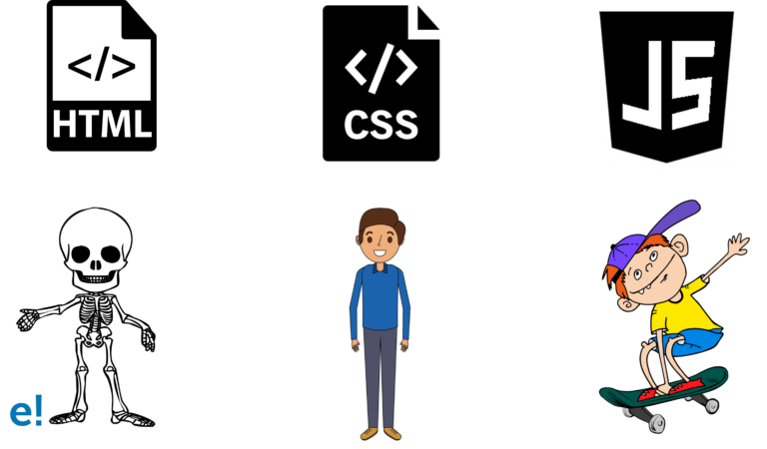

***Tentative* Course Schedule**

|  |  |  |
| --- | --- | --- |
| **Date** | **Topic** | **Due by 11:59 pm** |
| 8/23 | Syllabus, GitHub & VS Code |  |
| 8/25 | HTML |  |
| 8/30 | HTML & Q1 |  |
| 9/1 | CSS |  |
| 9/6 | CSS | **DUE: 9/7: Q1** |
| 9/8 | CSS & Q2 |  |
| 9/13 | Box Model |  |
| 9/15 | Box Model & Q3 | **DUE: 9/21: Q2** |
| 9/20 | Page Layout |  |
| 9/22 | Page Layout |  |
| 9/27 | Page Layout & Q4 |  |
| 9/29 | Lists and Links | **DUE: 9/21: Q3** |
| 10/4 | Lists and Links |  |
| 10/6 | Navigation Menu & Q5 |  |
| **10/11** | **Review /**  **Exam1: Multiple choices (ITS Certification) (10%)** |  |
| **10/13** | **Exam1: Multiple choices (ITS Certification)** | **DUE: 10/17: Q4, Q5** |
| **10/18** | **Exam1: Coding (15%)** |  |
| 10/20 | RWD |  |
| 10/25 | RWD |  |
| 10/27 | RWD & Q6 |  |
| 11/1 | Tables |  |
| 11/3 | Tables & Q7 |  |
| 11/8 | Forms | **DUE: 11/7: Q6** |
| 11/10 | Forms & Q8 |  |
| 11/15 | JS |  |
| 11/17 | JS & Q9 | **DUE: 11/20: Q7, Q8** |
| 11/22 | JS |  |
| *11/24* | *Thanksgiving* |  |
| 11/29 | JS & Q10 |  |
| **12/1** | JS | **DUE: 12/4: Q9, Q10** |
| **12/6 3:00 - 5:00 pm** | **Exam2: Multiple choices (ITS Certification) (25%)** |  |

**Syllabus Changes:** The instructor reserves the right to make changes to the syllabus as necessary.

**\*\*\* Students are responsible to be aware of changes announced in class, via email, and/or Blackboard. \*\*\***

**OTHER**

* + Students are responsible for abiding by all published University rules and regulations as printed in the *Undergraduate Catalogue*, *Student Guidelines*, and in other official University publications. You may find online a more detailed description of the following policies. These guidelines will also provide you with a link to the specific university policy or procedure: <http://www.shsu.edu/syllabus/>
  + **Academic Dishonesty**: All students are expected to engage in all academic pursuits in a manner that is above reproach. Students are expected to maintain honesty and integrity in the academic experiences both in and out of the classroom. Any student found guilty of dishonesty in any phase of academic work will be subject to disciplinary action. The University and its official representatives may initiate disciplinary proceedings against a student accused of any form of academic dishonesty including, but not limited to, cheating on an examination or other academic work which is to be submitted, plagiarism, collusion and the abuse of resource materials. For a complete listing of the university policy, see: <http://www.shsu.edu/administrative/faculty/sectionb.html#dishonesty>
  + **Student Absences on Religious Holy Days**: Students are allowed to miss class and other required activities, including examinations, for the observance of a religious holy day, including travel for that purpose. Students remain responsible for all work.<http://www.shsu.edu/~vaf_www/aps/documents/861001.pdf>
  + **Students with Disabilities Policy:** It is the policy of Sam Houston State University that individuals otherwise qualified shall not be excluded, solely by reason of their disability, from participation in any academic program of the university. Further, they shall not be denied the benefits of these programs nor shall they be subjected to discrimination. Any student with a disability that affects his/her academic performance should contact the Office of Services for Students with Disabilities in the SHSU Lee Drain Annex (telephone 936-294-3512, TDD 936-294-3786) to request accommodations.
  + COBA supports an inclusive learning community where a diversity of thought, perspectives, and experiences, are recognized, respected, and seen as a source of strength. Our college seeks to honor the intersection of race, ethnicity, national origin, culture, ability, gender, gender identity, sexuality, non-native English speakers, parental status, class, and religion (not an exhaustive list). COBA also supports the physical, emotional, and mental wellness of our community. This course will honor diversity, equity, and inclusion by integrating the COBA DEI philosophy as a norm for classroom interactions, assignments, and experiences.