1. OTDT — Complete Conceptual Overview
Full Name: OT Digital Twin (OTDT) — Agentic AI Operating Layer for Geothermal Critical Infrastructure
Core Purpose: To create a living, autonomous digital replica of GDC Kenya’s geothermal assets that continuously senses, predicts, reasons, simulates, optimizes, and acts — reducing unplanned downtime by >70% while optimizing maintenance costs.
Core Philosophy: Move from Reactive → Predictive → Agentic maintenance. The system doesn’t just alert — it autonomously manages risk through 5 collaborating AI agents.

2. Full System Architecture (Ideal State)
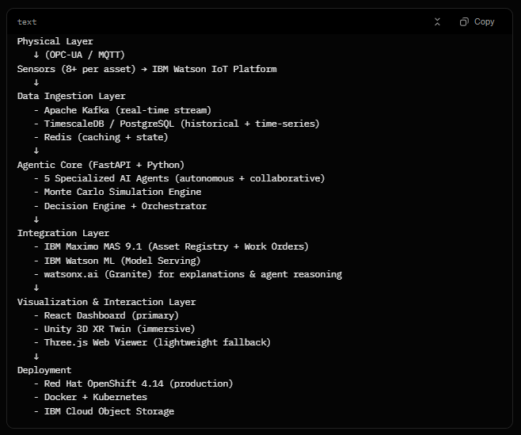
3. The 5 AI Agents — Full Specification
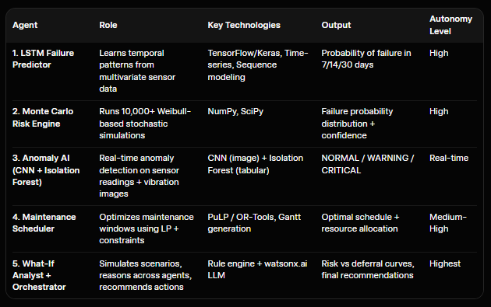
Agent Orchestration: A central Agent Orchestrator decides which agents to activate, resolves conflicts, and triggers autonomous actions (e.g., auto-create Maximo work order when risk > threshold).

4. Complete Feature Checklist (100% OTDT)
A. Asset & Data Management
- Registry of 50+ assets with full metadata (WP-07 as primary)
- 8+ real-time sensors per asset (Temperature, Vibration, Pressure, Flow, pH, Acoustic, etc.)
- Synthetic + real data pipeline
- Data quality & drift detection
B. Predictive Capabilities
- Failure prediction (7–14–30 days) with AUC-ROC ≥ 0.85
- Real-time anomaly detection (>85% accuracy)
- Remaining Useful Life (RUL) estimation
- Risk heatmaps across all 50 assets
C. Simulation & Optimization
- Monte Carlo simulations (<80ms for 10k runs)
- What-If scenario engine (defer maintenance, change load, etc.)
- Maintenance optimization with cost, resource, and risk constraints
- Digital Twin synchronization (near real-time)
D. Autonomous Actions
- Automatic work order creation in Maximo (with risk justification)
- Alert escalation hierarchy
- Self-healing triggers (where possible)
- Daily/weekly optimization runs
E. Visualization & User Experience
- React Dashboard: Live asset grid, gauges, risk cards, What-If panel
- Unity 3D XR Twin: Photorealistic plant view, color-coded assets, AR support
- Three.js Web Viewer: Browser 3D fallback
- Mobile-responsive + role-based views (Operator, Manager, Executive)
F. Integrations
- Full IBM Maximo MAS 9.1 bidirectional sync
- IBM Watson IoT (live MQTT)
- IBM Watson ML model serving
- watsonx.ai for natural language explanations
- OpenShift monitoring & logging
G. Non-Functional Requirements
- End-to-end latency: What-If < 50ms, Monte Carlo < 100ms
- 99.5% uptime
- Full audit trail & explainability
- Scalable to 500+ assets
- Multi-plant support (future)

5. Data Flow (End-to-End)
- Physical sensors → Watson IoT → Kafka
- Kafka consumers store in TimescaleDB + feed to agents
- Anomaly Agent runs continuously
- Every X minutes: LSTM + Monte Carlo update risk scores
- What-If + Scheduler agents evaluate when triggered
- Orchestrator decides action → Maximo work order + Dashboard update
- All actions logged + explained in natural language

6. Success Metrics (Target)
- Business: 650%+ ROI, >70% reduction in unplanned downtime
- Technical: LSTM AUC >0.85, Monte Carlo <100ms, Anomaly Acc >85%
- User: >90% of maintenance actions driven by OTDT recommendations
- Adoption: All GDC maintenance planners using the platform daily

