------------------------------ Soft Assert ---------------------------------
Assertion is performed immediately after the call check(),
but the expected result is obtained only after exit the context manager verify()

from soft_assert import check, verify

def test_something():
with verify():
check(1 == 1)
check(2 > 1, 'Message if test failed')
check('one' != 'two', 'Some message')

---------------- Show fixtures (dependent on the test) ---------------------

Using –setup-show:
This command shows the setup and teardown phases of each fixture during test execution, providing insights into their order.
$ pytest –setup-show [FILE]

Using –fixtures-per-test:
This command lists all fixtures used by a specific test, helping you understand dependencies.
$ pytest --fixtures-per-test <test_file>::<test_function>

Using pytest --fixtures -v:
----------------------------------------------------------------------------
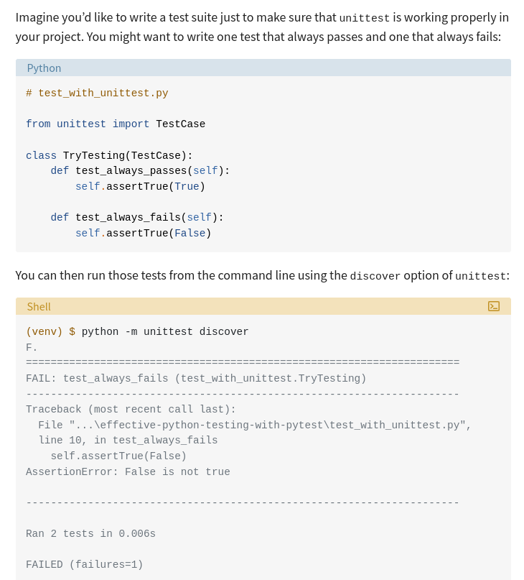

-------------------------------- Filter Tests -------------------------------

pytest provides a few ways of doing this:
- Name-based filtering: You can limit pytest to running only those tests whose fully qualified names match a particular expression. You can do this with the -k parameter.
- Directory scoping: By default, pytest will run only those tests that are in or under the current directory.
- Test categorization: pytest can include or exclude tests from particular categories that you define. You can do this with the -m parameter.
----------------------------- Fixture -------------------------------------
pytest looks for a conftest.py module in each directory. If you add your general-purpose fixtures to the conftest.py module, then you’ll be able to use that fixture throughout the module’s parent directory and in any subdirectories without having to import it.
scope=”function”
Run once per test function. The setup portion is run before each test using the fixture. The teardown portion is run after each test using the fixture. This is the default scope used when no scope parameter is specified.
scope=”class”
Run once per test class, regardless of how many test methods are in the class.
scope=”module”
Run once per module, regardless of how many test functions or methods, or other fixtures in the module use it.
scope=”package”
Run once per package, or test directory, regardless of how many test functions or methods, or other fixtures in the package use it.
scope=”session”
Run once per session. All test methods and functions using a fixture of session scope share one setup and teardown call.
------------------------------ monkeypatch ---------------------------------
Another interesting use case for fixtures and conftest.py is in guarding access to resources. Imagine that you’ve written a test suite for code that deals with API calls. You want to ensure that the test suite doesn’t make any real network calls even if someone accidentally writes a test that does so.
pytest provides a monkeypatch fixture to replace values and behaviors, which you can use to great effect:
# conftest.py

import pytest
import requests

@pytest.fixture(autouse=True)
def disable_network_calls(monkeypatch):
def stunted_get():
raise RuntimeError("Network access not allowed during testing!")
monkeypatch.setattr(requests, "get", lambda *args, **kwargs: stunted_get())

By placing disable_network_calls() in conftest.py and adding the autouse=True option, you ensure that network calls will be disabled in every test across the suite. Any test that executes code calling requests.get() will raise a RuntimeError indicating that an unexpected network call would have occurred.

-------------------------- Marks: Categorizing Tests ---------------------------

You can use the --strict-markers flag to the pytest command to ensure that all marks in your tests are registered in your pytest configuration file, pytest.ini. It’ll prevent you from running your tests until you register any unknown marks.

pytest provides a few marks out of the box:
- skip skips a test unconditionally.
- skipif skips a test if the expression passed to it evaluates to True.
- xfail indicates that a test is expected to fail, so if the test does fail, the overall suite can still result in a passing status.
- parametrize creates multiple variants of a test with different values as arguments. You’ll learn more about this mark shortly.
You can see a list of all the marks that pytest knows about by running pytest --markers.

------------------------------------------------------------------------------

1. Stopping a Test Session on the First Failure
On certain occasions, you might wish to abort the entire session after the first failure so you can fix the broken test immediately.

Fortunately, pytest comes with a very convenient CLI option for that, the -x / --exitfirst.

2. Re-Running Only the Last Failed Tests
If the full test suite takes minutes to run, you’ll probably want to execute only the ones that failed. pytest allows that via the --lf or --last-failed option.

3. Re-Run the Whole Test Session Starting With Last Failed Tests First

You want to start with the failed test first. And to accomplish that, use the --ff or --failed-first flag.

4. Displaying the Local Variables of a Failed Test

By using the --showlocalsflag, or simply -l, we can see the value of all local variables in tracebacks

5. Running Only a Subset of Tests

By using the -k option, one can specify keyword expressions that pytest will use to select the tests to be executed.

# tests/test_variables.py
def test_asdict():
...

def test_astuple():
...

def test_aslist():
...

$ pytest -k "asdict or astuple" tests/test_variables.py

6. Run Tests in Parallel

The best pytest plugin for that is pytest-xdist. To send your tests to multiple CPUs, use the n or --numprocesses option.

$ pytest -n auto

7. Re-Run Flaky Tests and Eliminate Intermittent Failures

The best pytest plugin for that is the pytest-rerunfailures. This plugin re-runs tests as much as we want, thus eliminating intermittent failures.

The simplest way to use it is to pass the --reruns option with the maximum number of times you'd like the tests to run.

$ pytest --reruns 5

@pytest.mark.flaky(reruns=5)
def test_flaky():
assert get_resut() is True

8. autouse = True

autouse=True argument with a fixture.

This automatically add the fixture into your tests without the need to explicitly add it as an argument to each test function.

@pytest.fixture(autouse=True)
def measure_time():
start = time.time()
yield
stop = time.time()
delta = stop - start
print("\ntest duration: {:0.3} seconds".format(delta))

9.

