**…HP QTP/UFT….**

QTP – Quick Test Professional

UFT – Unified Functional Testing

Choosing Tool :-

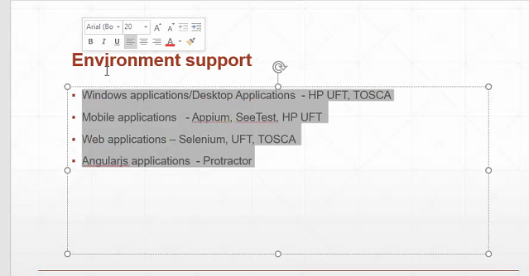

Price :-

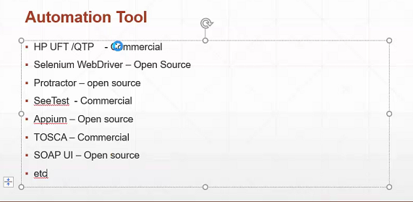

Dim num1, num2 As vbinteger. – Type Is Defined At Declrartion.

Dim num1, num – Type Not Defined. Dynamic Type

Now, num1 = 10 – Now, Dynamically num1 Becomes Integer Type

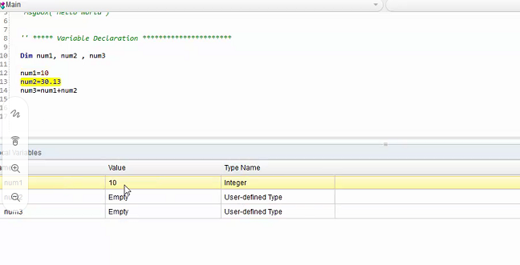

MsgBox(“Something”) -> It Opens a Dialog Box With The Msg Inside.

Dim num1 = InputBox(“Enter a number 1”) -> Prompt box. Returns a string value.

Dim num2 = InputBox(“Enter a number 2”) -> Prompt box. Returns a string value.

Dim num3 = Eval(num1) + Eval(num2)

MsgBox(num3)

& Is Used Instead Of + For Concatinating.

Print num3 -> For Printing On Console

For a = 1 to 10

Print a // 1, 2, 3, 4, 5,6,7,8,9,10

Next

For a = 1 to 10 step 2

Print a//1,3,5,7,9

Next

Ucase(“hello”) -> uppercase conversion

Lcase(“hello”) -> lowercase conversion

StrReverse(“hello”) -> Reverse The String

Object Repository :-

1. Local
2. Shared

Resources Menu Has Object Repository.

Object Identification :

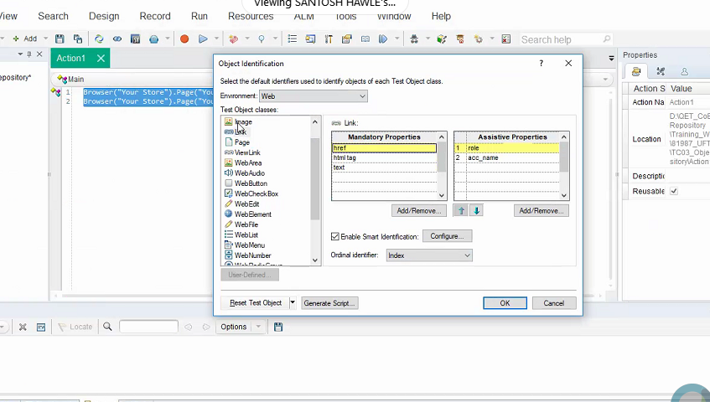

UFT Will Identify Object using Mandatory properties. If It fails Then I Will use Assistive properties Also.

We Can Add, Remove, Modify, Rename OR.

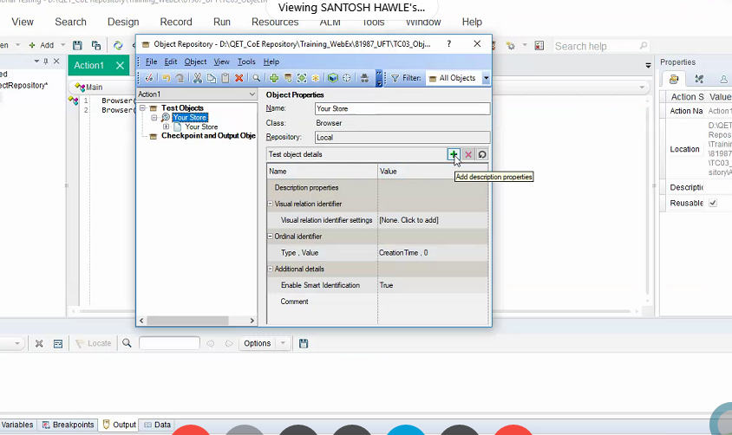

Shared OR Is Inside Resources -> OR Manager.

Click On + button And add Objects.

Click On any Element Which You Want to Add To OR.

Else, Click on WebPage Tab To Add All objects From The page. We Can Select Option From Select option.

Creating Function Library & TC Separate And Calling It After Associating.

to add function library to your test => File > Settings > Resources > (+) associate func library

Or,

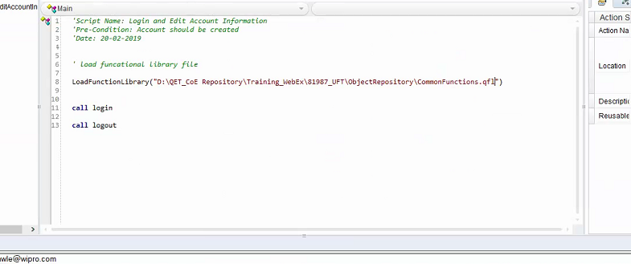

Object Synchronization timeout -> 20 second Default

PDF Report

