Practice file for Every Word Counts, Part 5 (Assessment 2). This is a fictional application. Inventors: Lin Mei-Hua and Samuel Okoye. Applicant: Verdant Loop Co., Ltd. Turn on Track Changes before you edit.

SELF-WATERING PLANTER

BACKGROUND
[0001] Potted plants need regular watering. People who travel or who forget to water their plants often lose them to dry soil, while people who water too often can drown the roots.
[0002] Some planters hold extra water in a tray under the pot. These trays must be refilled often, and it is hard to tell how much water is left without lifting the pot.

SUMMARY
[0003] A self-watering planter has an outer housing with a water reservoir in its lower portion and an inner pot supported above the reservoir. A wick draws water from the reservoir up into the soil in the inner pot, so the soil stays evenly moist for days or weeks. In some embodiments, a water-level indicator shows how much water is left.

DETAILED DESCRIPTION
[0004] Referring to FIG. 1, a self-watering planter 10 includes an outer housing 12, a water reservoir 14, an inner pot 16, and a wick 18. The outer housing 12 may be made of molded plastic, ceramic, or another waterproof material.
[0005] The water reservoir 14 is formed in a lower portion of the outer housing 12. In some examples, the water reservoir 14 holds between 0.5 and 2 liters of water. An overflow hole 26 in the outer housing 12 is positioned at a top of the water reservoir 14 so that excess water drains out instead of flooding the inner pot 16.
[0006] The inner pot 16 rests on a ledge 28 inside the outer housing 12, above the water reservoir 14. The inner pot 16 has a bottom opening 30. The wick 18 extends through the bottom opening 30 from the water reservoir 14 into the soil in the inner pot 16. The wick 18 may be made of cotton or polyester fiber and may have a width of 5 to 15 millimeters.
[0007] A fill tube 20 extends from a top of the outer housing 12 down into the water reservoir 16. The fill tube 20 may have an inner diameter of at least 10 millimeters so that a user can refill the water reservoir 14 without lifting the inner pot 16.
[0008] In some embodiments, the planter 10 further includes a water-level indicator 22. The water-level indicator 22 has a float 32 disposed in the water reservoir 14 and a window 34 formed in the outer housing 12. The float 32 rises and falls with the water. A colored top of the float 32 is visible through the window 34.
[0009] As the soil in the inner pot 16 dries, the feed strip 18 draws water upward from the water reservoir 14 by capillary action.
[0010] In some embodiments, the planter 10 further includes a drainage tray 24 removably attached to a bottom of the outer housing 12. The drainage tray 24 catches water that leaves through the overflow hole 26.
[0011] The embodiments described above are examples. Changes in shape, size, and materials may be made without departing from the scope of the claims.

BRIEF DESCRIPTION OF THE DRAWINGS
[0012] FIG. 1 is a cross-sectional side view of a self-watering planter according to an embodiment.

CLAIMS
What is claimed is:
1. A self-watering planter, consisting of:
an outer housing;
a water reservoir formed in a lower portion of the outer housing;
an inner pot supported in the outer housing above the water reservoir, the inner pot having a bottom opening; and
a wick extending through the bottom opening from the water reservoir into the inner pot.
2. The self-watering planter of claim 1, wherein the wick is made of cotton or polyester fiber.
3. The self-watering planter of claim 1, wherein the drainage tray is removably attached to a bottom of the outer housing.
4. The self-watering planter of claim 8, wherein the float has a colored top that is visible through the window.
5. The self-watering planter of claim 1, wherein the outer housing has an overflow hole positioned at a top of the water reservoir.
7. The self-watering planter of claim 1, further comprising a fill tube extending from a top of the outer housing into the water reservoir. The fill tube has an inner diameter of at least 10 millimeters.
8. The self-watering planter of claim 1, further comprising a water-level indicator having a float disposed in the water reservoir and a window formed in the outer housing.
9. The self-watering planter of claim 2, wherein the wick has a width of 5 to 15 millimeters.

ABSTRACT
A self-watering planter for indoor and outdoor plants is disclosed. The planter includes an outer housing made of molded plastic, ceramic, or another waterproof material, and a water reservoir formed in a lower portion of the outer housing that holds between 0.5 and 2 liters of water. An inner pot rests on a ledge inside the outer housing above the water reservoir and has a bottom opening. A wick made of cotton or polyester fiber, with a width of 5 to 15 millimeters, extends through the bottom opening from the water reservoir into the soil in the inner pot and draws water upward by capillary action as the soil dries, so that the soil stays evenly moist for days or weeks without daily watering. A fill tube with an inner diameter of at least 10 millimeters lets a user refill the water reservoir without lifting the inner pot. An overflow hole at the top of the water reservoir lets excess water drain out instead of flooding the inner pot. In some embodiments, a water-level indicator with a float and a window shows how much water is left, and a removable drainage tray attached to the bottom of the outer housing catches water that leaves through the overflow hole.

DRAWINGS
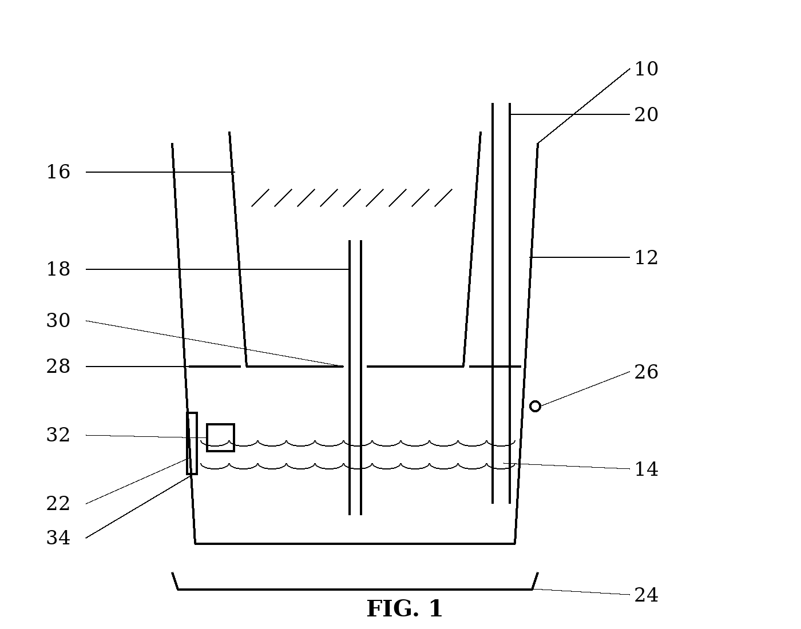
Reference numerals (text version of FIG. 1): 10 planter · 12 outer housing · 14 water reservoir · 16 inner pot · 18 wick · 20 fill tube · 22 water-level indicator · 24 drainage tray · 26 overflow hole · 28 ledge · 30 bottom opening · 32 float · 34 window

