# Dockerized Shift Left Quickstart Guide

## Pre-Requisites

Before you get started, you will need to have the following:

1. Docker – You can install Docker for Windows on your Windows machine or Docker for Mac on your Mac. All the instructions assume that Docker is installed on your local machine.
2. App Mon 7 Client
3. App Mon License – You will need a pre-production App Mon 7 license provisioned with at least 2 Java agents. Rename the license file to appmon.lic and put it in the Dynatrace-Server directory.

## Getting Started

1. Open a terminal window, and cd to the shiftleft directory.
2. Start up the containers: docker-compose up
3. After a couple of minutes, the images should be created and the containers should start.
4. Start the app mon client and point it to localhost, with the default login (username admin, password admin). Open up the Dynatrace Server Settings dialog and ensure that the license has been installed properly.
5. Start up a web browser and point it to http://localhost:8080. Click on the “log in” link at the top-right corner and login as admin / admin.
6. Click on the demo job, and followed by “Build Now”. The first build will take a while as maven pulls in all the dependencies.

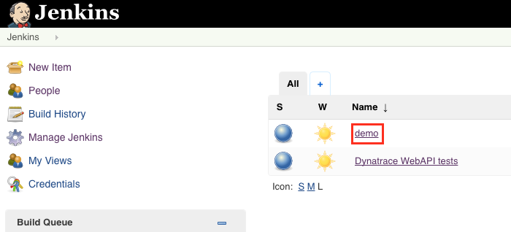

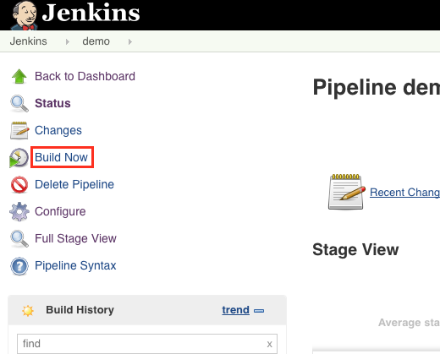

You can follow the instructions in the Powerpoint file for the rest of the demo with the exception of the trigger interval – the triggers should trigger every 7-10 minutes instead of every 5 minutes. The Web API tests have been modified include a delay at the end of the series of wget requests. This is to workaround the long-running PurePaths for certain requests to the reading service. If the server is terminated before those PurePaths have ended then the PurePaths disappear.

The only difference between that the setup here and the setup in the Powerpoint file is that Jenkins is configured to pull from a local git repository instead of pulling from github.

If you want to break the build (slides 78-79), open a terminal, and:

1. Get a shell into the git container: docker exec –it git /bin/bash
2. Switch to the correct directory: cd SpringBootBookstoreWithProblems/reading/src/main/resources/
3. Edit application.properties with vi or nano (if you’re not familiar with vi). Change the reading.version property from 1 to 2. Save the file and exit from the editor.
4. Commit the change with: git commit –a
5. The previous command will bring up nano. Enter a commit message, save the file, and exit from nano.