Test data for StaffID

**Normal Data**

Purpose: to ensure that the program produces the correct result based on valid StaffID given.

Test plan: Enter 2 Valid Staff ID (correct format )

Test data: 10805, 20936

Expected output: The program will continue to ask for the next input item

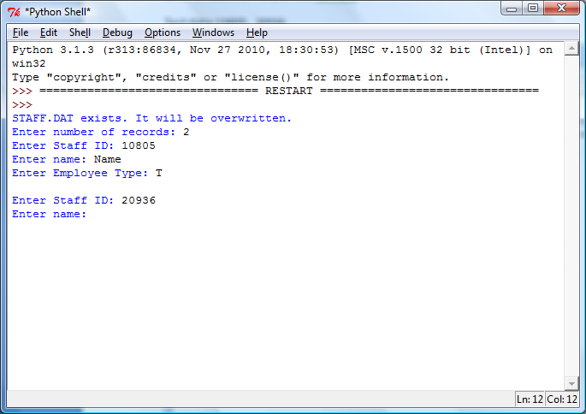

**Boundary/Extreme data**

Purpose: To ensure that the program can handle boundary/extreme cases correctly.

Test plan: Enter two values, one near the minimum accepted value, the other at the maximum.

Test data: 10801, 21299

Expected output: The program will continue to ask for the next input item

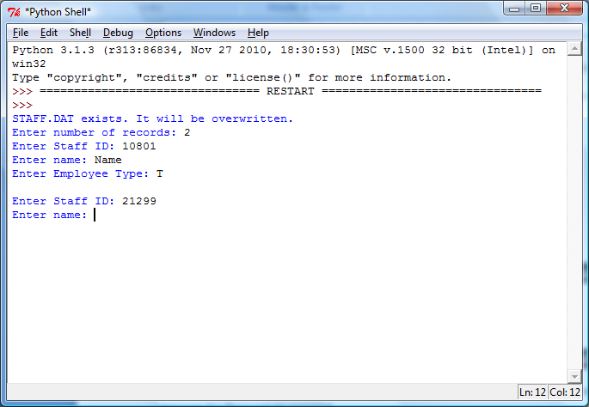

**Erroneous data**

Purpose: To ensure that the program will not crash given the invalid input, but respond with a specific error message to allow user to proceed.

Test plan: Empty input, length, invalid data types, invalid gender, invalid year, invalid staff number range

Test data: 90922, 10524, 20900

Expected output: The program asks the user to enter another StaffID, after responding with a corresponding error message.

