import foolbox
import keras
import numpy as np
from keras.applications.resnet50 import ResNet50
import matplotlib.pyplot as plt
import matplotlib.image as mpimg
import sklearn
import sys
# instantiate model
keras.backend.set_learning_phase(0)
kmodel = ResNet50(weights='imagenet')
preprocessing = dict(flip_axis=-1, mean=np.array([104, 116, 123])) # RGB to BGR and mean subtraction
fmodel = foolbox.models.KerasModel(kmodel, bounds=(0, 255), preprocessing=preprocessing)
for attacks in ['BlendedUniformNoiseAttack','ContrastReductionAttack','FGSM','SinglePixelAttack','SaliencyMapAttack']:
for i in range(10):
# get source image and label, unique idx: 0-19
image, label = foolbox.utils.samples(dataset='imagenet',index=10+i,batchsize=1)
image = image[0]
label = label[0]
# apply attack on source image
if attacks == 'FGSM':
attack = foolbox.v1.attacks.FGSM(fmodel)
elif attacks == 'BlendedUniformNoiseAttack':
attack = foolbox.v1.attacks.BlendedUniformNoiseAttack(fmodel)
elif attacks == 'ContrastReductionAttack':
attack = foolbox.v1.attacks.ContrastReductionAttack(fmodel)
elif attacks == 'SinglePixelAttack':
attack = foolbox.v1.attacks.SinglePixelAttack(fmodel)
else:
attack = foolbox.v1.attacks.SaliencyMapAttack(fmodel)
adversarial = attack(image, label)
# if the attack fails, adversarial will be None and a warning will be printed
plt.subplot(10, 3, (i*3)+1)
plt.axis('off')
if i==0:
plt.title('Image')
plt.imshow(image.astype(np.uint8))
plt.subplot(10, 3, (i*3)+2)
plt.axis('off')
if i == 0:
plt.title(attacks+'\n Perturbation')
plt.imshow(adversarial.astype(np.uint8))
plt.subplot(10, 3, (i*3)+3)
plt.axis('off')
if i == 0:
plt.title('Difference (scaled)')
diff = adversarial - image
plot_diff = 255 * (diff - np.min(diff)) / (np.max(diff) - np.min(diff)+sys.float_info.epsilon)
plt.imshow(plot_diff.astype(np.uint8))
plt.show()

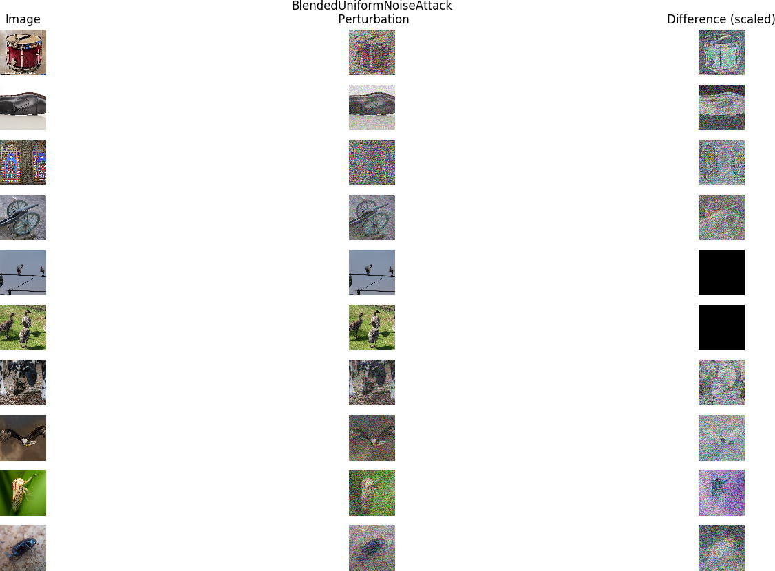

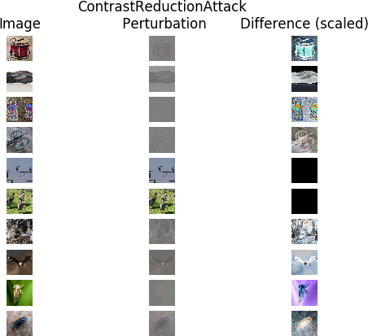

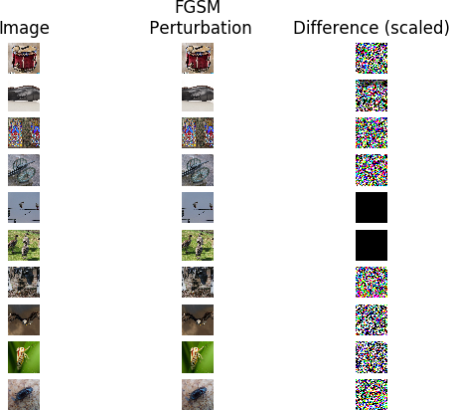

All Single Pixel Attacks failed
None returned for all attacks on VGG16

