**COMP 3005**

**AS #6**

**Krystian Wojcicki**

**101001444**

1a) Cannot be functional dependencies because first two tuples have values A = 10, but then for B they have b1 and b2.

b) The dependency holds

c) Cannot be functional dependencies because first and third tuple have C = c1, but then for B they have b1 and b4.

d) Cannot be functional dependencies because first and fifth tuple have B = b1, but then for A they have 10 and 13

e) Cannot be functional dependencies because first and third tuple have C = c1, but then for A they have 10 and 11

2a) The key for first is { A, B }

b)

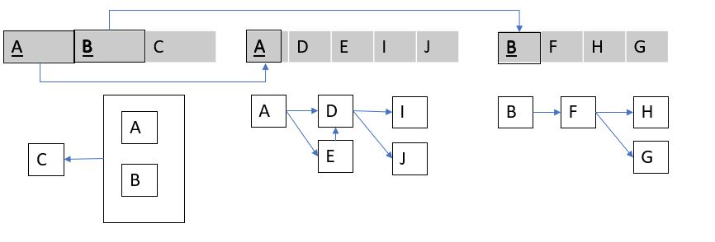

c)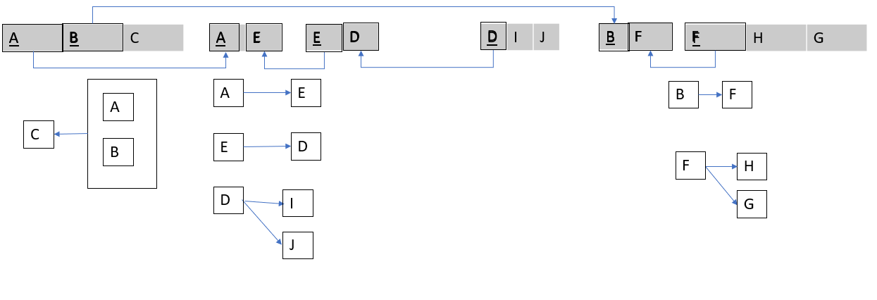

3a) The key is {A, B, D}

b)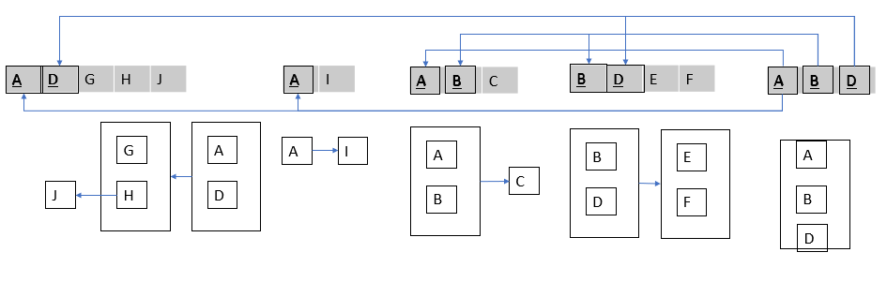

c)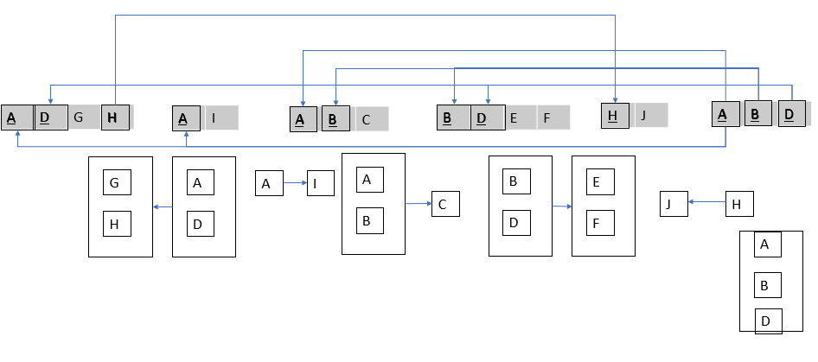

4a) The key is {C, D, E}

b) Second normal form is the highest normal form this relation is in

c)

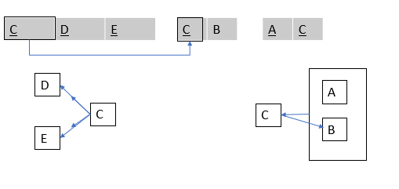

d)

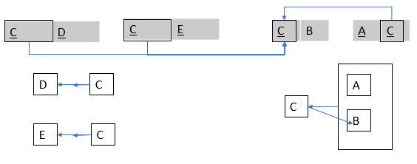

5)

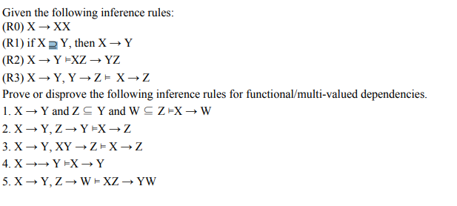

a) Valid

Z ⊆ Y then Y -> Z due to R1

W ⊆ Z then Z -> W due to R1

X -> Y and Y -> Z and Z -> W therefore X -> W due to R3

b) Invalid

|  |  |  |
| --- | --- | --- |
| X | Y | Z |
| x1 | y1 | z1 |
| x1 | y1 | z2 |

X -> Y and Z -> Y but X -> Z does not work since there are tuples x1, z1 and x1,z2

c) Valid

X -> XX due to R0

X -> Y therefore XX -> XY due to R2

X -> XX and XX -> XY and XY -> Z therefore X -> Z due to R3

d) Invalid

|  |  |
| --- | --- |
| X | Y |
| a | 1 |
| a | 2 |

Still satisfies X ->-> Y but not X -> Y since there are tuples a,1 and a,2

e) Valid

X -> Y therefore XZ -> YZ due to R2

Z -> W therefore ZY -> WY due to R2

XZ -> YW and ZY -> WY therefore XZ -> YW due to R3