Evaluative Research - Study Plan

Travel - Sustainable and Memorable Tourism via Local Businesses

Ali Askari, Kashvi Goel, Sophia Syed, Michael Kwok | November 11, 2024

| Background According to our research, authentic local experiences offered travelers a deeper connection to their destinations. A majority of travelers interviewed describe off-beat experiences as the most memorable part of their trips. These travelers (ages 20-40) often discovered these experiences through spontaneous exploration, word of mouth, and social media rather than during the initial trip planning.  Despite this, major tourist attractions were often the starting point for travel itineraries. Travelers left room for unplanned local activities, but expressed that planning for these experiences lacks centralization.  Our prototype aims to address this gap by consolidating the planning process into an interactive map and itinerary that emphasizes major tourist attractions while alerting users to nearby local experiences. We look to discover if this approach improves user’s feelings of preparedness, excitement, and clarity. |
| --- |

# Summary

Based on the insights from generative research, we asked **How might we:**

* **Weave authentic local experience in travel experiences ‘spontaneously’?**
* **Centralize travel planning research for both famous and offbeat local experiences?**
* Enable tourists to experience their destinations as if they lived there?
* Factor in personal preferences when suggesting local experiences?

With our design solution we aim to primarily address the statements in bold. Our intervention exists in the ‘planning’ phase of travel and aims to aid planners and spontaneous tourists by allowing for discovery and planning of local experiences in relation to nearby tourist hotspots.

## Evaluative Research Questions

🧠 Does our prototype match and facilitate user’s mental models for exploration and planning?

📆 Does our prototype provide value to both planners and non-planners?

## Links to Previous Work

* [Key insights presentation](https://www.figma.com/deck/efGUIjUHyOq1hQTQrBjGxG)
* [Research Data (Affinitized & Take aways)](https://www.figma.com/board/hyhdOz6Gu1jLyCEG65mW6B/Travel-Research-Research-Board?node-id=0-1&t=fL3Eh2j1GsDuEoW9-1)
* [Generative research study plan](https://drive.google.com/drive/folders/1FVo2I0lmq17s0jI-5Qufo8vs_h3fbAR4?usp=drive_link)
* [Desk Research Findings](https://docs.google.com/document/d/1A1PM0g_yZTD0jofJOUjF9cy2gmuNc-whz8wxOXK4jkM/edit?usp=sharing)

# Proposed Methods

| **Chosen method and rationale:** | Cognitive walkthrough: We would conduct in-person cognitive walkthroughs with 5 participants for our concept testing.  We chose this method because at this stage of our design process we are looking to evaluate the general flow and discover any design problems with the information architecture. |
| --- | --- |
| **Data collection plan:** | We would simulate a scenario and assign 3 tasks to the user, repeatedly asking what they see, want to do, and expect would happen. We would be using paper prototypes to avoid distracting details.  We would record the responses for each step of the flow using google sheets and use the “*pass*, *pass with issues* and *fail*” rubric of moderated UT along with a section for qualitative inputs and notes at each step.  One moderator would conduct the test and another would take notes.  Voice/ Video would also be recorded depending on permission from the interviewee to support the data analysis process. |

# Recruitment Plan

## Objective

To conduct a usability study for evaluating a prototype of a travel app that allows travelers to upload all their bookings for a consolidated view of their trip logistics. The app also offers personalized, time-bound activity suggestions displayed in a map and calendar view.

## Recruitment Strategy

The following 2 methods will be used to recruit participants:

1. Engage with travel enthusiast communities:

1. Online travel forums and communities (e.g., Reddit’s r/travel, TripAdvisor forums).
2. Social media groups for travelers (Facebook, Instagram).

2. Existing Contacts:

* Reach out to users from our existing connections on social media platforms such as LinkedIn, Instagram, Facebook and X.

## Screening Process

Use a screener to filter potential participants based on travel frequency, planning behavior, and comfort level with using mobile apps.

Link: <https://docs.google.com/forms/d/e/1FAIpQLSeDh0NDq06L5jXWXuLUtZaORIJ2W3qCcLBv0Yib086UYtyVbQ/viewform?usp=sf_link>

## Ideal Participant Profiles

To gather valuable feedback, the prototype needs to be tested by our two main audiences - Planners and Non-Planners.

### Profile 1: Planners

* **Behavioral Traits**
  + They may enjoy planning for their own mental security or for the benefit of their group.
  + Travel should match their expectations.
  + May use a variety of tools to keep track of interesting sights, bookings, and other logistics.
* **Pain Points**
  + May have to explore many sources to find sights that they are satisfied with.
  + No integration between sight finding and scheduling.

### Profile 2: Non-Planners

* **Behavioral Traits**
  + They may stay away from planning due to stress, a lack of pickiness regarding activities, or view relaxation as the main goal for travel.
  + May book flights and reservations last minute.
  + They generally view spontaneous exploration as the best part of travel.
* **Pain Points**
  + Because they do not do extensive research beforehand, they may worry about wasting time in areas that don’t interest them or missing a key tailored experience.
  + Others may complain that they do not contribute to planning.
  + If they have specific tastes, they may be frustrated with how spread apart key information is regarding sights that may interest them.
  + Too much planning by travel partners may inhibit their ability to explore or relax.

## Logistics and Scheduling

**Session Type:** In-person usability testing sessions

**Session Duration:** 30-60 minutes per participant

**In-person sessions:** Physical low-fidelity screens

## Timeline

| 11/11 - 11/20 | Evaluative Research | Data Collection | 11/12 - Roll out Screener  11/20 - Complete prototype testing and data collection |
| --- | --- | --- | --- |
| 11/25 - 12/2 | Evaluative Research Analysis | Data Analysis | 11/25 - Complete Initial Data Analysis  12/2 - Evaluative Findings Report |
| 12/3 - 12/13 | Final Findings | Findings | 12/9 - Submit Final Findings  12/13 - Submit Individual Portfolios |

## Consent Form

**Project Title:** Travel - Sustainable and Memorable Tourism via Local Businesses

**Researcher(s):** Ali Askari, Kashvi Goel, Sophia Syed, Michael Kwok

**Purpose of the Study:**The purpose of this study is to evaluate a prototype of a new travel app designed to help travelers organize their trip details by uploading all their bookings in one place. The app aims to give travelers a clear overview of their logistics while offering personalized, time-bound activity suggestions displayed on both a map and a calendar view.

**What You Will Be Asked to Do:**As a participant, you will be asked to:

* Interact with the travel app prototype.
* Complete a series of tasks related to travel planning, booking, and itinerary management.
* Provide verbal feedback during the session about your experience, preferences, and any issues you encounter.
* Answer brief questions at the end of the session.

The session will take approximately [30-60 minutes] and may be recorded for analysis purposes.

**Voluntary Participation:**Your participation is entirely voluntary. You may choose to stop the testing at any time or skip any task you do not wish to complete without any penalty.

**Confidentiality:**All information collected during this study will be kept confidential. Your personal information will not be shared with any third parties. Any data collected will be anonymized and used solely for research purposes. If you agree, the session may be recorded for internal use to analyze your interactions and feedback.

**Risks and Benefits:**There are no anticipated risks associated with participating in this study. Your feedback will help us improve the app's design and user experience.

**Contact Information:**If you have any questions or concerns about this study, please feel free to contact us at [askari25@uw.edu](mailto:askari25@uw.edu) or +1 (424) 337-3533

**Consent:**By signing below, you acknowledge that you have read and understood this consent form, and you agree to participate in the study.

* I agree to participate in the testing of the travel app prototype.
* I understand that the session may be recorded for research purposes.

**Name of Participant :** _______________________________

**Signature of Participant:** _______________________________

**Date:** _______________________________

**Researcher’s Signature:** _______________________________

# Cognitive Walkthrough Guide

## Intro

Hi! We’re aiming to enhance travel planning with a tool that should help you understand the popular and hidden sights at your destination and improve your ability to schedule both. Please imagine that you are planning a 5 day trip to London. It can be a solo, group, or couples trip. Please tell us who you imagine going with and for what reason! Now, imagine this trip to London in your mind. Think about what you want to experience and what comes to mind when you think about planning.

Let’s begin!

## Task 1

**Our first task is for you to enter the destination and any pre-confirmed bookings.**

**Steps:**

1. Use the input bar and enter the destination and duration.
2. If you would expect yourself to have and want to organize bookings, use the bookings entry function. Otherwise, click “explore”
   1. Please add your bookings and specify what you might be adding.
3. Congratulations! You have now reached the Explore screen. Please take a moment to look at the screen before we continue.

**Questions:**

1. Bookings
   1. Why did you choose to add or not add bookings?
   2. **If they added bookings:** How did this upload experience match your expectations?
2. Main Screen
   1. Now that you’re looking at the main screen, what do you notice? Are you interested in clicking on anything?
   2. How does the map line up with the vision of planning you thought about before starting?

## Task 2: Exploring Deeper

On the right is a map of your destination with some notable sights marked. On the left is a saved board which will help you manage the things you might want to check out!. One of the major features is highlighting notable local experiences around top sights. Let’s start exploring!

**Your second task will be to choose explore**

You can start by 1. clicking on a pre-marked sights (Soho), 2. Explore using the search bar, or 3. Use the same search bar to enter sights you have prior interest in.

**Questions/Procedure:**

* Team will mark which of the three primary actions the user does first.

1. If they clicked a pre-marked destination
   1. What information is most helpful to you in the information pop-up?
   2. How do you feel about the local experience panels?
2. If they clicked a local experience panel
   1. What interested you in this experience?
   2. Is there any information missing that you would like to have?
   3. Did they schedule any add-ons using the local experience panels? Why or why not?
   4. Would you schedule this as an add-on to a more popular destination or by itself?
3. If they use the search bar
   1. Did you expect the discover screen? Is it useful?
   2. How easy was it to enter your intended destination?

## Task 3: Generate Plan Evaluation

You’ve noted interest in three locations. At this point, please tell us if you would normally explore more or if you would start planning. Regardless of your answer, think of the two activities you would like to plan around.

**Now, let’s try generating a plan!**

Please note that you can expand the agenda panel.

**Steps**

1. Choose two activities that you would like to plan. If one or both are big sights, mark your interest in adding any of the local suggestions. Then, add it to your agenda.

**Questions:**

1. When during the planning process would you normally do this detailed planning?
   1. Would you normally do all of this agenda-setting near the end or update it as you go?
2. How intuitive was it to add items to your agenda?
3. How useful was the time-boxing?
   1. Was it useful to visualize how exploration may take more time?

## Closing Questions

1. After doing this exercise, are you more or less excited about a potential trip to London?
2. Which features in this prototype would you want to use when planning your next actual trip?
3. Did the balance between exploring and scheduling feel natural to you?
4. Were there any features that you were excited for that did not meet your expectations?
5. Did anything disappoint or confuse you?
6. How did the visual layout influence your decisions?
7. If you could expand one feature of this tool, what would it be and how?
8. Would you recommend this tool to a friend?

## Takeaways

We will organize the results of our cognitive walkthroughs using the following frameworks:

**Task Rubric:** More details in Analysis and Reporting.

**Guiding Questions:**

1. How well does our prototype match users’ mental models for exploration and planning?
   1. Did users find our prototype to be intuitive and pleasant to use?
      1. How did users respond to the Map side-by-side with Calendar?
   2. Were pre-picked top sights useful to those starting to plan?
   3. Does placing local experiences in context with top sights increase excitement and clarity?
   4. Do users prioritize tourist attractions when they have better tools to understand local experiences?
2. Does our prototype provide value to both planners and non-planners?
   1. Were workflows significantly different between Planners vs. Non-Planners?

# Prototype

This is a prototype representing our core flow for the travel planning app. Our tested prototype will be developed by building upon this flow: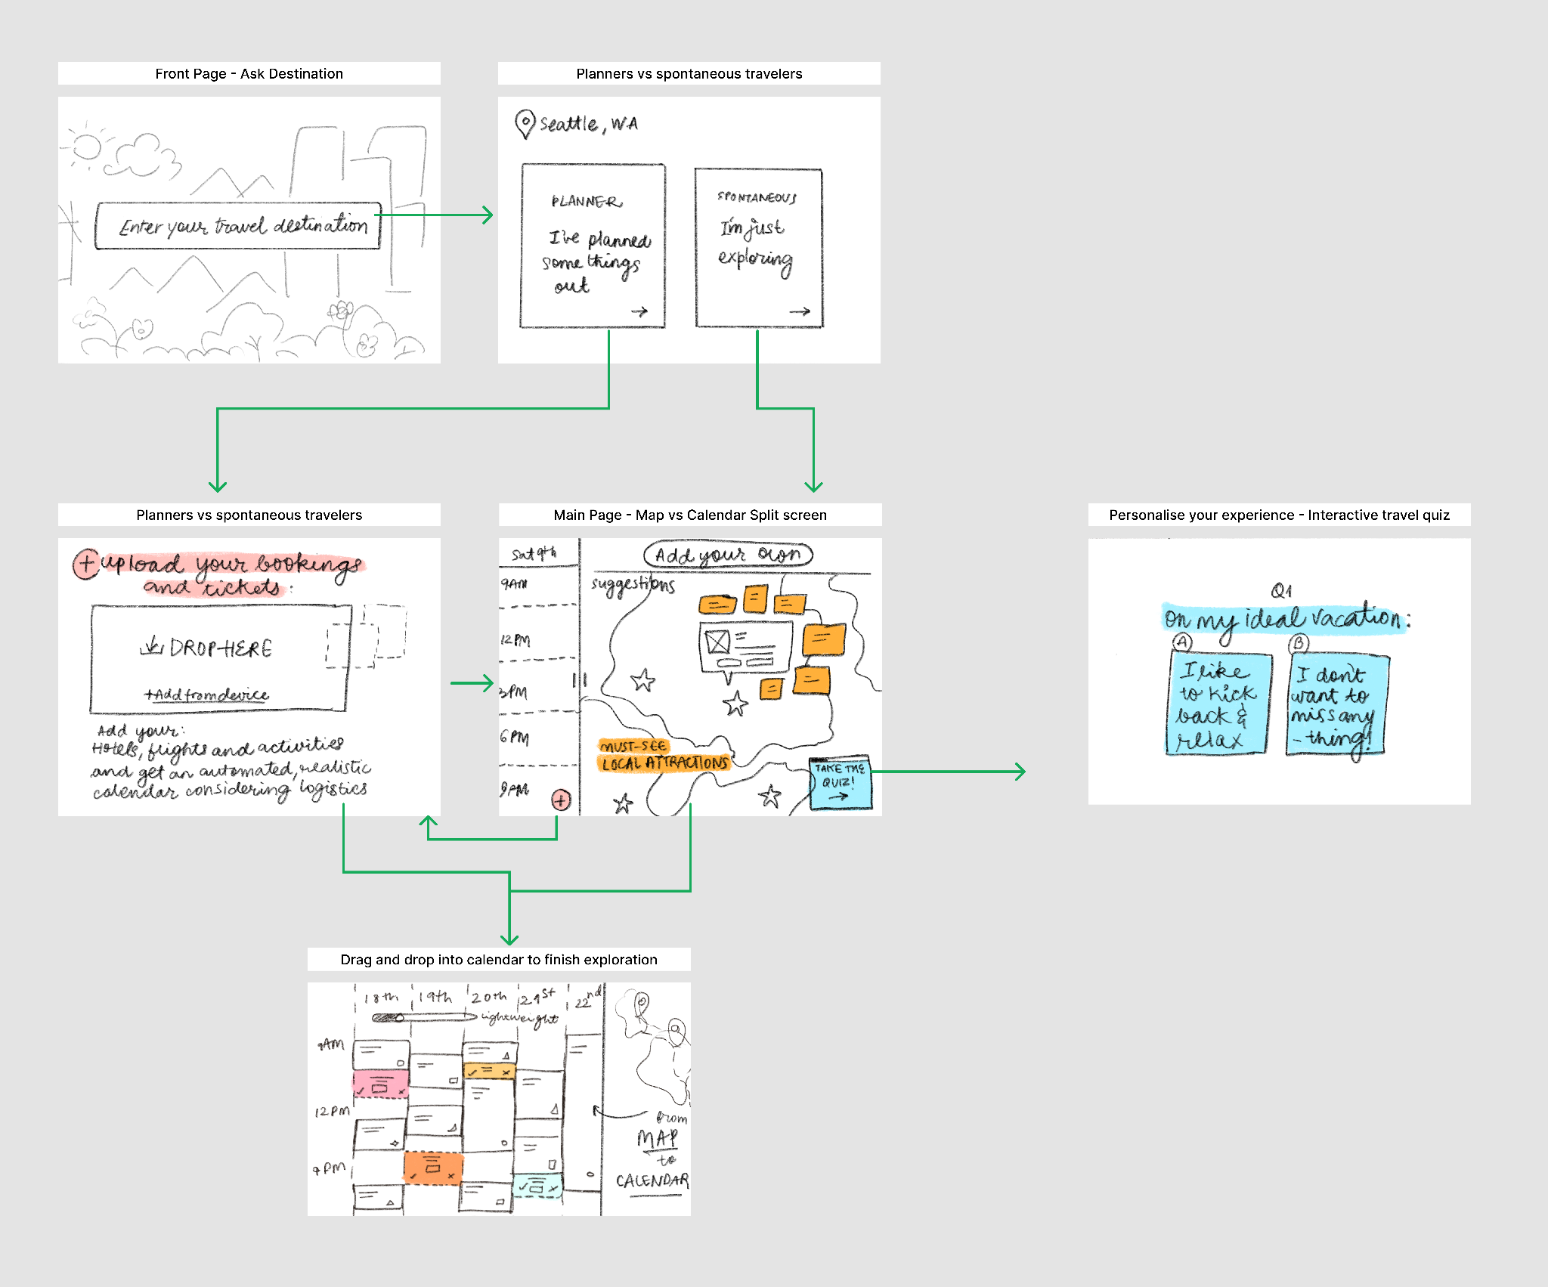

# Analysis and Reporting Plan:

* **Materials:**
  + **Paper prototype:** Our prototype of the application for a travel planning app
  + **Task Rubric:** Evaluates participants’ ability to successfully complete tasks at certain points during the user journey
    - **Metric**: Pass, Pass with Issues, Fail
  + **Task Tracking**: Document that maps out a participant’s actual user journey
  + **Consent Form:** Document consent for recording voice data/video; inform them of anonymization
  + **Pen and Paper:** Note-taking during sessions for any qualitative feedback on the prototype
* **Equipment**
  + **Mobile Devices:** Recording device for collecting audio/video recordings
  + **Google Sheets**: Task tracking data and analysis will be collected here
  + **FigJam**: Visual notes corresponding to the clicks on the prototype and the overall flow
* **Outcomes**
  + **Data Collection**
    - **Task Rubric Data**
      * **Success rate**
      * **Issues:** Each issue will fall under a different category so we can better understand where these pain points reside and how we can iterate on our design to better address them
        + **Navigation Issues**: Issues with how users moved through the prototype

Unexpected flows or actions

* + - * + **Content Issues**: Issues when it comes to how relevant information is for users
        + **Interaction Issues**: Issues related to the design

Unclear CTAs or visual elements

* + - * **Time to complete:** How long did it take for users to navigate to different parts of the prototype? How did issues impact this time?
* **Qualitative Insights & Analysis:** Our team will combine our rubric data, verbal feedback, notes during the session, and post-session analysis to identify common themes and design opportunities to expand on. Some moments to reflect on will include:
  + What were moments where users expressed delight or interest?
  + Did the user make any suggestions for the interface or the flow of events?
  + Did the user give up or resign from the process at any point during the process?
  + What are 3-5 findings that support or challenge our design decisions?

# Citations

SAWATSUK, B., DARMAWIJAYA, I. G., RATCHUSANTI, S., & PHAOKRUENG, A. (2018). Factors Determining the Sustainable Success of Community-Based Tourism: <https://doi.org/10.24088/IJBEA-2018-31002>

Tourism and Sustainable Community Development, edited by Derek Hall, and Greg Richards, Taylor & Francis Group, 2000. ProQuest Ebook Central, https://ebookcentral.proquest.com/lib/washington/detail.action?docID=169850.

United Nations *Tourism Statistics Database*. Retrieved September 27, 2024, from<http://www.unwto.org/tourism-statistics/tourism-statistics-database>

Vanhove, N. (2018). *The Economics of Tourism Destinations: Theory and Practice* (Third edition). Routledge, Taylor & Francis Group.