Logical Database Diagram

- A member borrows one or more borrowings (a member can borrow multiple items).
- A member reserves zero or more reservations (a member can make multiple reservations).
- Every member is a user, but not every user is necessarily a member
- A book can be borrowed in one or more borrowings (a book can be borrowed multiple times over its lifetime).
- A book can be reserved in zero or more reservations (a book can have multiple reservations).
- A borrowing can generate zero or one fine (a borrowing may result in a fine, but not all borrowings have fines).

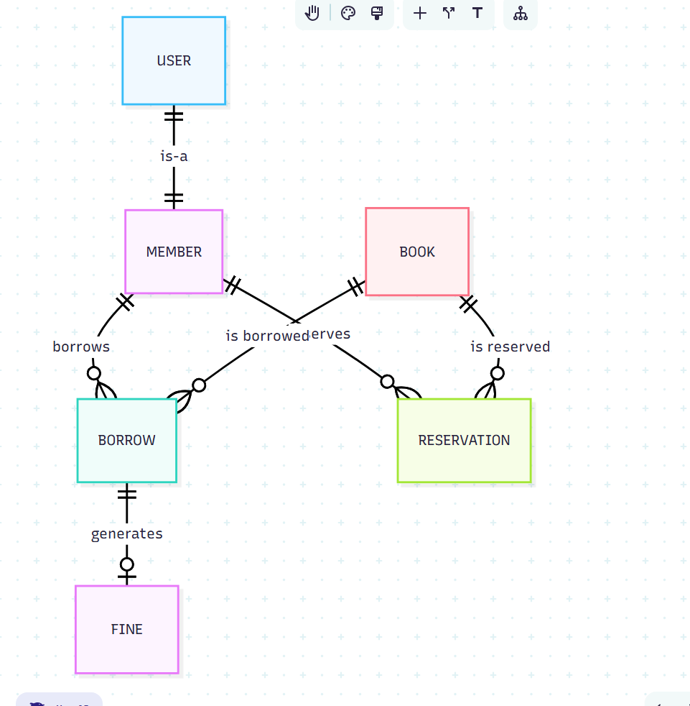

Entity-Relationship Diagram

Entity | Left Relation | Right Relationship | Entity
MEMBER | one-to-one | one-to-many | BORROW
MEMBER | one-to-one | zero-many | RESERVATION
USER | one-to-one | zero-to-one | MEMBER
BOOK | one-to-one | zero-to-many | BORROW
BOOK | one-to-one | zero-to-many | RESERVATION
BORROW | one-to-one | Zero-to-one | FINE

User
Field | Data type | Key | Contraint
id | int | PK
email | string |  | Unique
password_hash | string
full_name | string
phone | phone |  | /[1-9][0-9]*/
address | string
role | string |  | [Admin, Member]

Member
Field | Data type | Key | Contraint
user_id | int | PK, FK
member_id | string |  | Unique
join_date | date
status | status |  | [Active, Suspended, Expired]

Book
Field | Data type | Key | Contraint
id | int | PK
isbn | string |  | Unique
title | string
author | string
category | string
publication_year | date (year)
publisher | string
total_copies | int
available_copies | int |  | <= total_copies

Borrow
Field | Data type | Key | Contraint
id | int | PK
user_id | int | FK
book_id | int | FK
borrow_date | datetime
due_date | datetime |  | borrow_date + 14 days
return_date | datetime |  | >= borrow_date
times_renewed | int |  | <= 2 (default 0)
fine_amount | decimal |  | <= 20.00
is_returned | bool

Reservation
Field | Data type | Key | Contraint
id | int | PK
user_id | int | FK
book_id | int | FK
reservation_date | datetime
expiry_date | datetime |  | reservation_date + 14 days
is_fulflled | bool

Fine
Field | Data type | Key | Contraint
id | int | PK
borrow_id | int | FK
amount | decimal |  | <= 20.00
is_paid | bool
paid_at | datetime

