Group 2, Movie Database

Jeremy Watson, Andrew Kohlhagen, Waleed Mahmoud, Joseph Kwong

## Synopsis

We will create a database to store information about different movies, including where to stream them, with the ultimate goal of helping the user decide which movie to watch. Interaction with the database will be done through a Windows desktop gui. This application’s target users are anyone who is interested in watching movies. The database will store movies and basic information about them, streaming services where the user can watch a specific movie, and a set of actors which star in the movies.

## Functionality

* Search for movies by title, genre, actor, etc.
* List available streaming services for each movie
* Search for movies by streaming service
* Search for all the movies an actor has been in, and the other way around
* View information for each movie

## Database

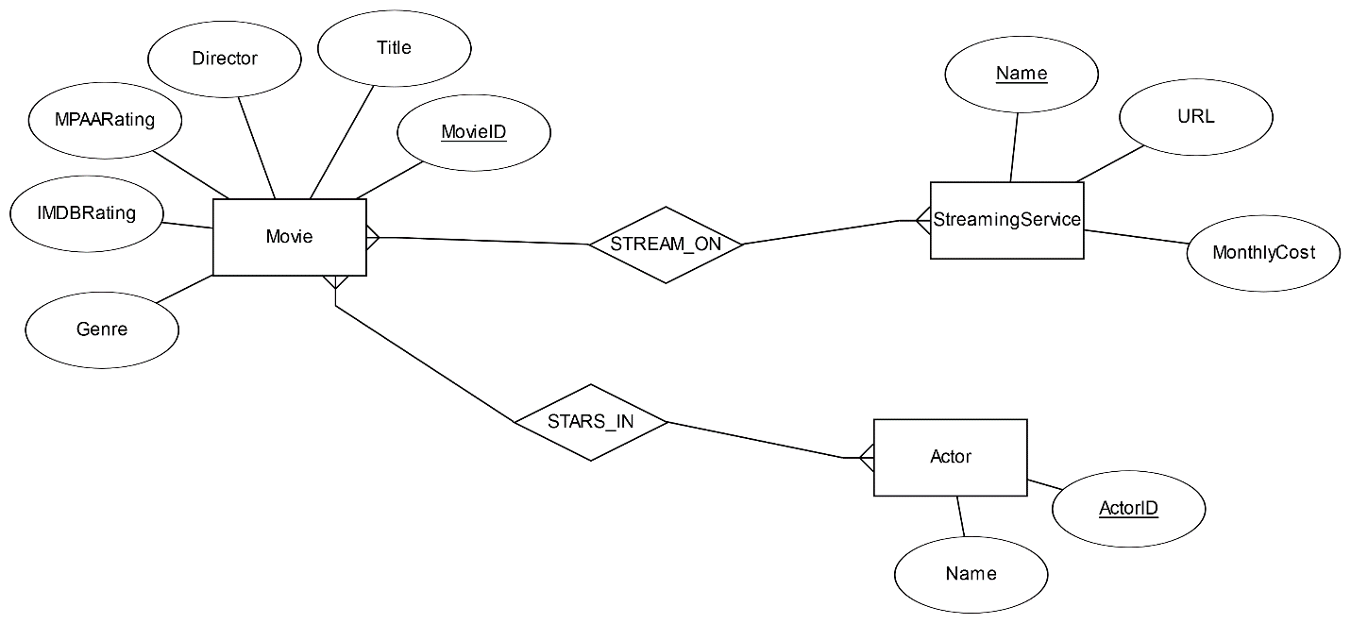

**Movie** – stores different movies and basic information that the user might be interested in.

* MovieID holds a unique id number for each movie
* Title, Director, MPAARating, IMDBRating, and Genre are all included as relevant information for each movie and can serve as ways to search movies.

**Actor** – stores different actors, and serves as an easy way to search for movies by actor

* ActorID holds a unique id number for each actor.
* Name holds the name of the actor.

**StreamingService** – stores streaming services where the user can watch a specific movie

* Name holds the unique name of the service
* URL holds the address of the service
* MonthlyCost holds the monthly cost of the streaming service, which can help inform the user in their decision to watch a particular movie.

**STREAM_ON , STARS­_IN** – relationships that will manifest as tables

## Stakeholders

We envision the users of our program to be anyone interested in movies to the point where they want to easily find a movie to watch and where to watch it.

## Technological Requirements

We will be implementing this project as a desktop application using C# and .NET. We will use SQLite for the database. Our group experience ranges from minimal to moderate with these components. We will be using Visual Studio to build the application.