|  |  |
| --- | --- |
| **Task** | **Man Hour** |
| Implement basic solution for the calculator | 2 |
| Implement the solution for the bracket operation for calculator | 1 |
| Study and set up of Spring Boot project | 2 |
| Integrate of existing calculator solution to Spring Boot | 1 |
| Implement Jquery with Boostrap UI and the JSON service for Calculator | 2 |
| Implement of Junit Test | 0.2 |
|  | 8.2 man hour |

The calculator assignment solution is based on the Spring Boot Web application. Please download **calculator-1.0.war** in the local drive and open command prompt to the location.

Type the command as “java –jar calculator-1.0.war” and it will be appear as below

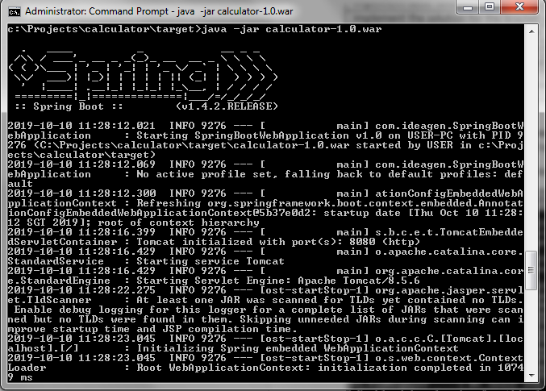

Open the browser and type in the URL as <http://localhost:8080>

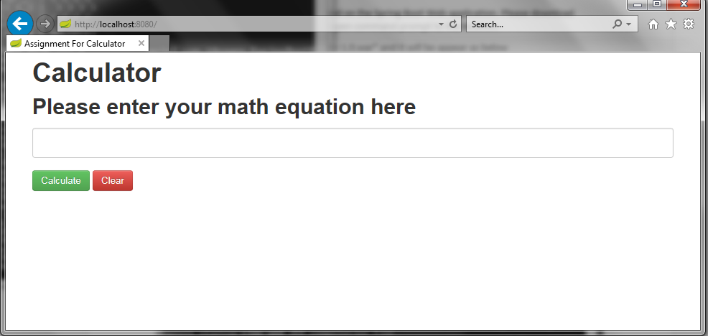

The solution also able to perform the equation calculation by accepting JSON object.

Sample Json format to pass in for the URL <http://localhost:8080/submitEquation>

{

equation :"1 + 2"

}

JSON format that result return as the sample below

{

"result": "3.00",

"status": "Success",

"message": "Success"

}

To do the testing, you may download PostMan as below

