**Interactive Graphics Notes in Class**

**January 19, 2018**

Creating libraries

Jos-MacBook-Pro:p5_hello_world jkwon$ touch index.html

Jos-MacBook-Pro:p5_hello_world jkwon$ touch main.css

Jos-MacBook-Pro:p5_hello_world jkwon$ mkdir libraires

* **Websites (3 languages):**

HTML-words and images, CSS (Cascading style sheet), Javascript (action)

1. doc-basic html written out
2. index.html -> it’s the main…other pages are communicating with index
3. main.css title

#title{

color: red;

}

1. sketch.js

function setup(){

createCanvas(800, 800);

}

function draw(){

fill(255, 0, 0);

rect(400, 400, 200, 200);

ellipse(400, 100, 20, 20);

}

1. Go live

* Questions

1. several sketches?

-iframes

-Instantiation Cases <https://github.com/processing/p5.js/wiki/Instantiation-Cases>

1. Sketches in function draw() later part seems to override the previous shapes. How can I stop that? All of the examples only have one shape in the function draw() so…

-3D overrides 2D

-backgorund() should only be written only once!

background(0, 191, 255);

* HW

-Draw some other shapes, try html and css. -Blogpost (on word page, 2 paragraphs)

->Task: Write a short blog post in Microsoft Word on at least two pieces that you’re interested in. What drew you to them? What do you find interesting about them? How are users expected to interact with the pieces? Download a few pictures of each piece and include links. No more than a paragraph for each piece.

1. *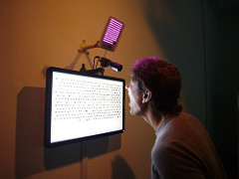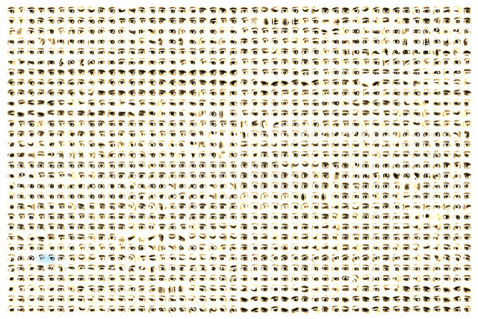Eyecode* (2007) by Golan Levin : http://www.flong.com/projects/eyecode/

I was looking through Golan Levin’s work and this piece instantly caught my attention. All the different eyes of all the views of the art are displayed on the screen. It’s interesting how the art work is interacting with the viewers. It captures the viewers’ eyes and they can find their own eyes when they blink. They can also look at other people’s eyes that have been captured. This allows viewers to also interact with other viewers. They can see how other people have been viewing the display. Levin’s *Eyecode* is interactive so it’s constantly changing, and it can never be the same. The constant change in the art is another uniqueness that attracted me.

1. *Lumen* by Arvind Sanjeev (http://www.creativeapplications.net/environment/lumen-mixed-reality-storytelling-device/)

I’ve read many articles about augmented and virtual reality. However, this work is beyond what I have imagined of virtual reality. This mixed reality has so many possibilities in art and other parts of the society. As the video mentions, it can be used in museums, cities, and escape rooms. Story telling will not be limited on screens, VR glasses, or smartphones. Most museums use headphones for explanations of the art works but *Lumen* will allow it to go beyond headphones. Headphones are limited in giving information because only narratives can be delivered to the visitors. *Lumen* will give more information with its moving projections. In cities, *Lumen* can be used as a tour guide. In *Does place affect user engagement and understanding? Mobile learner perceptions on the streets of New York* by Anthony Cocciolo and Debbie Rabina, people learn about New York by using a GeoStoryteller, a program with a place-based learning, for two hours. The article states advantages and disadvantages of the program which is on the boundary line between augmented and mixed reality. Many of them were frustrated using technology with the glitches and the overcrowded population of New York. Although Lumen may have similar problems to GeoStoryteller, it would definitely be more user friendly than using an iPad.

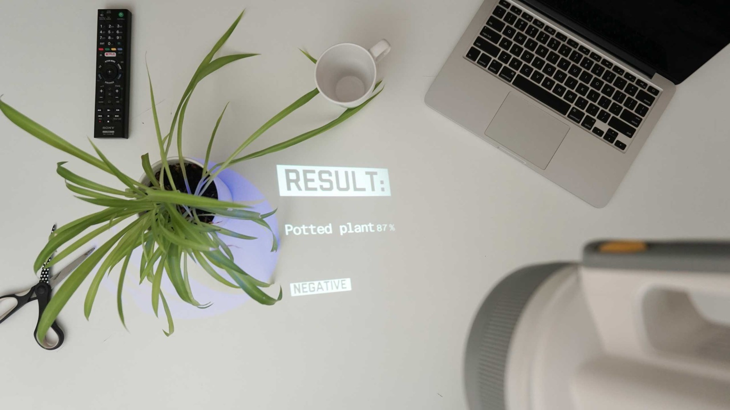

**January 24 & 26, 2018**

* How to put code on github

-download git

-what is git? Keep track

git init

git status : track files

git add . : all of the files

git commit -m "added circle"

git remote add origin https://github.com/kwonjo/helloworld_interactivegraphics.git

git push -u origin master : upload to github

git status

git add .

git commit -m “added sth”

git push -u origin master

-branch: new ideas from the main idea

**Review**

* Coordinate system

function setup(){

createCanvas(x,y); ->size of the canvas

}

where we set up the variables, canvas, artist’s set up their canvas and everything in this place

pixel scale

|  |  |
| --- | --- |
|  | (0,0) |
|  | Working here all the time |

rect(x ,y, width, height)

rect(x,y,w,h,[tl],[tr],[br],[bl])

rect(x,y,w,h,[detailX],[detailY])

ellipse(x,y,w,[h])

* Color system

fill(R, G, B)

fill(Black to White)

* HW   
  1. code: algorithm as art

-push your ideas to art or functional ideas

2. blog post

-Task: How did it feel? Are there any parts that were confusing or that you particularly struggled with? Are there any areas that moved too slowly or quickly for you? What is your plan of attack moving forward to overcome these obstacles?

The function draw was confusing at the beginning of the drawings because the shapes would disappear. I found out that I was having several backgrounds which were overlapping each other. The analogy of function setup is the artist setting up the canvas and function draw as the beginning of drawing on the canvas was helpful. We briefly talked about using multiple canvases through iframe and I hope we elaborate a little more on the topic. Although the first class was a bit quick, the review that we did today clarified many areas. I hope we often get to review technical problems like today. In order to overcome the problems, googling and looking up the p5js references and examples will be my solution. Today I was having problem inserting mp3 sound file on the canvas and the references and examples helped me to succeed into having music on my canvas.

**Notes on Digital Art by C. Paul**

* Chapter 1: Digital Technologies as a Tool

-digital medium allows for multiple kinds of manipulation and a seamless combination of art forms, blurring the distinctions between different media