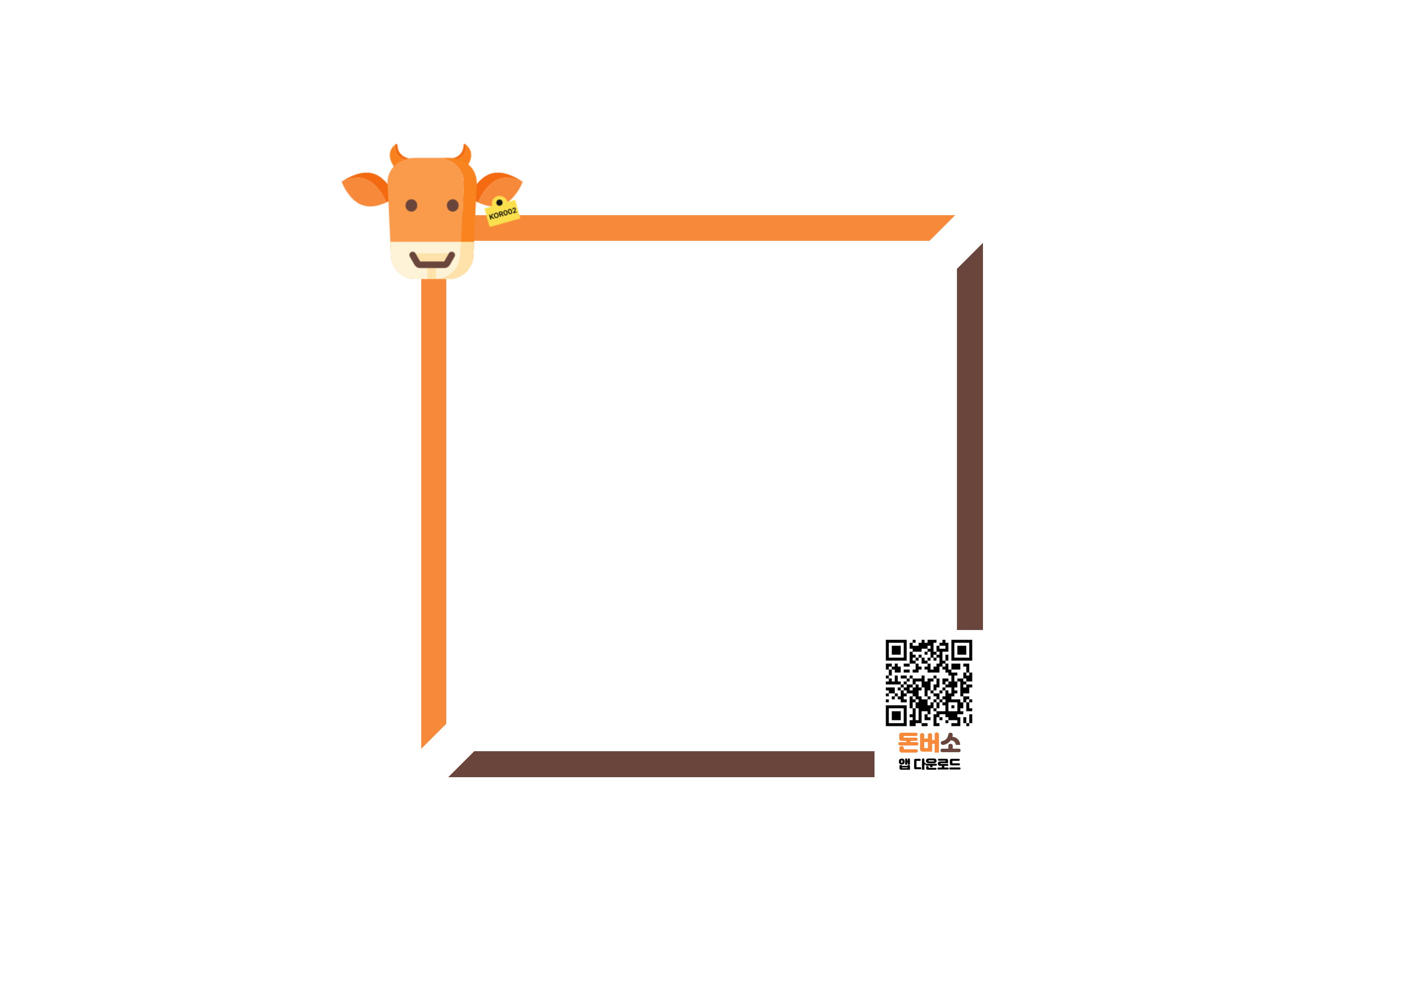

**한우**

**유전체 보고서**

**JBNU 농장**

|  |  |  |
| --- | --- | --- |
| **03** |  | **개체별 유전능력** |

|  |  |  |  |  |
| --- | --- | --- | --- | --- |
|  | **개체번호** | sample_10_20 | | |
| **SNP chip** | Illumina Hanwoo 50K Beadchip | | |
| **생년월일** | unknown | **성별** | unknown |
| **친자확인결과** | unknown | **친자정확도** | nan% |
| **형질** | **전체 평균** | **개체 능력** | **등급** |
| **도체중-CWT** | 0.0084 | 51.84 | SS |
| **등심단면적-EMA** | -0.0093 | 8.12 | S |
| **등지방두께-BFT** | -0.0009 | -0.49 | B |
| **유전능력** | **근내지방-MAR** | -0.0032 | 0.73 | A |

**▶ 형질별 개체 순위 백분율**

|  |  |  |  |
| --- | --- | --- | --- |
| **도체중** | **등심단면적** | **등지방두께** | **근내지방** |
|  |  |  |  |

|  |  |  |
| --- | --- | --- |
| **03** |  | **개체별 유전능력** |

|  |  |  |  |  |
| --- | --- | --- | --- | --- |
|  | **개체번호** | sample_151 | | |
| **SNP chip** | Illumina Hanwoo 50K Beadchip | | |
| **생년월일** | unknown | **성별** | unknown |
| **친자확인결과** | unknown | **친자정확도** | nan% |
| **형질** | **전체 평균** | **개체 능력** | **등급** |
| **도체중-CWT** | 0.0084 | 48.15 | S |
| **등심단면적-EMA** | -0.0093 | -0.05 | C |
| **등지방두께-BFT** | -0.0009 | -0.91 | B |
| **유전능력** | **근내지방-MAR** | -0.0032 | 0.3 | B |

**▶ 형질별 개체 순위 백분율**

|  |  |  |  |
| --- | --- | --- | --- |
| **도체중** | **등심단면적** | **등지방두께** | **근내지방** |
|  |  |  |  |

|  |  |  |
| --- | --- | --- |
| **03** |  | **개체별 유전능력** |

|  |  |  |  |  |
| --- | --- | --- | --- | --- |
|  | **개체번호** | sample_155 | | |
| **SNP chip** | Illumina Hanwoo 50K Beadchip | | |
| **생년월일** | unknown | **성별** | unknown |
| **친자확인결과** | unknown | **친자정확도** | nan% |
| **형질** | **전체 평균** | **개체 능력** | **등급** |
| **도체중-CWT** | 0.0084 | 29.94 | S |
| **등심단면적-EMA** | -0.0093 | 4.66 | A |
| **등지방두께-BFT** | -0.0009 | -0.63 | B |
| **유전능력** | **근내지방-MAR** | -0.0032 | 0.19 | B |

**▶ 형질별 개체 순위 백분율**

|  |  |  |  |
| --- | --- | --- | --- |
| **도체중** | **등심단면적** | **등지방두께** | **근내지방** |
|  |  |  |  |