**1)** Paste this URL into Microsoft Edge [Web Browser]:

<https://github.com/kwonus/AV-Addin-Wix5-Installer/raw/main/bin/x64/Release/en-US/AV-Addin-Wix5-Installer.msi>

*(requires Microsoft Windows 11 and Microsoft Word)*

AV-Bible Addin for Microsoft Word is now generally available (AG) and can be found at the link above.

Unlike most bible search/study/publishing tools, this Addin runs directly inside of Microsoft Word, allowing focus on writing, and obviating the need to switch between disparate applications. This Addin represents the culmination of a multi-year, solo, independent development effort. Here is what it does:

* Ability to insert verses or entire bible chapters, with formatting and labels, directly into the currently open Microsoft Word document.
* Ability to search the sacred text with a fuzzy search technique, based upon phoneme embeddings using my NUPhone library with a Manhattan Distance algorithm.
* Ability to precisely specify inter-word proximity and/or word order when searching using Search-for-Truth (S4T), a purpose built query language defined and built specifically for searching and rendering text in the AV-Bible Addin.
* Ability to search/insert either KJV or modernized-KJV text. The modernized text is not NKJV. Instead, it is transformation of the KJV bible by incorporating a parallel/modernized lexicon that renders the KJV in contemporary English (but not excessively so). "Hath" becomes "has", for example, but words like "Godhead" and "throughly" are left untouched.
* It is the only free and open source bible study tool that runs inside of Microsoft Word. It is also far more capable than even tools that run as standalone apps. In a code-signed installer, by someone that you trust (yours truly).

Installation instructions are provided herein

cost = free

**2)** Click on the downloads button, represented by a down-arrow [ 🡫 ]:  
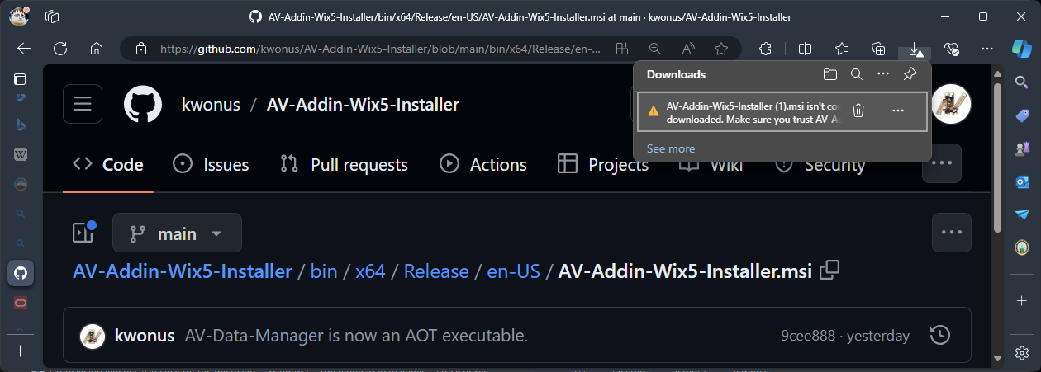

This action will download the AV-Bible Addin for Microsoft Word Installation program to your downloads folder. However, Windows is designed to protect your PC from malicious attacks. Consequently, there’s several extra steps required to tell Windows that you actually downloaded this file on purpose and that you’d like to keep it.

**3)** Click on the ellipsis [ … ] and then click [ keep ]:  
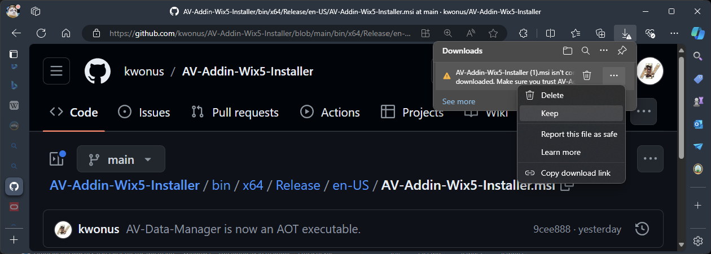

**4)** Click on [ Show more ⏷ ]

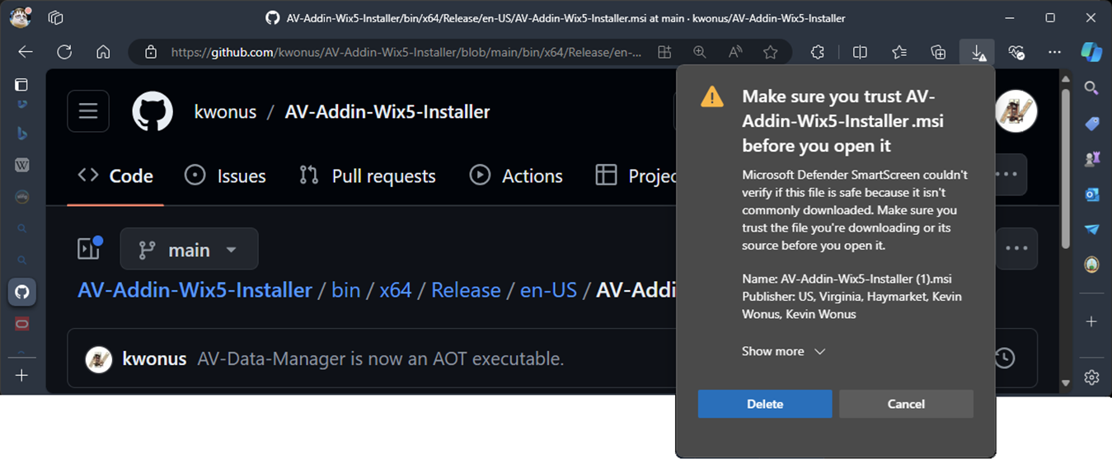

**5)** Click on [ Keep anyway ]

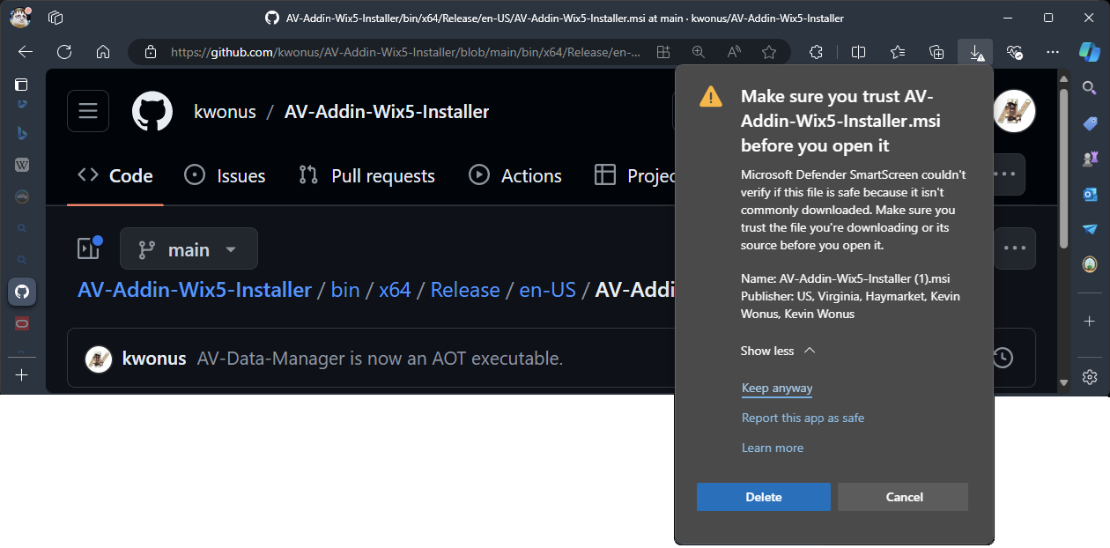

After you click on [ Keep anyway ] , the AV-Bible Addin for Microsoft Word Installation program will be permitted by Windows on your PC.

**6)** Click on [ Open file ]

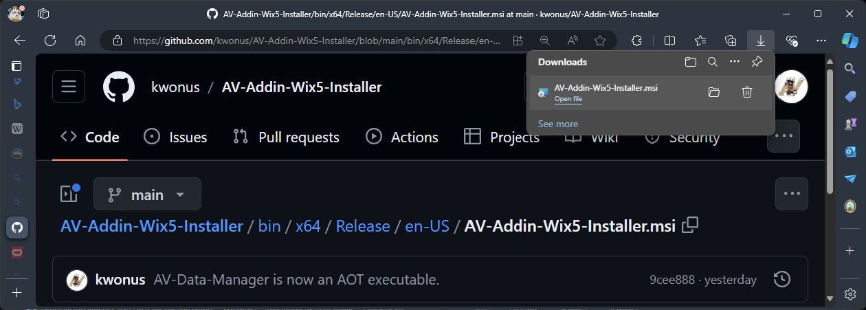

Clicking [ Open file ] will initiate the installation of AV-Bible Addin for Microsoft Word on your PC.

**7)** Click on [ Yes ]

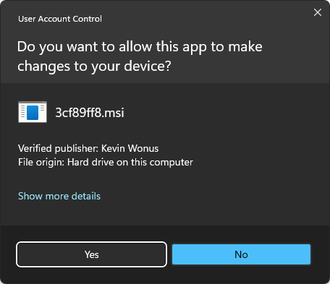

Optionally, you can click on [ Show more details ] which provides additional information about the installation program. You should see:

* Verified Publisher: Kevin Wonus

If it does not show Kevin Wonus as the publisher, then discontinue the installation. This installation program is code-signed to assure you that it can be trusted.

The name 3cf89ff8.msi may actually be different on your PC. This need not be concerning, so long as the verified publisher is a match.

**8)** Type “firewall” in the Search area of the Windows taskbar, and click on [ Windows Defender Firewall ]

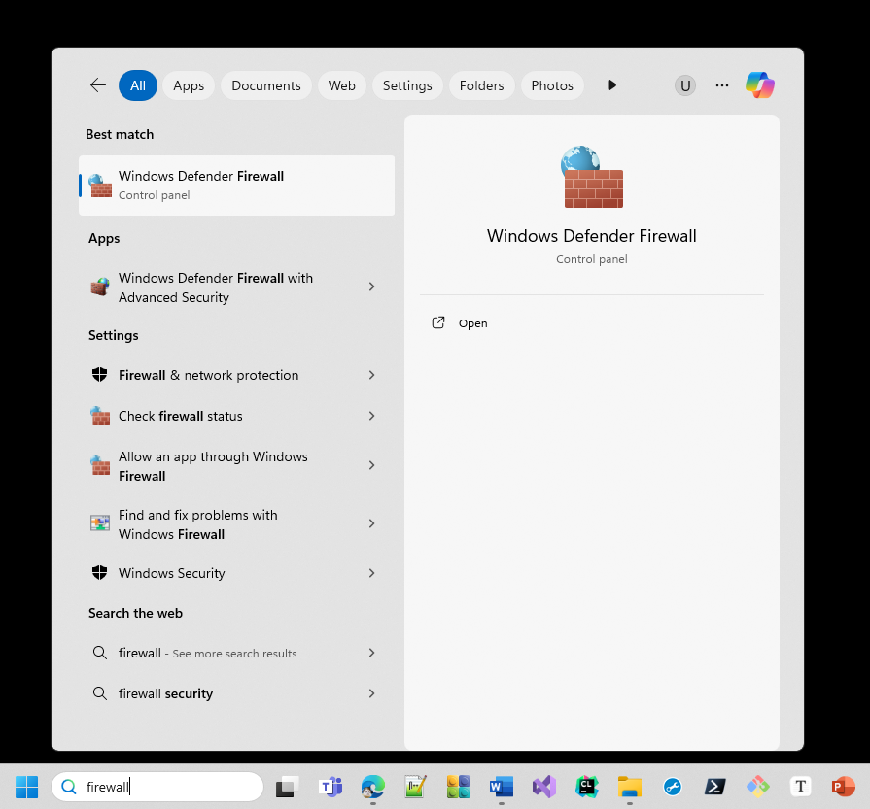

This will launch the settings dialog for Windows Defender Firewall. We need to tell Windows that the AV-Data-Manager is an application that is permitted by the firewall. AV-Data-Manager delivers data to the AV-Bible Addin for Microsoft Word using a tiny web-server that delivers bible content and search capabilities via an HTTP REST interface. This program is required for the Addin to function correctly.

**9)** Click on [ Allow an app or feature through Windows Defender Firewall ]

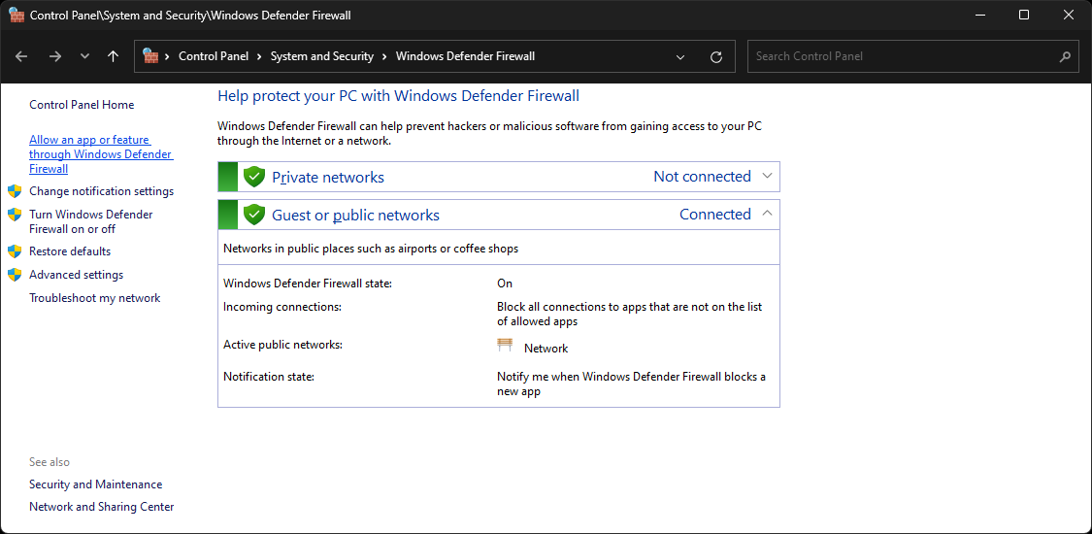

**10)** Click on [ Change settings ]

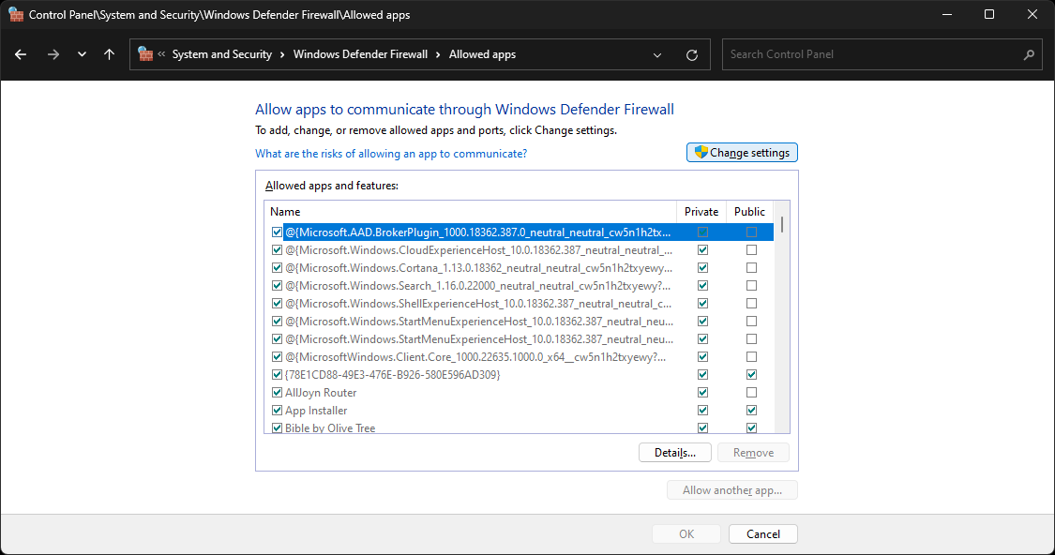

**11)** Click on [ Allow another app… ]

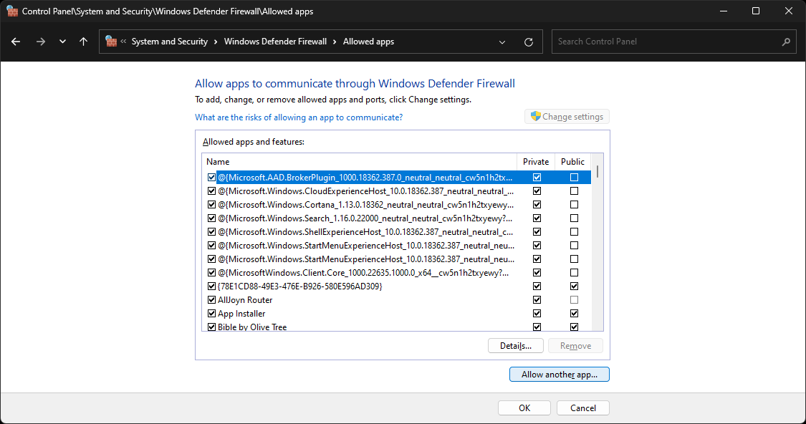

**12)** Click on [ Browse ]

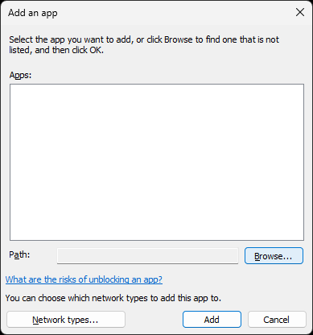

**13)** Open the folder “C:\Program Files\Digital-AV\AV-Bible-Addin\Manager” and select [ AV-Data-Manager ] or [AV-Data-Manager.exe ]

Then click [ Open ]

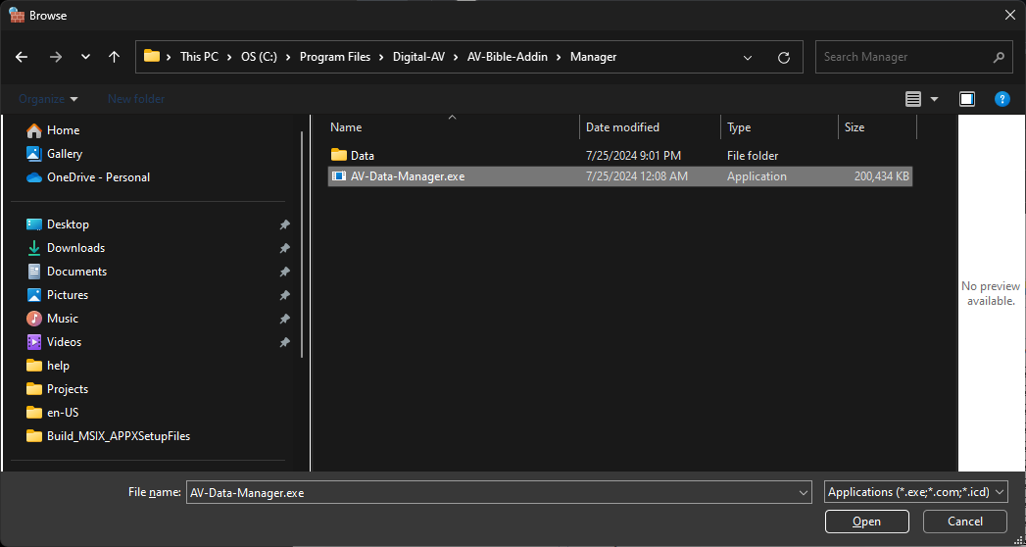

This is the location that the installation program placed AV-Data-Manager. Depending on your settings. It might not show the .exe extension on the filename. It might just show “AV-Data-Manager”. There are extra steps to finish adding this application to the allowed list. Continue on with steps #14 and #15 to complete the installation and authorization. Steps #1 thru #15 need only be done once.

**14)** Click [ Add ]

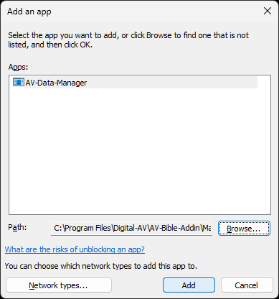

**15)** Click [ OK ]

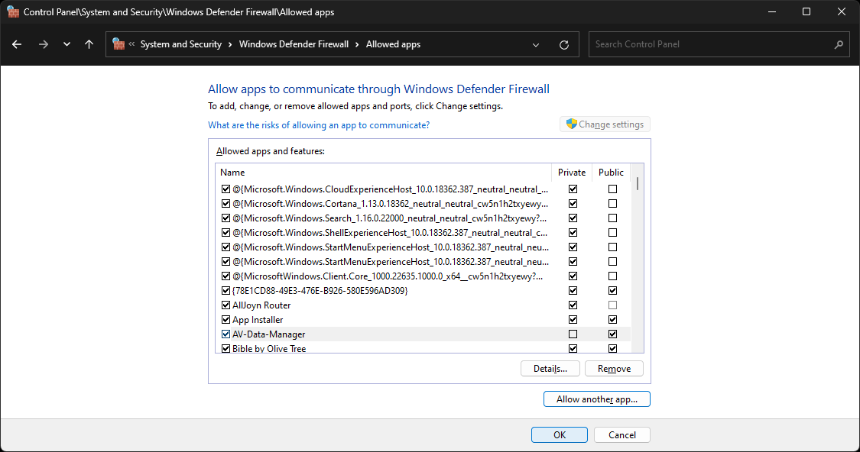

Whew! We’re almost done. Don’t forget to logout or restart 😊

**16)** Logout of Windows or Restart Windows

**17)** Open Microsoft Word

You should now see two new tabs [ Old Testament ] and [ New Testament ]

Click on either:

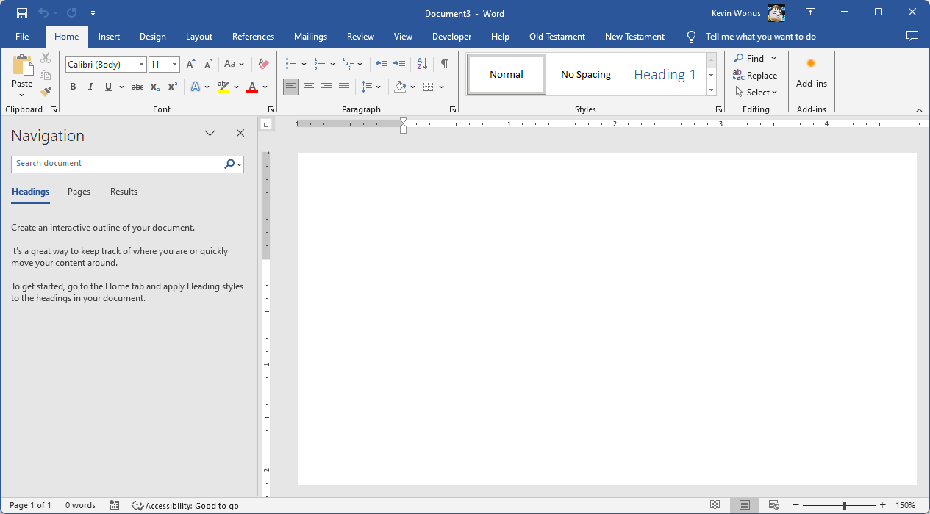

You are presented with three basic functions on either of these tabs:

* You can **click on a book**, which is the most direct way of inserting a verse or chapter from that chosen book
* You can click on [ **Insert Any Verse** ] … this does substantially the same thing, but allows you to choose any book: Old or New Testament
* You can click on [ **Find Any Verse** ] … regardless of which tab you selected, this finds verses in any book: Old or New Testament

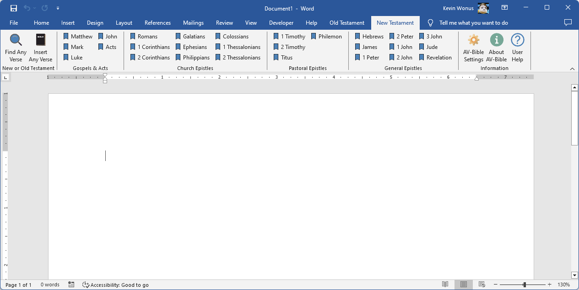

Two additional buttons are [ AV-Bible Settings ] and [ User Help ]. This latter button provides additional help on the usage of the AV-Bible Addin, including the available settings and how they effect search and search results.