**PowerShell Commands (runas admin):**

(1)  
New-SelfSignedCertificate -Type Custom -Subject "CN=DigitalAV, O=DigitalAV, C=US" -KeyUsage DigitalSignature -FriendlyName "Self-Signed DigitalAV cert…

$pswd = ConvertTo-SecureString -String 'foobar' -Force -AsPlainText

Export-PfxCertificate -cert Cert:\CurrentUser\My\EB860342ABBEBACCB1E20170D074B6C5FEE17F5F -FilePath C:\src\DAV-Self-Signed.pfx -Password $pswd

EB860342ABBEBACCB1E20170D074B6C5FEE17F5F is the thumbprint from above

(2)

Add this cert in advanced-installer

(3)

Right click on advanced-installer-generated MSIX and select <Properties>

Then follow instructions in dialogs.

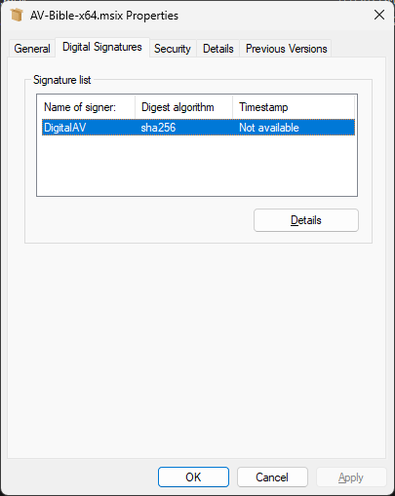  
  
(4)  
Choose <Digital Signatures> tab

Choose cert and use <Details> button

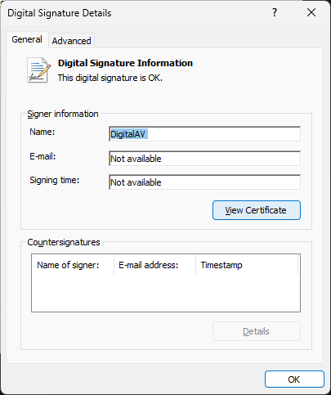

(5) Use <View Certificate> button

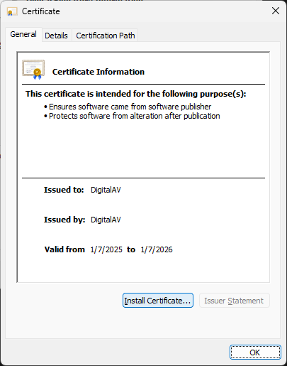

(6) Use <Install Certificate> button

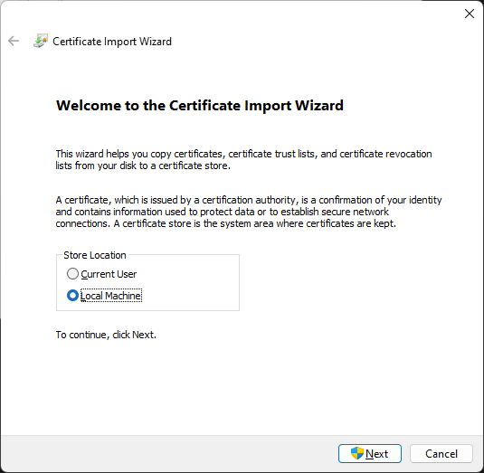

(7) Choose <Local Machine>

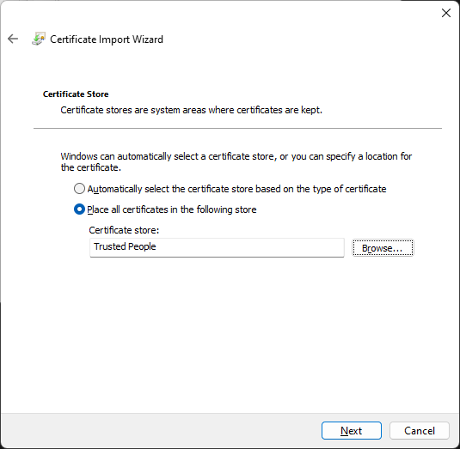

(8) Choose <Place all certifcates in the following store>

The <Browse> to “Trusted People”