Consider this phoneme inventory chart for English from the American Speech-Language-Hearing Association:

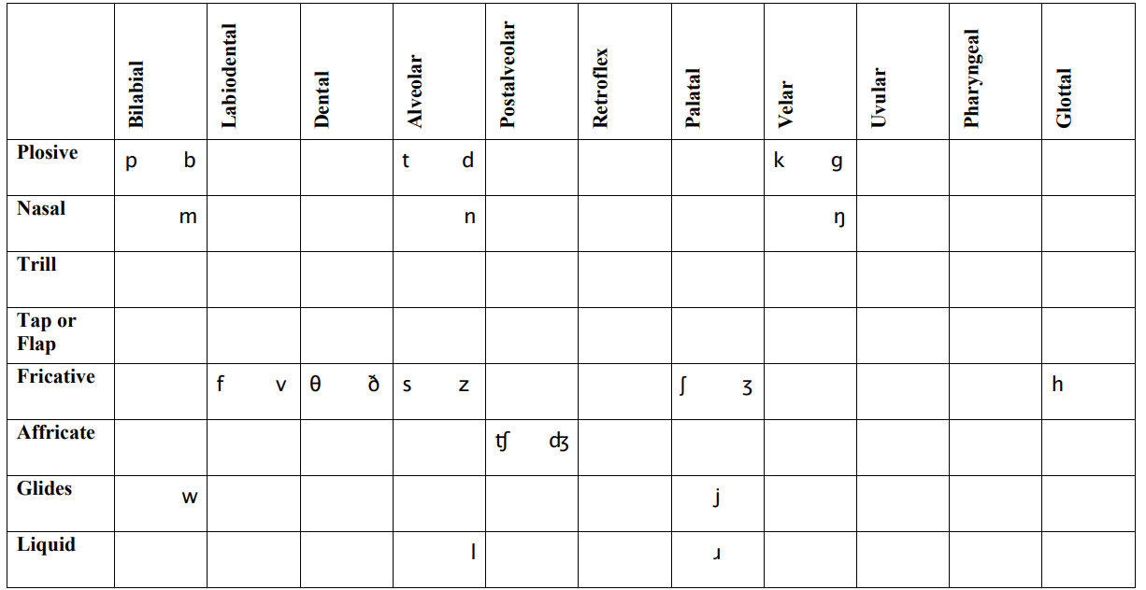

We simplify it with respect to NUPhone as this:

|  |  |  |  |  |  |  |  |  |  |
| --- | --- | --- | --- | --- | --- | --- | --- | --- | --- |
|  | Bilabial | Labiodental | Dental | Alveolar | Palatal | Velar | Glotal |  |  |
| Plosive | p b |  |  | t d |  | k d |  | 2 | 2 |
| Nasal | m |  |  | n |  | ŋ |  | 1 | 1 |
| Fricative |  | f v | Θ ð | s z |  | ʃ ʒ | h | 0 | 4 |
| Glides | w |  |  |  |  |  |  | -1 | 5 |
| Liquid |  |  |  | l | ɹ |  |  | -2 | 6 |
|  | -3 | -2 | -1 | 0 | 1 | 2 | 3 |  |  |
|  | 7 | 6 | 5 | 4 | 1 | 2 | 3 |  |  |

Note that we delete all blank rows and columns in the inventory. The affricate is also deleted, because in English NUPhone, we represent t͡ʃ as t|ʃ and d͡ʒ as d|ʒ. Using uncertainty here aids is fuzziness for comparison purposes.

Also note that while two phonemes can exist in a single cell, we treat it as a single numeric. This is because we track voicing with its own distinct bit.

Effectively, we always represent 0 in our 3-bit integers as -0. This tells us that zero is explicitly set (The 3-bit sequence will never actually contain zero. Zero is always represented by 4 (or -0).

We do the same thing for the vowel chart, assigning numerics to vowell positions. The middle of the chart is (0,0). We refer to Centerness and Middleness.

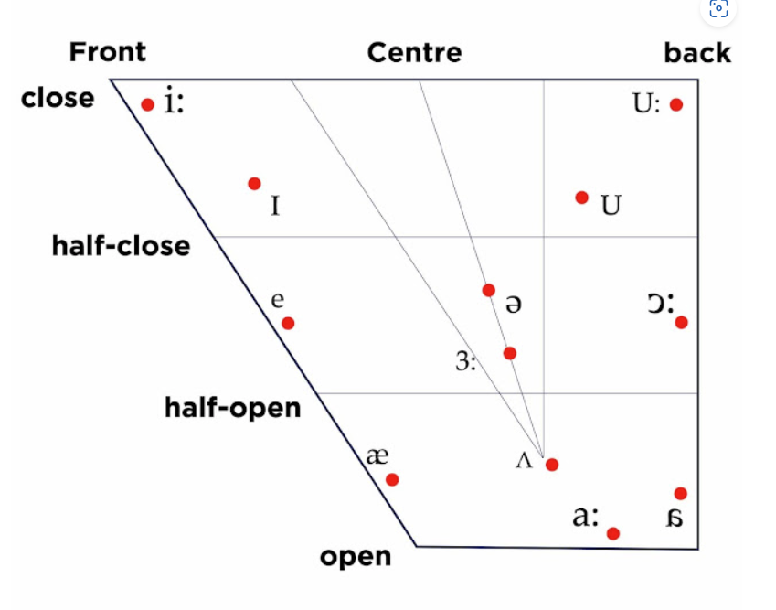

|  |  |  |  |  |  |  |  |  |  |  |
| --- | --- | --- | --- | --- | --- | --- | --- | --- | --- | --- |
|  | Front | Center | Back |  |  |  |  |  |  | |
| close | i |  | u | 2 | 2 |  | | | |
| ½ close | ɪ |  | ʊ | 1 | 1 |  | | | |
| middle | e | ə |  | 0 | 4 |  |  |  |  |
| ½ open | ɛ | ɜ | ɔ | -1 | 5 | (0x4 is the negative bit) | | | |
| open | æ | ʌ ɑ | ɐ | -2 | 6 | (0x4 is the negative bit) | | | |
|  | -1 | 0 | 1 |  |  |  |  |  |  | |
|  | 5 | 4 | 1 | (0x4 is the negative bit) | | | |  |  | |

**Bit mappings**

|  |  |  |
| --- | --- | --- |
| Description | Mask | Values |
| Phoneme-type: 2 bits | 0xC_ | 0x0_: vowel  0x8_: consonant-unvoiced  0xC_: consonant-voiced  0x4_: undefined |
| Vowel Middle-ness: 3 bits (only 2-bit needed) | 0x38 | see middle-ness in vowel table |
| Vowel Center-ness: last 3 bits | 0x07 | see center-ness in vowel table |
| Consonant: Place or articulation: 3 bits | 0x38 | see consonant table |
| Consonant: Manor or articulation: last 3 bits | 0x07 | see consonant table |

This means that we can store all phoneme embeddings for English NUPhone in an 8-bit integer (1 byte)

Each three-bit signed integer has a distance measurement. Distances of the two dimensions are additive. If we use percentage-like scores, we can establish these consonant scoring heuristics.

Not a consonant: 0%

Distance == 0 🡪 Similarity: 100%

Distance == 1 🡪 Similarity: 98% [-2%]

Distance == 2 🡪 Similarity: 94% [-4%]

Distance == 3 🡪 Similarity: 86% [-8%]

Distance == 4 🡪 Similarity: 70% [-16%]

Distance >= 5 🡪 Similarity: 38% [-32%]

Consider these two phonemes: k & ð

|  |  |  |  |  |  |  |  |
| --- | --- | --- | --- | --- | --- | --- | --- |
|  | Bilabial | Labiodental | Dental | Alveolar | Palatal | Velar | Glotal |
| Plosive | p b |  |  | t d |  | k d |  |
| Nasal | m |  |  | n |  | ŋ |  |
| Fricative |  | f v | Θ ð | s z |  | ʃ ʒ | h |
| Glides | w |  |  |  |  |  |  |
| Liquid |  |  |  | l | ɹ |  |  |

Manner delta = 2

Place delta = 3

Distance (2 + 3) = 5 🡪 Similarity: 38%

Voicing penalty = -1% 🡪 Similarity: 37%

**And a similar heuristic for vowels:**

Not a vowel: 0%

Distance == 0 🡪 Similarity: 100%

Distance == 1 🡪 Similarity: 99% [-1%]

Distance == 2 🡪 Similarity: 97% [-2%]

Distance == 3 🡪 Similarity: 93% [-4%]

Distance >= 4 🡪 Similarity: 85% [-8%]

Consider these two phonemes: ʊ & ə

|  |  |  |  |
| --- | --- | --- | --- |
|  | Front | Center | Back |
| close | i |  | u |
| ½ close | ɪ |  | ʊ |
| middle | e | ə |  |
| ½ open | ɛ | ɜ | ɔ |
| open | æ | ʌ ɑ | ɐ |

Middle-ness delta = 1

Centrality delta = 1

Distance (1 + 1) = 2 🡪 Similarity: 97%