**SMAT 2022**

**Semiconductor Manufacturing with AMHS Testbed 2022**

Release 0.1 – 11/2022

# Introduction

The purpose of this document is to describe Semiconductor Manufacturing with AMHS Testbed 2022 (SMAT2022). SMAT2022 contains 16 different types of tables: 7 tables from SMT2020 and nine new tables describing AMHS in modern FABs. A summary of the purpose of tables is as follows:

|  |  |
| --- | --- |
| **Table** | **Description** |
| Address | Information on all nodes of an OHT rail network and their characteristics |
| ZCU | Information on ZCUs (Zone Control Units) |
| Rail | Information on all links of an OHT rail network |
| Bay | Information on bays (Intrabay and Interbay) |
| Equipment | Information on equipment belonging to toolgroup |
| PortType | Information about the types of ports that interact with vehicles |
| Port | Information on ports |
| VehicleType | Information on the types of vehicles |
| Vehicle | Information on vehicles |

## Description of ZCU

In this dataset, we represent an OHT rail network as a graph consisting of nodes and links. In this section, we briefly introduce some terminology about the OHT rail network. OHT can drive following the rails in one direction. Usually, deadlock situations can happen in merging sections, as shown in Fig. 1. This dataset includes zone control units (ZCU). ZCUs are located at every junction in the OHT network. It keeps OHT to avoid deadlock situations. For each ZCU, there are stop nodes and reset nodes. When an OHT arrives at a stop node of a ZCU, the ZCU allows the OHT to pass that junction. If another vehicle arrives during the OHT passing, the ZCU blocks it from passing to prevent deadlock situations. For example, as shown in Fig. 1, there is one ZCU. n1 and n2 are stop nodes of that ZCU. In contrast, n3 is a reset node.

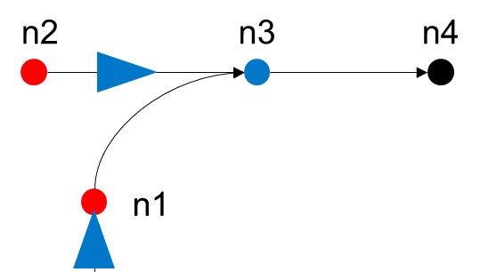

Fig. Example of OHT network

# Description of the tables

Each table will be described briefly in this section. A description of each column will be provided.

## Address

|  |  |
| --- | --- |
| **Column** | **Description** |
| NAME | The name of node |
| POSITION_X | X coordinate of node |
| POSITION_Y | Y coordinate of node |
| ZCU_NAME | The name of connected ZCU |
| ZCU_TYPE | Node type for ZCU (STOP/RESET) |

## ZCU

|  |  |
| --- | --- |
| **Column** | **Description** |
| NAME | The name of zone control unit |

## Rail

|  |  |
| --- | --- |
| **Column** | **Description** |
| NAME | The name of link |
| BAY_NAME | The name of bay containing the link |
| FROM_NODE | The name of the node at the origin of the link |
| TO_NODE | The name of the node at the end of the link |
| MAX_SPEED | The maximum rate of OHT on the link |
| CURVE | Whether the link is curved |

## Bay

|  |  |
| --- | --- |
| **Column** | **Description** |
| NAME | The name of bay |
| TYPE | The type of bay (Interbay/Intrabay) |
| RETICLE | Whether the bay is reticle bay |
| NEIGHBOR_BAY | The names of neighboring bays |

## Equipment

|  |  |
| --- | --- |
| **Column** | **Description** |
| NAME | The name of equipment |
| TOOL_GROUP | The name of toolgroup that containing equipment |
| BAY | The name of the bay in which equipment is located |
| WIDTH | equipment width |
| HEIGHT | equipment height |
| POSITION_X | X coordinate of equipment |
| POSITION_Y | Y coordinate of equipment |

## PortType

|  |  |
| --- | --- |
| **Column** | **Description** |
| NAME | Port type name |
| SIZE | The size of port type |
| INOUT_TYPE | Connection Type (IN/OUT/BOTH) |

## Port

|  |  |
| --- | --- |
| **Column** | **Description** |
| NAME | The name of port |
| PORT_TYPE | Type of port (From PortType table) |
| EQP_NAME | The name of equipment connecting with port |
| RAILLINE_NAME | The name of link to dock with port |
| DISTANCE | The position on the link to dock with port |

## VehicleType

|  |  |
| --- | --- |
| **Column** | **Description** |
| NAME | Vehicle type name |
| SIZE | The size of vehicle on the link |
| MAX_SPEED | The maximum speed of vehicle (mm/s) |
| ACCELERATION | The acceleration specification of vehicle (mm/s^2) |
| DECELERATION | The deceleration specification of vehicle (mm/s^2) |
| MIN_DISTANCE | The minimum distance gap between vehicles |

## Vehicle

|  |  |
| --- | --- |
| **Column** | **Description** |
| NAME | The name of vehicle |
| TYPE | Type of vehicle (From VehicleType table) |
| RAILLINE_NAME | The name of link where the vehicle is initially located |
| DISTANCE | The initial position on link of vehicle |