Stacks of Wax Report – Kiera Wright 40079955

For this project I have created a vinyl collection website, this site allows non-members to view vinyl’s and vinyl collections, with members able to create collections and comment and like other members collections. In this project I used visual studio code to build the website with HTML, CSS and JavaScript, with use of node and express JS. I also used a CSS library to help with the look of the website, I used Bootstrap 5.3 as well as some icons from Font Awesome. The website allows you to filter the vinyl’s by genre, likes and artist, and when clicked on will display details of that vinyl. The collections displayed show what vinyl’s are included as well as a description of the collection. The collections can be liked and comments added, but only by members.

URI of MS STREAM video demonstration of your system

References

* Bootstrap 5.3
* Font Awesome 6.4.0
* mdbootstrap.com
* bbbootstrap.com

Entity Relationship (ER) diagram

The initial design for this database was simple, it needed to have a member that could make a collection made up of vinyl records. To develop this I started with 3 basic tables of member, collection and vinyl, and from this developed further to ensure the constraints worked correctly. For this project as the main focus isn’t the database design, I didn’t focus too much on normalization, and therefore, there is room for improvement in this basic database.

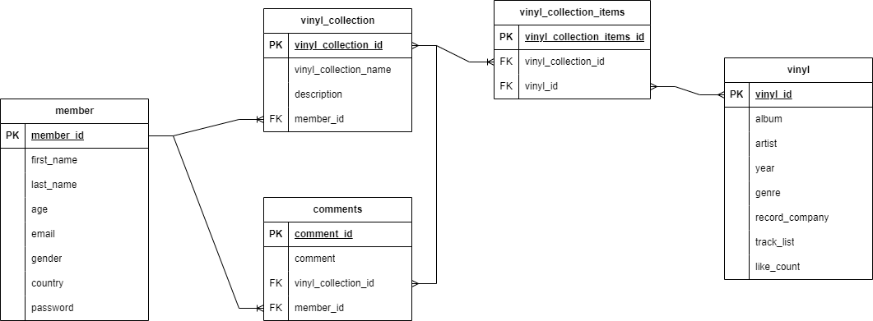

Fig. 1 Stacks of Wax ER diagram

As shown in figure 1, the collection table is the main link between all the components, there is a separate table for each vinyl in the collection so as to allow for more than one vinyl to be assigned to a collection. The database design also allows for liking albums and comment on collections.

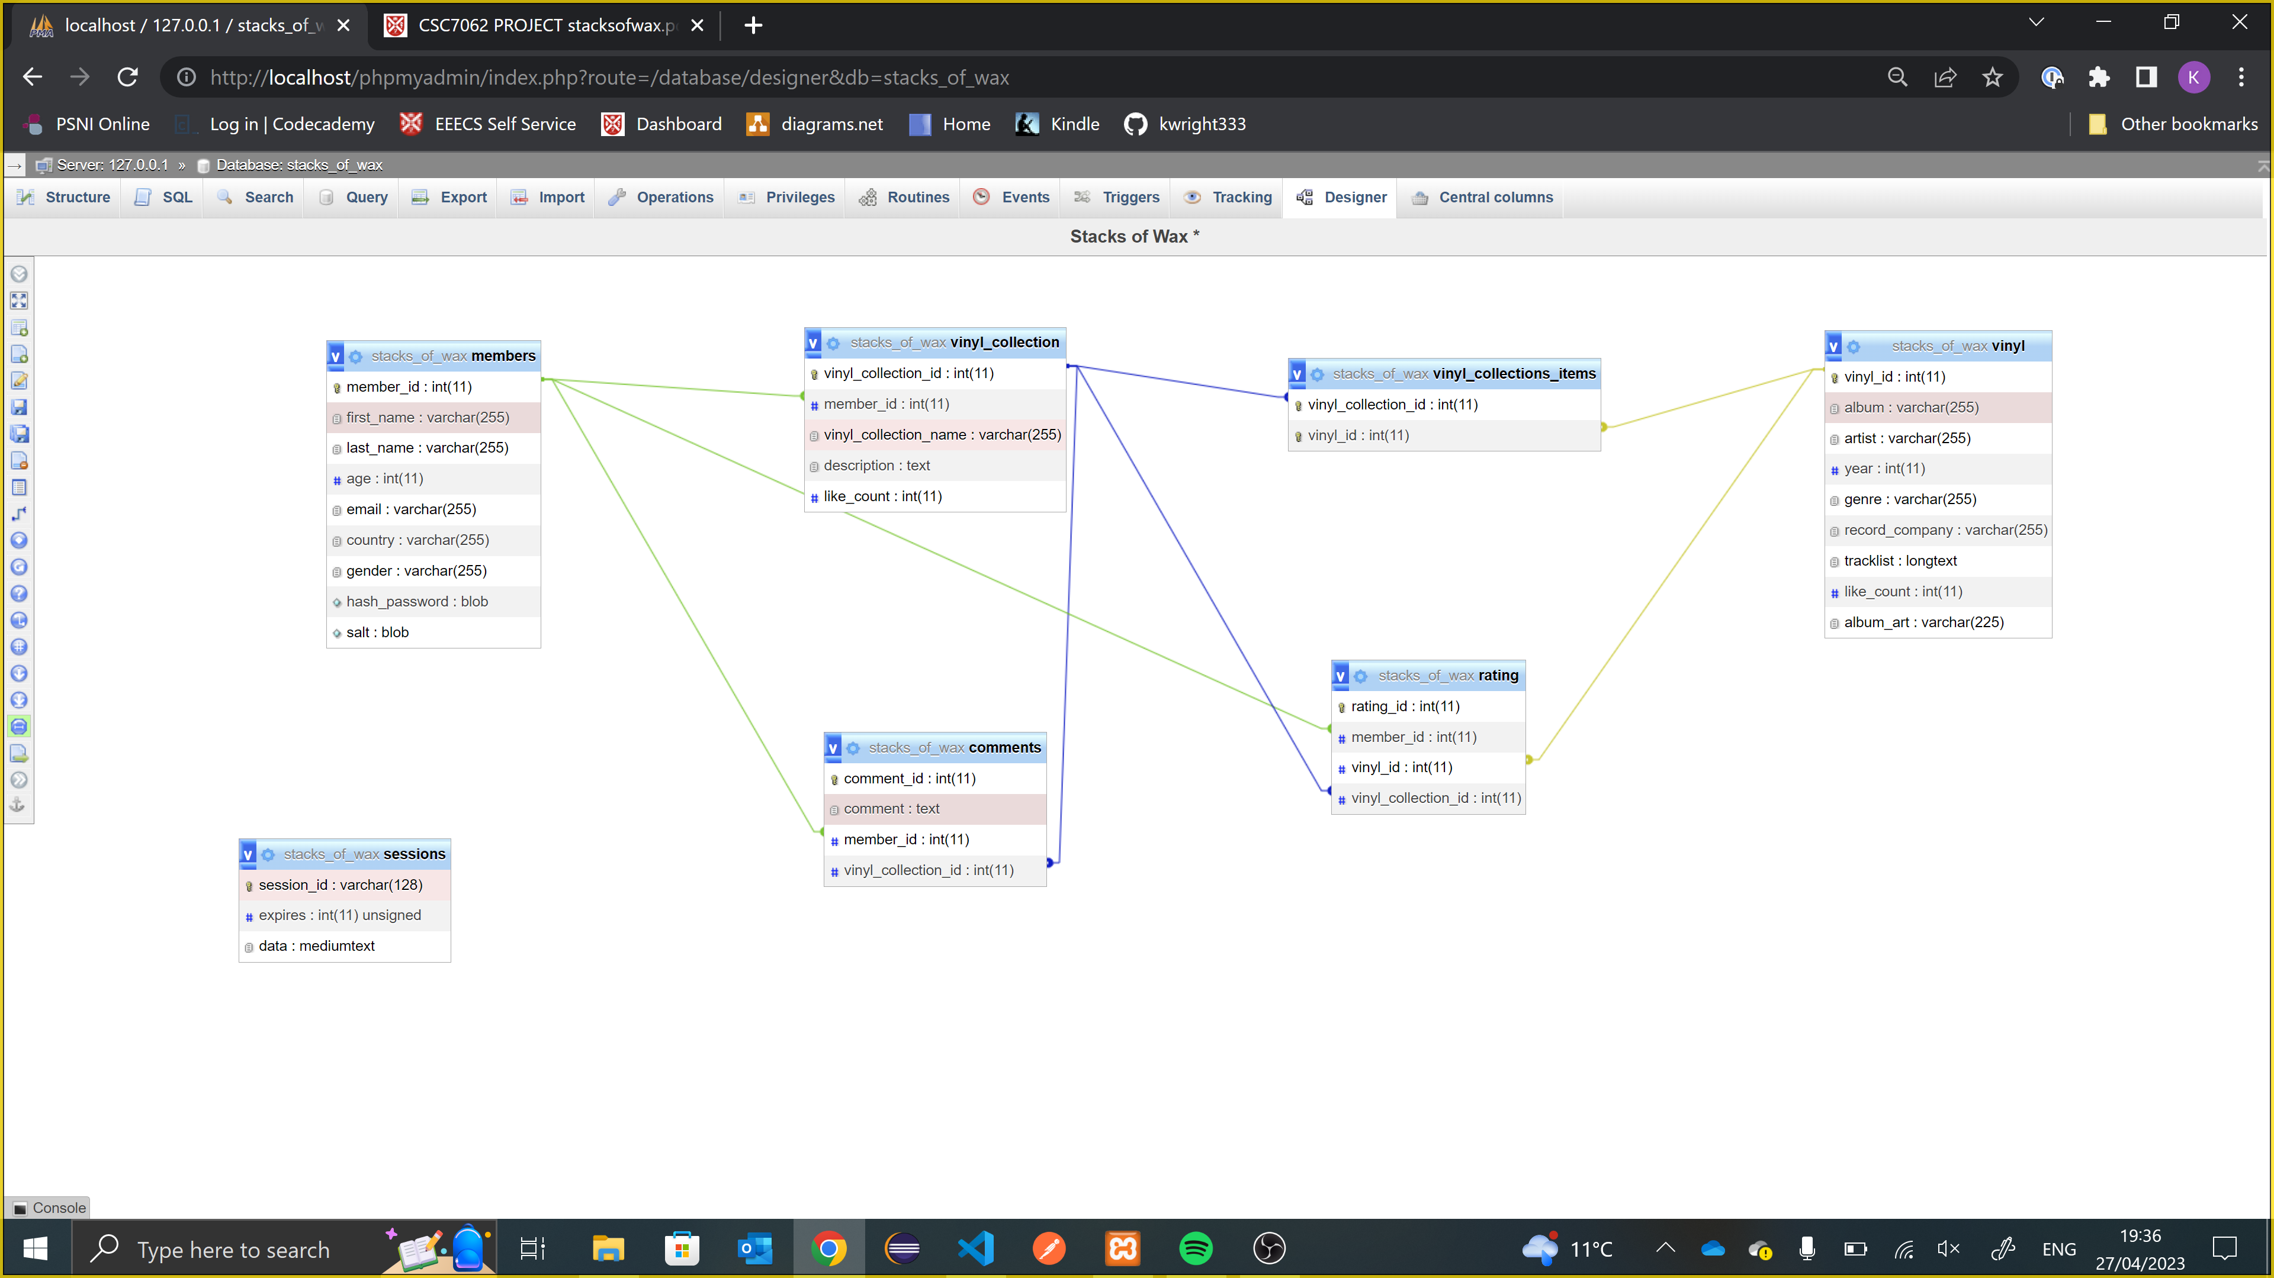

Fig 2. Stacks of Wax Database

The final databases had some changes made to it, a like count was added to the collections to allow them to be liked as well as commented, as well as adding a rating table to link the members to what they like. The vinyl collection items have a composite key as the primary key and album art was added to the vinyl table to aid display on the website. There is also a sessions table which is used to store user session data, which is used to keep the user logged in as they move about the site.

High-level description of system developed

A web applications that allows a user to browse the site, see the collections on the site as well as all vinyl records that are available to add to a collection, all as a non-member. As a member they can create collections from the vinyl records available as well as like vinyl records and like and comment on collections.

On the home page of this site there is a header including a logo for the site which is a home button, a navigation bar for the main pages which collapses into a hamburger menu when on a smaller screen, a login/register button as well as a search bar. This header stays on the top of the page when scrolling and is on all pages apart from the login and register pages. The home page itself contains a brief description of the site as well as the top nine rated vinyl records and the top three collections. Also displayed is the vinyl records on the site that have been released this year as well as some informative YouTube videos.

From the nav bar, the vinyls page is accessible. This page includes a list of the vinyl records in the database, displayed in rows of four by the album art. When hovering over the album art of a vinyl record, it will show the artist name and the name of the album. This can then be clicked on to give a pop up which gives more details of this album. The details include the track list, the year, the genre, the record company and the like count. From this pop up, if logged in, the vinyl can be liked. The list of vinyl records can also be filtered by genre, likes or by artist, these filters are done by drop down menus above the albums.

The collections are displayed on a different page, and they are displayed as cards in rows of two. The cards show the vinyl records by way of the art, with the collection name and the description displayed below as well as the like count. The collection card has a more details button, which will bring up a pop up which displays the album name of all the vinyl records in the collection as well as the first name of the person who created it. If logged in there will also be a comments button, which will bring up the comments on that collection as well as a box to add a comment, as well as the like button.

To log into this site the user can click on the login/register button which will bring them to a login screen which has fields for the email address and the password as well as the site logo which is a home button. By clicking the login button, if the details are correct, the user will be redirected to the home page with the members page now available on the header. If the user has not registered yet, they can select the register link on the login page which will bring them to a form to complete with all their details.

On the members page, the users details will be displayed along with an add collection button, which allows the user to create a collection on a pop up, name it, give it a description and add the vinyl records from a drop down list. The collections for the member will then be displayed down the right hand side of the page, in the same card format as the collections page. The more details, comments and like button will be the same but there will be an additional edit button, which allows the user to change the name, description and the vinyl records in the collection.

Brief analysis of your development approach

I started the creation of this website using basic HTML and CSS to create a home page with the use of the CSS library bootstrap, and to get started with this I made a basic diagram of how I wanted the page to look.

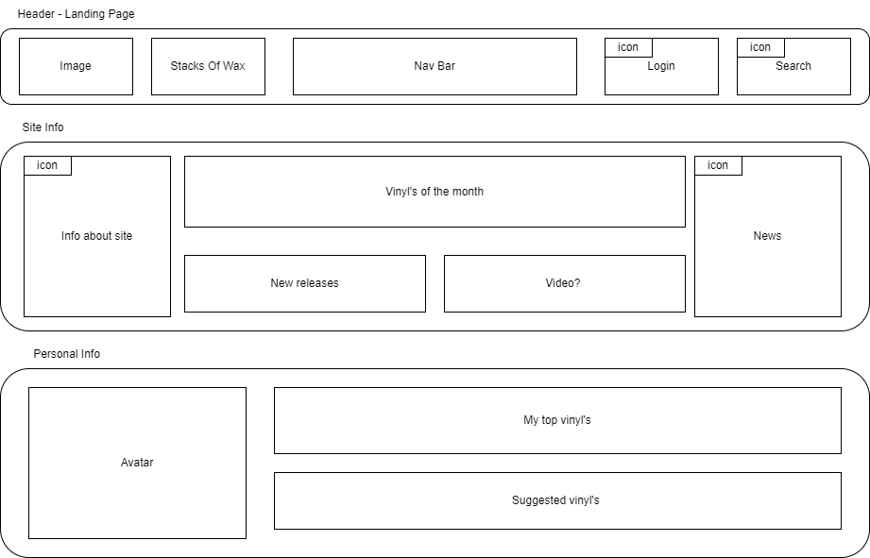

Fig. 3 Diagram of the landing page

I created this diagram as a starting point for the style of the page and what content I wanted it to include. The first thing I created with the header, which I wanted to be able to include in my other pages. I created this using elements from bootstrap, and a website with templates on it called mdbootstrap, however this website uses an old version of bootstrap so I had to update some of the HTML to match the version I was using. The header is a div with a class of sticky-top so that it will always be at the top of the page when scrolling down. I created the logo with the website brand on it and made it a clickable link to the home page, combining a graphic and the site name. The nav bar I created with the help of the template website, this has 3 nav buttons that when collapsed will be in a hamburger menu. I made this element a component that can be added to each page so any editing that is needed will be followed through all pages. I did this only with this part as I wasn’t sure how many pages I was going to make and what they would be called as I developed the page.

The header also has the link to the login/register page which has and icon from Font Awesome to indicate what it is. In addition to this, the header also has the search bar that allows the user to search for a vinyl record or collection by name, the bar has a drop down menu of the results. After completing this I spent time working on the structure of the header for smaller screen sizes, ensuring it suitable for phones and other smaller devices.

For the layout of the home page I started with the divs that I wanted in the general layout I had planned, but as the site developed, what I had in those divs changed. At this point I am still developing this site based mostly on HTML, later adding in JavaScript, this is due to my own inexperience. I wanted to be able to show the top rated vinyls as well as the new releases, to do this I needed to having the vinyls on the site. From this point I had to be able to have a back end supporting a database and dynamic population of items in a list. To help me visualise this as a whole I created a diagram depicting what tools I was using to build the site.

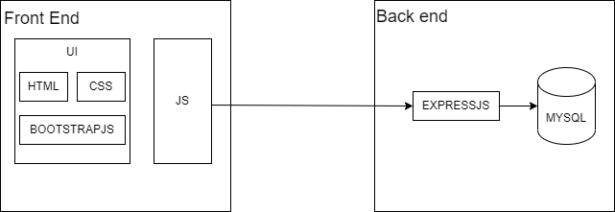

Fig. 4 Tools used to create Stacks of Wax

The next step in the development was the creation and population of the database, with the sample data provided for the vinyl list. The relational database management system I used was MySQL, and I needed a way to access this permanently stored data, to do this I created an API using express as my web server with the routes I could use to query the database. I also used ejs as my templating engine to do the server side rendering of the html pages. I created a file called app.js which has all my express code, where I created all my routes from and what I use to run the site. All the .ejs files are stored in a views folder, with the components separated out into their own folder.

I used a query to pull all the vinyl records from the database and looped through them all, using JavaScript, to populate the page, displaying them all as thumbnails of the album art. I used a hover over element to show the name and artist of the album and an on click to bring up a modal which would display all of the information of that album. I also added into this modal the like button, which when clicked had a route to the database, to store the number of likes.

With this completed I created an endpoint to give the top 9 liked vinyl albums, which will auto update as users like the albums. I added these to the home page into a carousel with just the album art displayed. I was also able to use an IF statement to display the new releases using the year field. With these in place as well as a short description and some embedded YouTube videos, I have the top section of the home page complete. To finish it I needed my site to support the creation of collections.

I felt the best way to get the collections up and running was to make members be a possibility. First I added in the functionality to my register and login pages. Both of these pages are a way for the user to input information used by the database. To ensure the security of the account created, I used crypto to encrypt the passwords.

With a member logged in, they are able to view their own page. To make this a members only function, the nav button for members is only viewable when logged in, as well as the like and the add comment buttons. When logged in the member can see all their details on their page, as well as manage their collections. The add a collection, edit, more details and comments buttons all bring up modals with more details. I felt the modals were more appropriate than bring the user to a new page as they only convey small snippets of information or functionality at a time, and having the page expand to show this detail would impact the formatting and structure too much.

To add a new collection, the user can type in a text box what the name and the description is, and choose from a drop down menu the vinyl’s. The vinyl records chosen will be displayed in a list that can be edited before the collection is created, with the list they choose from updating to remove what has already been selected as well as putting back in a vinyl that has been selected and deleted. The edit function works similarly in that vinyl’s can be added and removed, with the text changeable as well. The details of the collection can be viewed by clicking the more details button, which brings up a modal with the albums in the collection. A like count is displayed, similar to how the vinyl like system works, with an additional function of adding a comment. The comments are added by typing in the text box and clicking comment, the comments are listed using an accordion, so that if there are a large quantity of comments they can be collapsed to show just the name of the user who left the comment.

The collections are displayed using cards, with the name and description displayed and the buttons mentioned previously displayed. The art that is shown on the card is all the album art for the vinyl’s in the collection, so a user can just glance at the card to see its contents. These cards are displayed on the collections page as well as the individual members collections displayed on their own pages. The top three collections are displayed on the bottom of the home page, calculated using the likes.

Instructions on how to run the system

* The system will be stored in a zip file, with all the necessary components.
* The sql file for the database will be stored in a folder called `Database’, this will be the whole database which will need imported into phpMyAdmin.
* The entire code for the site will be in a folder called `Stacks of Wax’, this is the folder that will need to be opened by visual studio code.
* On the terminal within visual studio code run `npm install’
* Run `npm run watch’
* Open the browser and go to <http://localhost:3000/>