1. Go to [www.makesense.ai](http://www.makesense.ai) Click on **Get Started** at the bottom right.

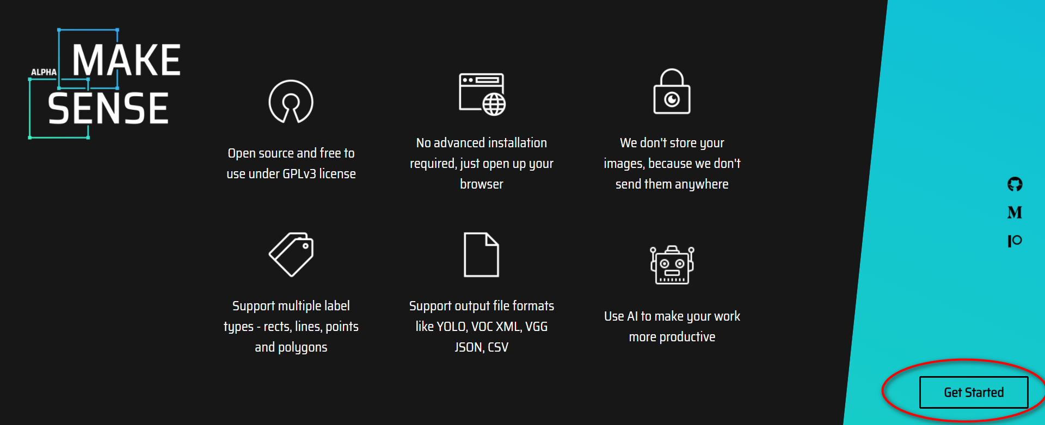

1. Upload the scooter images into the system by dropping them in or click on the box to select the images.

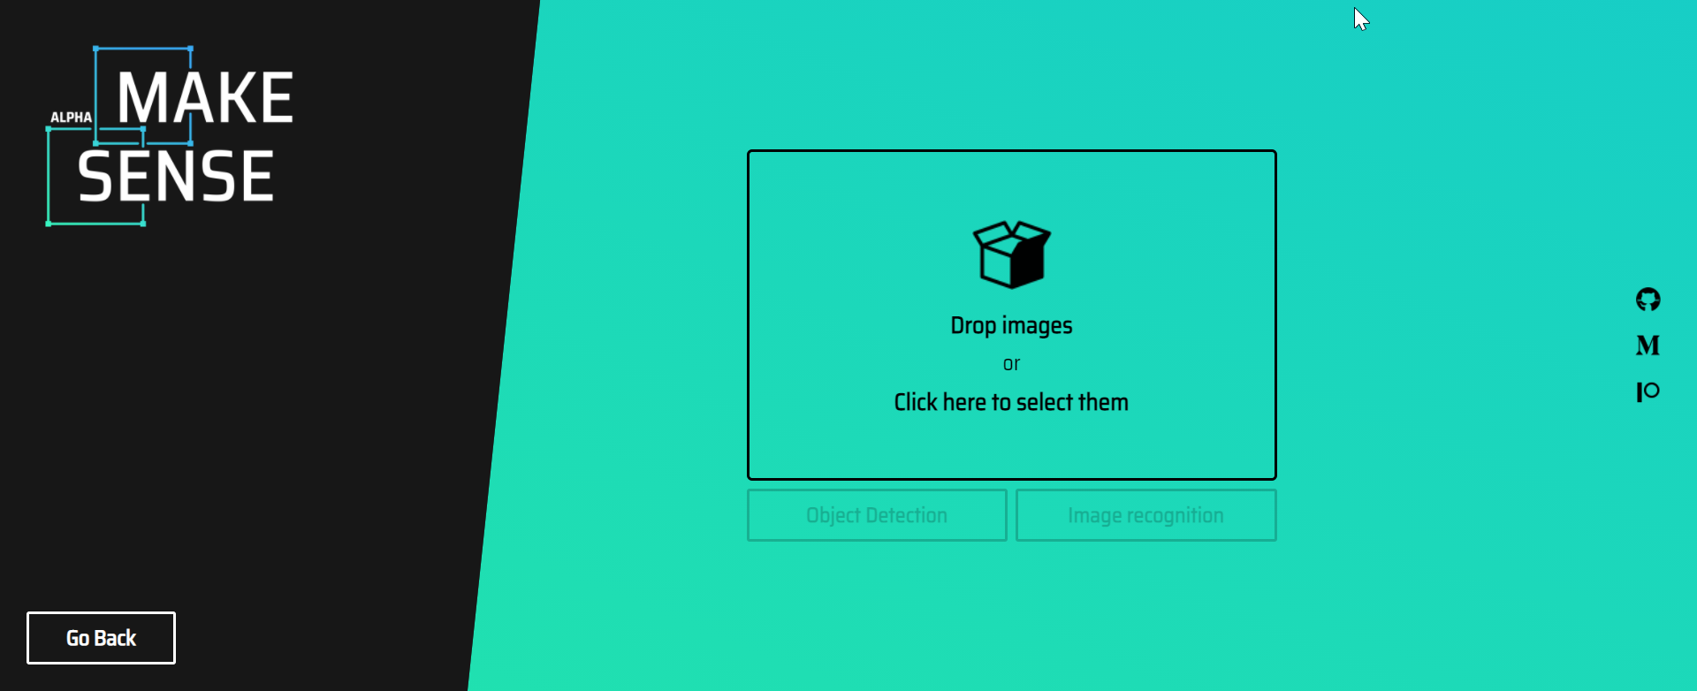

1. After the images are uploaded, clicked on **Object Detection**.

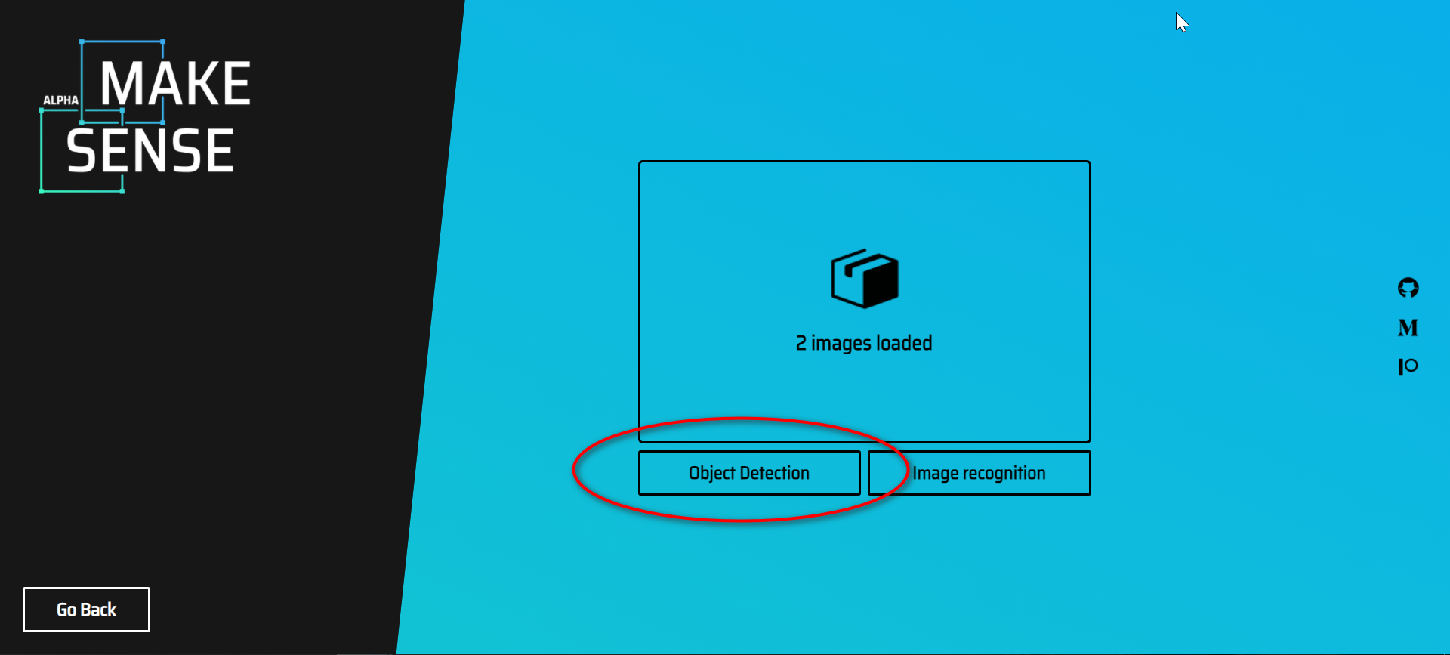

1. Click on the **+** sign at the top-left corner to create labels.

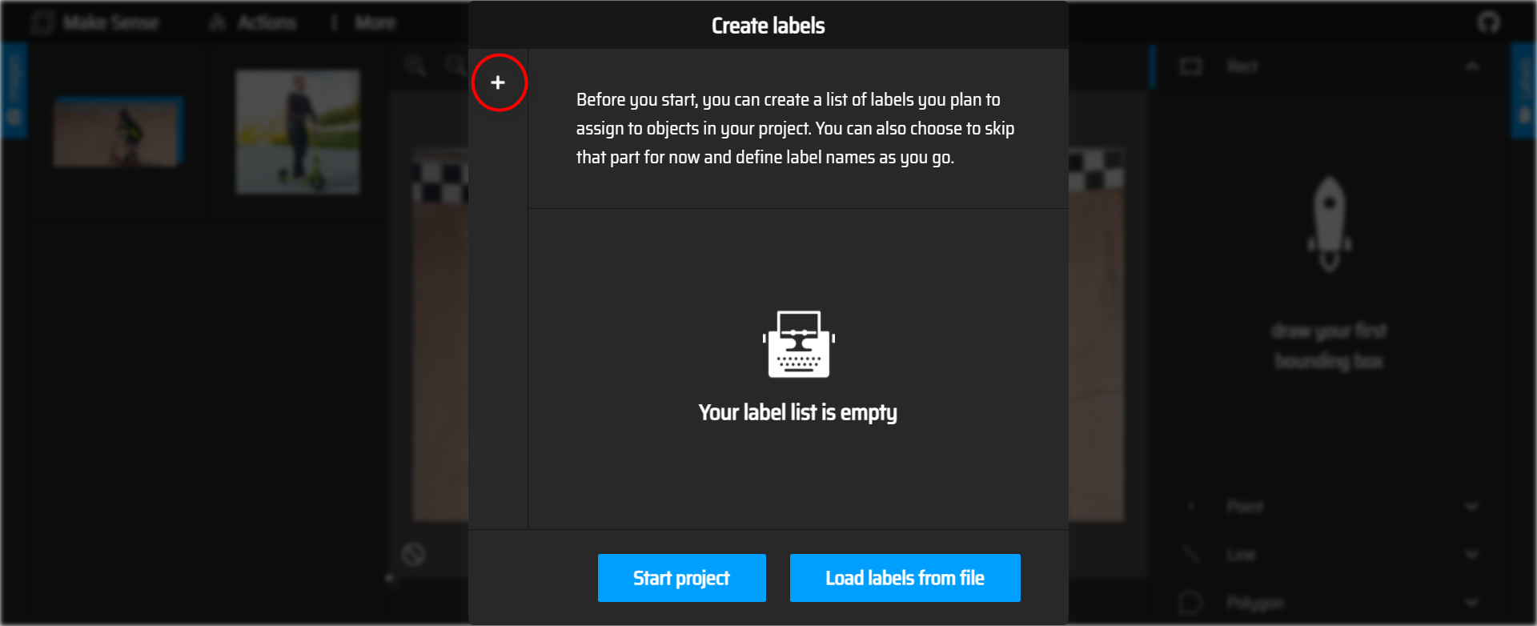

1. Enter **scooter** and click on **Start project**.

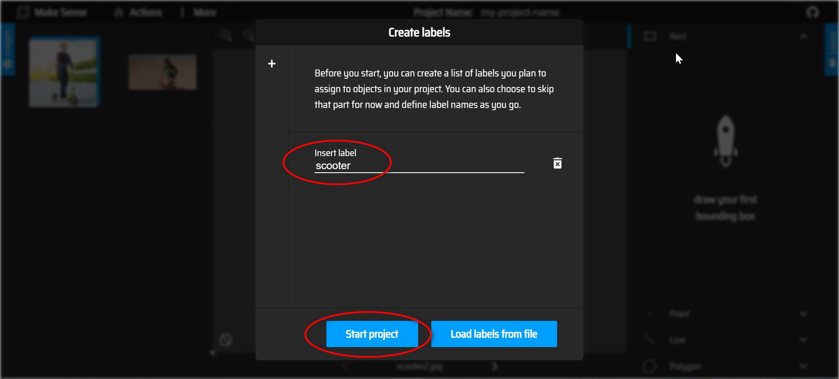

1. Select **Rect** at the right.

MakeSense.ai allows annotation using **Rect, Point, Line and Polygon.**

Draw a rectangle bounding the scooter.

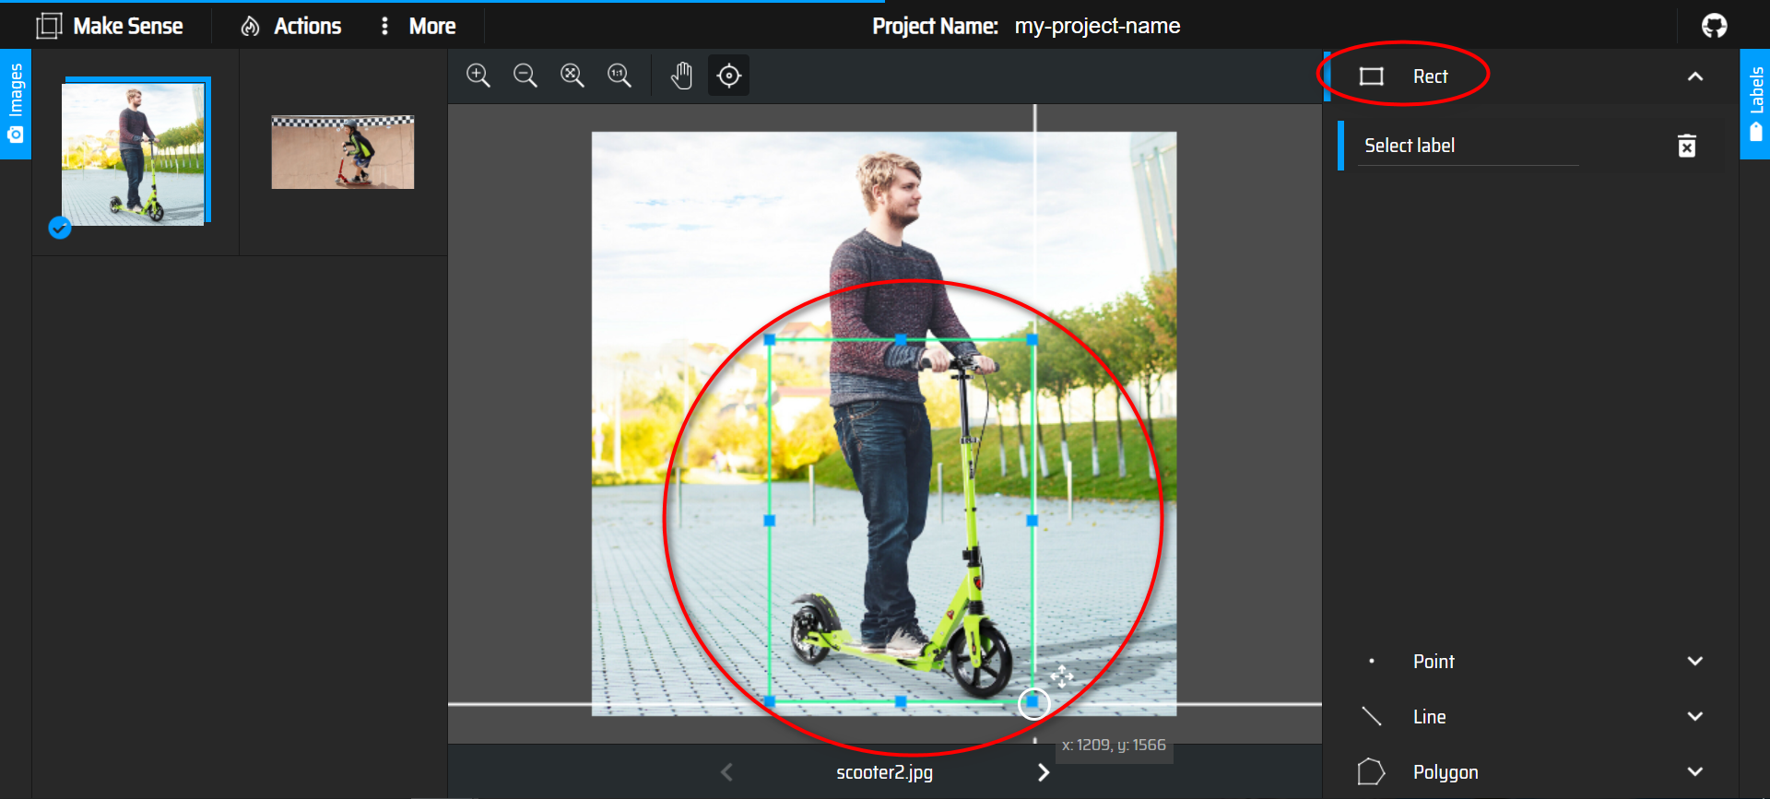

1. Click on **Select label** and select **scooter.**

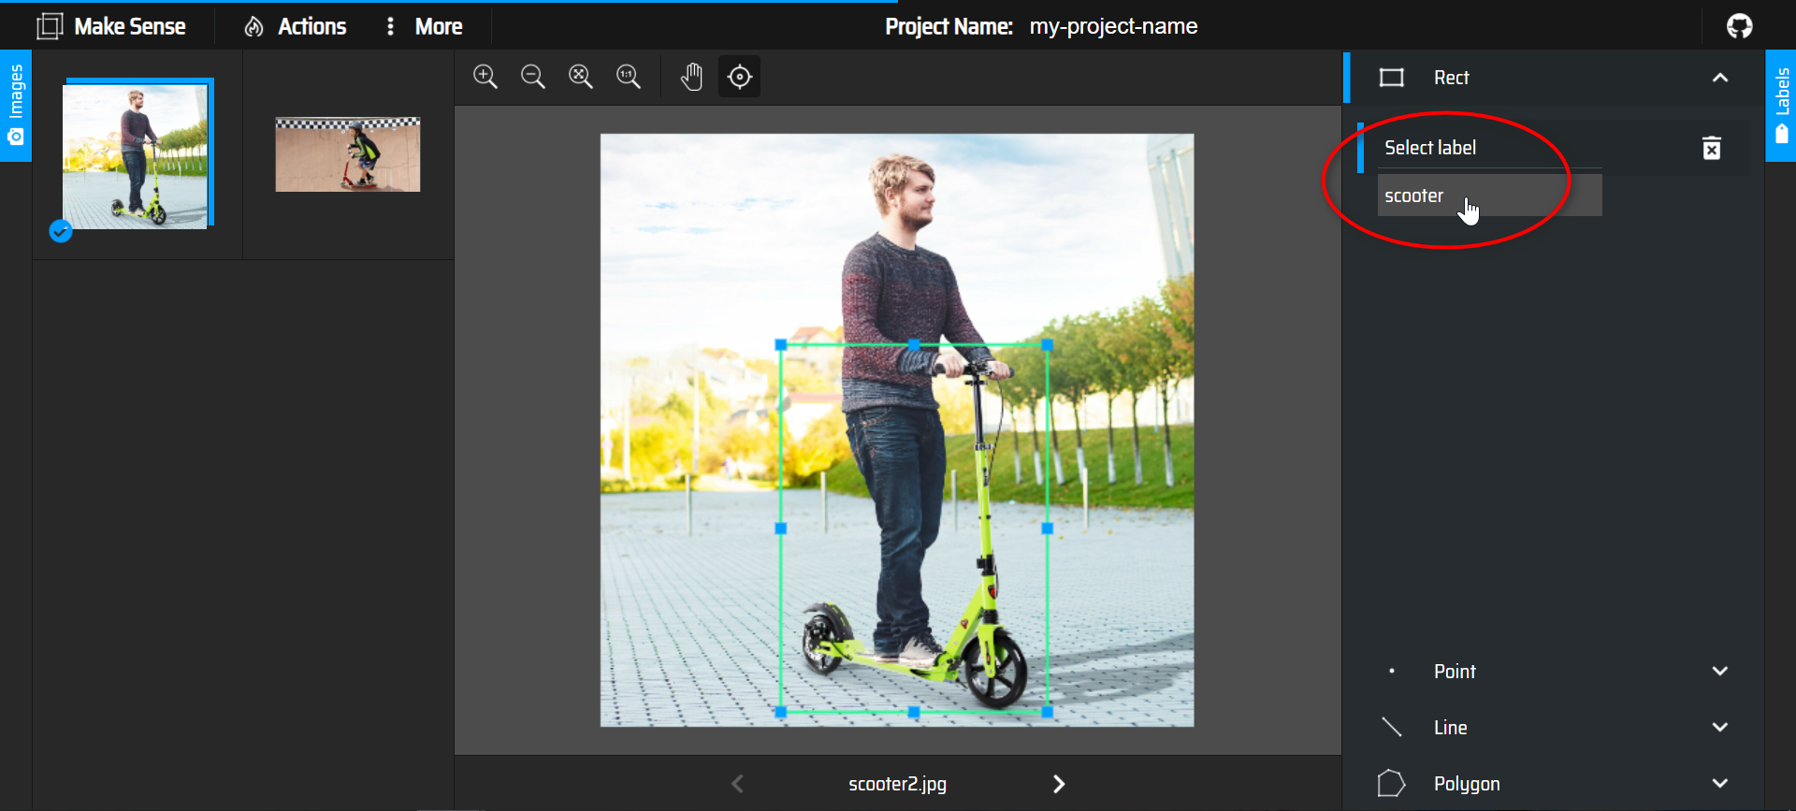

1. Repeat steps 6 and 7 for all images.
2. Click on **Actions**, follow by **Export Annotations.**

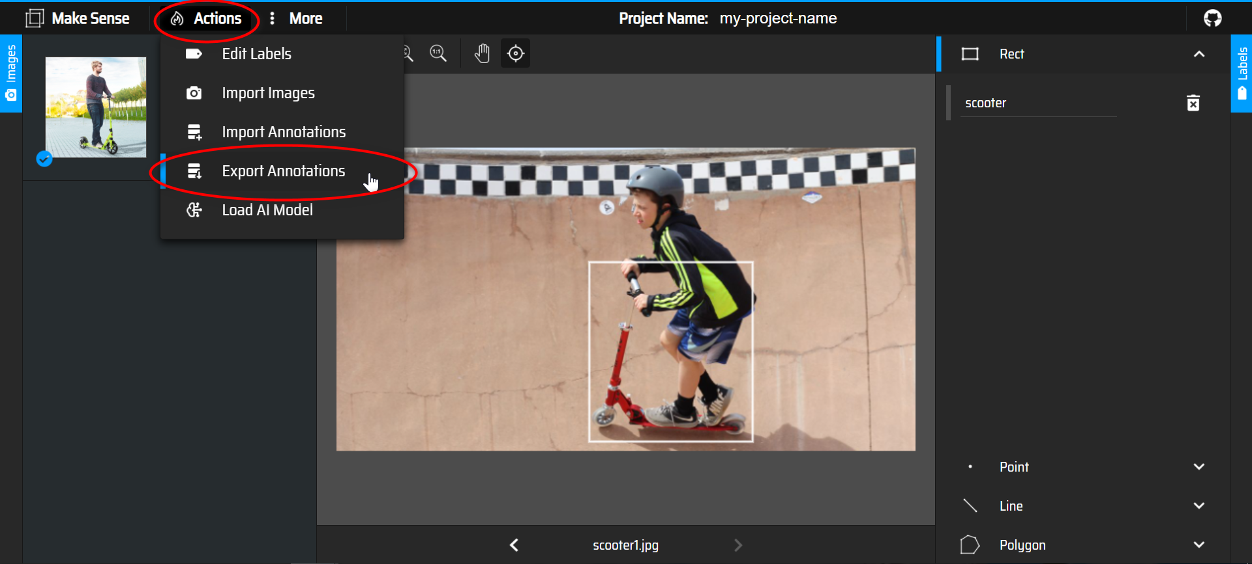

1. Choose **A .zip package containing files in YOLO format** follow by **Export.**

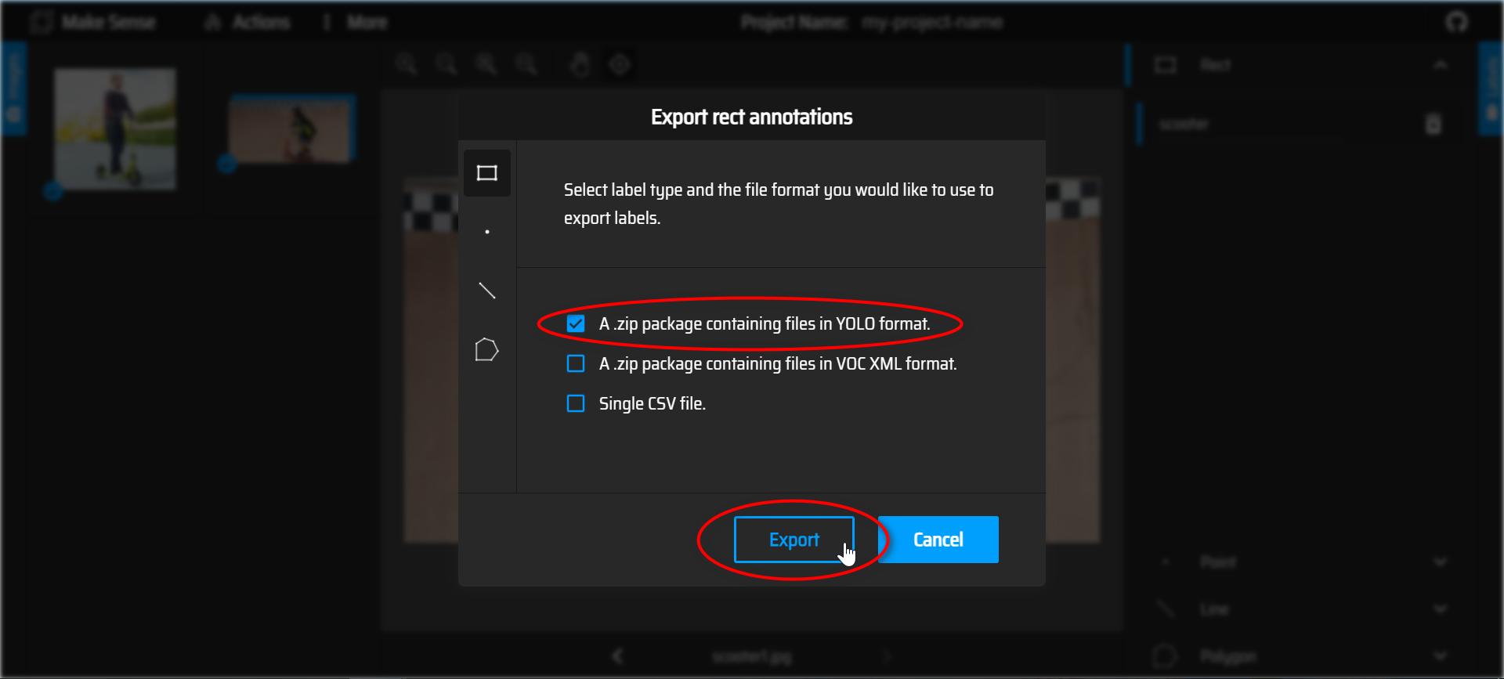

1. Unzip the exported .zip package.

You have successfully annotated your images for the training of YOLO.

