E-Auction System

**Design Document**  
  
  
  
**Document Change Control**

| **Version** | **Date** | **Authors** | **Summary of Changes** |
| --- | --- | --- | --- |
| 1.3 | 2024/02/02 | Yunfei Cao | Added Activity and Sequence Diagrams |
| 1.2 | 2024/02/02 | Kawshar Patel | Added Major Design Decisions and Architecture |
| 1.1 | 2024/02/01 | Jacob | Added Sprint and Project Backlog and group meeting logs |
| 1.0 | 2024/02/01 | Yash Dani | Added Test Cases |

**Document Sign-Off**

| **Name (Position)** | **Signature** | **Date** |
| --- | --- | --- |
| Kawshar Patel | Kawshar Patel | 2024/02/06 |
| Jacob | Jacob | 2024/02/06 |
| Yash Dani | Yash Dani | 2024/02/06 |
| Yunfei Cao | Yunfei Cao | 2024/02/06 |

**Contents**

**Introduction 4**

Purpose 4

Overview 4

Resources - References 4

**Major Design Decisions 6**

**Sequence Diagrams 7**

**Activity Diagrams 13**

**Architecture 17**

**Activities Plan 20**

Project Backlog and Sprint Backlog 20

Group Meeting Logs 21

**Test Driven Development 22**

**INTRODUCTION**

**Purpose**

## This document details the requirements of the system e-Auction. The goal is to develop a full-stack web application using React for the frontend, which communicates with the backend through HTTP/HTTPS responses. The architecture includes a middle layer using Spring Boot, and the backend is implemented in Java with various modules providing services. Following Model-View-Controller(MVC) principles and a microservices architecture, each service can be deployed individually using Docker. The backend connects to the database using a data access layer, utilizing both SQL and neo4j. The system enables users to interact with the application, facilitating an auction environment. The development process will incorporate Git version control, with GitHub serving as the repository for code management. The overall aim of this project is to create a straightforward and user-friendly web application.

## Overview

We have navigated through major design choices in this project to build an e-Auction web application. Using React for the front end and Java with Spring boot for the backend, ensuring smooth operations with databases like SQLite and Neo4j. Our design focuses on a client-server architecture, implementing a pub-sub architectural model for the front end and microservices with MVC principles for a strong backend. To visualize our understanding of the system, we have included sequence and activity diagrams for each use case. The architecture section presents a block-arrow figure illustrating the overall system, detailed tables on modules, and the exposed interfaces. We have also included plans for activities, product backlog, and sprint backlog which is supported by group meeting logs and a Gantt chart for clear scheduling. Additionally, we have also focused on the quality part of our systems. We have 17 test cases in the Test Driven Development section to ensure the functionality and reliability of our e-Auction platform. This comprehensive overview lays the foundation of our full-stack web application’s structured development and success.

## 

## Resources - References

Aroshelova, A. (2022, January 3). Crafting a Solutions Architecture: Foundations of a Real-Time Application Design. Medium.<https://medium.com/@aroshelova.tech/crafting-a-solutions-architecture-foundations-of-a-real-time-application-design-dfa3cf7fd16b>

1. Educative. (2022, May 31). Software Architecture: Diagramming and Patterns. Educative Blog.<https://www.educative.io/blog/software-architecture-diagramming-and-patterns>
2. Stack Overflow. (n.d.). Arrow Direction for Fetching Data from Database in Architecture Diagram. Stack Overflow.<https://stackoverflow.com/questions/66695185/arrow-direction-for-fetching-data-from-database-in-architecture-diagram>
3. Unadkat Jash (2023, June 14). What is Test-Driven Development? BrowserStack Guide.<https://www.browserstack.com/guide/what-is-test-driven-development>
4. Acunetix. (n.d.). SQL Injection. Acunetix Website Security.<https://www.acunetix.com/websitesecurity/sql-injection/#:~:text=Attackers%20can%20use%20SQL%20Injection,delete%20records%20in%20the%20database>
5. Gillis Alexander (n.d.). Dependency Injection. TechTarget Search App Architecture. [https://www.techtarget.com/searchapparchitecture/definition/dependency-injection#:~:text=Dependency%20 injections%20are%20useful%20to,or%20variables%20in%20an%20object](https://www.techtarget.com/searchapparchitecture/definition/dependency-injection#:~:text=Dependency%20injections%20are%20useful%20to,or%20variables%20in%20an%20object)
6. Harvey, J. (2018, August 14). A Beginner's Guide to Creating a Containerized Web Application Development Environment with Docker. Medium.<https://medium.com/@jharvey1012/a-beginners-guide-to-creating-a-containerized-web-application-development-environment-with-docker-e903169004ff>
7. Michael (2023, May 12). Using Docker in Web Hosting: Complete How-to Guide. SwissMade Host Blog.<https://swissmade.host/en/blog/using-docker-in-web-hosting-complete-how-to-guide>
8. Lin, Joyce (2019, March 4). Deploying a Scalable Web Application with Docker and Kubernetes. Medium.<https://medium.com/better-practices/deploying-a-scalable-web-application-with-docker-and-kubernetes-a5000a06c4e9>
9. Kolade, Chris (2023, February 16). SOLID Design Principles in Software Development. freeCodeCamp.<https://www.freecodecamp.org/news/solid-design-principles-in-software-development/>
10. Creately. (2022, September 2022). UML Diagram Types & Examples. Creately Blog.<https://creately.com/blog/diagrams/uml-diagram-types-examples/>
11. Girdler, Adriana (2022, November 30). Unified Modeling Language (UML) Tutorial - Use Case, Activity, Class and Sequence Diagrams. YouTube.<https://www.youtube.com/watch?v=Lx8INTdIJpY>
12. Garcia-Molina, H., Ullman, J. D., & Widom, J. (2009). Database systems: A complete book. Pearson Prentice Hall.

# 

# 

# 

# 

# 

# 

# 

**MAJOR DESIGN DECISIONS**

Our system will be utilizing React as the frontend framework with Java and springBoot serving as the backend. Our choices of databases include SQLite and Neo4j. The front end will communicate with the backend through HTTP/HTTPS requests and responses. In order to manage creating, updating, retrieving and deleting data(CURD) operations in the database, we will have a data access layer between the services and the database using Java and JDBC. This will ensure that we have low coupling between the database and the backend modules which will ensure that changes in the database will not significantly impact the services.

We are planning to construct our system using a client-server architecture. In the front end, which acts as the client, we intend to implement a pub-sub architecture within different react components to maintain loose coupling. This design will ensure that whenever an event occurs it could prompt the rendering of different react components without having them being closely coupled together and reducing dependencies between them. In the backend, which serves as the server, we intend to implement the microservices architecture while incorporating the Model-View-Controller(MVC) layered architecture style. This approach would help us have each module designed in accordance with the single responsibility principle, ensuring that each module has a clear and precise purpose. Within each service, we will have controllers to manage communication, service classes responsible for implementing the main business logic and updating or receiving information from the database, and models for storing data. Each service would also emphasize having low coupled and highly cohesive classes using dependency injection(either through method or constructor injection)(Gillis & Ferguson, 2023). All of the services will communicate with each other over HTTP/HTTPs protocol. Moreover, we will host each service independently using Docker containers which would allow our systems to be scalable.

We are also going to extend our client-server architecture to include a database, with the database acting as a server and the backend as a client. Our coding practices will follow a few principles: each class responsible for one thing (single responsibility), they will be open for extension but closed for modification( open closed), and will depend on abstractions(dependency inversion) so that our classes have single responsibilities, they are modular and have high cohesion low coupling between them(Chris, *Solid design principles in software development* 2023).

For the non-functional requirements, we are prioritizing security and performance. For security, we plan on implementing measures to prevent SQL injection by using parameterized queries which would prevent the attacker from breaking into the databases. Furthermore, we plan to boost performance by optimizing queries through data access techniques like indexing(Garcia-Molina et al., 2009).

In regards to the alternative, we wanted to use the pipe and filter architecture for continuous integration and continuous deployment using CI/CD pipelines. However, our team is not very familiar with DevOps tools and practices, and adopting this architecture will need a significant amount of time and effort. Another option we had was to use the repository architecture for the backend and database, but due to its design, which highly relies on a centralized repository in order to access data, would make the components tightly coupled.

**SEQUENCE DIAGRAMS**

USE CASE 1:

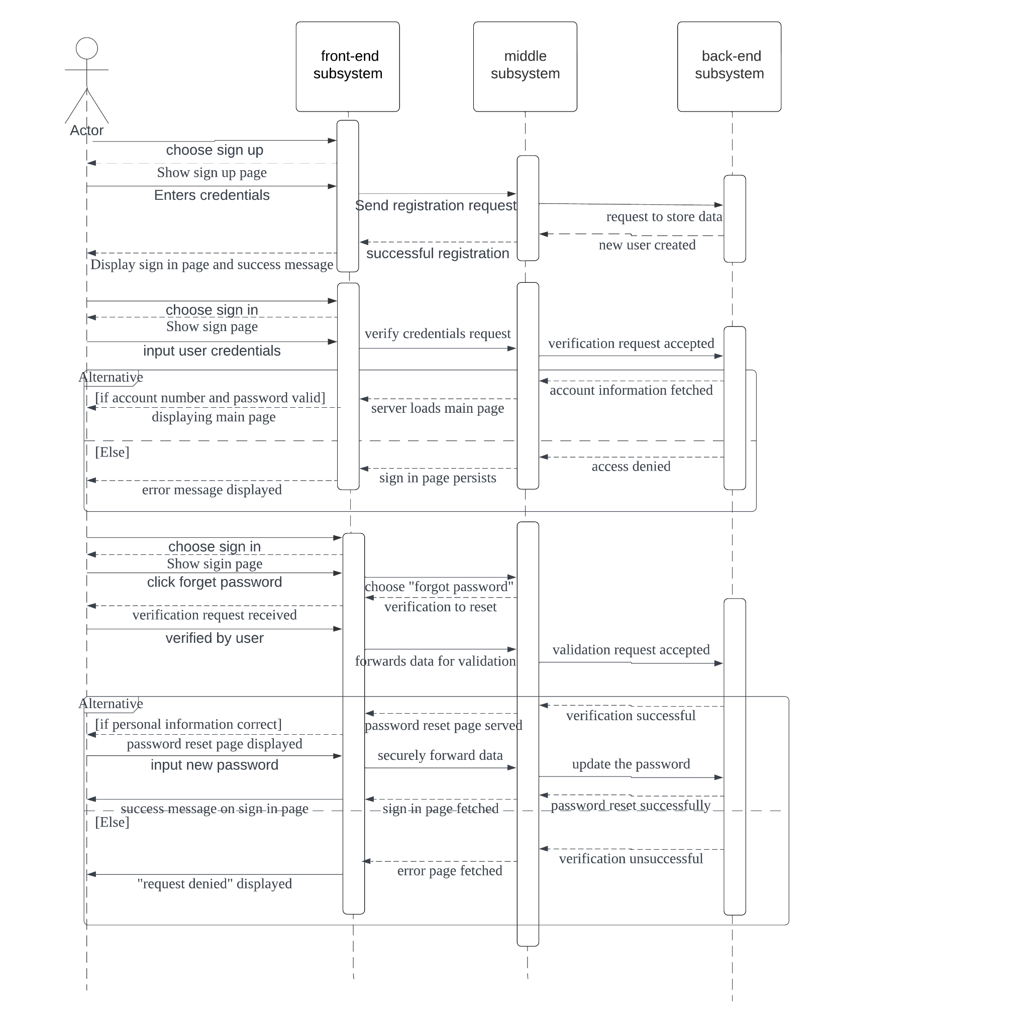

**Figure 1.1 *Sequence diagram for use case 1*** *Illustrates a site visitor signing in, creating an account and resetting their password*

USE CASE 2:

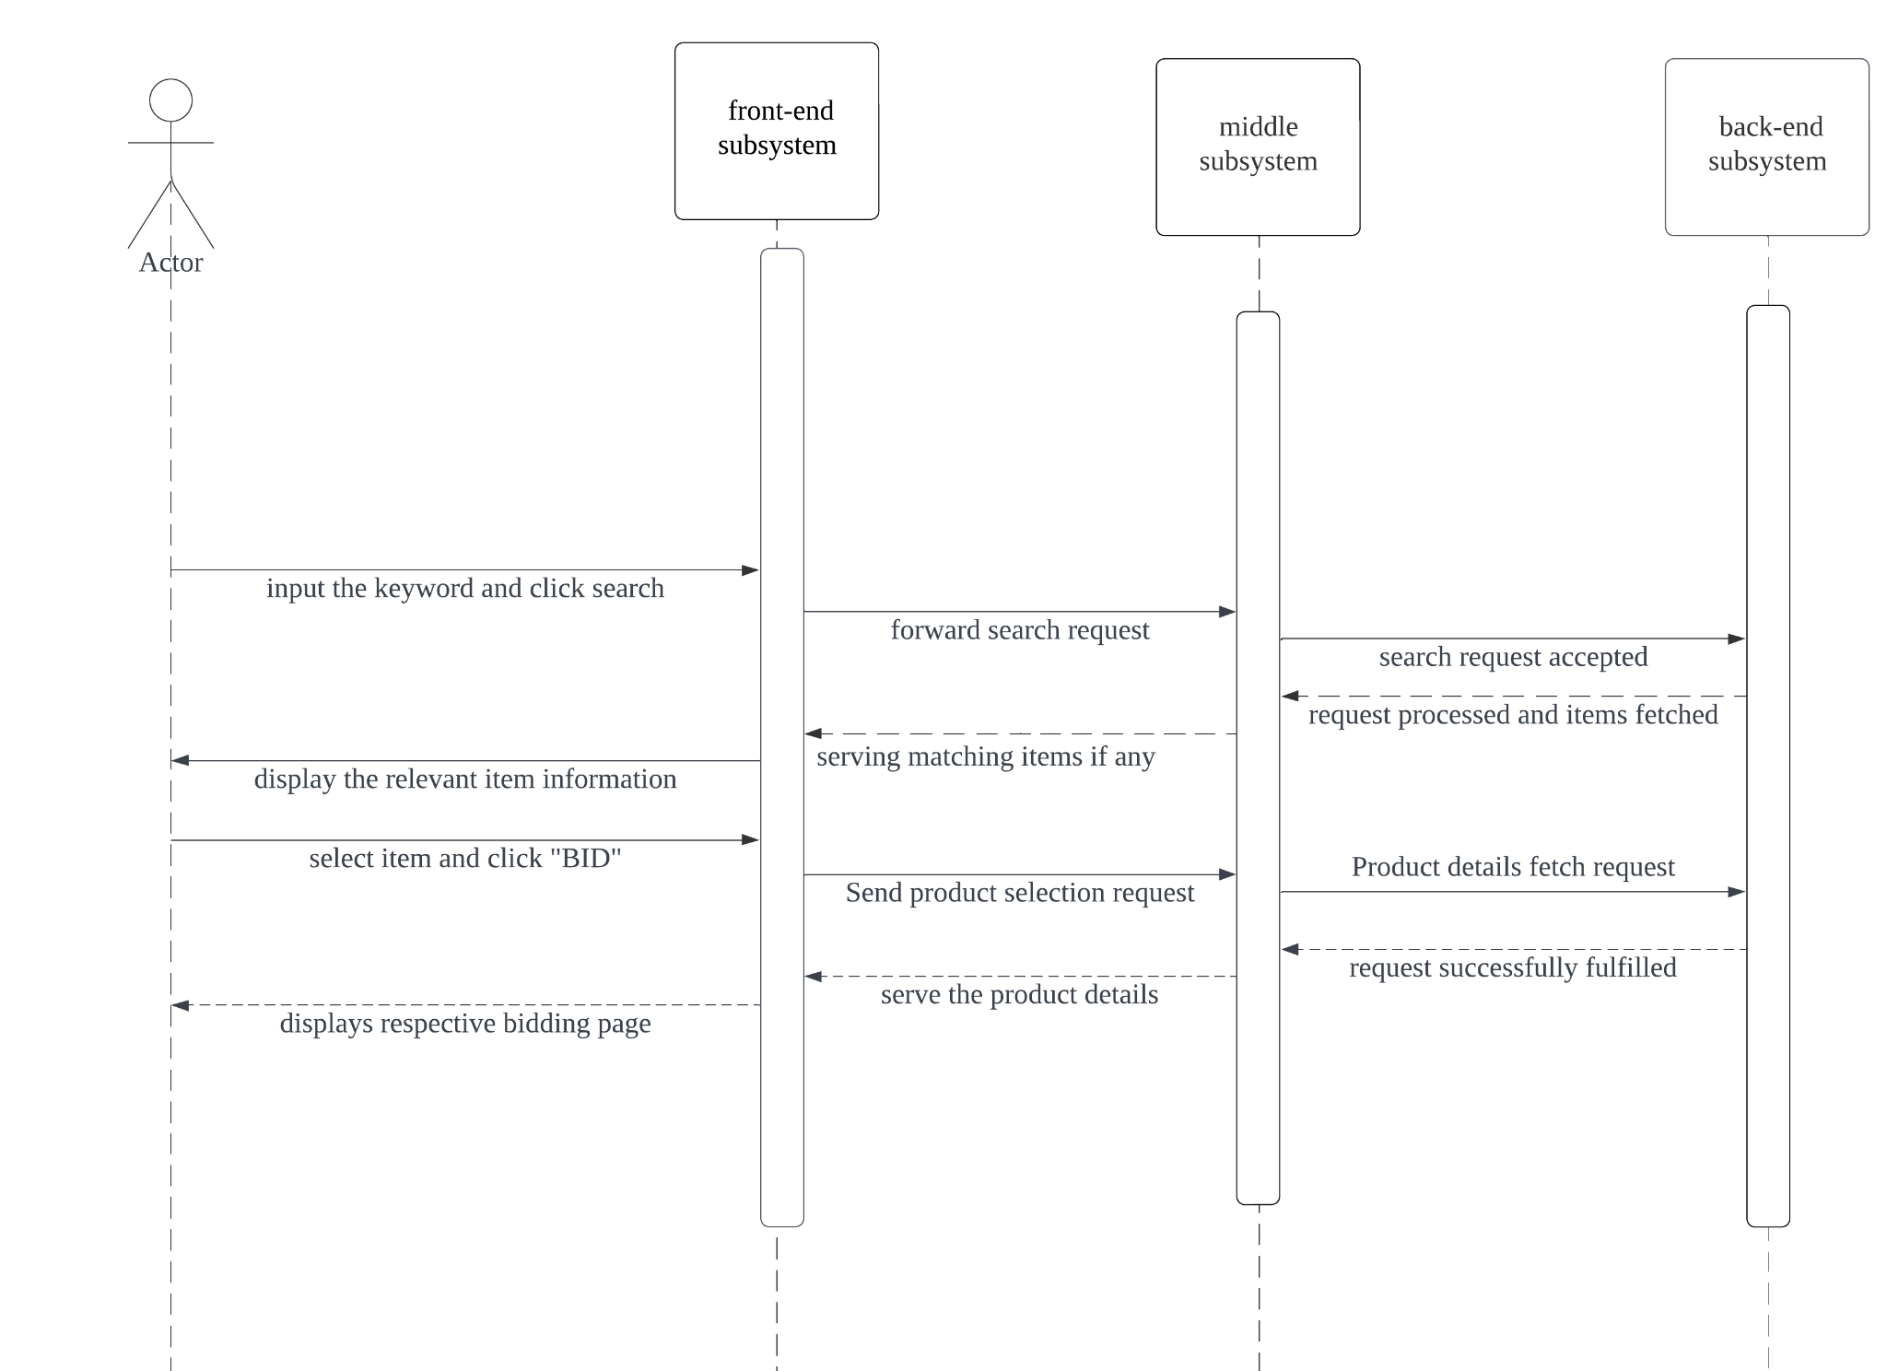

**Figure 1.2: *Sequence diagram for Use case 2****Illustrates when a site visitor signs in, searches for an item, information is returned and the visitor submits a bid*

USE CASE 3:

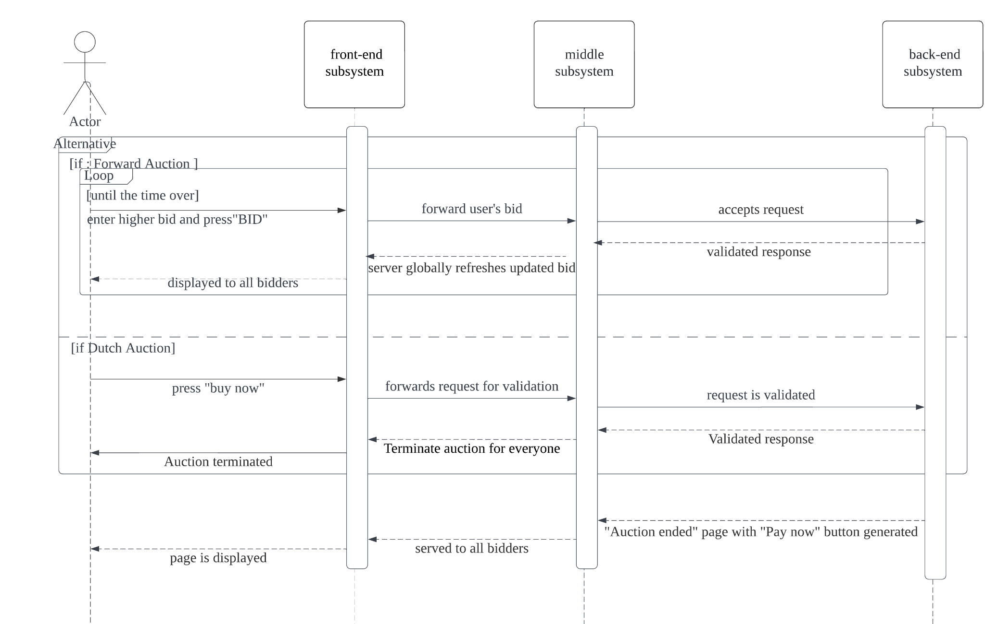

**Figure 1.3: *Sequence diagram for Use case 3****Illustrates when a site visitor selects an item for bid apart of a forward auction, and when a site visitor selects an item for bid apart of a dutch auction*

USE CASE 4:

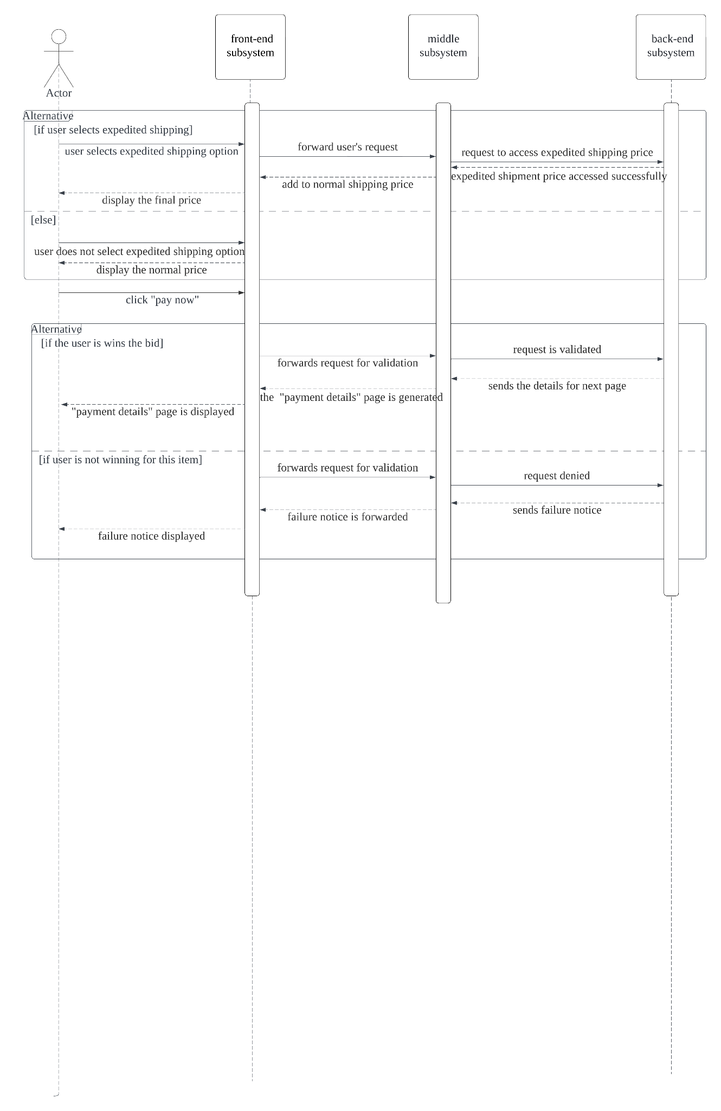

**Figure 1.4: *Sequence diagram for Use case 4****Illustrates when a user wins or loses a forward auction, and when a user wins or loses a dutch auction*

USE CASE 5: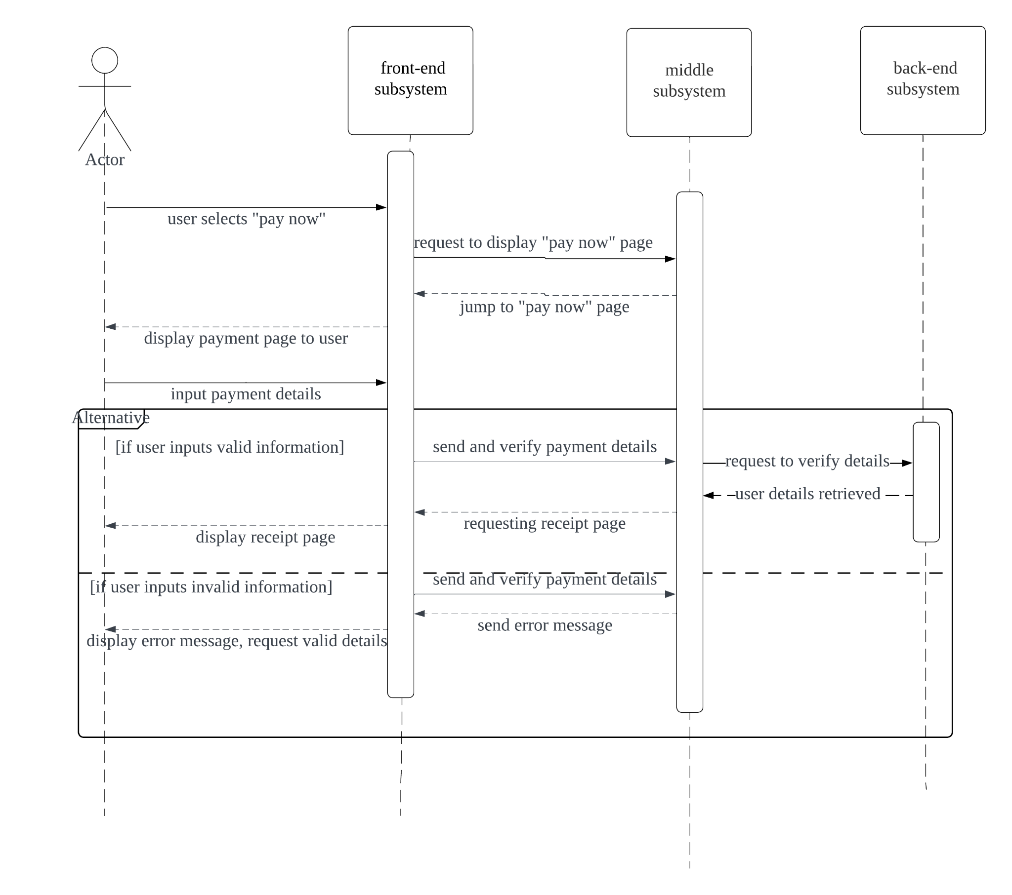

**Figure 1.5: *Sequence diagram for Use case 5****Illustrates the payment process for an auction winner*

USE CASE 6: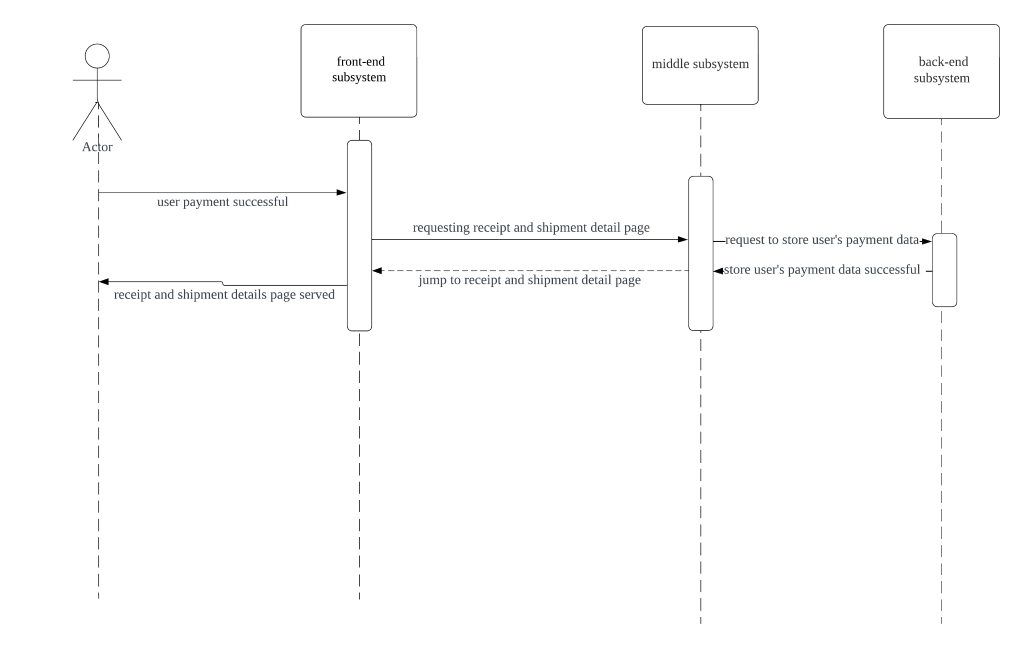

**Figure 1.6: *Sequence diagram for Use case 6****Illustrates when payment is a success, shipment details*

USE CASE 7:

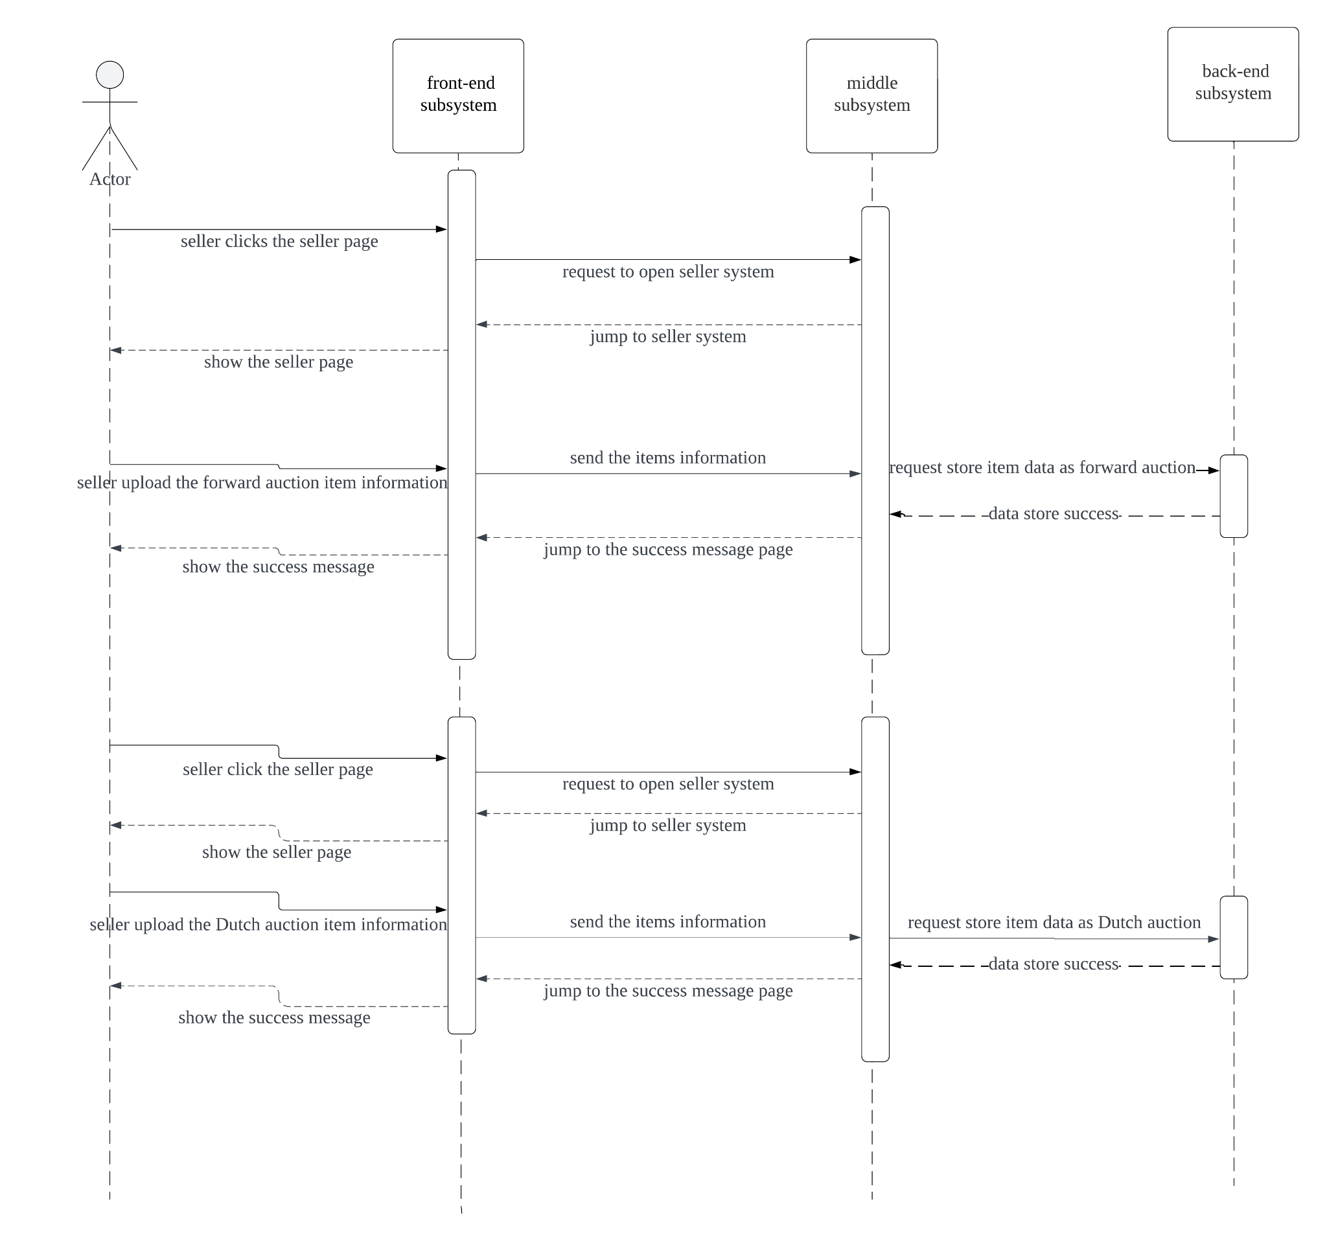

**Figure 1.7: *Sequence diagram for Use case 7****Illustrates seller creating forward auction or dutch auction*

USE CASE 8:

# 

**Figure 1.8: *Sequence diagram for Use case 8***  
*Illustrates a seller updating the price of an item for a dutch style auction*

# ACTIVITY DIAGRAMS

USE CASE 1:

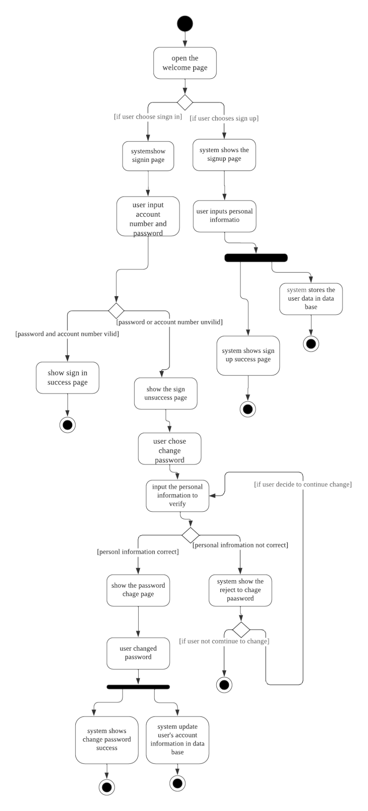

**Figure 2.1: *Activity diagram for use case 1****Illustrates when the user signs in or creates an account, and if forgot password is selected*

USE CASE 2:

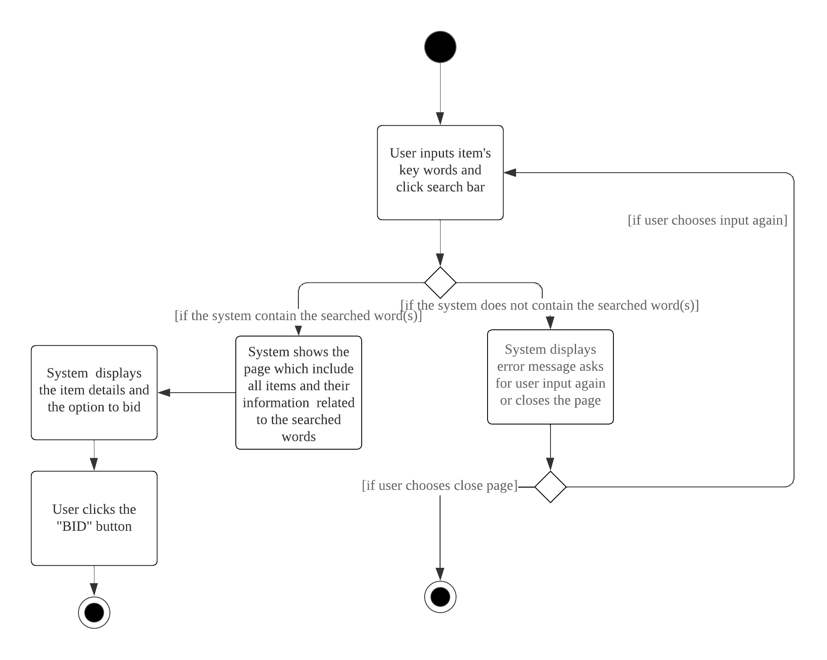

**Figure 2.2: *Activity diagram for use case 2****Illustrates when a user has successfully signed in and searches for an item if the item exists to display the item, if not, an error is displayed*

USE CASE 3:

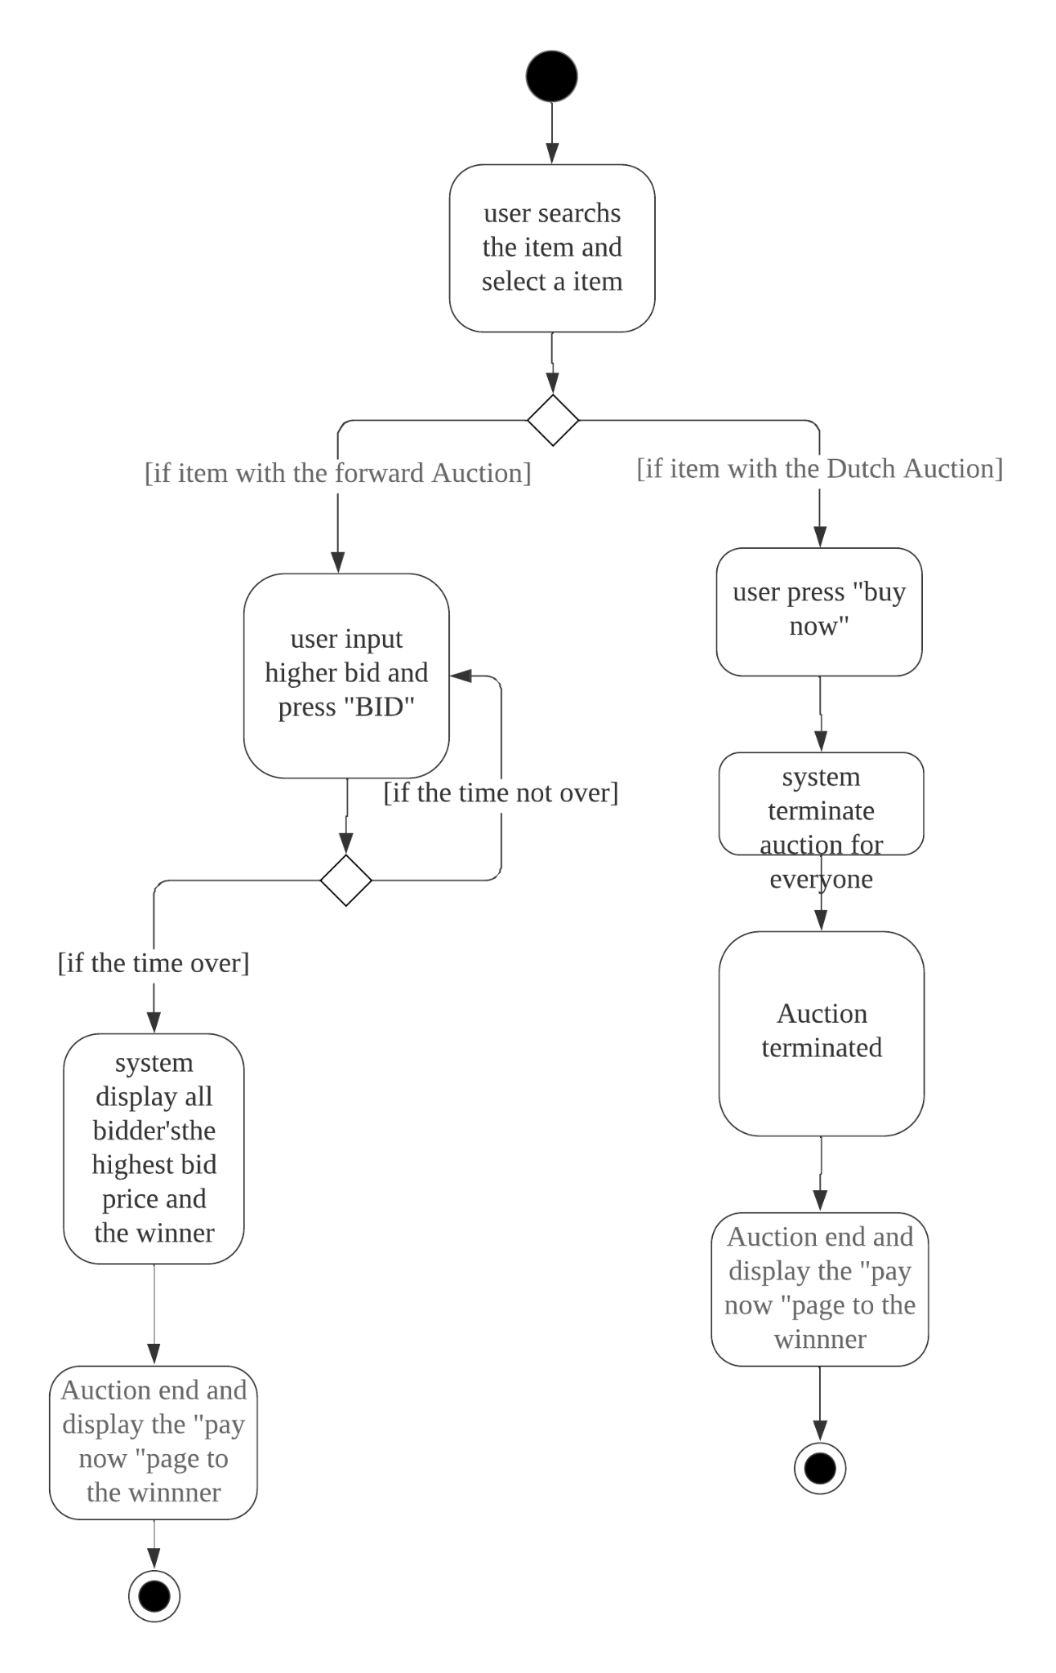

**Figure 2.3: *Activity diagram for use case 3****Illustrates user successfully searching for an item and bidding if forward auction and buying if dutch auction*

USE CASE 4:

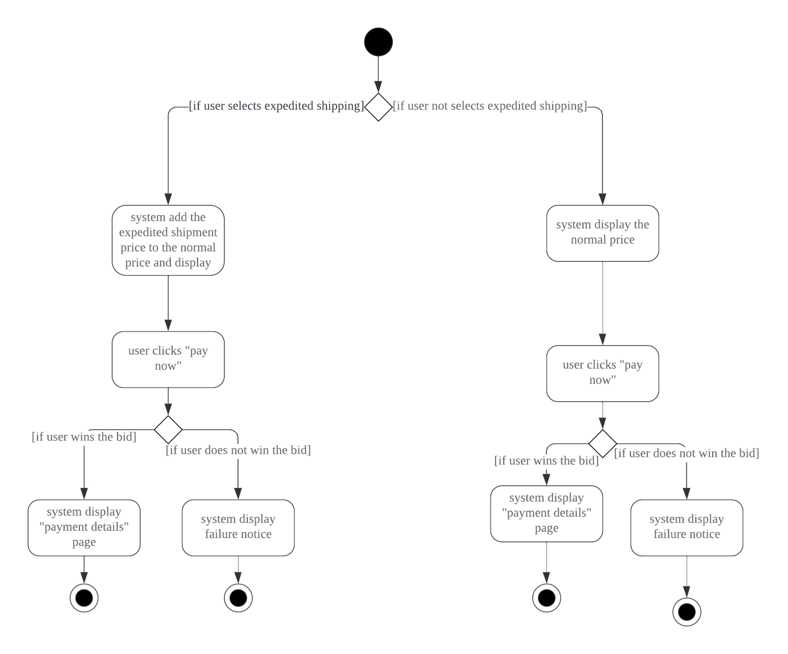

**Figure 2.4: *Activity diagram for use case 4***  
*Illustrates an auction ending and a user winning if they are the highest bidder in a forward auction*

# 

**ARCHITECTURE**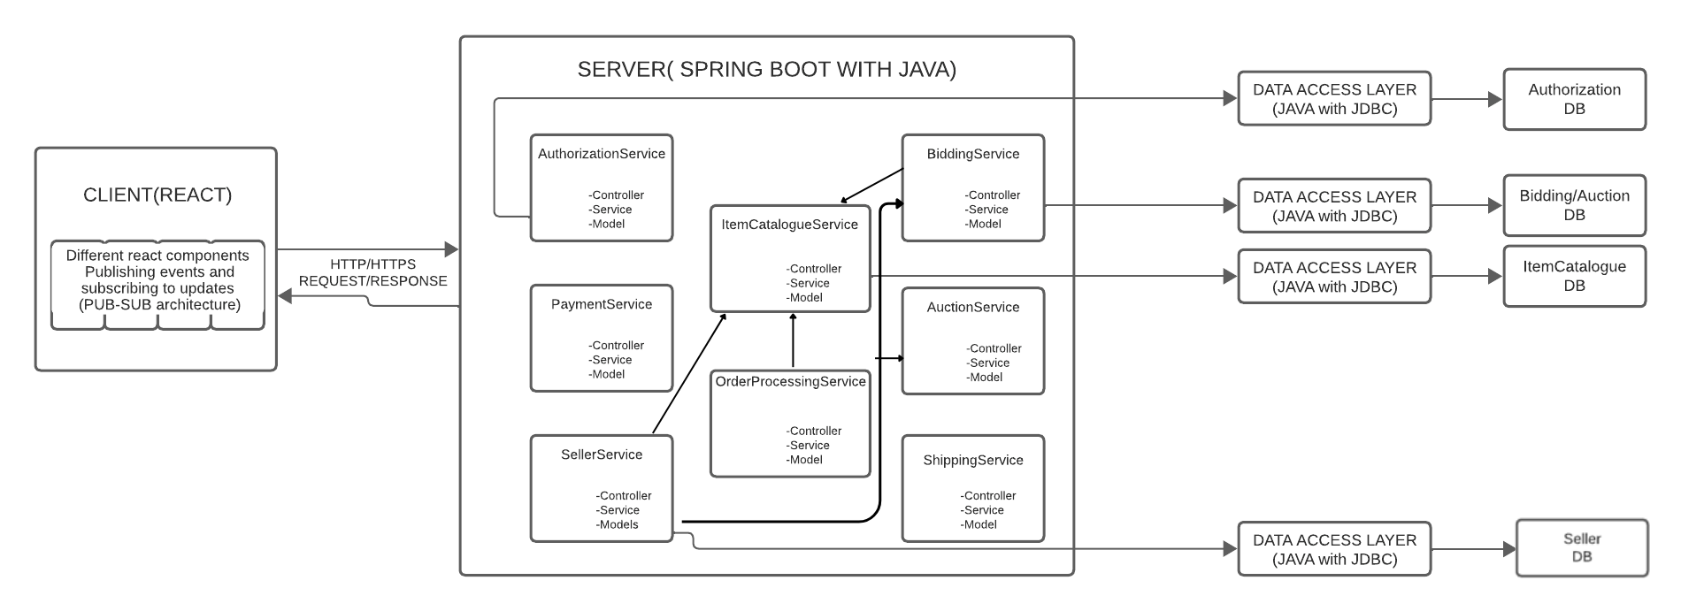

**Figure 3:** ***Bidding System’s architectural overview***

*The figure above shows the architectural overview of our bidding system. It has a frontend built with react using the pub-sub architecture within the frontend components. We have a server which communicates with the front end using http/https requests and responses. In the backend, we implement API’s (or services) adhering to microservices architecture with each service incorporating Model-View-Controller(MVC) principles, using Java with Spring Boot as the framework. There are four different databases that interact with the backend via a data access layer using JDBC. The frontend acts as a client to the backend while the backend acts as both a server to the frontend and a client to the database and the database acts as a server to the backend.*

| **MODULES** | | | |
| --- | --- | --- | --- |
| **Module Name** | **Description** | **Exposed Interface** | **Interface Description** |
| AuthorizationService | Handles the tasks of allowing users to sign in, sign up for new accounts, and handles an extra layer of security through two-factor authentication and manages user-related data. | Authorization | Provides the functionality of creating new accounts, signing into an existing account, enabling two-factor authentication an resetting passwords. |
| ItemCatalogueService | Manages information and data related to auction items. | ItemCatalogue | Provides functionality and data or information related to items. |
| BiddingService | Manages data and functionality related to bidding. | Bidding | Provides functionality of placing bids and updating the bidding prices. |
| AuctionService | Manages the auctions. | Auction | Provides functionalities to begin and end auction and get updates on the remaining time for the auction. |
| PaymentService | Manages the payment process. | Payment | Provides payment functionality. |
| OrderProcessingService | Manages the post-payment process including generating a receipt. | OrderProcessing | Provides functionality of generating receipts and updating the inventory for the auctioned item. |
| ShippingService | Handles shipment process. | Shipping | Provide functionality of calculating the shipping address and prints the shipping details. |
| SellerService | Handles operations related to a seller. | Seller | Provides the functionality of adding new items to the item catalogue and decreasing the bidding during dutch auctions. |

**Table 1.1: *Modules Overview****The table presented below provides a comprehensive overview of the modules and their exposed interfaces.*

| **Interfaces** | | |
| --- | --- | --- |
| **Interface Name** | **Operations** | **Operation Descriptions** |
| Authorization | void: SignUp(User user) used by Front-end  void : SignIn(Credential cred) used by Front-end  String: PasswordReset(String username) used by Front-end | SignUp(User user): registers a new user.  SignIn(Credential cred: lets a registered user login to the application.  PasswordReset(String username): resets a user’s password. |
| ItemCatalogue | List<Item> : Search (String keyword) used by Front-end  List<Item> : getAuctionedItems() used by Front-end  Item : getItem(int itemId) used by Bidding, Auction, and OrderProcessing | Search (String keyword): Gets a list of items based on the search criteria.  getAuctionedItems() : Gets the list of items up for auction.  getItem(int itemId) : Gets detailed information about a specific item |
| Bidding | void : placeBid (int itemId, double newPrice, User user) used by Front-end  double : updateForwardAuctionprice(int itemId, double newprice) used by Front-end | placeBid (int itemId, double newPrice, User user): Places a bid for an item in a forward auction.  updateForwardAuctionprice(int itemId, double newprice) : Updates the bid price during forward auction. |
| Auction | void : startAuction(int itemId) used by Seller  String : getRemainingTimeUpdate(int itemId) used by Front-end and ItemCatalogue  String : endAuction () used by Front-end | startAuction(int itemId) : Starts an auction.  getRemainingTimeUpdate(int itemId) : Get updates on the time remaining for an auction.  endAuction (): Determines the winner and ends an auction. |
| Payment | void : processPayment(PaymentInfo info) used by Front-end | processPayment(PaymentInfo info) : Process a payment transaction. |
| OrderProcessing | Receipt : generateReceipt (int itemId, User user) used by Front-end  void : updateItems(int itemId) used by Catalogue | generateReceipt (int itemId, User user) : Generates a receipt after the payment is complete.  updateItems(int itemId) : Updates the inventory after an auction ends. |
| Shipping | double : calculateShippingCost(int itemId, String shippingType)  String : displayShippingDetails(int itemId, Details userDetails) used by Front-end | calculateShippingCost(int itemId, String shippingType): Calculates shipping cost based on it’s type.  displayShippingDetails(int itemId, Details userDetails): Arrange the shipment of an item and returns the expected shipment date. |
| Seller | void : uploadSellItems(ItemDetails details) used by Front-end and Catalogue  void : updateDutchAuctionprice(int itemId, double newprice) used by Bidding | uploadSellItems(ItemDetails details): Adds an item to sell and updates its details.  updateDutchAuctionprice(int itemId, double newprice) : Decreases the price for a Dutch auction |

**Table 1.2: *Interface Operations Details****The table presented below provides details on the exposed interfaces and their operations.*

## 

## 

## 

**ACTIVITIES PLAN**

| **User Story** | **Priority** |
| --- | --- |
| As a user, I want to be able to bid on items | 13 |
| As a user, I want to be able to pay for items on won auctions | 7 |
| As a user, I can sign up and create an account | 9 |
| As a user, I can sign in with my credentials | 9 |
| As a seller, the auctions must end correctly | 13 |
| As a user, I want to be able to select an item to bid for | 9 |
| As a user, after paying I want to be able to see the receipt and shipment details | 9 |
| As a user, I want to see a list of auctioned items | 7 |
| As a user, I can search for items | 7 |
| As a user, I can reset my password if forgotten | 5 |

**Table 2: Product Backlog** *Table above illustrates the sprint backlog*

## 

**Figure 4: *Sprint Backlog*** *Figure above illustrates the sprint backlog*

| **Present Group Members** | **Meeting Date** | **Issues Discussed / Resolved** |
| --- | --- | --- |
| Kawshar, Jacob, Yash, Yunfei | 01/10 - 45 Minutes | Duties divided |
| Kawshar, Jacob, Yash, Yunfei | 01/17 - 30 Minutes | Architecture issues resolved, type of DB to use |
| Kawshar, Jacob, Yash, Yunfei | 01/29 - 90 Minutes | Halfway Check-in with group members, ensuring we are on track |
| Kawshar, Yash, Jacob, Yunfei | 01/31 25 Minutes | Sprint Backlog Refinement |
| Kawshar, Jacob, Yash, Yunfei | 02/04 40 Minutes | Refined Sequence and Activity Diagrams and Test Cases |
| Kawshar, Jacob, Yash, Yunfei | 02/05 - 35 Minutes | Final Review of Sprint 1 |

**GROUP MEETING LOGS**

**Table 3: *Group meeting logs table***

**TEST DRIVEN DEVELOPMENT**

| **Test ID** | TC001 |
| --- | --- |
| **Category** | Evaluation of new user details registered on file/DB |
| **Requirements Coverage** | UC1.1-Successful-User-SignUp-Flow |
| **Initial Condition** | System has been initiated and runs and the user is presented with the welcome screen with Sign-up/Sign-in options |
| **Procedure** | 1. User selects the sign-up option  2. User provides a valid user name, a password, their first name, their last name and their shipping address (street name, street number, city, country, postal code).  3. User selects the submit option to submit the above details |
| **Expected Outcome** | User is successfully registered, and the system navigates to the Sign-In page. |
| **Notes** | - (Alternate Flow) Failed Sign Up due to invalid credentials  Future considerations:  - A 2 Factor Authentication service could be implemented  - A “Strong password” check could be implemented  - Fails when the same user tries to sign up again |

***Table 6.1: Test Case TC001****This test outlines testing for the user sign up flow*

| **Test ID** | TC002 |
| --- | --- |
| **Category** | Server verifies new user details before registering on file/DB |
| **Requirements Coverage** | UC1.1-Unsuccessful-User-SignUp-Flow |
| **Initial Condition** | System has been initiated and runs and the user is presented with the welcome screen with Sign-up/Sign-in options |
| **Procedure** | 1. User selects the sign-up option  2. User provides a username, a password, their first name, their last name and their shipping address (street name, street number, city, country, postal code) but at least one of the fields is invalid or blank  3. User selects the submit option to submit the above details |
| **Expected Outcome** | User receives an error message and the Sign-Up page persists. |
| **Notes** |  |

***Table 6.2: Test Case TC002****This test outlines testing for unsuccessful user sign-up*

| **Test ID** | TC003 |
| --- | --- |
| **Category** | Server verifies user details registered on file/DB |
| **Requirements Coverage** | UC1.2-Successful-User-Login-Flow |
| **Initial Condition** | System has been initiated and runs and a registered user is presented with the welcome screen with Sign-up/Sign-in options |
| **Procedure** | 1. User selects the sign-in option  2. User enters a valid username and password  3. User selects the submit option to submit the above details |
| **Expected Outcome** | User is successfully signed in and the system navigates to the main page. |
| **Notes** | - Implementing a forgot password mechanism  - (Alternate flow) Failed Sign in due to invalid credentials  Future considerations:  - “Remember Me” option for convenience |

***Table 6.3: Test Case TC003****This test outlines testing for successful user login*

| **Test ID** | TC004 |
| --- | --- |
| **Category** | Server verifies user details registered on file/DB |
| **Requirements Coverage** | UC1.2-Unsuccessful-User-Login-Flow |
| **Initial Condition** | System has been initiated and runs and a registered user is presented with the welcome screen with Sign-up/Sign-in options |
| **Procedure** | 1. User selects the sign-in option  2. User enters an invalid username and password  3. User selects the submit option to submit the above details |
| **Expected Outcome** | User receives an error message and the Sign-In page persists |
| **Notes** |  |

***Table 6.4: Test Case TC004****This test outlines testing for unsuccessful user login*

| **Test ID** | TC005 |
| --- | --- |
| **Category** | Retrieval of matching items from file/DB |
| **Requirements Coverage** | UC2.1-Successful-Item-Search-Flow |
| **Initial Condition** | User is signed in, and the system is displaying the main page. |
| **Procedure** | 1. User enters a keyword in the search bar. 2. User selects the “search” option |
| **Expected Outcome** | System displays a list of items (up for auction or currently being auctioned) matching the search keyword, retrieved from the file/DB |
| **Notes** | - (Alternate Flow) No items matching search results  Future considerations:  - Might implement advanced search filters for more precise results. |

***Table 6.5: Test Case TC005****This test outlines testing for successful item search*

| **Test ID** | TC006 |
| --- | --- |
| **Category** | Retrieval of matching items from file/DB |
| **Requirements Coverage** | UC2.1--Item-Search-No-Matching-Results-Flow |
| **Initial Condition** | User is signed in, and the system is displaying the main page. |
| **Procedure** | 1. User enters a keyword in the search bar.   1. User selects the “search” option |
| **Expected Outcome** | System displays a message indicating no matching items found |
| **Notes** |  |

***Table 6.6: Test Case TC006****This test outlines testing for item search with no matching results*

| **Test ID** | TC007 |
| --- | --- |
| **Category** | Matching auctioned items retrieved from file/DB are served to the user |
| **Requirements Coverage** | UC2.2-Successfully-Display-Auctioned-Items |
| **Initial Condition** | User is signed in, and the system is displaying the list of all matching auctioned items after searching keyword |
| **Procedure** | 1. User views or scrolls through the displayed list of matching auctioned items |
| **Expected Outcome** | System displays the full item name, the current bidding price, the type of auction, and the remaining time (applicable only for forward auctions) for each matching item. |
| **Notes** |  |

***Tabke 6.7: Test Case TC007****This test outlines testing for displaying auctioned items*

| **Test ID** | TC008 |
| --- | --- |
| **Category** | Selected item details are retrieved from file/DB is served to the user |
| **Requirements Coverage** | UC2.3-Successful-Item-Selection |
| **Initial Condition** | User is viewing the displayed items, and their details and there is a selection radio button for each displayed item which allows the user to select the item to bid for |
| **Procedure** | 1. User clicks the radio button belonging to the desired item 2. User selects the “Bid” option. |
| **Expected Outcome** | System displays the item details and the option to bid |
| **Notes** | - User can select only one item to bid for  - We assume a bidder bids for only one item for each log-in session they have initiated  Future Considerations:  - User may have multiple log-in sessions in parallel in different browsers |

***Table 6.8: Test Case TC008****This test outlines testing for item selection*

| **Test ID** | TC009 |
| --- | --- |
| **Category** | Evaluation of server for refreshing the page after every bid and fetching data accurately from the respective file/DB |
| **Requirements Coverage** | UC3.1-Successful-Forward-Auction-Bidding-Flow |
| **Initial Condition** | User is on the bidding screen for the selected forward auction item where item details and option to bid are displayed |
| **Procedure** | 1. User provides a new bidding price which must be higher than the current price 2. User selects the “Bid” option. |
| **Expected Outcome** | Once a bid is submitted, the system (server) refreshes the page and the new highest bidding price and the highest bidder are displayed to all users bidding for this item so that the current highest price and the ID of the current highest bidder are always displayed |
| **Notes** | - The auction ends when the time expires and users are directed to “Auction ends” page and served with a “pay now” button  Future Considerations:  - Real-Time bidding updates feature |

***Table 6.9: Test Case TC009****This test outlines testing for forward auction bidding*

| **Test ID** | TC010 |
| --- | --- |
| **Category** | Evaluation of server directing all users to “auction ends” page. |
| **Requirements Coverage** | UC3.2-Successful-Dutch-Auction-Bidding-Flow |
| **Initial Condition** | User is on the bidding screen for the selected dutch auction item where item details and the option to bid are displayed |
| **Procedure** | 1. User clicks on the "Buy Now" button. |
| **Expected Outcome** | - System immediately terminates the auction and the user is directed to “Auction ends” page and served with a “pay now” button. |
| **Notes** | Future Considerations:  - Countdown timer for dutch auctions. |

***Table 6.10: Test Case TC010****This test outlines testing for dutch auction bidding*

| **Test ID** | TC011 |
| --- | --- |
| **Category** | Evaluation of server directing the user to the appropriate page and retrieving details from the DB |
| **Requirements Coverage** | UC4-Successful-Auction-Ended-Pay-Now-Flow |
| **Initial Condition** | Auction has ended (either time ended for forward auction or because of a “Buy Now” in Dutch auctions) and the users are served a “Auction Ended” page with a “Pay Now” button. Here, consider a winning user (“successful flow”) |
| **Procedure** | 1. (Optional) User selects the “expedited shipment” option  2. User clicks on the "Pay Now" button |
| **Expected Outcome** | - System displays the payment page with the user and shipping details from the DB that stores data when the user signed up |
| **Notes** | - If the user selects the “expedited shipment” option, then the price of expedited shipment is added to the normal shipping price. This expedited shipment cost information can be included in the Catalogue DB for each specific item  - (Alternate flow) The user is not a winner for the specific item and is served with a failure notice upon clicking the “pay now” button |

***Figure 6.11: Test Case TC011****This test outlines testing for auction ending*

| **Test ID** | TC012 |
| --- | --- |
| **Category** | Evaluation of server directing the user to the appropriate page and retrieving details from the DB |
| **Requirements Coverage** | UC4-Unsuccessful-Auction-Ended-Pay-Now-Flow |
| **Initial Condition** | Auction has ended (either time ended for forward auction or because of a “Buy Now” in Dutch auctions) and the users are served an “Auction Ended” page with a “Pay Now” button. Here, consider a losing user (“unsuccessful flow”) |
| **Procedure** | 1. (Optional) User selects the “expedited shipment” option  2. User clicks on the "Pay Now" button |
| **Expected Outcome** | - System displays an error message indicating that the user cannot pay for a non-winning item |
| **Notes** |  |

***Table 6.12: Test Case TC012****This test outlines testing for unsuccessful auction end*

| **Test ID** | TC013 |
| --- | --- |
| **Category** | Evaluation of server’s payment processing and operations on multiple respective DBs. (Confirm names) |
| **Requirements Coverage** | UC5-Successful-Payment-Flow |
| **Initial Condition** | User is on the Payment page displaying the user/shipping details from the DB that stores data when the user signed up |
| **Procedure** | 1. User adds valid payment details, i.e., the credit card number, the name on the card, the expiration date and the security code  2. User clicks the “Submit button” |
| **Expected Outcome** | - System processes the payment, and the receipt page with shipping details is displayed |
| **Notes** | - The payment includes the item price plus the shipping cost.  - (Alternate Flow) Payment declines due to unsupported pathway or invalid details  Future Considerations:  - Integrate multiple payment gateways. |

***Table 6.13: Test Case TC013****This test outlines testing for successful payment flow*

| **Test ID** | TC014 |
| --- | --- |
| **Category** | Evaluation of server’s payment processing and operations on multiple respective DBs. (Confirm names) |
| **Requirements Coverage** | UC5-Unsuccessful-Payment-Flow |
| **Initial Condition** | User is on the Payment page displaying the user/shipping details from the DB that stores data when the user signed up |
| **Procedure** | 1. User adds invalid payment details, i.e., one of the credit card number, the name on the card, the expiration date or the security code is invalid or blank (eg: expired credit card)  2. User clicks “Submit button” |
| **Expected Outcome** | - System displays an error message indicating that the payment was unsuccessful and the payment page persists |
| **Notes** |  |

***Table 6.14: Test Case TC014****This test outlines testing for unsuccessful payment*

| **Test ID** | TC015 |
| --- | --- |
| **Category** | Evaluation of server’s ability to fetch and display accurate details regarding a transaction from the DBs |
| **Requirements Coverage** | UC6-Receipt-Page-Shipment-Details-Display |
| **Initial Condition** | Payment is Successful |
| **Procedure** | 1. User views the receipt and shipment details |
| **Expected Outcome** | - System displays the total amount paid as well as the shipping details |
| **Notes** | - Consider that each item has a separate shipping time  - System does not need to calculate the actual shipping date from the current date; just indicate that “The Item will be shipped in xxx days”  - Shipping time information can be included in the Catalogue DB for each specific item  Future Considerations:  - Sending email notifications and tracking details |

***Table 6.15: Test Case TC015****This test outlines testing for displaying shipment details*

| **Test ID** | TC016 |
| --- | --- |
| **Category** | Evaluation that server stores new entry into DB |
| **Requirements Coverage** | UC7-Seller-Uploads-Item |
| **Initial Condition** | User is logged in as seller |
| **Procedure** | 1. User (Seller) uploads all required information regarding the item such as the description, the type of auction (Dutch or forward), the duration of the auction and the starting bid price |
| **Expected Outcome** | - System adds the item to the Catalogue DB with relevant details |
| **Notes** |  |

***Table 6.16: Test Case TC016****This test outlines testing for seller uploading an item*

| **Test ID** | TC017 |
| --- | --- |
| **Category** | Evaluation that server updates an existing entry in the DB and broadcasts it to all engaged users |
| **Requirements Coverage** | UC7-Seller-Updates-Dutch-Auction-Price |
| **Initial Condition** | Seller is logged in and is active in an ongoing Dutch Auction |
| **Procedure** | 1. Seller updates (decreases) the price for a Dutch auction item |
| **Expected Outcome** | * System updates the auction details with the new price and serves it to all the users engaging in that auction |
| **Notes** |  |

***Table 6.17: Test Case TC017****This test outlines testing for a seller updating a dutch auction price*