**BÁO CÁO THỰC HÀNH OOP 02**

*Trần Khánh Quỳnh – 20225762*

1. Usecase diagram

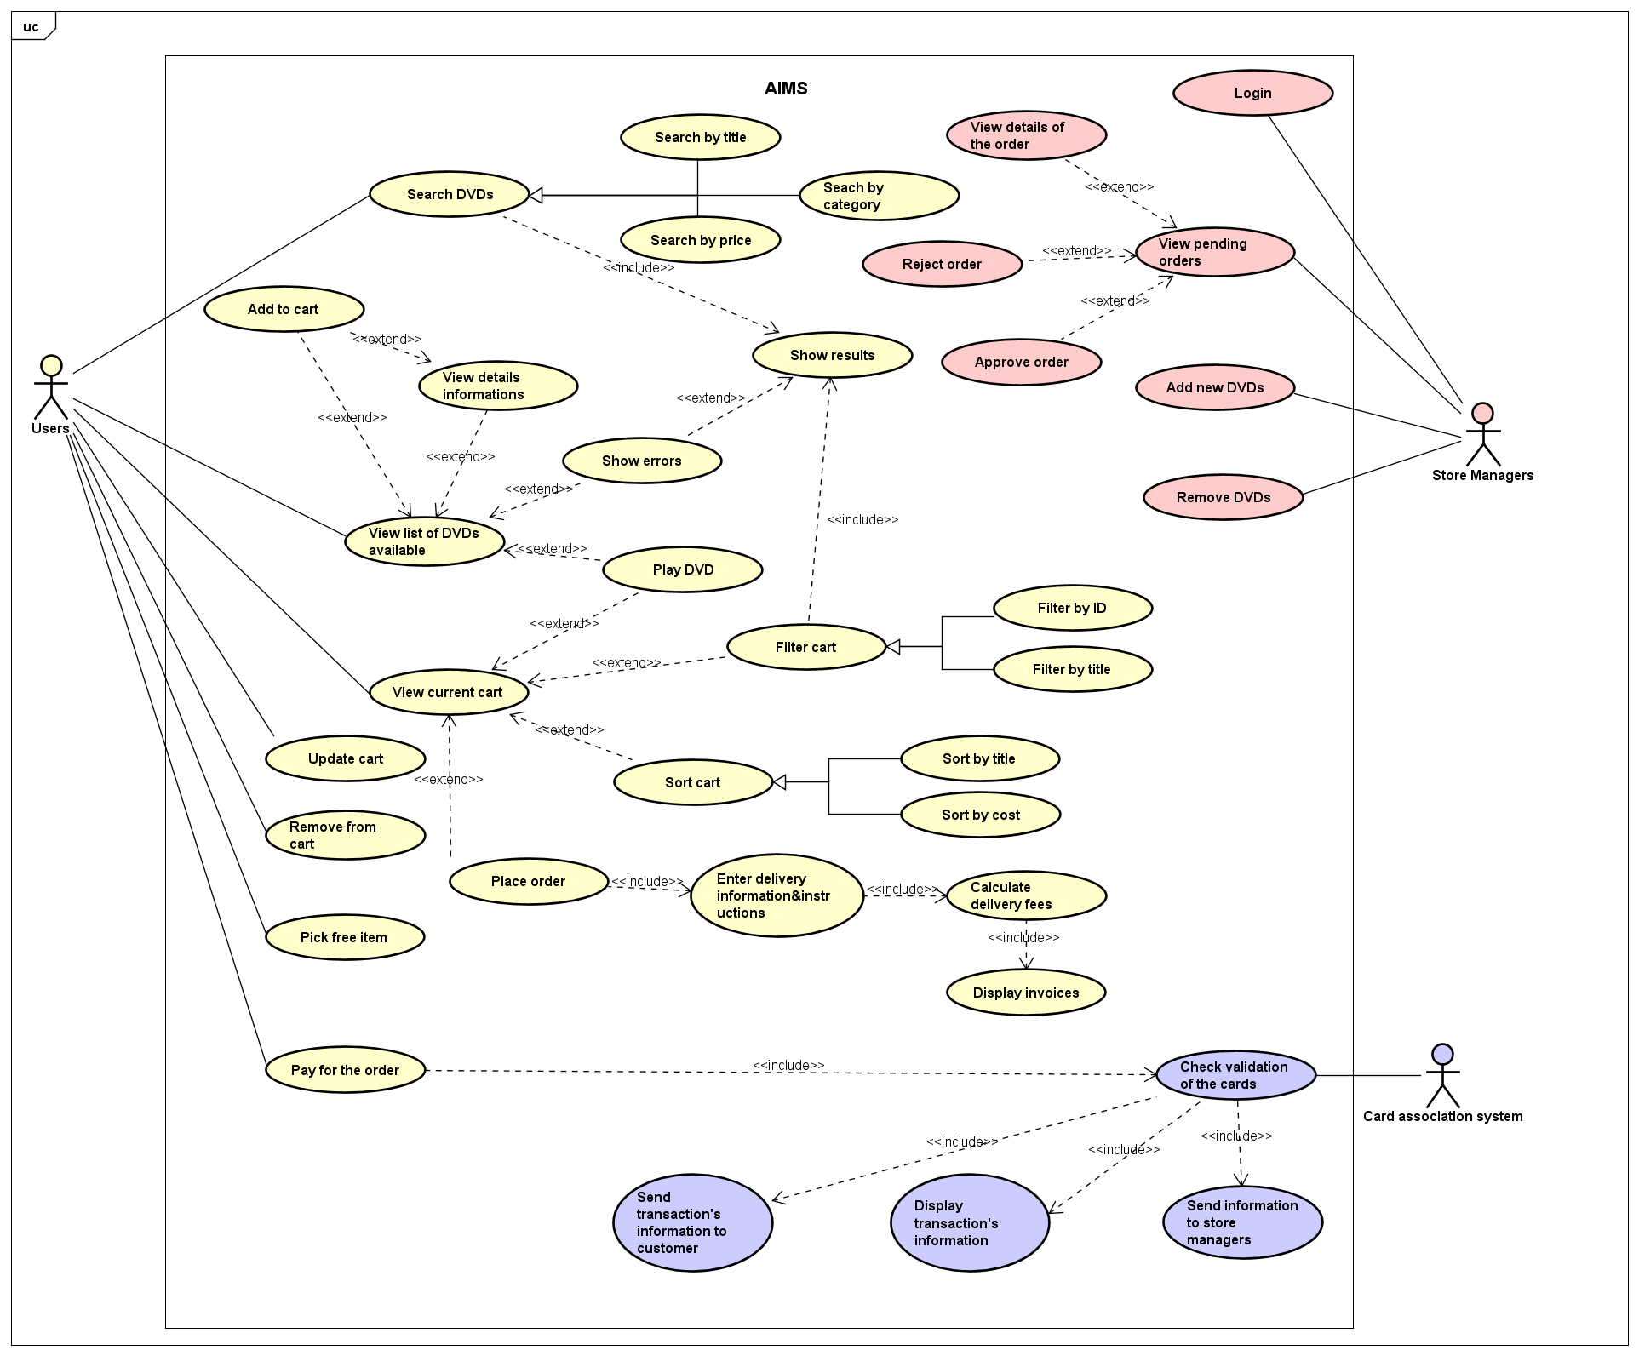

1. Class diagram
2. Reading assignment
3. Question