**Lab 03: Basic Object-Oriented Techniques – Report**

***Trần Khánh Quỳnh – 20225762***

1. **New written code**
2. Method addDigitalVideoDisc which allows to pass an arbitrary number of arguments for dvd

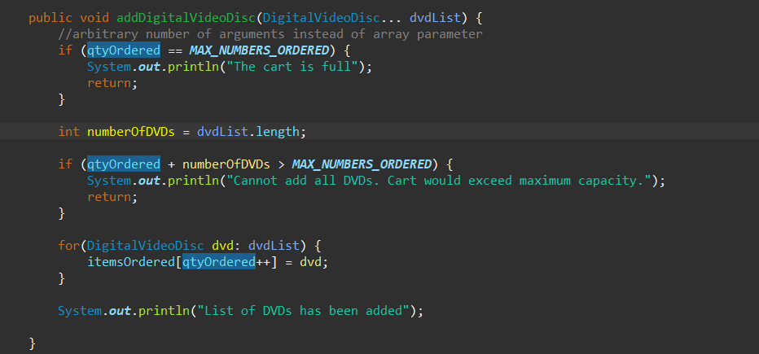

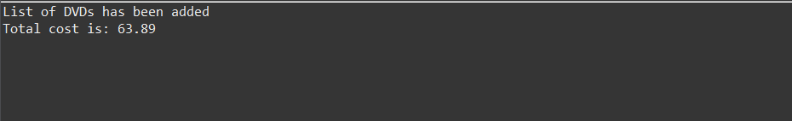

1. Method addDigitalVideoDisc with 2 parameters

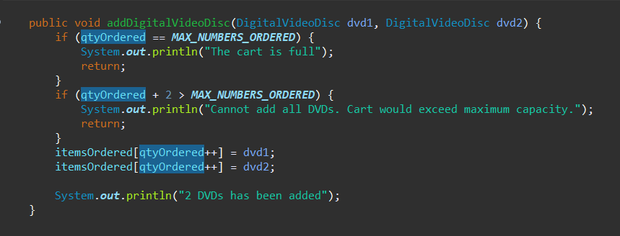



1. TestPassingParameter.java

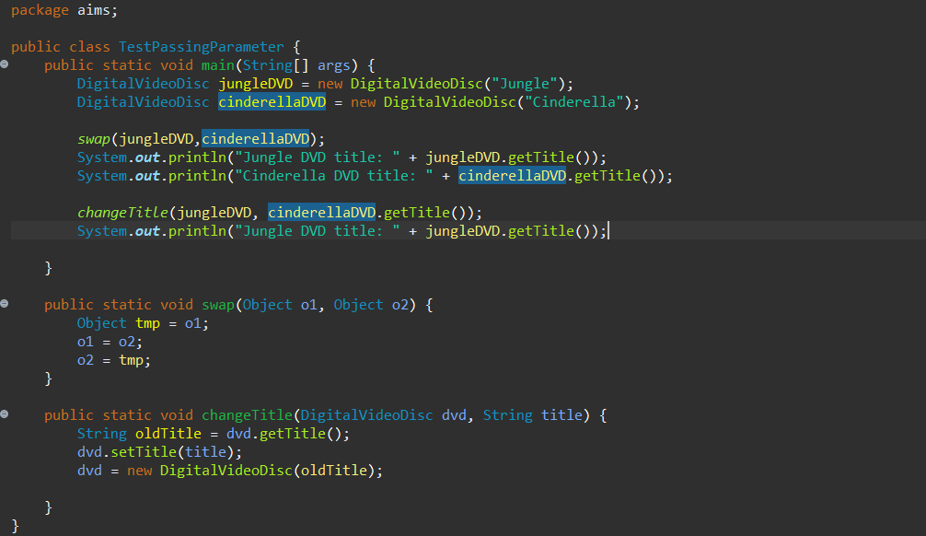



1. Keep track of the number of DVDs created

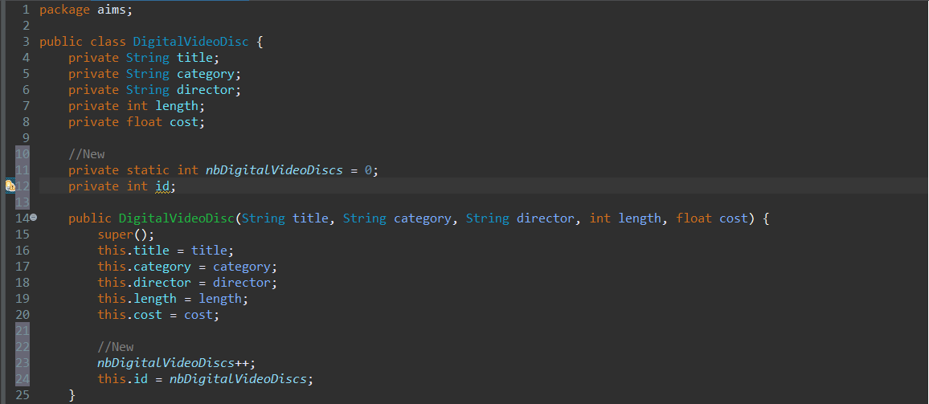

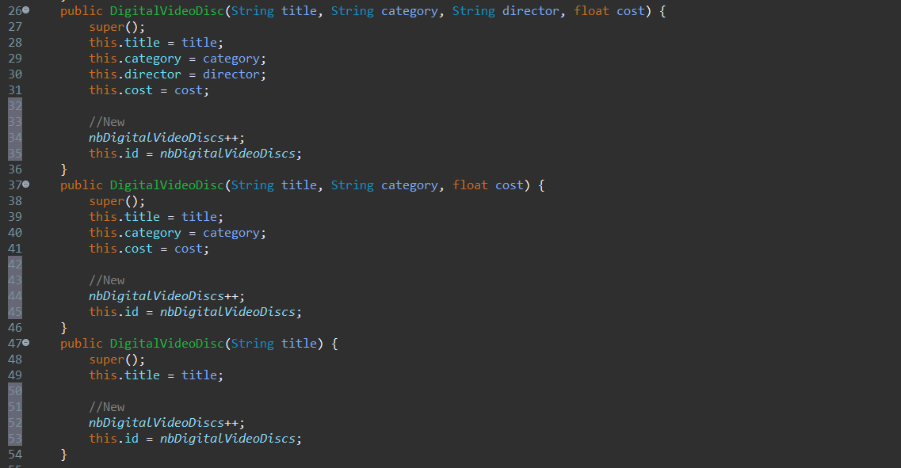



1. Method to print the list of ordered items of a cart, the price of each item, and the total price:

-toString() method in DigitalVideoDisc class:

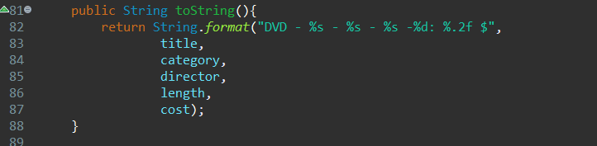

-printCart() method in Cart class:

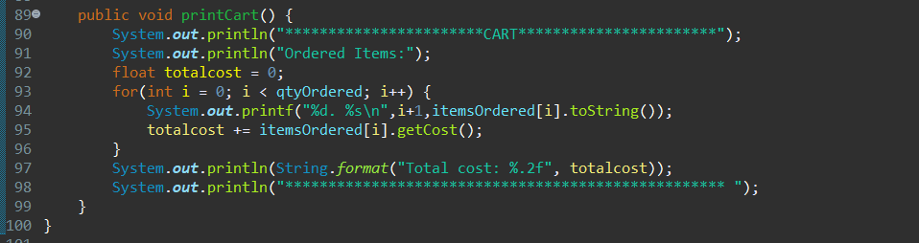

-Run printCart():

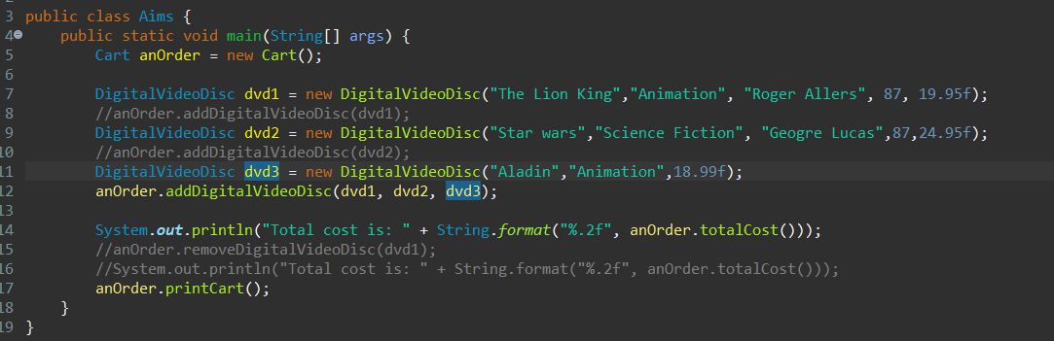

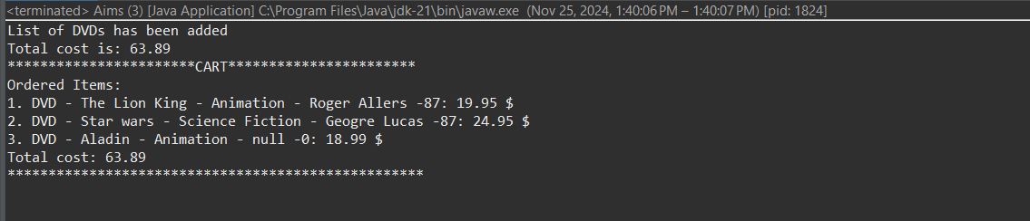

1. Search for DVDs in the cart by ID and display the search results:

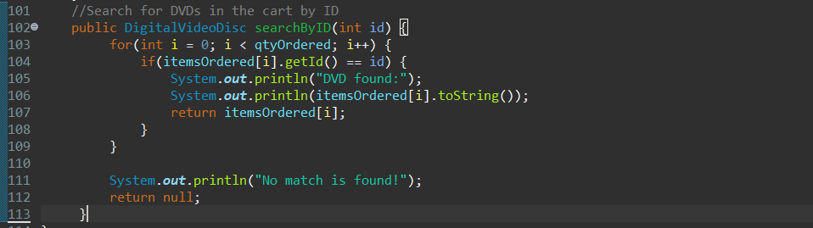

Result:

If ID = 1





If ID = 0





1. Search for DVDs in the cart by title

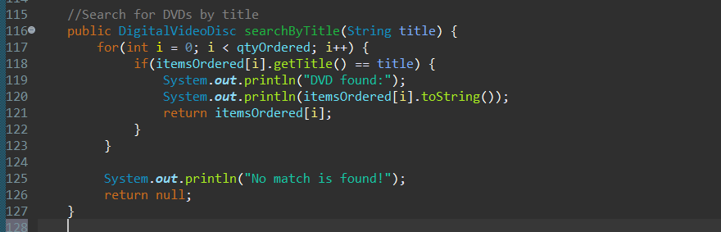

Result:

If title is “Star wars”:





If title is Cinderella





1. CartTest() method:

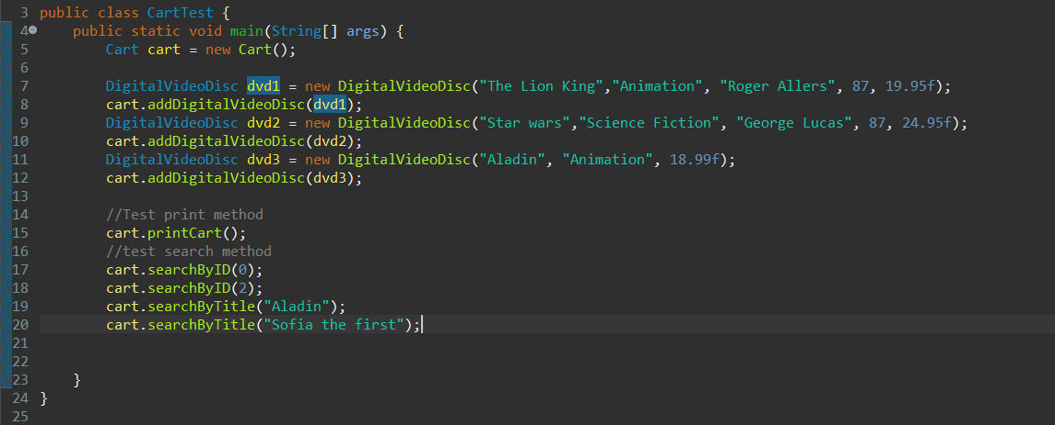

Result:

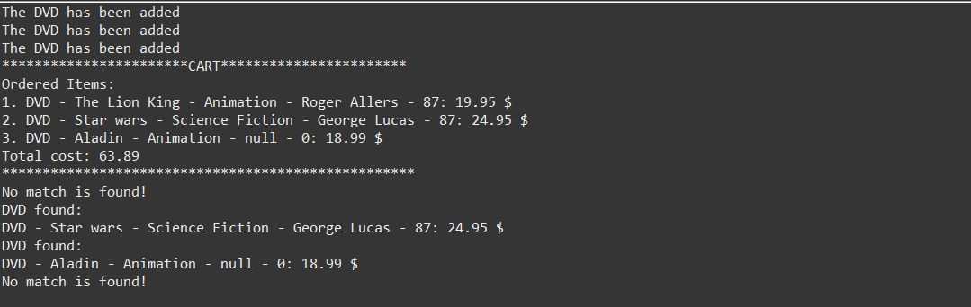

1. Implement the Store class

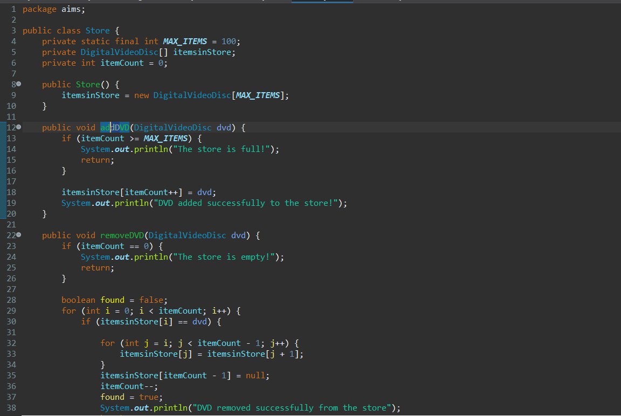



-StoreTest class:

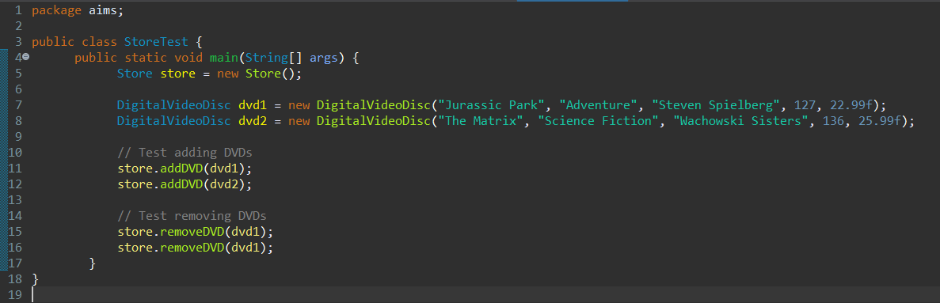

Result:

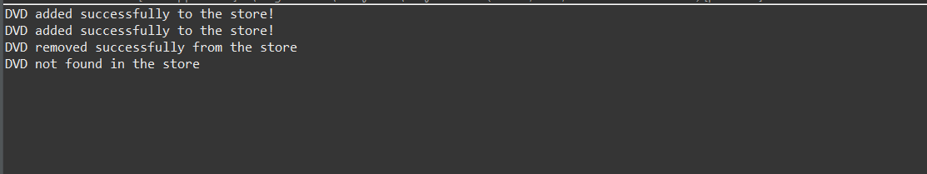

1. String, StringBuilder and StringBuffer

-ConcatenationInLoops.java:

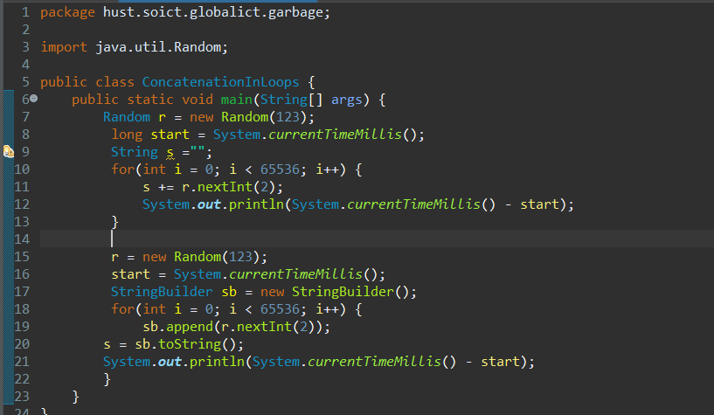

-GarbageCreator.java

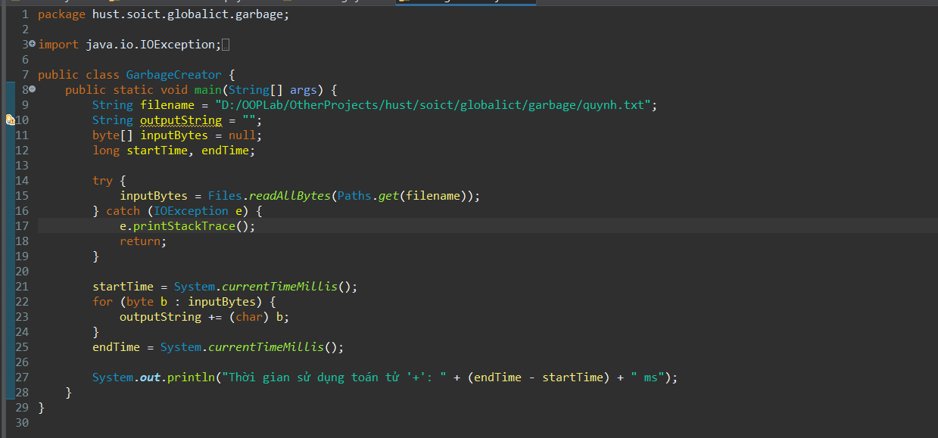

Result:

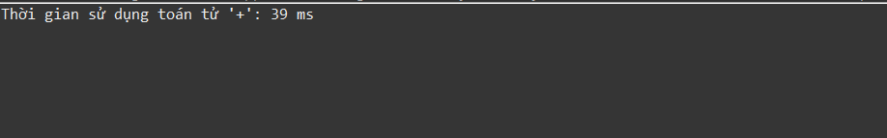

-NoGarbage.java

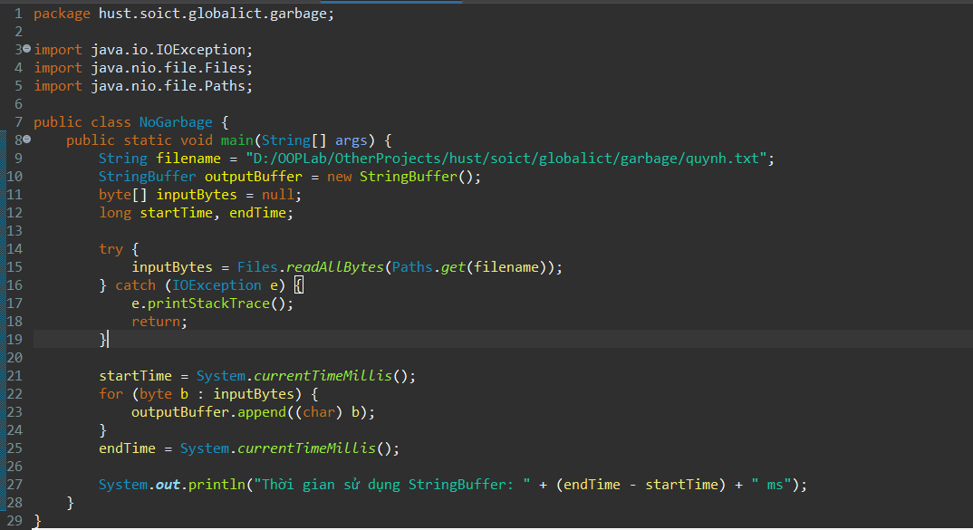

Result:

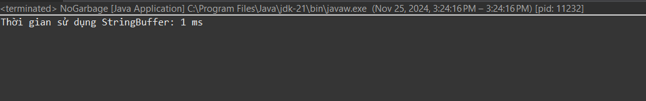

1. **Code debugging and results**

**-**Set a breakpoint:

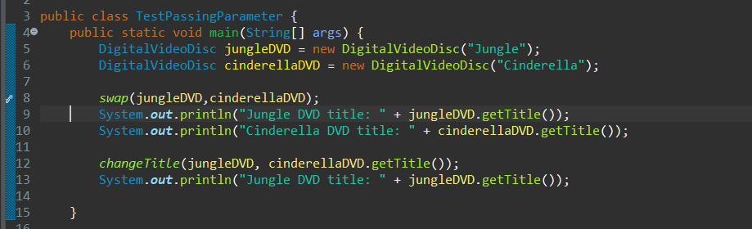

-Step into swap function:

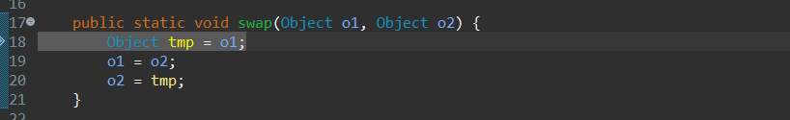

+Variable perspective

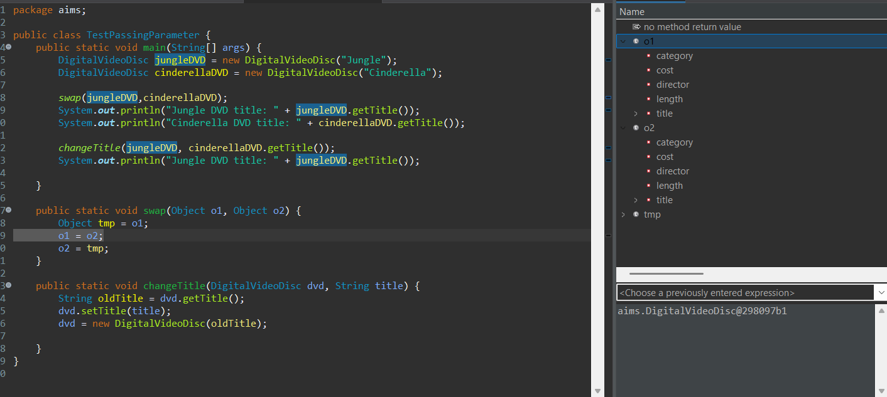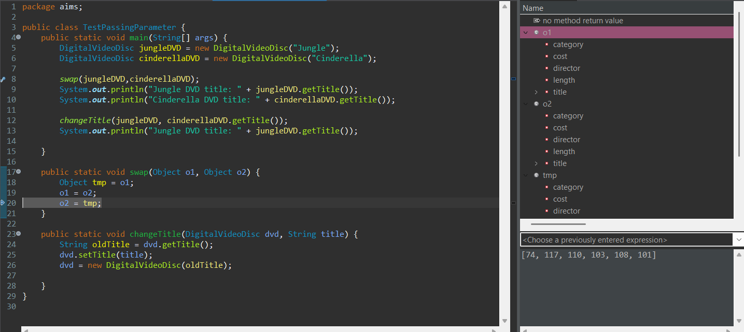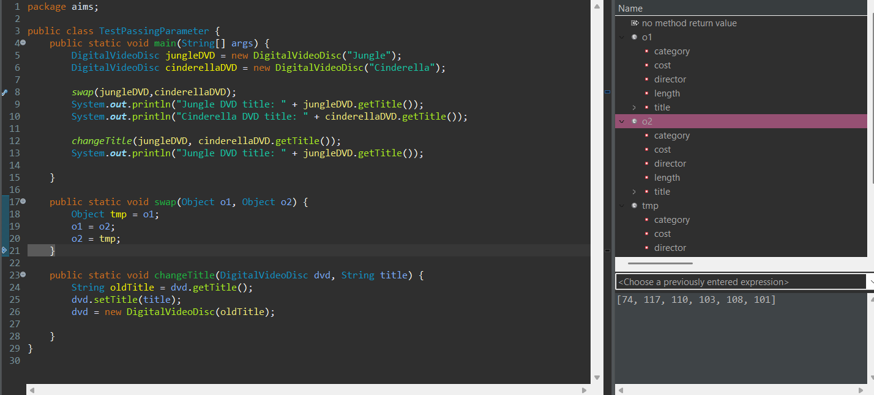

-Return to main function

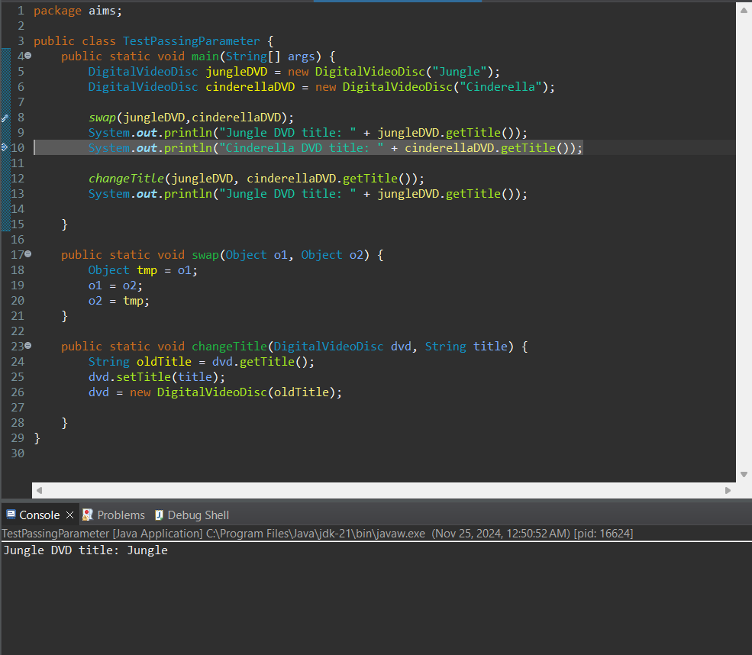

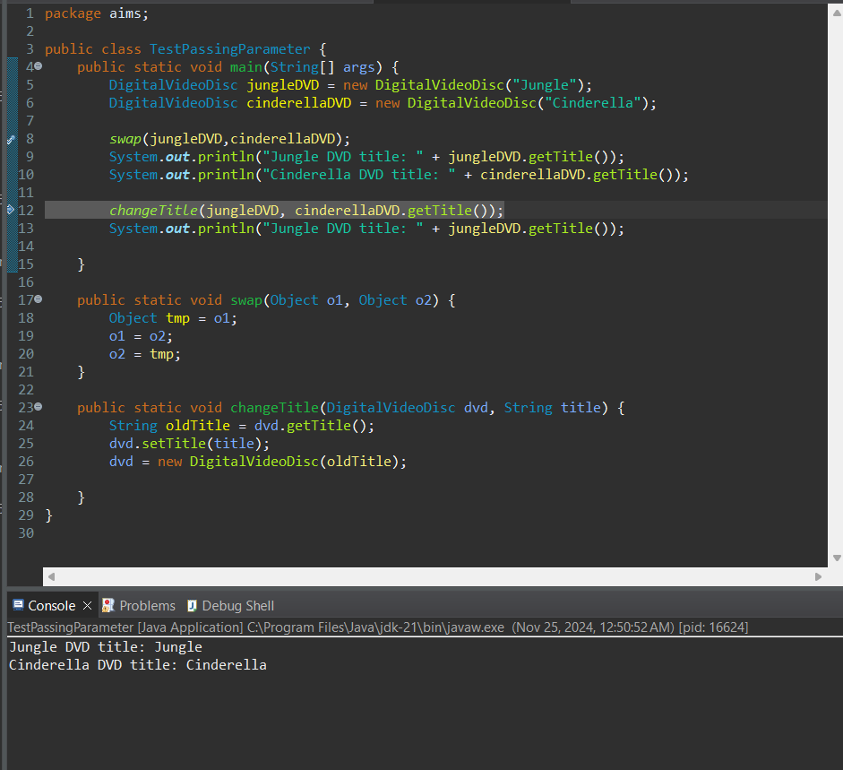

-After running the changeTitle function: the title of jungle DVD is now Cinderella

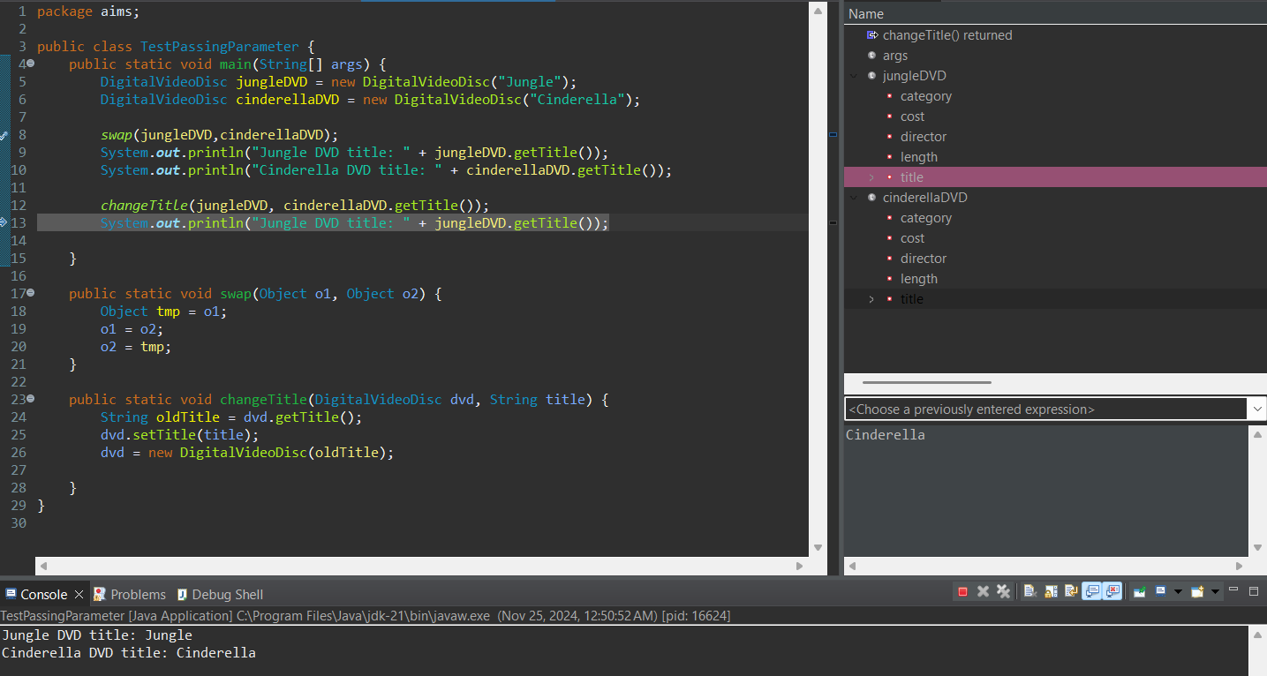

-Print the name of Jungle DVD:

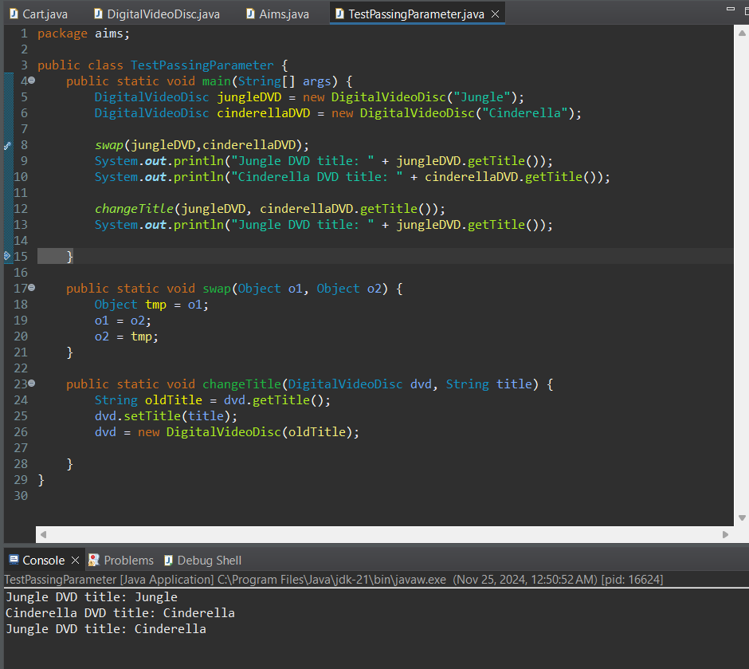

1. **Answer**

*Question: Is JAVA a Pass-by-Value or a Pass by Reference programming language?*

Answer: Java is a pass by value programming language.

*Questions:*

* *After the call of swap(jungleDVD, cinderellaDVD) why does the title of these two objects still remain?*
* *After the call of changeTitle(jungleDVD, cinderellaDVD.getTitle()) why is the title of the JungleDVD changed?*

Answer:

* When calling swap(jungleDVD, cinderellaDVD), Java created copies of the references. The swap only changes these copies inside the method, and the original in main() remains unchanged. Thus, after the method call, the jungleDVD still “Jungle” and the cinderellaDVD still “Cinderella”.
* The JungleDVD’s title changed because the line dvd.setTitle(title) changes the content of the object. Although dvd is just a copy of the reference, it still points to the same object in memory. So when we call the setTitle() method, we’re changing the data inside that object.

1. **Use-case diagram and Class diagram updates**