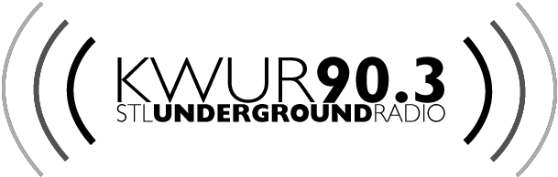
DJ APPLICATION
New DJs – 2016

This is an application to become a KWUR DJ, which entails a semester long training process. Don’t be nervous about filling this out, it’s just so we can get to know you better & have all your information in one place. Training will include familiarization with KWUR and FCC policy, technical instruction for operating equipment, and guaranteed fun social events. After training is done, you will be able to host a weekly show in the spring semester and onwards.

To contact KWUR with any questions, get in touch with Katie and Anya (the training directors) by emailing kwurtraining14@gmail.com or stopping by the station. We are located on the 3rd floor of the DUC, deep within the Harvey Media Suite. Return this application to the station in the folder by the door or email it back to us. The sooner you can get it in, the better. Try to have it submitted by Sunday February 14th

THE FIELDS BELOW ARE REQUIRED

Name:_____________________________________ School/Year:________________________

Student ID:_________________________________ Phone:_____________________________

Email:_____________________________________

Are you applying with a partner?______________ If so, who?__________________________

If you want to do a music show, what genre(s) of music are you interested in playing?

______________________________________________________________________________________

If you don’t want to do a music show, what do you plan to do (talk, sports, news, something else)?

______________________________________________________________________________________

(FLIP THIS OVER! IT'S DOUBLE SIDED!)

What has inspired you to apply to be a KWUR DJ?

How can you contribute to the KWUR community?

For people interested in doing a music show, who are some of your favorite artists?

And in true KWUR tradition, we proudly bring back the…
FREE FORM SPACE
(Do what you like in the space below)

