Multilevel Regression Modeling as a Complement to Traditional Repeated Measures Analysis of Variance in Sports Biomechanics Research

Kyle Wasserberger1,2, William Murrah3, Kevin Giordano4, and Gretchen Oliver2 1Research & Development; Driveline Baseball

2School of Kinesiology; Auburn University

3Department of Educational Foundations, Leadership, & Technology; Auburn University

4Department of Physical Therapy; Creighton University

Keywords: mixed-effects, hierarchical, longitudinal, growth curve

1 **Abstract**

2 With the growing availability of sport science technologies, longitudinal data are becoming

3 increasingly available to the biomechanics and broader sport science communities. To take full

4 advantage of this emerging wealth of data and understand its impact on injury and performance

5 research, considerations regarding the appropriate handling of longitudinal data are needed.

6 Traditionally, longitudinal data have been analyzed using repeated measures analysis of variance

7 (RM *·* ANOVA). However, RM *·* ANOVA is limited in its ability to handle missing data and unbalanced

8 designs, two scenarios common in longitudinal studies. Alternatively, multilevel regression modeling is

9 a flexible yet neglected analysis method in the sports biomechanics literature but capable of handling

10 unbalanced designs and missing data (among other benefits). In this paper, we hope to draw increased

11 attention to this underused research tool and lobby for its increased adaptation when examining

12 repeated measures biomechanics data. First, we introduce the rationale and approach underlying

13 multilevel regression models. We then present examples using simulated and real-world data to illustrate

14 their potential application and limitations in sports biomechanics research. Lastly, we provide some

15 recommendations, words of caution, and additional resources.

16 **1 Introduction**

17 We biomechanists like to throw away lots of data. Our cameras capture the positions of dozens of reflective

18 markers with sub-millimeter accuracy hundreds of times each second while our participants perform several,

19 sometimes dozens, of movement trials during data collection. Each new trial brings additional data that

20 could increase statistical power and be used to better understand our research questions. Yet, far too often,

21 choices related to experimental design or statistical analysis greatly reduce the volume of data we work

22 with. Reduced data volume negatively impacts inferential power when conducting statistical analyses and

23 can potentially indicate inefficient use of data collection resources and research labor.

24 Two research practices common in sports biomechanics that reduce data volume are discretization and

25 ensemble averaging. Discretization occurs when researchers extract one value, such as a maxima, minima, or

26 average value, from a continuous time series of data. Ensemble averaging occurs when researchers combine

27 several trials from the same participant into one *representative* trial. Discretization and ensemble averaging

28 can also be combined to further reduce the available data by averaging discrete values from multiple trials

29 or taking discrete values from ensemble averaged time series. Although sometimes appropriate depending

30 on the research question, discretization and ensemble averaging reduce the dimensionality and variability in

31 time series data, reducing statistical power.

32 While discretization can be ameliorated though emerging techniques such as statistical parametric

33 mapping,7 researchers may still wish to examine certain discrete measures if warranted by their domain

34 expertise and research question of interest. One such scenario is the repeated measure of biomechanic

35 or performance values over time. Typically, repeated measures data in sports biomechanics are examined

36 using univariate or multivariate repeated measures analysis of (co)variance. While these statistical tools

37 are appropriate under certain conditions, they make several assumptions that may often be problematic

38 in the observational or quasi-experimental settings common in sport biomechanics research. In such cases,

39 multilevel regression modeling may complement or replace more traditional repeated measures analyses.

40 Although multilevel techniques are present in other sport performance domains such as sport

41 psychology,1–3 they have yet to make significant headway into sport biomechanics. If fact, to our

42 knowledge, the use of multilevel modeling in sport biomechanics is limited to two papers, both published

43 since 2019.6, 8 Slowik et. al. used a multilevel framework to contrast the strong within and weak

44 between-participant relationships between elbow joint loading and baseball pitching speed8 while Iglesias

45 et. al. examined between-participant differences in the within-participant load-velocity relationship during

46 several weightlifting exercises.6 Although these two papers provide important insight into their respective

47 research areas, we feel a formal introduction of the advantages, disadvantages, and limitations of multilevel

48 modeling would benefit those in sport biomechanics working with repeated measures designs. Therefore,

49 our purpose is to introduce multilevel regression modeling to a sports biomechanics audience and offer a

50 brief tutorial on model notation, construction, and interpretation. We also outline the advantages and

51 disadvantages of multilevel modeling over traditional repeated measures designs and offer recommendations

52 for those interested in further exploration of multilevel techniques.

# 53 2 The Traditional Regression Model

54 Before examining the multilevel regression model, let us first consider a simple linear regression predicting

55 some outcome measure, *y*, from one predictor variable, *x*, given by Equation 1:

*y*ˆ*i* = *β*0 + *β*1*xi* + *ϵi* (1)

56 In Equation 1, *β*0 represents the model intercept and *β*1 represents the model slope. Recall that a model

57 intercept can be thought of as the predicted value of *y* when *x* equals zero and a model slope can be thought

58 of as the predicted increase (or decrease, if negative) in *y* for a 1-unit increase in *x*. *ϵi* represents the

59 residual error between the *i*-th model prediction and the *i*-th observed data point (*yi − y*ˆ*i*) (Figure 1). The

60 one-predictor linear regression model can be extended to multiple regression by adding additional predictor

61 variables (i.e. *x*2, *x*3*...xn*) or non-linear regression by adding polynomial (i.e. *x*2*, x*3*...xn*), exponential (*ex*),

62 or logarithmic (*ln*(*x*)) terms. Additionally, how predictor variables’ effects depend on one another can be

63 examined by introducing their product terms (i.e. *x*1 *∗ x*2) and analyzing their interactions.

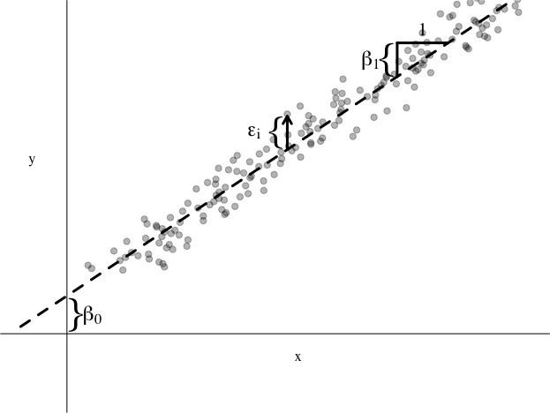

Figure 1: Hypothetical Simple Regression

# 64 3 The Multilevel Regression Model for Repeated Measures

65 Similar to traditional regression, we can start with a simple multilevel model predicting some outcome

66 measure, *y*, from one predictor variable, *x*. For this paper we will be following Hox’s5 notationi.

*y*ˆ*ij* = *β*0*j* + *β*1*jxij* + *ϵij* (2)

67 Equation 2 is often referred to as the *level-one* or *first-level* model since it deals with the first level of

68 nesting in our data. In repeated measures designs, observations are nested within individuals so we consider

69 observations to be at the first, or lower, level and individuals to be at the second, or higher, level. In other

70 applications, multilevel models may have individuals at the first level nested within some grouping structure

71 such as classrooms, congressional districts, or treatment arms.

72 Equation 2 is identical to Equation 1 except we now have a second subscript, *j*, denoting the nested

73 nature of the data. *xij* now represents the *i*-th observation from the *j*-th individual while *β*0*j* and *β*1*j*

74 represent the *j*-th individual’s model intercept and slope. *y*ˆ*ij* represents the model prediction for the *i*-th

75 observation from the *j*-th individual and *ϵij* represents the residual error between each observed outcome

76 and its corresponding predicted value (*yij − y*ˆ*ij*). The inclusion of a second subscript, *j*, thereby allowing

iIt should be known that other authors have used slightly (or sometimes very) different notations. Admittedly, this is one of the higher barriers to entry for those without strong analytical training. We encourage readers to take considerable time learning model notation as it will accelerate the remaining stages of the learning process

77 model intercepts and slopes to vary between individuals is the fundamental difference between traditional

78 and multilevel regression.

79 By allowing model intercepts and slopes to vary between individuals, the multilevel model for repeated

80 measures parses each individual’s intercept and slope into a combination of the average model intercept/slope

81 plus some individual-specific deviation from the average. Equations 3 and 4 represent the regression

82 equations predicting each individual’s model intercept (Equation 3) and slope (Equation 4) and make up

83 the second-level model. In Equations 3 and 4 the first term on the right side (*γ*00 and *γ*10) represent the

84 *average* model intercept and slope, respectively. These average model parameters are known as *fixed*-effects

85 since they do not vary between individuals (notice there is no *j* subscript). The second terms on the right

86 side (*µ*0*j* and *µ*1*j*) represent the individual-specific deviations from the average model intercept and slope,

87 respectively. Because *µ*0*j* and *µ*1*j* vary between individuals, they are known as *random*-effects. Modeling

88 parameter variability as a combination of fixed and random-effects is why multilevel models are sometimes

89 referred to as *mixed*-effects models (a mixture of fixed and random effects).

*β*0*j* = *γ*00 + *µ*0*j* (3)

*β*1*j* = *γ*10 + *µ*1*j* (4)

90 The multilevel model can then use second-level parameters (*zj*) to account for variance in the predicted

91 intercepts and slopes. With the inclusion of second-level parameters, *µ*0*j* and *µ*1*j* represent the residual

92 variation in the predicted intercept and slope after accounting for *zj*.

*β*0*j* = *γ*00 + *γ*01*zj* + *µ*0*j* (5)

*β*1*j* = *γ*10 + *γ*11*zj* + *µ*1*j* (6)

93 Substituting the right side of Equations 5 and 6 for *β*0*j* and *β*1*j* from Equation 2 yields the complete multilevel

94 model predicting one outcome from one first-level and one second-level variable:

*intercept*

*slope*

*y*ˆ*ij* = *γ*00 + *γ*0 1 *zj* + *µ*0 *j* + (*γ*10 + *γ*1 1 *zj* + *µ*1*j* ) *xij* + *ϵij* (7)

95 Distributing *xij* and arranging like terms helps delineate the fixed and random parts of the model:

*fixed random*

*y*ˆ*ij* = *γ*00 + *γ*01*zj* + *γ* 1 0*xij* + *γ*11*xijz* *j* + *µ* 1*jxij* + *µ*0*j* + *ϵi* *j* (8)

96 As with traditional regression models, the multilevel regression model can be generalized to multiple

97 multilevelii regression with *m* first-level and *n* second-level predictors:

*m*

*y*ˆ*ij* =*β*0*j* + *βmjxmij* + *ϵij* (9)

*m*=1 *n*

*β*0*j* =*γ*00 + *γ*0*nznj* + *µ*0*j* (10)

*n*=1 *n*

*βmj* =*γm*0 + *γ*1*nznj* + *µnj* (11)

*n*=1

# 98 4 Benefits and Drawbacks of Multilevel Models over Traditional Repeated

99 **Measures ANOVA**

100 The three assumptions made by repeated measures ANOVA that are most relevant to sport biomechanics:

101 temporal equivalence, design balance, and case completeness.

Repeated Measures ANOVA Multilevel Regression

Temporal equivalencea Assumes repeated measures are equally

spaced in time

Balanced design Assumes participants have same number of repeated measures

Case completeness Assumes no missing data; incomplete cases

are handled through listwise deletion

Repeated measures may be unequally

spaced in time Participants may have different number of

repeated measures

Missing data may be accounted for under

certain circumstancesb

a "Temporal" equivalence does not only apply to growth models, where time is placed on the x-axis. It may be extended to "whatever is on the x-axis of your scatterplot".

b Missing data analysis is an extremely rich stand-alone area of research that we cannot do justice in this article alone. Readers are directed to

works of Enders4 for a more thorough exploration of the topic

iiyeah, "multiple multilevel", I know. Yikes

102 **4.1 When ANOVA will do just fine**

103 Simple pre-post designs with no missing data

# 104 5 Other Figures to incorporate

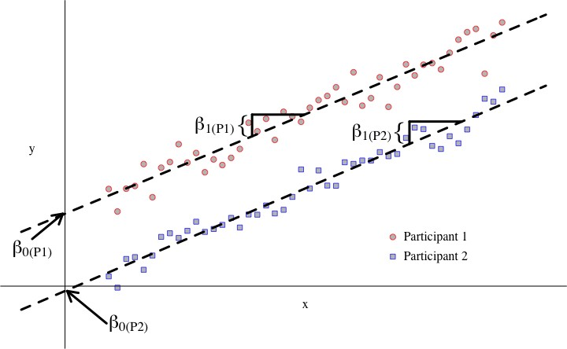

Figure 2: Fictional multilevel model with random intercepts. Individual regression lines are parallel (equal slopes) but differ in their respective intercepts

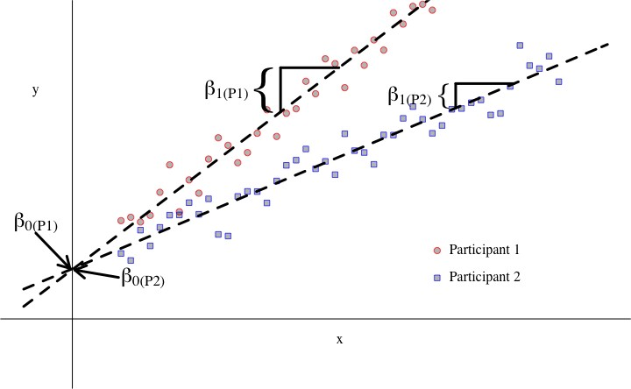

Figure 3: Fictional multilevel model with random slopes. Individual regression lines are not parallel (unequal slopes) but share a mutual intercept

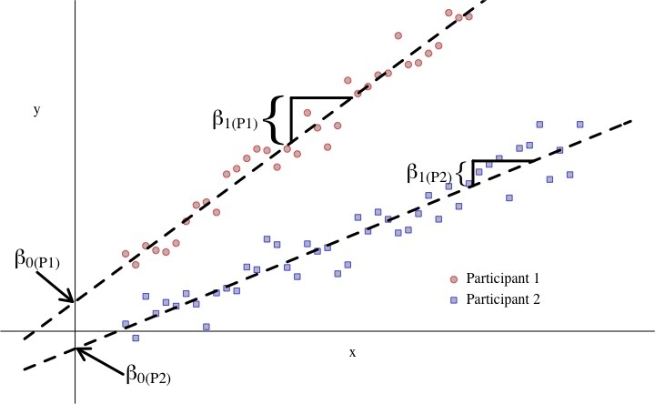

Figure 4: Fictional multilevel model with random intercepts and slopes. Individual regression lines are not parallel and do not share a mutual intercept

105 **6 Discard Pile**

106 Some of the more notable assumptions that can cause problems for sport biomechanists dealing with repeated

107 measures include temporal equivalence (i.e. time between data points must be the same for all participants),

108 balanced study designs (i.e. must have the same number of data points for each individual) and case

109 completeness (i.e. must have no missing data).

110 Compared with traditional univariate or multivariate analysis of (co)variance, multilevel modeling

111 allows more researcher flexibility through fewer statistical assumptions and the ability to handle missing

112 data, non-linear relationships, and time-varying covariates.5

113

114

115

116

117

118

119

120

121

122

123

124

125

126

127

128

129

130

131

# References

1. Beauchamp, M. R., Bray, S. R., Fielding, A., and Eys, M. A. A multilevel investigation of the relationship between role ambiguity and role efficacy in sport. *Psychology of Sport and Exercise*, 6(3):289–302, 2005.
2. Benson, A. J., Šiška, P., Eys, M., Priklerova, S., and Slepička, P. A prospective multilevel examination of the relationship between cohesion and team performance in elite youth sport. *Psychology of Sport and Exercise*, 27:39–46, 2016.
3. Cornelius, A. E., Brewer, B. W., and Van Raalte, J. L. Applications of multilevel modeling in sport injury rehabilitation research. *International Journal of Sport and Exercise Psychology*, 5(4):387–405, 2007.
4. Enders, C. K. *Applied missing data analysis*. Guilford press, 2010.
5. Hox, J. J., Moerbeek, M., and Van de Schoot, R. *Multilevel analysis: Techniques and applications*. Routledge, 2017.
6. Iglesias-Soler, E., Mayo, X., Rial-Vázquez, J., and Haff, G. G. Inter-individual variability in the load-velocity relationship is detected by multilevel mixed regression models. *Sports biomechanics*, 20(3):304–318, 2021.
7. Pataky, T. C., Vanrenterghem, J., Robinson, M. A., and Liebl, D. On the validity of statistical parametric mapping for nonuniformly and heterogeneously smooth one-dimensional biomechanical data. *Journal of biomechanics*, 91:114–123, 2019.
8. Slowik, J. S., Aune, K. T., Diffendaffer, A. Z., Cain, E. L., Dugas, J. R., and Fleisig, G. S. Fastball velocity and elbow-varus torque in professional baseball pitchers. *Journal of athletic training*, 54(3):296–301, 2019.