es酒店搜索业务

## 1.es部署及操作

【腾讯文档】ES安装、部署、使用

https://docs.qq.com/doc/DV1hrYkd1Rk1pTW5B

## 2、在234mysql中创建es库tb_hotel表

## 3、导入sql文件数据

链接：https://pan.baidu.com/s/1wOco9nyvG0MwnsbwxNgLfg

提取码：ik12

## 4、创建索引库

put /hotel

{

"mappings": {

"properties": {

"id": {

"type": "keyword"

},

"name": {

"type": "text",

"analyzer": "ik_max_word",

"copy_to": "all"

},

"address": {

"type": "keyword",

"index": false

},

"price": {

"type": "integer"

},

"score": {

"type": "integer"

},

"brand": {

"type": "keyword",

"copy_to": "all"

},

"city": {

"type": "keyword"

},

"starName": {

"type": "keyword"

},

"business": {

"type": "keyword",

"copy_to": "all"

},

"pic": {

"type": "keyword",

"index": false

},

"location": {

"type": "geo_point"

},

"all": {

"type": "text",

"analyzer": "ik_max_word"

}

}

}

}

## 5、把sql酒店数据导入es

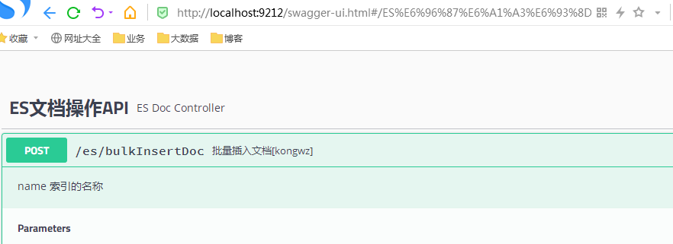

## 6、查询业务

项目地址：

<https://github.com/kwzgit/es-hotel.git>

master分支

主要实现类com.lantone.es.service.impl.TbHotelServiceImpl

展现形式：

