Homework

1. 改写题目

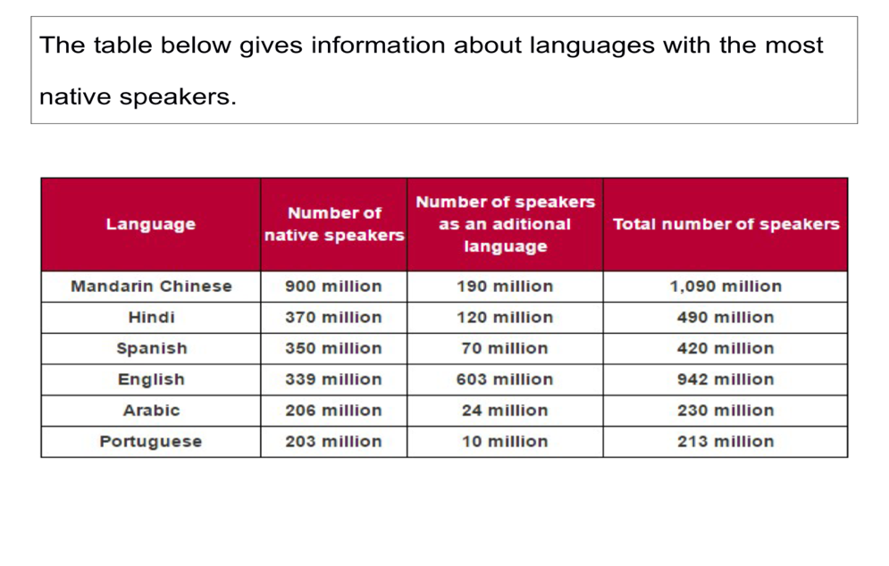

2. 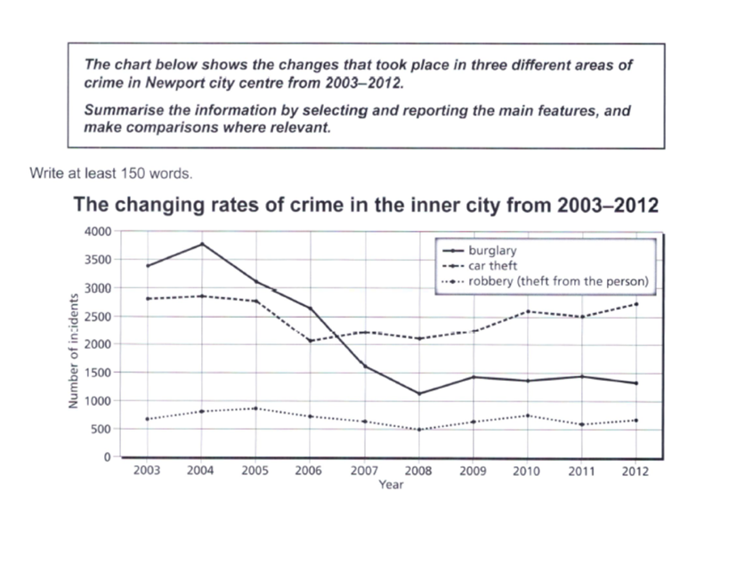

补充写作

Car theft& robbery

IELTS WRITING

Task 1: 1/3 score, 20 mins, 150 words,

Task 2: 2/3 score , 40 mins, 250 words,

四项评分标准

TR：(task response)/TA(task achievement ) ： 25%

CC:(coherence& cohesion) ： 25%

LR：lexical resource ：25%

GRA:grammatical range & accuracy ： 25%

Underlength

Penalty

Illegible

Off-topic

Memorized

TASK 1

类型：

* 数据类图表：line graph, bar chart,pie chart, table

静态图：二对多；多对多

动态图： 线图；非线图动态图（两个时间点； 三个及以上时间点）

* 非数据类图表 1：flow chart（工业制造；自然现象；生命特征）
* 非数据类图表2：map （变迁题；选址题；纯地点描述）

Task 1篇章结构

* **Deductive analysis(演绎)**

1. 开头段：改写题目

2. 宏观概括

3. 微观对比分析 （划分若干个段落）

* **Inductive analysis (归纳)**

1. 开头段：改写题目

2. 微观对比分析（划分若干个段落）

3. 宏观概括

**开头段：改写题目**

1. 话题性词汇

* 词性
* 近义词
* 解释
* 词序&增减词

2. 非话题性词汇

* 图表类型

Graph-line graph

Chart- bar chart; pie chart

Table-table

Diagram- flow chart; map

* 展示性动词

show=give information on=illustrate

* 数据类图表

百分比the percentage/proportion(of)

数量amount(U)& quantity(C&U)，number(C)

统称figure(s); data

* 状语

地点状语

时间状语（时间点&时间区间）

3. 增补内容

Example 1:

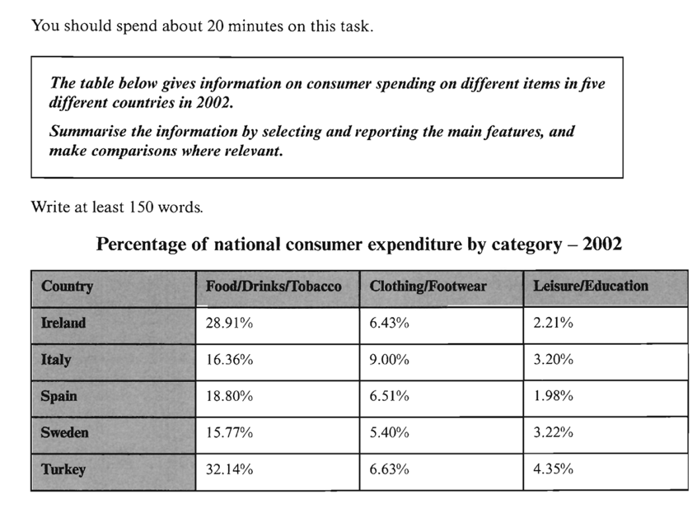

The table illustrates **the proportion of national consumer expenditure on** food/drinks/tobacco, clothing/footwear and leisure/education in five countries in the year of 2002.

Example 2:

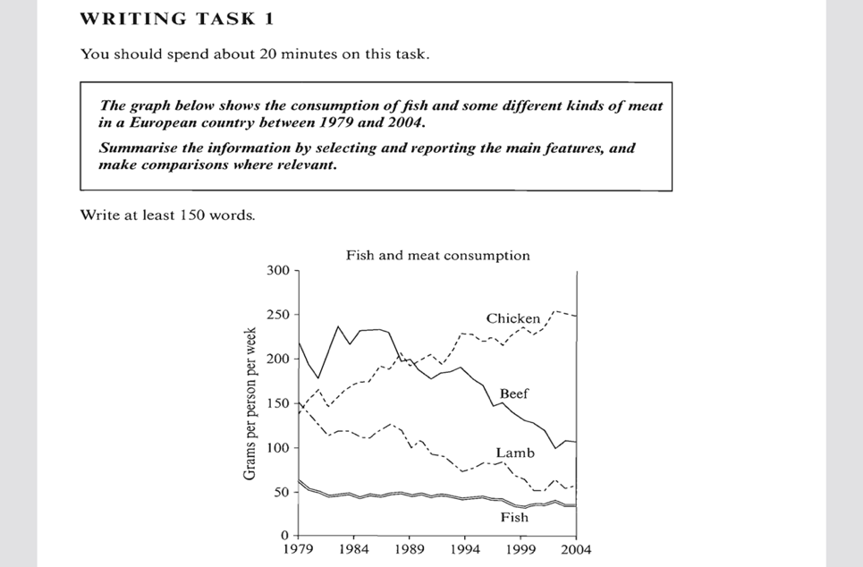

The line graph illustrates **the amounts of fish, chicken, beef and lamb eaten** by a European country over the 1979-2004 period, and units are measured in grams per capita per week.

Practice 1:

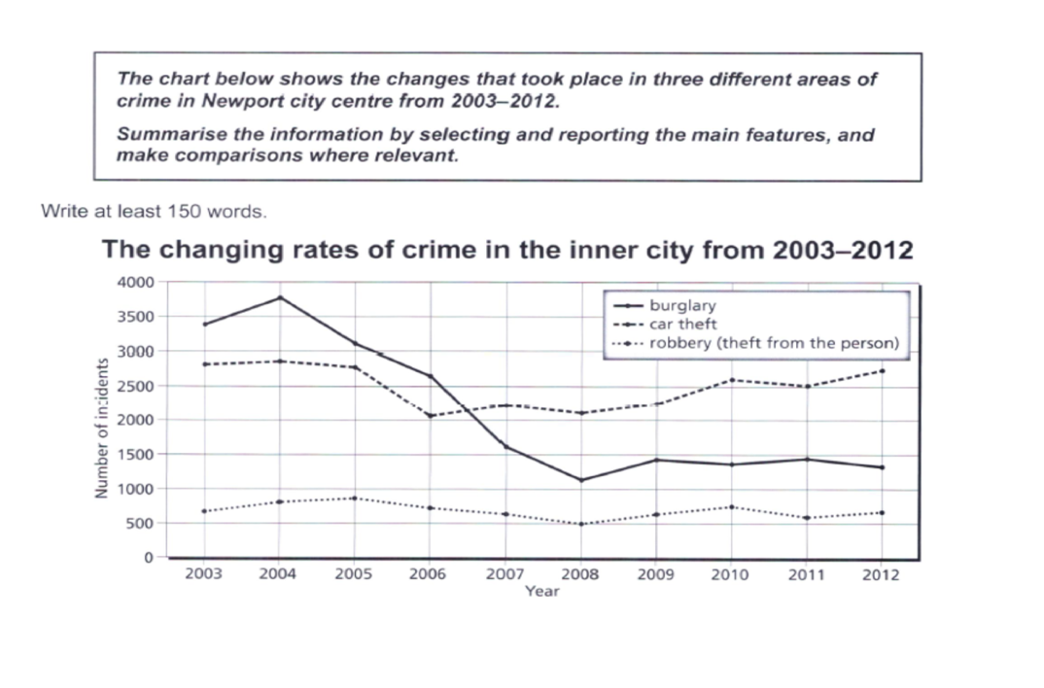

Practice 2:



**TASK 1 写作类型1： 静态图表（完全对比图）**

二对多；多对多

考点：大小对比

Task achievement(25%)

1. Summarise:

* **高低多少**
* **差距（明显／不明显）**
* 正比／反比

对象可以归纳

2. Main features: (挑选重要数据意识)& relevant comparison (有效对比)

多对多： 最大值，相似对象（数据&特征）；相反对象

二对多：差距最大，相似对象，相反对象

静态语法考点：大小对比（高低）

Primary school: F>M

A>B：1.比较级&最高级 2.超过动词(outnumber& overtake) 3. 其他

1. There were **more** female teachers in the primary school than male teachers /**More** female teachers were employed in the primary school than male teachers.
2. Females **predominated** in the primary school.
3. Female teachers **outnumbered** male teachers in the primary school.
4. The percentage of female teachers was **higher(more)** than that of male teachers in the primary school.
5. The percentage of female teachers **overtook(超过)** that of male teachers in the primary school.
6. Female teachers **accounted for(made up/represented/constituted占据动词)** a larger percentage in the primary school.

程度词

稍微: slightly/marginally +比较级

远远：significantly/far/much+比较级 ; by far +最高级

**Example 1: 静态图（多对多）**



Overall, all countries **spent most** on food/drinks/tobacco, and **the lowest expenditure** was on leisure/education. **The expenditure in** Turkey **was higher** than the other countries in two out of three.

When it comes to food,drinks, and tobacco, Turkey and Ireland spent **far more** than the rest of countries at 32.14% and 28.91% respectively. Spain, Sweden and Italy **paid** less than 20% **for** this item, with the relatively lower level in Sweden at 15.77%.

However, Italy **spent more** than the other countries on clothing& footwear(9%) as opposed to **the lowest expenditure** which could be seen in Sweden at 5.4%. The remaining three countries spent on average around 6.5%.

**The lowest expenditure** was on leisure& education which accounted for under 5% in all countries. Turkey **spent most** on this category at 4.35% of their **national expenditure**.

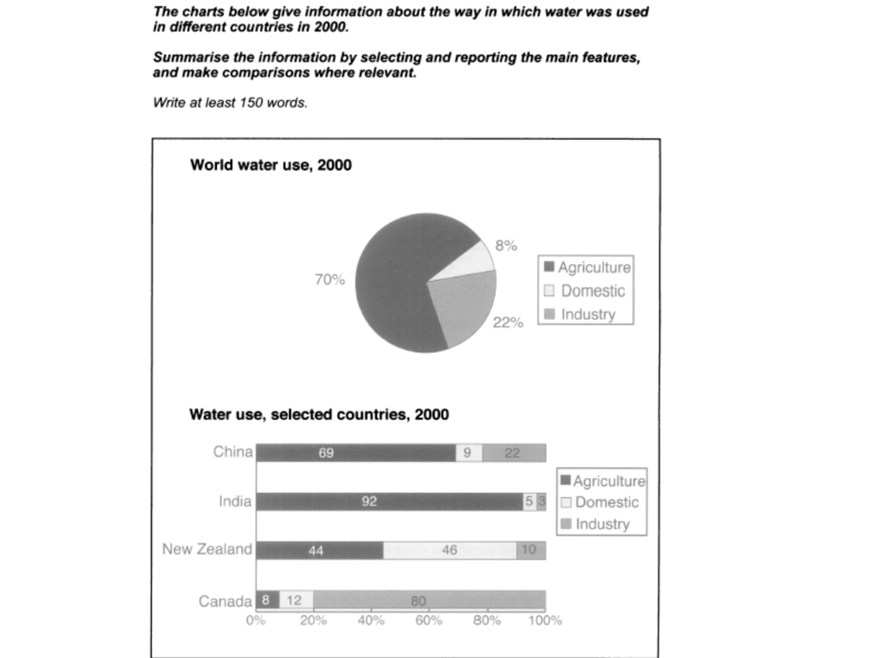

India and China consumed the vast majority of water for the agricultural purpose(92% and 69% respectively) as opposed to New Zealand who used 44% of water in this sector. Surprisingly, the agriculture use was minimal in Canada, accounting for merely 8%.

By contrast, the industrial water use in Canada clearly overtook that in the rest of countries, with up to 80% of water consumed for this purpose....

**Example 2: 静态图（二对多）**

**Test 3, C4**

**Model answer**

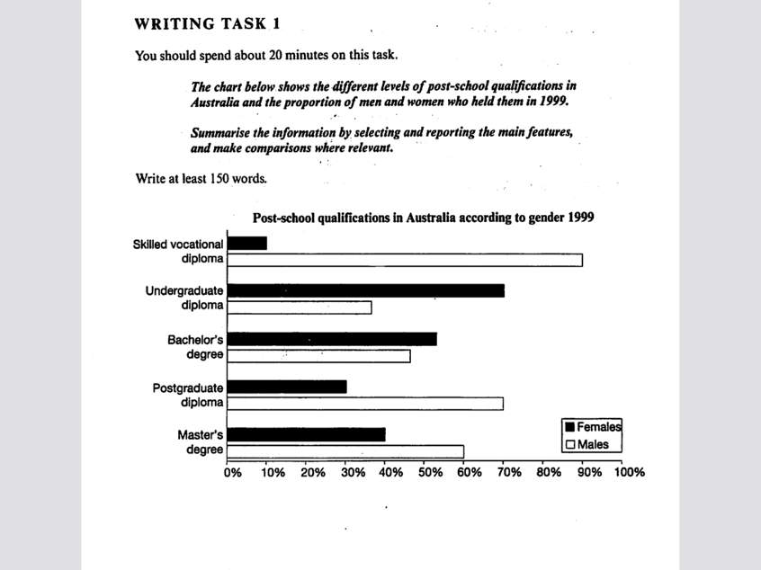

The chart gives information about post-school qualifications in terms of the different levels of further education reached by men and women in Australia in 1999.

We can see immediately that there were substantial differences in the proportion of men and women at different levels. The biggest gender difference is at the lowest post-school level, **where** 90% of those who held a skilled vocational diploma were men, compared with only 10% of women. By contrast,**more** women held undergraduate diplomas(70%) and **marginally more** women reached degree level(55%)

At the higher levels of education, men with postgraduate diplomas clearly **outnumbered** their female counterparts (70% and 30%, respectively), and also constituted 60% Master's graduates.

Thus we can see that **more** men than women hold qualifications at the lower and higher levels of education, while(whereas, 前后主语属性一致） **more** women reach undergraduate diploma level than men. The gender difference **is smallest** at the level of Bachelor' s degree.

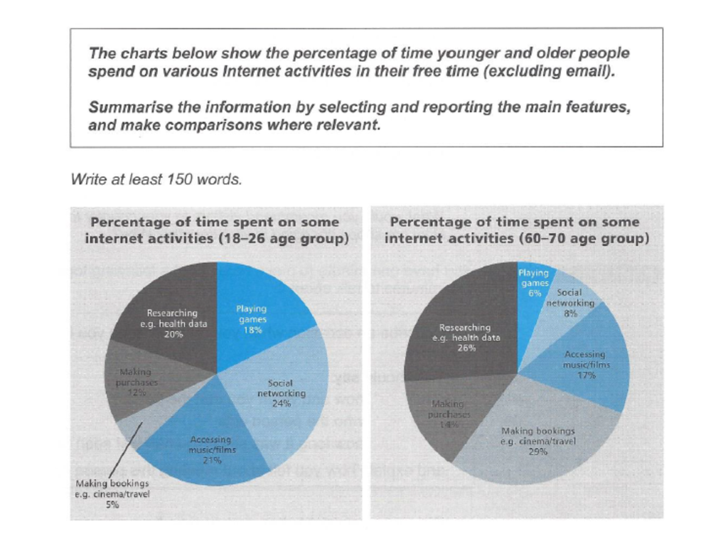

The most noticeable difference(gap) can be found on making bookings, **where** older users spend **far more** leisure time than younger counterparts (29% and 5% respectively). Researching is another popular internet activity for the older group who spend 26% of free time, compared to 20% for the younger group.

差别小

differ slightly(marginally)

Slight (marginal/insignificant) differences(gap)

Nearly as...as

Making online purchase is nearly as popular for older users as for younger users/Older users spend nearly as much leisure time on making bookings as younger users

基本句式

Making bookings: O>Y

1. Older users spend **far more** leisure time on making bookings than younger counterparts.
2. Making bookings is **far more popular** for older users than younger counterparts.
3. Making bookings takes up(时空占据) **much more** leisure time for older users than younger counterparts.
4. The percentage of time spent on making bookings is **much higher** for older users than that for younger users.
5. The percentage of time spent on making bookings for older users **overtakes** that for younger users.

**TASK 1 写作类型2： 动态图表（趋势对比图）**

1. 动态线图

2. 非线图动态图（动态饼图，表格&柱状图）- 两个时间点

3. 非线图动态图（动态饼图，表格&柱状图）-三个及以上时间点

TA (25%)

1. Summarise

* 总体趋势（起点-终点）
* 总体趋势+重要排名
* 正比／反比

2. Main features

* 时间点：起点，中间点：（交点，骤变点，重要转折点，明显的峰值／谷值），终点
* 非时间点：重要排位& 变化幅度&数值

3. Comparison (similarity& difference)

第一对象：起点最大值或者变化幅度最明显的对象开始

动态分组

* 趋势
* 变化幅度（快-慢）
* 数量（高-低)

**动态趋势表达（5*3）**

1. 上升

* a rise, rise, rose
* an increase, increase, increased
* a growth, grow, grew
* Show an upward trend
* 暴涨：soar(to, verb)/rocket(to, verb)=increase rapidly=a rapid increase

2. 下降

* a decrease, decrease, decreased
* a decline, decline, declined
* a dip, dip, dipped
* Show a downward trend
* 暴跌：slump（n&v);plummet(v), plunge(n&v)=decrease rapidly=a rapid decrease

上升／下降最终值（到）：to

上升／下降了变化幅度（了）； by

A: 20% -40%.

Increase by 20%

Increase to 40%

Increase by 20% to 40%

3. 峰值／谷值（线图)

* a peak(of)=the highest level , peak(at), peaked(at)
* a bottom(of)=the lowest level, bottom out(at), bottomed out(at)

4. 波动

* fluctuation(s), fluctuate (between.... and...), fluctuated
* variation(s), vary (between ... and...), varied

5. 稳定

* remain stable(steady；unchanged) at
* level out(at) /level off(at)

**程度修饰词(2)**

1. 缓慢

Slight(ly), marginal(ly) , gradual(ly), modest(ly)

2. 急剧

rapid(ly); sharp(ly), significant(ly), dramatic(ally) , enormously

UK- coffee sales increased(1.5-20)

1. The coffee sales in the UK increased enormously, from 1.5-20 million euros//The coffee sales in the UK increased enormously, from 1.5 million euros in 1999 to 20 million euros in 2004.
2. There was an enormous increase in the coffee sales in the UK, from 1.5-20 million euros.
3. The coffee sales in the UK showed an upward trend, **starting at** 1.5 million euros and **ending at** 20 million euros.
4. The coffee sales saw an enormous increase，from 1.5-20 million euros.

Example 1: line graph

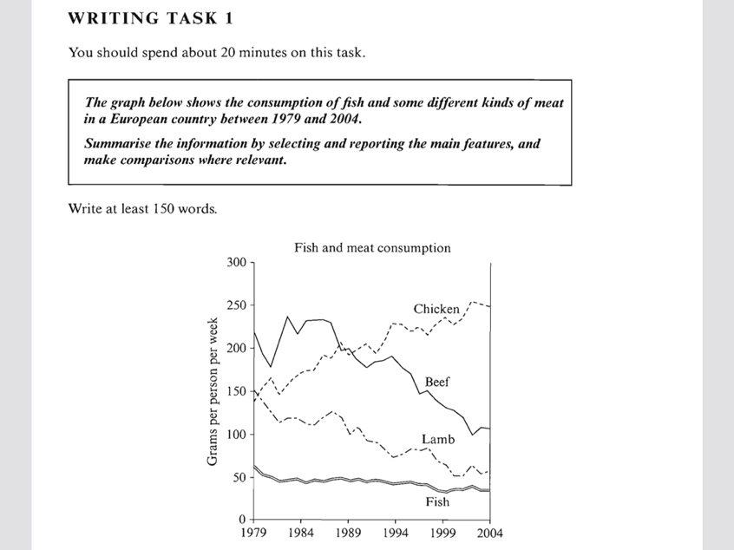

动态主语

1. the consumption of beef
2. The beef consumption
3. The amount of consumed beef=the amount of beef consumed by
4. The amount of eaten beef=the amount of beef eaten by
5. The popularity of beef

The graph illustrates changes **in the amounts of beef, lamb, chicken and fish consumed** in a particular European country between 1979 and 2004.

In 1979 beef was by far **the most popular** of these foods, with about 225 grams consumed per person per week. Lamb and chicken were eaten in similar quantities(around 150 grams), while much less fish **was consumed** (just over 50 grams).

However, during this 25-year period **the consumption of beef and lamb** fell dramatically to approximately(about/around/roughly) 100 grams and 55 grams respectively. **The consumption of fish** also declined, but much less significantly to just below 50 grams, so although it remained the least popular food, **consumption levels** were the most stable.

**The consumption of chicken**, on the other hand, showed an upward trend, overtaking **that of lamb** in 1980 and **that of beef** in 1989. By 2004 it had soared to almost 250 grams per person per week.

Overall, the graph shows how **the consumption of chicken** increased dramatically while **the popularity of these other foods** decreased over the period.



动态主语

1. The changing rate of burglary
2. The burglary rate
3. The number of committed burglary

The line graph shows the changing rate of burglary **decreasing** dramatically over the nine-year period: In 2003, burglary was by far the most common criminal act, with just below 3500 cases reported in this city centre. **After** an initial increase, this rate reached a peak in 2004 **when** it hit 3750. **From then on/After that,** there was a sharp decrease until 2008. (This was followed by a sharp decrease until 2008).....