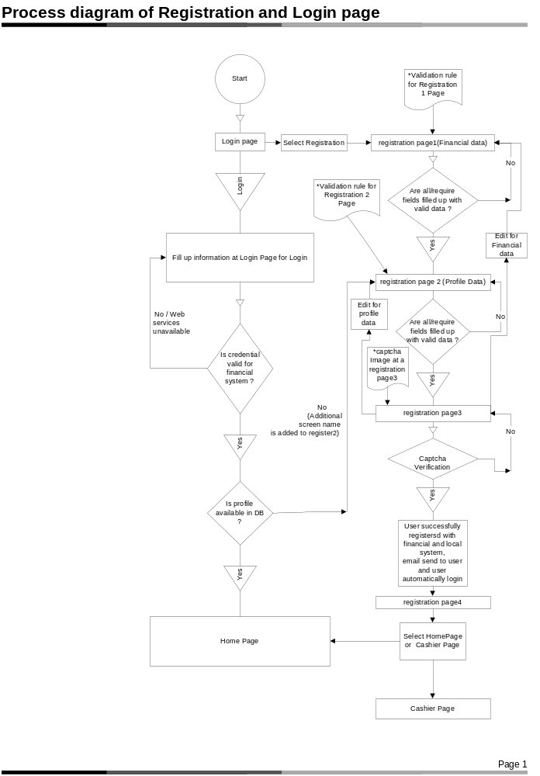

*Validation rule for Registration Page1 :

- Validation rule for Screen Name:
Minimum length=1
Maximum length=20
Allowed character= 0-9a-zA-Z - _

- Validation rule for E-Mail:
Minimum length=6
Maximum length=50
Enter E-Mail and Confirm E-Mail must be same.

- Validation rule for Password:
Minimum length=6
Maximum length=50
Password and confirm password must be same.

- Validation rule for First Name:
Minimum length=1
Maximum length=15
Allowed character = a-zA-Z '-

- Validation rule for Last Name:
Minimum length=1
Maximum length=15
Allowed character = a-zA-Z '-

- Date of Birth:
For select the complete date, There are three
combo box are define first one for the month
second is for date and last is for the year.

- Country:
Need to select the country from combo box.

- Validation rule for Street1:
Minimum length=1
Maximum length=34,
Allowed character = 0-9a-zA-Z # _ . -

- Validation rule for Street2:
Minimum length=1
Maximum length=10
Allowed character = 0-9a-zA-Z # _ . -
- Validation rule for City:
Minimum length=1
Maximum length=20
Allowed character = 0-9a-zA-Z # _ -

- State/Province:
Need to select the State/Province from combo
box.

- Validation rule for Phone:
Minimum length=10
Maximum length=21
Allowed character = 0-9+ -

- Validation rule for Postal code:
Maximum length=10
Allowed character = 0-9a-zA-Z _ -

- Gender:
Select male or female from radio button.

*Validation rule for Registration Page2 :

- Validation rule for Screen Name:
Minimum length=1
Maximum length=20
Allowed character = 0-9a-zA-Z - _

- Validation rule for Consoles Names(Xbox360,Ps2,Ps3):
Minimum length=1
Maximum length=30
There are define Three check box for select
Tags.

- Validation rule for Image:
Image can browse and also see the preview or select any one image from default images.

- Validation rule for Message:
Allowed character = 0-9a-zA-Z _ -,.;:"'

- Validation rule for Story:
Allowed character = 0-9a-zA-Z _ -,.;:"'

- Validation rule for Availability:
Allowed character = 0-9a-zA-Z _ -,.;:"'

- What Do you play for ?
Need to select from combo box.

- Validation rule for Skype,Aim,Msn and Yahoo:
Maximum length=254

- TimeZone:
Need to select TimeZone from combo box.

*captcha Image at a registration page3:

- Captcha Image:
Please type the character you see in the picture.

