Liquid Payment
system documentation

version 16



Impessa LTD

Plac Konstytucji 5/81
00-657 Warsaw, Poland
tel.: 0048 22 826 33 33
fax: 0048 22 621 43 92

Marcin Popielarz
marcin.popielarz@impessa.com

Szymon Bargłowski
szymon.bargłowski@impessa.com

Table of Contents

1 Table of Contents 2
2 Liquid Payment Client 4
2.1 Use example 4
2.2 Client Release Notes 4
3 Data Model 6
3.1 User Objects 6
3.1.1 User 6
3.2 Game objects 7
3.2.1 BetDetails 7
3.2.2 UserBet 8
3.3 Finance objects 8
3.3.1 Balance 8
3.3.2 DepositInput (abstract) 8
3.3.3 DepositOutput (abstract) 8
3.3.4 PaymentAccount 8
3.3.5 WithdrawalMethod 9
3.3.6 CreditCardPaymentAccount (extends PaymentAccount) 9
3.3.7 PayPalPaymentAccount (extends PaymentAccount) 10
3.4 Common objects 10
3.4.1 Money 10
3.4.2 Transaction 10
4 Deposits 11
4.1 CreditCard deposits 11
4.1.1 CreditCardPaymentRequest (extends DepositInput) 11
4.1.2 CreditCardPaymentResponse (extends DepositOutput) 11
4.2 PayPal deposits 11
4.2.1 PayPalEC (extends DepositInput) 11
4.2.2 PPECSetupRequest (extends PayPalEC) 11
4.2.3 PPECDetailsRequest (extends PayPalEC) 12
4.2.4 PPECPayRequest (extends PayPalEC) 12
4.2.5 PPECSetupResponse (extends DepositOutput) 13
4.2.6 PPECDetailsResponse (extends DepositOutput) 13
4.2.7 PPECPayResponse (extends DepositOutput) 14
5 Exceptions 15
5.1 InternalException 16
5.2 UserValidationException 16
5.3 InvalidPaymentException 17
5.4 MoneyException 17
5.5 AuthenticationException 17
5.6 PlayerStatusException 17
5.7 SiteNotFoundException 17
5.8 InvalidSessionException 17
6 Constants 17
6.1 Character sets 17
6.2 Transaction types 18
6.3 Credit card types 18
6.4 Supported currencies 18
6.5 CVV2 response codes 18
6.6 AVS response codes 19
6.7 Withdrawal methods 20
6.8 Country codes 20
7 Webservices provided by LiquidPayment 20
7.1 User webservices 21
7.1.1 User Registration (registerUser) 21
7.1.2 User Authentication (login) 21
7.1.3 Getting user details (getRegistrationDetails) 21
7.1.4 Getting user details 2 (getUserByUsername) 21
7.1.5 Getting user details 3 (getUserByUserId) 22
7.1.6 Setting user details (setRegistrationDetails) 22
7.1.7 Changing user password (changePassword) 22
7.1.8 Reseting user password (resetPassword) 23
7.2 Game webservices 23
7.2.1 Creating a bet (createBet) 23
7.2.2 Betting money (bet) 23
7.2.3 Moving money to player account (moveToPlayerAccount) 24
7.2.4 Moving money to house account (moveToHouseAccount) 24
7.2.5 Checking bet account (getBetDetails) 25
7.3 Financial webservices 25
7.3.1 Registration of payment account (registerPaymentAccount) 25
7.3.2 Delete payment account (deletePaymentAccount) 25
7.3.3 Getting payment accounts list (getPaymentAccounts) 25
7.3.4 Update payment account (updatePaymentAccount) 26
7.3.5 Money deposit (deposit) 26
7.3.6 Getting withdrawal methods (getWithdrawalMethods) 27
7.3.7 Money withdrawal (withdrawal) 27
7.4 Common webservices 27
7.4.1 Getting statement list (statement) 27
7.4.2 Getting url of CSR web interface (getCSRUrl) 28
7.4.3 Getting user balance (getBalance) 28
7.4.4 Getting user balance 2 (getBalanceByUsername) 28
7.4.5 Getting user balance 3 (getBalanceByUserId) 28
8 System Architecture & Design 29
8.1 Endpoint 29
8.1.1 Endpoint entities 29
8.1.2 Operation principles 30
8.2 Depositing funds 31
8.2.1 Deposit entities 31
8.2.2 Example of Credit Card Payment 34
8.2.3 Example of PayPal Express Checkout Payment. 34
8.3 Payment accounts management 36
8.3.1 Payment account entities 36
9 Deployment 37
9.1 Deployment diagram 37
9.2 Deployment instructions 37
9.2.1 Deployment pack directory structure 37
9.2.2 LP WEB/APP server 38
9.2.2.1 Initial steps 38
9.2.2.2 JAXWS RI configuration. 38
9.2.2.3 Configuring JRE to work with JAXWS 2.1.2 38
9.2.2.4 Configuring GMS and WG_API 38
9.2.2.5 Installation of GMS and WG_API 38
9.2.3 DB server 39
9.2.3.1 Creating schema 40
9.2.3.2 Populating tables 41
9.2.4 Global Properties Configuration 41
9.2.5 DCEGENCRYPTOR 42

Liquid Payment Client
Liquid Payment Client service is present in impessa.worldgaming.client.jar. All services which are available for this client are listed in section ‘Webservices provided by LiquidPayment’ section of this documentation.

Use example

LiquidPaymentService service = new LiquidPaymentService();
LiquidPayment lp = service.getLiquidPaymentPort();

try {
lp.createBet();
} catch (InternalException_Exception e) {
e.printStackTrace();
}

Client Release Notes
Starting from 1. October 2007 all changes that have impact for service consumers are recorded.
Date | Importance | Change | Impact | Affects Interface
3.4.2007 | High | getUserByUsername, getUserByUserId, getBalanceByUsername, getBalanceByUserId services added. | Update to client jar required. | Yes
15.11.2007 | Medium | getBalance bug updated. Now returned currency is USD instead of null. Notice that currency support is limited in existing Parlay system. There is also statement service updated. It does not throw InvalidTransactionException and takes List<TransactionType> - collection of enums instead of string. Inserting null | Calls of statement and getBalance should be reviewed. Update to client jar required. | Yes
25.10.2007 | Low | moveToPlayerAccount service is taking username instead of sessionKey as input parameter to identify user. It also throws UserNotFoundException instead of InvalidSessionException | Meaning of first parameter in method call is changed. All usages must be reviewed. Appropriate (UserNotFoundException) exception should be caught and catch clause for InvalidSessionException removed.  Update to client jar required. | Yes
24.10.2007 | High | TransactionType enumeration was introduced. moveToPlayerAccount is taking this enum as parameter, and statement service is returning list of Transaction objects, where type attribute is replaced from string to this enumeration. | All usages of statement and moveToPlayerAccount have to be reviewed. Update to client jar required. | Yes
24.10.2007 | Medium | ownerCountry in CreditCardPaymentAccount was changed from String to CountryType enum. | All usages of CreditCardPaymentAccount have to be reviewed. Update of client jar required | Yes
24.10.2007 | High | Type of currency field in Money object was changed from String to CurrencyType enum | All usages of Money.currency have to be reviewed. Update of client jar required | Yes
24.10.2007 | Medium | Type of issueNumber from CreditCardPaymentAccount was changed from integer to String | Calls to webservices where CreditCardPaymentAccount was used - must be modified to set issueNumber attribute to string. Update of client jar required | Yes
21.10.2007 | High | WithdrawalMethod is taken as parameter to withdrawal service. | All calls to withdrawal service should be reviewed. Update of client jar required | Yes
21.10.2007 | Medium | WithdrawalMethod is changed to enum type from class | Interface is changed. All calls to getWithdrawalMethods should be reviewed. Update of client jar required | Yes
17.10.2007 | Low | New service for reseting user password was introduced (resetPassword) | New functionality available, Update of client jar required | Yes
17.10.2007 | Low | New service for changing user password. (changePassword) | New functionality available, Update of client jar required | Yes
09.10.2007 | Medium | Attribute type from CreditCardPaymentAccount changed from string to enum | Calls to webservices where CreditCardPaymentAccount was used - must be modified to set type attribute to CreditCardType enum. Update of client jar required | Yes
01.10.2007 | High | Updated to work with JRE 1.5.x (Version 49) | Previous client was unable to work in 1.6 environment, Update of client jar required | No
01.10.2007 | High | Endpoint URL changed | Previous client was unable to connect to correct TST server, Update of client jar required | No

Data Model
Liquid payment system is designed for manipulation of user data, user events, financial data, and game data. Model is composed of following objects.

User Objects
User objects are Liquid Payment entities associated directly with user services.

User
Represents user in a Liquid Payment system. Email password and siteId are used for authentication purposes. Email must be unique in single site.
Name | Type | Description | Constraints
email | String | Player email, used also as username | Required  Max length: 50  EMAIL_CHARS  Mask: ^.+\\@.+\\..+$
password | String | Player password | Required  Min length: 5  Max length: 16  Validchars:  ALPHANUM_CHARS+GENERAL_CHARS
firstname | String | Player first name | Required  Max length: 15  Validchars:  ALPHANUM_CHARS+NAME_CHARS
lastname | String | Player last name | Required  Max length: 35  Validchars:  ALPHANUM_CHARS+NAME_CHARS
address | String | Players address | Required  Max length: 45  ALPHANUM_CHARS+ADDRESS_CHARS
city | String | Players town/city | Required  Max length: 20  ALPHA_CHARS+ADDRESS_CHARS
country | String | Player country | Required  Valid ISO country code.
state | String | Player state | Required  Max length: 20  ALPHANUM_CHARS+ADDRESS_CHARS
postalcode | String | Player postal code | Required  Max length: 10  POSTAL_CHARS  US & length5: \\d\\d\\d\\d\\d  US & length10: \\d\\d\\d\\d\\d-\\d\\d\\d\\d  CA & length6: \\D\\d\\D\\d\\D\\d  CA & length7: \\D\\d\\D[ -]\\d\\D\\d
phone | String | Player phone | Required  Min length: 10  Max length: 21  PHONE_CHARS  Mask: ^(\\(?\\+?[0-9]*\\)?)?[0-9_\\-\\. \\(\\)]*
birthdate | long | Player DOB | Required  In miliseconds
gender | char | Player Gender | Required  “M” or “F”
siteId | String | Site identifier | Valid site identifier
ipAddress | String |  | Valid IP address
custom1 | String | Custom field | Max length: 9

Game objects
User objects are Liquid Payment entities associated directly with gaming services.

BetDetails
Bet objects represents Bet In a Liquid Payment system. It contains information about total money wagered, creation time, and list of bet participants. It has its unique id used in game operations to wager money.
Name | Type | Description | Constraints
id | String | Bet identifier | //read only, non editable
amount | Money | Amount of money which is on a bet account. | //read only, non editable
participants | List<UserBet> | List of user session ids and amount of money bet | //read only, non editable
creationTime | Long | Bet creation time in miliseconds | //read only, non editable

UserBet
Represents bet participant.
Name | Type | Description | Constraints
amount | long | Amount of money that was deposited bet by user. | //read only, non editable
sessionId | String | SessionId of a user who has created a bet. | //read only, non editable

Finance objects

Balance
Balance is divided into two parts. Bank balance and winnings balance. Sum of them gives player cash balance.
Name | Type | Description | Constraints
bankBalance | Money | Amount of money on bank balance | //read only, non editable
winningsBalance | Money | Amount of money on winnings Balance | //read only, non editable

DepositInput (abstract)
This object is base for invocation of deposit service (deposit). It contains information about amount of money to be deposited and identifier of account which is going to be used to deposit money. (See PaymentAccount, CreditCardPaymentAccount and PayPalPaymentAccount)
Name | Type | Description | Constraints
orderTotal | Money | Amount of money | See ‘Supported currencies’ section of this documentation.
accountId | long | Account identifier which is going to be used to perform deposit.

DepositOutput (abstract)
This is base for all responses of deposit service (deposit).
Name | Type | Description | Constraints

PaymentAccount
Base for all payment accounts.
Name | Type | Description | Constraints
accountId | Long | Unique account identifier. When new payment account is created, its identifier is automatically generated. Then it can be used to perform deposit. | Read only – not going to be set externally.
name | String | Account name. | Read only – not going to be set externally. It is set automatically to PayPal, or any of CreditCardType values.

WithdrawalMethod
This object represents withdrawal method. All possible withdrawal methods are listed in ‘Withdrawal methods’ section of this documentation.
Name | Type | Description | Constraints
id | Long | Method identifier | Read only – not going to be set externally.
name | String | Withdrawal method name | Valid string 255 characters.

CreditCardPaymentAccount (extends PaymentAccount)
Particular payment account – using this account, deposit is done using credit card.
Name | Type | Description | Constraints
type | String | Credit Card Type | Valid credit card type.  See ‘Credit card types’ section of this documentation
number | String | Credit Card number | Numeric  characters only. No spaces or punctutation. Must conform with modulo and length required by each  credit card type.
expiryMonth | integer | Credit card expiration month | Two single-byte  numeric characters, including leading zero.
expiryYear | integer | Credit card expiration year | Four single-byte  numeric characters.
ownerName | String | credit card owners name. | 25 characters
ownerSurname | String | Credit card owners surname. | 25 characters
ownerStreet | String | First street address. | Character length and limitations: 100 single-byte characters
ownerCity | String | Name of city. | Character length and limitations: 40 single-byte characters
ownerState | String | State or province. | Character length and limitations: 40 single-byte characters
ownerCountry | CountryType | Character limit: Two single-byte characters | Country code.
ownerZip | String | U.S. ZIP code or other country-specific postal  code. | Character length and limitations: 20 single-byte characters
startMonth | Integer | Month that Switch or Solo card was issued. | Character length: two-digit, zero-filled if necessary. (only for SWITCH and SOLO)
startYear | Integer | Year that Switch or Solo card was issued. | Character length: four digits. (only for SWITCH and SOLO)
issueNumber | String | Issue number of Switch or Solo card. | Character length: two numeric digits maximum. (only for SWITCH and SOLO)

PayPalPaymentAccount (extends PaymentAccount)
Particular payment account – using this account, deposit is done using PayPal interface.
Name | Type | Description | Constraints

Common objects

Money
Represents Money In a system. contains amount and currency information. Amount is long value, which divided by 100 gives two decimal places of amount. Long is used instead of double for better accuracy of money operations.
Name | Type | Description | Constraints
amount | long | Amount of money
currency | CurrencyType | Currency ISO code | Valid currency code. See ‘Supported currencies’ section of this documentation.

Transaction
Represents transaction in a system.
Name | Type | Description | Constraints
id | String | Transaction id | //read only, non editable
type | String | Transaction type | See ‘Transaction types’ section of this documentation
balance | long | Balance after transaction | //read only, non editable
amount | Money | Amount of money transferred | //read only, non editable
comment | String | Comments refering to transaction | //read only, non editable
time | long | Transaction time | //read only, non editable

Deposits

CreditCard deposits
Theese objects are used together with deposit service, (accountId in DepositInput must be set to PaymentAccount of type CreditCardPaymentAccount)

CreditCardPaymentRequest (extends DepositInput)
Name | Type | Description | Constraints
ipAddress | String | Ip address of a payer | Valid Ip address
CVV2 | String | CreditCard CVV2 code. | Character length for Visa, MasterCard, and  Discover: exactly three digits.  Character length for American Express: exactly four digits.
orderTotal | Money | Amount of money | Valid currency code. See ‘Supported currencies’ section of this documentation.

CreditCardPaymentResponse (extends DepositOutput)
Name | Type | Description | Constraints
transactionId | String | Unique transaction ID of the payment. | 19 single-byte  characters
AVSCode | String | Address Verification System response code. | See ‘AVS Response Codes’ section of his documentation.
CVV2Code | String | Result of the CVV2 check. | See ‘CVV2 response codes’ section of his documentation.
orderTotal | Money | Amount of money. | See ‘Supported Currencies’ section of this documentation.

PayPal deposits
Player can deposit Money with his PayPalPaymentAccount. PayPal deposits are done using external (PayPal) system and are performed in three steps. All three steps are done using the same deposit service, but every time different input is used and different output generated.

PayPalEC (extends DepositInput)
Base class of PayPal Express checkout requests, (accountId in DepositInput must be set to PaymentAccount of type PayPalPaymentAccount)
Name | Type | Description | Constraints

PPECSetupRequest (extends PayPalEC)
Name | Type | Description | Constraints
returnUrl | String | URL to which the customer’s browser is  returned after choosing to pay with PayPal.
cancelUrl | String | URL to which the customer is returned if  he does not approve the use of PayPal to  pay you.

PPECDetailsRequest (extends PayPalEC)
Name | Type | Description | Constraints
token | String | A timestamped token, the value of which  was returned by deposit method with PPECSetup as input parameter.

PPECPayRequest (extends PayPalEC)
Name | Type | Description | Constraints
Token | String | A timestamped token, the value of which  was returned by deposit method with PPECSetup as input parameter. And passed to withdraw method in PPECDetails object.
payerId | String | Unique PayPal customer account identification  number as returned by  deposit method with PPECDetails as input. | 13 single-byte  alphanumeric characters.
orderTotal | Money | Amount of money | The only valid currencies are as follows:  AUD: Australian Dollar  CAD: Canadian Dollar  EUR: Euro  GBP: Pound Sterling  JPY: Japanese Yen  USD: U.S. Dollar

PPECSetupResponse (extends DepositOutput)
Name | Type | Description | Constraints
token | String | A timestamped token by which you identify to  PayPal that you are processing this payment with  Express Checkout.
redirectUrl | String | URL to which redirect in order to allow user to login to PayPal system.

PPECDetailsResponse (extends DepositOutput)
Name | Type | Description | Constraints
token | String | The timestamped token value that was returned in PPToken response and passed on  PPECDetailsRequest request.
email | String | Email address of payer. | 127 single-byte  characters
payerId | String | Unique PayPal customer account identification  number. | 13 single-byte  alphanumeric characters.
payerStatus | String | Status of payer. | Verified/  unverified
payerCountry | String | Payer’s country of residence. | ISO  standard 3166 two-character country codes.
payerBusiness | String | Payer’s business name. | 127 single-byte  characters
salutation | String | Payer’s salutation. | 20 single-byte  characters
firstName | String | Payer’s first name. | 25 single-byte  characters
middleName | String | Payer’s middle name. | 25 single-byte  characters
lastName | String | Payer’s last name. | 25 single-byte  characters
suffix | String | Payer’s suffix. | 12 single-byte  characters
addressStatus | String | Status of street address on file with PayPal | None/  Confirmed/  Unconfirmed/
name | String | Person’s name associated with this address. | 32 single-byte  characters
street1 | String | First street address. | 100 single-byte  characters
street2 | String | Second street address. | 100 single-byte  characters
cityName | String | Name of city. | 40 single-byte  characters
state | String | State or province | 40 single-byte  characters

PPECPayResponse (extends DepositOutput)
Name | Type | Description | Constraints
token | String | A timestamped token by which you identify to  PayPal that you are processing this payment with  Express Checkout.
transactionId | String | Unique transaction ID of the payment.
transactionType | String | The type of transaction | Cart/  expresscheckout
paymentType | String | Indicates whether the payment is instant or delayed. | None/  Echeck/  Instant
paymentDate | long | Time/date stamp of payment (in milliseconds)
grossAmount | Money | The final amount charged, including any shipping  and taxes from your Merchant Profile.
feeAmount | Money | PayPal fee amount charged for the transaction
settleAmount | Money | Amount deposited in your PayPal account after a  currency conversion.
taxAmount | Money | Tax charged on the transaction.
exchangeRate | String | Exchange rate if a currency conversion occurred.  Relevant only if your are billing in their nonprimary  currency. If the customer chooses to pay  with a currency other than the non-primary  currency, the conversion occurs in the customer’s  account.
paymentStatus | String | Completed: The payment has been completed,  and the funds have been added successfully to your  account balance.  Pending: The payment is pending. See “pendingReason” | Completed  Pending
pendingReason | String |  | none  address  echeck  intl  multi-currency  verify  other

Exceptions
Error handling in webservices calls is implemented using exceptions. Exceptions and their messages are transported using SOAP as faults.

InternalException
Internal exception is thrown when some unexpected internal behaviour of Liquid Payment system took part. Example of such a behaviour can be loosing a connection to Liquid Payment Database Server.

UserValidationException
Error message | Description
error.password.not.set | 'password' property is not set
error.firstname.not.set | 'firstname' property is not set
error.siteId.not.set | 'siteId' property is not set
error.lastname.not.set | 'lastname' property is not set
error.address.not.set | 'address' property is not set
error.city.not.set | 'city' property is not set
error.country.not.set | 'country' property is not set
error.state.not.set | 'state' property is not set
error.postalcode.not.set | 'postalcode' property is not set
error.phone.not.set | 'phone' property is not set
error.email.not.set | 'email' property is not set
error.gender.not.set | 'gender' property is not set
error.firstname.invalid | User's first name contains invalid characters
error.username.taken | Username is already taken
error.incorrect.alias.length | The length of alias is either too long or too short
error.inadmissible.alias | Aliast doesn't match the required mask
error.incorrect.password.length | The length of password is either too long or too short
error.inadmissible.chars.in.password | Password contains invalid characters
error.firstname.too.long | User's first name is too long
error.firstname.invalid | User's first name contains invalid characters
error.lastname.too.long | User's last name is too long
error.inadmissible.chars.in.lastname | User's last name contains invalid characters
error.address.too.long | Address is too long
error.inadmissible.chars.in.address | Address contains invalid characters
error.city.name.too.long | City name is too long
error.inadmissible.chars.in.city.name | City name contains invalid characters
error.invalid.country.iso.code | Specified country ISO code doesn't exist
error.state.name.too.long | State name is too long
error.inadmissible.chars.in.state.name | The name of the state contains invalid characters
error.postalcode.too.long | Postalcode is too long
error.inadmissible.chars.in.state.name | State contains invalid characters
error.invalid.us.postalcode | Country is US, the length of postalcode equals 5 or 10, but it is not a valid postalcode for this country
error.invalid.ca.postalcode | Country is CA, the length of postalcode equals 6 or 7, but it is not a valid postalcode for this country
error.incorrect.phone.number.length | The length of phone number is either too long or too short
error.invalid.phone.number | The phone number doesn't match the required mask
error.email.adress.too.long | The e-mail address is too long
error.invalid.email.address | The e-mail address provided is not a proper e-mail address
error.invalid.gender | The gender should be “M” or “F”, but is not
error.Custom1.too.long | Custom1 value is too long
error.ipAddress.too.long | ipAddress value is too long

InvalidPaymentException
Error message | Description
error.method.key | Method key is invalid.
error.method.connection | Connection with payment provider failed.
error.method.input | Payment details are incorrect

MoneyException
Error message | Description
error.money.method.key | Method key is invalid.
error.money.insufficientfunds | Insufficient funds on an account
error.money.currency | Currency is not supported. See ‘Supported currencies’ section

AuthenticationException
Error message | Description
error.auth.login | Player with provided login was not found in login list assigned to provided site.
error.auth.password | Player password is incorrect

PlayerStatusException
Error message | Description
error.status.disabled | Player status is disabled
error.status.activation | Player account is not activated

SiteNotFoundException
This exception is thrown whenever it happens that someone tries to call service with siteId which is not registered in Liquid Payment CSR view. SiteId is identifier of a site (usually three letters three digits eg. PAR001). It is creted in CSR view ➔ administration, where there is a list of companies and sites assigned to them. SiteId can be modified and set manually, such that it accepts any string values.

InvalidSessionException
Thrown when service was invoked wit sessionId which does not exist.

Constants
Several sets of constant tokens are used to denote types of transactions, payments, and deposit/withdrawal methods.

Character sets
Name | Characters.
ALPHA_CHARS | ABCDEFGHIJKLMNOPQRSTUVWXYZabcdefghijklmnopqrstuvwxyzĹĺÄäÖöÁáÉéÍíÓóÚúńŃŔÂČĘŕâčęôű
ALPHANUM_CHARS | ALPHA_CHARS+0123456789
NAME_CHARS | -.`'<space>
ADDRESS_CHARS | ',#<space>
PHONE_CHARS | 0123456789<space>-().#+
EMAIL_CHARS | abcdefghijklmnopqrstuvwxyz0123456789@._-
POSTAL_CHARS | ABCDEFGHIJKLMNOPQRSTUVWXYZ0123456789<space>-
GENERAL_CHARS | <space>~`!@#$*^(),.?

Transaction types
Transaction types are defined In TransactionType enumeration.
Transaction type | Description.
PC | Player Credit - bet cancel
PW | Player Credit – bet win
GB | Game Bet.
HC | House Credit
RR | Redemption Request
FD | Funds Deposit

Credit card types
Credit card types are defined In CreditCardType enumeration class
Key | Full name
VISA | Visa
MASTERCARD | MasterCard
DISCOVER | Discover
AMEX | Amex
SWITCH | Switch
SOLO | Solo

Supported currencies
Liquid Payment interface is designed to support many currencies. Unfortunately currency handling is not supported by old version of core system. In case of currency different then GBP CurrencyNotSupportedException is thrown. Only piece of Liquid payment which supports many currencies and performs automatic exchange is deposit operation. Currency data is stored in CurrencyType enumeration.

Currency ISO Code | Full name
AUD | Australian Dollar
CAD | Canadian Dollar
EUR | Euro
GBP | Pound Sterling
JPY | Japanese Yen
USD | U.S. Dollar

CVV2 response codes
CVV2 response codes for Visa, MasterCard, Discover, and American
Express

CVV Code | Meaning | Matched details
M | Match | CVV2
N | No Match | None
P | Not Processed | Not applicable
S | Service not supported | Not applicable
U | Service not available | Not applicable
X | No response | Not applicable

CVV2 response codes for Switch and Solo

CVV Code | Meaning | Matched details
0 | Matched | CVV2
1 | No match | None
2 | The merchant has not implemented CVV2 handling | Not applicable
3 | Merchant has indicated that CVV2 is not present on a card | Not applicable
4 | Service not available | Not applicable
All others | Error | Not applicable

AVS response codes
Address Verification System response codes for Visa, MasterCard, Discover, and American
Express

AVS Code | Meaning | Matched details
A | Address | Address Only (No ZIP)
B | International “A” | Address Only (No ZIP)
C | International “N” | None. (Transaction is declined)
D | International “X” | Address and Postal Code
E | Not Allowed for MOTO (Internet/Phone) transactions | Not applicable (Transaction is declined)
F | UK specific “X” | Address and Postal Code
G | Global Unavailable | Not applicable
I | International unavailable | Not applicable
N | No | None (Transaction is declined)
P | Postal (International “Z”) | Postal Code only (no Address)
R | Retry | Not applicable
S | Service not supported | Not applicable
U | Unavailable | Not applicable
W | Whole ZIP | Nine digit ZIP code (no Address)
X | Exact Match | Address and nine digit ZIP code
Y | Yes | Address and five digit ZIP code
Z | ZIP | Five digit ZIP code (no Address)
All others | Error | Not applicable

Address Verification System response codes for Switch and Solo

AVS Code | Meaning | Matched details
0 | All the address information matched | All information matched
1 | None of the address information matched | None (Transaction declined)
2 | Part of the address information matched | Partial
3 | The merchant did not provide AVS information, not processed. | Not applicable
4 | Address not checked, or acquirer had no response. Service not available. | Not applicable
Null | No AVS response was obtained. Default value of field. | Not applicable.

Withdrawal methods
Withdrawal methods available in Liquid Payment core system (historical) can change in nearest future. This list can be obtained using getWithdrawalMethods service. WithdrawalMethod is enum type, which can be later used to process withdrawal using withdrawal service.
Identifier | Full name
1 | Aldrapay Debit Card
2 | Bank Transfer
3 | Cheque
4 | Citadel
5 | Click2Pay
6 | Gold Exchange
7 | Lateral Payment Solutions Debit Card
8 | LPS CC Payout
9 | LPS Debit Card Payout
10 | Money Bookers
11 | My Citadel
12 | Navaho -900Pay
13 | Nerex EWallet
14 | NETeller Direct
15 | On Demand Funds
16 | Payment Trust Debit Card
17 | PrePaidATM
18 | SafeCharge Debit Card
19 | Ukash
20 | Vepos

Country codes
Country codes are stored in CountryType enumeration. They are coded according to ISO notation.
Identifier | Full name
GB | United Kingdom
US | United States
CA | Canada

Webservices provided by LiquidPayment
LiquidPayment system will provide web services that will be consumed by CodeFab system. Each web service interface is defined below, including a functional specification, details of parameters and return types. All complex input and output objects are described in ‘Data Model’ section of this documentation

User webservices

User Registration (registerUser)
Registers new user in a Liquid Payment system. Email is used as unique username. SiteId is valid site id registered in LiquidPayment system (by CSR)
Name | Type | Description
user | User | User object passed as an input
<return> | void
<throws>
UserValidationException | Exception | Thrown when input data is invalid.
SiteNotFoundException | Exception | Thrown when site id does not exist.
InternalException | Exception | Thrown when an internal system problem occurred.

User Authentication (login)
Authenticates user, records login event in event journal, returns sessionId - used to secure game and finance services.
Name | Type | Description
username | String | Unique username – users’ identifier – (user email)
password | String | Users’ password
siteId | String | Site's id
ipAddress | String | User's IP address
<return> | String | Session identifier which is going to be used for different operations.
<throws>
AuthenticationException | Exception | Thrown when user with username/password/siteId does not match
PlayerStatusException | Exception | Thrown when player account is disabled.
InternalException | Exception | Thrown when an internal system problem occurred

Getting user details (getRegistrationDetails)
It returns user details, basing on a session identifier.
Name | Type | Description
sessionId | String | Session identifier, obtained from login web method.
<return> | User | User object
<throws>
InvalidSessionException | Exception | Thrown when user does not exist
InternalException | Exception | Thrown when an internal system problem occurred

Getting user details 2 (getUserByUsername)
It returns user details, basing on a user username (email)
Name | Type | Description
username | String | User’s Username
<return> | User | User object
<throws>
UserNotFoundException | Exception | Thrown when session id does not refer to any user.
InternalException | Exception | Thrown when an internal system problem occurred

Getting user details 3 (getUserByUserId)
It returns user details, basing on a user identifier
Name | Type | Description
userId | String | User’s identifier
<return> | User | User object
<throws>
UserNotFoundException | Exception | Thrown when user does not exist
InternalException | Exception | Thrown when an internal system problem occurred

Setting user details (setRegistrationDetails)
Updates player details. WARNING. Ip address and siteId are non editable and their values are ignored when updating player profile.
Name | Type | Description
sessionId | String | Session identifier, obtained from login web method.
user | User | User object with data which is going to be edited.
<return> | User
<throws>
UserValidationException | Exception | Thrown when input data is invalid.
InvalidSessionException | Exception | Thrown when session id does not refer to any user.
InternalException | Exception | Thrown when an internal system problem occurred

Changing user password (changePassword)
Changes user password. User is identified basing on sessionId.
Name | Type | Description
sessionId | String | Session identifier, obtained from login web method.
oldPassword | User | User object with data which is going to be edited.
newPassword
<return> | void
<throws>
UserValidationException | Exception | Thrown when input data is invalid.
InvalidPasswordException | Exception | Thrown when old password does not match.
InvalidSessionException | Exception | Thrown when session id does not refer to any user.
InternalException | Exception | Thrown when an internal system problem occurred

Reseting user password (resetPassword)
Resets password for user with specified username. New password is random.
Name | Type | Description
username | String | Username (email address).
<return> | String | New password
<throws>
UserNotFoundException | Exception | Thrown when user with given username was not found.
InternalException | Exception | Thrown when an internal system problem occurred

Game webservices

Creating a bet (createBet)
Creates a bet. Bet is used to save money wagered by players.
Name | Type | Description
<return> | String | Bet identifier.
<throws>
InternalException | Exception | Thrown when an internal system problem occurred, for example database problem

Betting money (bet)
Moves funds from player account to bet account. Records GB transaction (See ‘Transaction types’)
Name | Type | Description
sessionId | String | Session identifier, obtained from login web method. Shows which user is going to bet.
betId | String | Bet identifier obtained from createBet method.
money | Money | Funds to be transferred.
<throws>
InvalidSessionException | Exception | Thrown when session id does not refer to any user.
MoneyException | Exception | Thrown when money is not valid. i.e. currency not supported or amount invalid, or insufficient funds.
InternalException | Exception | Thrown when an internal system problem occurred
InvalidBetException | Exception | Thrown when betId does not exist.

Moving money to player account (moveToPlayerAccount)
Updates user balance – moves funds from bet account to player account. Records PC or PW transaction. (See ‘Transaction types’)
Name | Type | Description
betId | String | Bet identifier obtained from createBet method.
username | String | Username (email) of a player, we are moving funds to.
money | Money | Funds to move
transactionType | PlayerTransactionType | Type of transaction – allowed values:  PC – bet cancelled  PW – player won  (See ‘Transaction types’)
<throws>
InvalidSessionException | Exception | Thrown when session id does not refer to any user.
MoneyException | Exception | Thrown when money is not valid. i.e. currency not supported or amount invalid, or insufficient funds.
InvalidBetException | Exception | Thrown when betId does not exist.
InternalException | Exception | Thrown when an internal system problem occurred
InvalidTransactionTypeException | Exception | Thrown when provided transaction type is unsupported – allowed values:  PC – bet cancelled  PW – player won  (See ‘Transaction types’)

Moving money to house account (moveToHouseAccount)
Updates house balance. Records transaction.
Name | Type | Description
betId | String | Bet identifier obtained from createBet method.
siteId | String | Site identifier, identifies the House.
money | Money | Amount of money to move
<throws>
SiteNotFoundException | Exception | Thrown when session id does not refer to any user.
MoneyException | Exception | Thrown when money is not valid. i.e. currency not supported or amount invalid, or insufficient funds.
InvalidBetException | Exception | Thrown when betId does not exist.
InternalException | Exception | Thrown when an internal system problem occurred

Checking bet account (getBetDetails)
Gets bet details.
Name | Type | Description
betId | String | Bet identifier obtained from createBet method.
<return> | BetDetails | Bet
<throws>
InvalidBetException | Exception | Thrown when betId does not exist.
InternalException | Exception | Thrown when an internal system problem occurred

Financial webservices

Registration of payment account (registerPaymentAccount)
Creates new record of payment account for user with specific sessionId
Name | Type | Description
sessionId | String | Session identifier, obtained from login web method.
paymentAccount | PaymentAccount | Payment account details
<return> | void
<throws>
InvalidSessionException | Exception | Thrown when session id does not refer to any user.
InternalException | Exception | Thrown when an internal system problem occurred
InvalidPaymentException | Exception | Thrown when data in payment account are invalid

Delete payment account (deletePaymentAccount)
Deletes payment account assigned to a player
Name | Type | Description
sessionId | String | Session identifier, obtained from login web method.
accountId | long | Identifier of a payment account which is going to be deleted
<return> | void
<throws>
InvalidSessionException | Exception | Thrown when session id does not refer to any user.
AccessException | Exception | Thrown when player with given sessionId does not have access to payment with accountId.
InternalException | Exception | Thrown when an internal system problem occurred

Getting payment accounts list (getPaymentAccounts)
Reads a list of payment accounts for the user denoted with sessionId. DetailsFlag decides wheather all information, or just accountId and name is returned.
Name | Type | Description
sessionId | String | Session identifier, obtained from login web method.
detailsFlag | Boolean | when set to ‘true’, means that detailed information about payment account will be returned. (leaf objects in inheritance tree for PaymentAccount) When false just id and name. (Just PaymentAccount – root objects are on a list)
<return> | List<PaymentAccount> | Payment accounts list.
<throws>
InvalidSessionException | Exception | Thrown when session id does not refer to any user.
InternalException | Exception | Thrown when an internal system problem occurred

Update payment account (updatePaymentAccount)
Updates payment account details basing on sessionId. Payment Id for payment which is going to be updated is in PaymentAccount input object
Name | Type | Description
sessionId | String | Session identifier, obtained from login web method.
paymentAccount | PaymentAccount
<return> | void
<throws>
InvalidSessionException | Exception | Thrown when session id does not refer to any user.
InvalidPaymentException | Exception | Thrown when paymentAccount data is invalid.
AccessException | Exception | Thrown when player with given sessionId does not have access to payment with id set in paymentAccount object
InternalException | Exception | Thrown when an internal system problem occurred

Money deposit (deposit)
Performs money deposit to user account. Records deposit transaction (FD) when successfully deposited (See ‘Transaction types’)
Name | Type | Description
sessionId | String | Session identifier, obtained from login web method.
depositInput | DepositInput | Detailed information about deposit.
<return> | DepositOutput | Reponse to deposit
<throws>
InvalidSessionException | Exception | Thrown when session id does not refer to any user.
InvalidPaymentException | Exception | Thrown when payment details are not correct. Limit exceeded, insufficient funds.
InternalException | Exception | Thrown when an internal system problem occurred
LimitExceededException | Exception | Deposit limit was exceeded

Getting withdrawal methods (getWithdrawalMethods)
Performs money deposit to user account. Records deposit transaction (FD) when successfully deposited (See ‘Transaction types’)
Name | Type | Description
sessionId | String | Session identifier, obtained from login web method.
<return> | List<WithdrawalMethod> | List of withdrawal metods available for player
<throws>
InvalidSessionException | Exception | Thrown when session id does not refer to any user.
InternalException | Exception | Thrown when an internal system problem occurred

Money withdrawal (withdrawal)
Performs money withdrawal from user account. Records redemption request (RR) transaction (See ‘Transaction types’)
Name | Type | Description
sessionId | String | Session identifier, obtained from login web method.
amount | Money | funds to withdraw.
method | WithdrawalMethodKey | Key of withdrawal method
<return> | String | transactionId – internal transaction identifier.
<throws>
InvalidSessionException | Exception | Thrown when session id does not refer to any user.
MoneyException | Exception | Thrown when money is not valid. i.e. currency not supported or amount invalid or not enough funds. (See MoneyException description)
InternalException | Exception | Thrown when an internal system problem occurred
LimitExceededException | Exception | Withdrawal limit was exceeded.

Common webservices

Getting statement list (statement)
Used to obtain report about transactions which took place within supplied timestamps. See ‘Transaction types’
Name | Type | Description
sessionId | String | Session identifier, obtained from login web method.
transactionList | List<TransactionType> | List of transaction types. All transactions included when null.
from | long | Start time for transaction list
to | long | End time for transaction list
<return> | List<Transaction> | List of transactions.
<throws>
InvalidSessionException | Exception | Thrown when session id does not refer to any user.
InternalException | Exception | Thrown when an internal system problem occurred

Getting url of CSR web interface (getCSRUrl)
Used to obtain URL of CSR web interface.
Name | Type | Description
<return> | String | url of CSR web interface

Getting user balance (getBalance)
Used to get user balance.
Name | Type | Description
sessionId | String | Session identifier, obtained from login web method.
<return> | Balance | User balance in two parts - winnings balance and bank balance. Total balance is sum of both.
<throws>
InvalidSessionException | Exception | Thrown when session id does not refer to any user.
InternalException | Exception | Thrown when an internal system problem occurred

Getting user balance 2 (getBalanceByUsername)
Used to get user balance.
Name | Type | Description
username | String | Username of a user
<return> | Balance | User balance in two parts - winnings balance and bank balance. Total balance is sum of both.
<throws>
UserNotFoundException | Exception | Thrown when user does not exist
InternalException | Exception | Thrown when an internal system problem occurred

Getting user balance 3 (getBalanceByUserId)
Used to get user balance.
Name | Type | Description
userId | String | UserId of a user
<return> | Balance | User balance in two parts - winnings balance and bank balance. Total balance is sum of both.
<throws>
UserNotFoundException | Exception | Thrown when user does not exist
InternalException | Exception | Thrown when an internal system problem occurred

System Architecture & Design

Endpoint
Endpoint is an object which publishes its methods to the external world. This chapter is describing Liquid Payment endpoint architecture, design and operation principles.

Endpoint entities
Entity | Description
LiquidPayment | Endpoint. It implements LiquidPaymentEndpointInterface, but all tasks performed by this object are delegated to particular implementation. It uses ServiceFactory to obtain particular implementation of service.
ServiceFactory | It chooses which implementation of a service create and return.
StubbedService | Implementation of LiquidPaymentEndpointInterface. It just logs operation in webservice log. Does not execute any particular operations, and does not interact with database.
StandardService | Implementation of LiquidPaymentEndpointInterface. To perform its operations it uses subservice implementations. Subservices are divided to financial services, user services, game services and common services.
LiquidPaymentEndpointInterface | It defines all operations which are going to be available for webservice clients. Extends 4 interfaces which are grouping functions according to their type. The groups are financial services, user services, game services and common services.
LiquidPaymentFinance | Interface which includes financial services
LiquidPaymentUser | Interface which includes user services
LiquidPaymentGame | Interface which includes game services
LiquidPaymentCommon | Interface which includes common services
FianaceSubservice | Real implementation of LiquidPaymentFinance interface. It interacts with database.
UserSubservice | Real implementation of LiquidPaymentUser interface. It interacts with database.
GameSubservice | Real implementation of LiquidPaymentGame interface. It interacts with database.
CommonSubservice | Real implementation of LiquidPaymentCommon interface. It interacts with database.

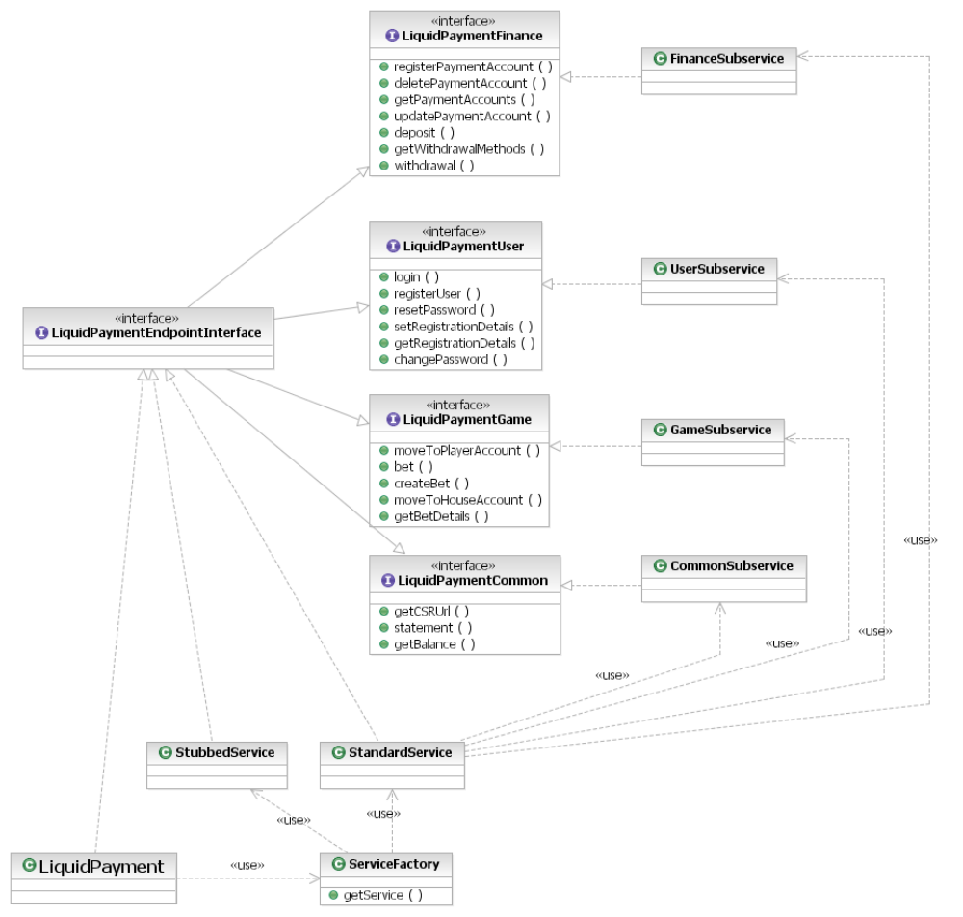
Schema 1. Liquid Payment endpoint class diagram

Operation principles
This part of a document is describing how entities interact with each other when webservice call is being made. Its illustrated on an example of login webmethod call.

LiquidPayment object represents webservice endpoint. External client called login webmethod. LiquidPayment used ServiceFactory to obtain service implementation. ServiceFactory (depending on configuration) chooses either StandardService or StubbedService. If system is configured to perform real database operations – StandardService is returned. Liquid Payment delegates execution of login webmethod to StandardService. Login method from StandardService is being invoked. StandardService chooses appropriate subservice (it case of login – UserSubservice) to perform login operation. UserSubservice is performing login, and returns result. Result is passed back to StandardService, and then back to LiquidPayment.

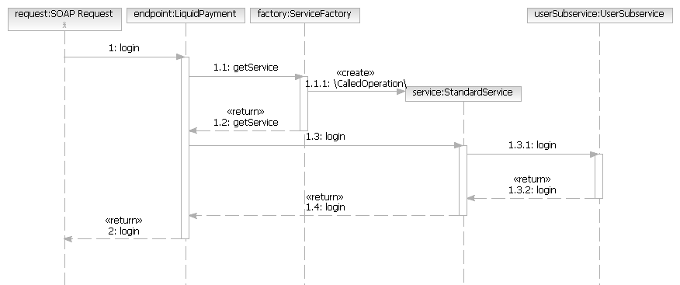
Schema 2. Webservice Endpoint – operation principles on an example of login call

Depositing funds
Liquid Payment system is prepared to handle funds deposits. Deposit operation is implemented with PayPal payment provider. Using Liquid Payment - client can perform two kinds of deposits.

- Credit Card deposit
- PayPal express checkout deposit

Both kinds of deposits are achieved using the same webmethod – namely: deposit. When depositing funds via credit card, appropriate object (CreditCardPaymentRequest) should be passed as input parameter. Liquid Payment will automatically recognize it, process credit card payment, and return appropriate output object (CreditCardPaymentResponse). Similar situation happens when processing payments with Express Checkout.

Deposit entities
Entity | Description
LiquidPaymentFinance | Interface describing financial operations. One of the methods is deposit. Deposit method takes DepositInput as input parameter and returns DepositOutput. Such an architecture allows to perform different kinds of deposit using the same method.
Request | Request interface. Used only because of JAXWS RI 2.1.2 specification.
Response | Request interface. Used only because of JAXWS RI 2.1.2 specification.
DepositInput | Base class for all deposit requests. Input to deposit webmethod.
DepositOutput | Base class for all deposit responses Output from deposit webmethod.
CreditCardPaymentRequest | Request for Credit Card deposit.
CreditCardPaymentResponse | Response obtained when calling deposit with CreditCardPaymentRequest as input.
PayPalEC | Base request for all PayPal express checkout operations. When depositing funds with PayPal express checkout, client needs to perform three calls in correct order. Setup, Details, and finally Pay
PPECSetupRequest | First request for PayPal Express Checkout deposit.
PPECDetailsRequest | Second request for PayPal Express Checkout deposit.
PPECPayRequest | Third request for PayPal Express Checkout deposit.
PPECSetupResponse | Response obtained when calling deposit with PPECSetupRequest as input.
PPECDetailsResponse | Response obtained when calling deposit with PPECDetailsRequest as input.
PPECPayResponse | Response obtained when calling deposit with PPECPayRequest as input.
Money | Object representing money. Type for orderTotal parameter of DepositInput and CreditCardPaymentResponse

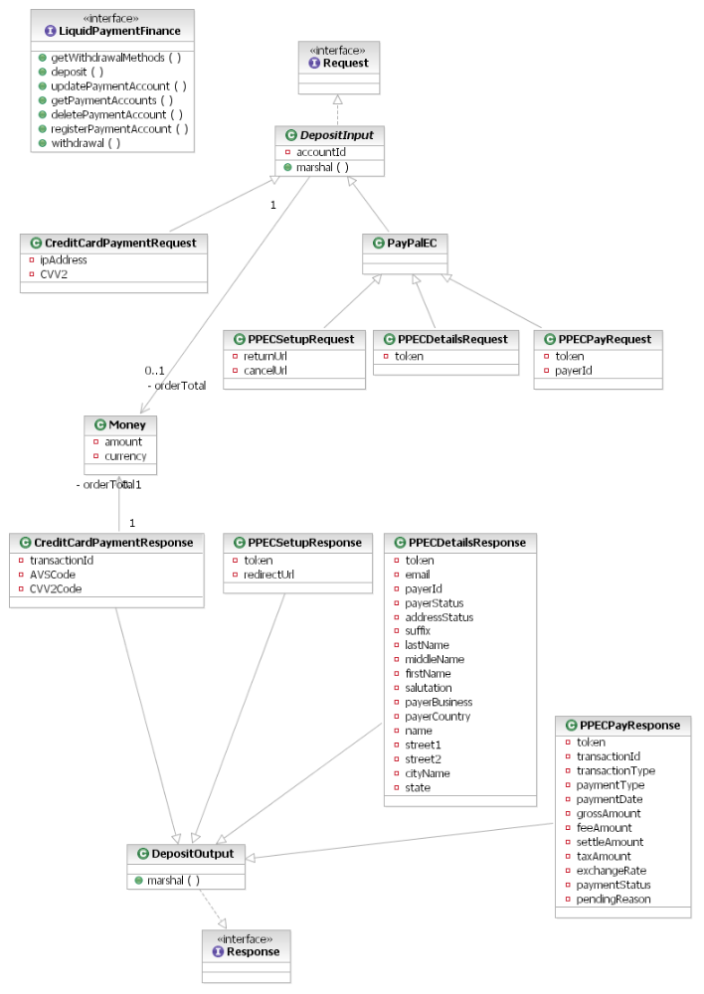
Schema 3. Deposit entities

Example of Credit Card Payment
Credit Card Payment can be done using deposit webmethod. CreditCardPaymentRequest is passed as input parametr.

NOTE:
In payment.setAccountId(1); “1” is valid account Id created using registerPaymentAccount method. Retrieved by getPaymentAccounts

LiquidPaymentService service = new LiquidPaymentService();
LiquidPayment lp = service.getLiquidPaymentPort();

CreditCardPaymentRequest payment = new CreditCardPaymentRequest();

payment.setIpAddress("83.31.179.1");
Money m = new Money();

m.setAmount(1000);
m.setCurrency(CurrencyType.GBP);

payment.setOrderTotal(m);
payment.setAccountId(1); // NOTE THAT ACCOUNT ID is VALID Credit Card Account Id.

CreditCardPaymentResponse response = null;
try {
response =
(CreditCardPaymentResponse) liquidPayment.deposit(this.getValidSession(), payment);
} catch (InternalException_Exception e) {
//TODO: Log Exeption and handle
} catch (InvalidPaymentException_Exception e) {
//TODO: Log Exeption and handle
} catch (InvalidSessionException_Exception e) {
//TODO: Log Exeption and handle
} catch (LimitExceededException_Exception e) {
//TODO: Log Exeption and handle
}

//TODO: do sth with response.
String tranId = response.getTransactionId();

Example of PayPal Express Checkout Payment.
PayPal Express Checkout Payment Is performed in three steps. Steps are presented on a diagram below.
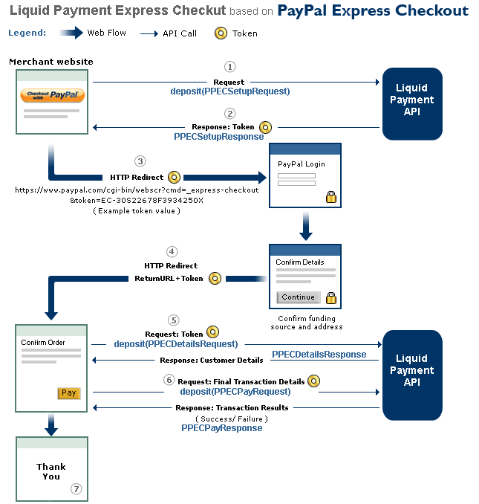

- When Your Customer chooses to pay with PayPal, you make the deposit(PPECSetupRequest)
- PayPal sends back a token, a string value used to track Your customer throughout the checkout process.
- You direct Your customer to the PayPal site where they log in, select a funding source, and confirm contact and shipping info.
- Your customers click the Continue button and PayPal redirects them to the returnUrl You specified in the PPECSetupRequest. The token Identifying customer is appended to the url
- You make the deposit(PPECDetailsRequest) call to get Your customers’ details from PayPal. Send the token to identify the customer and PayPal returns the details
- When Your customer completes payment You make the deposit(PPECPayRequest) call. PayPal sends back the transaction results.
- You display the transaction results to Your customer.

Payment accounts management
In order to perform deposits user has to register his payment accounts. Possessing payment account is obligatory condition to make a deposit, that’s why accountId attribute is present in DepositInput class. It forces passing account identifier with each deposit method call.

Payment account entities
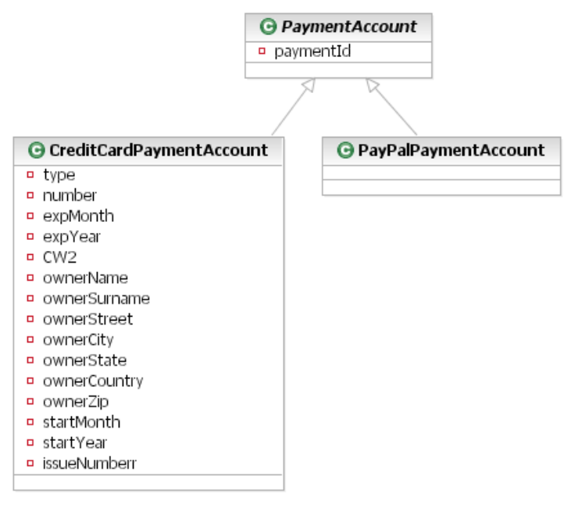

Deployment

Deployment diagram
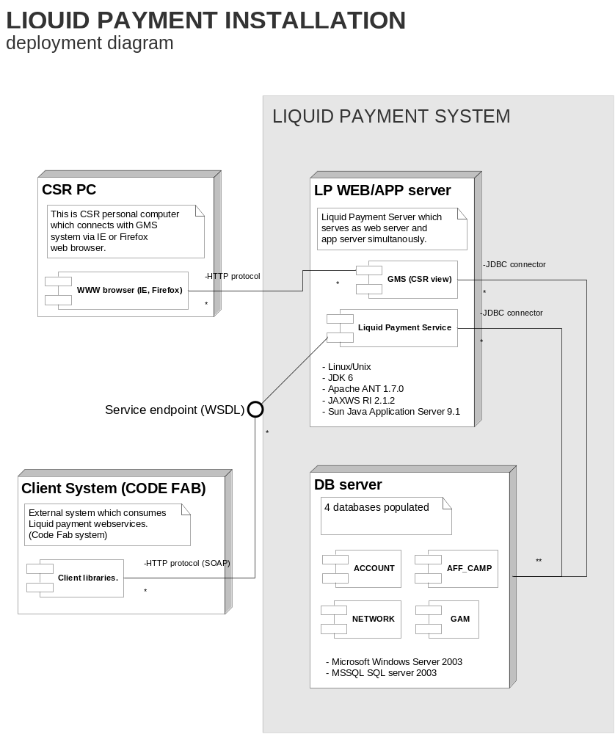

Deployment instructions

Deployment pack directory structure
Directory | Contents
/ | Root directory
/gms30 | CSR application
/SRC_LIB/3.0/ant | ant files for database building
/SRC_LIB/3.0/lib/precyse | Libraries used in gms and WG_API subsystems
/SRC_LIB/3.0/thirdparty | Thirdparty libraries used in gms and WG_API subsystems
/tools | directory with wg.global.build.properties file and dcegencryptor.exe
/WG_API | Liquid Payment application with webservice endpoint

LP WEB/APP server
LP WEB/APP server serves as web and app server simultaneously. It’s a box with linux based OS. Please do the following to install and configure WEB/APP server:

Initial steps
- download and Install JDK 6,
- add <JAVA_INSTALL_PATH>/bin folder to env. PATH variable,
- set <JAVA_INSTALL_PATH> as JAVA_HOME environment variable,
- download and unpack apache ant (1.7.0) ,
- add <ANT_INSTALL_PATH>/bin folder to env. PATH variable,
- download JAXWS RI 2.1.2,
- download and install Sun Java Application Server 9.1,
- add <SUN_INSTALL_PATH> folder to env. PATH variable.
- set <SUN_INSTALL_PATH> as AS_HOME env. variable.

JAXWS RI configuration.
- go to <JAXWSRI_PATH> and install JAXWS 2.1.1 executing command
java –jar JAXWS2.1.2-(*).jar
- go to unpacked directory (jaxws-ri) and execute command
ant install
ant install command is using build.xml which is configured to point to Sun Application Server via AS_HOME environment variable.

Configuring JRE to work with JAXWS 2.1.2
- go to <JAVA_INSTALL_PATH >/jre(*)/lib and create ‘endorsed’ folder
- go to <SUN_INSTALL_PATH>/lib/endorsed and copy all of the files from directory to JAVA_INSTALL_PATH >/jre(*)/lib/endorsed

* is a specific extension of JRE (1.6_11, 1.6_5 etc.)

Configuring GMS and WG_API
in order to sucessfully build GMS and WG_API wg.global.build.properties should be placed in Your <USER.HOME> directory, simirarly as it was during DB server preparation and buiding the database. Properties should be set according to the rules described in “Global Properties Configuration” section of this documentation.

Installation of GMS and WG_API
REMARK: First DB server should be ready, and both GMS and WG_API configured
- go to /gms30/ant directory and run build.xml clean-all target with command:
ant clean-all
- go to /gms30/ant directory run build.xml deploy-war-folder with command:
ant
- go to /WG_API/ant directory and run build.xml clean-all target with command:
ant clean-all
- go to /WG_API/ant directory run build.xml deploy-war-folder with command:
ant
- Go to Sun Java Appilication Server admin console (default port 4848) and deploy gms30 Web application. (Change C:/Sun/AppServer to Your install path of application server)
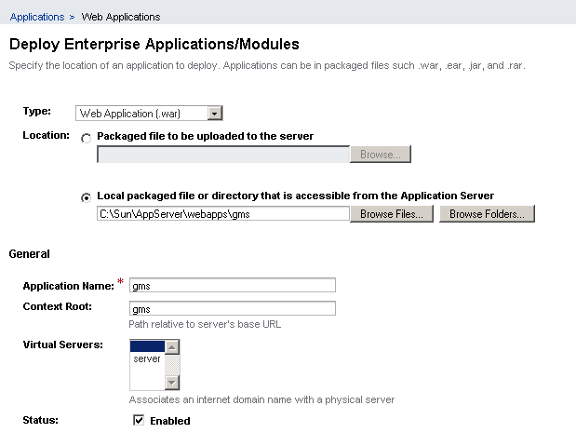
- In the same way deploy WG_API application.

DB server
Installation
Download Install and configure MSSQL 2000 sqlserver. After the installation You should know few parmeters parameters

Parameter | Meaning
IP | IP address of database
PORT | Port where MSSQL server is listening to connections (default: 1433)
USERNAME | Username with admin access rights to database (default: sa)
PASSWORD | Password of admin user

Creating schema
For security reasons create new user and assign him a password.
Choose your prefix (dev_, tst_, uat_ ….) and create 4 databases. Make sure that the collation of databases is set to SQL_Latin1_General_CP1_CI_AS, and make sure that owner of schemas is user that was just created.

The databases that need to be created are:

- <prefix>_account
- <prefix>_game
- <prefix>_aff_camp
- <prefix>_network

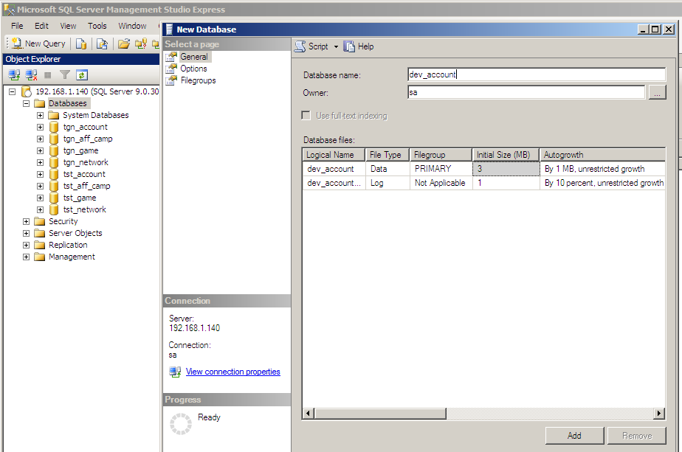
Creating new table 'dev_account' and assigning owner rights to 'sa' user

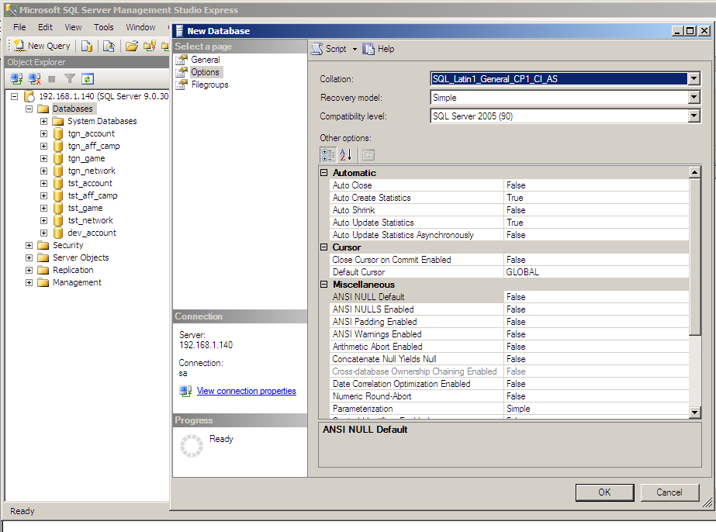
Setting Collation to SQL_Latin1_General_CP1_CI_AS

Populating tables
- Make sure that the user who is going to run db creation script has read and write rights to all directories where project was uppacked.
- copy wg.global.build.properties file to <USER.HOME> directory
- edit wg.global.build.properties and set following variables according to the rules described in “Global Properties Configuration” section of this documentation.
- Run the SRC_LIB/3.0/ant/recreate-db.xml using command
ant –buildfile recreate-db.xml

Global Properties Configuration
variable | Meaning
project.home.dir | Directory where LP deployment pack was unpacked
tomcat.dir | Direcotory to Sun Java Application Server 9.1
db.port | Database port, where MSSQL is listening
db.server | IP of a box where MSSQL was installed
db.<*>.name | Name of appropriate database
db.<*>.userid | User to appropriate database
db.<*>.password | Password to appropriate database
db.<*>.xmlpassword | XML encrypted password (password encrypted with DCEGENCRYPTOR)
db.creation.log | Path where to put DB creation log. (This path must have write access for the user who will be running db creation scripts)
global.config.email.xml.smtphost | Adress of a system responsible for sending emails
global.config.email.xml.password | Password to the email system. (password encrypted with DCEGENCRYPTOR)
global.config.email.xml.fromname | Value which will appear in field „From” when sending email.
global.config.email.xml.fromemail | Email which will appear in field „From” when sending email.
global.config.email.xml.username | Username to the email system.

DCEGENCRYPTOR
In order to encrypt passwords, dcegencryptor.exe tool was provided. In order to encrypt password <PASSWD>, run command
dcegencryptor.exe <PASSWD>

The reason the payment is pending: - none: No pending reason - address: The payment is pending because your customer did not include a confirmed shipping address and your Payment Receiving Preferences is set such that you want to manually accept or deny each of these payments. To change your preference, go to the Preferences section of your Profile. - echeck: The payment is pending because it was made by an eCheck that has not yet cleared. - intl: The payment is pending because you hold a non-U.S. account and do not have a withdrawal mechanism. You must manually accept or deny this payment from your Account Overview. - multi-currency: You do not have a balance in the currency sent, and you do not have your Payment Receiving Preferences set to automatically convert and accept this payment. You must manually accept or deny this payment. - verify: The payment is pending because you are not yet verified. You must verify your account before you can accept this payment. - other: The payment is pending for a reason other than those listed above. For more information, contact PayPal customer service.

