NSCC, Truro

GAME2000 – Portfolio Development I

Kristopher Charuk

PROJECT BOLTS: Progress Reports

**Week One: April 26th - April 30th, 2021**

**Event Log:**

* Created Game Design Document
* Created Project Board/Task List/Schedule on Trello
* Added boilerplate code to project(rendering to canvas, main update, basic event manager -> “gameStart”, “gameOver”, “game reset” event cases)
* Imported scripts: Asset Manager, Tool-kit, Constants
* Published initial commit to GitHub
* Added artist Zaina as a collaborator on GitHub
* Created Placeholder Art to aid in next week’s development
* Broke down Trello boards to be more specific
  + Turned elements of the tasks(cards) into their own tasks (animations have their own task cards)
* Re-Edited Trello board
  + Didn’t like how crowded the board became
  + Combined tasks into larger groups and utilized Trello’s checklist to aid in monitoring progress of tasks
* Made some changes to Constants script (cleaned up unnecessary code)
* Used TexturePacker to create placeholder assets spritesheet + json
* Created branch for player/player controls (commit changes to constants + placeholder art)

**Trello Board:**

The Trello board gave me some problems but I think what I have now is clean and will be suitable for the project. The tasks for Art generally have two components, design and animations. The animation tasks have checklists for each animation.

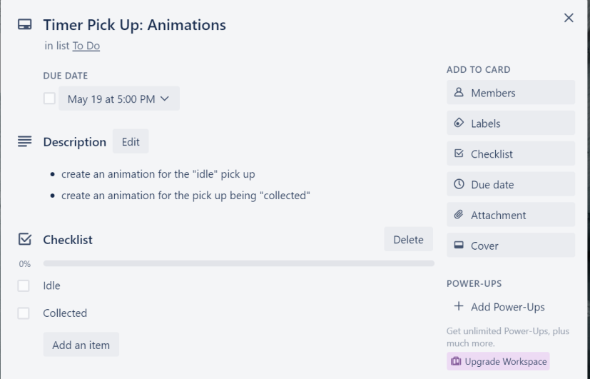Ex.

The benefits of this are a less cluttered project board. All tasks are ordered by due date (closer due dates at the top). If kept up by the users of the board, this allows at a glance to see: what it is, when it’s due, whether it’s been started yet, and how many items (if any) have been checked off (what percent of it is done). I think this works as the main and important information is viewable at a glance while more detailed information can be found by clicking on the task.

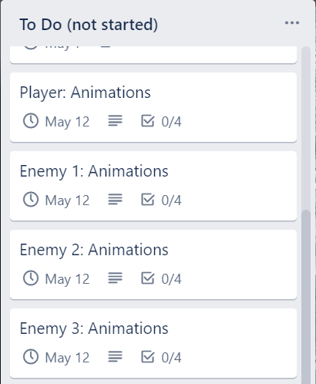Ex.

**Placeholder Sprites:**

Create some placeholder sprites to help develop the first playable. Create a circle (player) and a square (enemy) character with an arrow to display the direction facing (rotation of sprite) as well as: a solid black background, a solid white wall tile, and a simple missile.

