BKK COMMUNITY PLATFORM

PHASE 3 — DEVELOPMENT AND
PHASE 4 — SOFTWARE TESTING
WDP371 — SS2 Assignment 2
Submission detail | Confirmed value
Campus | Online Campus
Group | Ctrl Freaks
Group member | Kagiso Mmatloa — Student number: NOT SUPPLIED
Group member | Ipeleng Sithole — Student number: NOT SUPPLIED
Group member | Blessing Rugoyi — Student number: NOT SUPPLIED
Group member | Masase Mukhinindi — Student number: NOT SUPPLIED
Project | BKK Community Platform
NPO/client | BKK Community — Andrew Spaumer
Submission date | 21 August 2026
Live website | https://www.bkkcommunity.online
Public repository | https://github.com/kxcy77/BKKCommunity-Platform
Android APK | https://github.com/kxcy77/BKKCommunity-Web/releases/tag/android-test-v1.0.0
Contribution target | At least 20 meaningful GitHub commits per member before final hand-in; pending final GitHub verification

Before final submission
Replace every ‘Student number: NOT SUPPLIED’ entry with the real student number. This information was absent from the uploaded documentation and was not invented.

Table of Contents
Section | Page | Section | Page
Phase 3 — Development | 3 | 2.6 Security controls | 21
1. User Documentation | 3 | 3. Coding Standards | 22
1.1 Access and platforms | 3 | Phase 4 — Software Testing | 23
1.2 Account access/recovery | 5 | 4. Test Plan | 23
1.3 Navigation guide | 7 | 5. Test Templates | 23
1.4 Task instructions | 15 | 6. Functional Results | 26
1.5 FAQs | 16 | 7. User Acceptance | 27
1.6 Contact/support | 16 | 8. Environments | 28
2. Technical Documentation | 17 | 9. Feedback | 28
2.1 Architecture | 17 | References | 29
2.2 Technology stack | 17 | Appendix A — Traceability | 29
2.3 Database design | 18 | Appendix B — Evidence | 31
2.4 Modules/code | 19 | Appendix C — Checklist | 31
2.5 Repository structure | 20 | Appendix D — Glossary | 32

Page references were checked against the rendered PDF dated 20 August 2026. Update them if content is edited.

Evidence and honesty statement
This document follows the Student Guide’s numbered Sections 1–9. A result is marked PASS only where a dated code, API, browser, emulator or test-record reference exists. Unperformed UAT, physical-device notification testing, real password-reset inbox receipt and missing production screenshots are shown as BLOCKED or NOT RUN. No participant names, signatures, Lighthouse scores, email delivery, client approval or production result has been fabricated.
Submission status
The document remains detailed and preserves the baseline evidence. Administrator security, migration 007, security headers, deployment readiness and backup restoration are now technically verified. The platform is not yet release-ready because the website-wide login policy remains inconsistent with public guest routes, authenticated live admin CRUD screenshots are outstanding, the real reset email has not yet been consumed, performance/browser/accessibility evidence is incomplete, and six-person elderly-user UAT has not been completed.

Phase 3 — Development

1. User Documentation
The BKK Community Platform gives older community members one place to access events, senior discounts, local services and BKK contact support. The implementation consists of a responsive website, a native Android application, a SwiftUI iOS companion, a shared PHP JSON API, an administration area and a MySQL database. The intended access policy is account-first: a user should land on Login before entering the member platform. Android currently enforces this; the deployed website requires the critical routing correction recorded as DEF-001.

1.1 System access and supported platforms
Access item | Instructions and verified facts
Website | Open https://www.bkkcommunity.online using an internet connection. Live route verified HTTP 200 on 20 August 2026.
Android | Install the APK from the public release link. Android 8.0/API 26 is the coded minimum; this exceeds the guide’s required Android 10 compatibility by also supporting older devices. API 26 emulator tests passed.
iOS | Open BKKCommunity.xcodeproj or Package.swift in Xcode and run on iOS 16+. This is a companion build and is not distributed through TestFlight because an Apple Developer membership was not available.
Browser evidence | Chrome mobile viewport and desktop screenshots exist. Safari, Firefox and Edge still require separate dated evidence before claiming cross-browser completion.
Account | Registration uses full name, email and password. RSVP, profile, notification preferences and attendance history require authentication.
Connectivity | Readable Android content may be cached; attendance changes require a successful server response and must not display false success offline.

Android APK installation
- On an Android phone, open the public APK release link and download app-debug.apk.
- If Android displays an unknown-app warning, allow installation only for the browser or Files app used for this download.
- Open the downloaded APK, choose Install, and then Open.
- The first screen should be Sign In. Choose Register if the test user does not yet have an account.
- After testing, the one-source permission can be disabled again in Android settings.
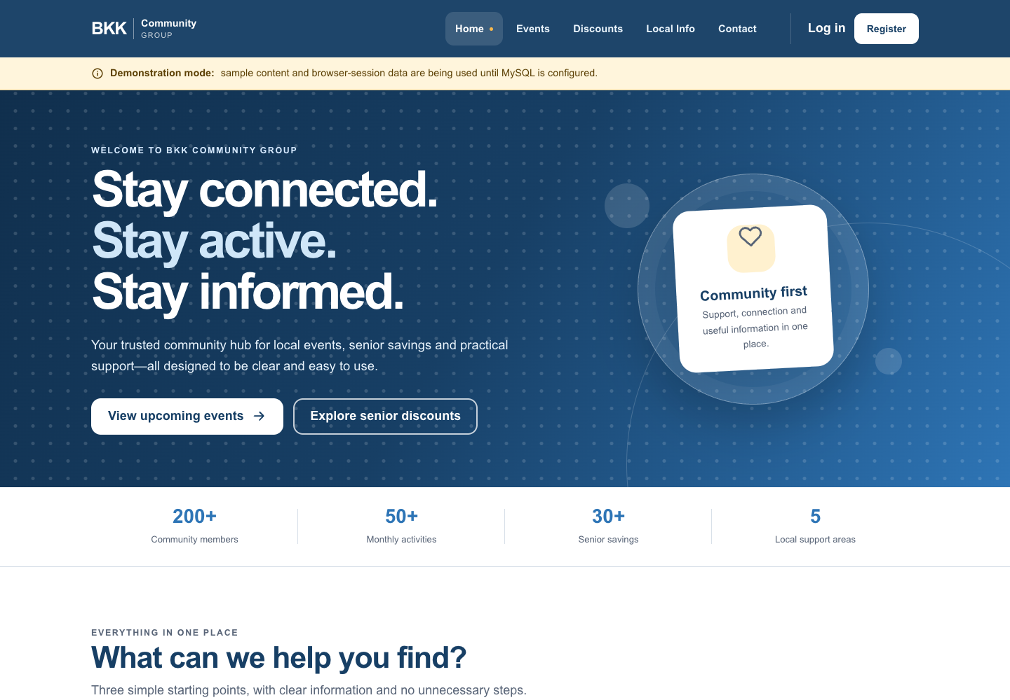
Figure 1. Live-coded responsive website Home screen retained from the current project documentation.
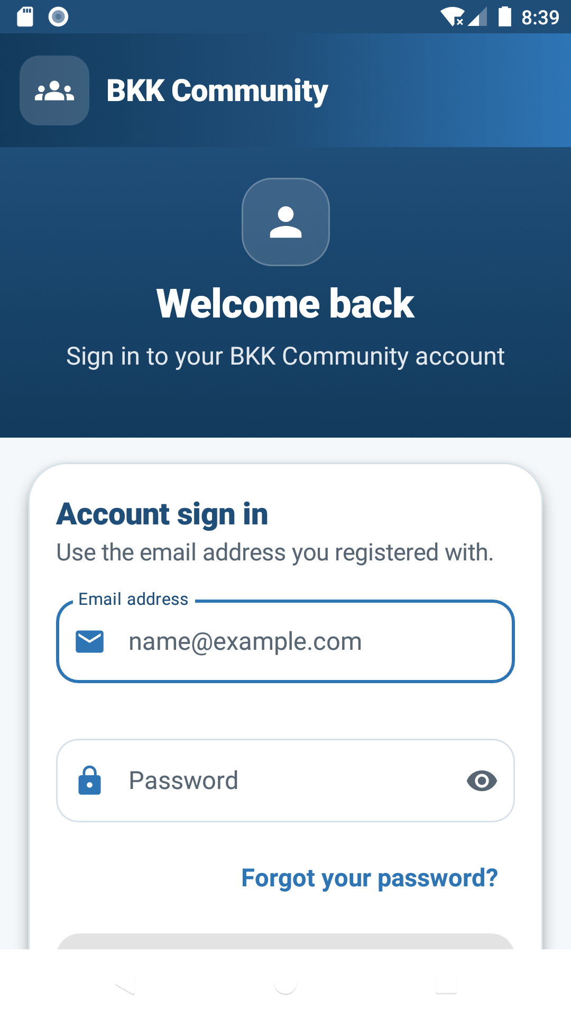
Figure 2. Current Android Login screen captured from the API 26 emulator against the live API on 20 August 2026.

1.2 Registration, login and password recovery

Register a member account
- Open Register from the Login screen.
- Enter the member’s full name and a valid email address.
- Enter a strong password that satisfies the on-screen rules, confirm the privacy consent, then submit.
- If the email already exists, the service returns a conflict without creating a second account.
- After successful registration, sign in using the same email and password.

Sign in and sign out
- Enter the registered email address and password on Sign In.
- Use the password-visibility control only in a private space.
- Choose Sign In. A successful authenticated API call opens Home.
- To sign out, open Me/My Account and choose Sign Out.
- The Android retest on 20 August 2026 returned to Login and cleared member access. The web gate still requires DEF-001 before the same guarantee is valid there.

Reset a forgotten password
- Choose Forgot your password? and enter the exact email used at registration.
- Submit once. The public response remains neutral whether or not the account exists, preventing email enumeration.
- For a real account, the server creates a cryptographically random six-digit code, invalidates older unused codes, stores only a keyed hash and sets a 15-minute expiry.
- Enter the code and a new password. Five failed attempts invalidate the code; successful use invalidates all other reset tokens and revokes active sessions.
- Inbox delivery to a real external address still needs a redacted email screenshot and a successful reset retest. The document does not claim this evidence exists.
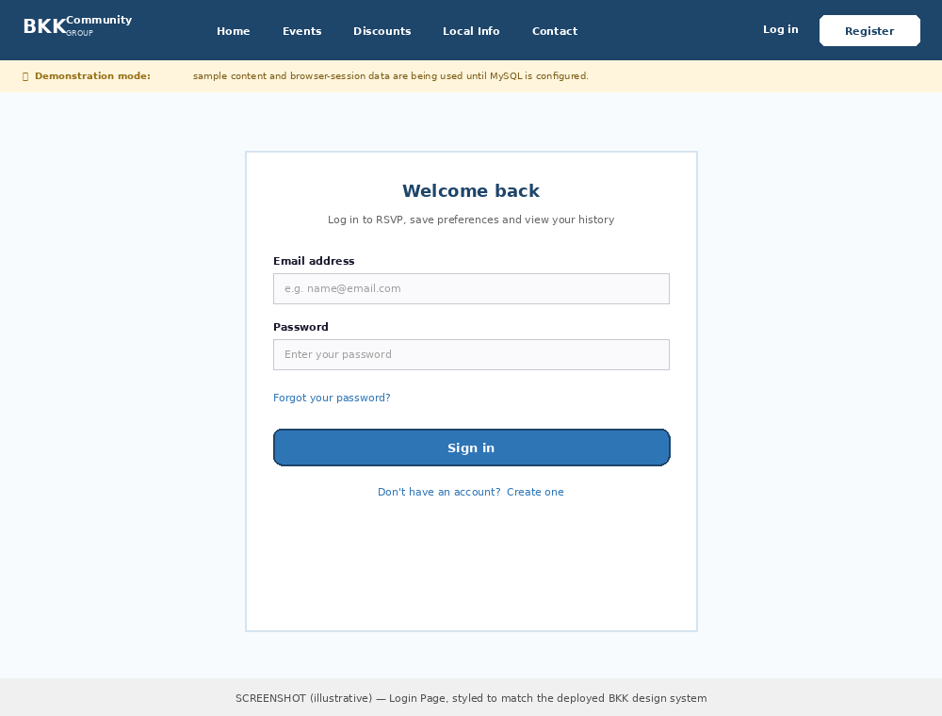
Figure 3. Login design reference retained from the original documentation. It is a design reference, not production test evidence.
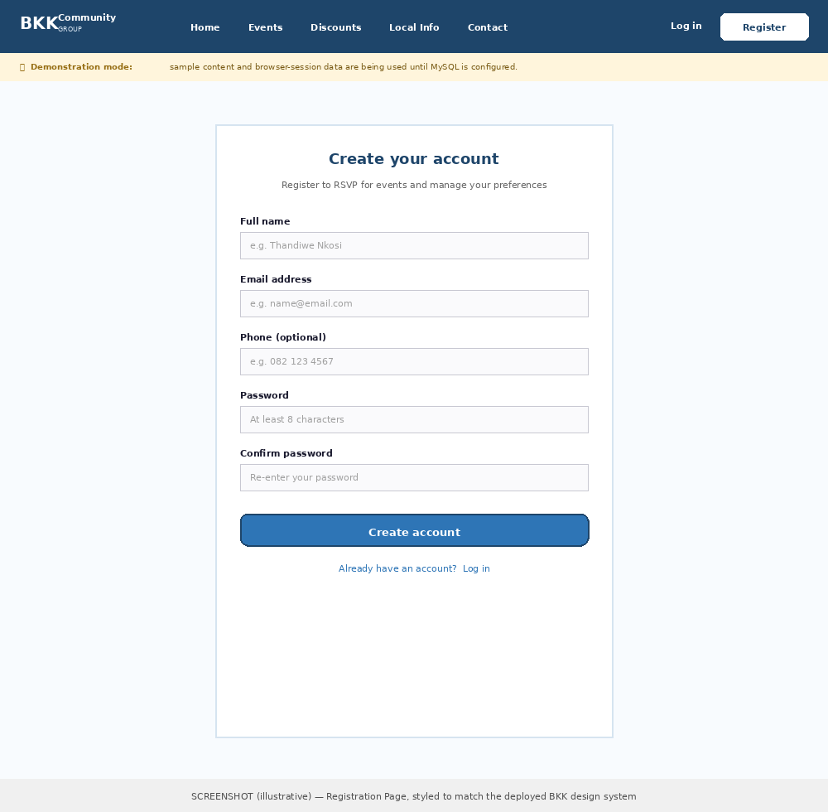
Figure 4. Registration design reference retained for traceability; live route verification must replace this with a production screenshot before final hand-in.
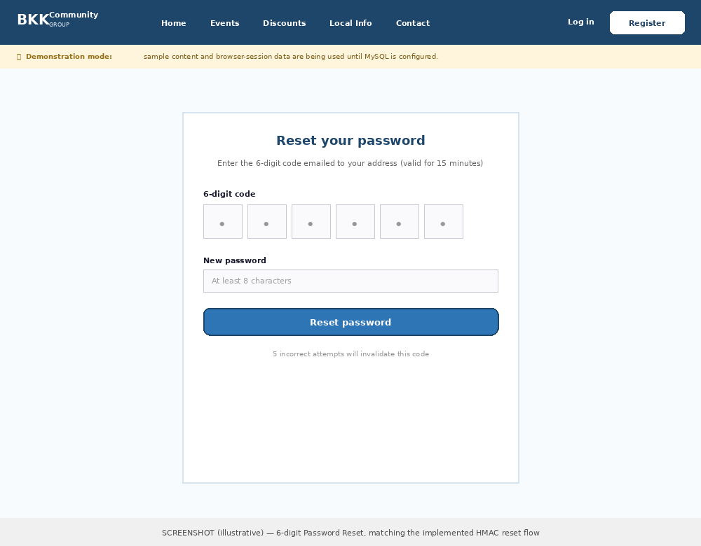
Figure 5. Password-reset design reference retained for traceability; real inbox receipt remains outstanding.

1.3 Navigation guide and screen inventory
Platform/screen | Purpose | Primary actions | Authentication/evidence
Web Login/Register/Reset | Account access and recovery | Sign in, create account, request/use code | Routes live; known-account reset request accepted and token created; inbox receipt/code consumption still pending
Web Home | Overview and shortcuts | Events, Discounts, Local Info, Contact | Live screenshot; web gate currently bypassable
Web Events | Browse schedule | Filter, read detail, confirm/cancel attendance | Live screenshot; authenticated RSVP retest pending
Web Discounts | Browse senior offers | Filter category, read eligibility/claim instructions | API data verified; public route exposes content signed out
Web Local Info | Find community services | Filter, call, read directions/hours | API data verified
Web Contact | Request help | Submit form, call, email, find hall | Direct details match live coded page
Web Profile | Account and attendance | Preferences, history, cancel attendance, delete account | Account deletion verified by API
Web Admin | Manage platform content | Create/edit/archive/restore events, discounts and services; manage messages; inspect audit history | Signed-out redirect PASS; one audited active administrator provisioned; migration 007 deployed; authenticated live UI screenshots pending
Android Home | Personal dashboard | Four core actions and Today’s Schedule | Current live-connected screenshot
Android Events/Details | Browse and RSVP | Filter, view venue/time, attend/cancel | List screenshot; real RSVP test data pending
Android Deals/Details | Discount discovery | Category list and claim instructions | Current live-connected screenshot
Android Info | Local services | Call/directions/details | Current live-connected screenshot
Android Me | Profile/settings | Preferences, saved schedule, sign out, delete account | Current screenshot; logout-to-login passed
iOS five tabs | Home, Events, Deals, Info, Me | Equivalent member journey | Build/safety passed; full UI journey interrupted

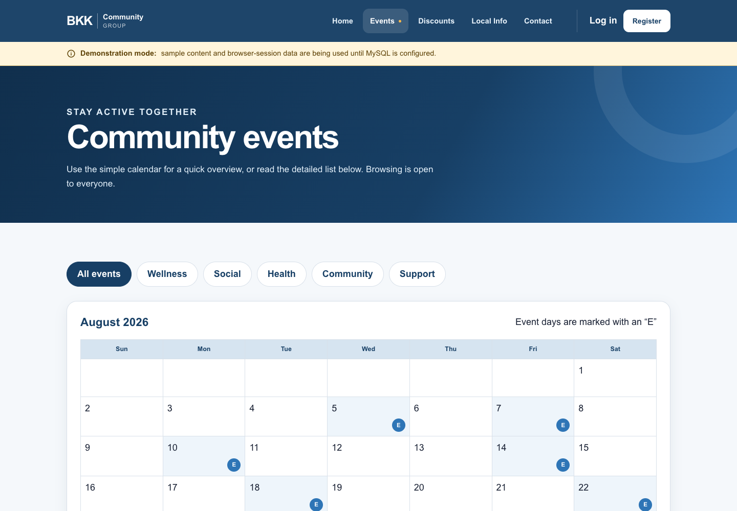
Figure 6. Live-coded desktop Events page retained from the current documentation.
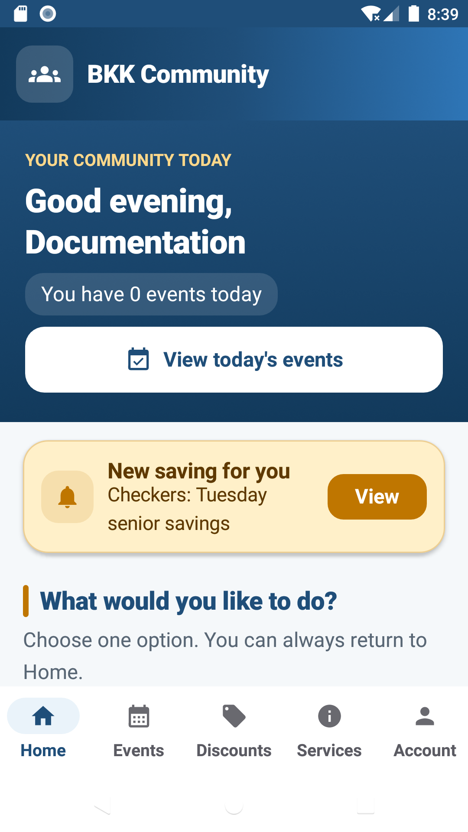
Figure 7. Android Home after authenticated live-API login.
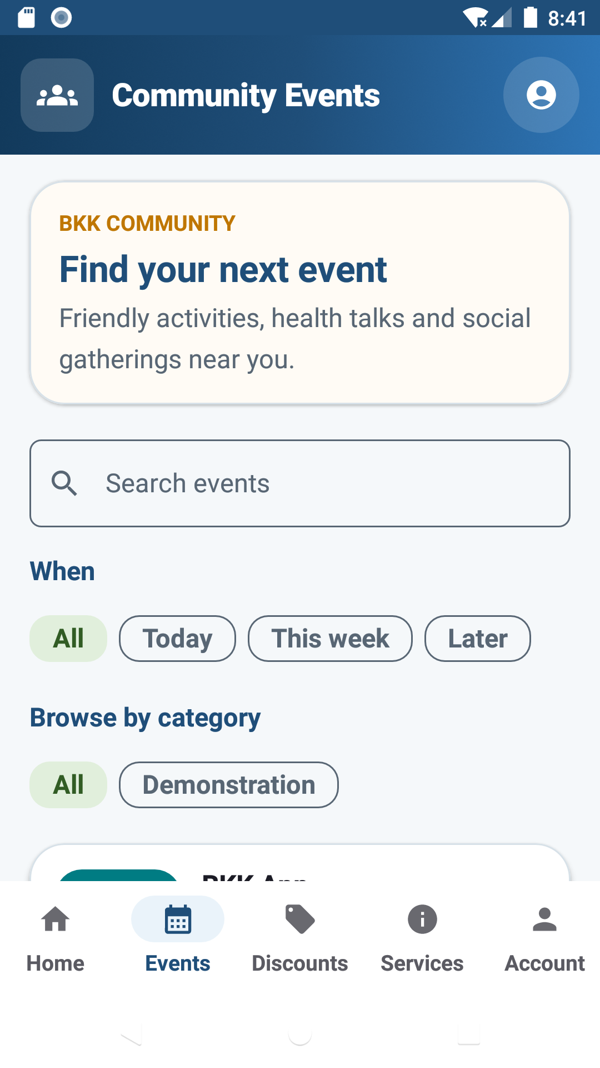
Figure 8. Android Events list with labelled demonstration content.
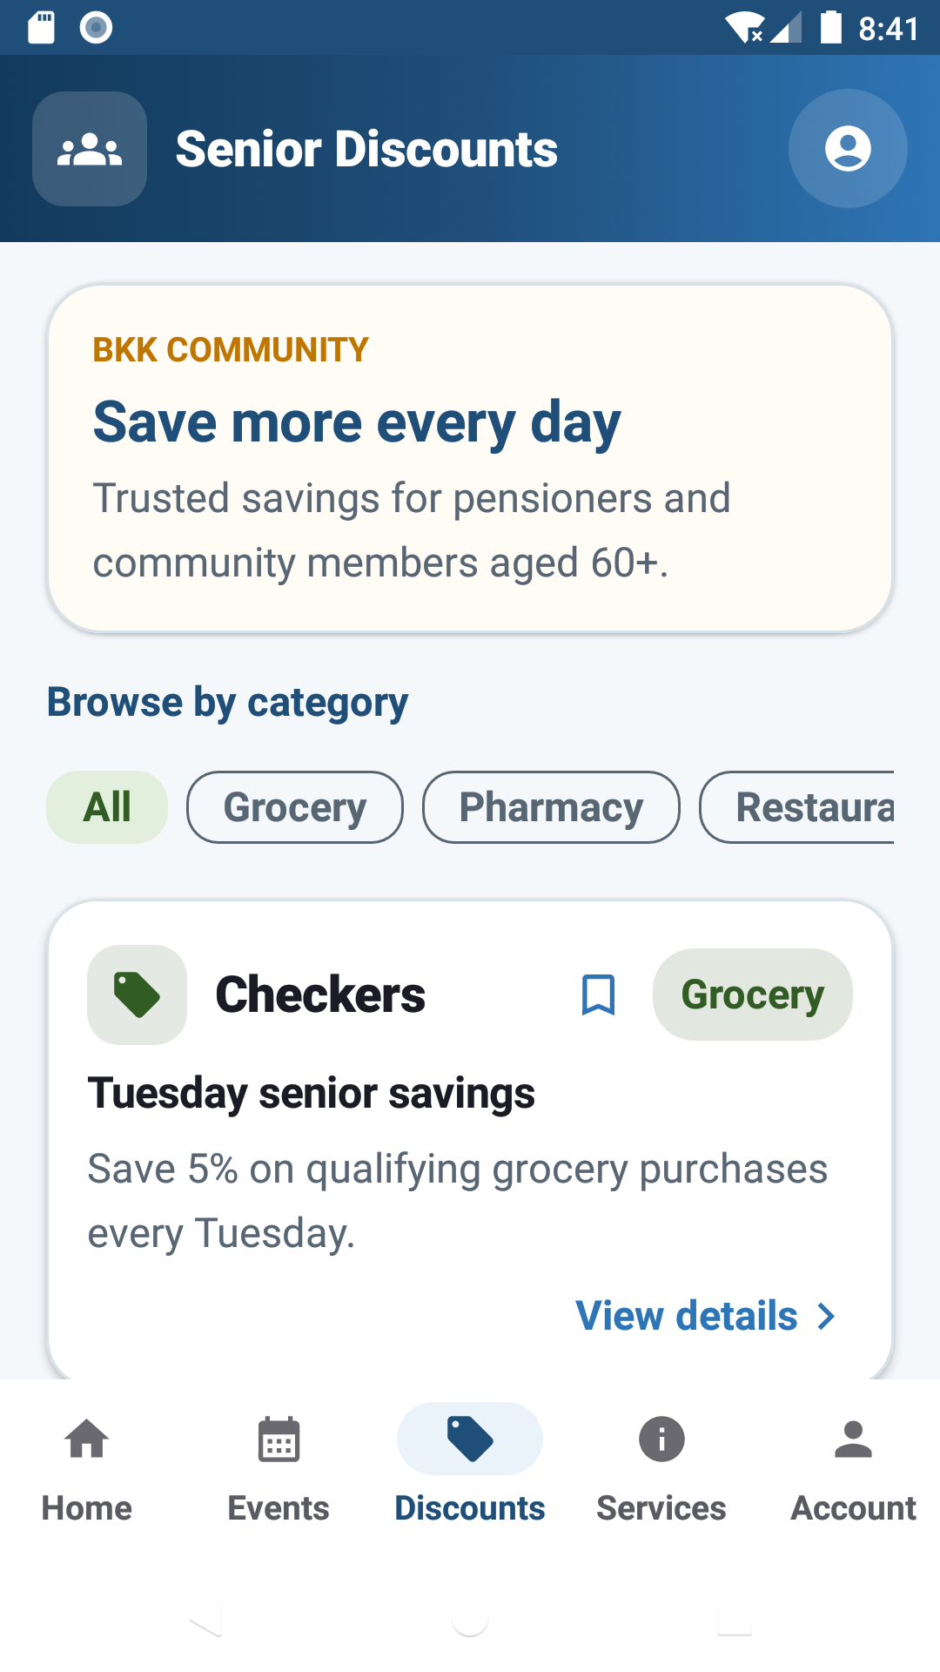
Figure 9. Android Deals list populated from the shared API.
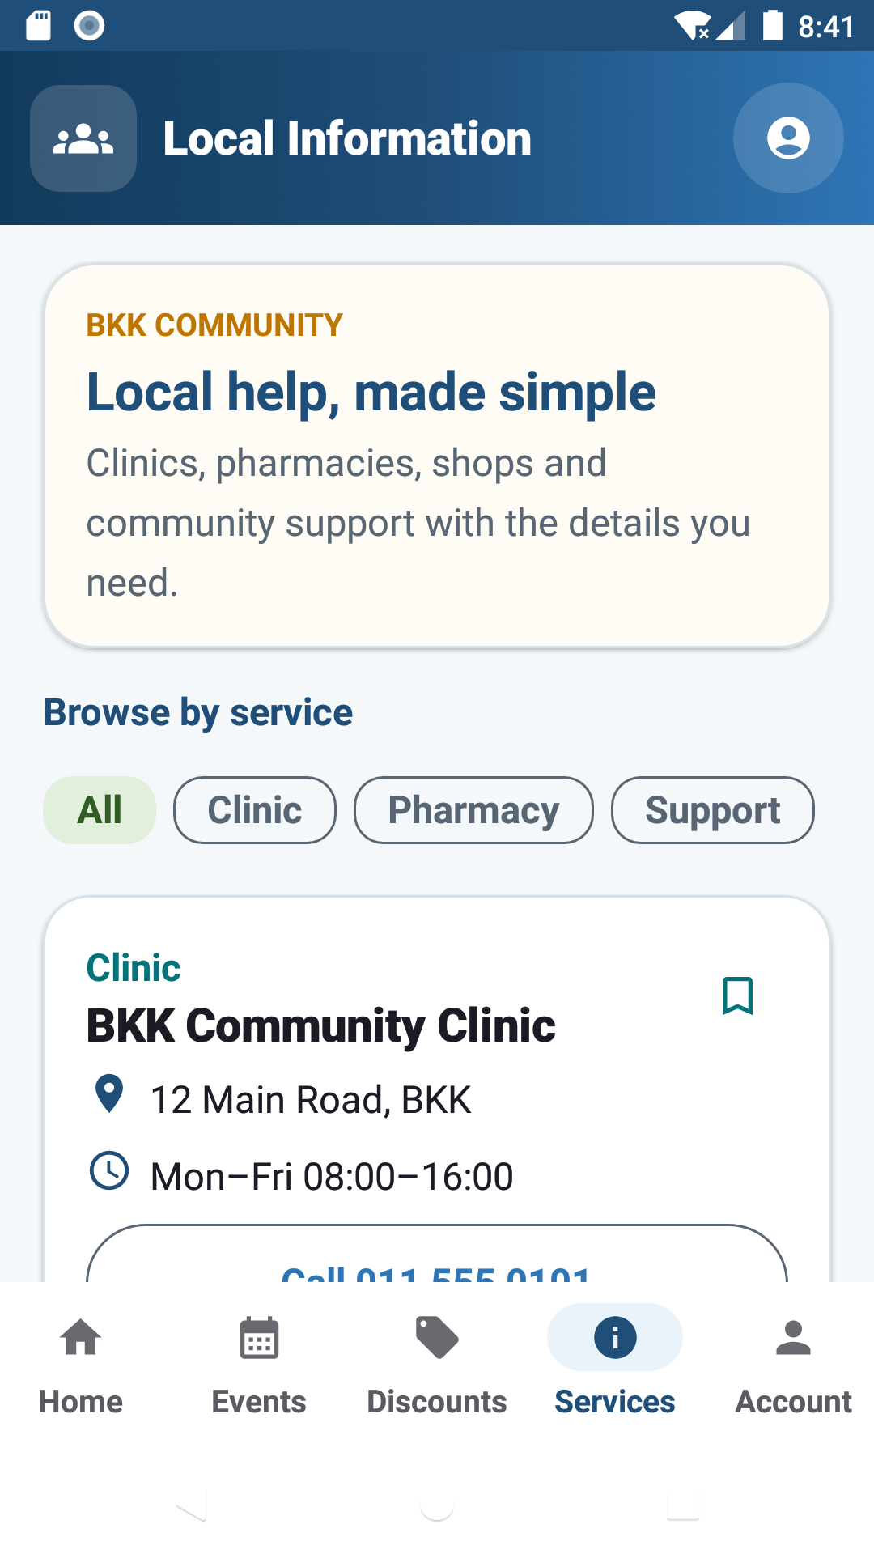
Figure 10. Android Local Info list populated from the shared API.
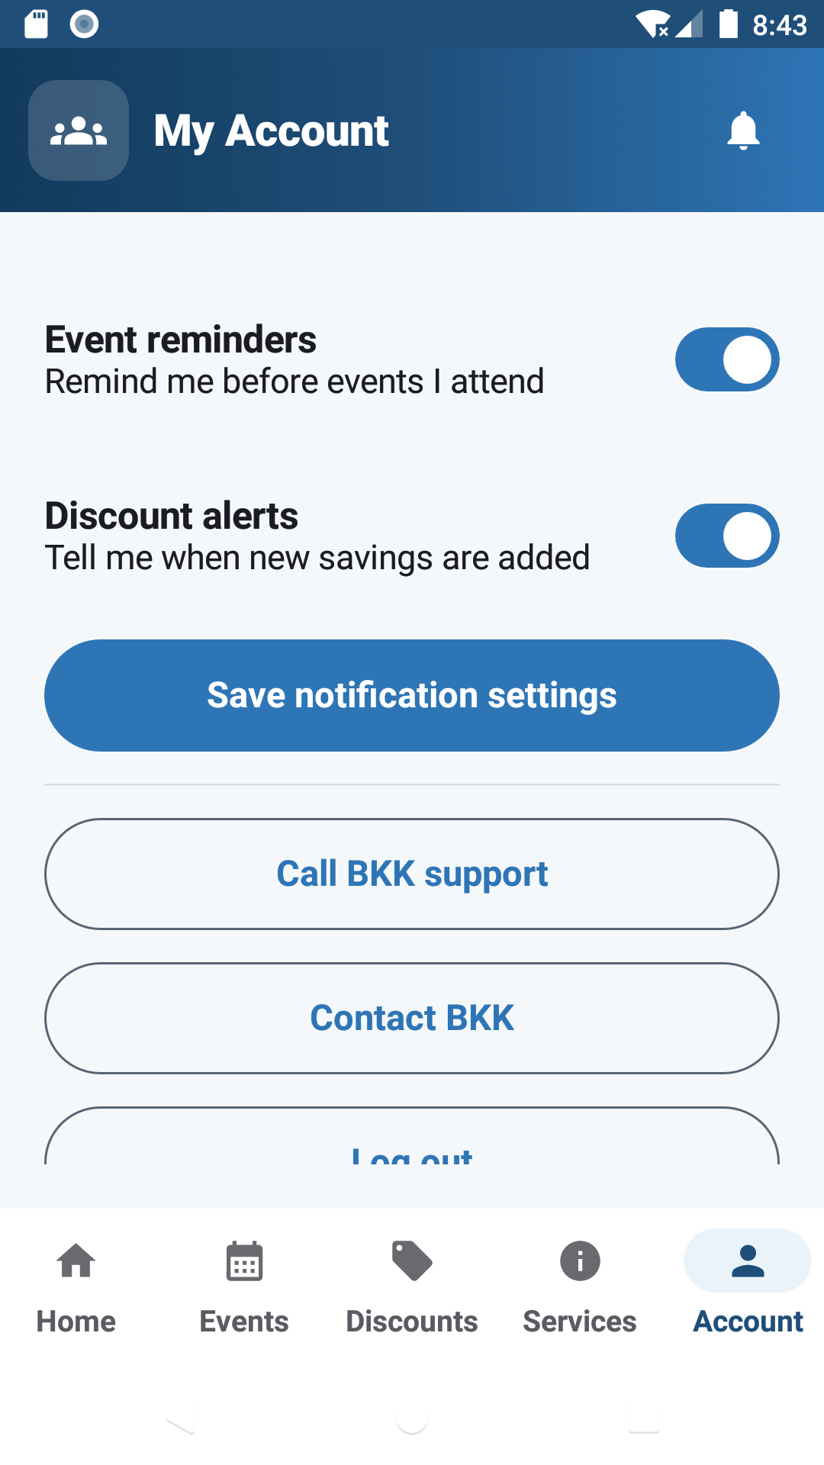
Figure 11. Android My Account settings and Sign Out control.
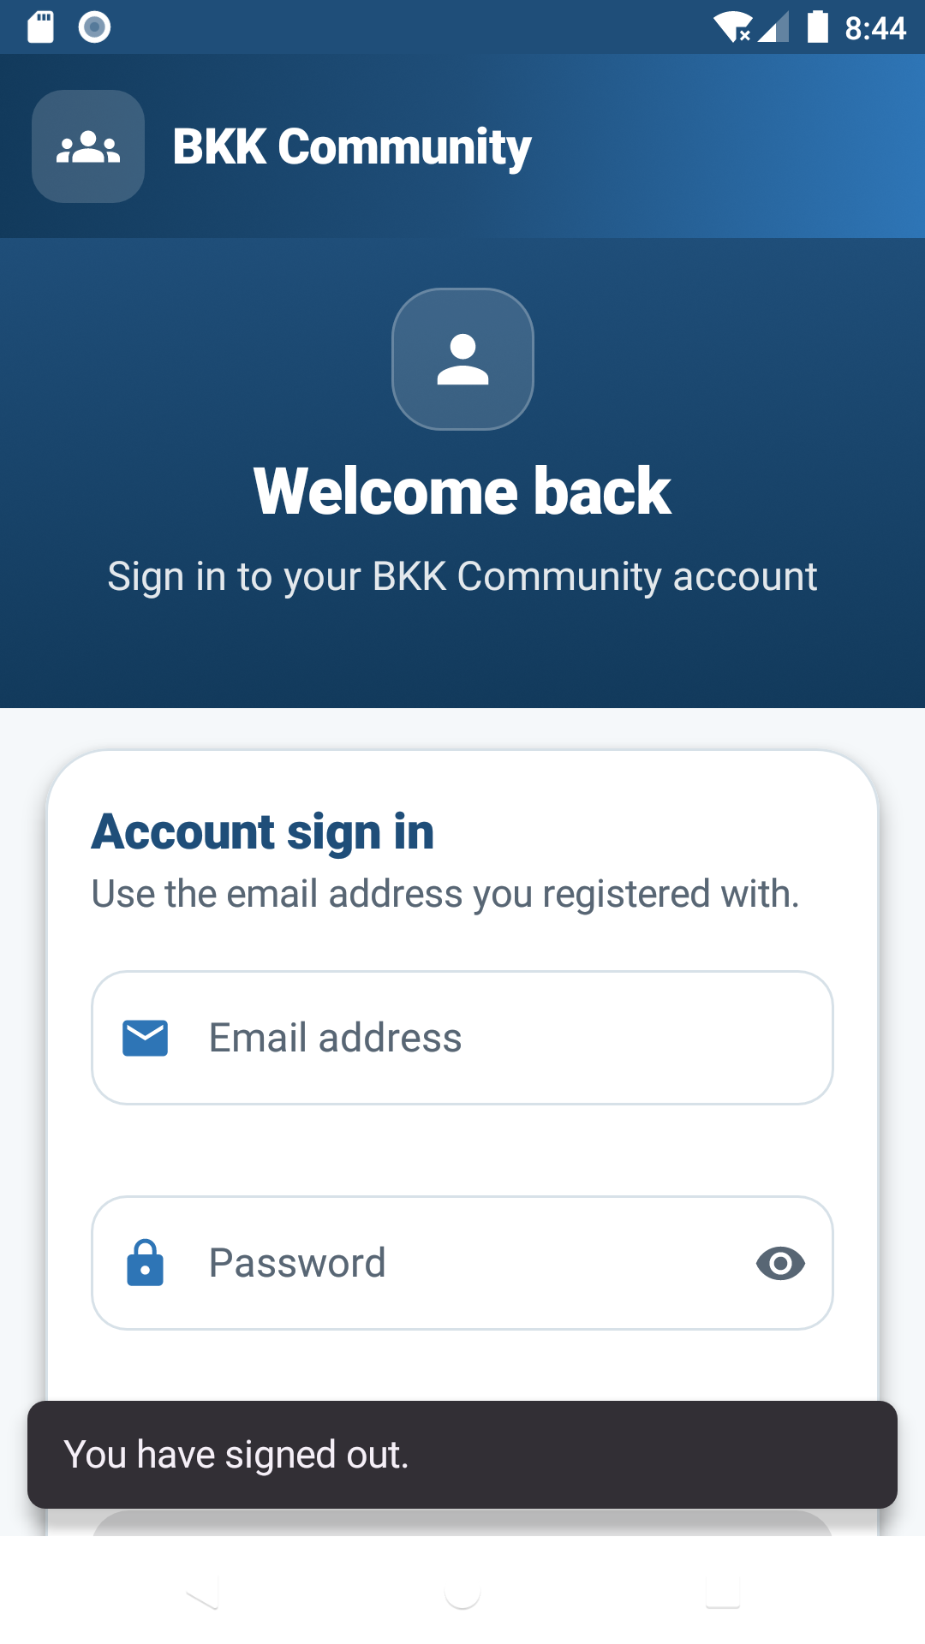
Figure 12. Android logout retest result: Login displayed on 20 August 2026.

1.4 Detailed task instructions

Task 1 — Create an account
- Open Register.
- Enter full name, email and password.
- Accept the privacy statement.
- Submit and resolve any field-specific error.
- Return to Sign In and use the new credentials.

Task 2 — Sign in and sign out
- Open Login.
- Enter registered email and password.
- Choose Sign In and confirm Home loads.
- Open Me/My Account.
- Choose Sign Out and confirm Login is displayed.

Task 3 — Find an event and manage attendance
- Open Events.
- Use category/date controls if available.
- Open an event and verify date, time, venue, duration and directions.
- Choose Attend only for a real approved test event.
- Wait for server confirmation; cancel later from Event or Profile.

Task 4 — Find and claim a discount
- Open Deals/Discounts.
- Select a category.
- Open an offer.
- Read eligibility, validity and claim instructions.
- Confirm details with the provider before travelling because current seeded records require authentic BKK confirmation.

Task 5 — Find a local service
- Open Info/Local Info.
- Select Clinic, Pharmacy, Support, Shop or Transport.
- Open the service.
- Use Call or Directions on a physical device.
- Verify the number/address before relying on it.

Task 6 — Contact BKK
- Open Contact.
- Enter full name and email.
- Choose the subject.
- Enter a 10–2,000 character message without banking, ID or medical data.
- Submit and retain the confirmation reference/screenshot.

Task 7 — Reset a password
- Open Forgot Password.
- Enter the registered email.
- Retrieve the six-digit code from the inbox.
- Enter the code and new password within 15 minutes.
- Sign in with the new password; confirm the old session is revoked.

Task 8 — Administer content
- Sign in with an approved admin account.
- Open Admin.
- Create or edit an event/discount/service.
- Save and verify it appears correctly in member views.
- Remove only test-labelled content; record before/after evidence.

Task 9 — Manage preferences and account
- Open Profile/Me.
- Change reminder and discount-alert preferences.
- Relaunch and confirm persistence.
- Review attendance history.
- Use Delete Account only with a disposable account and explicit confirmation.

Task 10 — Install and test Android
- Download the APK from the public release.
- Install on Android 10 or newer for marking.
- Register/sign in.
- Complete Tasks 2–7.
- Record device model, Android version, results and screenshots in the workbook.

1.5 Frequently asked questions
Question | Answer
1. Why do I see Login first? | The intended policy protects member actions and account details. The website currently needs DEF-001 so Home cannot be opened signed out.
2. Can I use a Gmail, Outlook or Yahoo address? | Yes. The address provider does not matter; the reset email is sent by the configured server to the address registered on the account.
3. Why has my reset code not arrived? | Check spam, verify the exact registered email and wait briefly. Do not request repeatedly. Current production inbox delivery still needs formal evidence.
4. Is the reset code always the same? | No. random_int creates a new six-digit value for each request, and older unused codes are invalidated.
5. Can I RSVP while offline? | No. Attendance changes require a successful server response so the app never shows false success.
6. Why is an event labelled Demonstration? | It is test content only. Do not travel or attempt attendance. It is deliberately blocked from RSVP.
7. Are discount details guaranteed? | No. Offers can change. Confirm validity and eligibility with the restaurant, pharmacy or retailer before travelling or buying.
8. How do I make text larger? | Use the device/browser text-size or zoom settings. The formal 200% physical-device accessibility test is still outstanding.
9. How do I contact BKK? | Use the Contact form, call 072 888 5030, email andrew.spaumer@gmail.com, or visit BKK Community Hall.
10. How is my data used? | Only the minimum account, attendance and requested communication information is intended to be stored. Do not send sensitive medical, identity or banking data.

1.6 Contact and support
Method | Exact live detail
Phone | 072 888 5030
Email | andrew.spaumer@gmail.com
Location | BKK Community Hall
Web form | https://www.bkkcommunity.online/contact.php — response target: two working days

2. Technical Documentation

2.1 System architecture
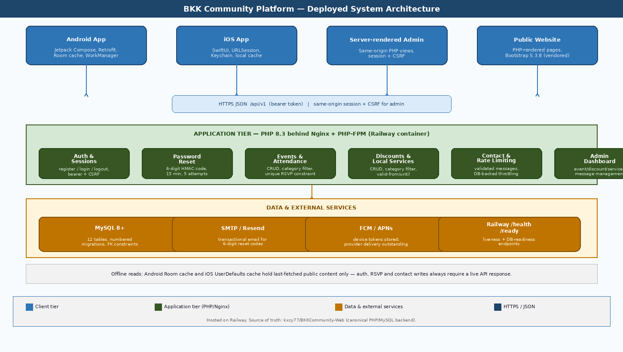
Figure 13. Implemented multi-client architecture retained from the original documentation.
The platform uses a multi-client, layered architecture. The responsive website is rendered by PHP and served through Nginx/PHP-FPM on Railway. The native Android client uses Kotlin, Jetpack Compose and an MVVM-style separation between screens, view models, repositories, Retrofit services and Room/DataStore persistence. The iOS companion uses SwiftUI, URLSession and Keychain-backed session storage. All clients communicate with the versioned HTTPS JSON service at /api/v1, which contains the authentication, events, attendance, discounts, local-services, contact, profile and notification-preference contracts.
The PHP application separates bootstrap/configuration, authentication, password reset, email delivery, rate limiting, API routing, administrator actions and repository/data access. Prepared PDO statements operate on MySQL. The database applies unique email, unique session token, unique device token and one-attendance-per-user/event constraints. Web forms add server-side validation and CSRF tokens; API clients use bearer sessions whose raw values are not stored in the database. Reset codes are generated with random_int, stored as HMAC-SHA256 hashes, limited to five failures and expire after 15 minutes. Protected administrator requests revalidate role, deleted status and auth_version; administrator sessions use a 30-minute idle limit and an eight-hour absolute limit. Content updates use row_version conflict protection, and privileged changes are recorded in admin_audit_log.
Railway supplies the running PHP/MySQL environment, while the custom bkkcommunity.online domain provides the public HTTPS entry point. Resend is the intended transactional email provider. Firebase Cloud Messaging and Android WorkManager are present in the design for discount alerts and event reminders, but production FCM credentials and physical-device delivery evidence are not yet supplied. Readable Android content can be cached, whereas RSVP deliberately requires a successful online write. This architecture gives the web, Android and iOS interfaces a common source of truth, but also means deployment configuration, database readiness and API authorization are release-critical dependencies.

2.2 Technology stack and actual versions
Layer | Technology/version | Reason for selection / evidence
Web/API | PHP 8.3 | Suitable for Railway container deployment; one codebase serves pages, admin and versioned JSON API.
Web dependency | PHPMailer 7.1.1 | SMTP fallback; Resend HTTP transport is also implemented.
Database | MySQL | Relational constraints match accounts, content, RSVP and notification records.
Web server | Nginx + PHP-FPM | Container routing, static assets and front controller.
Android | Kotlin 2.2.10; AGP 9.0.1; compile/target SDK 35; min SDK 26 | Native Android Studio project with modern Compose UI and Android 8+ compatibility.
Android UI | Compose BOM 2025.05.01; Material 3; Navigation 2.9.0 | Accessible declarative screens and five-tab navigation.
Android data | Retrofit 2.11.0; OkHttp 4.12.0; Moshi 1.15.2; Room 2.7.1; DataStore 1.1.7 | Typed HTTPS client, readable cache and preference/session persistence.
Android background | WorkManager 2.10.1; Firebase BOM 33.14.0 | Scheduled reminders and push integration; real credentials still required.
Android JVM | Java/Kotlin bytecode target 17; build environment JDK 21+ | Modern supported build chain; sourceCompatibility and jvmTarget are explicitly 17.
iOS | SwiftUI, URLSession, Keychain; iOS 16+ | Native Apple interface and secure token storage without a third-party networking layer.
Hosting | Railway + custom HTTPS domain | Managed deployment for PHP and MySQL with environment-based secrets.
Source control | Public GitHub repository, main branch; 9-commit verified snapshot on 20 Aug | Combined downloadable repository. Team target is >=20 meaningful commits per member; final counts must be refreshed and evidenced, not assumed.

2.3 Database design and data dictionary
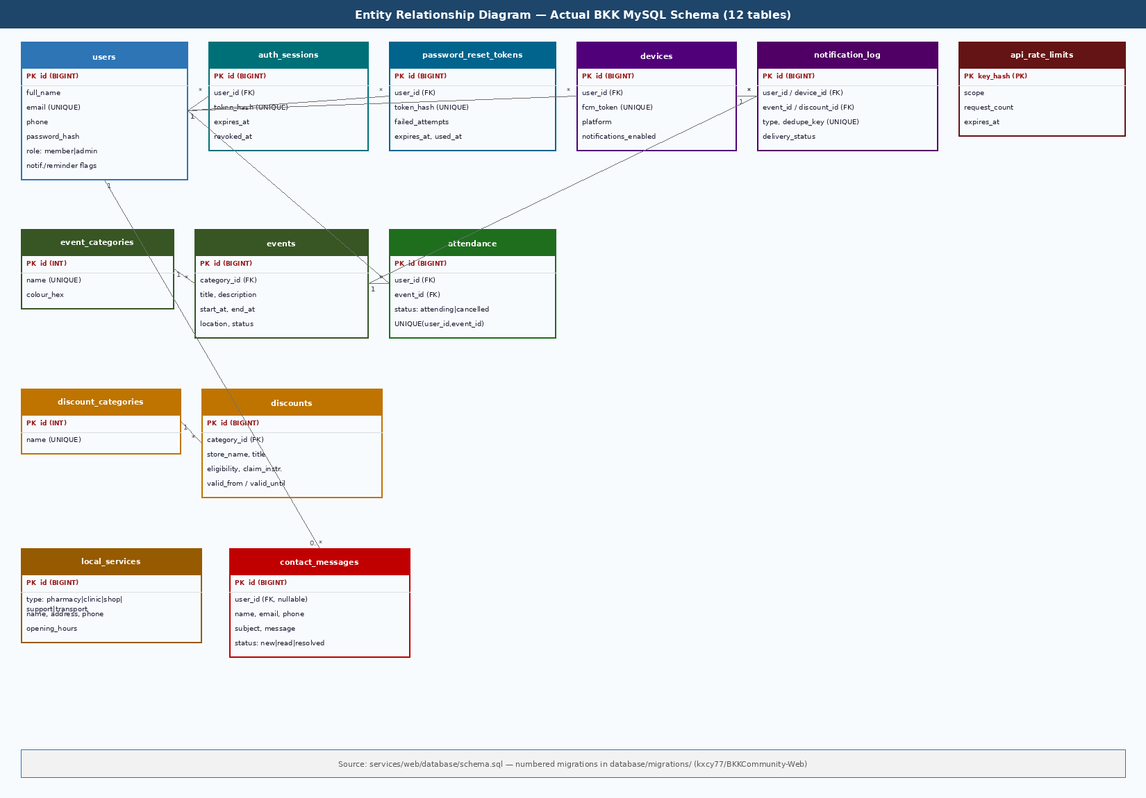
Figure 14. Entity-relationship diagram retained from the original documentation.
Table | Fields, types and keys | Relationships/business rule
users | id BIGINT PK; full_name VARCHAR(120); email VARCHAR(190) UNIQUE; phone VARCHAR(30); password_hash VARCHAR(255); role ENUM; auth_version INT; notification booleans; timestamps; deleted_at | Parent of sessions, reset tokens, attendance, devices and administrator audit entries; auth_version invalidates stale privileged sessions.
auth_sessions | id BIGINT PK; user_id FK; token_hash CHAR(64) UNIQUE; expires_at; last_used_at; revoked_at; created_at | Many sessions belong to one user; cascade delete.
password_reset_tokens | id BIGINT PK; user_id FK; token_hash CHAR(64) UNIQUE; failed_attempts; expires_at; used_at; created_at | Many historical resets per user; only latest active code accepted.
event_categories | id INT PK; name VARCHAR(80) UNIQUE; colour_hex CHAR(7) | One category to many events.
events | id BIGINT PK; category_id FK; title; description; start_at/end_at UTC; location; directions; status; row_version; timestamps | One event may have many attendance and notification rows; row_version rejects stale administrator edits.
attendance | id BIGINT PK; user_id FK; event_id FK; status; confirmed_at; updated_at; UNIQUE(user_id,event_id) | Associative entity preventing duplicate RSVP.
discount_categories | id INT PK; name VARCHAR(80) UNIQUE | One category to many discounts.
discounts | id BIGINT PK; category_id FK; store_name; title; details; eligibility; claim instructions; validity dates; is_active; row_version; timestamps | Can be linked to notification_log; row_version rejects stale administrator edits.
local_services | id BIGINT PK; type ENUM; name; address; phone; directions; opening_hours; is_active; row_version; timestamps | Independent directory records; row_version rejects stale administrator edits.
contact_messages | id BIGINT PK; user_id nullable FK; name; email; phone; subject; message; status; submitted_at | Guest/member message; user deletion sets FK null.
devices | id BIGINT PK; user_id FK; fcm_token VARCHAR(512) UNIQUE; platform; notifications_enabled; last_seen_at; created_at | Many devices per user; cascade delete.
notification_log | id BIGINT PK; optional user/device/event/discount FKs; type; title; message; dedupe_key UNIQUE; delivery status/provider id/timestamps | Auditable and deduplicated notification delivery.
api_rate_limits | key_hash CHAR(64) PK; scope; request_count; expires_at; updated_at | Server-side request throttling for sensitive routes.
admin_audit_log | id BIGINT PK; admin_user_id FK; action; entity_type; entity_id; before_json; after_json; reason; created_at | Append-only evidence for administrator privilege and content lifecycle actions; administrator relationship is preserved with controlled FK behaviour.

Cardinalities: users 1—many auth_sessions, password_reset_tokens, attendance, devices and administrator audit entries; event_categories 1—many events; events 1—many attendance; users many—many events through attendance; discount_categories 1—many discounts; users 0/1—many contact_messages; notification_log optionally references one user, device, event and/or discount. Migration 007 adds users.auth_version, row_version to events, discounts and local_services, and admin_audit_log for actor/action/entity/before/after/reason/time evidence. Foreign keys use cascading or SET NULL behaviour to preserve integrity while supporting controlled deletion.

2.4 Major modules and code explanation
Module | Key files | Responsibility
Configuration/bootstrap | services/web/app/config.php; bootstrap.php | Loads environment-based settings and shared dependencies.
Authentication | app/auth.php; public/actions.php; app/api.php | Registration, login, logout, session and role enforcement.
Password recovery/email | app/password_reset.php; app/mail.php | Random code, hashed storage, expiry/attempts, Resend/SMTP delivery.
Content repositories | app/repository.php; app/api.php | Events, RSVP, discounts, services, contact and profile data.
Admin | public/admin/*.php; app/admin_actions.php; bin/create-admin.php | Protected dashboard; event/discount/service create-edit-archive-restore; message workflow; audit history; controlled administrator provisioning.
Android | apps/android/app/src/main/java/... | Compose screens, ViewModels, Retrofit, Room, DataStore, WorkManager and FCM.
iOS | apps/ios/Sources/BKKCommunity | SwiftUI views, APIClient, Keychain session and notification logic.
Database | database/schema.sql; migrations/*.sql | Versioned tables, constraints, migration history, auth_version, row_version and administrator audit records.
Tests | services/web/tests; apps/android tests; apps/ios Tests | Smoke, API, database, journey, unit and safety checks.

Random, single-use password-reset code
$code = str_pad((string) random_int(0, 999999), 6, '0', STR_PAD_LEFT);
$insert = $db->prepare('INSERT INTO password_reset_tokens
(user_id, token_hash, failed_attempts, expires_at)
VALUES (?, ?, 0, DATE_ADD(UTC_TIMESTAMP(), INTERVAL 15 MINUTE))');
$insert->execute([$userId, password_reset_code_hash($userId, $email, $code)]);
Source: services/web/app/password_reset.php
Duplicate RSVP prevention
CREATE TABLE attendance (...
CONSTRAINT fk_attendance_user FOREIGN KEY (user_id) REFERENCES users(id) ON DELETE CASCADE,
CONSTRAINT fk_attendance_event FOREIGN KEY (event_id) REFERENCES events(id) ON DELETE CASCADE,
UNIQUE KEY uq_attendance_user_event (user_id, event_id)
);
Source: services/web/database/schema.sql
Android production API configuration
val verifiedApiBaseUrl = "https://www.bkkcommunity.online/api/v1/"
val releaseApiBaseUrl = providers.gradleProperty("BKK_API_BASE_URL")
.orElse(verifiedApiBaseUrl)
...
buildConfigField("String", "API_BASE_URL", releaseApiBaseUrl.get().asBuildConfigString())
Source: apps/android/app/build.gradle.kts

2.5 Repository structure and source control evidence
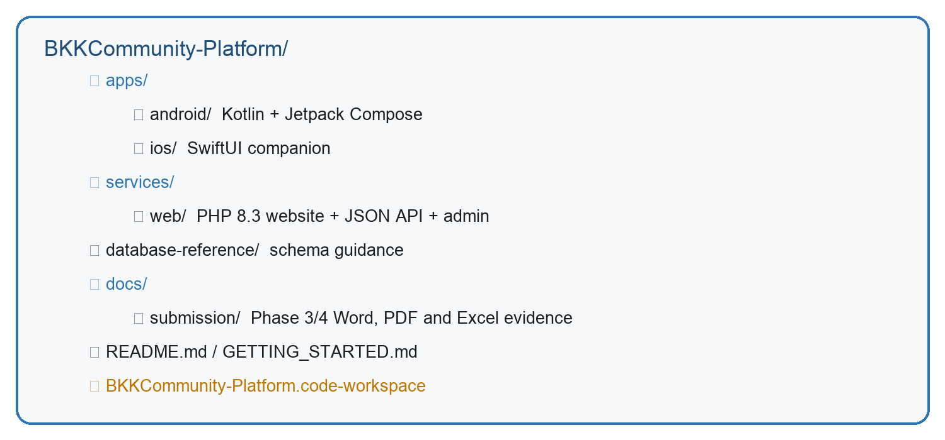
Figure 15. Annotated repository structure used by Android Studio, Xcode, VS Code and Railway.
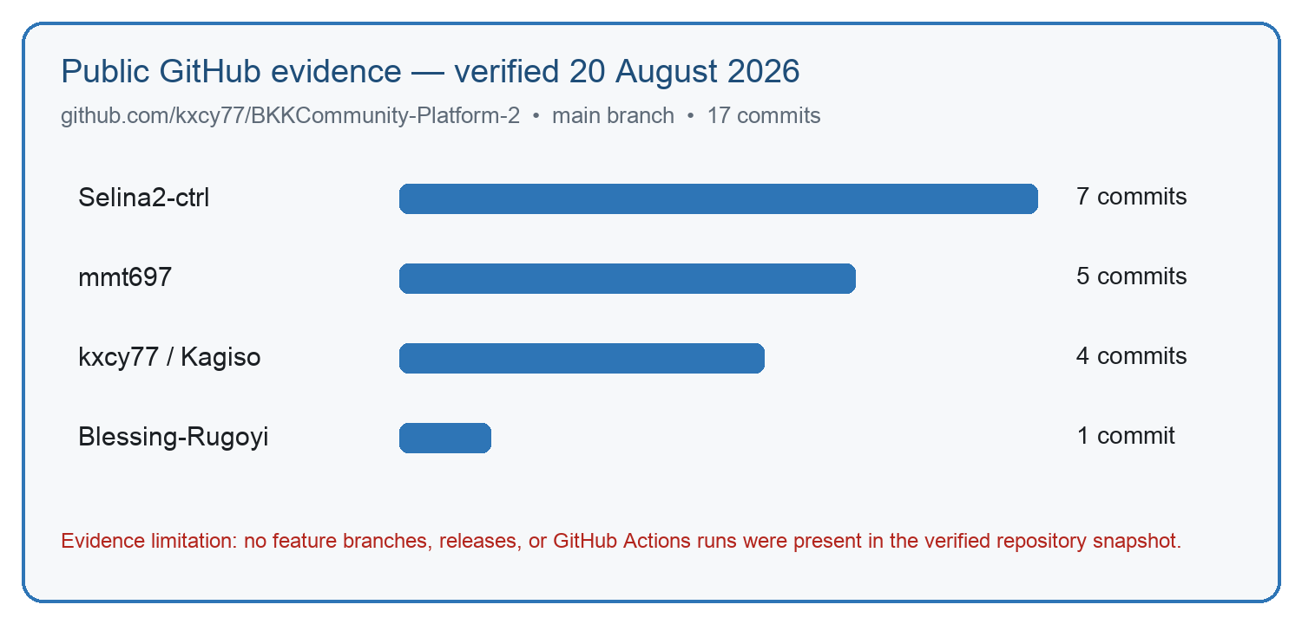
Figure 16. Baseline GitHub contribution snapshot retained as historical evidence. Refresh the screenshot after genuine team contributions are visible.
The verified combined repository is https://github.com/kxcy77/BKKCommunity-Platform. Its main branch contained 9 commits at the 20 August 2026 documentation update; this is a dated snapshot, not a final submission count. The group contribution target is at least 20 meaningful commits per member before final hand-in. Final counts must be refreshed from GitHub and supported by each member's own account, changed files and review evidence. Commits must reflect genuine work; dates, authorship and contribution history must not be invented or backdated. The separate BKKCommunity-Web release currently contains the Android test APK, while the combined repository still requires a final tagged release after release gates pass.

2.6 Security controls
Control | Implemented mechanism | Verification/gap
Password storage | PHP password_hash/password_verify; never plaintext | Code inspected
Session storage | Database stores SHA-256 token hash; raw token returned only to client | Code/schema evidence
Reset security | random_int, HMAC hash, 15-minute expiry, five failures, single use, session revocation | Code inspected; known-account request accepted and active token created; inbox receipt and successful consumption still pending
SQL injection | PDO prepared statements and bound values | Sampled repository/API paths
CSRF | Per-session token in state-changing web forms | Contact/actions code evidence
Authorization | Bearer sessions, database role revalidation, auth_version, admin guards and administrator session limits | Signed-out admin redirect PASS and isolated member-role revocation PASS; public Home/Discounts remain open, so the later website-wide login requirement is still unresolved
Data minimisation | Consent text; contact warns against ID/medical/banking details; soft deletion field | Manual POPIA review recommended
Transport | Public HTTPS custom domain plus CSP, HSTS, nosniff, DENY framing and referrer policy | PASS on live login response after 20 Aug remediation
Rate limiting | api_rate_limits table and sensitive-route checks | Live threshold stress test pending
Secrets | .env.example and ignored local/Firebase files | Run and attach full history secret scan before release

3. Coding Standards

3.1 Naming conventions
Area | Standard | Example
PHP | snake_case functions; descriptive route/action names; strict types | issue_password_reset_code(), api_set_attendance()
Kotlin | PascalCase types/composables; camelCase values/functions; clear state names | BkkViewModel, notificationsEnabled
Swift | PascalCase types/views; camelCase methods/properties | APIClient, MainTabView
SQL | snake_case plural tables; singular descriptive columns; fk_/idx_/uq_ prefixes | password_reset_tokens, uq_attendance_user_event
Tests | Platform-prefix and requirement-focused IDs | FT-019, SC-011, DEF-003

3.2 Formatting and project configuration
PHP files declare strict types, use four-space indentation and separate routing, repository and view concerns. Kotlin uses Gradle version catalogues and Kotlin DSL so dependency versions are centralised. Swift follows Xcode/Swift formatting. SQL migrations are numbered and immutable after deployment. VS Code workspace settings and tasks are included for the web service, while Android Studio opens apps/android and Xcode opens apps/ios.

3.3 Comments and maintainability
Comments explain security or non-obvious design decisions rather than restating code. For example, the password-reset module explains why SMTP transport is verified before account lookup: infrastructure failures must be uniform for known and unknown addresses. README, API, deployment, security, UAT and release-gate documents explain operational behaviour outside source files.

3.4 Git and collaboration standards
- Use small, meaningful commits such as fix(auth): enforce signed-out login gate or test(api): add reset-code expiry coverage.
- Each member commits only work they genuinely performed under their own GitHub account; do not rewrite dates or invent contribution history.
- Create a feature branch for each change, open a pull request and obtain one group review before merging to main.
- Never commit .env, API keys, Gmail/Resend credentials, database passwords, google-services.json or signing keys.
- Before merge: build the affected client, run relevant tests, update the workbook/defect log and attach evidence.
- Tag the combined-repository submission and publish the Android APK as a release asset after release gates pass.

Phase 4 — Software Testing

4. Test Plan
This test plan verifies that the BKK Community Platform is usable, secure and reliable across its responsive website, Android application, iOS companion, shared JSON API, administration area and MySQL database. Testing was iterative rather than a single activity performed immediately before submission. Cycle 1 on 14 August 2026 established the baseline and exposed login-gate, reset-email, security-header and mobile-session defects. Cycle 2 covered implementation correction, platform builds and live API verification. Cycle 3 on 20 August deployed the combined repository, applied administrator migration 007, verified health/readiness and security headers, ran isolated MySQL administrator integration, and restored a protected production backup into a temporary verification database. The final submission regression, authenticated administrator screenshots, outstanding browser/accessibility checks and evidence consolidation are scheduled for 21 August and must be recorded only after execution. Testing is risk-based: authentication, password recovery, attendance accuracy, account deletion, contact, administrator authorization, real-content safety and elderly-user accessibility receive the highest priority. Every result records a date, tester, environment, actual outcome and evidence reference; a code change alone is not a passed retest. PASS means the criterion was observed, FAIL records a reproduced defect, BLOCKED records an unmet dependency, and NOT RUN records an outstanding test. Release still requires reconciliation of the website login policy, all Must requirements, no unresolved critical defects, real reset-email and notification evidence, and six independent BKK participants aged 60+ meeting the UAT thresholds.
Test type | Date/window | Team member(s) | Scope/tool | Pass criterion/evidence
Cycle 1 — baseline | 14 Aug 2026 — executed | Ipeleng Sithole; Kagiso Mmatloa | Gradle/JUnit, Swift tests and elderly-core journey | Established baseline; defects recorded rather than treated as final results
Build/unit regression | 20 Aug — executed; 21 Aug — final check | Ipeleng Sithole; Kagiso Mmatloa | Android, iOS and PHP build/unit checks | Builds pass; zero unit failures; dated logs attached
Live API integration | 20 Aug 2026 — executed | Kagiso Mmatloa | HTTPS auth/content/profile lifecycle | Expected 2xx/4xx; disposable data removed
Database/admin integration | 20 Aug — executed; 21 Aug — authenticated UI evidence | Kagiso Mmatloa; Masase Mukhinindi | MySQL constraints, migration 007, role revocation, content lifecycle, audit and backup restore | Isolated integration and restore pass; live UI screenshots still required
Functional UI regression | 20 Aug — Android/live checks; 21 Aug — final | All members | Web, Android and iOS core journeys | Every Must task passes with dated screenshot/video
Responsive/browser | 21 Aug 2026 — scheduled | Masase Mukhinindi | 375, 768, 1440; Chrome/Safari/Firefox/Edge | No blocked/clipped controls; same functional outcome
Accessibility | 21 Aug 2026 — scheduled | Ipeleng Sithole; Blessing Rugoyi | Keyboard, 200%, TalkBack/VoiceOver | Core tasks independently possible
Performance | 21 Aug 2026 — scheduled | Masase Mukhinindi | Lighthouse/DevTools, Android Profiler, API load | NFR2 budgets; no severe UI stalls
Security regression | 20 Aug — deployed/retested; 21 Aug — final gate review | Kagiso Mmatloa | Auth, authorization, reset, headers, rate limit, admin sessions and secret scan | Headers/admin controls pass; website-wide login decision, reset consumption, rate-limit stress and full secret scan remain
UAT | Before pilot/submission — outstanding | Blessing Rugoyi + six external participants | Ten tasks on real devices | >=80% independent; avg >=4/5; no critical defect
Final evidence review | 21 Aug 2026 — scheduled | Whole group | Defect log, screenshots, workbook, repository and sign-off | Every claim has a dated evidence reference

5. Test Templates
The companion workbook BKK_Test_Suite_GUIDELINE_COMPLIANT_2026-08-20.xlsx is the controlled test record. It contains seven sheets: Overview, 41 Functional Test Cases, Responsive & Browser, Performance Results, Security Checklist, UAT Task Sheet and Defect Log. Status dropdowns and colour coding distinguish PASS, FAIL, BLOCKED and NOT RUN. COUNTIF formulas summarise functional execution. Testers must not overwrite historical evidence; update Actual result, Status, Tester, Date and Evidence after execution, then log every failure in Defect Log.
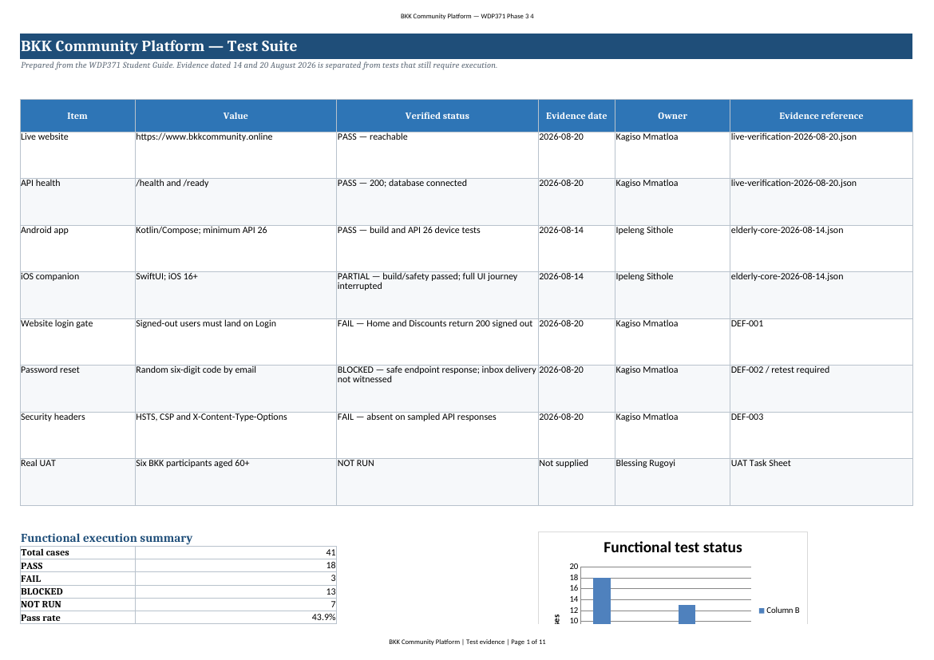
Figure 17. Rendered Excel Overview sheet showing evidence status and formula-driven execution summary.
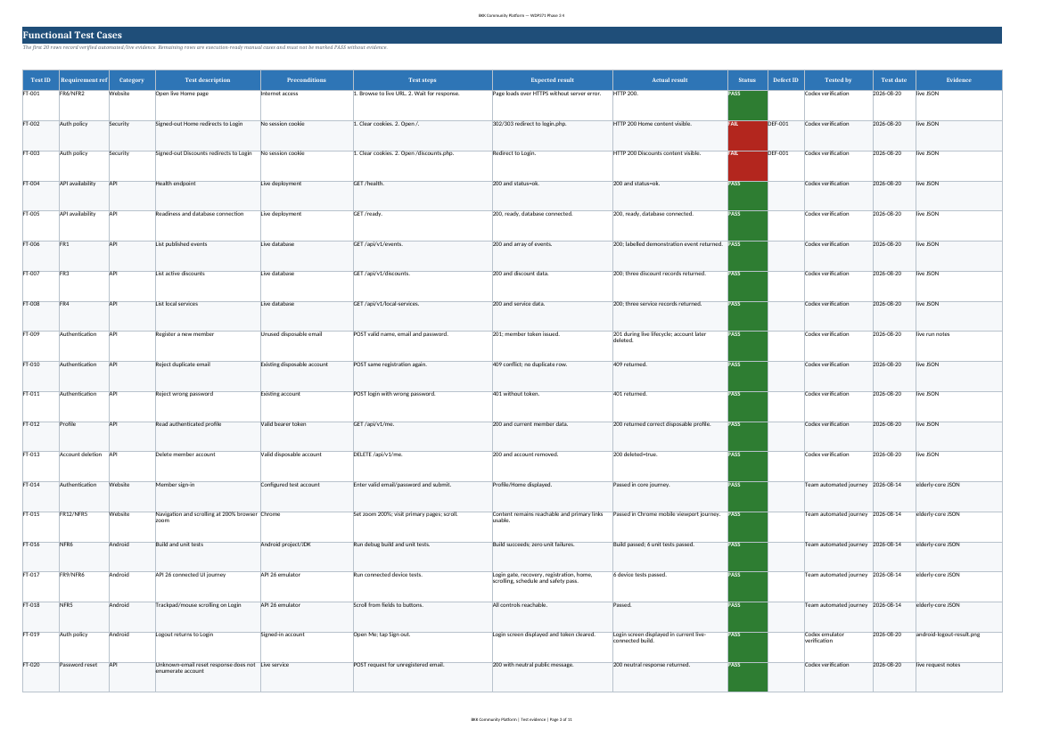
Figure 18. Rendered Functional Test Cases sheet with requirement references, preconditions, steps, expected/actual results and evidence.
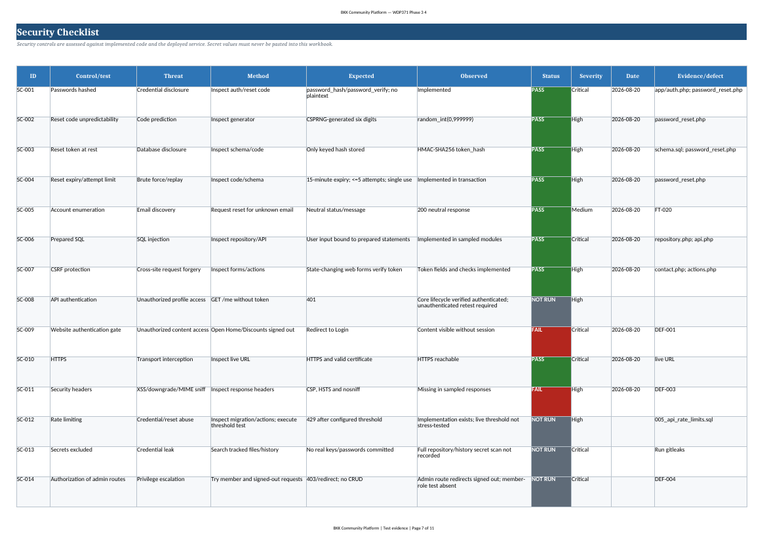
Figure 19. Baseline Security Checklist retained for traceability. Post-deployment header and administrator remediation results are recorded in Appendix E and must be synchronized back to the workbook.
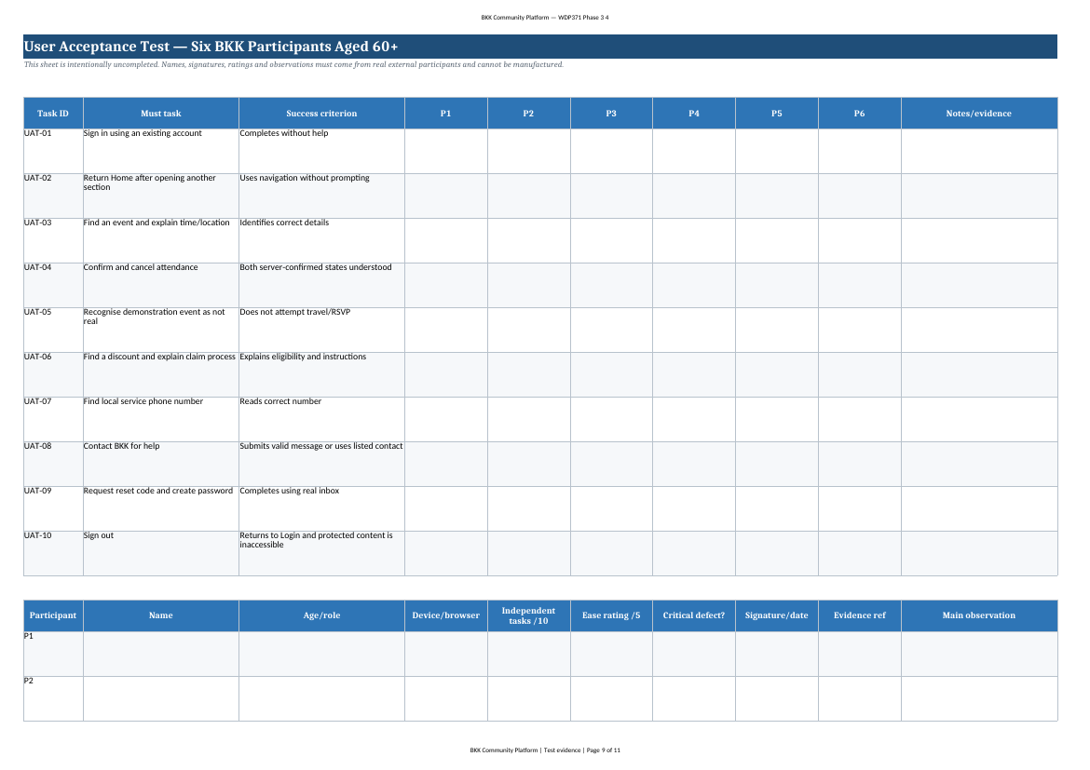
Figure 20. UAT task sheet intentionally blank pending six real participants.
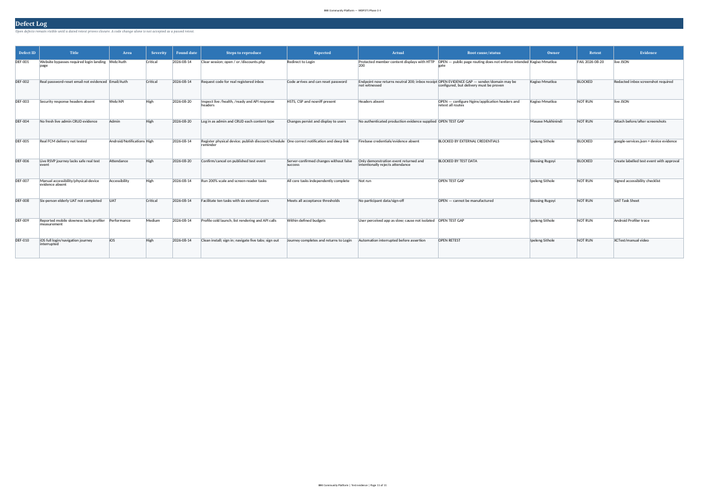
Figure 21. Defect Log linking open issues to owners, retest state and evidence.

6. Test Results — Functionality
Status | Count | Meaning at 20 August 2026
PASS | 19 | Dated evidence meets the criterion, including the post-remediation security-header retest.
FAIL | 2 | Signed-out Home and Discounts remain public under the later login-first requirement.
BLOCKED | 13 | External credentials, test data, devices, UAT or inbox/live-admin evidence required.
NOT RUN | 7 | Execution-ready cases with no current result.
Total | 41 | Complete functional case inventory in the workbook.

6.1 Verified live results
Area | Verified outcome | Evidence
Deployment | Website, /health and /ready returned 200; readiness reported database connected. | 20 Aug live JSON
Content API | Events, discounts and local-services endpoints returned current JSON records. | 20 Aug live JSON
Authentication lifecycle | Disposable registration 201, duplicate 409, wrong password 401, profile 200 and account deletion 200. | 20 Aug run; account cleaned up
Android | Current live-connected screens captured; logout returned to Login; prior API 26 journey and six unit tests passed. | Android figures + 14 Aug JSON
iOS | Build and two safety tests passed; fresh signed-out launch passed. | 14 Aug JSON
Password reset | Unknown email remains account-neutral. A known-account request was accepted and an active hashed token was created; mailbox receipt and code consumption remain unproven. | 20 Aug live request/database verification; DEF-002 remains open
Administrator security | Migration 007 applied; one active administrator provisioned through the protected audited command; signed-out routes redirect; role revocation and stale-write rejection pass in isolated MySQL. | 20 Aug admin audit and isolated integration evidence
Security headers | CSP, HSTS, nosniff, DENY framing and strict referrer policy returned by the live login page. | 20 Aug post-deployment HTTP verification; DEF-003 closed
Backup/restore | Compressed production backup passed integrity testing and restored successfully into a temporary isolated MySQL database containing 15 tables and migration 007; temporary database removed. | 20 Aug protected operational evidence; checksum recorded outside public source

6.2 Open defects and root-cause response
Defect | Severity/root cause | Required correction and proof
DEF-001 Web login gate | Critical — public member routes do not enforce the intended session-first policy. | Add centralized route guard; verify signed-out 302/303 for every protected page; verify back-button/session expiry.
DEF-002 Reset inbox evidence | Critical evidence gap — safe endpoint response does not prove provider delivery. | Use a real registered inbox; capture redacted email; consume code; confirm new password and session revocation.
DEF-003 Security headers | High — originally absent; remediated in Nginx/application deployment. | CLOSED 20 Aug — live login returns CSP, HSTS, nosniff, DENY framing and referrer policy. Synchronize workbook result and attach redacted header evidence.
DEF-004 Admin CRUD evidence | High test gap — implementation, migration, admin provisioning and isolated integration now pass. | Remain OPEN only for authenticated production screenshots of event, discount, service, message and audit journeys. Do not create unlabelled real content.
DEF-005 Notifications | High — real Firebase credentials and device evidence absent. | Configure project outside Git; test token refresh, denial, reminder cancellation and deep links.
DEF-007/008 Accessibility and UAT | High/Critical human-evidence gaps. | Complete signed physical-device checks and six-person UAT; do not self-test as participants.
DEF-009 Performance | Medium — reported slowness has no profiler trace. | Measure cold launch, recomposition/list rendering and API timing before optimizing.

6.3 Results not claimed
- No Lighthouse score is reported because the public PageSpeed attempt was rate-limited and no local report was captured.
- No Safari, Firefox or Edge pass is reported without dated screenshots/results.
- No real FCM delivery, deep-link or notification-permission result is reported.
- No live admin CRUD pass is reported without an authenticated production evidence set.
- No real reset email success is reported until the inbox and code-consumption flow are evidenced.

7. Test Results — User Acceptance
UAT status: NOT RUN
The Student Guide requires actual users and documented results. No six-person BKK elderly-user evidence was supplied. Names, ratings, signatures, photos or quotations cannot be generated by the development team or by AI.

Recruit at least six independent BKK participants aged 60 or older. Use a physical Android phone and iPhone where possible and the website with mouse/trackpad plus keyboard-only navigation. Give each participant a test account and clearly labelled safe test content. Ask the participant to think aloud but do not point at controls. Record independent/helped/failed for all ten tasks, exact confusion, ease rating, device, date and evidence permission. Repeat Login, Events, Discounts and Contact at 200% text scaling; repeat core tasks with TalkBack or VoiceOver.
Participant | Device | Independent /10 | Critical defect | Ease /5 | Evidence/sign-off
P1 | NOT SUPPLIED | NOT RUN | NOT ASSESSED | NOT RATED | REQUIRED
P2 | NOT SUPPLIED | NOT RUN | NOT ASSESSED | NOT RATED | REQUIRED
P3 | NOT SUPPLIED | NOT RUN | NOT ASSESSED | NOT RATED | REQUIRED
P4 | NOT SUPPLIED | NOT RUN | NOT ASSESSED | NOT RATED | REQUIRED
P5 | NOT SUPPLIED | NOT RUN | NOT ASSESSED | NOT RATED | REQUIRED
P6 | NOT SUPPLIED | NOT RUN | NOT ASSESSED | NOT RATED | REQUIRED

UAT release rule | Threshold
Must tasks | All pass without a critical defect
Independent completion | At least 80% across all tasks/participants
Ease rating | Average at least 4/5
Safety | No participant treats demonstration data as real
Accessibility | 200% and screen-reader/keyboard tasks completed
Approval | Client/stakeholder sign-off and evidence attached

8. Development, Staging and Production Environments
Environment | Purpose and tools | Configuration/data | Current evidence/gap
Development | VS Code for web/API; Android Studio for Android; Xcode for iOS; local tests and emulators. | Local/example environment values; test-labelled content; no production secrets in Git. | Build/unit/device evidence exists. Repository includes .code-workspace and setup guides.
Staging | Safe pre-production regression/UAT environment expected by the guide. | Separate database, email sandbox, Firebase test project and non-production domain. | NOT DEPLOYED. Current work moved between local and production; this is a release-process risk.
Production | Railway Nginx/PHP-FPM and managed MySQL behind https://www.bkkcommunity.online; shared /api/v1 for clients. | Environment secrets; demo mode disabled; migration 007; 30-minute/8-hour admin limits; 365-day configured contact retention; seeded records still include demonstration/unverified content. | Health/readiness, database, headers, admin migration/account and backup restore verified 20 Aug. Website-wide login policy, authenticated CRUD screenshots, reset consumption, notifications and UAT remain pending.

Required promotion path: feature branch → automated/local verification → pull request review → staging deployment and migration → staging regression/security/accessibility/UAT → client approval → production deployment → smoke test → evidence update. A staging environment should be created before the pilot; using production as a test environment risks member data and makes rollback evidence weak.

9. Client and Stakeholder Feedback
Source/date | Feedback | Action/status | Evidence
BKK client requirements — Phase 1/2 | Simple uncluttered navigation, large readable text, events, discounts, local information and contact support. | Four core actions, larger controls and five-tab mobile navigation implemented. | Original requirements/design documentation
Blessing Rugoyi — 14 Aug 2026 | Concern that many features may make the platform difficult for elderly users to navigate. | Core-task emphasis, larger controls and formal elderly UAT plan added; real UAT remains outstanding. | Internal group feedback message
Project review — 14 Aug 2026 | Login/Register contrast was poor; interface felt basic/bland; app felt slow. | Login design/contrast revised and performance cases added. Profiler measurements still required. | Design screenshot and DEF-009
Project review — 14–20 Aug 2026 | Logout did not return to Login. | Android session/navigation corrected; current emulator retest shows Login after sign-out. | Figure 12 / FT-019
Project review — Aug 2026 | Forgot password did not deliver email. | Random-code hardening, Resend/custom-domain delivery, neutral responses and active-token creation implemented. A known-account request is now accepted; mailbox receipt and successful reset must still be evidenced. | Code inspection + 20 Aug live request / DEF-002
Final client acceptance | No dated final client approval supplied. | Schedule review after critical defects and UAT are complete; attach signed/email acceptance. | REQUIRED — do not fabricate
Administrator security review — 20 Aug 2026 | Production administrator workflows lacked full lifecycle, session revalidation and audit evidence. | Implemented role/auth_version revalidation, timeouts, create-edit-archive-restore, row_version locking, audit history, contact-message tools and protected administrator provisioning; deployed migration 007. | docs/ADMIN_AUDIT_2026-08-20.md + post-deployment verification

References
- Android Developers (2026) Jetpack Compose documentation. Available at: https://developer.android.com/compose (Accessed: 20 August 2026).
- Android Developers (2026) Room and WorkManager documentation. Available at: https://developer.android.com/jetpack (Accessed: 20 August 2026).
- Apple Developer (2026) SwiftUI and URLSession documentation. Available at: https://developer.apple.com/documentation/ (Accessed: 20 August 2026).
- Firebase (2026) Firebase Cloud Messaging documentation. Available at: https://firebase.google.com/docs/cloud-messaging (Accessed: 20 August 2026).
- Microsoft (2026) Visual Studio Code documentation. Available at: https://code.visualstudio.com/docs (Accessed: 20 August 2026).
- OWASP Foundation (2025) OWASP Top 10. Available at: https://owasp.org/www-project-top-ten/ (Accessed: 20 August 2026).
- PHP Documentation Group (2026) Password hashing and random_int. Available at: https://www.php.net/manual/ (Accessed: 20 August 2026).
- Republic of South Africa (2013) Protection of Personal Information Act 4 of 2013.
- W3C (2023) Web Content Accessibility Guidelines (WCAG) 2.2. Available at: https://www.w3.org/TR/WCAG22/ (Accessed: 20 August 2026).
- WDP371 (2026) SS2 Student Guide v2. Unpublished module guide supplied with the assignment.

Appendix A — Requirements Traceability Matrix
ID | Requirement | Implementation | Tests | Status
FR1 | View events | Web/Android/iOS Events; GET /events | FT-006, 027 | Partial
FR2 | RSVP/cancel | attendance table and API/UI | FT-023–026 | Blocked live UI
FR3 | Discounts | Discount list/detail/categories | FT-007, 028 | API pass/manual pending
FR4 | Local info | Services list/detail | FT-008, 029 | API pass/device pending
FR5 | Contact | Web/app form and messages | FT-030–031 | Manual evidence pending
FR6 | Home | Dashboard/core actions | FT-001, 015 | Pass; auth gate fail
FR7 | 24-hour reminders | WorkManager/notification model | FT-035 | Blocked FCM/device
FR8 | Discount alerts | FCM/device/log model | FT-036 | Blocked FCM/device
FR9 | Mobile events/reminders | Android/iOS clients | FT-016–019, 035 | Partial
FR10 | Admin event CRUD | admin/events.php + admin_actions.php + archive/restore + audit | FT-032 + isolated integration | Implemented/deployed; authenticated production screenshots pending
FR11 | Admin discount CRUD | admin/discounts.php + admin_actions.php + archive/restore + audit | FT-033 + isolated integration | Implemented/deployed; authenticated production screenshots pending
FR12 | Responsive | CSS layouts | RB-001–007 | Partial
FR13 | Directions | Service/event directions actions | FT-029 | Physical-device pending
FR14 | Filters | Event/discount/service filters | FT-027–029 | Manual evidence pending
FR15 | Contact validation | Client/server validation | FT-031 | Manual evidence pending
NFR1 | Accessibility | Large controls, scalable UI | FT-038–039 | Human evidence blocked
NFR2 | Performance | Defined load budgets | PF-003–007 | Measurement pending
NFR3 | HTTPS/security headers | Custom HTTPS domain, CSP, HSTS, nosniff, DENY framing, referrer policy | SC-010–011 / FT-040 | PASS after 20 Aug remediation
NFR4 | POPIA/minimal data | Consent, minimisation, deletion | SC-015 | Partial review
NFR5 | Navigation simplicity | Four actions/five tabs | FT-015/UAT | Automated pass/UAT pending
NFR6 | Android API 26+ | minSdk 26 | FT-016–018 | Pass
NFR7 | Availability target | Health/readiness | PF-001–002 | Point-in-time pass only
NFR8 | Maintainability | README/docs/workspace | Section 3 | Partial; CI absent

Appendix B — Evidence Register
Evidence | Location | What it proves
Live verification JSON | docs/submission/evidence/live-verification-2026-08-20.json | Dated HTTP/API/auth/account-deletion results and header/login-gate findings.
Core journey JSON | docs/test-reports/elderly-core-2026-08-14.json | Android API 26, iOS build, web journey and original defects.
Android screenshots | docs/submission/evidence/document-images/android-*.png | Current live-connected screens and logout result.
Existing web screenshots | docs/assets and evidence/document-images | Implemented Home and Events layouts.
Excel workbook | docs/submission/BKK_Test_Suite_GUIDELINE_COMPLIANT_2026-08-20.xlsx | Formal templates, cases, results, UAT and defects.
Public repository | github.com/kxcy77/BKKCommunity-Platform | Combined source is public; verified snapshot had 9 commits. Final >=20 meaningful commits/member target requires refreshed GitHub evidence.
Required but absent | UAT signatures; consumed real reset email; FCM; full browser/responsive; authenticated live admin CRUD screenshots; Lighthouse/profiler; final client sign-off | These must be collected, not manufactured.
Administrator remediation audit | docs/ADMIN_AUDIT_2026-08-20.md | Source remediation, isolated MySQL integration, live deployment/header verification, migration 007 and remaining manual evidence gaps.
Protected backup/restore verification | Private backup location; SHA-256 recorded in protected handover, not GitHub | Backup integrity, restoration of 15 tables and migration 007, followed by temporary database removal.

Appendix C — Final Submission Checklist
Checklist item | Current status
Student numbers entered on cover | NO — required from group
TOC updated in Word/LibreOffice | UPDATE FIELD BEFORE EXPORT
Public repository opens signed out | YES — https://github.com/kxcy77/BKKCommunity-Platform; refresh final contribution screenshot/counts
Live website opens | Verified 20 Aug
Combined-repo tagged release and APK | NO — APK is in separate repository release
Web login gate fixed/retested | NO — critical DEF-001
Real reset email consumed | NO — DEF-002
Security headers pass | YES — CSP, HSTS, nosniff, DENY framing and referrer policy verified after deployment
Live admin CRUD evidence | PARTIAL — account/migration/route protection and isolated lifecycle tests pass; authenticated screenshots still required
375/768/1440 screenshots | INCOMPLETE
Chrome/Safari/Firefox/Edge results | INCOMPLETE
Lighthouse and profiler evidence | NO
TalkBack/VoiceOver/200% evidence | NO
Six-person external UAT | NO
Final client approval | NO
Original source documents preserved | YES — outputs are separate files
Administrator migration/account/audit verified | YES — migration 007, active audited admin grant and protected routes verified 20 Aug
Minimum 20 meaningful commits per member | TARGET — refresh GitHub Insights and contribution table only after genuine commits exist

Appendix D — Glossary
Term | Meaning
API | Application Programming Interface used by web/mobile clients to exchange JSON with the server.
APK | Installable Android application package.
CRUD | Create, read, update and delete administration operations.
CSRF | Attack where another site causes an authenticated browser to submit an unwanted action.
FCM | Firebase Cloud Messaging for Android notifications.
HMAC | Keyed message authentication code used to hash reset codes.
NFR | Non-functional requirement such as performance, accessibility or security.
POPIA | South African Protection of Personal Information Act.
RSVP | Member confirmation or cancellation of event attendance.
UAT | User Acceptance Testing performed by representative external users.
WCAG | Web Content Accessibility Guidelines.
Audit log | Append-only administrator record showing who performed a privileged action, what changed, why and when.
Optimistic locking | row_version check that rejects a stale edit instead of silently overwriting a newer administrator change.
auth_version | Account security counter used to invalidate older sessions after a password or administrator-role change.

Appendix E — Production Remediation and Contribution Update
This appendix records verified changes completed after the baseline screenshots and test workbook were produced. It supplements rather than replaces the original Phase 3/4 content so the development history, failed baseline results and remediation evidence remain traceable.

E.1 Verified deployment and security changes
Area | Verified change | Evidence | Current status
Combined deployment | Railway web service now uses kxcy77/BKKCommunity-Platform with the root deployment wrapper. | Railway status + live domain | PASS
Readiness | /health and /ready returned 200; readiness reported database connected. | 20 Aug live HTTP checks | PASS
Database migration | 007_admin_security_and_audit.sql is recorded in production schema_migrations. | Production MySQL query | PASS
Administrator account | One existing member account was granted admin through the protected CLI; auth_version increased and the action was audited. | Role/audit aggregate check; email omitted | PASS
Route protection | Signed-out dashboard, events, discounts, services, messages and audit routes redirect to Login. | 20 Aug route matrix | PASS
Headers | CSP, HSTS, nosniff, DENY framing and strict referrer policy are active. | Live login headers | PASS
Backup | Production backup passed gzip/checksum validation and restored into a temporary isolated database containing 15 tables and migration 007. | Protected operational record | PASS
Reset request | Known-account request was accepted and an active hashed reset token was created. | Live request/database state | PARTIAL — inbox consumption pending

E.2 Administrator security and content lifecycle
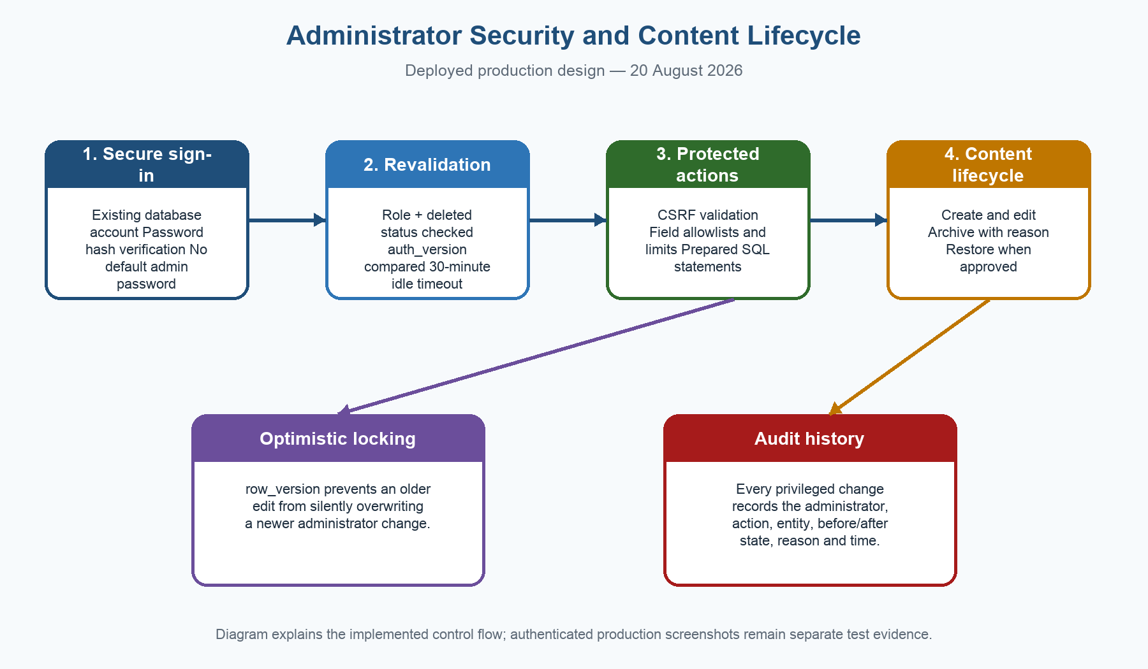
Figure 22. Deployed administrator authentication, revalidation, protected action, lifecycle, conflict and audit flow.
- Administrator credentials are not embedded in source code or documentation.
- An existing account is promoted through a protected CLI command; the action increments auth_version and is written to the audit log.
- Every protected administrator request rechecks the database role and deleted status and enforces idle and absolute time limits.
- Events, discounts and local services support create, edit, archive and restore; archive reasons and changes are auditable.
- row_version rejects stale concurrent updates so one administrator cannot silently overwrite another administrator's newer edit.

E.3 Database migration update
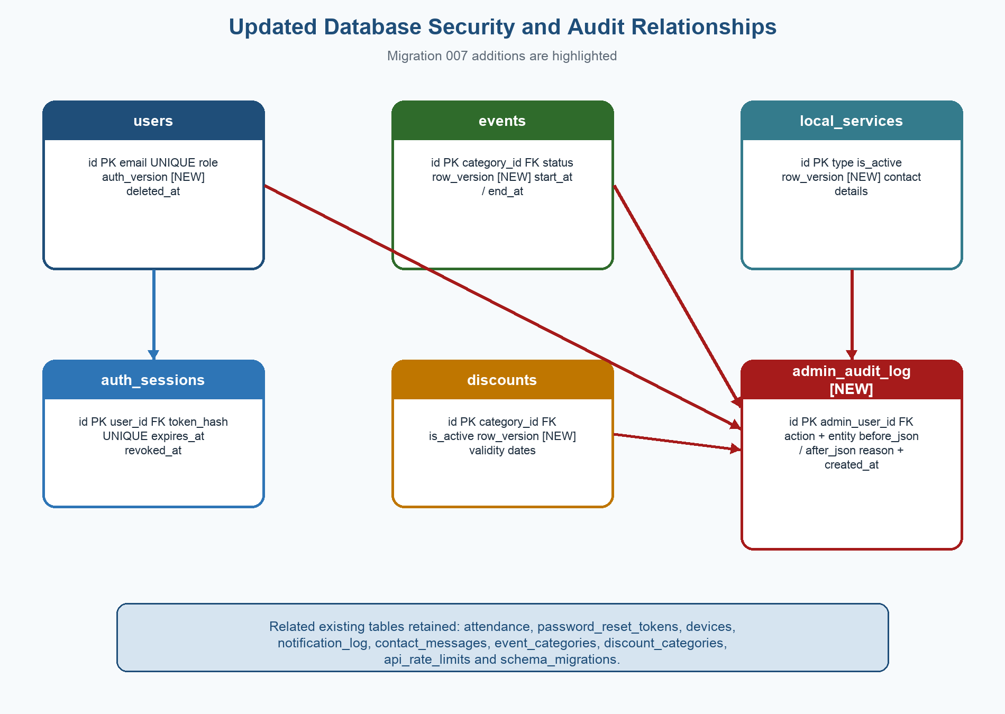
Figure 23. Migration 007 security and audit additions to the existing database model.
Figure 14 remains in the document as the baseline ERD. Figure 23 documents the deployed additions without deleting the original design evidence. The complete data dictionary in Section 2.3 now includes auth_version, row_version and admin_audit_log.

E.4 Test-status corrections after remediation
Record | Baseline | Updated truthful result | Required evidence remaining
FT-040 / SC-011 / DEF-003 | Security headers failed | PASS / CLOSED after live retest | Synchronize workbook and attach redacted header capture
FT-032–034 / DEF-004 | Admin evidence blocked | Implementation, migration, provisioning and isolated integration pass | Authenticated production screenshots for each workflow
DEF-002 | Reset email blocked | Request accepted and active token created | Redacted inbox email, successful reset and rejected code reuse
DEF-001 | Website-wide login gate failed | Still open: Home and Discounts remain public | Choose guest-browsing policy or implement protected routes
DEF-007/008 | Accessibility/UAT absent | Still NOT RUN | Real physical-device evidence and six elderly participants

E.5 Team contribution target and verification
The group has set a target of at least 20 meaningful commits per member. This is a target, not a completed-result claim. Before submission, GitHub Insights and the commit history must show the genuine work under each member's own account. Small copy-and-paste-only or artificial commits should not be used to inflate counts; each commit should represent a reviewable documentation, testing, design, accessibility or code improvement.
Team member | Target | Current statement | Final evidence required
Kagiso Mmatloa | >=20 meaningful commits | Pending final GitHub verification — not asserted as achieved | Own GitHub account, commit list, changed files and refreshed contribution screenshot
Ipeleng Sithole | >=20 meaningful commits | Pending final GitHub verification — not asserted as achieved | Own GitHub account, commit list, changed files and refreshed contribution screenshot
Blessing Rugoyi | >=20 meaningful commits | Pending final GitHub verification — not asserted as achieved | Own GitHub account, commit list, changed files and refreshed contribution screenshot
Masase Mukhinindi | >=20 meaningful commits | Pending final GitHub verification — not asserted as achieved | Own GitHub account, commit list, changed files and refreshed contribution screenshot

E.6 Remaining release evidence
- Reconcile the newer login-first requirement with the earlier guest-browsing design; signed-out Home and Discounts currently remain public.
- Complete the real inbox reset journey and prove that the consumed code cannot be reused.
- Capture authenticated administrator Dashboard, Events, Discounts, Services, Messages and Audit History screenshots using clearly labelled safe test content.
- Run responsive/browser checks at 375, 768 and 1440 pixels in Chrome, Safari, Firefox and Edge.
- Capture Lighthouse/load-testing and Android Profiler evidence instead of relying on perceived speed.
- Complete TalkBack, VoiceOver, keyboard-only and 200% text-scale checks on physical devices.
- Complete real FCM notification, denial, token-refresh, cancellation and deep-link evidence.
- Conduct UAT with six independent elderly BKK participants and obtain final client/stakeholder sign-off.
- Refresh the repository commit counts and contribution visual only after each member's genuine work is present.
Evidence integrity statement: Figures 22 and 23 are explanatory diagrams, not screenshots of executed tests. PASS status is used only for observations that were verified through the deployed service, the production schema, isolated integration tests or protected backup restoration.

