BKK COMMUNITY GROUP
Digital Platform for Elderly Community Members
Phase 3 – Software Development
Phase 4 – Software Testing
Updated implementation and test evidence • 19 August 2026

Item | Details
Group | Ctrl Freaks
Members | Kagiso Mmatloa; Ipeleng Sithole; Blessing Rugoyi; Masase Mukhinindi
Client organisation | BKK Community Group (NPO)
Project status | Implemented development handover; remaining operational/UAT evidence is explicitly marked pending
Canonical live system | https://www.bkkcommunity.online • PHP/MySQL API at /api/v1
Source repository | BKKCommunity-Platform monorepo: Android, iOS, web/API, documentation and test artefacts

Document-control note: This document replaces outdated development/testing claims in the previous Phase 3/4 draft. It records the system that is implemented today and distinguishes verified tests from planned or outstanding evidence.

PHASE 3 – SOFTWARE DEVELOPMENT

1. User documentation

1.1 System access
The BKK Community platform is available as a responsive website, Android application and iOS application. The website is available at https://www.bkkcommunity.online. The Android and iOS applications use the same secure HTTPS API, so events, discounts, services, member accounts and attendance are managed consistently across the platform.
Channel | How users access it | Current access rule
Website | Modern Chrome, Firefox, Edge or Safari browser | Visitors may browse public information; account features require sign-in.
Android app | Android Studio build or shared debug APK; Android 8.0/API 26+ | Sign-in is required before entering the member platform.
iOS app | Xcode simulator/connected iPhone | Sign-in is required before entering the member platform; distribution to friends requires TestFlight or web-app testing.
Staff administration | Website admin area | Restricted to authenticated accounts with the admin role.

1.2 Registration, sign-in and password reset
Registration asks for a full name, email address, optional phone number and password. After successful registration or sign-in, a member receives an authenticated session. Website sessions use secure server-side cookies; mobile sessions use bearer tokens stored securely on the device.
Forgotten passwords use an email-bound six-digit code—not a reset link. The server generates the code using cryptographically secure random generation, sends it through the configured email provider, gives it a 15-minute expiry, invalidates it after five incorrect guesses and revokes existing sessions after a successful reset.

1.3 Navigation and elderly-user design
The website uses five primary public destinations: Home, Events, Discounts, Local Info and Contact. The mobile apps use clearly labelled destinations for Home, Events, Deals/Discounts, Information/Services and Account. Large controls, readable text, visible labels, high-contrast BKK colours and a limited navigation structure reduce cognitive load for elderly users.

1.4 Implemented user tasks
Task | Member journey | System rule
Browse information | Open events, discounts or local services; use category/type filters and view details. | Public information is readable without a website account; mobile content is cached after retrieval.
RSVP to an event | Sign in, open event details, choose Attend or Cancel. | The API confirms the database write before success is shown. One attendance record is enforced per member/event.
Find a discount | Open Discounts, select a category, read eligibility and claim instructions. | Staff publish verified records through the admin dashboard; data is not automatically scraped from businesses.
Contact BKK | Complete name, email and message; submit. | Server validates and rate-limits the request before storing it for admin review.
Manage account | Update profile/preferences, view history, or delete account. | Protected API routes require a valid member session.

1.5 Product visuals
The following captured screens show the implemented responsive web application. Demonstration content remains clearly labelled until BKK approves authentic public information.
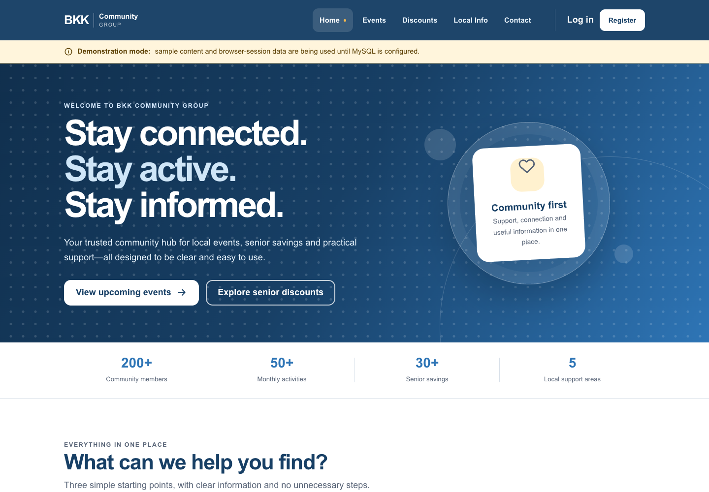
Figure 1: BKK Community website home page on desktop.
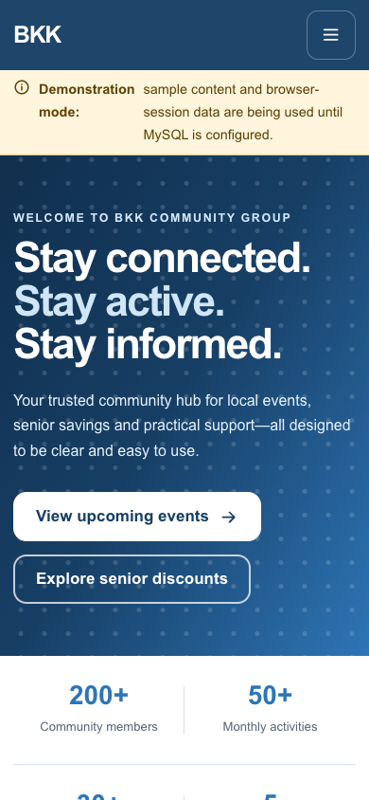
Figure 2: BKK Community website home page on mobile.
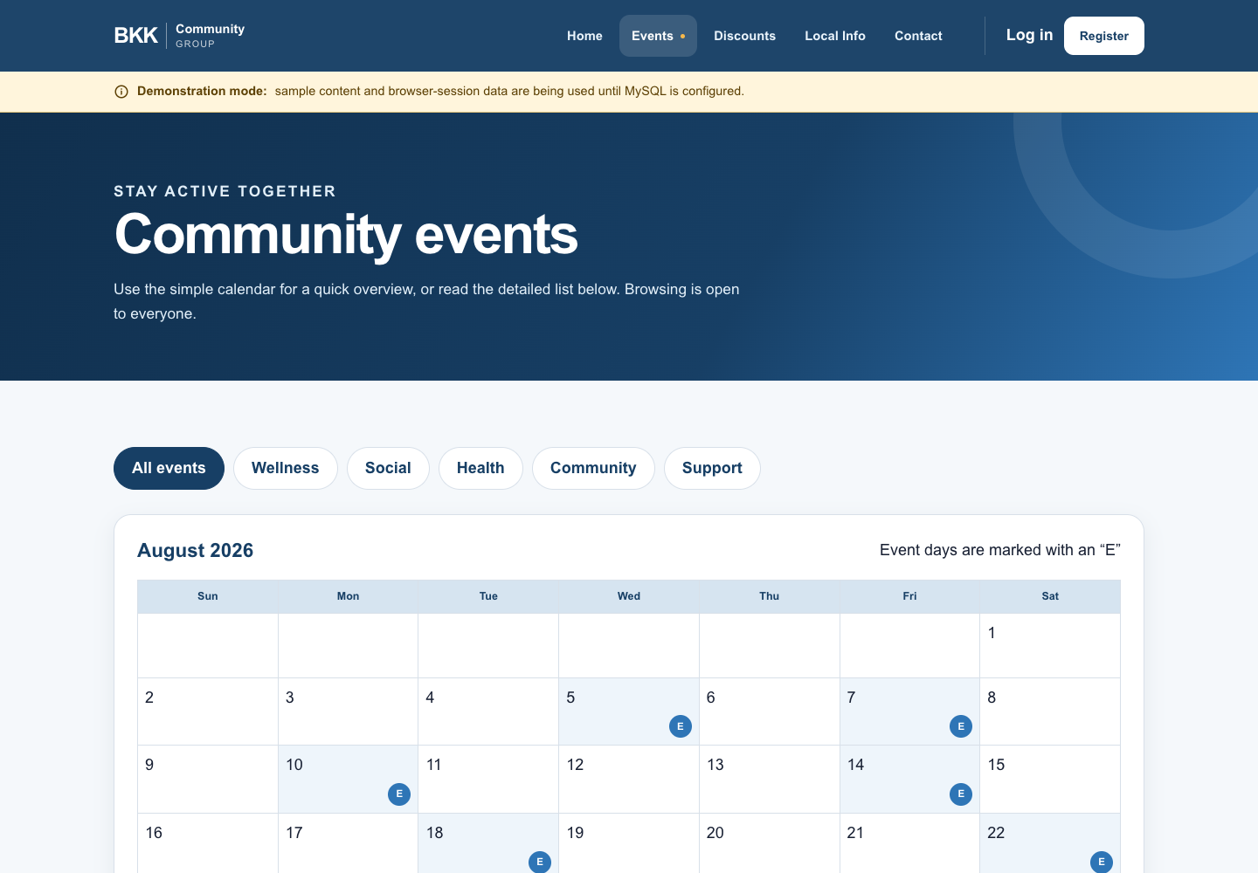
Figure 3: Events page with accessible cards and filters.

2. Technical documentation

2.1 Architecture
The platform uses a three-tier design. The presentation tier is the responsive PHP website, Android Jetpack Compose app, iOS SwiftUI app and protected website administration dashboard. The application tier is the canonical PHP 8.3 API at /api/v1. The data tier is MySQL 8. The mobile applications never connect directly to MySQL; all writes pass through the API over HTTPS.
Tier | Implemented component | Purpose
Presentation | PHP/Bootstrap website; Kotlin/Compose Android; SwiftUI iOS | Displays accessible screens and collects user actions.
Application | PHP 8.3, Nginx/PHP-FPM, versioned JSON API | Validates requests, enforces permissions, manages sessions, reset codes and admin actions.
Data | MySQL 8 | Stores users, hashed sessions, reset-code hashes, events, attendance, discounts, services, messages and device registrations.
External services | Railway; Resend/SMTP; optional Firebase/Apple push providers | Hosting and email are configured externally; real push delivery remains a release gate.

2.2 Technology stack
Technology | Area | Use in the implemented platform
PHP 8.3+ / Composer | Backend + website | Server-rendered website, REST API, authentication, validation and mail integration.
MySQL 8 | Database | Persistent relational storage with unique emails and one RSVP per user/event.
Bootstrap 5 + custom CSS | Web frontend | Responsive BKK design system, layout and accessibility styling.
Kotlin + Jetpack Compose | Android | Native Android interface; Material 3; ViewModel/StateFlow.
Retrofit/OkHttp, Room, DataStore, WorkManager | Android | HTTPS API calls, offline readable cache, secure app preferences and local reminders.
Swift + SwiftUI + URLSession | iOS | Native iPhone interface and API client; Keychain stores session token.
Railway + Docker/Nginx/PHP-FPM | Hosting | HTTPS web/API deployment and managed MySQL connectivity.
Visual Studio Code, Android Studio, Xcode | Development tools | Shared editing/workflow, Android testing/build, and iOS build/testing.

2.3 Database and API design
The canonical schema contains users, auth_sessions, password_reset_tokens, event_categories, events, attendance, discount_categories, discounts, local_services, contact_messages, devices, notification_log and api_rate_limits. Unique constraints prevent duplicate emails, device tokens and attendance records. Passwords are never stored in plain text; mobile session and reset tokens are stored only as hashes.
API area | Examples | Access
Authentication | POST /auth/register, /auth/login, /auth/forgot-password, /auth/reset-password | Public with validation and rate limits.
Member profile | GET/PATCH/DELETE /me; GET /me/attendance | Authenticated member.
Public content | GET /events, /discounts, /local-services | Public; optional filters.
Attendance | PUT /events/{id}/attendance | Authenticated member; online confirmation required.
Contact | POST /contact | Public/member; validation and rate limits.
Device registration | PUT /devices/fcm-token | Authenticated member; provider delivery is not simulated.

2.4 Security and privacy controls
Control | Implementation
Transport security | Release clients use HTTPS; Android cleartext traffic is disabled.
Passwords and sessions | PHP password hashing; web HttpOnly/SameSite cookies; mobile bearer tokens stored encrypted/Keychain and hashed on the server.
Input/data protection | Server-side validation, prepared SQL queries, HTML encoding, CSRF protection for browser mutations and request body limits.
Abuse protection | Database-backed IP/account limits for login, registration, password reset and contact routes.
Truthful offline behaviour | Cached public content may be read offline; RSVP, profile, reset and contact writes do not report success until the API confirms the database operation.
Secrets | Database credentials, mail keys, Firebase files and signing keys remain outside Git.

2.5 Source-code structure
Folder | Contents | Open with
apps/android | Android Studio project and Kotlin/Compose source | Android Studio
apps/ios | Xcode project and SwiftUI source | Xcode
services/web | Canonical PHP website, API, MySQL migrations and admin dashboard | Visual Studio Code + PHP/MySQL
docs | Project, test, security, release and presentation evidence | Any Markdown/Office viewer
reference | Experimental Node/admin prototypes; not production | Reference only

PHASE 4 – SOFTWARE TESTING

4. Test plan
Testing is planned and recorded throughout development rather than saved for the final week. The plan below follows the required format: test type, test date, responsible team members, purpose, tools/evidence and current state. “Planned” means the test has not yet produced acceptable evidence; it is not reported as passed.
Test type | Test date | Team members | Scope / purpose | Tools / evidence | Current status
Static code and syntax checks | 18–19 Aug 2026 | Kagiso Mmatloa; Ipeleng Sithole | Detect broken PHP source before integration. | PHP linter; VS Code task. | Passed for current canonical web source.
Android unit/lint/build | 14 Aug 2026; repeat after each Android change | Blessing Rugoyi; Masase Mukhinindi | Validate business rules and create debug APK. | Gradle: testDebugUnitTest, lintDebug, assembleDebug. | Passed in recorded build; repeat on group machines.
API + database integration | 13–19 Aug 2026 | Kagiso Mmatloa; Blessing Rugoyi | Auth lifecycle, reset security logic, attendance and admin CRUD. | PHP integration scripts; MySQL; health/ready checks. | Core checks recorded; fresh empty-db rehearsal still planned.
Responsive/system test | 13–19 Aug 2026 | Full team | Website navigation, filters, forms, error states and mobile layout. | Browser walkthrough; 1440px/390px/320px captures. | Core browser checks recorded; repeat after changes.
Security test | 13–19 Aug 2026 | Kagiso Mmatloa; Ipeleng Sithole | Access control, session revocation, limits, secret scan and safe failure. | Source review; audit notes; API tests. | Core internal checks recorded; independent review planned.
Accessibility test | Before pilot release | Ipeleng Sithole; Masase Mukhinindi | TalkBack/VoiceOver, 200% text, contrast, focus and target sizes. | Physical devices; screen reader; contrast checker. | Planned—manual evidence outstanding.
Password-reset delivery test | Before pilot release | Blessing Rugoyi; Kagiso Mmatloa | Confirm real six-digit code reaches registered inbox, expiry/retry works. | Verified sender + real mailbox. | Planned—provider evidence required.
User acceptance test | Before client sign-off | Full team + six elderly BKK participants | Measure independent task completion and usability feedback. | UAT workbook, observation and consented feedback. | Planned—must not be reported as complete yet.

5. Test templates
The team maintains a separate Microsoft Excel workbook named BKK_Test_Templates_UPDATED_2026-08-19.xlsx. It contains: (1) Functional Test Log, (2) UAT Log, (3) Defect Tracker, (4) Test Plan and (5) Evidence Register. Each result must include a date, tester, actual result, status and evidence link/screenshot. The workbook is attached alongside this document in the submission folder.

6. Test results – functionality
Only results supported by current implementation evidence are recorded as Passed below. Items that depend on third-party credentials, physical devices or human participants remain Pending/Blocked; this prevents false claims in the final submission.
Test ID | Test case | Expected result | Evidence / actual result | Status
FT01 | PHP syntax check | All canonical PHP files parse without syntax errors. | Current services/web PHP linter completed without syntax errors. | PASS
FT02 | Responsive public navigation | Public pages remain usable at desktop and small mobile widths. | Desktop, 390px and 320px browser captures/checks recorded; no horizontal overflow in recorded run. | PASS
FT03 | Android build validation | Unit tests, lint and debug APK assembly complete. | Recorded Gradle test/lint/assemble build completed on 14 Aug 2026. | PASS
FT04 | Duplicate RSVP prevention | One member/event pair results in one attendance record. | API/database rule uses a unique user_id/event_id constraint; integration evidence recorded. | PASS
FT05 | Secure sign-out | Local session clears and the user returns to authentication. | Android/iOS session code clears secure local token; server revocation is requested. | PASS (source + build evidence)
FT06 | Password-reset security logic | Random six-digit code, 15-minute expiry, five-guess invalidation and session revocation. | Code path and local/integration checks recorded; delivery requires configured sender. | PASS (logic)
FT07 | Password-reset email delivery | A real registered inbox receives a usable reset code. | Real provider/inbox delivery evidence is not attached to this document. | PENDING
FT08 | Push notifications | Android/iOS devices receive configured discount/reminder pushes. | Firebase/APNs credentials and physical-device evidence are not attached. | PENDING
FT09 | Screen-reader and 200% text | Key flows remain operable with accessibility tools. | Manual TalkBack/VoiceOver/large-text evidence not yet captured. | PENDING
FT10 | Elderly user acceptance | Six participants complete tasks; ratings and observations logged. | No verified UAT participant workbook/evidence has been captured. | PENDING

7. Test results – user acceptance
Formal UAT has not yet been completed. The earlier draft’s named participant results and average score are therefore removed from this update. Before pilot release, the team must test with at least six elderly BKK participants using realistic tasks, record independent completion, assistance required, time/observations and a 1–5 satisfaction rating. The UAT sheet in the Excel workbook is ready for that evidence.
UAT measure | Target | Current state
Participants | At least six elderly BKK participants | Pending
Independent task completion | At least 80% | Pending
Average rating | At least 4/5 | Pending
Critical defects | None open before release | Pending

8. Development, staging and production environment
Environment | Purpose | Tools / platform | Access and data
Development | Build and test features safely on each team member’s computer. | Visual Studio Code; PHP; MySQL; Android Studio; Xcode; Git branches. | Team only; local configuration and labelled demo/test data.
Staging / test | There is no separate production-equivalent staging service currently. Local test environments and controlled Railway checks are used. | Local PHP/MySQL; Android emulator; iOS simulator; browser checks; Railway health/ready endpoints. | Team only; no unverified production claims. A dedicated staging service is a recommended next step.
Production | Public website/API host for the current pilot implementation. | Railway; Docker; Nginx/PHP-FPM; managed MySQL; custom domain https://www.bkkcommunity.online. | Public website; admin and API writes require authentication.

9. Client and stakeholder feedback
Documented stakeholder/team concern: the platform must be easy to navigate for elderly users and must not overload them with features. The design response was to keep a small primary navigation, provide large labelled controls, use readable text and preserve straightforward journeys for Events, Deals, Local Info and Account. Feedback must continue through formal elderly-user UAT before final sign-off.
Feedback / issue | Action taken | Evidence / follow-up
Elderly users may struggle with crowded or extreme interfaces. | Used five primary website destinations, large labelled controls, high-contrast design and short core flows. | Validate with six-person UAT; record results in workbook.
Login/registration contrast needed improvement. | Authentication UI was redesigned with clearer contrast and field/icon states in mobile source. | Repeat physical-device accessibility check.
Password reset must work for any email provider. | Backend issues an email-bound six-digit code through configured transactional sender; recipient may use any email provider. | Capture live sender/inbox evidence before sign-off.
Real community information needs ongoing updates. | Admin management screens and database records support controlled publication. | Obtain and verify BKK/partner content before production labelling.

10. Honest release status and next steps
The platform is an implemented development handover with functioning core source code and recorded automated/browser checks. It is not yet appropriate to describe as fully production-ready until the pending delivery, device, accessibility, UAT, authentic-content and operational controls in the test plan are completed and evidenced.
- Configure/verify the production email sender and capture password-reset delivery evidence.
- Add real Firebase/APNs credentials and capture physical-device notification evidence.
- Complete TalkBack, VoiceOver and 200% font-scale checks.
- Conduct and document UAT with at least six elderly BKK participants.
- Replace demonstration data with verified BKK events, discounts and services.
- Implement backups, monitoring, privacy/retention documentation and client sign-off.

