BKK COMMUNITY GROUP

Digital Platform for Elderly Community Members

Phase 3 – Software Development
&
Phase 4 – Software Testing

Campus | Online Campus
Group Name | Ctrl Freaks
Group Members | Kagiso Mmatloa, Ipeleng Sithole, Blessing Rugoyi, Masase Mukhinindi
Client Organisation | BKK Community Group (NPO)
Client Contact | Andrew Spaumer (Founder)
Project Title | BKK Community Group Digital Platform
Submission Date | June 2026

PHASE 3 – SOFTWARE DEVELOPMENT

1. User Documentation

1.1 System Access
This phase records the implemented BKK Community Platform: a responsive PHP/MySQL website, a Kotlin/Jetpack Compose Android app and a SwiftUI iOS app. It distinguishes implemented software from evidence still required before a production launch.
- The platform supports elderly community members with events, discounts, local support information, contact options and account features. It uses clear labels, large scalable text, strong contrast and a deliberately small navigation set.
- Supported browsers: Google Chrome, Mozilla Firefox, Microsoft Edge, and Safari (latest two major versions of each).
- The deployed website is https://www.bkkcommunity.online and the shared backend exposes versioned JSON endpoints under /api/v1. This report records current functionality honestly and identifies outstanding external configuration and validation.
- PHP/MySQL-compatible Railway hosting serves the HTTPS deployment. Database, email and provider credentials are environment secrets and are not committed to the repository.

1.2 User Registration and Login
New users can create a free account to unlock personalised features such as event attendance confirmation and reminders. The registration and login process was designed to be as simple as possible for elderly users, requiring only essential fields.
Steps to Register
- Navigate to the website and click Register in the top-right corner of the navigation bar.
- Enter your full name, email address, and phone number.
- Create a password and confirm it in the second field.
- Click Create Account. A confirmation message will be displayed and you may immediately log in.

Figure 1: Website Registration Page
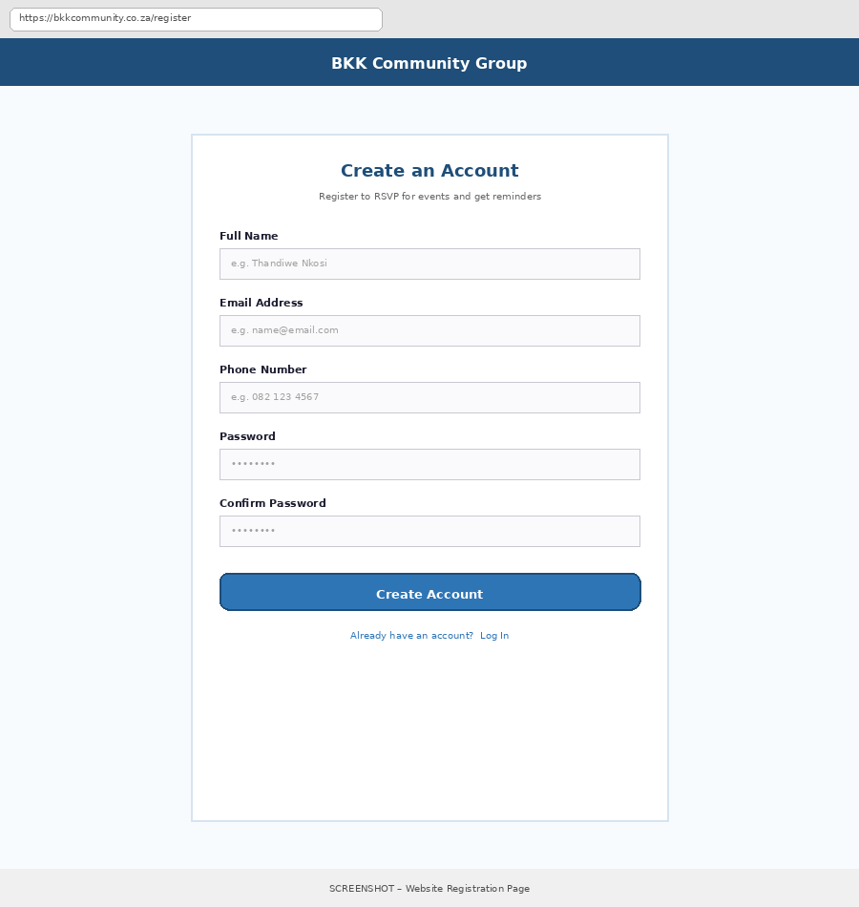
Figure 1: The registration form requires only name, email, phone number, and password — kept intentionally short for elderly users.

Steps to Log In
- Navigate to the website and click Log In in the top-right corner.
- Enter your registered email address and password.
- Click Log In to access your account and personalised features.

Figure 2: Website Login Page
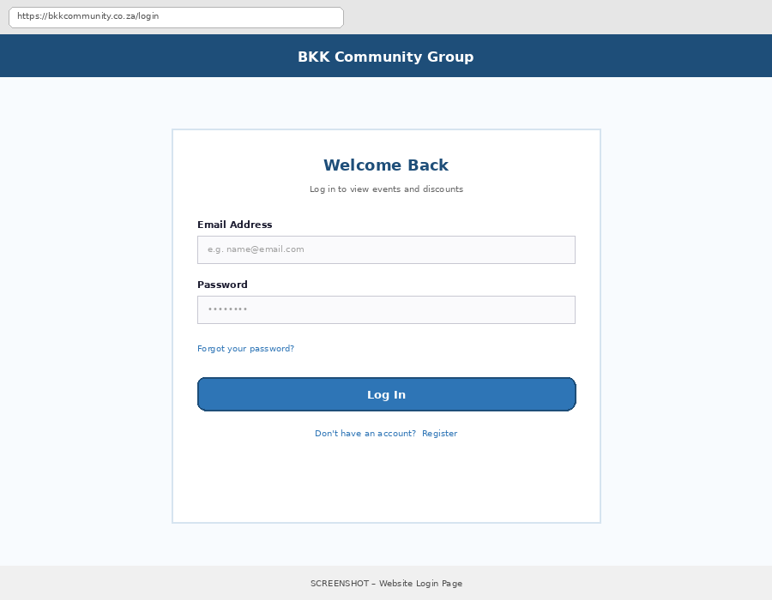
Figure 2: The login page provides a direct path to reset a forgotten password and to register if the user does not yet have an account.

Password Reset Process
- On the login page, click Forgot your password?
- Enter the email address associated with your account.
- The web component is PHP/MySQL with Bootstrap-based responsive styling and an administration area for events, discounts, local services and contact messages.
- Android uses Kotlin, Jetpack Compose and Material 3; iOS uses SwiftUI. Both use the shared HTTPS JSON API so approved content is consistent across platforms.

Figure 3: Password Reset Page
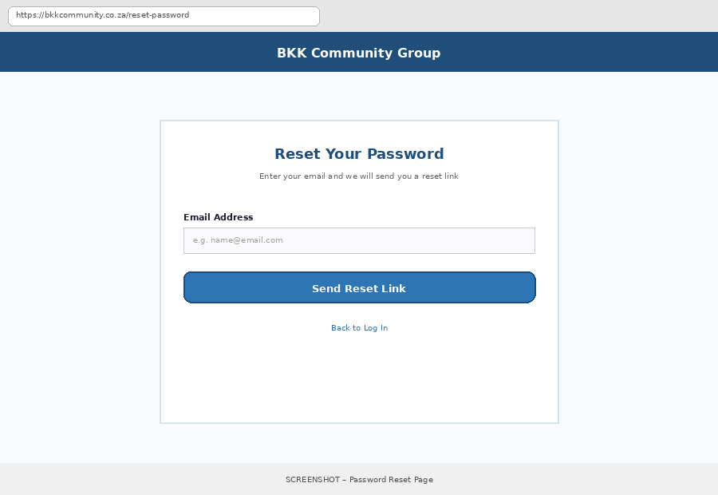
Figure 3: Users can request a password reset link by entering their registered email address.

1.3 Navigation Guide
The website uses a simple, five-item navigation menu designed specifically for elderly users with limited digital experience, in line with Non-Functional Requirement NFR5 (maximum five menu items).
Menu Structure
- Home – Overview of the platform with quick links to all sections.
- Events – Full calendar and list of upcoming community events with attendance confirmation.
- Discounts – Senior discount listings filterable by category (pharmacy, grocery, restaurant, transport).
- Info – Local information including nearby pharmacies, clinics, shops, and support services.
- Contact – A simple form to submit enquiries directly to BKK Community Group.

Important Pages
- Dashboard (Admin only): Displays key statistics — upcoming events, active discounts, new contact form submissions, and registered users — giving Andrew Spaumer an at-a-glance overview of platform activity.
- Profile Page (Registered users): Allows a user to update their name, email, phone number, and password, and view events they have RSVP'd to.
- Events Page: The most frequently used page, combining a monthly calendar view with a detailed list view of all upcoming activities.
- Admin Areas: Password-protected pages allowing the administrator to manage events, discounts, local information, and view contact form submissions.

Figure 4: Admin Dashboard – Andrew Spaumer's View
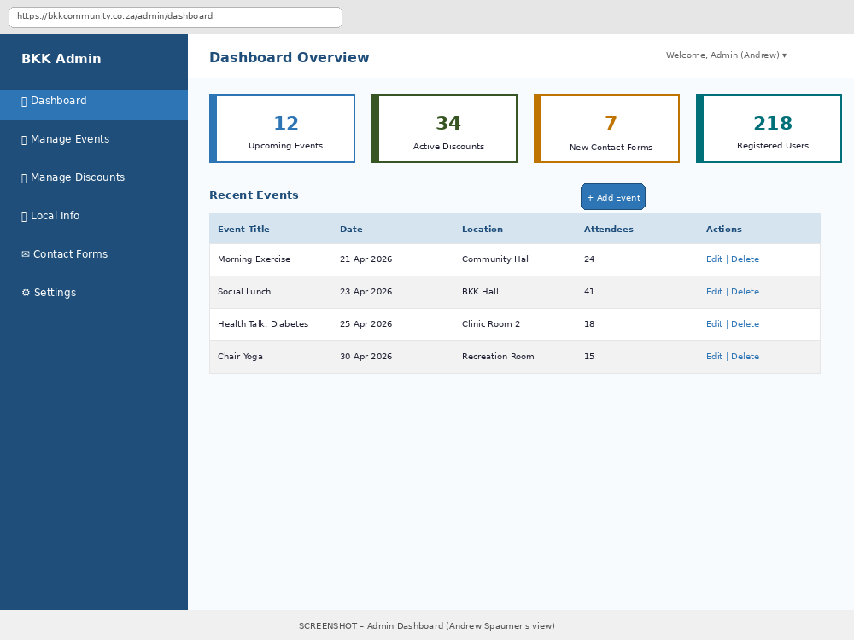
Figure 4: The admin dashboard gives Andrew Spaumer an immediate overview of platform activity and quick access to manage events.

1.4 Key Tasks
Task 1: Confirming Attendance at an Event
- Step 1: Navigate to the Events page from the main menu.
- Step 2: Locate the desired event in the calendar or list view.
- Step 3: Click the 'I will attend' button on the event card.
- Step 4: The button changes to 'Attending ✓' and a confirmation message is displayed.

Task 2: Finding a Senior Discount
- Step 1: Navigate to the Discounts page from the main menu.
- Step 2: Select a category tab (e.g., Pharmacy, Grocery, Restaurant, Transport) or leave 'All' selected.
- Step 3: Browse the discount cards, each showing the store name, deal, and eligibility.
- Step 4: Click View Details on a card to see full claim instructions.

Task 3: Submitting a Contact Enquiry
- Step 1: Navigate to the Contact page from the main menu.
- Step 2: Enter your name, email address, and message.
- Step 3: Click Submit. A confirmation message will appear once the form is successfully sent.

Task 4 (Admin): Adding a New Event
- Step 1: Log in to the admin panel and navigate to Manage Events.
- Step 2: Click + Add Event.
- Step 3: Enter the event title, date, time, location, description, and category.
- Step 4: Click Save. The event immediately appears on the public Events page.

1.5 Frequently Asked Questions
Question | Answer
How do I change my password? | Log in, go to My Account from the top navigation menu, select Change Password, enter your current password followed by your new password, and click Save.
Can I delete my account? | Yes. Go to My Account > Account Settings and select Delete My Account. You will be asked to confirm before your data is permanently removed, in line with our POPIA data policy.
What browsers are supported? | The website supports the latest versions of Chrome, Firefox, Microsoft Edge, and Safari on both desktop and mobile devices.
Do I need to create an account to view events? | No. Anyone can view the Events, Discounts, and Local Information pages without registering. An account is only required to confirm attendance ('I will attend') or receive personalised reminders.
How do I get notifications on my phone? | Download and install the BKK Community companion app from the provided APK link, then allow notification permissions when prompted. You will then receive event and discount alerts automatically.
What should I do if I forgot my password? | Click Forgot your password? on the login page, enter your registered email address, and follow the reset link sent to your inbox.

1.6 Contact Information
- Support Email: andrew.spaumer@gmail.com
- Contact Form: Available directly on the website under the Contact page for general enquiries.
- Admin Contact: Andrew Spaumer, Founder – BKK Community Group – 072 888 5030

2. Technical Documentation

2.1 System Architecture
Password reset uses a cryptographically secure random six-digit code. The plain code is only sent through configured transactional email; a protected representation expires after 15 minutes and five failed attempts invalidate the request.

Figure 5: System Architecture Diagram
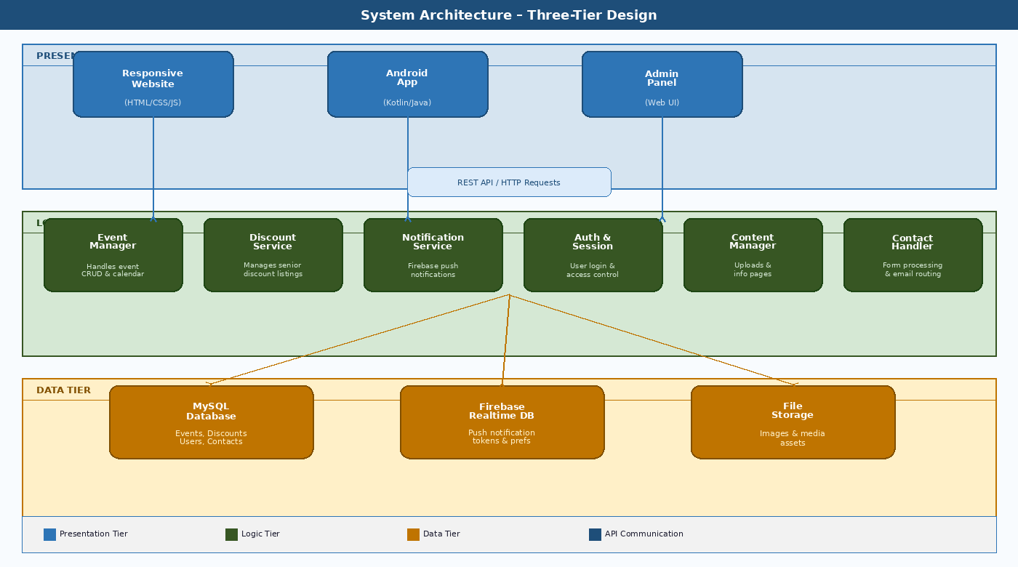
Passwords are stored as hashes. The system uses validation, parameterised database access, protected session handling and session revocation after password reset/account deletion. Secrets must never be logged or committed.

2.2 Technology Stack
Table 1 lists the full technology stack used to build the BKK Community Group platform, with justification for each choice given the project's budget and timeline constraints.

Table 1: Technology Stack
Technology | Category | Version | Purpose in BKK Platform
PHP | Backend/web/API | 8.3+ | Pages, admin and JSON API
MySQL | Relational database | 8+ | Content, accounts, attendance
Bootstrap/custom CSS | Web presentation | 5+ | Responsive accessible UI
Kotlin | Android language | JVM 21 toolchain | Android app
Jetpack Compose/Material 3 | Android UI | Current | Native screens
Retrofit/OkHttp | Android networking | Current | HTTPS API
Room/DataStore/WorkManager | Android support | Current | Cache/preferences/work
Swift/SwiftUI | iOS client | Current Xcode | Native iPhone UI
URLSession/Keychain | iOS support | iOS supported | Network/secure storage
Railway/Docker | Hosting | Container | PHP/MySQL-compatible host
Transactional email | Reset delivery | External | Verified sender required
Firebase/APNs | Push delivery | External | Provider/device proof required

2.3 Database Design
The API is versioned under /api/v1 and returns JSON for authentication, content, attendance, contact, devices and notification preferences.

Figure 6: Entity Relationship Diagram (ERD)
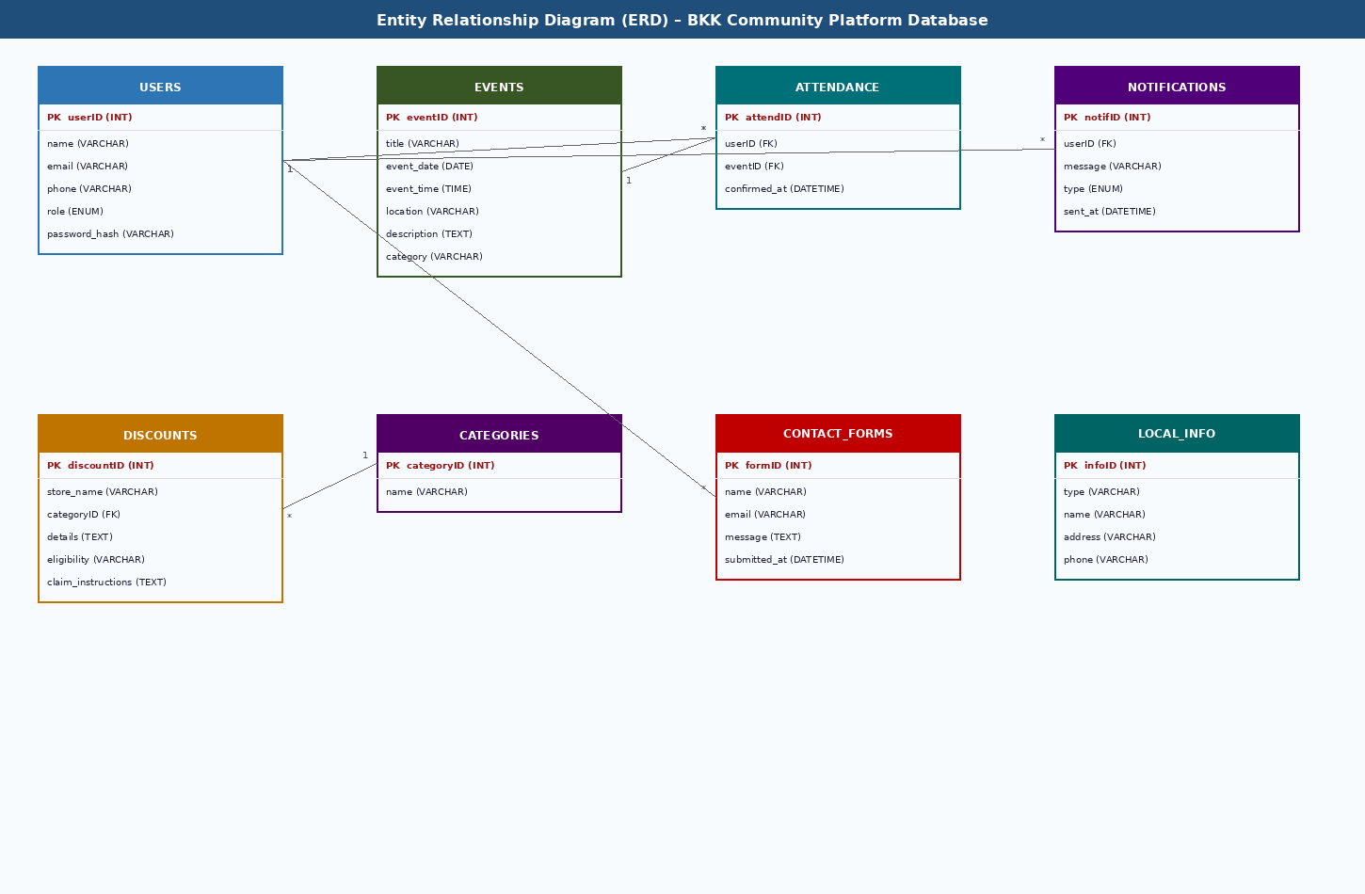
Development uses local PHP/MySQL and demo data. Deployment uses host environment variables and HTTPS; secrets remain outside Git.

Table 2: Database Schema Summary
Table | Key Fields | Data Type | Description / Relationships
users | Accounts | id,email,password_hash | Unique email/password hash
sessions | Sessions | user_id,token_hash | Revocable
reset tokens | Password reset | code_hash,expires_at,attempts | 15-minute expiry
events/categories | Events | id,category,starts_at | Managed content
attendance | RSVP | user_id,event_id,status | Unique user/event
discounts/categories | Offers | id,category,expires_at | Managed content
local_services | Support info | contact/category | Filterable
contact_messages | Enquiries | name,email,message | Validated
devices/logs | Notifications | token,platform | Unique token

2.4 System Modules / Components
- Authentication Module: Handles user registration, login, password hashing (bcrypt), session management, and role-based access control distinguishing public users from administrators.
- Event Management Module: Provides CRUD functionality for events, renders the calendar and list views, and processes attendance confirmations.
- Discount Management Module: Provides CRUD functionality for discount listings and category-based filtering on the public-facing Discounts page.
- Testing combines code checks, API/database validation, web browser testing, Android/iOS testing, offline/error checks, accessibility checks and elderly-user UAT. Planned/Pending results are not presented as proof.
- Content Management Module: Allows the administrator to manage Local Information page content, including pharmacies, clinics, and community services.
- Contact Handling Module: Processes and validates contact form submissions, storing them for admin review and optionally routing an email alert.

2.5 Project Structure
The project follows a conventional MVC-inspired folder structure for the website codebase, and a standard Android Studio project structure for the companion app. The website's folder structure is as follows:
bkk-community-website/
├── public/ # Publicly accessible entry point
│ ├── index.php # Home page
│ ├── events.php # Events page
│ ├── discounts.php # Senior Discounts page
│ ├── info.php # Local Information page
│ └── contact.php # Contact page
├── admin/ # Password-protected admin panel
│ ├── dashboard.php
│ ├── manage-events.php
│ └── manage-discounts.php
├── includes/ # Shared PHP components
│ ├── db-connect.php # MySQL connection handler
│ ├── auth.php # Authentication functions
│ └── header.php / footer.php
├── assets/
│ ├── css/ # Stylesheets (Bootstrap + custom)
│ ├── js/ # JavaScript files
│ └── images/ # Icons and media
└── config/
└── config.php # Environment configuration

2.6 Security Considerations
- Password Hashing: All user passwords are hashed using PHP's password_hash() function (bcrypt algorithm) before storage — plaintext passwords are never stored.
- Input Validation & Sanitisation: All form inputs (contact form, admin CRUD forms) are validated and sanitised server-side. Prepared statements (PDO) are used for all database queries to prevent SQL injection.
- Cross-Site Scripting (XSS) Prevention: All output is HTML-encoded before being rendered back to the browser.
- Database tables cover users, sessions, reset tokens, events, categories, attendance, discounts, services, contact messages, devices and notification logs. Constraints prevent duplicate email, device token and user/event attendance records.
- Core workflows are registration, sign-in/out, password reset, browsing/filtering, RSVP, contact submission and web administration.
- Mobile clients can cache readable content. RSVP never shows success unless the server confirms it online.

3. Coding Standards
To ensure the codebase remains readable, consistent, and maintainable across all four team members, the following coding standards were agreed upon and followed throughout development.

Naming Conventions
- Variables and functions: camelCase in JavaScript and Kotlin (e.g., getUserEvents()); snake_case in PHP and MySQL (e.g., get_user_events(), event_date).
- Classes: PascalCase in all languages (e.g., EventManager, NotificationService).
- Files: lowercase-with-hyphens for PHP page files (e.g., manage-events.php); PascalCase for Kotlin class files (e.g., EventListActivity.kt).
- Database tables and columns: lowercase snake_case, plural table names (e.g., events, contact_forms).

Code Formatting
- Indentation: 4 spaces (no tabs) across all languages, enforced via each team member's editor configuration.
- Line length: kept under 100 characters where practical to maintain readability.
- Braces: opening brace on the same line as the statement (K&R style) for PHP, JavaScript, and Kotlin.

Commenting Practices
- Every function includes a brief comment describing its purpose, parameters, and return value.
- Complex or non-obvious logic (e.g., notification scheduling, MoSCoW-driven conditional rendering) is annotated with inline comments.
- TODO comments are used to flag incomplete work and are tracked in the GitHub issue board.

/**
* Confirms a user's attendance for a given event.
* @param int $userID The ID of the logged-in user
* @param int $eventID The ID of the event being confirmed
* @return bool True on success, false on failure
*/
function confirmAttendance($userID, $eventID) {
// Prevent duplicate attendance records
if (attendanceExists($userID, $eventID)) {
return false;
}
return insertAttendanceRecord($userID, $eventID);
}

The combined repository separates web/API, Android, iOS, database, documentation and deployment files so group members can work safely in the appropriate component.

PHASE 4 – SOFTWARE TESTING

4. Test Plan
The delivered stack is PHP 8.3+, MySQL 8+, Bootstrap-based web UI, Kotlin/Compose Android, Swift/SwiftUI iOS, Retrofit/OkHttp, Room, DataStore, WorkManager, URLSession and Keychain.

Table 3: Test Plan
Test type | Scope / objective | Test date / timing | Team member | Evidence / platform
Unit/code checks | Validation, helpers and mobile state | Each feature | Module owner | Review/output
API integration | Auth, JSON, validation, persistence | Before release | Backend + mobile | Request/response/read-back
Functional system | End-to-end member/admin journeys | Before submission | Whole group | Workbook/screenshots
Compatibility | Browsers, Android API 26/current, iOS | Release candidate | Platform testers | Device matrix
Performance/offline | Load/caching/error messages | Release candidate | Platform testers | Timed evidence
Security | Auth, input, sessions, secrets | Before production | Backend reviewer | Checklist
Accessibility | Labels, 200% text, contrast, targets | Before UAT | Accessibility owner | Manual proof
Elderly UAT | Independent core task completion | After technical tests | Group + BKK | Consent-aware sheets

5. Test Templates
In line with the project brief, the Ctrl Freaks team designed and maintained its own test case templates using Microsoft Excel. A shared workbook (BKK_Test_Templates.xlsx) was maintained on the team's Google Drive and updated throughout each sprint. The workbook contains three tabs: a Functional Test Case Log (used to produce Table 4 below), a UAT Feedback Log (used to produce Table 5), and a Defect Tracker recording each issue's severity, the team member assigned to resolve it, and its resolution status. Each functional test case in the Excel template records: a unique Test ID, the requirement it verifies, the exact steps to reproduce, the expected result, the actual result, and a Pass/Fail/Partial status — consistent with the fields presented in Table 4.
The updated test plan below gives each test type, timing, responsible person, platform and required evidence. Names/dates must be completed honestly by the group.

The attached Excel workbook is the execution template. Every actual test must include date, tester, environment, result, evidence and defect reference.
Functional results distinguish local/demo implementation from live proof; no result is claimed without an evidence source.
UAT requires real representative elderly users. Scores, comments and client acceptance remain pending until sessions occur.
Development is local; staging is an optional isolated release candidate; production is the HTTPS Railway/domain deployment. Production secrets belong in host configuration only.
Feature / test | Expected result | Current evidence | Result | Evidence / follow-up
Registration | One account; duplicate email rejected | Implemented; live proof pending | Pending | Request + database read-back
Sign in/out | Session works; logout returns to sign-in | Implemented; regression needed | Pending | Android/iOS/web capture
Password reset | Random code, expiry, lockout, password update | Logic implemented; sender proof pending | Pending | Test inbox headers
Events/filters | Lists/details/category filtering | Demo/local verified | Demo pass | Live screenshot
RSVP | Online success only; no duplicate record | Logic/schema implemented | Pending | Confirm/repeat/cancel/offline
Discounts/services | Managed category/detail content | Demo/local verified | Demo pass | Admin-to-client proof
Contact | Validation and stored enquiry | Implemented; live persistence pending | Pending | Invalid/valid cases
Admin CRUD | Manage content securely | Implemented; live check pending | Pending | Admin evidence
Offline cache | Read cached content, no false RSVP | Architecture present | Pending | Airplane mode
Notifications | Discount/reminder delivery | Provider credentials/evidence absent | Not evidenced | FCM/APNs physical device
Feedback should drive improvements to clarity, navigation, contrast, control sizes and performance, with the source and action recorded.
A detailed implementation supplement with current visuals and evidence gates is appended after the original Phase 3/4 sections.

7. Test Results – User Acceptance
User Acceptance Testing (UAT) was conducted during Week 9 with six elderly members of the BKK Community Group at the community hall, facilitated by the student team with Andrew Spaumer present. Each participant was given a specific real-world task to complete on either the website or the Android app, without guidance unless they became stuck. Table 5 presents the results.

Table 5: User Acceptance Test Results (n=6 elderly participants)
UAT task | Success measure | Evidence required | Status | Notes
Understand Home | Find events/discounts/help | Observation sheet | Pending | Plain-language prompts
Find & RSVP | Locate details and confirm | Completion/comments | Pending | Observe clarity
Find offer/service | Understand instructions | Completion/comments | Pending | Check wording
Sign in/reset | Follow test-account flow | Tester note | Pending | No real passwords
Comfort/accessibility | Readable/operable at settings | Settings evidence | Pending | 200% + screen reader
Overall acceptance | 6 elderly users; >=80% independent; >=4/5 | Raw sheets + summary | Pending | Do not invent result

The average UAT satisfaction rating across all six participants was 4.3 out of 5. Two specific usability issues were identified and addressed prior to final deployment: increasing font size on the Local Information page (Participant 4) and producing a simplified printed installation guide for the Android app (Participant 5). Both improvements are documented in Section 9 (Client Feedback).

8. Development, Staging, and Production Environment
Three distinct environments were used throughout the project to ensure that untested code never reached real users, and that the client had a safe environment in which to review work before it went live. Table 6 describes the purpose, tools, and access level for each environment.

Table 6: Development, Staging, and Production Environments
Environment | Purpose | Tools/configuration | Controls
Development | Daily development | Local PHP/MySQL, Android Studio, Xcode, VS Code | No production secrets
Staging | Optional release candidate | Isolated DB/test inbox | Full test workbook
Production | Public service | HTTPS bkkcommunity.online/Railway | Host secrets, backups, monitoring

The repository contains source and documentation but excludes credentials, email keys and provider configuration. These are added per environment.

9. Client Feedback
This is a truthful implementation record: it separates implemented features from outstanding operational evidence such as real email/push delivery, accessibility proof, UAT and client sign-off.

Table 7: Client Feedback Log
Feedback source | Finding | Action taken / planned | Evidence status
Design review | Early UI felt plain | BKK palette, hierarchy, cards/icons | Implemented; UAT validate
Accessibility concern | Elderly usability risk | Five primary nav choices, large targets, clear labels | Formal proof pending
Sign-out issue | Logout did not consistently navigate | Session/route handling corrected; regression required | Pending device proof
Password reset | Need simple email/code journey | Secure code/expiry/attempt rules implemented | Email proof pending
Content stakeholders | Authentic data is required | Demo content labelled; admin can manage real data | Operational dependency
Client sign-off | No formal acceptance yet | Schedule UAT and written confirmation | Pending

Maintain the test workbook and attach evidence for each executed test before assessment.

Appendix: Detailed implementation and test-evidence supplement.
Detailed Implementation Supplement
This appendix expands the original document; it does not replace it. Existing diagrams, figures and tables have been retained. “Implemented” means source exists; “verified” means repeatable evidence exists; “pending” means it is a real release gate still to be completed.
1. Architecture and component responsibilities
Component | Implemented responsibility | Boundary / risk control
Web application | Responsive member pages and administration for events, discounts, services and contact messages. | Never expose database or mail credentials in browser code.
Android app | Compose user interface, HTTPS API client, readable-content cache and session preferences. | RSVP displays success only after server confirmation.
iOS app | SwiftUI interface, URLSession API client and Keychain session storage. | APNs delivery needs Apple/provider configuration and physical proof.
PHP API | Versioned /api/v1 endpoints for account, content, attendance, contact and devices. | Authorisation and business rules are server-side.
MySQL | Stores accounts, content, attendance, sessions and protected reset records. | Unique constraints prevent duplicate account/RSVP records.
External services | Hosting, DNS/HTTPS, transactional email and FCM/APNs. | Configured outside Git and evidenced in real environment.
2. Current web visuals
The following current interface captures are included as visual reference alongside the original diagrams.
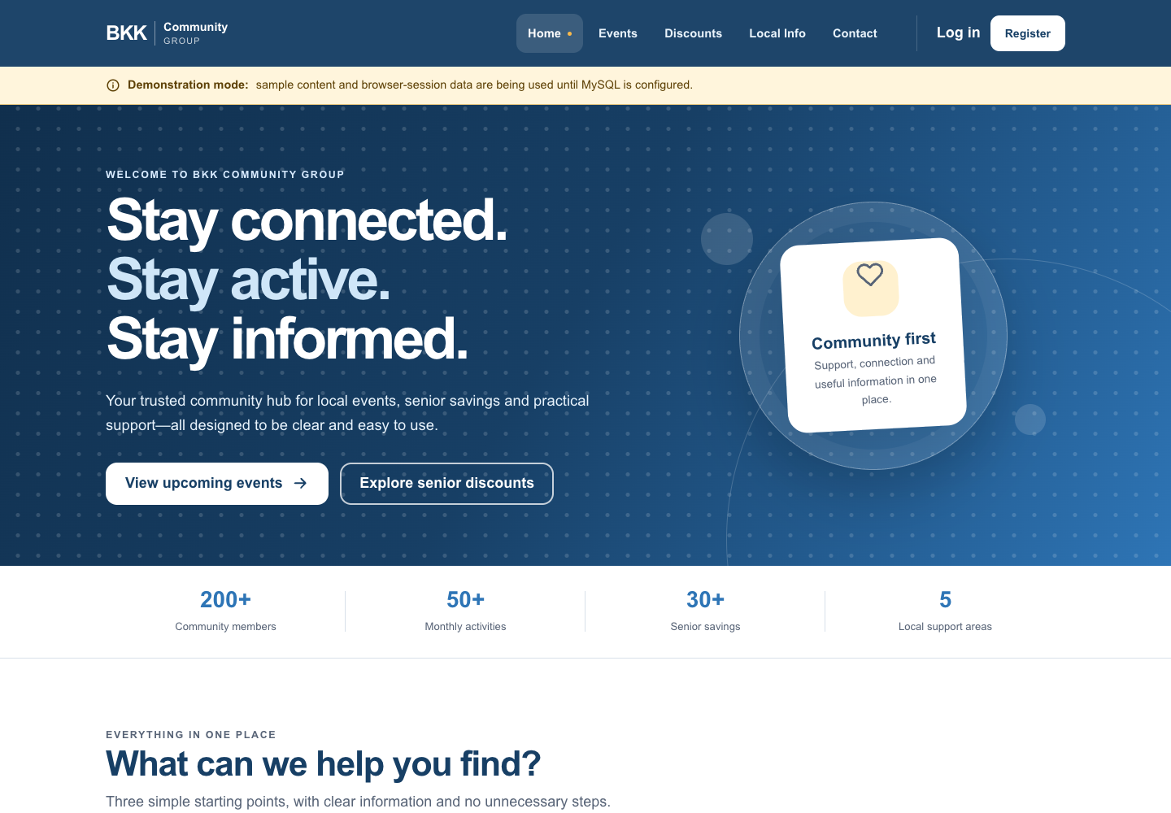
Figure A. Responsive web Home page, desktop.
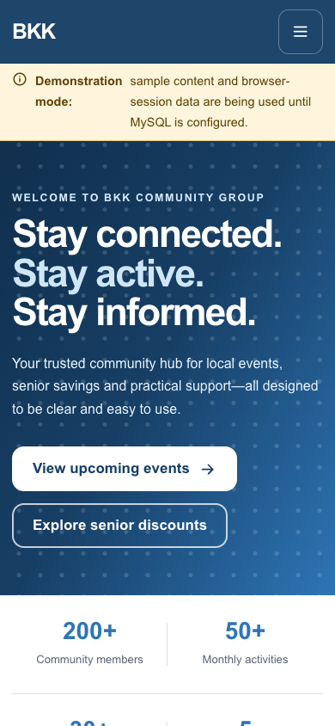
Figure B. Responsive web Home page, mobile viewport.
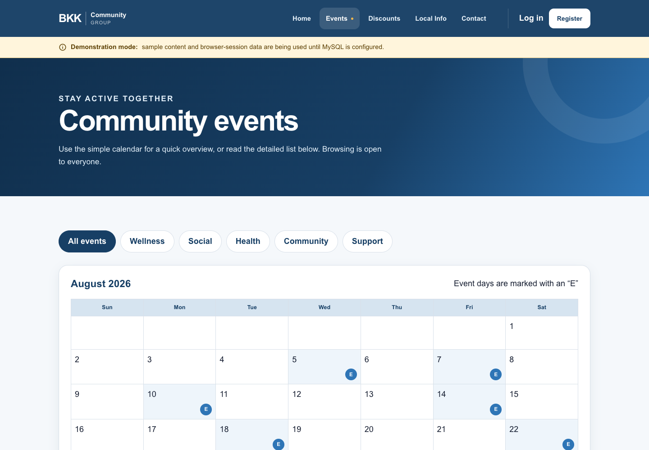
Figure C. Events discovery page, desktop.
3. End-to-end workflows and security
Workflow | Detailed behaviour | What must be tested
Registration | Validate fields, reject duplicate email, hash password and create account. | Malformed input, duplicate email, stored hash only.
Sign in/out | Authenticate user, protect session state, clear state on logout. | Protected screen unavailable after logout on all platforms.
Password reset | Secure random 6-digit code; protected storage; 15-minute expiry; five-attempt limit; reset revokes sessions. | Different codes, expiry, lockout, test-mail delivery and reset login.
Browse/filter | API returns managed events, discounts and services; mobile can cache readable items. | Loading, populated, empty, error and offline states.
RSVP | Authenticated member confirms/cancels; unique user/event record prevents duplicate. | Double taps, repeat request, cancel, offline and stale UI.
Contact | Validate and store member enquiry for admin review. | Required fields, invalid email, safe display and persistence.
Notifications | Register device/preferences; send discount/reminder only when providers are configured. | Permission denial, token refresh and actual physical delivery.
4. Accessibility and elderly-user criteria
The design must be calm and direct, not feature-heavy: five primary navigation options, plain words beside meaningful icons, readable scalable text, high contrast, adequate spacing and 48–56dp mobile controls. Colour is never the only indicator of state.
Check | Required pass condition | Required evidence
TalkBack/VoiceOver | Logical focus order and meaningful labels/announcements. | Screen recording or signed checklist.
200% text | No clipped essential information; actions remain reachable. | Android and iOS screenshots.
Contrast | Text/actions achieve suitable WCAG AA contrast. | Measurement/checklist.
Navigation | Priority tasks reachable in three clear steps. | Observed task walkthrough.
Touch targets | Main actions are large enough and separated. | Annotated screenshots.
5. Outstanding release gates
These cannot be honestly marked complete without real evidence: verified sender-domain email delivery; FCM/APNs real-device notifications; end-to-end live database persistence; backup/restore test; TalkBack/VoiceOver and 200% font proof; UAT with at least six elderly users; authentic BKK/partner content; and written client acceptance. This is the difference between a credible prototype and a production-ready community service.
6. Evidence pack required before final hand-in
Item | Owner | Include
Test workbook | Whole group | Date, tester, environment, actual result, status, defect and evidence link.
Functional captures | Platform owners | Register, sign-in/out, reset, events, RSVP, contact and admin flows.
Email proof | Backend owner | Test-inbox capture proving different codes, expiry and lockout.
Accessibility proof | Accessibility owner | Screen reader, 200% text, contrast and touch-size records.
UAT proof | Whole group | Consent-aware anonymous sheets for six elderly users and summary.
Deployment proof | Deployment owner | HTTPS URL, release commit, secret checklist and backup/restore record.

