
TextbookHub SS4 Final Project Report
Mobile Application Development A | MADA372 | Summative Assignment SS4
Item | Details
Project Title | TextbookHub - Student Textbook Marketplace
Student / Project Member | Kagiso Mmatloa
Student Number | 24301339
Technology Stack | Android Studio, Kotlin, XML layouts, ViewBinding, RecyclerView
GitHub Repository | https://github.com/kxcy77/TextbookHub
Document Name | Kagiso_Mmatloa_MADA372_SS4.docx

Table of Contents
- Project scope and goals
- Planning and design alignment from SS1 to SS4
- System architecture and flow diagrams
- Project application overview
- Implemented Kotlin functionality
- XML user interface and visual consistency
- ViewBinding and dynamic UI updates
- Deployment and hosting evidence
- Screenshots and UI references
- References and AI-use declaration
- Final submission checklist

1. Project Scope and Goals
TextbookHub is a mobile Android application developed as a student peer-to-peer textbook marketplace. The app helps higher education students find affordable second-hand textbooks, view listing details, contact sellers, and create book listings. The SS4 version finalises the MVP planned in SS1, designed in SS2, and implemented in SS3.
Scope Area | SS4 Implementation
Purpose | Provide an accessible textbook marketplace for students in higher education institutions.
Target users | Students who need affordable textbooks and students who want to sell used textbooks.
Core problem | Textbooks are expensive, and students need an easier way to browse, compare, and contact sellers.
MVP boundary | The app uses local sample data, ViewBinding, RecyclerView, SharedPreferences, and Android intents without a persistent remote database.
Cultural relevance | The interface uses warm local colours, rounded cards, and an African pattern background to support a context-aware design identity.

2. Planning and Design Alignment
The final SS4 application remains aligned with the staged project workflow. SS1 defined the strategy and MVP, SS2 established the user experience and visual prototype, SS3 implemented the Android screens and functionality, and SS4 refines the project into a final app with documentation, deployment evidence, and presentation material.
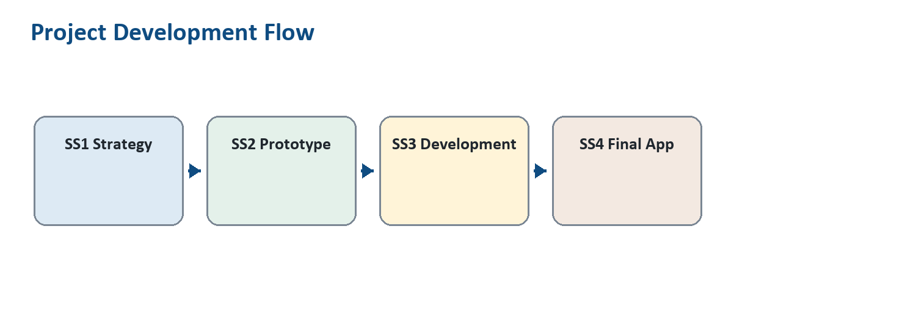
Figure 1: Alignment from SS1 strategy to SS4 final application.
Phase | Deliverable | How SS4 Uses It
SS1 | Problem statement, MVP scope, functional requirements, conceptual architecture, DevOps plan | Guides the student marketplace purpose, user journey, and GitHub workflow.
SS2 | Wireframes, style guide, prototype, sitemap, information architecture | Guides the implemented Android XML screens, colours, spacing, and navigation structure.
SS3 | Kotlin/XML implementation, navigation, listing features, messages, profile, GitHub commits | Forms the working MVP refined for SS4 marking.
SS4 | Final application, documentation, deployment/hosting, recorded presentation | Packages the project for final assessment and demonstration.

3. System Architecture and Flow Diagrams
TextbookHub follows a simple layered Android structure suitable for the assignment requirements. Activities control each screen, XML files define the interface, ViewBinding connects Kotlin code to UI elements, adapters bind collections into RecyclerViews, and SharedPreferences stores registration/profile details locally.
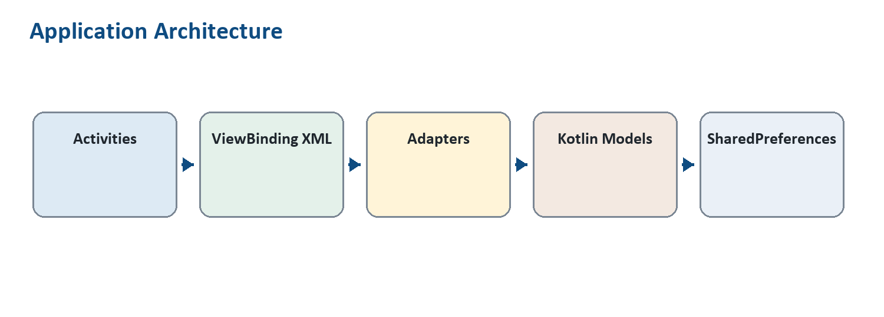
Figure 2: TextbookHub Kotlin/XML architecture.
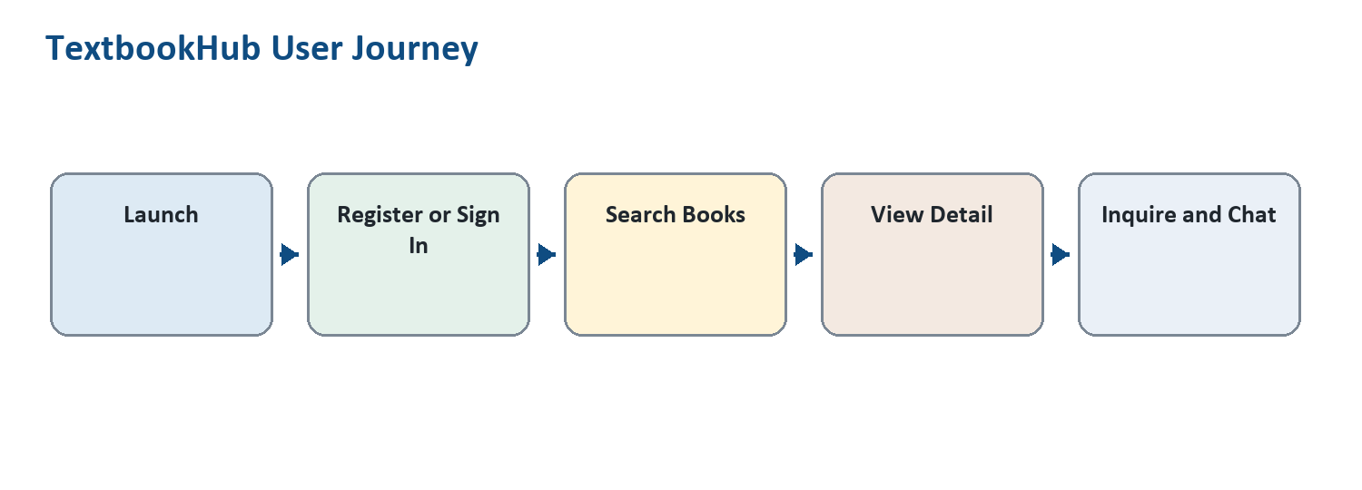
Figure 3: Main user journey through the application.

4. Project Application Overview
Component | Overview
App purpose and target audience | TextbookHub supports students in higher education by creating a peer-to-peer marketplace for affordable second-hand textbooks.
Core features | Registration, sign-in validation, browsing listings, search/filtering, book details, seller inquiry, messages/chat, profile display, sell-book form, image upload, and notifications.
Technical architecture | Android app built with Kotlin activities, XML layouts, ViewBinding, RecyclerView adapters, Material Components, and SharedPreferences for local profile storage.
User journey | The user launches the app, registers or signs in, searches listings, opens a book detail screen, sends an inquiry, and replies in a message thread.
Value proposition | Students save money and time by accessing locally relevant textbook listings within an institutional environment.

5. Implemented Kotlin Functionality
Rubric Area | Implementation Evidence
Textbook data models | `Book.kt` defines title, author, edition, course code, condition, price, seller name, description, campus, and image resource fields.
Listing management | `HomeActivity.kt` stores sample listings in a Kotlin list and passes them into `BookAdapter`.
User interaction logic | Click listeners open book details, inquiry, messages, profile, sell listing, and notification actions.
Navigation control | Android intents connect Splash, Login, Registration, Home, BookDetail, Inquiry, Messages, MessageThread, Sell, and Profile screens.
Search/filtering logic | `Book.matches()` and `HomeActivity.filterBooks()` filter by title, author, edition, course, condition, and description.
Input validation | Login, registration, sell listing, and chat reply screens validate empty/invalid fields and display errors or toast messages.

6. XML User Interface and Visual Consistency
The app uses XML layouts with Material Components, ConstraintLayout, CardView, RecyclerView, and consistent type styles. The visual system uses a textbook-marketplace layout: prominent search, listing cards, readable detail screens, and clear bottom chat input. The African-pattern background supports the cultural design direction described in the project brief.
- Main listing interface: `activity_home.xml` and `item_book_card.xml` display textbook cards through RecyclerView.
- Book detail screen: `activity_book_detail.xml` presents image, title, edition, price, condition, description, and seller details.
- Interaction screen: `activity_inquiry.xml` and `activity_message_thread.xml` support seller contact and chat replies.
- Navigation layout: Home provides access to Sell Book, Messages, and Profile, while detail and thread screens include back navigation.
- Visual consistency: shared colours, typography styles, rounded components, spacing, and icon assets are reused across screens.

7. ViewBinding and Dynamic UI Updates
The SS4 version strengthens the data-binding requirement by enabling ViewBinding in Gradle and using generated binding classes for key screens and RecyclerView items. This gives type-safe UI access and directly connects Kotlin data values to XML components.
Binding Requirement | Evidence in Project
View-model connection / Kotlin variable binding | `ActivityHomeBinding`, `ActivityBookDetailBinding`, `ActivityMessagesBinding`, `ItemBookCardBinding`, and `ItemMessagePreviewBinding` connect Kotlin variables to XML views.
Dynamic UI updates | Search filtering updates the book list dynamically through `bookAdapter.submitList(filteredBooks)`. Book detail values update from intent data.
RecyclerView binding | `BookAdapter` binds each `Book` into `item_book_card.xml`; `MessageAdapter` binds each `MessagePreview` into `item_message_preview.xml`.
Input validation binding | TextInputLayout and TextInputEditText fields display validation errors for login, registration, sell listing, and message replies.

8. Deployment and Hosting Evidence

8.1 GitHub Repository
The final Android Studio project is hosted on GitHub at https://github.com/kxcy77/TextbookHub. The repository uses `main` as the final submission branch and includes a `development` branch to demonstrate staged progress.
Version Control Requirement | Evidence
Repository created and structured | GitHub repository: https://github.com/kxcy77/TextbookHub
Meaningful commits | Examples include `Add SS3 implementation documentation`, `Persist registration details in profile`, and `Implement app navigation and marketplace flows`.
Branches | `main` and `development` branches exist.
Final code pushed | The project should be pushed again after SS4 report/code updates are committed.

8.2 Amazon Appstore Deployment Preparation
The Android project builds successfully as a debug APK at `app/build/outputs/apk/debug/app-debug.apk`. For Amazon Appstore submission, the final release must be signed using a release keystore, uploaded through the Amazon Developer Console, and supported with screenshots, app description, category, privacy details, and contact information (Amazon Developer, n.d.).
Amazon Requirement | Status / Action
Signed APK/AAB | Prepare a release build in Android Studio using Build > Generate Signed Bundle/APK.
App listing | Use the app name TextbookHub and describe it as a student textbook marketplace.
Screenshots | Use final app screenshots from emulator/phone for splash, register, home, detail, sell, messages, and profile.
Submission evidence | Add Amazon Developer Console screenshots to the final zip once the listing has been created.

9. Screenshots and UI References
The following UI references show the SS2 design screens that guided the SS3 and SS4 Android implementation. The final app screens implement the same major flow: splash, registration, home/search, book detail, inquiry, messages, sell listing, and profile.
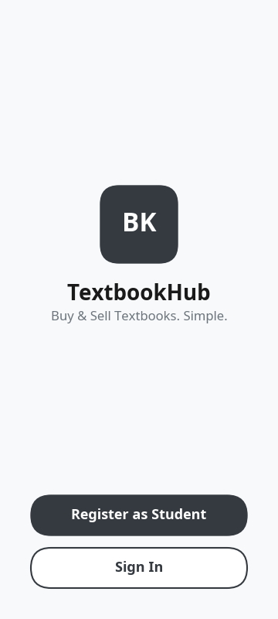
Figure: Splash / Welcome screen.
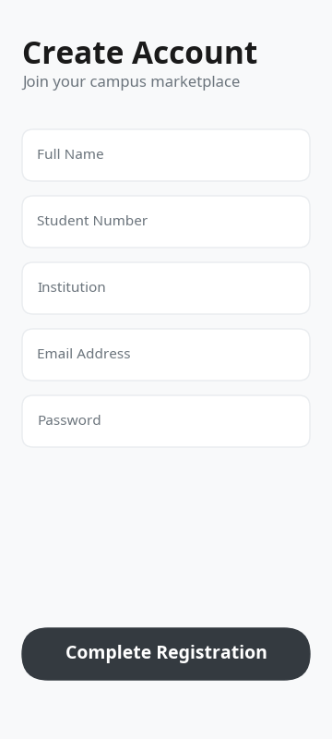
Figure: Registration screen.
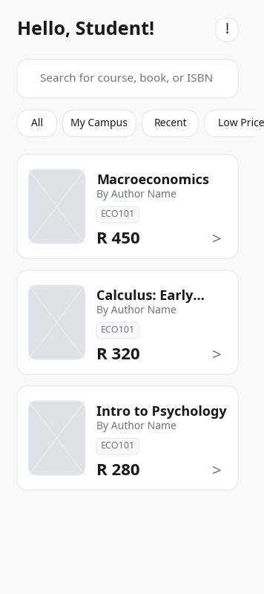
Figure: Home search and listings screen.
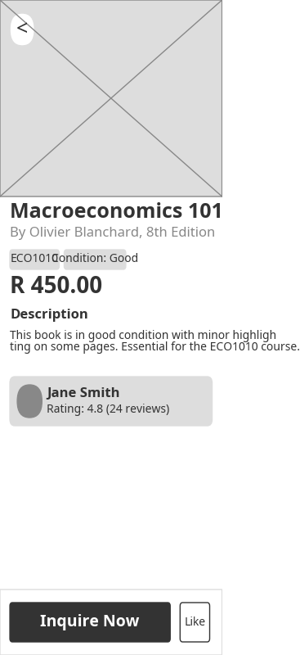
Figure: Book detail screen.
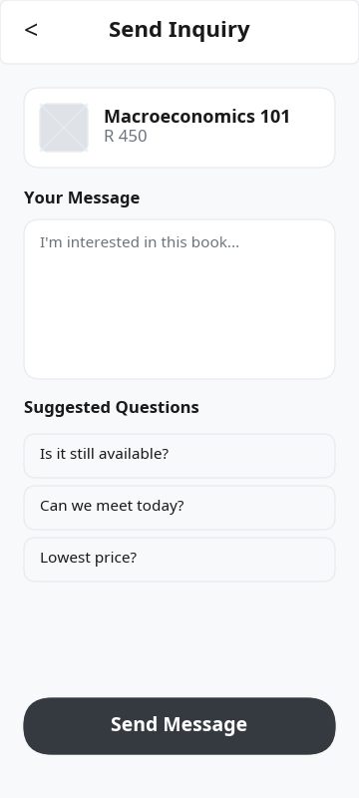
Figure: Inquiry screen.

Figure: Messages screen.
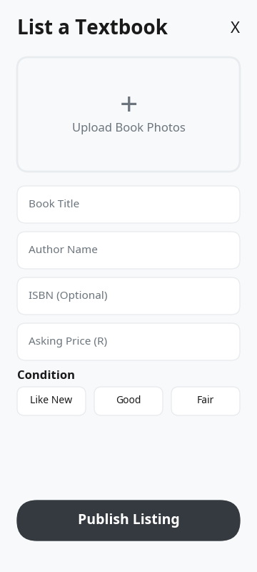
Figure: Sell textbook screen.
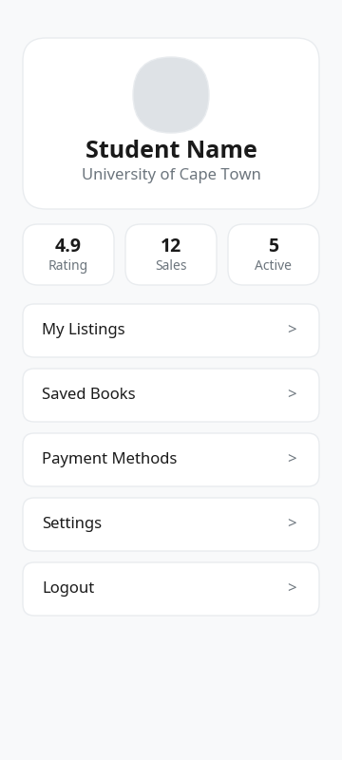
Figure: Profile screen.

10. Presentation Video Guide
The recorded SS4 presentation should be no longer than 15 minutes. It should introduce the project, explain the development journey, demonstrate the live app, and show final hosting/deployment evidence.
- Introduce TextbookHub, the target users, and the textbook affordability problem.
- Explain how SS1 strategy, SS2 prototype, SS3 implementation, and SS4 final refinement connect.
- Show the app running: register, sign in, search books, open detail, send inquiry, reply in messages, upload a listing photo, and view profile.
- Show GitHub repository and explain branches/commits.
- Show Amazon Appstore preparation or submission evidence.
- End with final project value proposition and limitations.

11. AI-Use Declaration and Evidence
AI assistance was used for Section 2 support tasks, including generating an outline, reviewing rubric coverage, improving code structure, and preparing documentation drafts. The student must include evidence of AI prompts and outputs with the final submission as required by the SS4 instructions. Recommended evidence includes screenshots or exported chat records showing the prompts and responses used during the development/documentation process.
Declaration: All AI-assisted outputs must be reviewed, edited, and verified by the student before submission. The final project remains the student's responsibility.

12. Final Submission Checklist
Requirement | Status
Final updated Word report named correctly | Created: Kagiso_Mmatloa_MADA372_SS4.docx
Android Studio project files | Included in project folder.
GitHub link | Included: https://github.com/kxcy77/TextbookHub
Screenshots / UI references | Included in this report and available in docs/ui-references.
Recorded video presentation | To be recorded and uploaded before Canvas submission.
Amazon Appstore evidence | Prepare release listing/screenshots through Amazon Developer Console.
AI-use evidence | Attach screenshots/export of prompts and outputs.
Final zip folder | Zip the organised Android project, documentation, screenshots, links, and video evidence.

13. References
Amazon Developer. (n.d.). Submitting apps to the Amazon Appstore. https://developer.amazon.com/docs/app-submission/submitting-apps-to-amazon-appstore.html
Android Developers. (n.d.). Design for Android. https://developer.android.com/design/ui
Android Developers. (n.d.). Gradle build overview. https://developer.android.com/build/gradle-build-overview
Cprime. (n.d.). Agile and AI: Navigating the future.
Figma. (n.d.). Best practices. https://www.figma.com/best-practices/
GitHub Docs. (n.d.). About repositories. https://docs.github.com/en/repositories
International Organization for Standardization. (2019). ISO 9241-210: Human-centred design for interactive systems. https://www.iso.org/standard/77520.html

