

Greywater

treatment

in Cape York

The Cape York, Queensland,

Australia

10 June 2023 I

|  |  |  |
| --- | --- | --- |
| Team name:  YYDS | Team number :  3 | Tutorial:  Friday 8am – 12am |
| **Teamwork Declaration** | | |
| Team member name | Document sections | Signature |
| Zhengjie Zhao | 1. introduction 2.background   3.Proposed Design of Greywater collection device 4.Implementation Plan of Greywater collection device | Zhengjie Zhao |
| Jun Qi | 1. Implement plan   2.discussion  3.conclusion and recommendations(treatment) | Jun Qi |
| Xiaoyuanying Kuang | 1. Team reflection 2. Design options 3. Editing the final report 4. Design prototype of exporting | Xiaoyuanying Kuang |
| Jiayi Li | 1. Cost analysis of greywater collection device  2. Design prototype of greywater collection device  3. Discussion of greywater collection device | Jiayi Li |
| Fanghua Dai | 1. Deisgn solution 2. Design prototype 3. Summary 4. Cost analysis of treatment | Fanghua Dai |
| Yueheng Wang | 1. Editing the final report 2. Implement plan of exporting 3. Discussion of exporting 4. Design prototype of exporting | Yueheng Wang |

**Executive Summary**

The topic of our report is greywater treatment. When groups camp on Country, there is a certain amount of waste water runoff from activities such as showering that is released into the environment. This can have negative effects on the environment and it is illegal to release greywater in National Parks along with other types of waste, and that is the problem our group is trying to solve. Since water is the important natural resource, many people including government, companies and local people are all stakeholders.

Our proposed solution to solve this situation includes three kinds of approaches, the physical treatment, the chemical treatment and the biological treatment. Among them, the physical method is relatively cheap and the process is simple, but it cannot dispose of extremely small substances such as viruses in the water. The water is purified after chemical treatment, but this method is more expensive and complicated to treat. Since then, we can combine the physical treatment with chemical treatment in order to purify greywater better. Biological method is initially low cost and environmentally friendly, but require subsequent care of the plant and are limited in scope due to the characteristics of the plants themselves. That is to say, the process of biological method is easier than the physical-chemical one, but it may be more difficult to maintain and its using may be limited.

**Team Reflection**

Our EWB team was established in response to the need for better water supply systems in local areas. Our project focused on designing and installing a sustainable water supply system in a remote area. While our project was successfully implemented, we encountered a number of challenges that tested our skills and commitment.

The first challenge we encountered was a lack of information about the area, including the size of the community, existing water supply systems and the type of terrain in the area. We spent several weeks researching and gathering data before we designed the system.

Another challenge we faced was a lack of capital. We had to work with limited funds, which meant that we had to be creative in finding affordable solutions. We also had to make some difficult decisions about the needs of the community and how to prioritize them.

One of the most important lessons we learned from our project is the importance of team communication and coordination. As each member of the team had different strengths and skills, we had to ensure that everyone was working towards the same goal. This required regular communication, including weekly team meetings and progress updates. We had to be flexible and adaptable, especially when we encountered unexpected challenges, and we worked together to find solutions.

Overall, our project was a success, but it was not without its challenges. Through our experience, we learned important lessons about community involvement, resourcefulness, and teamwork. We also recognized the impact of our work, and the importance of sustainable projects in improving the lives of people in need. We believe that our project has paved the way for future projects in the same area, and we are proud of the progress we have made.

Table of Contant

1.Introduction III

2.Background IV

3.Design Options V

3.1 Design Criteria V

3.2 Design options for greywater treatment: VIII

3.3 Option Selection: X

4. Proposed Design XI

4.1Greywater collection device XI

4.2 Greywater treatment device: XII

5.Implementation Plan XIII

5.1 Greywater collection device: XIII

5.1.1 Implementation: XIII

5.1.2 Component List: XIV

5.1.3 Implementation Procedure: XIV

5.2 Greywater treatment device: XIV

5.3 Greywater exporting device: XV

6.Cost Analysis XVI

6.1 Greywater collection device XVI

6.2 Greywater treatment device: XVII

6.3 Greywater exporting device: XVIII

7. Design Prototype XIX

7.1 Greywater collection device: XIX

Figure 2: Bathroom design XX

7.2 Greywater treatment device: XXI

7.3 Greywater exporting device: XXIII

8.Discussion XXV

8.1 How to meet the needs of the client? XXV

8.2 The benefits and impacts in culture, environment, economic? XXV

8.3 How will the client,community and other stakeholders be engaged in the project? XXVI

8.4 Strengths/weaknesses XXVI

8.4.1 Strengths: XXVII

8.4.2 Weaknesses: XXVII

9. Conclusion and Recommendations XXVIII

10.Reference XXVIII

## 1.Introduction

This report outline is to offer a solution for 2021 Engineering Without Borders (EWB) Challenge. The report focused on project opportunity 5.5 Greywater Treatment. It will evaluate and select the most suitable design plan to solve the difficulties encountered by the local community and a specific implementation plan.

Cape York region has vast and charming National Park, a lot of group choose the National Park as the camping destination. During the camping, there is a certain amount of greywater that is released into the environment. The greywater has bad effect on the environment and it is illegal to release greywater in National Parks, so greywater treatment is the important part of camping. The important issues of the moment is the current greywater trenches expensive. Our team needs to design a sustainable and low-cost solution to solve this problem.

Comparing the feasibility and cost of each plan many times, after greywater collecting, alum and activated carbon will be added into the pool to absorb the large granular impurities in the greywater, then set the greywater in the pool for a while in order to remove the small granular impurities are the most suitable plan for our team to solve the Cape York greywater treatment problems.

## 2.Background

The Cape York region contains 30 broad vegetation groups including 72 different types of rainforest comprising 20% of Australia’s remaining rainforest(“Our region”, 2012). There are a lot of National Parks in the Cape York region, many traveler camping in the National Parks to enjoy the beauty and climate of the rainforest.

The National Park’ natural environment is complex and fragile, and environmental protection work is of great significance. Among them, greywater treatment is an important work. During the camping of traveler, there is a certain amount of greywater that is released into the environment. The greywater has bad effect on the environment and it is illegal to release greywater in National Parks. Therefore, it is urgent to think about how to deal with greywater and the reuse of greywater.

At present, there are two main directions for greywater treatment, one is to establish a intent greywater treatment system, and the other is to recycle greywater. Centralized greywater treatment systems are costly in construction and maintenance, ignoring other useful substances in greywater (Kariuki et al., 2011), technically difficult, and lack financial support from investors, but research institutions are working hard to find ways to reduce costs. In areas where water resources are short, many campers are conscious of greywater recycle (Antoine Morel and Stefan Diener, 2006), which can not only reduce costs but also improve water resource utilization efficiency. Greywater systems typically cost between $1,000 and $4,000 (HomeAdvisor, 2022). Compared with the cost of construction materials, the cost of manual installation is often higher. Therefore, the current greywater trenches and greywater treatment cost is high.

The Cape York region has more than 3338 terrestrial plant species (“Our region”,2012), some of that can be used in greywater treatment of the Cape York region, the environmental biodiversity of that region is globally significant.

The native plants of the Cape York region has different kinds, such as flowering plants, ferns, algae and fungi. The famous “ resurrection plants” that some ferns which are drought-adapted(“Native plants,”2023) maybe will increase, in recent years, as the climate of the Cape York region become hotter and hot days become more frequent (“Climate chance in the Cape York region,”n.d.). A lot of algae has inhabited in the Cape York region, algae not only playing an important role in the aquatic ecosystems underpinning food webs, but also contributing to global carbon and nitrogen and sulfur cycles, improving water quality by stabilizing sediments, and providing habitat for many other fauna species (“Native plants,”2023) . Besides algae, fungi as the principal decomposers in many ecosystems also has the ability to improve water quality , playing a important role in the breakdown of organic matter and in the recycling and exchange of nutrients throughout the environment. Therefore, algae and fungi can be used in greywater treatment of the Cape York region.

In recently experiment, the Cape York region was expected to have higher temperatures, less frequent but more intense tropical cyclones and more frequent hot days, which means the require of water will increase, at the same time the greywater will be produced more, which make the greywater treatment become more important. More intense downpours, one of the changes of climate, can destroyed the over-ground greywater trenches (“Climate chance in the Cape York region,”n.d.) .Therefore, the greywater treatment can use other ways like treat in treatment plant or underground pipe.

## 3.Design Options

### 3.1 Design Criteria

To ascertain the best solution for Greywater treatment in Cape York, we select a set of design criteria to normalize our design process. These criteria (out of five) will be scored in the following table on the importance of their application and their ability to benefit the local economy, politics and culture.

Culturally appropriate:

There has always been a tension between the maintenance of indigenous culture and the realization of a social-economic reality, which is essentially a conflict between "self-determination" and "assimilation". Implicit in this tension is the idea that attachment to traditional cultures and ways of life is an obstacle to achieving "mainstream" economic goals. However, indigenous culture should be seen as part of the solution to indigenous Australian disadvantage, not part of the problem(Dockery, 2010).

Indigenous people respect the land on which they live, and we should also respect the premise of rational social construction work.

Low cost:

According to relevant data, the income of individuals aged 15 and above in Cape York region was $520, and the total income of families was $1253, compared with the average of $787、$2024 and $805、$2120 in Queensland and most other parts of Australia respectively.(Australian Bureau of Statistics, 2021)

At the same time, sewage treatment has become an important issue because of the high cost of previous sewage treatment projects. Therefore, in order for the project to meet the needs of local people as much as possible, the cost of the project should be reduced to the minimum possible.

Environmental protection:

Based on the principle that all economic activities should not be at the expense of the environment, both the relevant government departments and the project designers themselves should strictly deal with all possible emission problems in the process of project implementation， implementing standardized management.

Accessibility of construction:

Project implementation is not just a piece of paper, but can be implemented. Therefore, the design of the project should be combined with the actual situation of the region, from the actual source of sewage, the specific operation during treatment, the control of natural factors such as local terrain and climate, as well as the utilization of sewage after the final treatment.

Technical enforceability:

In the end, the solutions selected range from collecting grey water to treating grey water and introducing grey water into households for use in ways that local governments and their capacity can achieve.And the technical requirements should not be too high, and the research and development involved should not consume too much manpower and material resources, which will cause more losses than gains.

High efficiency:

The project needs to be minimized the length of the pipe collecting and transporting water, while making the best use of the local terrain to achieve convenience and efficiency.High efficiency is to achieve twice the result with half the effort, so that the device can be more widely used.It also needs to try to choose chemicals that can efficiently deal with impurities in grey water to achieve high efficiency.

Energy utilization:

In the construction of the device, gravity potential energy is used as much as possible to facilitate the transportation of water. In the process of water transportation, some power generation devices can be added to provide other energy while transporting, which is convenient for urban construction.

High safety performance:

An important factor in the design of the device is the safety issue, whether the laying process of the pipeline will affect the lives of the surrounding residents, whether the damage of the pipeline will cause harm to the surrounding residents, and whether the gray water treated by our program can be safely used without endangering human health and the ecological environment.Therefore, we try to choose strong and not easy to rust materials to make pipes, choose harmless activated carbon in the physical method, and use harmless agents and microorganisms in the biochemical method.The pipe is also separated when it is finally used to prevent confusion with pure water.

### 3.2 Design options for greywater treatment:

Design option 1 –Artificial floating island

Inspired by the successful experience, the floating island was artificially designed and constructed to float on the water surface, ensuring the growth of plants while completing the purification of the water.

Working mechanism： The roots of plants from huge webs in the water that effectively absorb suspended solids, while it can also provide oxygen for a variety of microorganisms, so that water pollution can be repaired and a benign ecological balance environment is formed.

The project can directly utilize the water area and combine landscape design with water restoration. However, different lakes, their water conditions are different, cultivation is not easy to carry out standardized popularization and application, at the same time, it is very inefficient

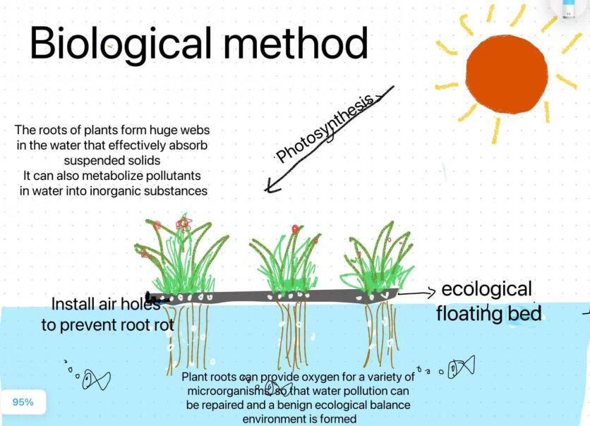

Design option 2 –Chemical treatment method

This chemical treatment uses a variety of chemical reagents and has a remarkable effect on purifying the main pollutants in the water body.

The methods of aeration and disinfectant are used in the important links, the first step is to oxidize and decompose the organic matter in the sewage by inhaling oxygen, and the second step is to kill the fine bacteria by adding chemicals (such as ClO2,O3).

These operations use a lot of modern industrial achievements to treat water bodies to prescribed standards, but because they use too many chemicals, they are expensive and pollute the environment badly.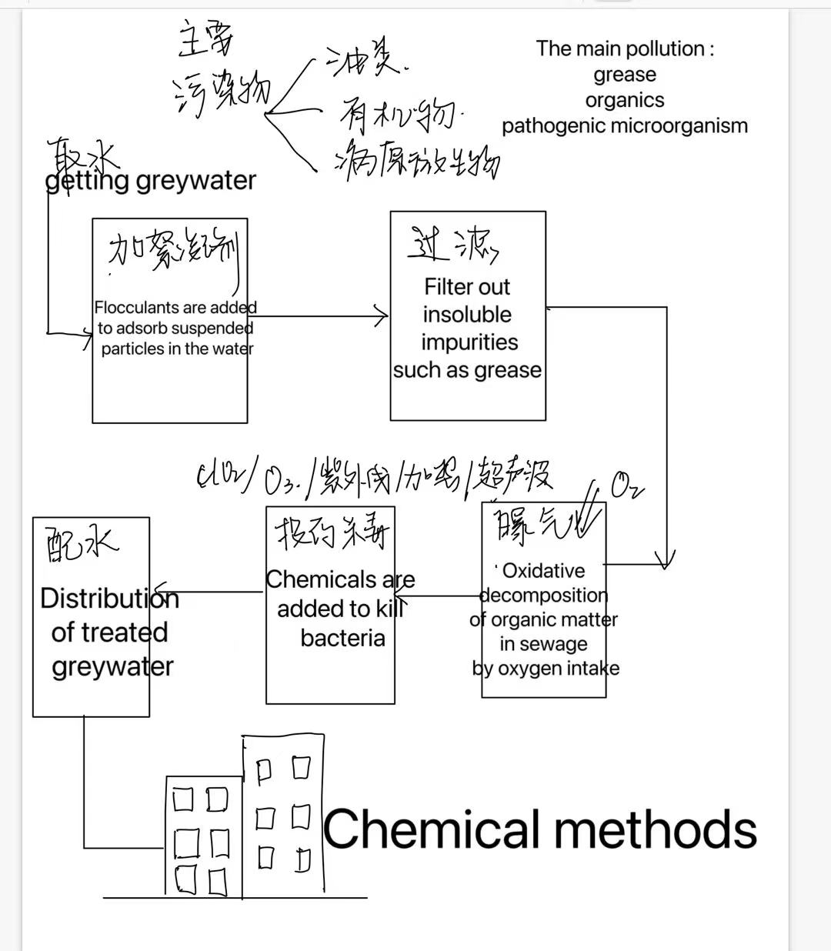

Design option 3 –Physical adsorption precipitation method

The third option is a physics-based water treatment unit that can efficiently meet the grey water treatment requirements of Cape York.

The solution combines adsorption, precipitation and separation, and completes the gray water treatment with low cost, low pollution and high efficiency through the treatment device running synchronously at different stages, so as to achieve the application of non-drinking water in household, industrial and agricultural fields.

The innovative use of electronic pulses in this process, when the electric valve is opened, the treated sewage leaves the unit through the water outlet, and the resulting pulse can discharge the sludge in the sedimentation tank, playing an effective role in separation

.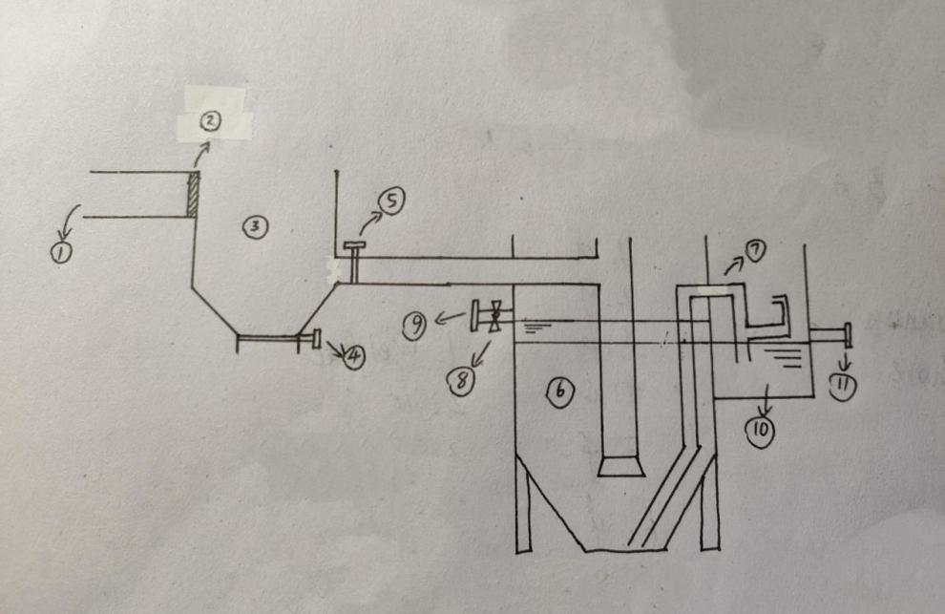

### 3.3 Option Selection:

|  |  |  |  |
| --- | --- | --- | --- |
| Design options  Design criteria | Artificial floating island | Chemical treatment method | Physical adsorption precipitation method |
| Culturally appropriate | 4 | 2 | 3 |
| Low cost | 4 | 1 | 5 |
| Environmental protection | 5 | 1 | 4 |
| Accessibility of construction | 3 | 2 | 4 |
| Technical  enforceability | 2 | 4 | 4 |
| High efficiency | 1 | 5 | 4 |
| Energy utilization rate | 1 | 4 | 4 |
| High safety performance | 5 | 1 | 5 |
| Total | 25 | 20 | 33 |

In summary, we choose Design option 3 –Physical adsorption precipitation method as our final grey water treatment scheme.

## 4. Proposed Design

Our final design scheme will be divided into three processes, namely collection, processing and export. The following will be analyzed and studied from these three aspects respectively.

### 4.1Greywater collection device

Camper’s recreational vehicle has washing area, cooking area and so on.

The greywater that people produced in washing area like bath water, laundry water is collected by drainage pipe and pooled into the water tank.

The greywater that people produced in cooking area like water used to wash vegetable, dishwashing water is collected by pipe and pooled into the water tank.

The greywater collected from washing area and cooking area are pooled in the greywater treatment device.

### 4.2 Greywater treatment device:

The introduction of physical methods of grey water treatment

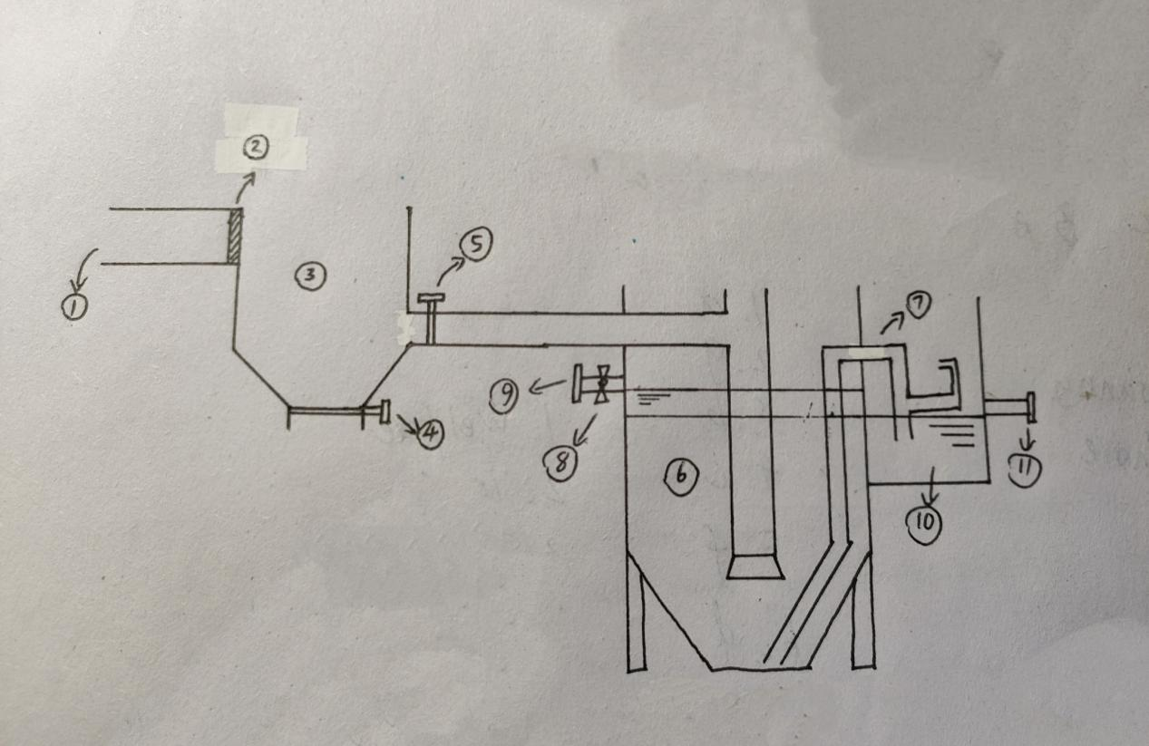

The picture above is the sectional drawing of the physical treatment of grey water device. This device is used for centralized physical treatment of grey water.

1. in the picture is water inlet, grey water in this district will enter this device for treatment through the water inlet.
2. is a sieve. It is located at the junction of the water pipe and the adsorption pool. When grey water flows from the water inlet to the adsorption pool, the sieve does a preliminary filtration of the grey water.
3. is the adsorption pool, while ④ and ⑤ are valves. Before the grey water enter the adsorption pool, ④ and ⑤ must be turned off to control the water flow and prevent the grey water from escaping. After the grey water flows into the adsorption pool, alum and activated carbon will be added into the pool to absorb the large granular impurities in the grey water. After complete adsorption, the large granular impurities in the grey water are basically cleaned up. Then we can open the valve ⑤ to let the grey water go to the follow-up device for the next step. After the grey water passes through the pipe into the settling pool, we can open the valve ④ to clean the used alum and activated carbon out.

⑥ is the settling pool. When the grey water flows into the settling pool, it's going to sit in this pool for a while in order to settles further, and then small granular impurities will be removed. This process further purifies the grey water, making it pure enough to meet most water reuse needs. ⑧ is the electric valve and ⑨ is water outlet. After the process of the physical treatment of grey water is over, the electric valve should be opened to control grey water that has been treated to leave the device through the water outlet. Meanwhile, the pulse generated by the operation of electric valve can cause silt inside the settling pool(those small granular impurities after being settled) to pass from the sludge pipe ⑦ into the sludge tank ⑩. That is to say, with the electric valve, this device can discharge the silt from the sedimentation tank while discharging the treated grey water. Also, silt in the sludge tank can be cleaned out when valve ⑪ is opened.

The above contents are the whole process of physical grey water treatment and the function of each part of the device. Since simply using physical treatment cannot dispose of extremely small substances such as viruses in the water, we can treat the water chemically after it has been physically treated. With combining the physical treatment with chemical treatment in order to purify greywater better.

## 5.Implementation Plan

### 5.1 Greywater collection device:

### 5.1.1 Implementation:

The implementation of this project was split into three parts:

Greywater collection device:

To collected the greywater produced by people in washing area and cooking area during camping.

#### 5.1.2 Component List:

The physical implementation of this project requires a number of components and other equipment:

O drainage pipe: to collected the bath water from bathroom.

O water tank: Temporarily collect greywater in the corresponding area

#### 5.1.3 Implementation Procedure:

- For Greywater collection device:

1. Pipe the water from vegetable sink and dishwasher to the water tank.
2. Use drainage pipe to pipe the bathwater to the water tank.
3. Pipe the water from washbasin and washing machine to the water tank.

### 5.2 Greywater treatment device:

how is it made/constructed?

Because of the local economy and harsh natural conditions,most of people in Cape York live scattered.As a result, it is costly to rebuild sewage treatment plants.At present, most of the greywater in this area is discharged directly through sewers without treatment,which is harmful to local environment.So,we make a decision to retrofit the existing foul water sewer.We first collected the greywater through the existing water channels.Then,we build the infrastructure which is our design solution to treat graywater.In order to improve work efficiency and reduce costs,we decide to produce raw materials in bulk,and then install directly in the specified area.As for building materials,we need to take the local natural conditions into consideration. With extreme weather conditions in Cape York, the design have to resist extremes,for example, bushfires, extreme heat, cyclones and flooding.(Forrest, L. 2019). Therefore,we chose [aluminium alloy](javascript:;)that has good corrosion resistance as our materials

How will be introduced to the community and used,managed,maintained?

There are abundant bauxite resources in the western part of Cape York .Moreover,some companies have already exploited the mineral resources,which almost form the complete industrial chain.So,the building materials are easily to get and use.Our project will start with small-scale implement.After a lot of experimentation and assessment,this project will be put into use on a large scale in real life .In the facilities management and maintenance section,we can hire the local people to check the use of facilities and switch the valve regularly.Because of the hot and humid environment,the building materials made of aluminum alloy are needed to maintain regularly .We need to clean the greasy dirt or stains on the surface in time,which improve the service life of facilities.If the facilities are damaged seriously, report it to the local government for timely replacement.

How to transfer knowledge to the community?

Because of its remote location,Cape York is little known and people who live there are almost half aboriginal and Torres Strait Islander,which constitute the Australian indigenous peoples or races.The local people have a deep belief and feelings in water and land in Cape York,because they depend on it for survival generations after generations.Therefore,we need to respect their belief and culture. And we have effective communication to express our ideas and pass related knowledge to them.We can also contact the local government to organize the activities to impart knowledge.What’s more,we can use the Internet for remote instruction if something goes wrong.

### 5.3 Greywater exporting device:

Use pipes to feed into the original water pipeline for household and factory use.At this stage, the original pipelines in the area can be used to transport the treated sewage into the household, taking advantage of the advantages of the pipelines in the underground linking the whole area.

## 6.Cost Analysis

### 6.1 Greywater collection device

The cost of the greywater collection device mainly includes material cost and construction cost. Material costs mainly include water pipes, storage tanks, waterproof floors, pumps and valves; construction costs mainly consider workers' wages.

The selection of water pipes needs to consider the price, corrosion resistance, the ability to withstand hot water, the ability to withstand water pressure, and whether it contains toxic substances. The greywater collection device mainly considers the use of Copper pipes, PEX pipes, CPVC pipes, Galvanized pipes, and Cast iron pipes. On the one hand, considering that the greywater produced in many scenes in camping is hot water, the pipe needs to be resistant to high temperature, because the PEX pipe is only suitable for cold water, so the CVPC pipe is more suitable; on the other hand, considering the price issue, the price of metal pipes is higher, and the price of CPVC pipe is more appropriate. In summary, the CVPC pipe is the final choice.

Due to the design of the pipeline, it is necessary to take some waterproof measures to prevent water leakage. So install waterproof laminate flooring where the pipes converge is necessary. Waterproof laminate flooring is more expensive than regular flooring, averaging $4.50 per square foot and ranging between $3 and $5 per square foot.

There are no special requirements for water tanks, and the price is around $800 each; the average wage of an interior decorator is about $100; the price of a water pump is around $200; a valve costs around $1.85 to $1.87.

The total cost of the greywater collection device is as follows:

|  |  |
| --- | --- |
| Component | Unit price |
| Water pipe | $0.50-$1 Per Linear Foot |
| Water tank | $800 each one |
| Water pump | $200 each one |
| Interior decorator | $100 each time |
| Valve | $1.85-$1.87 each one |
| Waterproof laminate flooring | $4.50 Per square foot, ranging between $3 and $5 per square foot. |

Table1: The price of greywater collection device

### 6.2 Greywater treatment device:

#### 6.2.1Material selection for manufacturing the physical grey water treatment device

Australia's mineral resources have the characteristics of abundant varieties, large reserves, excellent quality, shallow burial and easy exploitation. Due to the large proportion of mineral exports in total merchandise exports, Australia is also known as "the country sitting on the mining cart". According to the reports, Australia accounts for 12 of the 32 new bauxite projects in Fitch's database of key mine projects, more than any other country. Meanwhile, the Rio Tinto Group, headquartered in Melbourne, Australia, is not only the world's second largest producer of iron ore, but also the world's top producer of bauxite. As one of the major producers of bauxite in the world, Australia's aluminum has advantages in production and quality. On the other hand, since the device we are going to design in this project is for the treatment of gray water, the material for manufacturing this device needs to be resistant to corrosion. Aluminum alloy is the second most widely used metal after steel, due to its low density, one-third lighter than steel, corrosion resistance, and excellent combined physical and chemical properties. At the same time, the toughness of aluminum alloy is high, and it has strong plasticity. In summary, aluminum alloy will be an excellent choice for manufacturing this device. Since Australia is rich in bauxite, the local price of aluminum related industrial products in Australia will be relatively low, and aluminum as a commonly used material for industrial products, its own characteristics also make it able to meet most of the demand. Aluminum alloy made from bauxite has stronger corrosion resistance and lower mass than other aluminum products, which makes the device made of aluminum alloy easier to handle, longer service life and better treatment effect than the device made of other materials. In other words, the use of aluminum alloy to manufacture physical grey water treatment devices not only reduces the cost of manufacturing devices, but also reduces the cost of subsequent maintenance and repair equipment to a certain extent, and can also better meet the needs of physical grey water treatment devices.

#### 6.2.2 Estimated cost of manufacturing the physical grey water treatment device

First of all, the price of bauxite is 1000 yuan per ton, and the density of bauxite is 2.7g/cm3, so the price of bauxite per cubic meter is 2700 yuan.

Secondly, the price of aluminum alloy is 20,000 yuan per ton, and the density of aluminum alloy is 2.7g/cm3, so the price of aluminum alloy per cubic meter is 27,000 yuan.

Finally, the volume of the domestic sewage adsorption tank is 1 cubic meter, and the volume of the domestic sewage sedimentation tank is 2 cubic meters.

Therefore, it takes 2700 yuan to make a domestic sewage adsorption tank with bauxite, and 54000 yuan to make a domestic sewage adsorption tank with aluminum alloy.

Since the specific price of electronic valves depends on the brand, model, specifications and other factors, the price of electronic valves for sewage treatment ranges from 400.00 yuan to 27,000 yuan. Here we can take the middle value of 13,700 yuan.

Adding up the costs required for these components means that the manufacture of such a physical grey water treatment unit costs about 70,400 yuan. Translated into Australian dollars, this is $14,575.1941.

### 6.3 Greywater exporting device:

During the process of using the greywater which has been dealt with, the main cost is the choice of pipe material, length, and the cost of laying the pipe.Considering the local climate in Cape York, we mainly choose to use aluminum or stainless steel pipes to prevent rust and reduce the service life. And Australia's local bauxite can provide aluminum, reducing costs while stainless steel is about 2940.00052 AUD per ton.The laying of pipes is also a problem. Since the treated water can be used directly, it is best not to mix it with the pipes that carry the water, which can cause additional pollution. It is better to converge with the already laid water pipeline, and try to lay in a straight path to reduce the cost of materials where there is no original pipeline.

In terms of household and factory use, we will collect the treated clean water and the original clean water into a pipe for household use and factory use, which can also save the cost of additional pipeline construction.We also have to consider the follow-up maintenance of the pipes, Under normal circumstances, the maintenance of 1 meter long, 300 diameter pipe about the need 637.39492 AUD.

## 7. Design Prototype

### 7.1 Greywater collection device:

The greywater produced in the camping life is mainly from bathroom and kitchen. Therefore, the greywater collection device is mainly designed in two scenes of bathroom and kitchen. Especially considering the smart devices such as dishwashers and washing machines that are often used in life. The places using water are installed with pipes to ensure that the greywater will not be discharged outdoors arbitrarily. Gravity self-flow is used where gravity flow can be used, and on the other hand, water pumps are added in places where gravity flow is not suitable for collection. Especially considering the problem of water pressure, a valve is designed at the nozzle connection to ensure the water pressure. Waterproof laminate flooring is installed in areas prone to water leaks and a sunken collection pipe is installed in the bathroom shower to prevent overflow problems. At the same time, considering that part of domestic greywater does not need to be collected by pipes, a manual greywater collection device is also designed in this design.

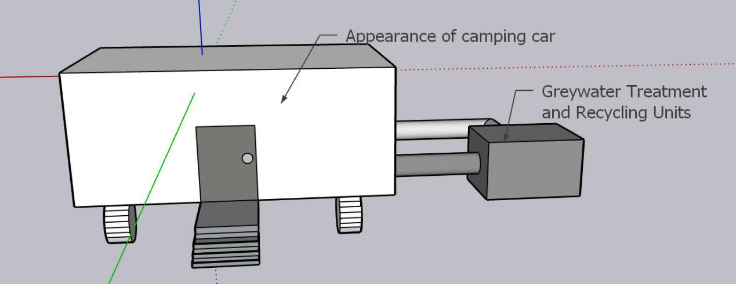

**Figure1: The outside of the design**

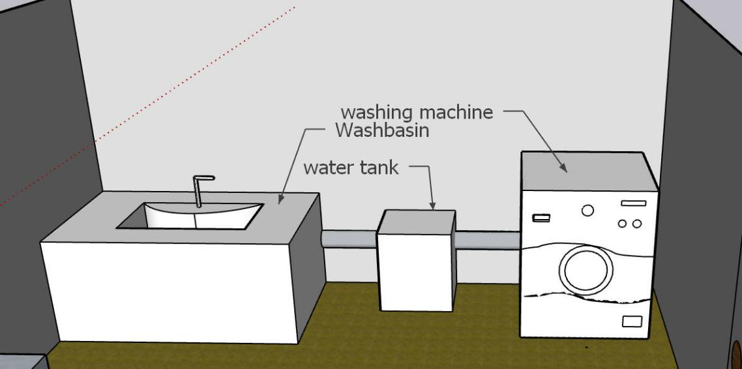

**Figure 2: Bathroom design**

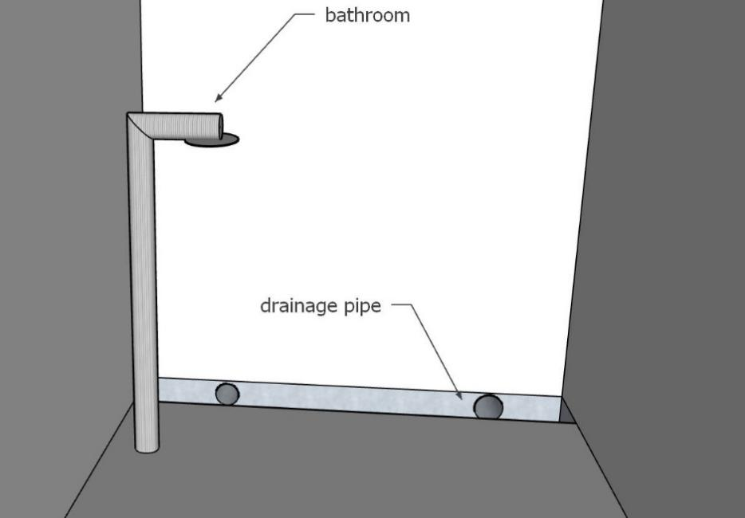

**Figure 3: Shower room design**

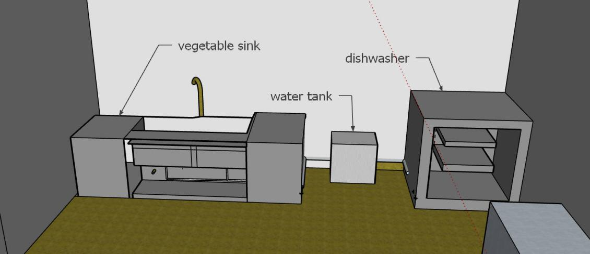

**Figure 4: Kitchen design**

### 7.2 Greywater treatment device:

The three-dimensional modeling of physical grey water treatment device and screenshots of its various perspectives：

①The three-dimensional modeling of physical grey water treatment device



②screenshots of its various perspectives

Front view:

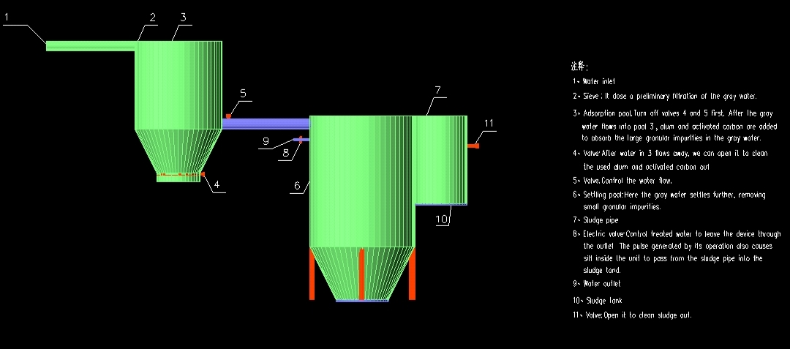

**Figure 5**

Left view:

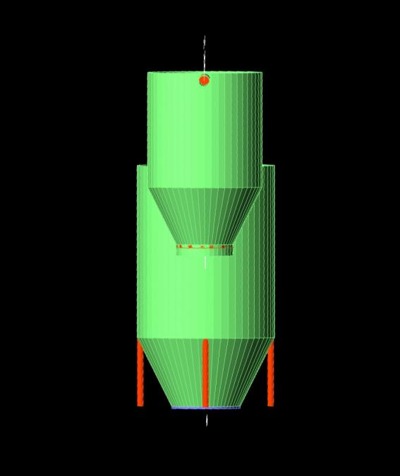

**Figure 6**

Vertical view:

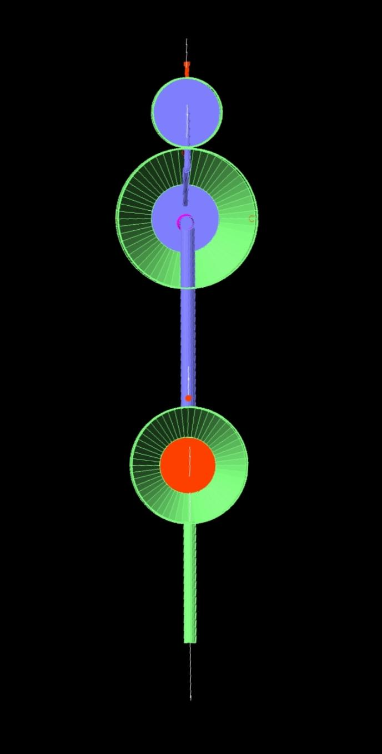

**Figure 7**

Others:

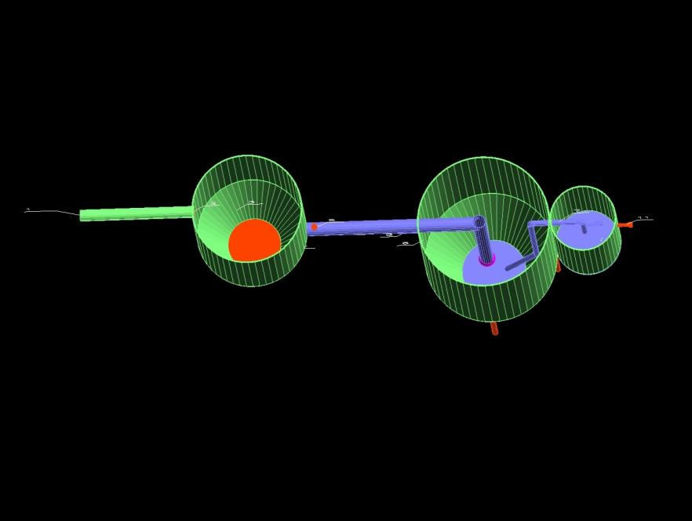

**Figure 8**

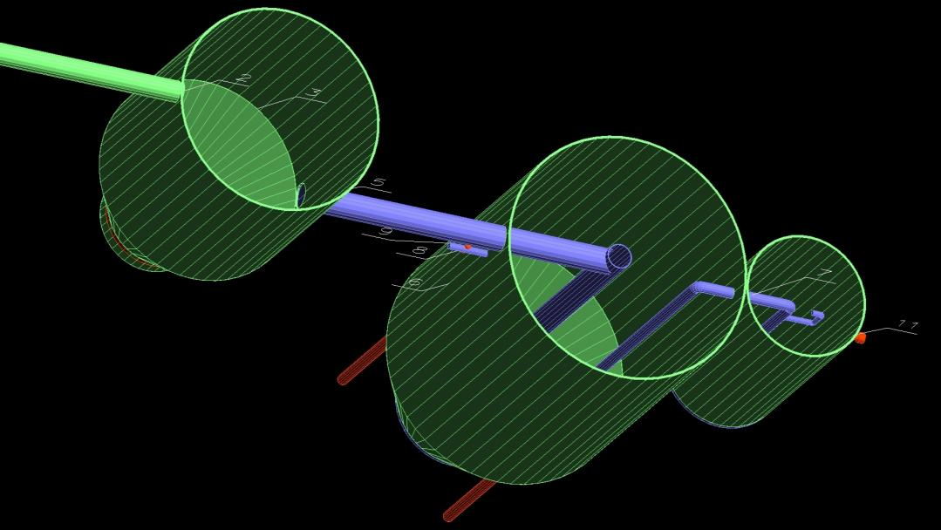

**Figure 9**

### 7.3 Greywater exporting device:

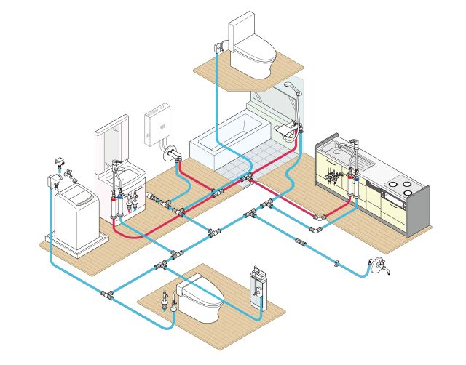

**Figure10:** Pipeline connection+Home application

As shown in the figure, the red line represents the drinkable pure water, and the blue line represents the water with lower requirements for cleaning and flushing. The water that we treat thoroughly can be used for drinking, and the water that is treated less thoroughly and simply can be used for flushing.

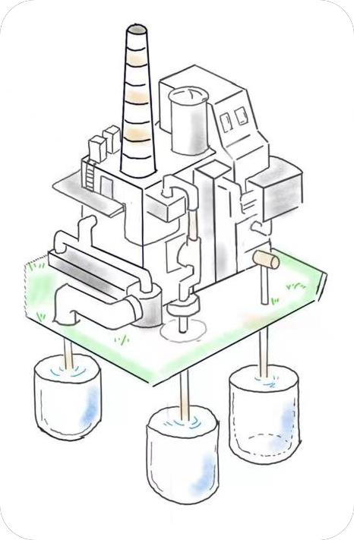

**Figure11**: Industrial application

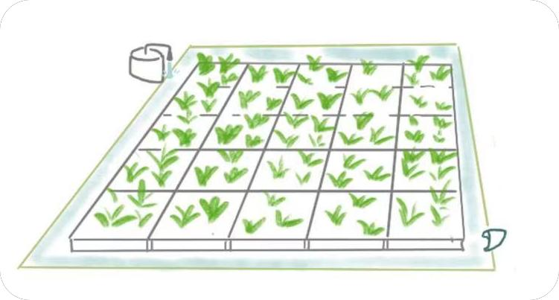

**Figure12:** Agricultural application

## 8.Discussion

### 8.1 How to meet the needs of the client?

Our design is aimed at treating the greywater to mitigate environmental harmful impacts.We design the physical device to purify the greywater by adsorption and precipitation.Though the greywater treated is still unable to drink directly,it can reuse in industry and agriculture areas.

### 8.2 The benefits and impacts in culture, environment, economic?

Culture and social

Water is one of the most important part of local culture,because they depend on it for survival generations after generations.We will communicate with local people to learn about their culture and belief sincerely before the project stars.Our design must be based on protecting and respecting local traditional culture.Regarding the maintenance and construction of facilities,we also organize some activities to impart knowledge and share experience with local people,which would promote cultural exchange and social development.

Environment:

The greywater is not released into environment directly by carrying out our design.It would reduce people's impact on the natural environment and maintain the local ecological balance.Moreover, our approach to purification is primarily physical,which is almost environmentally friendly comparing to other methods.And our design materials can be recycled to improve people’s life in different areas.

Economic:

Because of the unique natural landscape and colorful culture in Cape York,more and more people come there for exploring the mystery and experiencing aboriginal life.However,the local infrastructure is not adequate to satisfy tourist’s needs.Our project is designed to treat greywater during visiting activities.Our design can improve visitor’s satisfaction and recognition,which boost the development of tourism partly.Moreover,our design realize the secondary utilization of water resources ,which improve efficiency and save costs

### 8.3 How will the client,community and other stakeholders be engaged in the project?

For government:

The government acts as the bridge to communicate with local people,The government strengthened publicity to help the masses actively accept the implementation of new projects.

For local people:

The local people can be participated in this project as the simple labour.Moreover,the local people actively responded to the work of the government, took the initiative to join the propaganda team, expanded the influence of the project, and enhanced the public's conviction of the project

For company:

The company need to conduct comprehensive and systematic surveys to gain a deeper and more systematic understanding of Cape York's human geography.And the company also evaluate and improve the project so that it can be carried out successfully.

### 8.4 Strengths/weaknesses

#### 8.4.1 Strengths:

##### 8.4.1.1 For materials

we choose the aluminium alloy as the main building materials.It has light and high strength and strong corrosion resistance,which is appropriate to local environment.And Aluminum alloy is easy to process, shape and weld, can be made into a variety of shapes.So it is widely used in industry.The last,the auminum alloy can be recycled,which is conducive to environmental protection and resource saving.

##### 8.4.1.2 For implement

We choose a combination of physics and chemistry, focusing on physics, to protect the local environment to a certain extent.Moreover, the operation is simple and convenient and the purification efficiency is high,which is appropriate to be used by local people.

#### 8.4.2 Weaknesses:

##### 8.4.2.1 For materials:

The high temperature resistance of aluminum alloy is poor, and it is easy to soften and oxidize at high temperatures.Moreover,it is complicated and costly to make large-scale aluminum alloy

##### 8.4.2.2 Limitations of application

Because we choose the method combined with physical and chemical methods to treat greywater, the treated sewage still contains impurities.Therefore,this design’s application is also be limited.

## 9. Conclusion and Recommendations

In conclusion,our design is aimed at solving greywater problems during camping.Our final solution is divided into three processes, namely collection, processing and export.We collect greywater through pipes, purify it with a physical device, and finally recycle the treated greywater into different areas.Our solution is appropriate to local culture and environment.In operation, this design is more efficient and less costly than other design options in our many comparisons.Of course, it also has design defects and application limitations, which need to be further improved and studied in the future.All in all,the scheme of treating greywater by our method is worth considering.

## 10.Reference

Forrest, L. (2019). Lama Lama for the long-term. [https://landandgroundwater.com/story/lama-lama-for-the-long-term (Links to an external site.)Links to an external site.](https://landandgroundwater.com/story/lama-lama-for-the-long-term" \t "https://lms.cloudcampus.com.cn/courses/54/pages/_blank)

Census QuickStats for Cape York (2021):

[https://www.abs.gov.au/census/find-census-data/quickstats/2021/315011396 (Links to an external site.)Links to an external site.](https://www.abs.gov.au/census/find-census-data/quickstats/2021/315011396" \t "https://lms.cloudcampus.com.cn/courses/54/pages/_blank)

Dockery, A. M. (2010). Culture and wellbeing: The case of Indigenous Australians."Social Indicators Research 99(2): 315-332. [http://www.miqols.org/howb/wp-content/uploads/2016/06/Dockery_Indigeneous-and-Cultural-WB_2010.pdf (Links to an external site.)Links to an external site.](http://www.miqols.org/howb/wp-content/uploads/2016/06/Dockery_Indigeneous-and-Cultural-WB_2010.pdf" \t "https://lms.cloudcampus.com.cn/courses/54/pages/_blank)

Native Plants.(2023, march 8).in Queensland Government. <https://www.qld.gov.au/environment/plants-animals/plants/native-plants>

Kariuki, F. W., Kotut, K., & Nganga, V. G. (2011). The potential of a low cost technology for the greywater treatment.

<http://repository.embuni.ac.ke/bitstream/handle/123456789/232/Kotut%20-%20The%20potential%20of%20a%20low%20cost%20technology%20for%20greywater%20treatment%20-The%20Open%20Environmental%20Engineering%20Journal.pdf?sequence=1>

Antoine Morel, Stefan Diener.(2006). Greywater Management in Low and Middle-Income Countries.

<https://sswm.info/sites/default/files/reference_attachments/MOREL%20and%20DIENER%202006%20Greywater%20Management.pdf>

Climate chance in the Cape York region.(n.d.)in Queensland Government.

<https://www.qld.gov.au/__data/assets/pdf_file/0019/68140/cape-york-climate-change-impact-summary.pdf>

Our region.(2012).in Cape York natural resource management.

<https://capeyorknrm.com.au/about/region>